Prediction of Aerodynamic Coefficients Using Deep Learning Methods Based on Xfoil Simulations of CST Generated Random Airfoils

Kourosh Ghahramanimarangalou[1], Buğrahan Öztürk[2],

Ahmet C. Özgören[3], Volkan Aydıngül[4], Oğuz Uzol[5]

*Department of Aerospace Engineering*

*Middle East Technical University (METU), Ankara, Turkey*

**Deep learning techniques are used to train a neural network using a 2D aerodynamics dataset obtained through Xfoil simulations of approximately 16,000 different airfoils in a wide range of Reynolds numbers and angles of attack. The airfoil geometries are randomly generated using Class Shape Transformation (CST) Methodology. Each generated airfoil shape is then analyzed in a Reynolds number range from 1 Million to 8 Million, with a delta Re of 500k, and in an angle of attack range of -10 degrees to 15 degrees, with a delta alpha of 1 degree. Mach number is kept constant at incompressible domain. The resulting data set, which consists of approximately 3 Million data points for lift, drag and moment coefficients each, is used to train the deep learning model. The predictions of the model are tested for a different set of airfoils and Reynolds numbers that do not exist in the training dataset. The results show that the network performs well on test data by lowering the maximum error by half compared to previous studies in literature.**

1. **Nomenclature**

CFD = Computational fluid dynamics

CST = Class Shape Transformation

*CD*= Drag coefficient

*CL*= Lift coefficient

*CM*= Pitching moment coefficient

*Cp*= Pressure coefficient

MLP = Multi layer perceptron

Re = Reynolds number

ReLU = Rectified linear unit

1. **Introduction**

Airfoil aerodynamic polars are the basis for design in many different applications from aircraft wings to propellers to helicopter or wind turbine rotor blades. These polars are commonly obtained either using numerical tools such as Xfoil [1] , MSES [2] or CFD or through wind tunnel tests albeit at reduced Reynolds numbers in general than actual operational conditions. In order to obtain an actual three-dimensional optimized design these polars have to be generated first for a wide range of Reynolds and Mach numbers, if need be, extrapolated to operational Reynolds numbers (in case of wind tunnel tests) and subsequently incorporated into a design optimization tool.

In recent years, data driven techniques are becoming increasingly popular and deep learning techniques are being implemented in a variety of aerodynamics problems. Wallach et al [3] investigated obtaining the aerodynamic coefficients for the NACA 23012 airfoil using a Multi Layer Perceptron (MLP) neural network trained using results from Xfoil simulations at 125 data points. The aerodynamic coefficients of a transport twinjet geometry as well as a wing-body configuration were also investigated in their study. Their neural network models were able to successfully capture variations of lift and drag coefficients for the geometries investigated in their paper. Dos Santos et al [4] parameterized airfoil geometries using Sobieczky polynomial functions [5] and generated aerodynamic databases for limited angle of attack ranges, either using Xfoil or MSES depending on Mach number regime, for thousands of airfoil geometries at fixed Mach or Reynolds numbers. These datasets are then used in training MLP neural networks for prediction. Their results showed good agreements for airfoils from their validation set but they concluded that the accuracy of their predictions for lift and drag coefficients is not sufficient for the neural network model to be included in design optimization studies. Sun et al [6] investigated airfoil inverse design using neural networks. They have generated an aerodynamic database for 208 airfoils by solving full potential equation for transonic flow conditions and trained neural networks to obtain an input-output relationship between aerodynamic coefficients as input parameters and the shape of the airfoil as output, which was characterized using 11 parameters of PARSEC methodology. They concluded that neural networks can successfully be used in airfoil and wing inverse design studies with enough accuracy and efficiency. More recently Zhang et al [7] trained a convolutional neural network to predict the lift coefficient. The training is performed using an aerodynamic coefficient database that they have generated using Xfoil simulations of 133 airfoils from the UIUC airfoil database in a wide Reynolds and Mach number range. To enhance the data quality they also created flipped airfoil data using the symmetry for the lift coefficient, totaling a number of 80,000 data points for training. Their predictions of lift coefficient using the trained neural network showed reasonable agreement for airfoils that were not included in the training dataset.

This paper presents the results of a deep learning implementation study to predict aerodynamic coefficients through training a neural network using a large database of Xfoil simulations for 16,000 different airfoil shapes in a wide range of Reynolds numbers and angles of attack. The airfoil geometries are randomly generated using Class Shape Transformation (CST) Methodology. Each generated airfoil shape is then analyzed in a Reynolds number range from 1 Million to 8 Million, with a delta Re of 500k, and in an angle of attack range of -10 degrees to 15 degrees, with a delta alpha of 1 degree. Mach number is kept constant and the n factor is fixed at 9 to simulate free transition conditions. The resulting data set, which consists of approximately 3 Million data points for lift, drag and moment coefficients each, is used to train the deep learning model. The performance of the trained network is tested with NACA 4 digit airfoils as well as with DU series airfoils, which were not used in the training process.

1. **Methodology**
2. **Random Airfoil Geometry and Aerodynamic Database Generation**

Any airfoil shape can be represented using Class/Shape Transformation (CST) methodology [8]. CST is a decoder that utilizes Bernstein polynomials and is based on two arrays of coefficients. The coefficients in arrays represent the upper and lower surfaces of the airfoils. Equations for these surfaces in CST are given as:

|  |  |
| --- | --- |
| $Ϛ_{U}\left(ψ\right)=C\left(ψ\right)S_{U}\left(ψ\right)+ψ.∆Ϛ_{U}$ |  |
| $Ϛ_{L}\left(ψ\right)=C\left(ψ\right)S_{L}\left(ψ\right)+ψ.∆Ϛ_{L}$ | (1) |

where $ψ=x/c and Ϛ=z/c$

The class function to create a 2D airfoil shape in CST is given below:

|  |  |
| --- | --- |
| $C_{1.0}^{0.5}\left(ψ\right)=ψ^{0.5}.{\left(1-ψ\right)}^{1.0}$ | (2) |

In Equation (2), coefficients of 0.5 and 1.0 are constants to produce 2D airfoil shape in CST. The final shape function to define the specific shape for the upper and lower surfaces is defined as:

|  |  |
| --- | --- |
| $S_{U}\left(ψ\right)=\sum_{i=0}^{N_{U}}{}A_{U}\left(i\right).S\left(ψ,i\right)$ |  |
| $S_{L}\left(ψ\right)=\sum_{i=0}^{N_{L}}{}A_{L}\left(i\right).S\left(ψ,i\right)$ | (3) |

In Equation (3), A is the weight input coefficient and decisive parameter in CST method. S is called as the component shape function. The component shape function is represented by a Bernstein polynomial as following:

|  |  |
| --- | --- |
| $S\left(ψ,i\right)=K_{i}^{N}.ψ^{i}.{(1-ψ)}^{N-i}$ | (4) |

Binomial coefficient (K) in Equation (4) is defined as:

|  |  |
| --- | --- |
| $K_{i}^{N}=\frac{n!}{i!\left(n-i\right)!}$ | (5) |

The final equation representing the upper and lower surfaces are obtained by combining the previous equations.

|  |  |
| --- | --- |
| $Ϛ_{U}\left(ψ\right)=ψ^{0.5}. {(1-ψ)}^{1.0}\sum_{i=0}^{N_{U}}{}\left[A_{U}\left(i\right).\frac{N_{U}!}{i!\left(N_{U}-i\right)!}.ψ^{i}.{(1-ψ)}^{N_{U}-i}\right]+ψ.∆Ϛ_{U}$ | (6) |
| $Ϛ_{L}\left(ψ\right)=ψ^{0.5}. {(1-ψ)}^{1.0}\sum_{i=0}^{N_{L}}{}\left[A_{L}\left(i\right).\frac{N_{L}!}{i!\left(N_{L}-i\right)!}.ψ^{i}.{(1-ψ)}^{N_{L}-i}\right]+ψ.∆Ϛ_{L}$ |  |

In equation 6, the first and last weighting coefficients for the upper and lower surface (AU and AL) are known to determine the leading edge radius and the trailing edge angle, respectively. Rest of the weighting coefficients vary the thickness distribution in general [9]. Since our main objective in this study is to train a neural network for learning the correlation between the variation in shapes and their corresponding aerodynamic polars, we generate a wide range of airfoil shapes based on randomly selected values for the weighting coefficients (AU and AL), for the order of Bernstein polynomials (N, equation 6) as well as for the exponents of the class shape functions (equation 2).

The random selection process is performed using a uniform distribution in order to sample a stochastic range of shapes. The order of Bernstien polynomials are randomly selected from integers between 2 and 10, and the class function exponents are selected from the ranges 0.45 to 0.55 and 0.95 to 1, instead of using constant values of 0.5 and 1. The first weighting function that determines the leading edge radius is selected within a range of 0.01 to 0.05, and last weighting function for the trailing edge angle is selected from integers between -10 to 20. The rest of the weighting coefficients are selected within a range of -0.1 to 0.6 for the upper surface and -0.6 to 0.1 for the lower surface. The upper and lower boundaries for these ranges were selected such that the upper and lower surfaces will not cross and intersect with each other. The selection of these ranges allowed us to create a wide range of airfoil shapes, some of which actually can be “impractical” for aerodynamic applications. However these wide range of airfoils provided large enough shape variations for the neural network to establish a good link between these shape variations and aerodynamic coefficients. The “impractical” airfoils were intentionally not excluded from the Xfoil calculations, as long as Xfoil provided converged results for the simulations.

Using the methodology described above we have generated 16000 airfoil shapes and analyzed all of them using Xfoil. Simulations for each airfoil were done in a Reynolds number range from 1 Million to 8 Million, every 500k, and in an angle of attack range of -10 degrees to 15 degrees with a step of 1 degree. As expected some runs at certain airfoil, Reynolds number and angle of attack combinations did not converge. Using the converged results we used 2,256,624 data points in total for training (total number of converged airfoil, Reynolds number and angle of attack cases). Of course for each of these cases the dataset includes the aerodynamic coefficients CL, CD and CM.

1. **Neural Network Architecture and Training**

We have implemented a multi layer perceptron (MLP) to find the correlation between the shape of the airfoil and its polars. The network consists of five fully connected layers and leaky rectified linear unit (ReLU) is used as the activation function of all neurons. The hidden layers consists of 512, 256, 200, 128 neurons. The input layer has 326 points representing the z coordinates of the airfoil interpolated on a uniform grid. The output layer consists of four neurons corresponding to lift coefficient (CL), Drag Coefficient (CD), pressure drag (C $D_{p}$), and pitching moment coefficient (CM). A small subset of the generated data was used for the hyper-parameter tuning and we trained the network on 2,256,624 data-points for which we excluded the angles of attack after stall. All geometry generation and training codes are written in Python using the libraries provided by PyTorch, which is an open source machine learning framework (<https://pytorch.org/>).

1. **Results**

The network was tested on 100000 data points generated from Xfoil runs of 300 NACA four digit airfoils that were built in to Xfoil and were not included in the network training process. Figure 1 shows the variation of computed lift, drag, moment, and lift/drag coefficients using the trained network vs. their actual values calculated by Xfoil for all of the 300 NACA four digit airfoils. We observe that the general prediction capability is quite reasonable and scatter levels are different for different coefficients. The highest for CD is observed to be around 51% with a value of 0.0112 where the network predicted the value 0.0169.

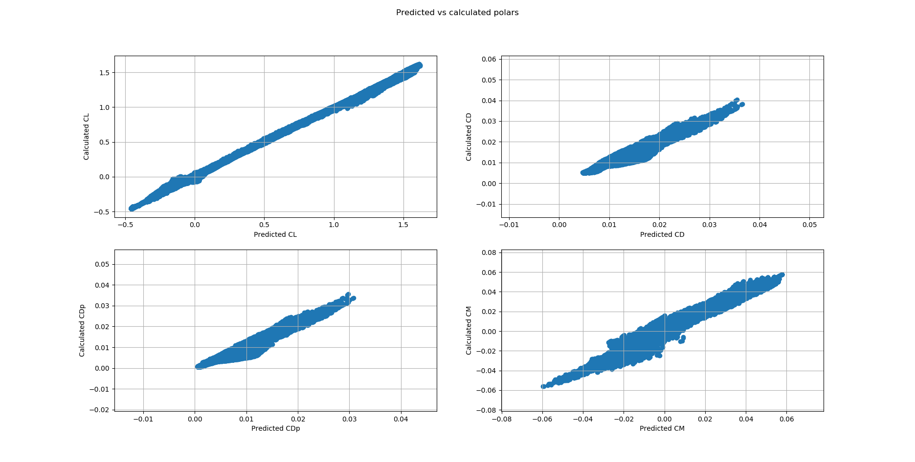

Figure 1. Variations of computed aerodynamic coefficients using the trained network (x axis) with the actual Xfoil calculated ones (y axis)

Figures 2 and 3 show two different sample comparisons of polars for the predicted and calculated cases for the NACA 000618 and DU 91-W2-250 airfoils. The corresponding Reynolds numbers are 1,700,000 for the NACA profile and for 6,250,000 for the DU91-W2-250 profile. The network performs well in predicting the polars and extrapolating to a domain that it has not observed before.

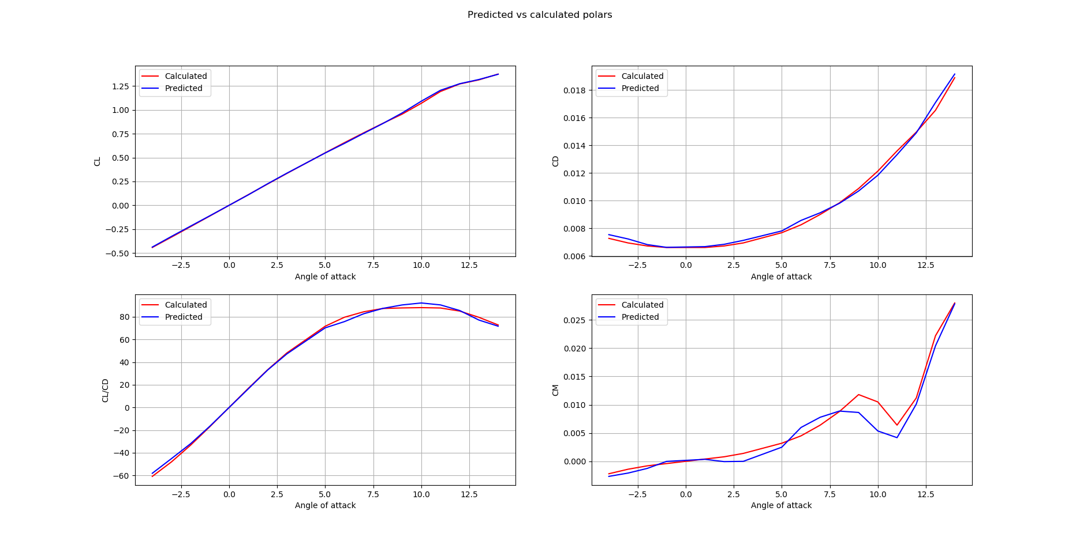

Figure 2. Predicted and computed aerodynamic coefficients of the network for NACA 0618 profile for a Reynolds number of 1,700,000

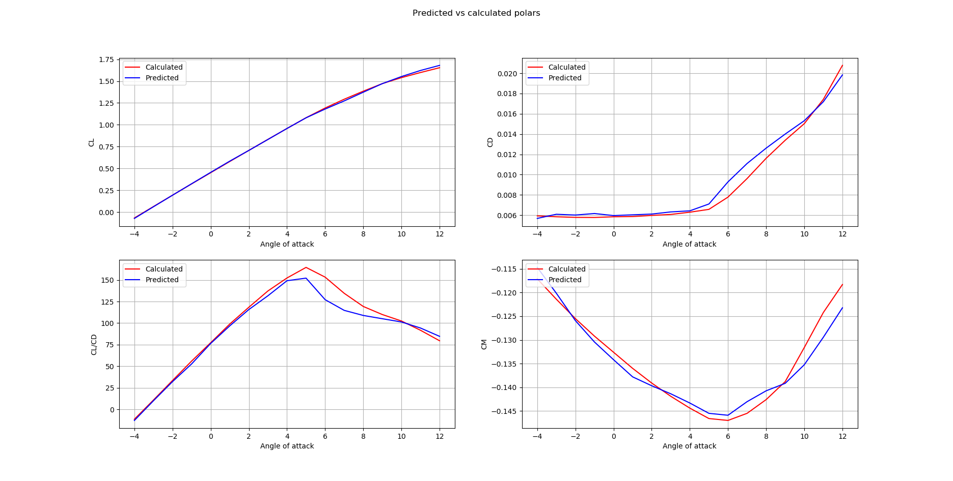

Figure 3. Predicted and computed aerodynamic coefficients of the network for DU91-W2-250 profile for a Reynolds number of 6,250,000.

1. **Conclusions**

We have presented preliminary results from a deep learning implementation study to predict aerodynamic coefficients through training a neural network using a large database of Xfoil simulations for randomly generated airfoil shapes using CST methodology in a wide range of Reynolds numbers and angles of attack. Though more results will be presented in our final paper current results show quite good prediction capability of the trained model when tested with standard NACA airfoils as well as with wind energy related airfoils such as the DU series. This trained network could be further improved by including additional CFD or available experimental data through transfer learning techniques. A better trained network can also be used to inverse design airfoil shapes by giving aerodynamic coefficients or even Cp distributions as inputs. These types of trained networks can also be used for modeling the Reynolds number dependency of aerodynamic coefficients.

**Acknowledgments**

We thank METU Center for Wind Energy for the access provided to the HPC system

# References

|  |  |
| --- | --- |
| [1] | Drela, M., "XFOIL: An Analysis and Design System for Low Reynolds Number Airfoils," in *Low Reynolds Number Aerodynamics*, Berlin, Heidelberg, 1989. |
| [2] | Drela, M, "A User’s Guide to MSES 3.05," MIT Department of Aeronautics and Astronautics, Massachusetts, 2007. |
| [3] | Wallach , R., Mattos, B. S., Roberta, G. d., and Curvo, M., "Aerodynamic Coefficient Prediction of a General Transport Aircraft Using Neural Network," in *44th AIAA Aerospace Sciences Meeting and Exhibit*, Nevada, 2006. |
| [4] | dos Santos, M. C., de Mattos, B. S., and Girardi, R. d., "Aerodynamic Coefficient Prediction of Airfoils Using Neural Networks," in *46th AIAA Aerospace Sciences Meeting and Exhibit*, Nevada, 2008. |
| [5] | Sobieczky, H., "Parametric Airfoils and Wings," Notes on Numerical Fluid Mechanics, vol. 68, no. Vieweg, pp. 71-88, 1998. |
| [6] | Sun , G., Sun, Y., and Wang, S., "Artificial neural network based inverse design: Airfoils and wings," *Aerospace Science and Technology,* pp. 415-428, 2015.  doi: 10.1016/j.ast.2015.01.030 |
| [7] | Zhang, Y., Sung , W., & Mavris, D., "Application of Convolutional Neural Network to Predict Airfoil Lift Coefficient," in *AIAA SciTech Forum*, Kissimmee, Florida, 2018.  doi: 10.2514/6.2018-1903 |
| [8] | Kulfan B.M., “Universal Parametric Geometry Representation Method,” Journal of Aircraft, Vol. 45, No.1, January-February 2008. |
| [9] | Oğuz, K., “Aerodynamic Optimization of HAWT Blades by Using CST Method, BEM Theory and Genetic Algorithm,” MSc Thesis, Middle East Technical University, 2019. |
|  |  |

1. Graduate Student
2. Graduate Student
3. Undergraduate Student
4. Undergraduate Student
5. Professor