Uygar Tolga Kara, Tuğrul Yazgan, Arda Furkan Yıldırım, Serdar Yavuz Küçükberber, Deniz Demir, Batuhan Demirtaş

TEAM AURORA | YILDIZ TECHNICAL UNIVERSITY

International UAV Competition

FLight science 2 class project

# Statement of Work

This project is prepared to construct a simulation environment for a quadcopter. The main idea is to test the quadcopter without building it to make a design formulation and produce ideas. The simulation is based on a real scenario where the UAV completes two tasks in a competition. The performance parameters are transferred into a point system to find the optimum point of design. The first task performance is dependent of speed and weight while the second task performance is dependent of speed, weight and water carrying capacity. The simulation software is selected as MATLAB, Simulink, Stateflow. The project has a deadline of nearly 2 months as preparation. The budget of the project is zero and the project is aimed to be completed with team effort.

The project has a report to inform the reader about some aspects. The report consists of cover page, statement of work, system architecture and system functions/ use case scenarios, test cases to satisfy the requirements and pass/fail criterias at system level and user level, user level requirements/system level requirements, implementation (system level models, simulation with simple controls), components and component level requirements , component level models and simulations per requirements, subsystem level models and simulation per requirements, system level models and simulation per requirements, design of experiments, results.

The project follows a competition and the competition has rules to follow. Some of the rules are specified as design requirements. Some requirements are:

* UAV is a rotary wing type of plane.
* UAV needs to complete the tasks autonomously. This is a special challenge for implementing the means of control with joystick configuration. Therefore, the need of controller is visible.
* No plagiarism during design is appreciated.
* At the first task, UAV needs

1. The first task consists of

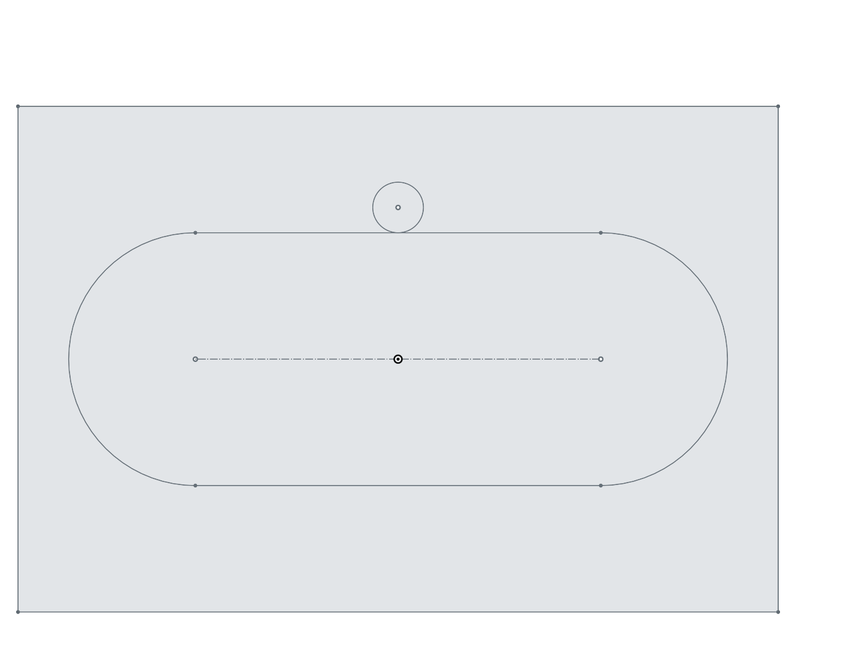

1. The second task consists of

gece göğü içeren bir resim

Açıklama otomatik olarak oluşturuldu