IZMIR UNIVERSITY OF ECONOMICS
FACULTY OF ENGINEERING

FENG 498 PROJECT PROPOSAL



PROJECT NAME
Authors:
Deniz ETENSEL 20220608025
Deniz Ege MEMETOĞLU 20220608049
Nehir KONYAR 20220608046
Elif BOSTANCI 20210608203
Yiğit KAÇAR 20220608036
Sümeyra PULÇA 20210608049

1. Abstract
This study develops new material allocation and storage policies for Schneider Electric's storage system, aiming to improve operational efficiency, flexibility, and scalability. To correct classification errors in the current system, a more nuanced approach considering product-based operational dependencies is presented, and the performance of these policies is digitally tested.
The primary motivation is to correct reliability issues and resulting unoptimized placement decisions stemming from the current ABC/FMR analysis tool treating materials as if they originated from a single source. This leads to materials within the same kit order being spread across different areas, coordination confusion, and delays in material supply.
The simulation model evaluates different policies using travel distance, order fulfillment times, resource utilization, and material flow rates as key performance indicators.
The findings demonstrate how data-driven policy changes can improve operational performance before physically altering the warehouse layout. This research provides a statistical and comparative framework supporting warehouse design and management processes, rather than relying on fixed operational rules.

2. Introduction
Warehouse optimization is the process of improving warehouse operations to achieve efficient and cost-effective performance. The key factors for achieving this are improving workflows, utilizing technology, enhancing spatial layouts and accurate inventory management to cut costs, improve speed, accuracy and productivity. In today’s rapidly evolving industrial landscape, the optimization of warehouse systems has emerged as a critical factor for enhancing operational efficiency, reducing costs, and achieving sustainable competitiveness. Warehouse optimization plays a crucial role in ensuring efficient warehouse operations regardless of scale. It involves a systematic approach that integrates automation and process improvements to reduce time, space, and resource usage while minimizing errors and enhancing flexibility, coordination, and overall operational performance.

Schneider Electric is a global leader in energy management and automation, operating in more than 100 countries with a major emphasis on digital transformation and industrial efficiency. The company develops solutions for smart manufacturing systems, industrial automation, and energy distribution. Effective material handling and warehouse management are crucial to maintaining continuous production flow in its manufacturing facilities, especially in assembly-based processes.
The Schneider Electric warehouse environment considered in this study, includes a combination of pallet-based and box-based material handling processes. The facility consists of multi-level rack systems with high storage capacity, fast mover shelves for frequently used materials, and dedicated kitting areas that support production lines. Material handling operations are carried out using equipment such as reach trucks, forklifts, electric pallet trucks (ETP), and milkrun systems, which are responsible for transporting materials between the warehouse and production lines.

2.1 Problem Statement
The warehouse system of Schneider Electric operates in processes such as pallet storage, kitting operations, and internal transportation occur simultaneously. However, there are major operational and capacity-related issues with the current warehouse structure that restrict its scalability, flexibility, and efficiency.
The current warehouse consists of a multi-level rack system designed to store materials primarily on standard euro pallets (80×120 cm), with an overall capacity of approximately 3000 pallet positions distributed across multiple rack modules. Each rack module includes several compartments, which are structured based on pallet dimensions and can accommodate 3 pallets per section.
The warehouse layout is organized into parallel rack aisles, where material handling operations are mainly performed using reach trucks.These aisles are designed to be approximately 3 meters wide to allow for safe and efficient operation of equipment. Due to safety requirements, access to most racks is restricted to one side only, and the rear sides are generally closed to prevent interaction between operators and vehicles. In addition to standard rack areas, the system includes fast mover racks, where frequently used materials are stored at ergonomically accessible levels.
These racks are designed to allow for double-sided access; replenishment is performed from the front using reach trucks, and operators retrieve materials from the rear side through dedicated kitting aisles. This configuration improves safety and enables simultaneous picking and replenishment operations.
Materials enter the warehouse through receiving processes and are assigned to storage areas according to stock levels and operational decisions. Frequently used materials are generally placed on fast mover racks, while less frequently used items are stored in upper rack levels. Material retrieval for production is carried out either through kitting operations or direct pallet handling, depending on the material type. Additionally, internal transportation is managed through milkrun systems that follow predefined routes to deliver materials to production lines at regular intervals.
Despite this structured system, the current storage and allocation policies don't accurately represent the actual usage of materials across different production lines. The existing classification approach in the warehouse is based on a combined ABC/FMR analysis. In this framework, the ABC component represents the usage frequency of materials, while the FMR component reflects their cost. This analysis is performed using an internal tool that updates classifications on a quarterly basis and provides alerts such as “no longer frequently used” or “rarely used.” However, there is a significant problem with the tool. It ignores the differing product quantities across various manufacturing lines and computes all materials assuming they come from a single source. As a result, the raw output lacks reliability for direct operational use. As a more dependable alternative, the company currently performs an analysis based on consumption quantities of kit materials per production line, ranked from highest to lowest. The current system relies on a simplified classification approach, where materials are assigned to storage locations based on general usage frequency without considering variations across different production lines or operational dependencies. This leads to suboptimal placement decisions, where materials required for the same kitting order are stored in different rack levels or zones. Overall operational performance is negatively affected by this circumstance, which adds to the complexity of coordination, transportation, and possible delays in material supply.
The warehouse's layout does not fully maximize the usage of available space. Rack systems can nevertheless boost storage density by layout redesign, extra racking techniques, or advances in vertical space usage, even though they are standardized and developed based on euro pallet dimensions. However, choices such as increasing internal storage are still open to debate and need to be quantitatively assessed.
While the company currently operates under a predefined storage and classification policy, this study aims to evaluate and improve this approach by introducing alternative policies based on the literature or with policies we have developed ourselves. The existing system relies on internally developed rules and practices; however, these policies are not systematically compared against other potential strategies under consistent conditions.
The study specifically targets the inefficiencies appearing from the lack of a systematic and structured approach in current storage assignment and classification practices. Rather than directly modifying the physical layout of the warehouse, this study evaluates different improvement alternatives in a virtual environment, making it possible to assess whether such large-scale investments would be beneficial, which alternative would be more cost-effective, and how these changes would impact operations before any physical implementation. Within this scope, different policy alternatives will be examined, including variations in classification methods and allocation strategies. The current system will be used as a baseline, and its performance will be compared with alternative policies developed based on both literature and system-specific observations.
These alternatives will be developed based on established methods in the literature, such as double ABC and travel distance-based classification. In addition to these methods, customized policies can be designed to correspond with the specific operational characteristics of the facility.
The main objective is to assess how different storage and allocation policies influence warehouse performance. To achieve this, a set of key performance metrics will be defined, including travel distance and order preparation time.
A discrete-event simulation model will be developed to evaluate these policies under identical operational conditions. The model will represent real warehouse operations using SAP-based historical data and model material flows, resource usage, and operational constraints.
This approach enables a fair comparison between the current policy and the proposed alternatives without disrupting real warehouse operations. By simulating different scenarios, the study aims to identify which policy structure provides the most efficient and balanced performance.
Ultimately, this research contributes by providing a statistical and comparative framework that supports decision-making in warehouse policy design, rather than relying simply on fixed operational rules.

2.2 Motivation
Warehouse efficiency serves as the primary driver for production stability in this facility. The entire material flow is governed by a strictly timed milkrun system that operates on 45-minute cycles, completing 9 tours per day to replenish the production lines. Each station requires enough stock to last the 45-minute interval, plus a narrow 20% tolerance margin. Within these rigid constraints, even minor inefficiencies in material retrieval or order preparation can exceed this buffer, leading to immediate disruptions or costly production line stoppages. Beyond purely operational metrics, Occupational Health and Safety is a fundamental design constraint for this study. This project is motivated by the need to enhance system throughput while ensuring that these safety boundaries are strictly maintained, preventing any conflict between pedestrians and vehicles like reach trucks or forklifts.
The facility demonstrates a high level of operational maturity, supported by an established culture of optimization and digital integration. A previous internal study successfully reduced the fleet by one reach truck while maintaining performance levels, proving that significant gains can be achieved through better system design rather than capital expenditure.
Currently, the warehouse manages its complex operations using a diverse fleet and advanced digital tools: A total of 7 reach trucks, 3 forklifts, 7 milkrun trains, and 2 electric pallet trucks. Kardex units are utilized for the efficient handling and storage of small goods.
Despite the existing infrastructure, several critical inefficiencies persist that this research aims to address. The primary analytical failure stems from the tool that calculates data as if all materials belong to a single homogeneous group, ignoring the specific product complexity across different production lines. This leads to inaccurate classification results, which in turn result in suboptimal storage decisions that do not reflect actual consumption patterns. Operationally, this misalignment creates significant "waiting waste" during order preparation. Materials for a single kitting order are often scattered; some are stored in accessible fast mover racks, while others are placed in high-level positions requiring reach truck intervention. This creates a bottleneck where manual operators in the kit corridor must wait for a reach truck driver in the 3-meter aisles to retrieve items, extending lead times and reducing overall synchronization. Furthermore, the interaction of multiple milkrun vehicles in main corridors creates traffic congestion, threatening the stability of the vital 45-minute fixed-cycle system.
The motivation of this study is to provide a scalable and cost-efficient solution to these challenges through a data-driven layout optimization approach. By integrating refined ABC (value-based) and FMR (frequency-based) analysis , the research seeks to optimize slotting which means positioning high-frequency materials in ergonomic, lower-level locations to facilitate faster manual picking.
Ultimately, this study contributes to the field of Industrial Engineering by demonstrating how advanced classification and simulation-based validation can enhance synchronization in a real-world industrial environment without requiring additional resource investment.

3. Literature Review

3.1 Simulation-Based Warehouse Analysis
In addition to routing optimization, simulation-based approaches are frequently used to evaluate warehouse performance and capacity-related issues. Discrete-event simulation enables the analysis of complex systems involving stochastic arrivals, processing times, and resource constraints. Negahban and Smith (2014)[2] demonstrate that simulation is an effective tool for identifying bottlenecks, evaluating storage utilization, and testing alternative system configurations in manufacturing and warehouse environments. Such approaches are particularly useful for assessing shipment area sufficiency and workforce allocation without disrupting real operations. Nevertheless, existing studies often focus on individual aspects such as routing or capacity, whereas real-world warehouse systems require an integrated analysis combining layout, routing, and operational decision-making.

3.2 Warehouse Layout Optimization
Ardiansyah et al. (2024)[3] address critical operational inefficiencies in warehouse picking processes caused by unoptimized layouts and irregular product placement, highlighting that picking often consumes significantly more time than checking, packing, or loading. The study specifically identifies how large-volume items, such as expired motorcycle tires, can obstruct forklift lanes and exceed racking capacity, leading to a breakdown in First-In-First-Out (FIFO) principles. To resolve these challenges, the authors integrate Double ABC Analysis—which classifies inventory based on both Pickup Frequency and Outer Volume—with Discrete-Event System (DES) Simulation using Arena software to model and validate outbound processes. Statistical evaluation through One-Way ANOVA confirmed a significant reduction in "Moving Time," proving that the proposed layout effectively minimizes operator travel distance and identifies bottlenecks within the system. This research provides a robust, mathematically validated framework for optimizing limited-space warehouses by proving that strategic layout changes are essential engineering solutions for reducing lead times and maximizing storage density.

3.3 Automated Storage and Retrieval Systems (AS/RS)
In addition to layout and routing improvements, automation technologies such as Automated Storage and Retrieval Systems (AS/RS) have been proposed as advanced solutions to enhance warehouse performance. AS/RS systems automate storage and retrieval operations using cranes or robotic systems within high-density rack structures, enabling more efficient use of space and reducing dependency on manual labor.
According to the literature, AS/RS systems offer several advantages, including increased storage density due to narrower aisles, reduced travel time, improved accuracy, and enhanced safety by minimizing human-vehicle interaction. However, these systems also involve trade-offs such as high initial investment costs and reduced operational flexibility.
The design of AS/RS systems typically involves two main components: physical design and control policies (Roodbergen & Vis, 2009). Physical design includes decisions related to rack dimensions, aisle configuration, and storage density, while control policies involve storage assignment strategies such as dedicated, random, and class-based storage. Among these, class-based storage is widely preferred as it balances accessibility and space utilization. Performance evaluation of AS/RS systems is typically based on key metrics such as travel time, throughput, waiting time, and system utilization.

3.4 Decision Support Systems in Warehouse Management
Decision Support Systems (DSS) have been increasingly utilized in warehouse management to support data-driven decision-making and improve operational efficiency. In the case study conducted in Totomak, a warehouse management decision support system is developed to analyze operational data and assist managers in evaluating alternative scenarios related to layout design, material flow, and resource utilization. The system integrates various performance indicators and enables a systematic assessment of warehouse operations rather than relying on intuitive decisions.
The findings indicate that DSS-based approaches enhance visibility of warehouse processes, improve decision quality, and support the identification of inefficiencies in material handling and storage operations. By providing a structured framework for evaluating different operational strategies, such systems contribute to more efficient and consistent warehouse performance. However, these studies primarily focus on decision-making frameworks rather than the detailed modeling and analysis of underlying operational processes.
Therefore, combining DSS approaches with analytical methods such as simulation and optimization can provide a more comprehensive solution. In this context, our study aims to support decision-making by first modeling warehouse operations in detail and evaluating alternative configurations, which can later be integrated into a decision support framework.
4. Methodology
In this research, the methodology is a problem-solving framework that outlines the key stages of the study and how each stage contributes to addressing the identified problem. The methodology is structured to analyze the current warehouse system, develop alternative storage and classification policies, and evaluate their impact on system performance.
This framework is based on the use of historical SAP data, system modeling, and simulation-based analysis. Different policy scenarios will be tested under consistent conditions, and their performance will be compared using predefined metrics
The figure below presents the overall methodology of the study, summarizing the sequence of steps and the activities to be performed at each stage.
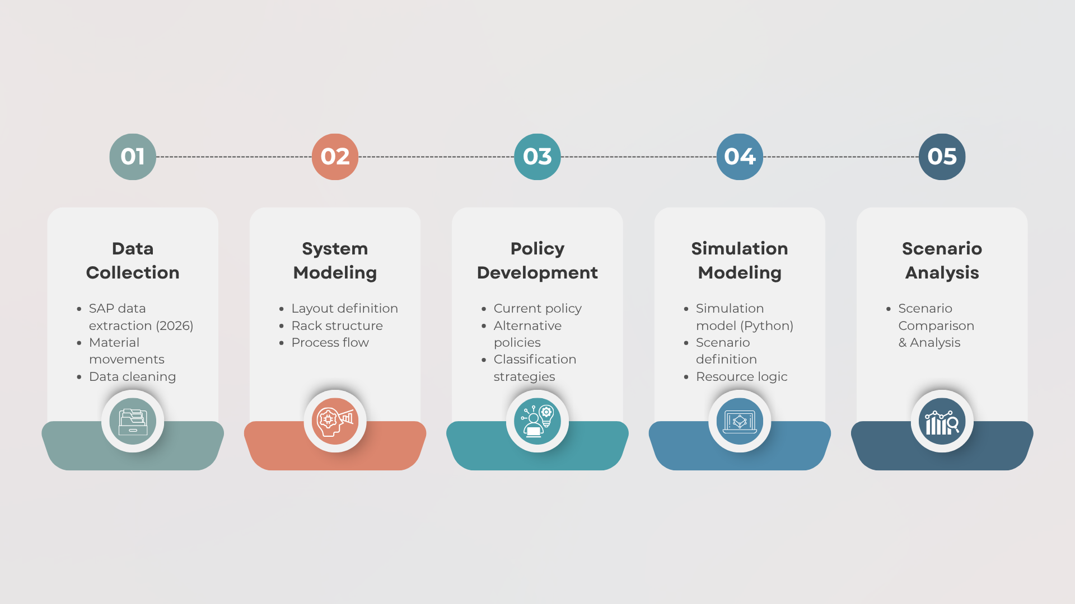

4.1 Data Collection
The data used in this study was extracted from SAP, focusing specifically on the year 2026 in order to reduce data volume and processing time. Initially, material movement records were obtained from the system and then merged with the corresponding material issue data for 2026.
During the data cleaning phase, records with zero or negative values were removed, and duplicate entries were eliminated to ensure data accuracy. The remaining dataset was then sorted in descending order based on total consumption quantities.
Subsequently, the total consumption quantity was calculated, and the proportion of each material relative to the total was determined. Based on these ratios, a Pareto analysis was conducted. Materials contributing up to 80% of total consumption were classified as A items, those contributing up to 95% as B items, and the remaining materials were classified as C items.
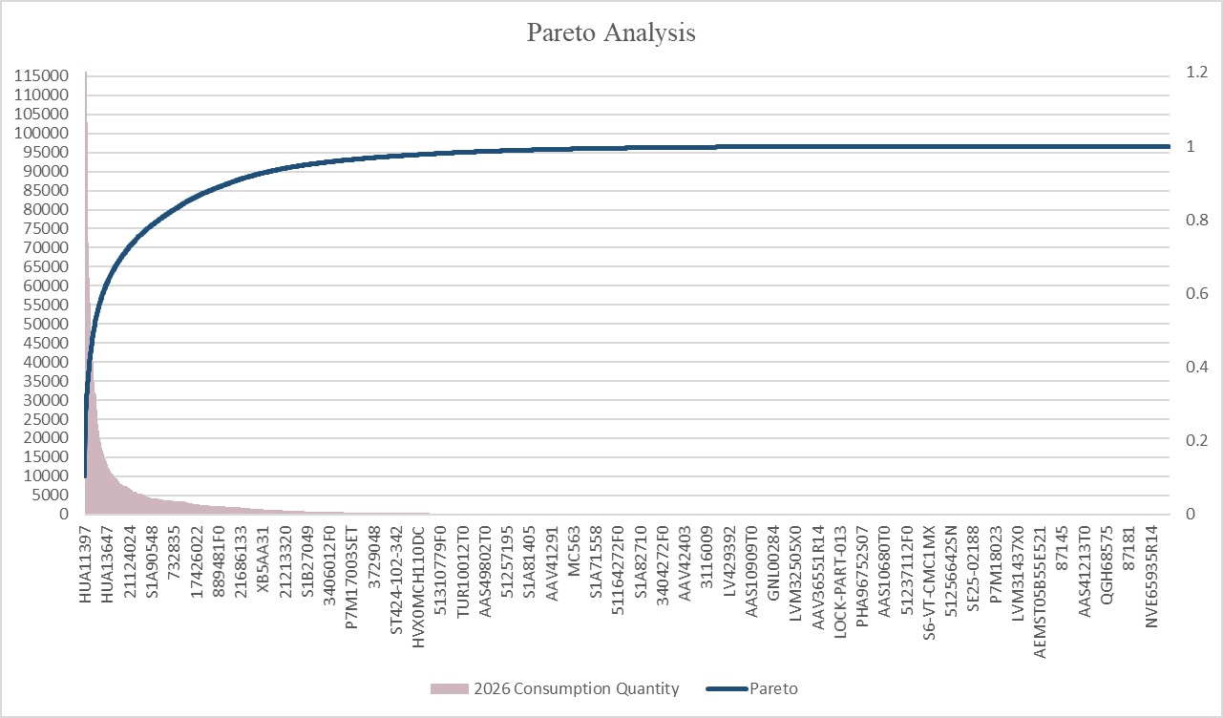
In addition to the existing ABC classification available in the system, a new ABC analysis was independently performed. The results of both classifications were then compared, and the differences between them were documented to provide further insight into material prioritization.
Following the data preparation and ABC analysis, additional data will be collected to support the operational analysis. Material location information will be obtained from SAP, and items stored in Kardex systems will be excluded from the scope. The storage locations of the remaining materials will be identified and mapped accordingly. Furthermore, data regarding the production lines to which each material is supplied will be collected to better understand material flow within the facility.
In the next phase, a time study will be conducted for reachtrucks and their operators. The collected time data will be analyzed using Minitab, where appropriate statistical distributions will be fitted to represent the operational processes. However, if the available data cannot be fitted to an appropriate distribution using Minitab, the data will be added to the simulation model by making assumptions.
Observations will also be carried out to determine the waiting time of the operators. These analyses will provide a comprehensive understanding of the current system and support further optimization efforts.

4.2 System Modeling
The warehouse system is modeled by representing its key physical and operational components. Storage areas are defined as storage locations, while operators and reach trucks are modeled as resources responsible for handling material movements. The internal transportation system, including milkrun or train-based movements, is represented as transport entities. Orders are modeled as kit preparation requests triggered by production demand.
The main processes considered in the system include picking, replenishment, and transportation. These processes define the flow of materials from storage locations to production lines and capture the interactions between resources and operations within the warehouse.
4.3 Policy Design
The study evaluates different inventory placement and operational policies to improve warehouse performance. The current system is defined as the baseline policy, reflecting the existing layout and material handling practices.
The current system will be used as a baseline for comparison.
Several alternative policies are developed and tested. These include usage-based ABC classification, travel-distance-based ABC classification, class-based storage strategies. In particular, a double ABC approach is applied by integrating usage frequency and travel distance to identify critical materials and improve placement decisions.
These policies aim to reduce unnecessary travel, improve material accessibility, and enhance overall system efficiency.

4.4 Simulation Model
A discrete-event simulation model is developed in Python to represent warehouse operations and evaluate alternative scenarios. Simulation is selected as the primary analysis tool because it allows the system to be tested under different configurations without disrupting real operations.
The model includes key system elements such as order arrivals, processing activities, resource constraints, and material flows. Order arrivals are generated based on historical demand patterns, while processes such as picking and transportation are modeled using time-based logic. Resources, including operators and handling equipment, are incorporated to capture system capacity and potential bottlenecks.
The simulation model provides a flexible environment to test different layout and policy configurations under realistic conditions.

4.5 Performance Metrics
The performance of the system is evaluated using several key performance metrics. These include order preparation time, which measures the total time required to complete an order, and waiting time, which reflects system delays and bottlenecks.
Resource utilization is also analyzed to assess how efficiently operators and equipment are used within the system. In addition, total travel distance is measured to evaluate the effectiveness of layout and placement decisions.
These metrics are selected to capture both operational efficiency and system performance under different policy scenarios.
5. Conclusion

6. References
Koç, Ç., Bektaş, T., Jabali, O., & Laporte, G. (2016). The vehicle routing problem with simultaneous pickup and delivery: A review. European Journal of Operational Research, 257(3), 801–817.[1]
Negahban, A., & Smith, J. S. (2014). Applications of discrete-event simulation in manufacturing systems: A review. Journal of Manufacturing Systems, 33(2), 241–261.[2]
Ardiansyah, D. P., Reynaldi, F. A. O., & Widaningrum, D. L. (2024). Improving Warehouse Layout Effectiveness and Process Picking Efficiency with the Discrete Event System Simulation Approach. Procedia Computer Science, 234, 1753-1760. [3]
Roodbergen, K. J., & Vis, I. F. A. (2009). A survey of literature on automated storage and retrieval systems.

