The New Means of the Means of Production: A Discourse Analysis on
the media’s treatment of the Means of Production
University of Tennessee - Knoxville

Introduction
Propaganda is nothing new. Although the term may leave a sour taste in the mouths of many, some see it as an integral part of culture. In some academic circles the view that all art could be analyzed based on its political ideology is far from uncommon. In fact there are quite a few theorists who would argue that being aware that art is ideology is an important part of understanding the more general sociological aspects of a culture. Political entertainment is therefore art which is aware of its role. Creators of entertainment are major contributors to the foundation of national ideology. Artists which recognize this are then in a position of both power and responsibility.
Naomi Burton puts it most clearly in her interview with Filmmaker Magazine: “Entertainment is politics, and we can create entertainment that is more impactful.” Which is the exact thing she and her partner Nick Hayes have set out to do with their newly form film production cooperative Means of Production. Means of Production is a multifaceted video production agency with two clearly distinct yet overlapping goals. What has brought them most of their media attention as well given them a place on the national stage is their production of campaign videos. If art is connected to ideology, campaign ads are the bridge between them. They serve a unique role since not only are the creators aware of the political messages but the audience is as well. With their award winning production of ads for congressional candidates including Alexandria Occasio-Cortez of New York and Kaniela Ing of Hawaii many media outlets started to take notice of Means of Production. The videos produced were well received and went vital due to their quality in narrative story-telling. Although, high impact and effective campaign ads are not uncommon the level of cinematic attention to detail set these videos apart which is what made so many news sources care.
The secondary goal of Means of Production called Means TV is intended to further utilize the role of entertainment in politics. Calling it “Netflix for the Left,” Means of Production intends for Means TV to be an alternative source of entertainment for the new generation of politically active viewers. Means TV has received little mainstream attention aside from a small segment on Fox News at Night which showed a clip of one of the videos and proceeded to provide a defense of capitalism. Considering the directness with which Means of Production has decided to recognize their role as a politically entity it seems important to question how they have been represented in the news media. Does the media see Means of Production as a niche political advertising agency or a new creative endeavor? How has this view been presented to audience? Does the media interpretation of Means of Production indicate the medias own view of their political role? To answer these questions this paper will look at a collection of articles with various degrees of overlap discussing in some way or another the role of Means of Production using computational and rhetorical tools along the way.
Literature Review
The number of sources discussing this topic were limited. This is probably in part due to how recent the development of Means of Production has been. As a result not all the sources discuss them directly. Although, their success with the Occasio-Cortez video has especially become a main talking point and their involvement has been a repeated point of discussion in related contexts. The sources could broadly be grouped in terms of their core focus, those which focus on the campaign content created by Means of Production Otterbein (2019), Jilani (2018), Hornaday (2018), Peters and Maheshwari (2018) and those focusing on the company itself: Macaulay (2018), Diavolo (2019), Day (2019), Derringer (2018), and Daalder (2018). The articles which focus on the campaign content can then even be further subdivided. Otterbein’s and Peters/Maheshwari’s articles discuss broader and more political topics. They take the perspective of Means of Production as a political ad agency. Their discussion revolves around the role the company has had in producing viral videos. In contrast Jilani and Hornday look at the videos in and of themselves. They analyze the works from a cinematic perspective while trying to isolate and understand the cause of the success of these more novel approaches to political campaign advertising.
Means of Production, however, see themselves as more than their work so far. This became obvious in reading the other articles. In their interviews with Macaulay, Diavolo, Day, Derringer, and Daalder they discuss their production techniques, what they believe to be the root causes of their success, as well as their political role and ideology. None of the articles discuss the broader implications of the roles of media and ideology in general. However, in the interviews the ideological role media plays becomes apparent.
Methodology
I was motivated to learn about this topic by a tweet from Alexandria Occasio-Cortez linking to the Means of Production website. On the website a list of news articles mentioning the company were shared. This was my initial data set however most were very short mentions and some were simply tweets so I expanded my search using Google search where I typed in “Means of Production company,” “Means TV,” “Means of Production campaign ad,” and “Means of Production videos.” After a few articles were collected I followed links within the articles to grow the data set. Reading through them I eliminated articles which did not mention the company frequently enough or were too short to give any real information. In addition to reading articles which I found I also watched the ads and videos they produced to get a better understanding of their messaging and goals.
My initial research question was: “How is the media talking about Means of Production?” After acquiring and narrowing down my data set, I began reading. As I read through the articles, I was looking for specific patterns which I could use to narrow down my research question. One pattern which emerged to me when reading the Hornaday and Peters/Maheshwari articles specifically was the language used to refer to the videos. Hornaday described the Occasio-Cortez video as a short-style documentary. In contrast, Peters and Maheshwari referred to it as a short documentary style political ad. This distinction caught my eye because it contrasted with the way that Means of Production described themselves in the interviews. I reread the articles through this lens to determine how the company was being portrayed. Did people see them as a production campaign with political content or a political company which happened to produce videos? Reading into this formed the more specific questions I would come to ask about what propaganda means and how Means of Production portrays themselves in relation to it?
Once I had a rhetorical understanding of what I was looking for I moved to more computational tools. The first step was to copy the contents of the articles into text files. Text files can be easily read by computer programs and thus would make it easier to look at the data through a more technical lens. After creating these text files I went to through them to delete remnants of the websites they were posted on such as deleting links to the website or ads. Once I had cleaned text files I created a Jupyter-Notebook to analyze the text through Python 3. (All the code for this analysis is available in the GitHub page). I read in the data making sure to get rid of punctuation as I read in each word. Once I stored all the data I used the Stanford GloVe model to represent the words. To give some context, the GloVe model is a word embedding tool which uses trained word correlations to assign numerical vector values to words. More plainly GloVe is a mechanism which takes a word and turns it into a point in space. That point is selected based on its distance to other points. An intuition for this can be developed by considering an example. The word “men” in GloVe is equal distant to the word “women” as the word “king” is distant from the word “queen.” Similarly, the word “men” is a distant from the word “king” as “women” is to “queen.” This is done for every word across thousands of Wikipedia articles. Therefore this gives us a sense of what a word means by looking at how far it is from other words. Of course, an article is a collection of words and thus a collection of points. Using the Natural Language Toolkit list of stopwords: “is,” “a,” “the,” “in,” etc. I removed words which did not contribute to the meaning of the article; I then took the numerical average of points in the article to give me a central point. Thus I created a single point associated with each article. This method has a few drawbacks but with some caveats it gives an approximation of the central meaning of the article. Once I had an associated points with each document I experimented with and explored relationships among the documents and relationships between the documents and specific words.
In my initial reading of the texts I had created mental categories for each article. I first separated the articles out by their main focuses depending on whether they were specifically talking about the campaign video or Means of Production as a whole. Then I noticed that those talking about the video could be further divided into how they were talking about the video, whether that was talking about it as a cinematic work or a political one. To determine whether the data pointed to the same kind of categories I had observed, I generated a heat map. To get the values for the heatmap I took the cosine distance between the points I had developed for each article. Once I generated the heatmap I noticed the pattern was different and so I read through the articles to see what about them could the computational methods be noticing. Once I understood what the results meant I further refined my categorization of the articles and continued to explore the data.
My next approach was to develop scatter plots to look at how related the articles were to specific words. To test whether these metrics would be accurate I also checked how far each article was to a random word. Articles were sufficiently different when plotting against random words that I was confident my approach captured valid information. I picked words which captured the rhetorical differences I had found in the documents: “film,” “politics,” “art,” and “propaganda.” By plotting against these words I found some unique patterns in the data. I then went back through the original articles to once again look for the information my analysis had captured. To get a better understanding of the relationship among the articles over time I rearranged by the data so that they were ordered by when they were written and plotted how related they were to the above terms. This generated a line graph which gave me an idea of the way the discourse around Means of Production had changed over time.
I used the results of the heatmaps and my readings to develop categories of articles. I selected the two arcticles which seemed to be the most unique in the heatmap. After this I created a distance threshold and selected articles within a specific range. This divided the articles into two categories which will be called heatmap1 and heatmap2. Once I had these categories I used the visualization tool Voyant where I created word clouds for both the categories I developed in my readings as well as word clouds around the categories of heatmap1 and heatmap2.
Results
The first set of results I generated was the heatmap described above.
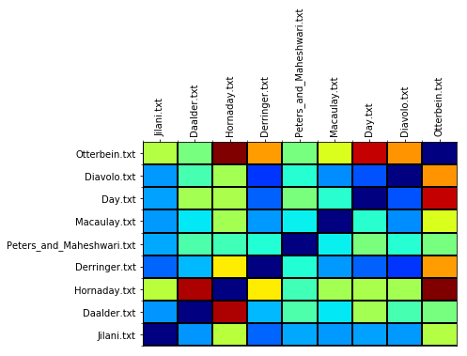
What we see here is a grid where the x and the y axes are the sources used. Each block is colored based on the distance between the “core idea” of each article. The dark blue represents very similar ideas and the dark red indicates very different ideas. Other colors represent corresponding degrees between. The data shows that the articles are related to one another in varying degrees. The dark red indicates which articles are completely different and the light blue shows which are similar. It also highlights the variety of core concepts among the sources. This also allows us to group the sources based on these similarity metrics.
To further understand the heatmap above we can look at the two main categories derivable from it.
Below are the word clouds generated by the combined texts of categories heatmap1 and heatmap2.

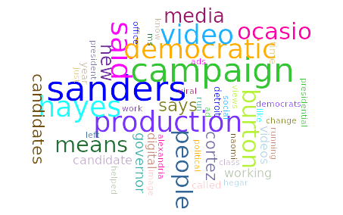

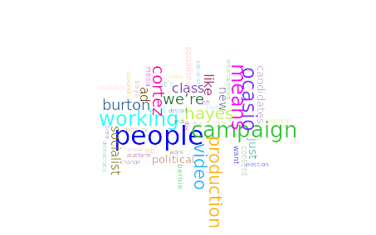
The word clouds show us the most commonly repeated non-stop words. Each word is scaled by the proportional amount with which it appears in the articles. The word cloud around heatmap1 shows the most common words include: Sanders, Campaign, Production, … These are similar but slightly different from the words which appear in the word cloud around heatmap2 such as: People, Working, Occasio, … The visualization also includes words which seem to be unique to each cloud such as Democratic in heatmap1 and Socialist in heatmap2.
Selecting the words which are unique across these heatmaps we can plot how close the computed value of each article is to the computed value of these specific terms. Each point represents a specific article and is labeled with the first three letters of the author’s name. The axes represent the numerical distance between the value of the word on the axis and the article. The number represents how similar the score for an article is to the word. Smaller numbers indicate a closer relationship.
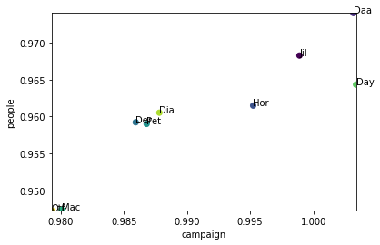
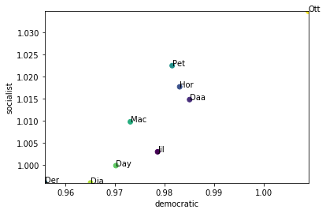
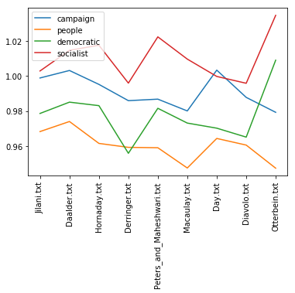
To get further the understanding of this data we can also compare how these relationships have developed over time.
Above we have the same numerical values on the left as in the scatter plot before it. However, in this graph the articles are organized in order of time they were created. Each inflection point on the line corresponds to an article and each line corresponds to a single word as described in the legend.
To contrast we can apply the series of graphs as above to the categories that I defined through my initial reading. The first category contains the Otterbein, Jilani, Hornday, and Peters and Maheshwari articles, all of which are about the ads created by Means of Production and the secondary category which is all other articles consists of interviews with the creators of Means of Production. Below is the the word cloud with words scaled by frequency of the first category.
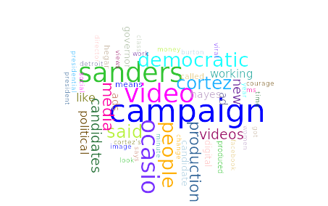
We can see the difference in the word choice. The most common words seem to be words like Campaign, Video, Sanders, Occasio, Cortez,… This can be compared to the word cloud produced by the word cloud generated by the other category.
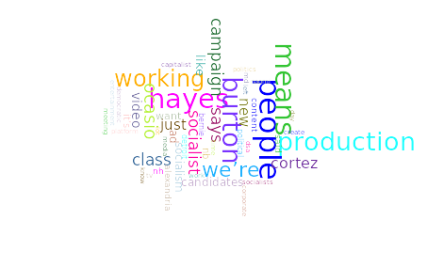
Here we see clearly distinct results from the other world cloud. The names of the interviewees and creators of Means of Production Burton and Hayes appear frequently. Additionally, words which appear often are People, Means, Class, … Since I had already developed an expectation of the semantic meaning of the articles I chose words which would highlight the distinctions between the two categories. Applying the same analysis above we can generate a scatter plot with the same criteria as before.

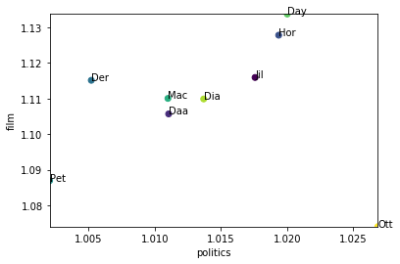
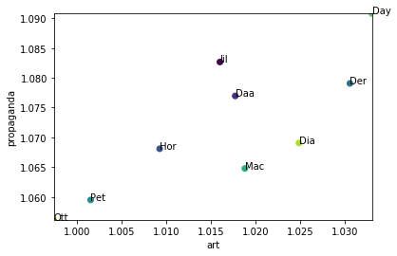
The words are Film, Politics, Propaganda, Art with the axes once again representing how different the score of the article is from the score of the word. Each point is labeled with the first three letters of the authors name.
Below is once again the same values labeled by word and organized by the date of release, where the x axis is the author in order of date and y axis is the distance from the word.
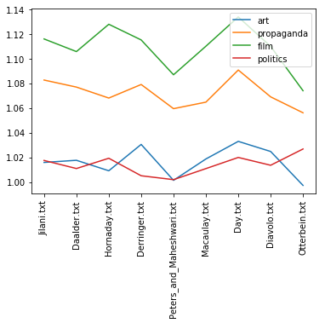
Discussion
In my initial reading of the articles I found a very clear picture of how Means of Production was initially presented in the media. The analytical approach to the data however told a different story which seemed much more random and less clear and concise. Under further analysis it can be seen that the relationships in the data are in a sense very similar to my initial readings however the way the underlying themes are presented is much different. To develop an appreciation for this difference we can compare the results of the analyses informed by the different means of categorization. This can be done by examining at the categories and the evidence which they seem to present.
Firstly, we can look at the rhetorical categories developed from initial readings of the articles. The articles by Hornaday, Peters/Maheshwari, and Jilani have a clear and concise focus on the ads with Means of Production taking a secondary role. This are concerned with the role the company played in the production of the campaign video of eventual congresswomen Alexandria Occasio-Cortez. The articles take different perspectives on how to present the role of Means of Production. All of them agree that the campaign video was far from conventional. While Hornaday recognizes the video for its cinematic authenticity, Peters and Maheshwari are concerned with the implications of this new form of political advertising. Jilani takes a middle ground, while concerning himself with the novelty of the video he also discusses its implications and cinematic achievements. This is a different direction than Politico which looks to the future of the company and their upcoming work with Bernie Sander. What keeps articles tied together is that they concentrate on what Means of Production has accomplished.
This is easily contrasted with the other five articles which all involve interviewing the creators of Means of Production, Nick Hayes and Naomi Burton. When they explain their intentions with Means of Production and the upcoming Means TV to the media they are much more explicit in their ideology and goals. Where as the other news pieces present them as a politically oriented video production company, Means of Production seem to consider themselves more than that. In their interviews they talk explicitly about the role of their ideology in their production and their motivations which has lead them to produce the content that they have.
This contrast can easily be seen in the analytical data collected from partitioning these two sets. When looking at the set of articles which are concerned with their recent activity we see the words campaign and video pop up frequently. The names of the politicians they work with are clearly part of the pattern. This emphasizes the representational focus. Although, the way they may be presented is different they serve the role of a campaign video production company. On the other hand looking at the word bubble generated from the interviews we see a different narrative. people, working, socialist, words which conjure up their ideals are the obvious focus of these interviews. Means of Production is honest about what it stands for.
Looking at the the relatedness between words which describe different aspects of this image we see a clear representation of how others talk about Means of Production as opposed to how they talk about themselves. Interestingly enough a there is a split in the data when comparing how related the articles are to the words “art” and “propaganda.” This split parallels the way Means of Production presents themselves and how they are presented by others. By looking at how their image has fluctuated over time we also see that the popular labels of politics and art are interrelated for the company fluctuating between one another over time..
This rhetorical distinctions are easily understood immediately by reading the articles. However, when looking at the heatmap the patterns actually become less apparent. The data shows that the article by Jilani is the most similar to the others and serves as a middle ground. On the other end of the spectrum Otterbein seems to be an outlier dissimilar from the others likely due to the pieces focus on the Sanders campaign. We also see a clear distinction between Hornaday and a few other others. Going back through the texts it seems this is in part due to her use of cinematic language and theory to analyze the video as opposed to the classical political lenses of the other writers. The categories generated from the heatmap do not seem very coherent at initial glance.
To understand where the categories and the underlying relationships come from we can look at the word clouds generated by the categories defined from the heatmap. Although both word bubbles share quite a bit of overlap the edge words are the ones which give real insight into the underlying similarities which the algorithm has found. The first heatmap category contains words like media, campaign, video where as the second contains words like people, working, political, socialist.
By comparing these words and returning to the articles which were collected under the heatmap categorization we see a clearer picture of the relationship which the algorithm discovered. The articles which were found to be similar were not similar not in context but in content. The articles grouped together by the algorithm were those which focused on the company and its role as an organization and those which highlighted the ideological aspects of the Means of Production. In some ways this parallels the rhetorical categorization I developed from my initial readings in that it distinguishes between the perceived function of the Means of Production and its intended goals but it does so in different manner. This is further captured by seeing that the relationships between articles presented in the heatmap is preserved when looking at the placement of the articles in the scatter plots. This also explains the pattern we see when looking at the distance from words over time. The lines are parallel because the cor ideas the word represent are consistent across the articles.
The heatmap and resulting data tells us that there is a different underlying pattern than simply how the company is presented. The way that their ideology is disussed is an important point. It explains why articles from The Intercept and Jacobin are considered similar, because they present the socialist ideology of Means TV in much more direct way. The discussion of Means is not only framed in terms of what they are but also the framing is limited by what the different forms of media are willing to say about their core message.
Conclusion
The pattern that emerges from both the analytical and the rhetorical approach is clear. Means of Production serves a different role than many of the organizations before it. The role of political entertainment is not clearly defined but it is definitely important. Means of Production recognizes the uniqueness of their brand and their message. As a media company not only are they aware of their ideological biases but they are actively representing them. The medias reaction to this is to see it as something new. Much of the media sees this form of entertainment novel and unique. However, this creates an interesting contrast. The articles repeatedly talk about how two people in the media industry became aware of their political role and tried to change it for the better. Of course, the question for many of these media outlets is how much they are willing to share the core values of Means of Production with their audience. Means of Production is willing to present their message, the question remains: who is willing to hear it?

References
- Daalder, M. (2018). How Detroit filmmakers helped a socialist unseat a New York lawmaker. Retrieved from https://www.freep.com/story/news/politics/2018/06/28/alexandria-ocasio-cortez-joe-crowley/742202002/
- Day, M. (2019). “Trust the Rich Less, Trust Each Other More”. Retrieved from https://jacobinmag.com/2019/01/means-of-production-video-ads-ocasio-cortez
- Derringer, N. (2018). Video: After 3 Million Views, 2 Detroit Socialists Are Ready for Their Closeup. Retrieved from http://www.deadlinedetroit.com/articles/20198/video_after_3_million_views_2_detroit_socialists_are_ready_for_their_closeup
- Diavolo, L. (2019). Meet the Team That's Building "Netflix for the Left." Retrieved from https://www.teenvogue.com/story/means-tv-video-streaming-platform-netflix-for-the-left
- Hornaday, A. (2018). Ocasio-Cortez, Hegar and the art of making your political ad feel like an uplifting movie. Retrieved from https://www.washingtonpost.com/lifestyle/style/ocasio-cortez-hegar-and-the-art-of-making-your-political-ad-feel-like-an-uplifting-movie/2018/07/05/1d741a5a-8062-11e8-b0ef-fffcabeff946_story.html?noredirect=on&utm_term=.287c907ab017
- Jilani, Z., & Jilani, Z. (2019). How a Ragtag Group of Socialist Filmmakers Produced One of the Most Viral Campaign Ads of 2018. Retrieved from https://theintercept.com/2018/06/05/ocasio-cortez-new-york-14th-district-democratic-primary-campaign-video/
- Macaulay, S. (2018). Means of Production | Filmmaker Magazine. Retrieved from https://filmmakermagazine.com/people/means-of-production/
- Otterbein, H. (2019). Bernie Sanders staffs up for 2020. Retrieved from https://www.politico.com/story/2019/01/14/bernie-sanders-campaign-2020-election-1098795
- Peters, j., & Maheshwari, S. (2018). Viral Videos Are Replacing Pricey Political Ads. They’re Cheaper, and They Work. Retrieved from https://www.nytimes.com/2018/09/10/us/politics/midterm-primaries-advertising.html

