Creating an Application Specific Bug Detector on a Static Analysis Tool

Deniz Hekimci
Dept. of Computer Science
Ozyegin University
Istanbul, Turkey
deniz.hekimci@ozu.edu.tr

Abstract— Static analysis tools provide warnings for potential software faults. However, developers are usually exposed to a large number of warnings. It requires a lot of time and effort to investigate each and every warning. Hence, developers need to prioritize these warnings and focus on a subset of them. In this project, we aim at automatically filtering static analysis tool warnings based on user profile recorded at runtime. Faults that take place in the mostly used parts of the program are more likely to be exposed to users as failures. Therefore, warnings that are associated with the mostly executed methods are considered to have the highest priority. In the project, we exploit filter extensions of the FindBugs static analysis tool. The recorded user profile is used for automatically generating filter specifications that surpress warnings related to rarely executed methods in the program. As such, only a highly prioritized subset of the warnings are provided to developers.
Keywords—software testing; static analysis; Java; fault; Findbugs; custom bug detectors;

Introduction
Static analysis is a good way to improve software quality. A static analysis tool doesn’t execute code. It does some software inspections and some forms of analysis. [1] Static analysis tools can detect (potential) faults in software systems. These tools can also help programmers to prevent future-introduced defects.
Most static analysis tools create error reports about the software. However, these tools generate an extensive amount of warnings especially for large scale software. Moreover, some of these warnings are subject to false positives. As reported before [2], all tools that effectively find errors have false positive rates that can easily reach 30–100%. There is not enough time for developers to investigate each and every warning. Most static analysis tools have an error ranking system to issue error reports, without handling false positive. This ranking method may lead to that some true errors are often staying at the bottom of the list. As reported in previous work [15], these false positives can quickly render static detection tools useless by hiding real errors amidst the false. It is also likely to cause programmers to stop using static analysis tools, especially in large-scale software systems.
Faults that take place in the mostly used parts are more likely to be exposed by the users. If a method is not executed most of the time, this means that user will not be exposed to it too much. So failure of such method is less important than a method which was executed too many times. Fixing a method which is executed most of the times is more critical than a method which is not executed most of the times. Especially in case of limited resources (time, developers), focus should be on the most critical faults. Based on that result, in this project user profile is collected and methods are ranked based on their invocation times. The most executed method has highest rank. The least executed method has lowest rank so it will only show the scariest type of warnings. If a method is not executed, the warnings of the method will be ignored.
The focus of this project is to generate a custom detector for an application specific bug in order to eliminate some of the warnings and errors. Then the extended tool had been compared with respect to the original tool in terms of the number of bugs detected, false positives and false negatives. The user profile had been collected and the static analysis tool had been enhanced to detect faults in methods that are most frequently executed when the system is being used. The generated warnings had been ranked according to their importance.
The rest of this paper is organized as follows. Firstly the background of FindBugs and its structure is introduced in Section II. Section III describes the problem. Section IV describes the solution approach. Finally, evaluation, related work and concluding remarks are given in Section V, VI and VII respectively.

Background
In this section, introduce of FindBugs will be made. FindBugs is a popular static analysis tools which looks for bugs in Java language. The current version of FindBugs is 2.0.3. As of September 2006, FindBugs had more than 270,000 downloads [3]. Bug exploration is based on the concept of bug patterns. A bug pattern is a code idiom that is often an error. There are eight categories of bug patterns which are Bad Practice, Correctness, Experimental, Malicious code vulnerability, Multithreaded correctness, Performance, Security and Dodgy Code. For experienced users, they can define new bug patterns [4]. According to the report structure of FindBugs, each bug category includes many bug kinds and each bug kind consists of several bug patterns.
FindBugs also categorizes bugs with bug rank property. This ranks are between 1 - 20 and grouped into categories scariest (rank 1 – 4), scary (rank 5 – 9), troubling (rank 10 – 14) and of concern (rank 15 – 20).
In this project, the FindBugs Eclipse plugin and the source code of FindBugs had been used. BCEL library is also a part of the source code so it will also be explained in this document. The FindBugs Eclipse plugin allows FindBugs to be used within the Eclipse IDE. It made easier to explore bugs and add the filter files. To be able to start the plugin, right click on a Java project in Package Explorer, and select the option labeled “Find Bugs”. FindBugs will run and problem markers will point to places where a potential bug pattern occurs. FindBugs can be customized by opening the Properties dialog for a Java project and choosing “FindBugs” property page. This is where filter files are added to FindBugs.

Problem Statement
The aim of this project is to detect application specific bug types and create custom alerts for these bugs. Filter warnings of the software with the order of importance. This will help developers to debug the code more easily and efficiently.
In this project, FindBugs tool has been used. FindBugs is a static analysis tool that works on Java. On a typical production Java application or library, FindBugs finds one likely code defect per 800–2400 lines of non-comment source code. By likely code defect we mean it is likely that most programmers would consider it important to correct the defect. FindBugs also finds bugs of lower priority and bugs in categories that some programmers might not care about [1].
To be able to eliminate useless warnings, they should be ranked according to their importance. In this project, these warnings were ranked based on user profile. Filtering was performed based on information collected at runtime. However, FindBugs also provides some filtering but this filtering is not based on user profile. FindBugs has types of bug ranks from 1 to 20 and using these ranks, filtering can be done. From rank 1 to 4, these warnings are classified as Scariest warnings. From 1 to 9, these warnings are classified as Scary and from 1 to 14, they are classified as Troubling. In this project, these rank types will be utilized based on user profile.

Solutıon Approach
In this section, the solution to the problem is presented. In this project, in order to detect custom bugs, some classes are added to project. The FindBugs tool and source code of FindBugs had been manipulated. The user profile had been collected using jvisualvm tool and the FindBugs tool had been enhanced to detect faults in methods that are most frequently executed when the system is being used. According to invocation times of methods, ranking had been made. In mostly used methods, the tool shows every fault and in less frequently used methods, it shows only high profiled faults.

Monitoring
Firstly, the program had been monitored by jvisualvm. The program executed in Eclipse and jvisualvm tool was opened. In Local tab on the Applications window, program name appeared. When it was double clicked, overview of the program was opened. On the Sampler tab, CPU sampling selected and it showed the invocation times of methods. After that, a snapshot of the sampling had been taken. Snapshot of program had been saved as .csv type.
Figure 1: jvisualvm monitoring
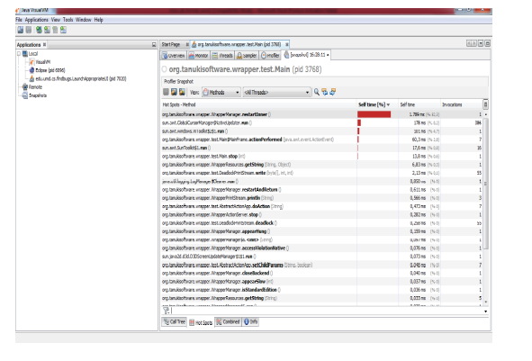

Filter Generation
After creating the .csv file, a parser program written in Java parsed this .csv file and it created two .xml file. This .xml files are called filter files. These files have Rank tags. It takes a number between 1 and 20. These numbers were calculated based on invocation times and were written into Rank tag of .xml file. For mostly executed methods, this Rank value hadn’t been set because each warning of this method should be seen. For less frequently executed methods, this Rank value is set to 10, so that only bugs with ranks from 1 to 10 can be seen. For merest ones, Rank value had been set to 5, so that only bugs with ranks from 1 to 5 can be seen. These frequencies are calculated based on average and standard deviation of data.

Execution of FindBugs
After the creation of .xml file, Eclipse, FindBugs plugin had been opened. Under the project settings, Properties -> Java -> FindBugs menu; there is a filter files section. The .xml file that filters non executed methods had been added to include filter files part. The .xml file that filters warnings based on ranks had been added to exclude filter files part. When FindBugs started to run, in most frequently executed methods, it showed every bug from 1 to 20. But in less frequently used methods, it shows only ones with highest ranks.
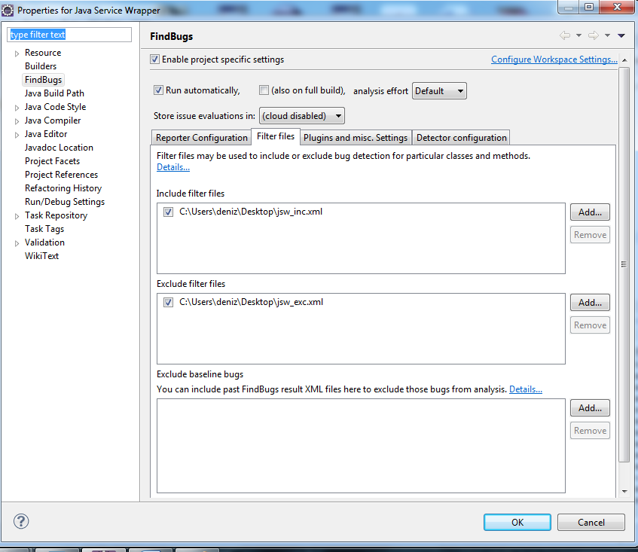
Figure 2: Adding the filter file

Evaluatıon
This section presents the results produced by the .xml file and FindBugs on a Java open-source project, Java Service Wrapper [4].

Objective
The objective of this experiment is to answer the following questions:
- Does the filter file improve the ranking of errors compared to original FindBugs?
- Can users find potential bugs more quickly and easily using the filter file?
- Is this file is efficient for large-scale Java applications?

Subject Programs
In the experiment, an open-source Java application was the subject program which is Java Service Wrapper (jsw for short) [4]. This program enables a Java Application to be run as a Windows Service or UNIX Daemon. It also monitors the health of the Application and JVM [5].
Eclipse FindBugs plugin had been ran on subject program and the error reports had been counted in Bug Explorer category. After that filter file had been added to FindBugs and then it had been ran again and counted in Bug Explorer.

Comparison Indicators
Next, the ranking results of the result with filter file and without filter file had been compared and FindBugs Bug Explorer had been observed to see the effectiveness of the error ranking strategy.
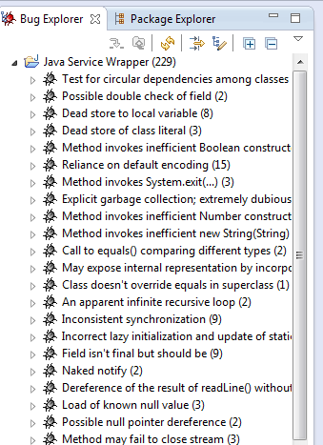
Figure 3: The result without filter file

When we include the filter, it can be seen that bugs are significantly filtered.
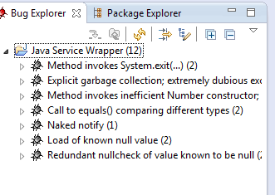
Figure 4: The result with the filter file

Related Work
There exist several case studies based on improving the usefulness of static analysis tools by ranking or classifying warnings [5]. A ranking model [6] is suggested for adjusting the ranking factor of each warning type based on its statistical contribution to the previous rankings and the feedback of developers for the previously ranked warnings. A benchmark [7] is introduced based on a set of Java programs for comparing classifiers with respect to their effectiveness. In particular, 3 Java programs are used for testing different machine learning algorithms with a wide range of artifact characteristic [8] to identify the most effective subset(s) of characteristics for warning classification. Kim and Ernst propose and approach for exploiting “historical information” to prioritize warnings [9]. Hereby, they mine the software change history for warnings that are removed during bug fixes. Warning categories are prioritized based on fixes applied on the corresponding warnings. Liang et al. also employ bug fixes as either “project-specific” or “generic”. They conclude that one may improve precision by using history regarding the “generic” bug fixes only.
Previous studies use ranking models in different ways, like statistics, feedbacks and historical information. In this work, ranking model is executed using the user profile.

Conclusion and Future Work
In this project, a filtering on a static analysis tool based on user profile had been applied. Profiles of the execution of two programs had been produced by jvisualvm tool. Then these profiles had been written on .csv files. By a java program called “FilterGenerator”, these .csv files had been converted into FindBugs bug filters. When these filters are given to Eclipse FindBugs profile, the warnings of systems are filtered based on user profile. This filtering operation is done by FindBugs bug ranks which are 1 to 20, 1 represents the highest ranked bug which should immediately be corrected and 20 is the least ranked bug which is the most unimportant bug. For mostly executed methods, user sees each warning for the method from 1 to 20. For the methods which have medium level of execution, user sees only very important and less important ranked warnings. For the methods which have rare execution, user sees only very important warnings. If some methods are not executed, warnings of these methods are not listed.

For the future work, a new bug description will be added to the FindBugs. As the first step, additional bug definitions and custom detectors for some bugs will be introduced. Then the extended tool will be compared with respect to the original tool in terms of the number of bugs detected, false positives and false negatives.

References
- P. Ammann, J. Offutt, Introduction to Software Testing. The Edinburgh Building, Cambridge CB2 8RU, UK, 2008.
- T. Kremenek and D. R. Engler. Z-ranking: Using statistical analysis to counter the impact of static analysis approximations. In Proc. SAS, pages 295–315, 2003.
- FindBugs, users page, http://findbugs.sourceforge.net/users.html
- IBM DeveloperWorks, FindBugs, Part 2: Writing custom detectors
http://www.ibm.com/developerworks/java/library/j-findbug2/
- B. Cole, D. Hakim, D. Hovemeyer, R. Lazarus, W. Pugh, and K. Stephens, “Improving Your Software Using Static Analysis to Find Bugs,”.
- Java Service Wrapper, http://wrapper.tanukisoftware.com/doc/english/download.jsp
- Java Service Wrapper, product overview
http://wrapper.tanukisoftware.com/doc/english/product-overview.html
- S. Heckman and L. Williams, “A systematic literature review of actionable alert identification techniques for automated static code analysis,” Information and Software Technology, vol. 53, no. 4, pp. 363–387, 2011
- S. S. Heckman, “Adaptively ranking alerts generated from automated static analysis,” Crossroads, vol. 14, no. 1, p. 7:17:11, Dec. 2007.
- S. Heckman and L. Williams, “On establishing a benchmark for evaluating static analysis alert prioritization and classification techniques,” in Proceedings of the Second ACM-IEEE international symposium on Empirical software engineering and measurement, ser. ESEM ’08. New York, NY, USA: ACM, 2008, p. 4150
- ——, “A systematic model building process for predicting actionable static analysis alerts,” Ph.D., North Carolina State University, United States – North Carolina, 2009.
- S. Kim and M. D. Ernst, “Prioritizing warning categories by analyzing software history,” in Proceedings of the Fourth International Workshop on Mining Software Repositories, ser. MSR ’07. Washington, DC, USA: IEEE Computer Society, 2007, p. 27.

