CS423-TAKEHOME PROJECT

DENIZ ISKENDER

WHAT IS THE PROBLEM?

In this homework, our mission is to read the dice from an image. However, there are some nice properties for us. For instance, we will always see the dice from the top. There will 10 dataset images and we will try to come up with the best readings of dices.

HOW I APPROACH TO PROBLEM?

1. Firstly, I thought that if I detect all rectangles and circles, then I will be able to do the clustering easily. However, this part is not that simple because even edge detectors are not exactly perfect in finding the edges like canny edge detector. After that I thought that Hough Circle Transform and Hough Line Transform can be helpful for me and I really spend time on them. If I thought I find the lines and I can make them squares then cluster groups will be easy to find because rectangles are the cluster groups. However, Hough Circle Transform and Hough Line Transform could not come up with good answer. They even cannot detect lines and circles properly.
2. Secondly, I thought that if I find circles and their locations, then I can find everything because smallest distances can provide me the cluster groups. Using these distances, I can detect the groups so that I don’t have to know the locations of rectangles. However, I notice that distance between two dices in a group can be larger than distance between two dices in different group. So, I could not come up with good clustering.
3. Thirdly, I thought I can make a connection from one circle to all others and while going to other circle, I can check whether there is an edge between these two or not. If there is an edge, they are in different clustering group. If there is no edge, then they are in the same clustering group. However, I could not find a good edge detector (I used canny), so that this idea was also corrupt for me. For instance, there are even edges for circles so if I go from their centre, I will see the edge of this circle already. Instead of going from centres to centres, I try to go from right up corners to right up corners of all dices. However, even in the same group, I can see a lot of edges. So, this idea also did not work.
4. Lastly, the only way for me to solve this problem was to find all rectangles, circles and their information. So that I can group them nicely because I know the location, centre and radius information of all images. Then I started to search on the internet.

HOW I FIND A SOLUTION TO THIS PROBLEM?

Firstly my algorithm gets the image and forms this image in a wanted format. Since there are noises on images, I used threshold and dilate. Moreover, I also used Gaussian and Median Blur but they were not helping me like how I want.

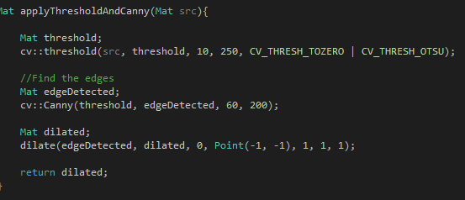

When input image is ready, my algorithm tries to find all shapes in an image. As far as I remember, although we did not cover contours in the class, internet was really helpful for me. For more information, you can visit <http://opencv-code.com/tutorials/detecting-simple-shapes-in-an-image/> website. For that openCV provides nice method which finds all shapes in an image. It even can give the names of shapes, their centres, their areas and their locations as points etc. In other words, when I find any shape, I have their information mentioned above. Here is the some part of it.



Firstly, I get the circles. Here is the code for it. I have locations of circles as well.

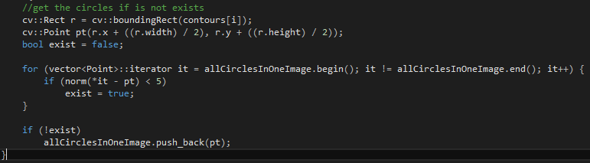

Now, If I also find the rectangles, with simple algorithm, I am able to put these circles to rectangles because my clusters are actually rectangles. I have and add circles to clusters method which works really fine for this operation. It takes set of circles, rectangles and circles added clusters. In this method, I take the circle and go over all rectangles. I have small check here. If this circle is inside of any rectangle, I will add this circle to this rectangle. For this, I hold circles added clusters parameter which basically holds rectangles and what these rectangles have.

Lastly, I take the information from circles added cluster and then, I create the output for this.



This method creates an output array and it prints to information of this array to screen looking at the values inside of circle added clusters taken as a parameter.

READABILITY AND UNDERSTANDIBILITY (DID I WRITE MY CODE NICE?)

First of all, I try to come up with comments which explain the code. Here is how they seem.

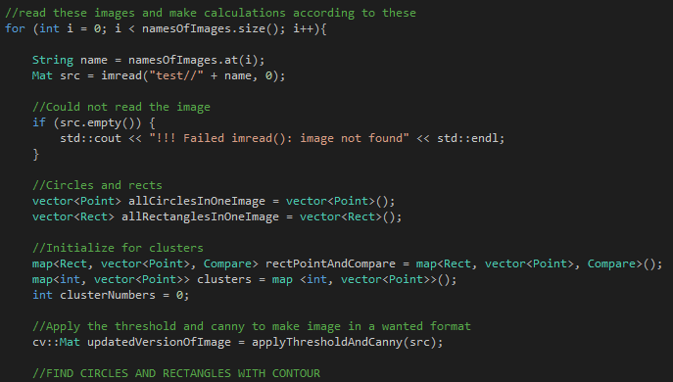

After that I give meaningful names to methods and variables so that my code will be readable and understandable by anyone. Here are the examples.

  

RESULTS

As explained above, I have a method which is write output as I mentioned above. I had an option to show found circles and rectangles but I did not do that. However, I have still the information of them. If you want, you can check all circles in one image and all rectangles in one image parameters. They have all data. Here is how my result seems. This answer is for two images you provided.

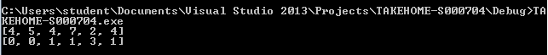

THANK YOU

DENIZ ISKENDER

S000704