Analysis of Stand-Alone C programs

Deniz İskender
Begüm Demirel

Abstract—This project focuses on the analysis of stand-alone C programs. We use the model checker tool PRISM and concolic testing tool CREST in order to achieve branch coverage, expected time information, worst case execution time and other timing information. We evaluated these approaches by applying them to C programs. The results show that concolic testing can come up with timing information which can be expressed in terms of seconds. PRISM can come up with timing information which can be useful in comparing results of algorithms, programs and systems with different parameters and implementations.
Keywords—software testing and analysis; stand-alone C programs; Prism; Prism Language; Crest; concolic testing; WCET; worst case execution time; best case execution time;

Introduction
In this report, we focus on the problem of analysis of stand-alone C programs. To start with, C programs are frequently used in embedded systems. Since timing is one of the main issues in embedded systems and there are time constraints in embedded systems. So that C programs need to be analyzed carefully, then embedded systems can finish their job on time. For instance, cars have airbags which have to inflate extremely rapidly during collision. Worst case execution time of this system should be less than 3 seconds after collision, maybe even less. So, addressed problem in this paper is analysis of stand-alone C programs and their timing issue. So, we used one of model checking tools, which is PRISM and one of the concolic testing tools, which is CREST to overcome this issue.
In the end, we achieved that both of the methods can come up with time details. Real timing information in terms of seconds was achieved by Crest and other useful timing information was achieved by Prism tool. However, they can not be compared since their unit are different from each other.
In the next section, we provide background information for the problem which is analysis of stand-alone C programs and embedded systems, their expected execution time, worst case execution time and best case execution time. Also, we provide background information for our used methods and techniques which are concolic testing and model checking tool PRISM. In Section III, we explain our project, related challenges and our evaluation methods. In Section IV, we summarize and discuss the results. In Section V, we summarize related studies published in the literature. Finally, in Section V, we conclude the report by enlisting the lessons learned.

Background

Concolic Testing and CREST
Concolic testing is a combination of concrete execution and symbolic execution. Symbolic execution allows the program to be executed through all possible execution paths whereas concrete execution refers to running the program with specific inputs. For feasibility purposes, these methods are used together in concolic testing.
CREST is a concolic test generation tool for programs written in C. CREST insert instrumentation code, using CIL, into a target program and performs concolic testing. The output of CREST is a file that specifies the covered branches as well as some other files that are not related with our purposes in this project. When executed from the terminal, the coverage in each iteration is observable.

PRISM
PRISM is a probabilistic model checker, a tool for formal modelling and analysis of systems that exhibit random or probabilistic behaviour. It has been used to analyse systems from many different application domains, including communication and multimedia protocols, randomised distributed algorithms, security protocols, biological systems and many others. PRISM provides support for automated analysis of a wide range of quantitative properties of these models, e.g. "what is the probability of a failure causing the system to shut down within 4 hours?", "what is the worst-case probability of the protocol terminating in error, over all possible initial configurations?", "what is the expected size of the message queue after 30 minutes?", or "what is the worst-case expected time taken for the algorithm to terminate?".
PRISM can build and analyse several types of probabilistic models: discrete-time Markov chains (DTMCs), continuous-time Markov chains (CTMCs), Markov decision processes (MDPs), probabilistic automata (PAs), probabilistic timed automata (PTAs).
Models are described using the Prism Language, a simple, state-based language. In order to construct and analyse a model with PRISM, it must be specified in the PRISM language.

The Project Work

We used CREST to obtain the branch coverage and execution time of the C program in this project. CREST is executed from the terminal, by giving the name of the input file, number of iterations and the name of the strategy as parameters. The strategy must be one of the following options; dfs (depth-first search), cfg (uncovered branch first), random, uniform_random and random_input. In this project, we have tested our inputs with dfs and cfg strategies, with ten iterations.
CREST does not give the execution time of a program when executed. Therefore, in order to obtain the execution time of a C program from CREST, the difference of the starting time and completion time of the program should be calculated manually. To achieve this, we have modified the input C code with code blocks that take the initial time before the initial branch and the final time after the last branch and the elapsed time, which is given by the difference between the final and initial time, is printed on the terminal.
The execution time for each iteration was observed separately when the C file was executed using CREST, and we have seen that the execution time increased with the increasing number of covered branches. The worst case execution time is determined to be the iteration in which the majority of the branches were covered.
Execution time showed a difference when the program was executed with different strategies and different number of iterations. It was observed that depth first search (dfs) strategy with ten iterations covered more branches (21) in a much shorter time (0.000091 sec) than when the program was executed with uncovered branch first (cfg) strategy with ten iterations, in which 17 branches were covered in 0.000170 sec.
Moreover, Prism can also calculate execution time, worst case execution time and best case execution time. This is done by adding “rewards” part to each module then, cumulative rewards can be seen with changing some configurations. Cumulative rewards are in the hidden structures section. Then, we put it in the visible reward structures section.
In prism, execution time can be calculated assigning a cost of one unit to each step of the algorithm. For instance, if the number of steps is equal to 6, then the number of execution time will cost 6. This can be seen in rewards columns in simulation part of the Prism tool just like Figure 1.
Although this achieved number can be seen impractical, we can use these values in the comparison of same algorithms with different parameters and implementations, or different algorithms. This numerical data means really a lot to understand programs behaviors in terms of number of steps. In the Figure 2, we can see maximum expected and minimum expected completion times for Herman’s self stabilisation algorithm with a ring of N processes and an initial configuration of K tokens.

Results & Discussion

Figures and Tables
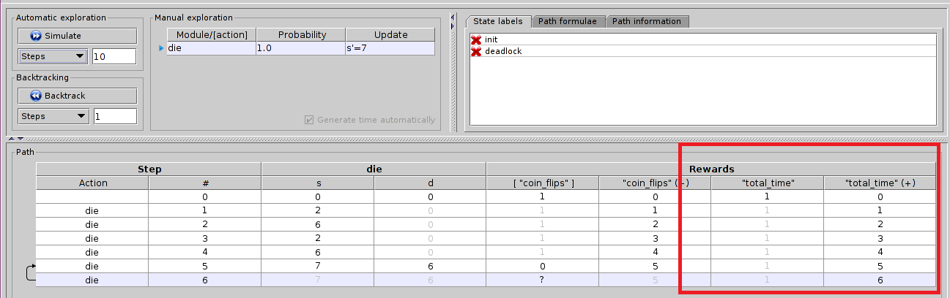

Fig.1. execution time information achieved by “rewards part”.
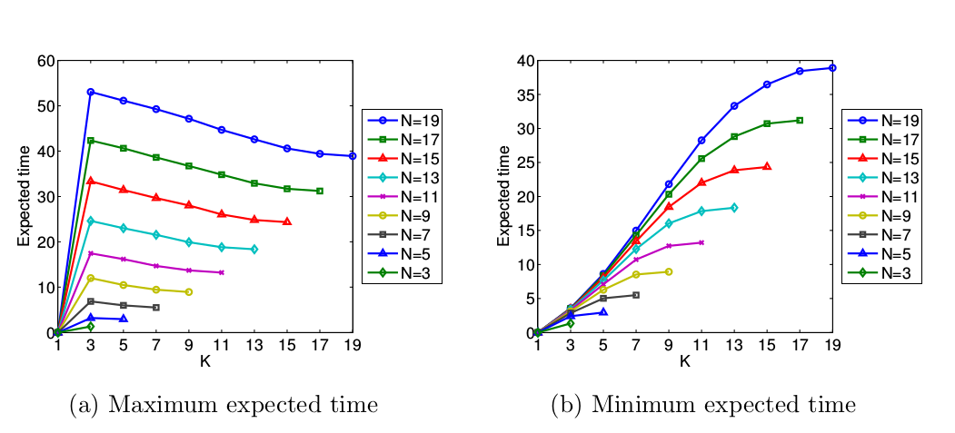
Fig.2. comparison of same algorithms with different parameters

Related Work
The first study I reviewed is Automated Concolic Testing of Smartphone Apps. This paper presents an algorithm and a system for generating input events to exercise apps. Formally, they address the branch coverage problem in the setting of event-driven programs in general, and apps in particular. Their approach uses concolic testing to generate a separate tap event to each widget and starts by sending a random tap event to the current screen of the given app. There are some similarities and differences in this study with our work. Firstly, application domains are different since we work on stand-alone C programs and their paper focuses on android apps. Secondly, we both use same technique which is Concolic testing but we use concolic testing to cover all branches so that we come up with worst case execution time but their approach generates sequences of events automatically and systematically.
The second study I reviewed is Concolic Testing on Embedded Software. The problem they focus on is safety of systems in terms of usage and they try to find faults and errors in embedded systems. This paper reports case studies on the application of CREST (an open-source concolic testing tool) to mobile platform C programs developed by Samsung Electronics. Through this work, they have detected new faults in the Samsung Linux Platform (SLP) file manager and security library: an infinite loop fault was detected in the SLP file manager and an invalid memory access fault was detected in the security library functions that handle large integers. They generally focus on bit-wise operators (&,|,«, etc.) in a target program and integer overflow semantics of C programs. The main similarities are that we both use CREST tool, concolic testing and both of us focus on embedded systems. However, the difference is that they try to find bugs, errors and faults in the program using concolic testing but we focus on performance, which is two different concern of programs.
The last one I reviewed is Probabilistic model checking in practice: Case Studies with prism. In this paper, their main aim is to illustrate several benefits of using formal verification techniques to analyze probabilistic systems, including: a wide range of numerical properties to be computed accurately; and a complete and exhaustive analysis enabling, for example, a study of best- and worst-case scenarios. In other words, probabilistic behavior and numerical properrties of PRISM are used together here. They used costs and rewards property of PRISM to analyze power consumption, expected completion time and other reliability measures. This paper has lots of benefits for our study especially in terms of numerical research. The similarities are that we both use Prism tool and its property of creating numerical values. I have used their example in my presentation and report directly since we both try to calculate execution time, worst case execution time and best case execution time.

Conclusions
We addressed the problem of timing issues for stand-alone C programs. We evaluated the effectiveness of our approach on 2 simple C programs. Results show that the approach is effective with the usage of concolic testing and Prism since both of them come up with time calculations. On the other hand, we observed the connection of concolic testing and Prism as limitations. Further studies might be necessary to investigate the link between concolic testing tools and model checking tools so that both of them can be used together as one or they both give same unit results so that results are comparable.

References
- PRISM - http://www.prismmodelchecker.org/
- Saswat Anand, Mayur Naik and Hongseok Yang, “Automated Concolic Testing of Smartphone Apps”
- Yunho Kim, Moonzoo Kim and Yoonkyu Jang, “Concolic Testing on Embedded Software - Case Studies on Mobile Platform Programs”
- Marta Kwiatkowska, Gethin Norman and David Parker “Probabilistic model checking in practice: Case studies with PRISM”

