Research Rabbit
The time has come for you to conduct your own research! You formulate a good hypothesis,
have a general idea of what to do, and all you need to do now is to look through past research findings.
Some just go diving into a relevant journal. Others use tools such as Google or Google Scholar to look up things more specific. Few are aware of Research Rabbit (RR).
Used by universities such as Harvard, Peking, or the Imperial College, one would think RR would be much more popular. Yet, it feels as if it were one of those “if you know you know” tools.
How Research Rabbit stands out is through its methodology of accumulating information relevant to your needs through the means of nodes. You connect ideas and papers, which receive an update each time a study that is relevant to your “collection” is published. This allows the researcher to stay up-to-date on new findings and visualizes how strongly the papers are connected to each other. Some authors can be “tracked” so you can stay up-to-date on their findings.
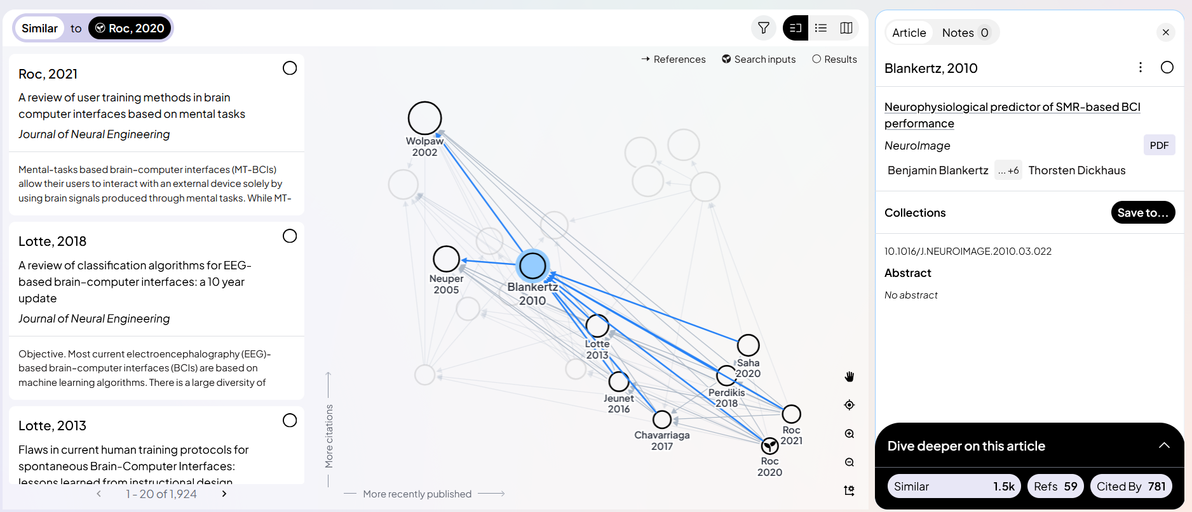
Through this following of citations, related topics and other keywords and studies, RR generates a network which is divided into similar work, all references and all citations. Other useful utilities include making notes to each paper, exporting collections to other text formats (such as BibTeX or RIS) and, what every student loves, the option to share with others for further collaboration.
Making an account is easy, with the key features being available for free and the paid option allowing access to peripherals such as more detailed search options and a greater number of projects. Overall, it is a great tool for speeding up the process of finding research, noticing crucial gaps in the knowledge and receiving inspiration.
So, like rabbits, RR is awesome and plenty of fun to play with. It is a key tool to have with you at all times.

