You might remember from the last edition of PAIR Recommends this nifty tool called Research Rabbit. It allows researchers to find articles which are connected to each other through topics, keywords and whichever other data inputs one desires. Sounds cool! Sure would be nice if there was some way of organizing all this new research, finding new insights from the gathered data, and being able to put all of them into an easy-to-learn format that helps present these ideas to others…
...is what one would think if such a tool didn't already exist! In comes NotebookLM, a fancy note-taking software which allows the user to do all of that, and more, for free!



By this point, you are likely aware of Google's role in this wave of AI research. From spearheading the innovative Transformer model to developing Gemini, Google (and its research 'lab' Deepmind) have been advancing the practical uses of AI wherever possible. Making notes was the next step.

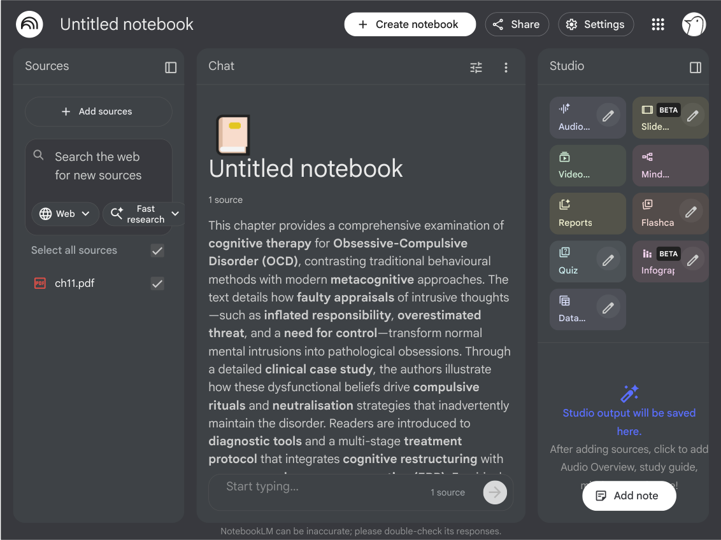

There is not much to be said, in all honesty. The beauty of this tool presents itself in its user-friendly experience. The left side of the screen shows you the sources you have added either manually or through the built-in search (which can range from the standard PDF to videos and websites). The middle is the chat section where you can directly interact with an AI agent to find what you need. Finally, the right-hand side is the 'Studio', which allows the user to create things such as 'Audio Overviews’, ‘Mind Maps', flashcards and much more.
Overall, it is a very useful tool. While, understandably, there may be concerns regarding the privacy of personal documents, or an absolutely necessary habit of double-checking any AI output, it is a really good first step in taking control of the AI pipeline for self-customization.

