**Make a Circle**

The purpose of this project is to create a 30x30 white circle when clicked on the screen, and when clicked elsewhere, a new one is formed and the old one disappears. With the help of the Opengl3 example, the window creation process was done, the while part was recreated.

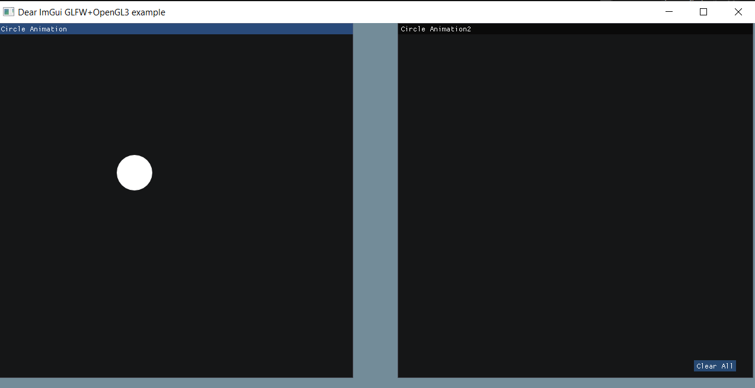

As you can see on the figure above, a 30x30 white circle appeared when clicked on the left window. The circle drawn on the screen is formed by an effect, the radius is increasing from 0 to 30.

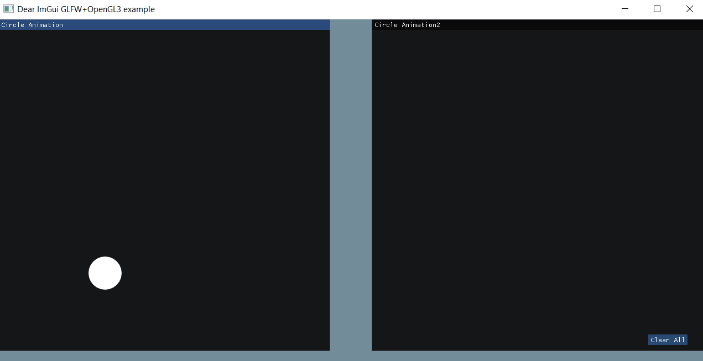

When the mouse clicked somewhere else, the old one disappeared and a new one appeared.

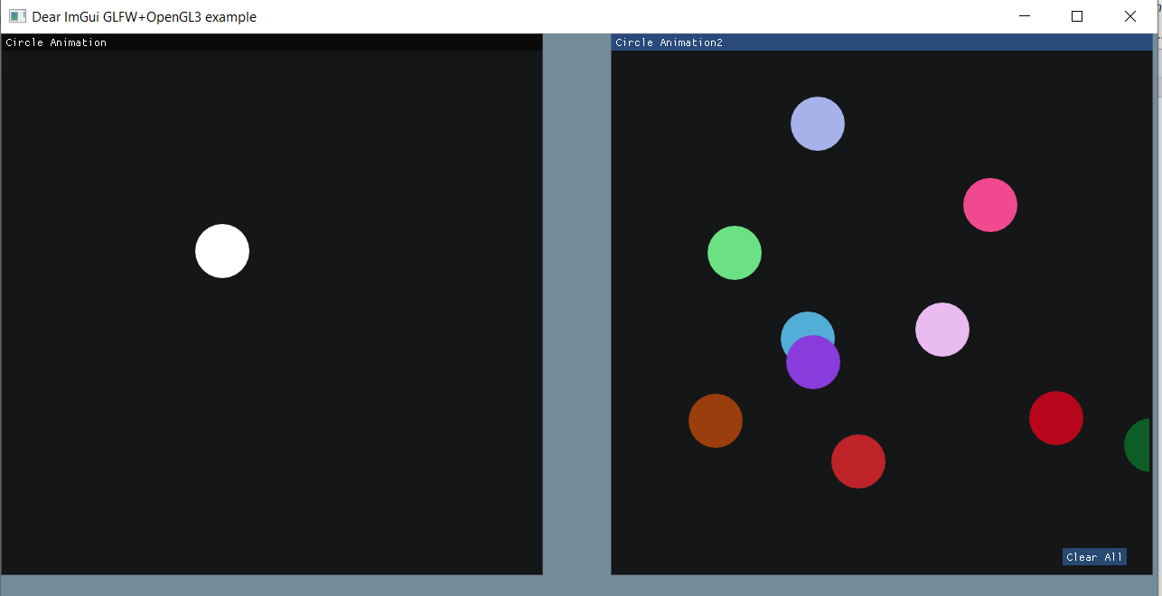

On the right screen, several features have been added to the desired project. First, circles with random colors were drawn instead of white circles. Another feature is that the previous circle does not disappear when clicked elsewhere. And another feature that has been added recently is the "Clear All" button, when this button is clicked, all the circles drawn in the right window are deleted.

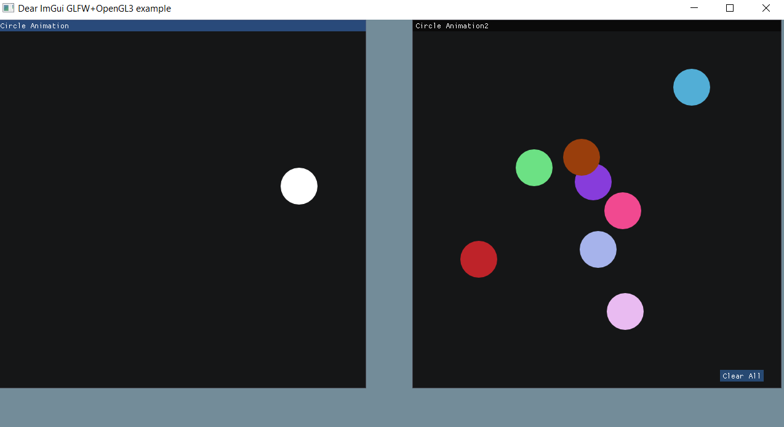 Here the two windows work separately. Clicking on the left screen does not affect the right screen, likewise, clicking on the right screen does not affect the left screen.

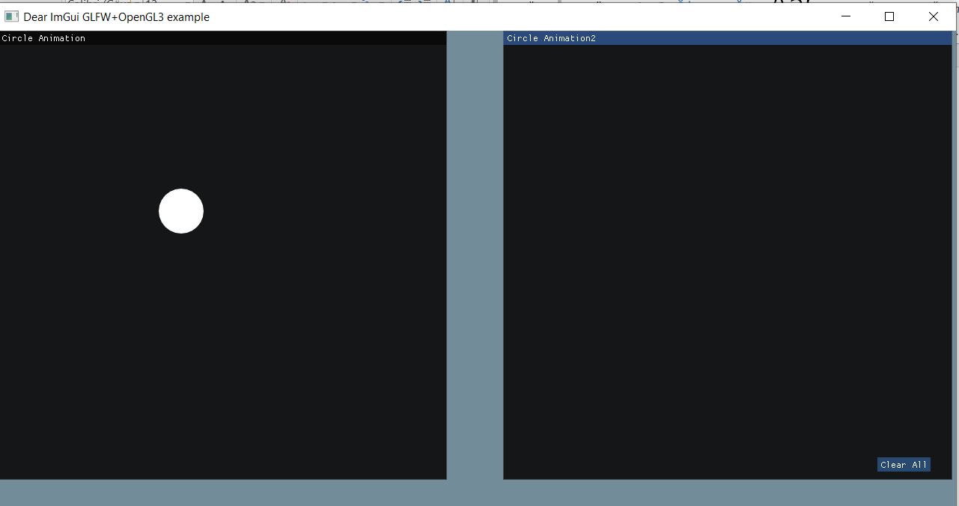

Here, when the "Clear All" button is clicked, it is seen that all the circles on the right are deleted.