Vehicle Page :

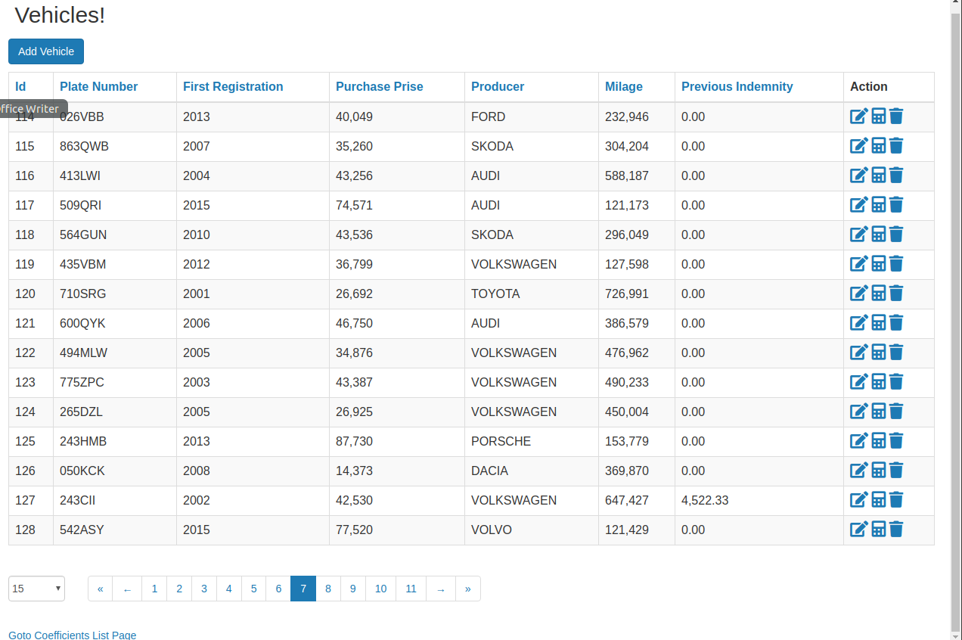
Vehicle Add/Edit Page :
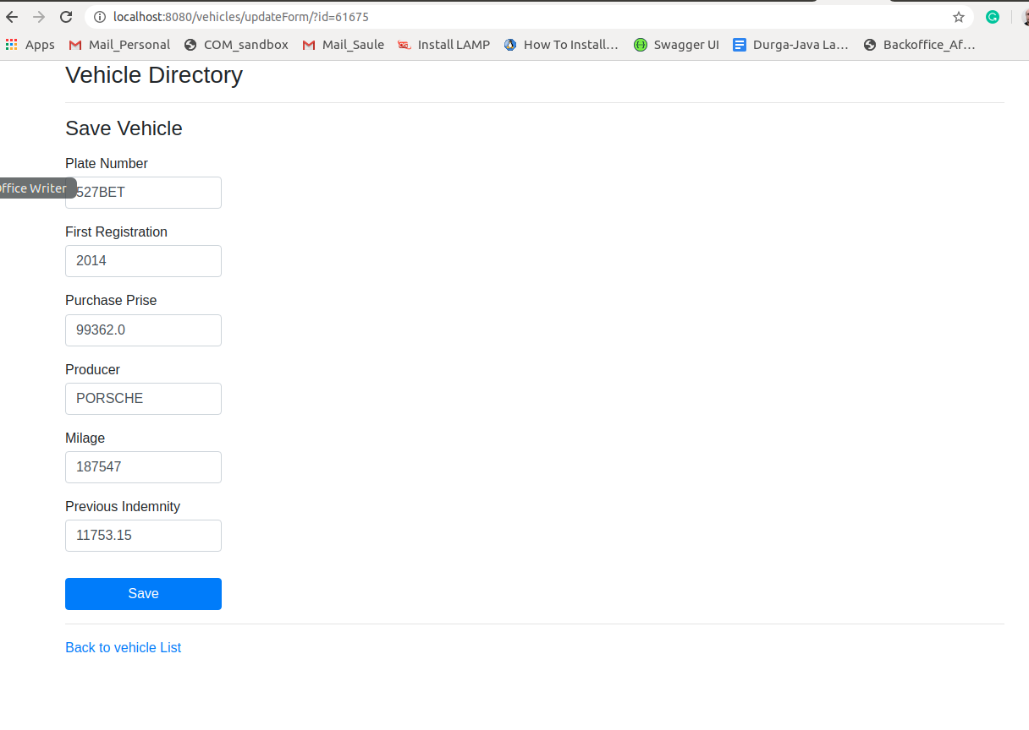

Vehicle Casco Calculation Page :
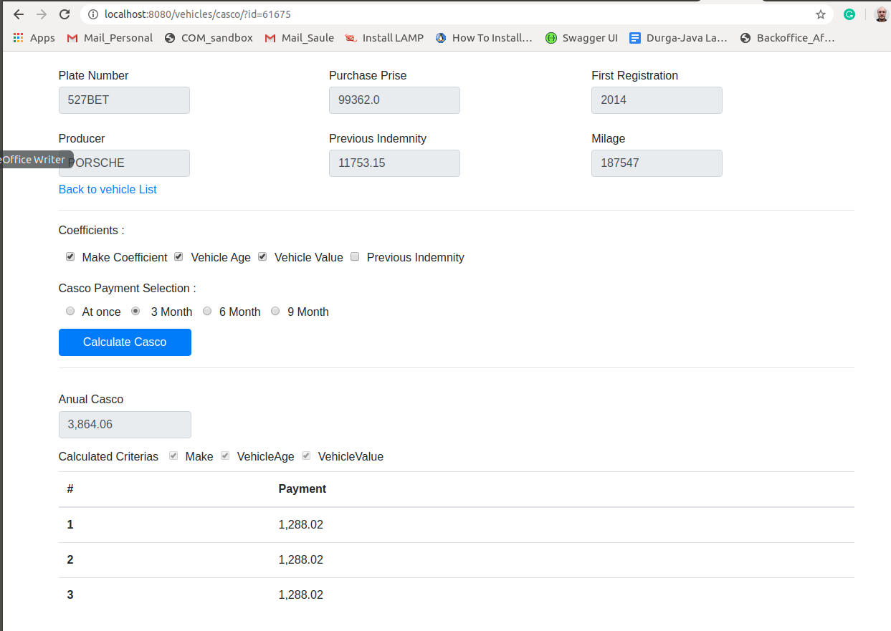

Coefficient Groups Page :
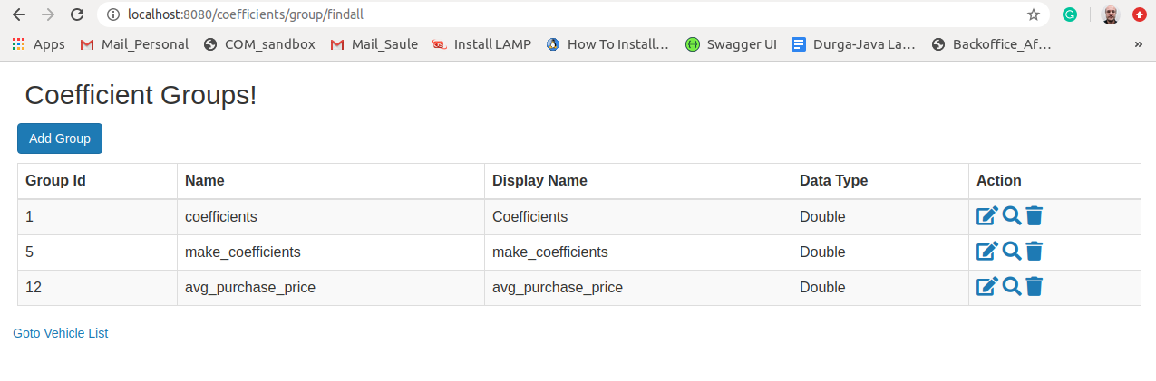

Add/Edit Coefficient Group Page :

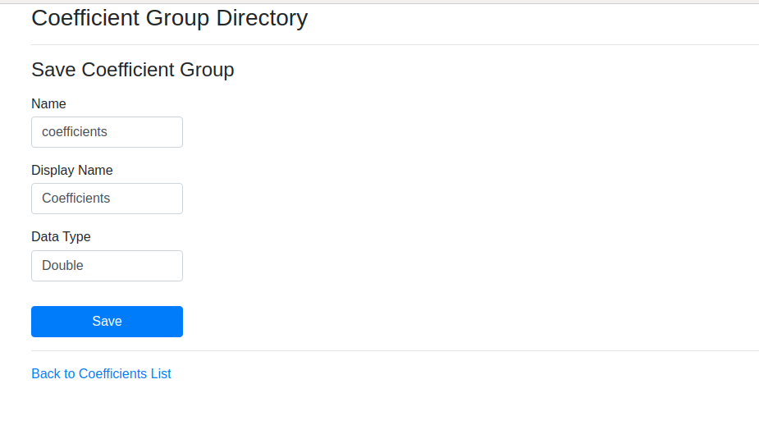
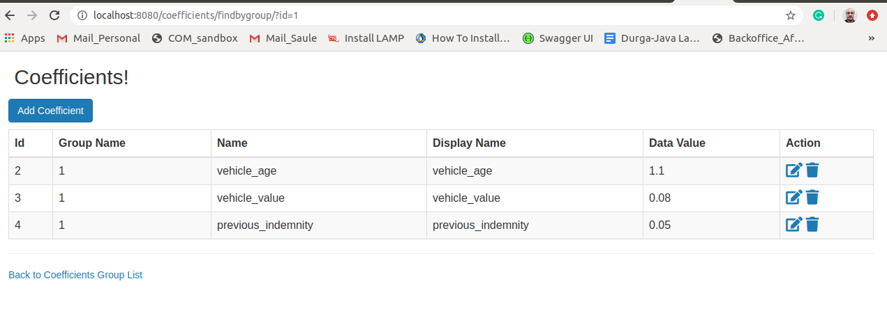
Coefficient Group Detail Coefficient Page :

Edit/Save Coefficient Page :

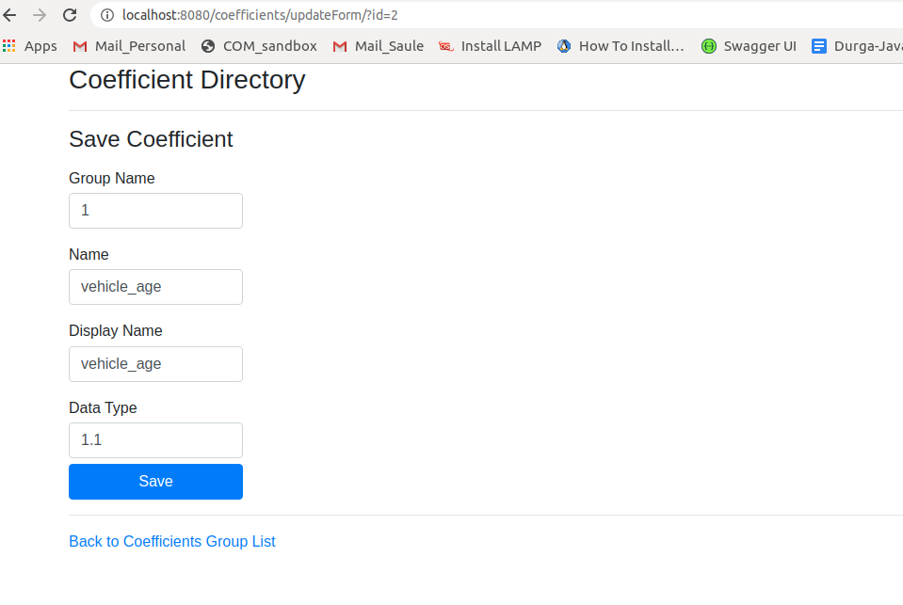
Form Validation Example :

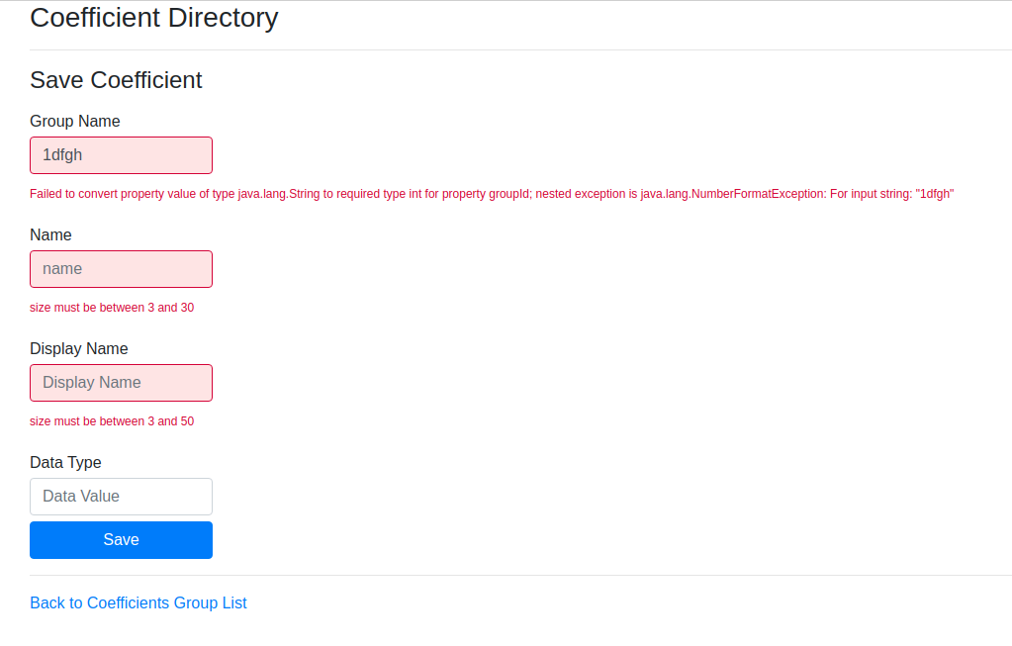

Coefficient Validation Rules :
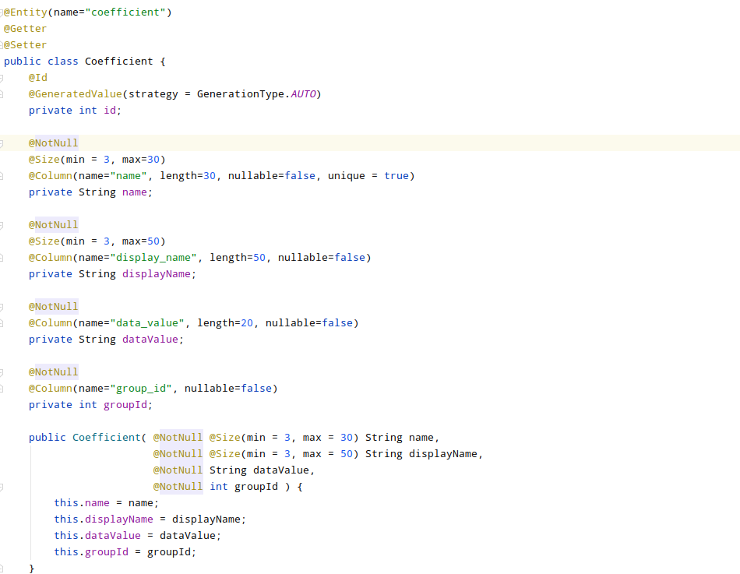

Vehicle Validation Rules:

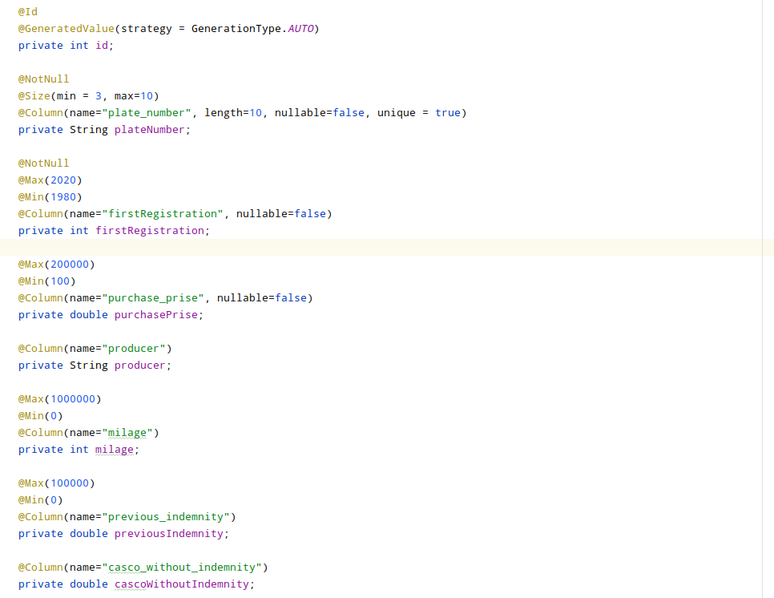

csvErrors.dat file Display:
