**Introduction**

What’s the aim of the study?

The aim of the study is to learn to build a neural network from scratch and understand how the deep learning frameworks operate under the hood. We use a Standard Scaler, ReLU activation function, and other vital modules such as momentum, and dropout.

Why is the study important?

The study is important to understand what is going on under the hood in libraries such as Tensorflow, Keras and PyTorch while training libraries for deep learning and using them for prediction. The project enables both theoretical and practical application of the concepts that were taught in the deep learning class. We review

**ReLU Activation**

ReLU is equal to zero if the input is greater than or equal to zero. Relu output is equal to the input if its input is greater than zero.

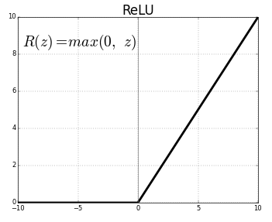

Figure 1: <https://towardsdatascience.com/activation-functions-neural-networks-1cbd9f8d91d6>

**Weight Decay**

Weight decay module erodes a portion of the weights in every update, thus causing a regularization effect overall. This works as a countermeasure to prevent overfitting.

[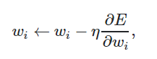](https://stats.stackexchange.com/questions/29130/difference-between-neural-net-weight-decay-and-learning-rate)

**Momentum**

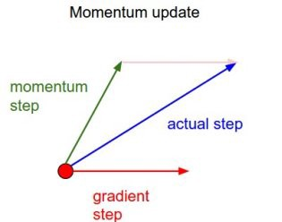

**Appendix**

**Instructions on running the code:**

**Hardware Specs:**

CPU: Intel i7-8700K CPU @3.70 GHz

RAM: 16.0 GB

Operating System: 64-Bit Windows 10 Pro