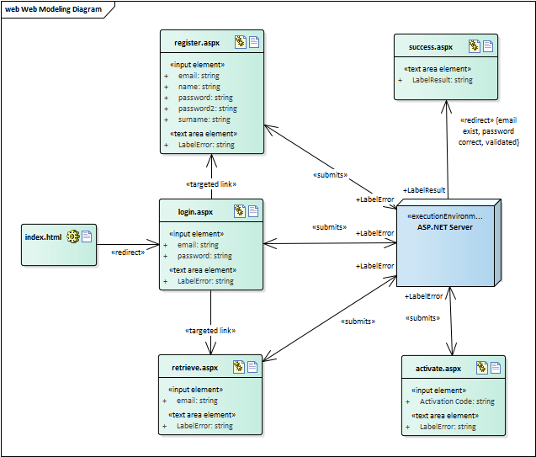

Class Diagram:

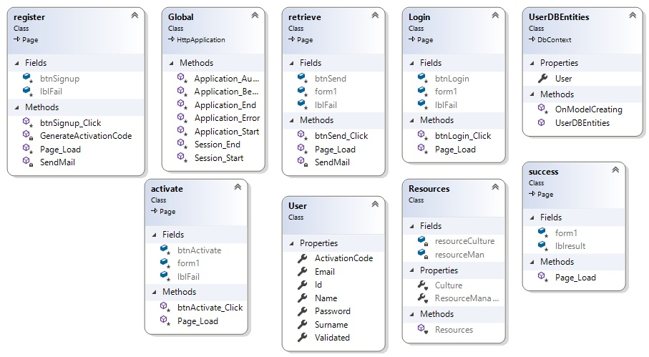

Flowchart:

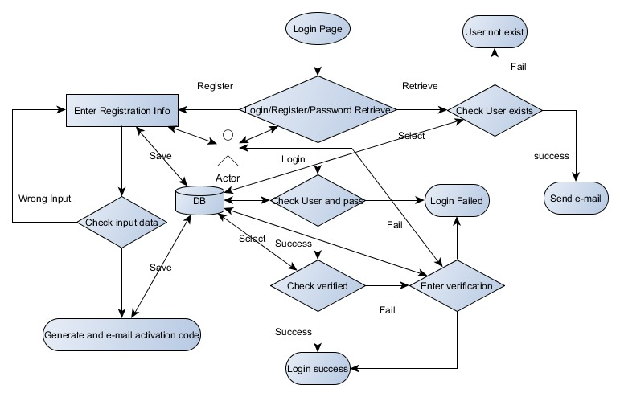

DB Diagram:

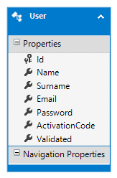

Used technologies:

IDE: Visual Studio 2017, Enterprise Architect (for web model)

ASP.NET, SQL DB, Entity Framework, HTML5, LINQ, C#

\*Account info should be written into web.config for sending mails.

\*DB is emty