# COVER

# Contents

COVER 1

Contents 2

1. Introduction 3

1.1 Project Definition and Problem Formulation 3

1.2 The purpose and motivation of the project 3

1.3 Term Definitions 4

1.4 Related Work 4

2 Method and Simulation 5

2.1 Simulation and Modeling Concepts 5

2.2 Simulation Environment/Tool 5

2.3 Network Design Requirements 7

2.4 Requirement Analysis 13

2.4.1 Functional Requirements 13

2.4.2 Performance Requirements 13

2.4.3 Constraints 13

2.5 Definitions of the System/Model 14

2.6 Simulation Elements 17

3 Traffic Analysis and Simulation Results 20

4 Conclusion 28

5 References 29

6 Appendices 30

# Introduction

Today’s business life depends on information more than ever. In order to compete in related markets, it’s necessary to access data faster and complete. Sharing data with sister businesses or partners not only necessary but also essential for business continuity. The improvements in wireless and mobile device technology ensures the access to data every time from everywhere. These needs show the importance of servers and computer networks for all kind of information access.

Computer networks play vital role in not only business field but also in education. Therefore, campuses on the other hand, take advantage of the improvements in networking technologies. These special places have been the center of knowledge for a long time and knowledge can be improved by information exchange. The demand for faster and higher bandwidth networks increases as the number of students and teachers increase in these areas.

## Project Definition and Problem Formulation

This project aims to plan and design a MAN (Metropolitan Area Network) simulation that will include two distinct campuses and an ISP (Internet Service Provider) which is responsible for the connection between these campuses. It is assumed that these campuses are in same city. Each campus has three facilities and these facilities have various number of end devices. These devices have different kind of connection types like wired and wireless. Besides the users of these end devices have different need of services such as web browsing, email, file transfer, VoIP (Voice over IP) etc. These services are provided by the servers at one of the facilities in second campus.

After defining the main concepts of the project, the problem formulation and the answer can be clearer; Why we need to connect these two campuses and which requirements for users enforce us to provide a successful network connection? The communication between these two campuses is necessary as the end devices are arranged in two distinct areas and the users of these devices need to access web pages, send or get their emails or share their files with each other. These services in one campus can be used by the users in other campus only by the help of a network connection between these two sites.

## The purpose and motivation of the project

Campuses are the special places where students learn new information and gain knowledge. A fast and wide computer network is one of the key factors to achieve this. Not only for students but also for the teachers who work in research and development areas need a stable network to collaborate. Thus, availability and easy transfer of information becomes the purpose for the success of these users. In this way students and teachers can share their knowledge easily even from far distances.

This connection provides 3 main benefits;

* fast communication
* access to services by all users
* exchanging of scientific and technical information

The improvements in teaching and researching in the study and work life of these users is the main motivation of this project. These improvements may lead them to develop new information, research clean resources and/or medicines which can save millions of lives. It would be great to be part of such an important and gorgeous inventions. On the other hand, such responsibility brings the importance of risks to be covered. The design of the network must be solid and stable where the performance and availability must be high.

## Term Definitions

In computer network research, network simulation is a technique whereby a software program models the behavior of a network by calculating the interaction between the different network entities. [1] The model is built on a computer and testing is done without the network being physically installed.

Networks may extend beyond the boundaries of a building. A network that is larger than a LAN and connects clients and servers from multiple buildings—for example, a handful of government offices surrounding a state capitol building—is known as a MAN (metropolitan area network). Because of the distance it covers, a MAN may use different transmission technology and media than a LAN. [2] A service provider is used to connect customer sites which are existing in the same city.

## Related Work

During the study of this project, especially best practices of Cisco Campus designs are covered and inspired. We decided to use each facility as distribution site and create a separate closet for core devices.

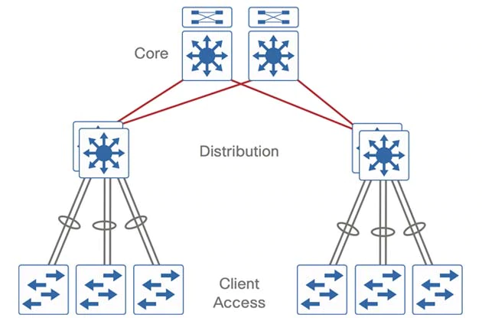

Figure 1- Campus LAN Design

# Method and Simulation

Likewise, in any systems design, network design aims to meet some requirements while working within certain constraints. In this project, the network design is required to support maximum number of network users, traffic load with minimum delay and support for hardware expansions. There can be constraints like money, technology, labor and time. It’s assumed that money and technology are the basic constraints while developing our solution.

Economic constraints have the major role in most of the network designs. In almost every project there is a point where the designer must choose between cost and performance. The main target should be achieving best possible service at the lowest possible cost which is not easy.

The importance of the requirement analysis should never be underestimated during the network design.

## Simulation and Modeling Concepts

 Modeling is understood as the purposeful abstraction of reality, resulting in the formal specification of a conceptualization and underlying assumptions and constraints. The execution of a model over time is understood as the simulation. While modeling targets the conceptualization, simulation challenges mainly focus on implementation, in other words, modeling resides on the abstraction level, whereas simulation resides on the implementation level. [3]

Modeling and simulation help to reduce costs and increase the quality of the final system. The fails can be documented, and these experiences can be used in future projects. As mentioned above, simulation is the running form of the model. Therefore, simulation can be as good as the model. This is the reason the model must be paid a special attention to.

Models and simulations are not real-world experimentations. Thus, the cost and time that would be spent on a possible failure can be saved. Updates or improvements on the model can be easily and cheaply tested where at the end the results can be compared. Simulations can decrease the cost in education as well as improve the realism environment for students and beginners.

During the application of the results of simulation to real world, the assumptions and constraints must be fully understood. Otherwise the project may produce different results than it has produced within the simulation.

## Simulation Environment/Tool

Network simulators are the primary tools for engineers who will design and test a network system. Especially in big projects, creating a physical environment with all possible hardware like routers, switches, access points etc. may not be possible. As a result of this, one of these tools, Packet Tracer v7.3 is chosen as a modeling and simulation tool in this project. This tool is developed by Cisco, free of charge and is running on Windows, Linux and MacOS systems.

Packet Tracer is a powerful visualization and simulation tool that enables users to design, build, and troubleshoot network problems in a secure environment. It has an easy-to-use interface that allows you to create your topology with drag-and-drop ease.

The benefits of the Cisco Packet Tracer program include:

* It provides a comfortable and well-informed environment.
* It provides multi-user, real-time training laboratories.
* It can prepare exams for students and give points according to what they do.
* Network environment is designed, and network devices are configured using virtual equipment. [4]

Packet Tracer is widely used. Therefore, any kind of help on usage or project specific can be found on the internet. Learning phase of the application is fast. Adding devices, making connections and adding, removing interfaces can be done simply. The status of the devices and connections can be seen clearly with colorful marks. It supports variety of network equipment and connection types. Cisco is still improving the software by adding support to new devices and parameters. For more advanced configurations, CLI (Command Line Interface) is also present for routers and switches.



Figure 2- Packet Tracer 7.3 GUI

Cisco Packet Tracer has two workspaces—logical and physical. The logical workspace allows users to build logical network topologies by placing, connecting, and clustering virtual network devices. The physical workspace provides a graphical physical dimension of the logical network, giving a sense of scale and placement in how network devices such as routers, switches, and hosts would look in a real environment. The physical view also provides geographic representations of networks, including multiple cities, buildings, and wiring closets. [5]

Packet Tracer does not include all functions of routers and switches. It supports limited set of commands. Therefore, Cisco advices it be used for learning purposes not for replacement of Cisco routers and switches.

## Network Design Requirements

There are two different network design models; top-down and bottom-up.

Top-down design facilitates the process by dividing it into smaller and more manageable steps. Top-down design clarifies the design goals and initiates the design from the perspective of the required applications and network solutions such as IP telephony and content networking. The top-down approach adapts the physical infrastructure to the needs of the network solution. [6]

When you deploy a bottom-up approach by selecting network devices and technologies first, the network might not meet the needs of the organization. With a bottom-up approach, the risk of redesigning the network is very high. [6] It starts from the physical layer and more widely used in projects where fast implementation is necessary. Expanding the existing network is an example to this.

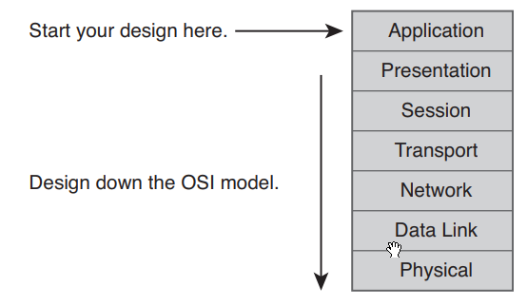

Figure 3- Top-Down design method

When the benefits of top-down design are realized, the choice was clear. We had to first find the services that would be used by both campuses. There are web, ftp and email services which are installed on servers at facility3 in Campus2. These services must be used by the both campuses. The problem is how the communication would be done between these sites. The most cost-effective solution would be, hiring this service from a local service provider.

There will be six physical areas where three facilities in first campus and three facilities in second campus. In order to have them also logically separated, we decided to use a different network for each of these locations. The IP address ranges are arranged to be more than the required number for future device and/or user expansion. With the usage of 255.255.255.0 subnet mask, 254 IP addresses obtained for assignment. Because of the static IP needs that can be used in some devices, the first ten IP addresses are reserved, and the dynamic IP assignment started from 11 as the last octet. Facility3 of Campus2 is given a different class of IP address as this location will be used by the servers and wanted to be differentiated from other clients. A DHCP server is one of the requirements and we wanted to take the best advantage of this by giving all end users a dynamic address. In this way we can take configure and observe the IP assignments centrally.

Table 1 - IP address plan

|  |  |  |  |
| --- | --- | --- | --- |
| **CAMPUS 1** | | **CAMPUS2** | |
| Facility 1 | 192.168.1.0/24 | Facility 1 | 192.168.4.0/24 |
| Facility 2 | 192.168.2.0/24 | Facility 2 | 192.168.5.0/24 |
| Facility 3 | 192.168.3.0/24 | Facility 3 | 172.16.1.0/24 |

After the logical and physical concepts appeared in mind, we started to work with Packet Tracer. It would be better to divide the process into smaller steps. Thus, we decided to create each facility one by one. Workstations, laptops and other wireless devices added according to the requirements on the document. For the switching part, we decided to use a fast but low-cost switch. These switches are chosen to work at Layer2. We didn’t want to use a routing or different IP range for the wireless devices. These devices should get the IP from DHCP like other clients. Therefore, we chose Layer2 access points for wireless devices. The routers at the facilities will act like a gateway and work at Layer3. The IP address of the router interface that connects to switch is configured as the first IP address of that facility. The connection to core router will be the responsibility of this router. It will provide flexibility and security if needed in future decisions. Middle range routers are chosen for cost efficiency. The hostnames of switches and routers are given according to their locations.

The connections between these devices are all done with copper cables. The important point to be mentioned here is that the connection between switch-router and switch-access point are done using gigabit interfaces. These ports are chosen to avoid bottlenecks and network delays as these connections will be shared by multiple end users at the same time.

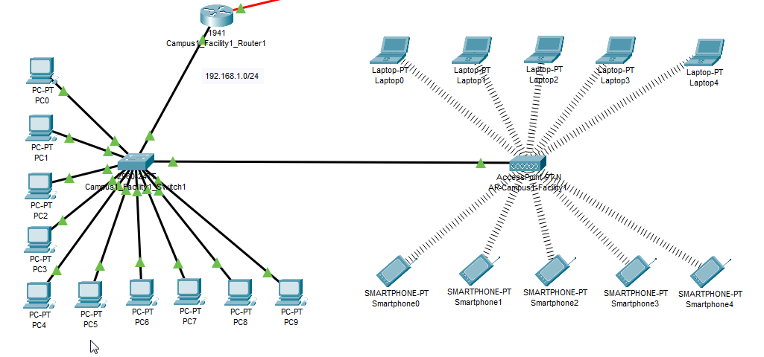

Figure 4- Campus1 Facility1 Logical view

The physical workspace in Packet Tracer was also used to demonstrate the MAN. Izmir city is chosen for the campuses. Facilities are presented with the buildings and by drawing a circle covering the three facility, a campus is formed. Every facility has a closet for the rack. The devices are distributed in the building where the switch and router are installed in the rack.

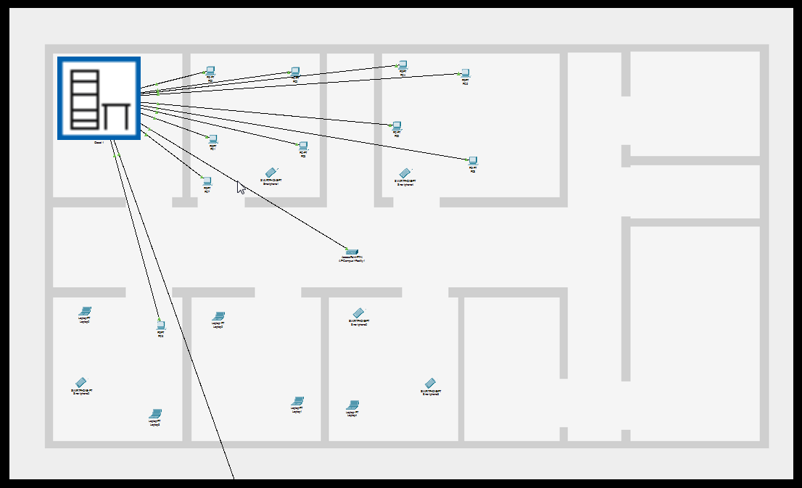

Figure 5- Campus1 Facility1 Physical view

The server farm in Campus2 Facility3 is an exception to these physical and logical implementations. The need for high speed connections in this location lead us to choose different kind of connection medium and therefore a switch that can support many fiber interfaces. Unlike the clients, the servers are given static IP address from the 172.16.1.0/24 network. This will give more control to administrators for client configurations. We decided to install these servers into the closet of Facility3 for centralized security and physical management benefits.

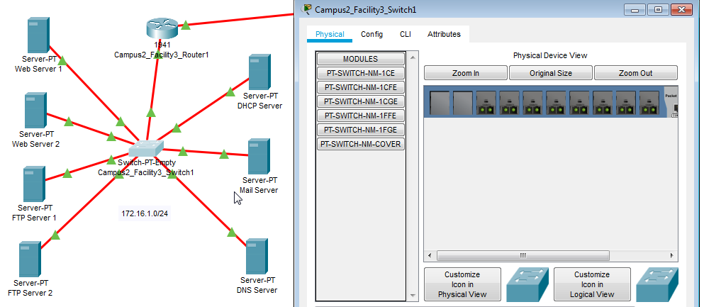

Figure 6- Campus2 Facility3 Server Farm

The hostnames, services and IP addresses of servers are given in Table 2- Server list.

Table 2- Server list

|  |  |  |
| --- | --- | --- |
| Hostname | Service | IP Address |
| DHCP Server | DHCP | 172.16.1.2 |
| DNS Server | DNS | 172.16.1.3 |
| Mail Server | Mail | 172.16.1.4 |
| Web Server 1 | WEB | 172.16.1.5 |
| Web Server 2 | WEB | 172.16.1.6 |
| FTP Server 1 | FTP | 172.16.1.7 |
| FTP Server 2 | FTP | 172.16.1.8 |

Following the generation of facilities including network devices and end points, we need to define the connection between these facilities. As advised by Cisco for Campus networks, we wanted to create a location for core router and outside communication device which is another router. By physically separating this area, more strict security preventions can be taken, physical works can be done without disturbing users, the sound of continuously working air conditioners avoided from people. Thus, we created a closet that is called “communication closet” inside of each campus site.

The routers of each facility connected to core router via fiber cables considering the distance between the communication closet and each facility. The core router also connects to communication router which usually belongs to service provider and runs as a gateway for the campus.

So far, we have added the facilities, devices and clients. Connected them to network devices and arranged the physical workspace according to the requirements. We added the second campus and do the same steps there.

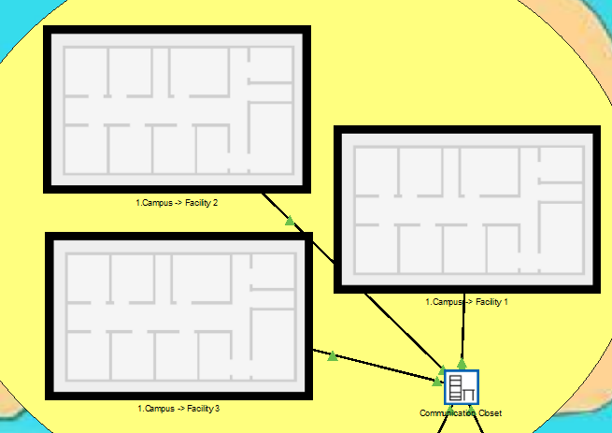

Figure 7- Campus Physical View

The following step is configuring the network devices for communication. The IP addresses for router interfaces are given. 192.168.200.0/32 networks are chosen so that only two IP addresses would be occupied by each connection line. The routes are statically entered. Routers in each facility has the default forwarding address of the core router. Thus, all the packets coming from their switch side interface will be forwarded to core router. The routers need to forward DHCP messages between clients and the DHCP server. To make that work, the routers connected to the remote LAN subnets need an interface subcommand: the **ip helper-address** *server-ip* command. [7] In our project this will be: *ip helper-address 172.16.1.2*. In campus2 facility2 IP phones are used. Therefore, we need a different router that will support telephony service. The configuration is done with the help of Cisco sources on the internet. [8] A DHCP configured on the router with the IP address 192.168.100.0/24 for IP phones and they are registered for VoIP usage.

The core router has all fiber connections to facilities. The interfaces have static IP addresses from192.168.200.0/32 and the following networks. The static routes to connected facility networks are entered and communication between facilities of a campus is done here. This can provide a control for access, meaning a security point, if needed in future. DHCP helper command also issued in this router. If the packet has a destination network of an unknown network, that packets are forwarded to the communication router, meaning default gateway, to be sent to ISP.

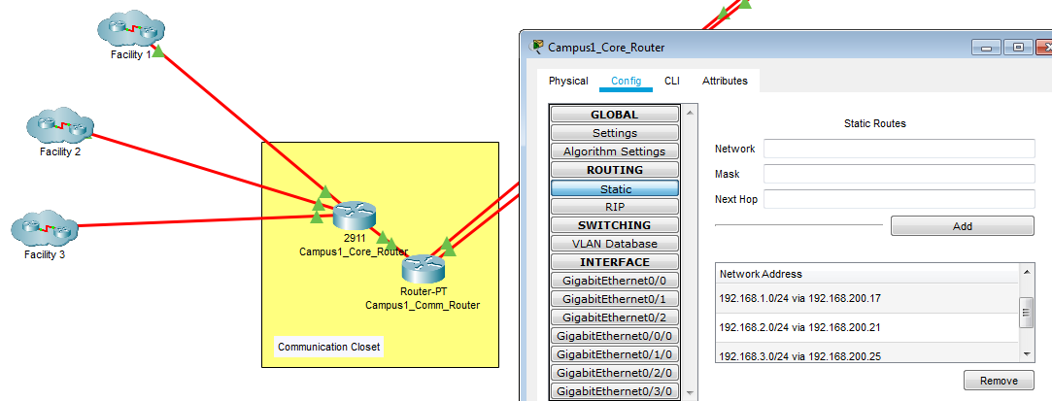

Figure 8- Campus logical view and core router static routes

Usually the communication router is provided and administered by ISP. We add the static routes of internal networks and route of ISP for the rest of the packets. In order to use DHCP for the first campus, ip helper-address command is used in communication and ISP routers. ISP router is configured for testing purposes and used public IP addresses for interfaces. All the networks in both campuses added for static routing in ISP router. Thus, ISP router will know where to forward the packets according to their destination addresses. Two different type of connections used for ISP access; fiber and serial. Fiber is the main line and serial is used for the backup purpose.

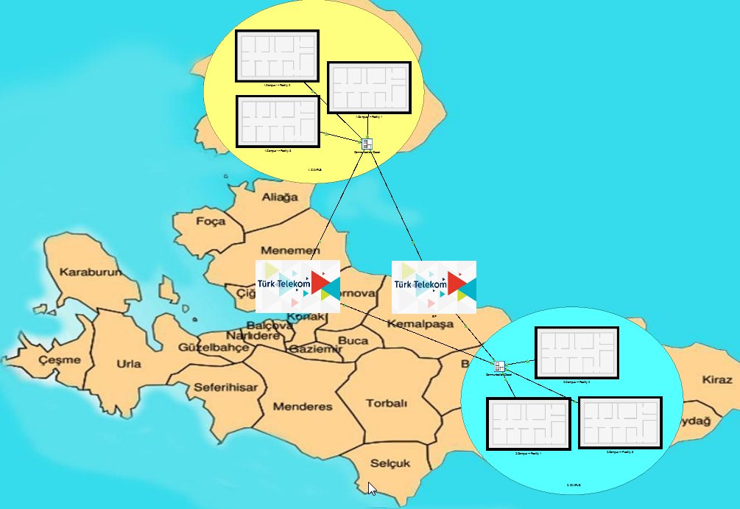

Figure 9- General physical view

The network devices that are used in this project can be seen in the table below with their locations.

Table 3- Network device list

|  |  |  |  |
| --- | --- | --- | --- |
| Campus 1 | | | |
| Facility 1 | Facility 2 | Facility 3 | Comm. Closet |
| Cisco WS-C2960-24TT | Cisco WS-C2960-24TT | Cisco WS-C2960-24TT | Cisco 2911/K9 |
| Cisco 1941/K9 | Cisco 1941/K9 | Cisco 1941/K9 | Cisco Router-PT |
| Access Point-PT-N |  | Access Point-PT-N |  |
| Campus 2 | | | |
| Facility 1 | Facility 2 | Facility 3 | Comm. Closet |
| Cisco WS-C2960-24TT | Cisco WS-C2960-24TT | Cisco Switch-PT | Cisco 2911/K9 |
| Cisco 1941/K9 | Cisco 2811 | Cisco 1941/K9 | Cisco Router-PT |
| Access Point-PT-N | Access Point-PT-N |  |  |
| ISP |  |  |  |
| Cisco Router-PT |  |  |  |

## Requirement Analysis

### Functional Requirements

* Two distinct LAN in separate campuses should be included in the metropolitan area network.
* The services (web, mail, FTP, DNS, DHCP) that exist in one campus should be used by the clients of both campuses.
* In second campus Facility2, five users should be able to make VoIP conference events.
* The system should be consisting of adequate hardware support for network expansions.
* The network should support traffic load with minimum delay.

### Performance Requirements

* Each network must support minimum 20 endpoints.
* The bandwidth of network must handle all traffic. Each user should be able to have minimum 2Mbps when the network is fully loaded.
* MAN, latency should be less than 100ms.

### Constraints

* Cost

It’s assumed that there are no constraints on time, ISP services, application services, staff expertise and labor. There’s only one constraint which is cost. The project asks to balance the cost of hardware and the network requirements. Meaning that the best hardware cannot be chosen in every location We have to choose the necessary hardware according to the requirements. There’s no aim to use a core switch in access locations. That would be waste of money.

## Definitions of the System/Model

The campuses are composed of users who are split into different facilities and servers that reside in one location. The users aim to access the services served by the servers. This domain model is known as client-server model.

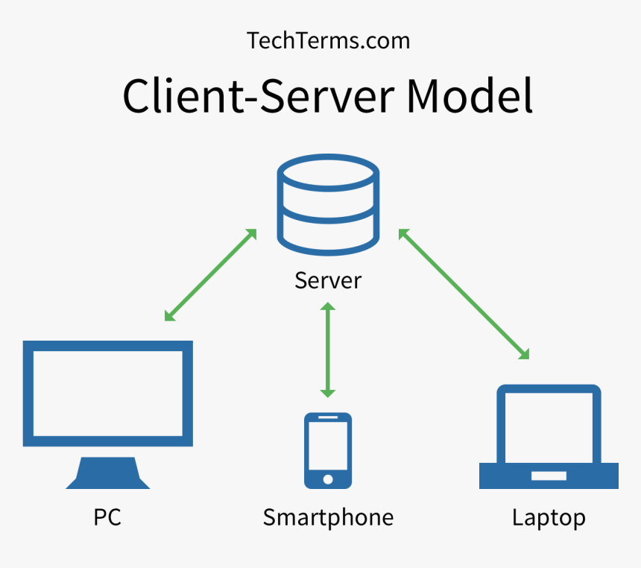

Figure 10- Client-Server Model

The workstations connected to access switches with copper media and having 100Mbps. The transmission media used between access points and switches is copper with speed of 1Gbps. This will avoid the bottleneck of wireless users’ network access as this connection will be shared by all of them. Access switches connect to facility routers with 1Gbps connections. Server farm is an exception to this transmission medias. The server fam switch uses all fiber optic interfaces for server and router connections. This will provide high speed and large bandwidth for users that need to reach services at the same time. All the connections between routers use fiber optic media. This kind of media used to have speed, bandwidth and to avoid the distance problems of copper media.

All the clients get IP from the DHCP pools.

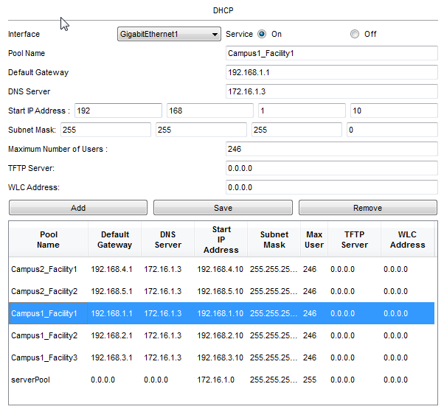

Figure 11- DHCP pools

Campuses have their own local area networks and these networks are connected to each other via private ISP connection. The connection from the communication router of each campus to ISP is over fiber optic media. Because of the high distances between the ISP and the campuses the best reliable choice would be fiber connection. In case of a failure in fiber connection, the backup line is installed. Backup line is selected as serial media which is slower but less costly. This line will be used temporarily for connection during the maintenance of main line.

The connection to ISP is done over 1Gbps fiber lines to avoid speed drops. The bandwidth can be less according to the requirements in order to decrease the costs.

In our design MAN connection is provided by ISP which has ownership on fibber and serial transmission medias that connects two campuses. The hardware and the transmission medias that reside in campus and facilities are property of the university. Therefore, administrative and maintenance complexities and costs of LANs belong to administration of university.

In campus LAN design, star topology used as network structure. A star, or hub-and-spoke, topology features a single hub (central router) that provides access from remote networks into a core router. All communication between networks goes through the core router. [6]

Advantages of star topology:

* Centralized management of the network, using the central computer, router or switch.
* Easy to add another computer to the network.
* If one computer on the network fails, the rest of the network continues to function normally.

Disadvantages of start topology:

* The central device represents a single point of failure
* The central device may limit overall performance
* The topology’s scalability is limited to the resources of central device

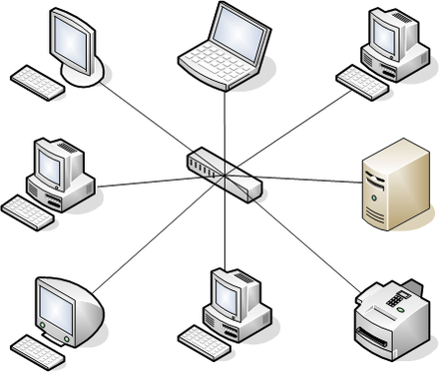

Figure 12- Star topology

In our network model, there are several network devices exist. As mentioned in Requirement Analysis section; there are two campuses and each one has three facilities. There are routers, switches and access points are used as network devices in this project.

Table 4- Number of used components

|  |  |  |  |  |  |
| --- | --- | --- | --- | --- | --- |
| ***Type/Number*** | ***Switch*** | ***Router*** | ***Access Point*** | ***Client*** | ***Server*** |
| **1st Facility of 1st Campus** | 1 | 1 | 1 | 20 | - |
| **2nd Facility of 1st Campus** | 1 | 1 | - | 10 |  |
| **3rd Facility of 1st Campus** | 1 | 1 | 1 | 20 | - |
| **1st Facility of 2nd Campus** | 1 | 1 | 1 | 20 | - |
| **2nd Facility of 2nd Campus** | 1 | 1 | 1 | 20 | - |
| **3rd Facility of 3rd Campus** | 1 | 1 | - | - | 7 |
| **Comm Cabinet of 1st Campus** | - | 2 | - | - | - |
| **Comm Cabinet of 2nd Campus** | - | 2 | - | - | - |
| ***TOTAL*** | ***6*** | ***10*** | ***4*** | ***90*** | ***7*** |

Network design can be seen in Figure 13.

There are some network services required to be implemented in our project. These are;

**File Transfer Protocol (FTP):** It’s a standard network protocol that is used to transfer files between workstations on computer network. It is built on client-server model and security is provided in the username-password form. It uses Transmission Control Protocol (TCP) port 20 and 21. In our design FTP service is given by two servers;

172.16.1.7 – FTP server 1

172.16.1.8 – FTP server 2

**Hypertext Transfer Protocol (HTTP):** is an application protocol for distributed, collaborative, hypermedia information systems. HTTP is the foundation of data communication for the World Wide Web, where hypertext documents include hyperlinks to other resources that the user can easily access. [9] HTTP uses TCP port 80 for connections. We have two webservers in our project;

172.16.1.5 – Web Server 1

172.16.1.6 – Web Server 2

**Simple Mail Transfer Protocol (SMTP):** It’s a communication protocol for electronic mail transmission. Mail servers use SMTP to send and receive mail messages. It generally uses TCP port number 25. In our design we have one server for this service;

172.16.1.4 – Mail Server

**Domain Name System (DNS):** DNS is responsible for the translation of domain names to the numerical IP addresses needed for locating computer services and devices in the network. It primarily uses the User Datagram Protocol (UDP) port 53 to accomplish its tasks. In this project one DNS server is used;

172.16.1.3 – DNS Server

**Dynamic Host Configuration Protocol (DHCP):** is used on IP networks where the DHCP server dynamically assigns IP address and other network parameters to devices. Thus, these devices can communicate with each other. It uses UDP ports 67 and 68.

172.16.1.2 – DHCP Server

**Voice Over IP (VoIP):** allows delivery of voice communication and multimedia sessions over IP. So, it can work both in LAN environment and on Internet. It is also known as IP Telephony. This service is provided by the router in Campus2 Facility2. The IP address of phones are given by the DHCP server in this router from 192.168.100.0/24 range. The IP phones are also registered to the telephony service in this router.

**Wi-Fi Protected Access Pre-Shared Key (WPA2-PSK):** is used for the wireless networks for authentication. It doesn’t require an additional server for authentication.

## Simulation Elements

Following activities simulated and analyzed with our model:

1. A smartphone user from first facility of first campus wants to send email to her friend in the 3rd facility of first campus.

Mail transmissions between sender and receiver is done with the service provided by the Mail Server in datacenter. The IP of the server is 172.16.1.4. SMTP is used for sending and POP3 used for receiving mails. Domain name for the mails is selected as *deuceng.com* and two users are created with the names and passwords as *user1* and *user2.*

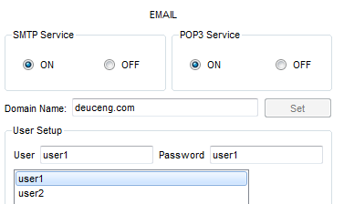

Figure 13- Mail Server settings

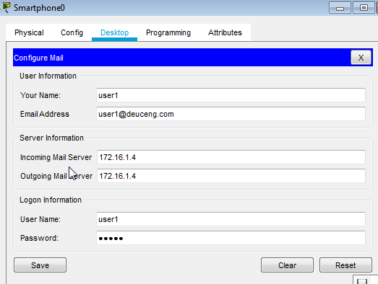

Figure 14- Smartphone Mail Settings (Campus1 Facility1)

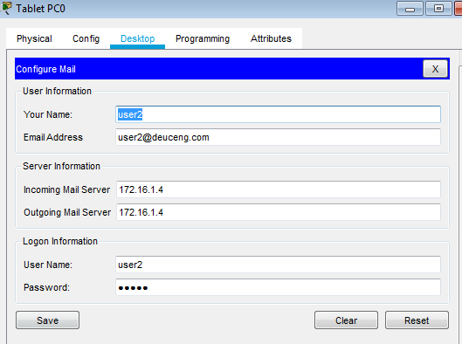

Figure 15- Tablet user Mail Settings (Campus1 Facility3)

1. A user from second facility of first campus wants to browse a Web page.

For a user to browse a web page first the computer needs to access the DNS server for domain name to IP address translation. We add two records to DNS server for the Web Servers. *www.deu.com* resolves to IP address of the first Web Server which is *172.16.1.5* and *www.deuceng.com* resolves to the second Web Server which is *172.16.1.6*. After resolving the IP address, the browser can get the html files on the server.

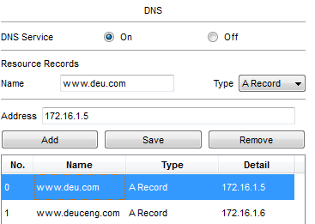

Figure 16- DNS configuration

1. A computer engineer from second facility of second campus developed a web application and wants to send her code files to FTP server in the third facility of second campus.

We have two FTP servers in our design with IP addresses of *172.16.1.7* and *172.16.1.8*. We will use the first one in our simulation. As FTP needs user name and password for access, we generate a user with credentials name as *user1* and password as *user1*. We give all permissions to this user.

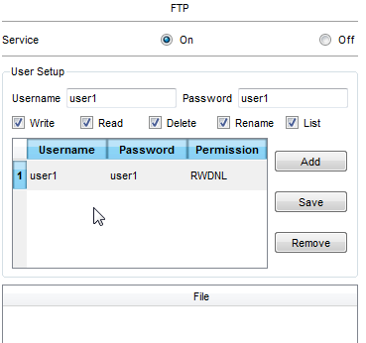

Figure 17- FTP Configuration

1. Two users from second facility of second campus want to talk with VoIP.

We have 5 VoIP telephones numbering 101-105. They are getting IPs from the DHCP server at the router. We must filter the SCCP packets to see the simulation of the VoIP calls. We tested this activity with a call from number 101 to number 105.

1. A user in the second facility of first campus wants to send an email message to his friend in the second facility of second campus.

This event is almost same as the 1st event. The only difference is the sources and physical locations. Therefore, the server and client settings are not mentioned again here. The same user accounts will be used during the simulation.

1. A user from first facility of second branch pings Web server of third facility of second campus.

Ping is a utility that is used to test the reachability of a host on an IP network. It also gives the info of round-trip time for messages from source to destination and back to source again. Ping operates by sending Internet Control Message Protocol (ICMP) echo requests. In this activity ping will be done from the client PC to either 172.16.1.5 or 172.16.1.6. We will test both servers.

1. A tablet user from first facility of second campus wants to read her emails.

The user must connect to Mail server with IP 172.16.1.4 using POP3 protocol to receive his/her e-mails. The same user credentials used for this activity. As a source *Tablet PC10* is chosen.

1. A smartphone user from second facility of second campus wants to browse the web page.

The user first needs to access the DNS server for IP resolving and then the web page can be retrieved from the destination web server.

1. A PC user from the third facility of first campus wants to share a file with a user in first facility of second campus.

The user needs to upload the file to an FTP server first. Same credentials will be used as earlier scenarios.

1. A user from first facility of first campus ping the mail server.

ICMP packet will be used for ping utility. Therefore, we will filter ICMP packets to catch the simulation results.

1. A user from second facility of first campus wants to learn the IP address of www.deuceng.com from the DNS server.

In order to find out the IP address of a web site, *nslookup* utility is used. It means “name server lookup”. This utility will check the IP address from the DNS server.

# Traffic Analysis and Simulation Results

The analysis of traffic and simulation results of the activities are below;

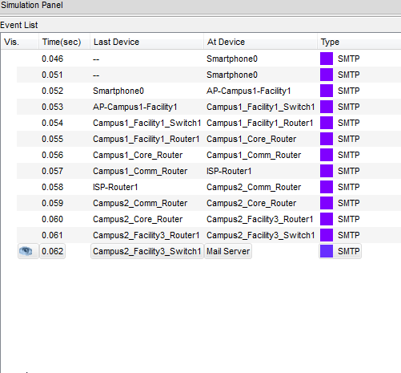

Figure 18- Smartphone to Mail Server

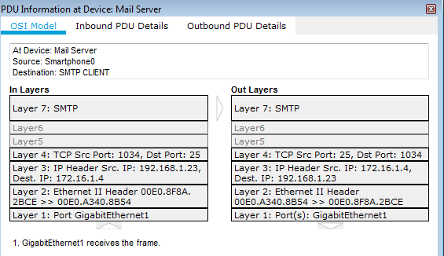

Figure 19- PDU Information at Mail Server

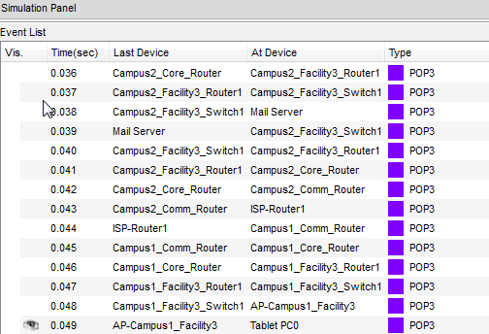

Figure 20- Mail Server to Tablet

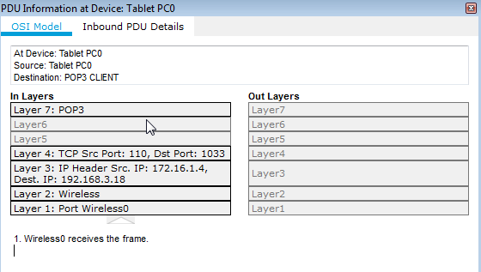

Figure 21- PDU Information at Tablet

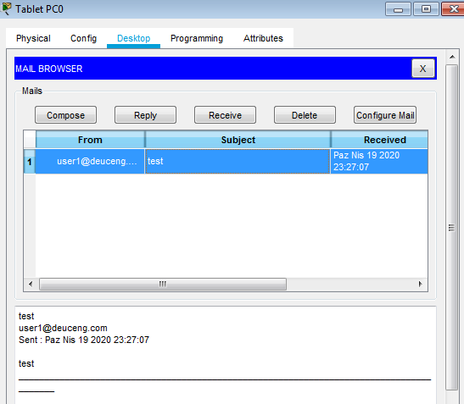

Figure 22- Received E-Mail from Smartphone

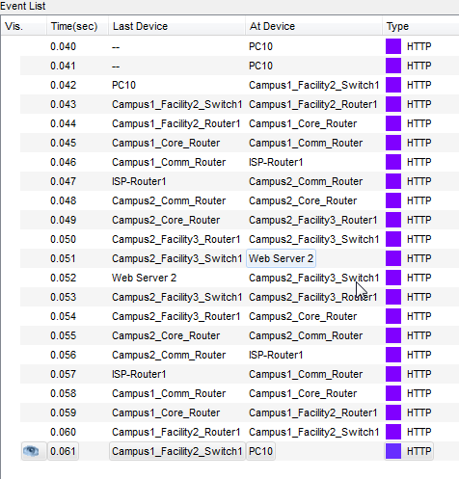

Figure 23- PC10 to Web Server Access

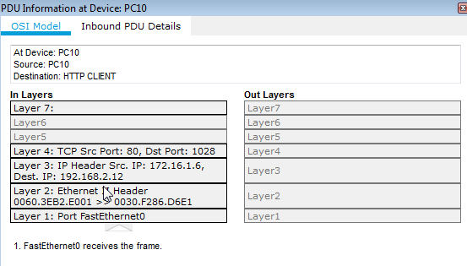

Figure 24- PDU Information

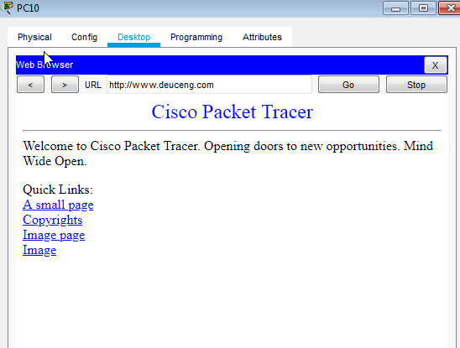

Figure 25- Web browser result

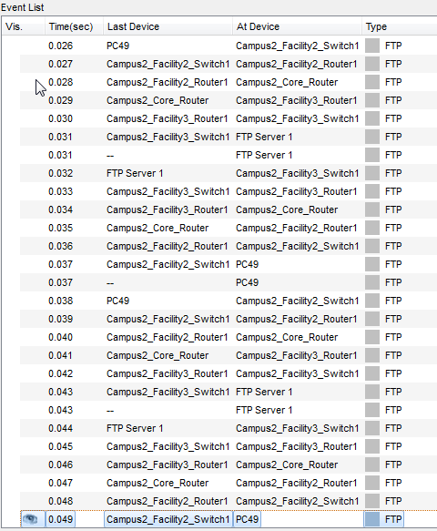

Figure 26- FTP connection

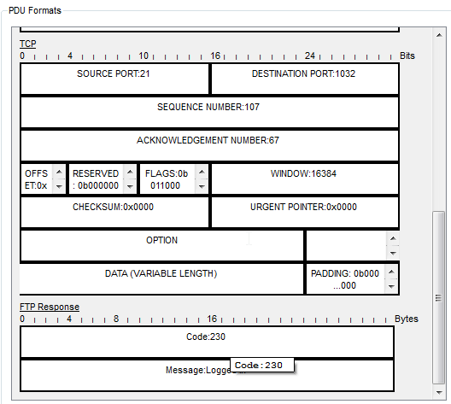

Figure 27- FTP logged in PDU

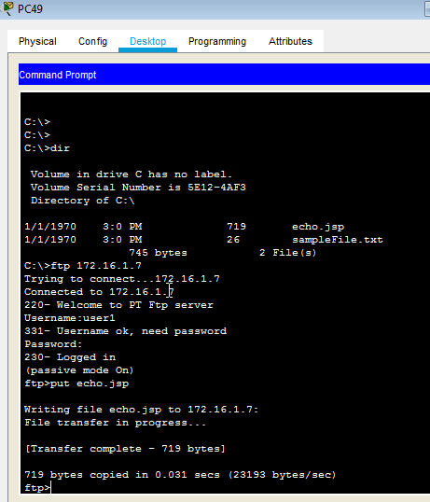

Figure 28- File transfer result

As it can be seen on the Figure 28, 719 bytes took only 0.031 seconds with 23193 bytes/sec transmission rate.

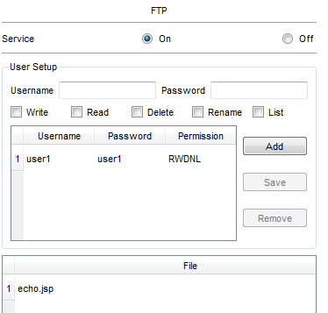

Figure 29- File at FTP server

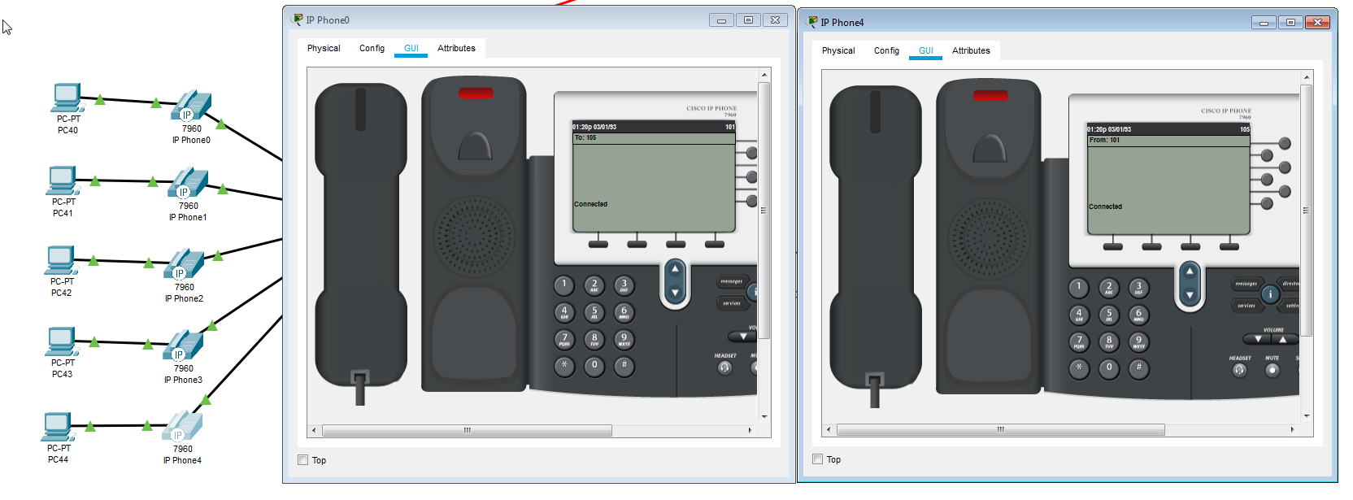

Figure 30- VoIP call from 101 to 105

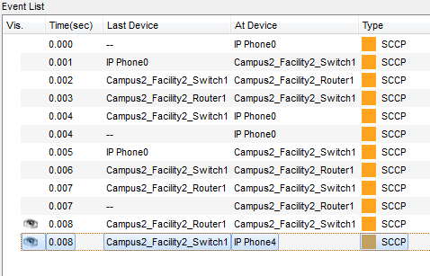

Figure 31- Event List of VoIP call

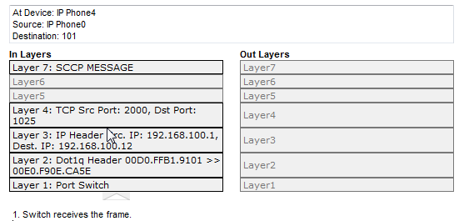

Figure 32- SCCP PDU

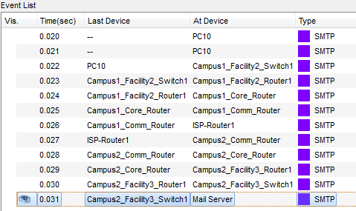

Figure 33- Sending e-mails of PC10 to Mail Server

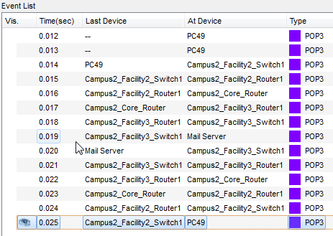

Figure 34- Receiving e-mails of PC49 from Mail Server

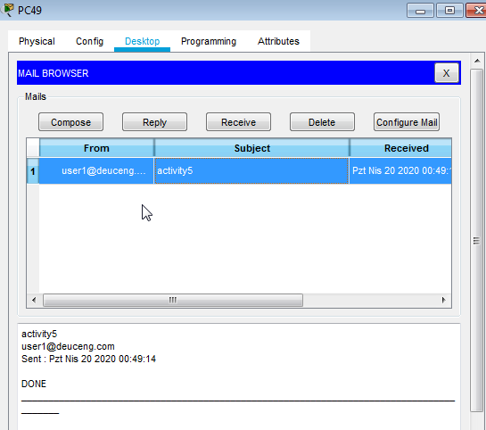

Figure 35- Mails in the mailbox of PC49

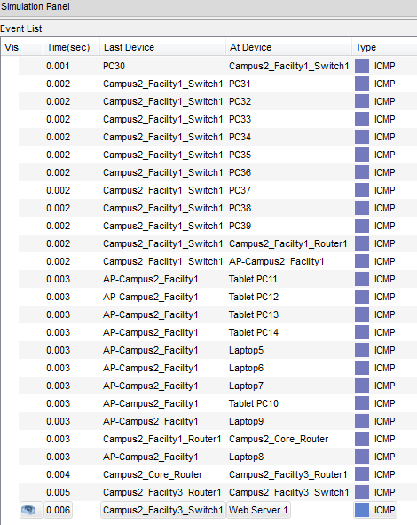

Figure 36- Ping simulation events

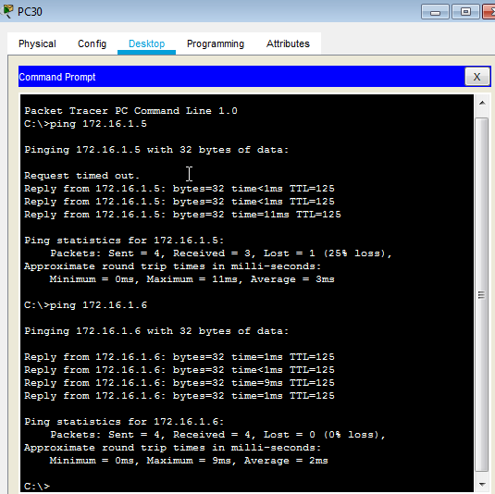

Figure 37- Ping results to Web Servers

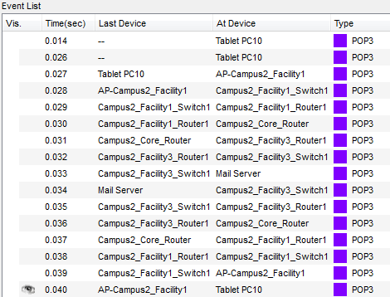

Figure 38- Tablet PC10 to Mail Server and back to Tablet PC10

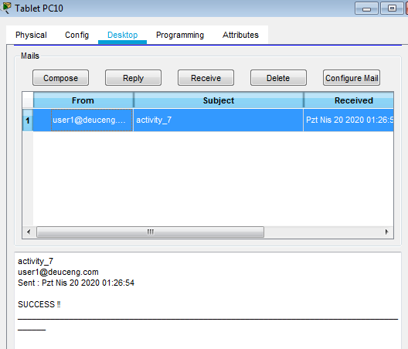

Figure 39- Tablet PC10 received email

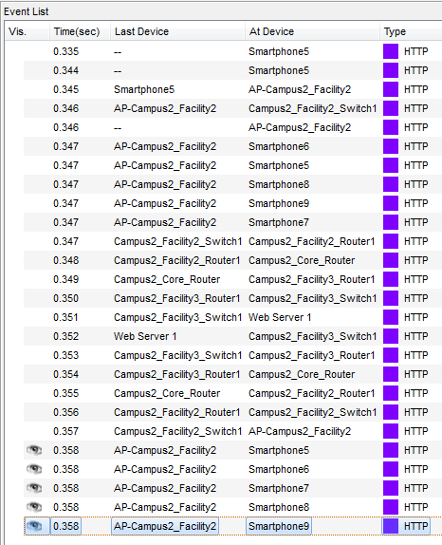

Figure - Smartphone to web server access evet list

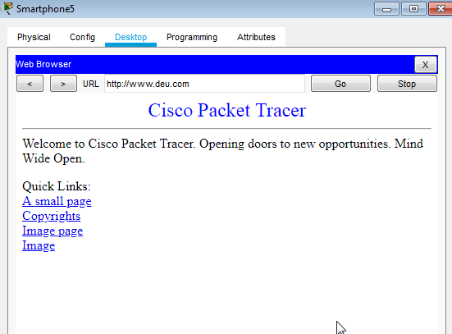

Figure 41- Smartphone5 web browser

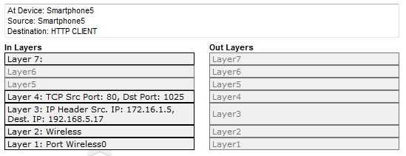

Figure 42- Smartphone PDU answer

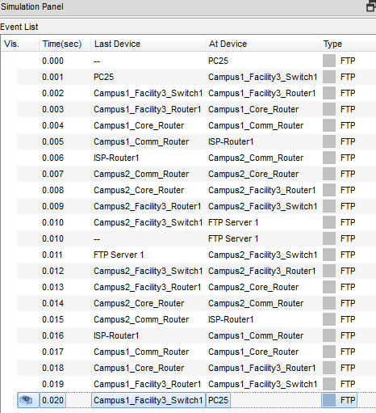

Figure 43- PC25 FTP server access events

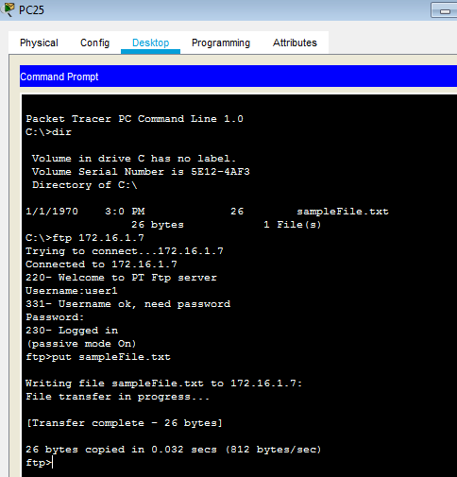

Figure 44- PC25 command screen

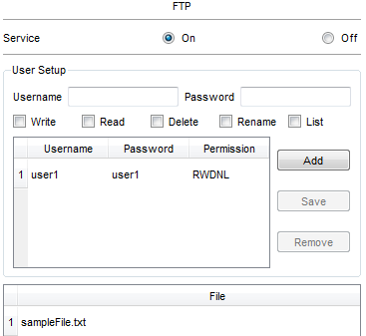

Figure 45- File in FTP server

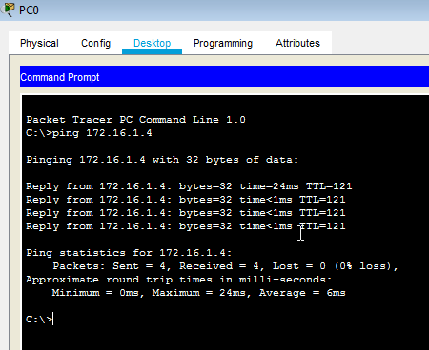

Figure 46- PC10 ping to Mail server result

All pings are successfully replied.

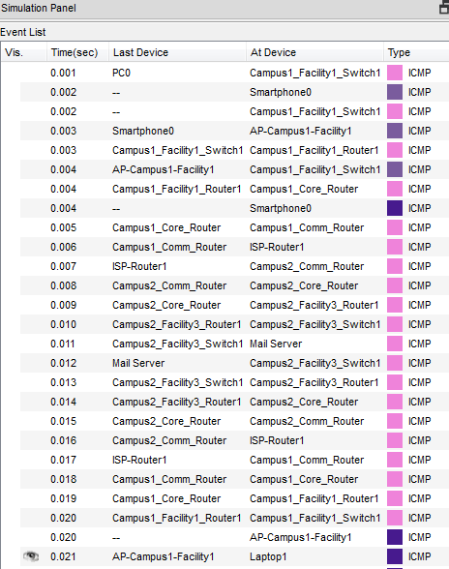

Figure 47- Ping event list from PC0 to mail server

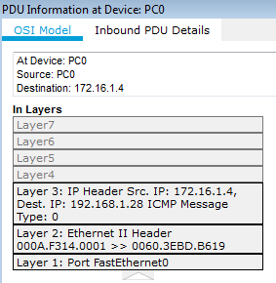

Figure 48- PDU information of ICMP packet

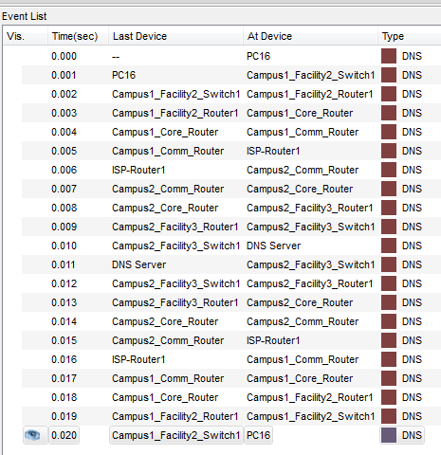

Figure 49- nslookup event list (PC16 to DNS)

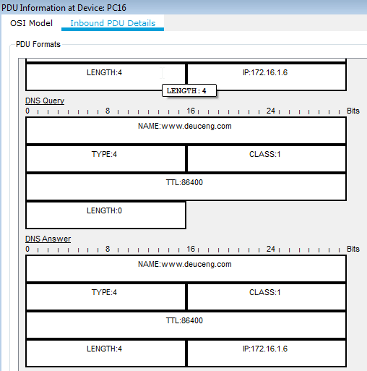

Figure 50- Reply from DNS server

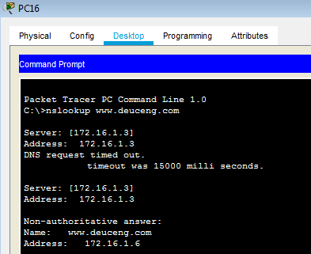

Figure - nslookup command

As it can be seen from the screen, the answer from DNS is 172.16.1.6 which is the IP of www.deuceng.com web server.

# Conclusion

In the final analysis, MAN project is totally completed. The connection between campuses established successfully with support from ISP. The required services are implemented for both wired and wireless users. Workstations can send/receive mail, send/receive files from other workstations through the FTP server. Besides, after successful DNS and Web Server Configuration, they have abilities of browsing/accessing on the web using the domain. By the help of the DHCP server, all clients can get their IP address from the server. This minimizes the administrative effort while centralize the control. IP telephones and VoIP technology provides the communication of users by transferring voice over IP network.

Still there can be some improvements made in this solution. Another DHCP server in Campus1 will provide faster IP address assignment to clients. There won’t be latency caused by the MAN design in that case. There’s almost no reliability in this network. We didn’t use backup devices and except ISP connection no backup lines. Although reliability causes increase in the cost, its benefits in continuity of the network communication and services are undeniable. There can be also extra connections between switches and routers that can work together for higher speed and communication continuity in case of one connection failure. The servers especially mail server can be configured to fail-over another mail server or work in a clustered environment. The access switches that connect to end devices can be replaced with Gbit connection switches and the switch-router and router-router connections can be replaced with 10 or 40 Gbit connections. The control of access points can be centralized. There must be firewalls at each campus where the outside connection is made. In addition, the servers that need to service outside of internal network must be in demilitarized zone (DMZ) in the network. There must be configurations made in the communication routers to sense the failure of the main line and bring up the back-up line. Of course, all these improvements cost extra money, time, labor and technology for the project.

This project contributes us to get knowledge about Cisco Network technologies, how to design a Computer Network, how to configure the network devices such as switches, routers, connection medias, IP address assignments and the basics of networking with definitions.

# References

|  |  |
| --- | --- |
| [1] | "Network Simulation," Wikipedia, April 2019. [Online]. Available: http://en.wikipedia.org/wiki/Network_simulation. [Accessed 21 4 2020]. |
| [2] | T. Dean, Network+ Guide to Networks 6th Edition, Boston: Cengage, 2013. |
| [3] | "Modeling and Simulation," Wikipedia, [Online]. Available: https://en.wikipedia.org/wiki/Modeling_and_simulation. [Accessed 22 4 2020]. |
| [4] | S. Kurnaz, "IMPLEMENTATION OF CISCO PACKET TRACER IN ADVANCE COMPUTER NETWORK," *AURUM JOURNAL OF ENGINEERING SYSTEMS AND ARCHITECTURE,* vol. 2, 2018. |
| [5] | Cisco, "Cisco Packet Tracer Data Sheet," 2010. |
| [6] | S. R. Wilkins, Designing for Cisco Internetwork Solutions, Indianapolis: Cisco Press, 2012. |
| [7] | W. Odom, Cisco CCENT/CCNA Official Cert Guide, Indianapolis: Cisco Press, 2013. |
| [8] | "CCNA Voice lab configuration in Packet Tracer (One Router)," 2014. [Online]. Available: http://ccnavoicelab1.blogspot.com/2014/09/ccna-voice-lab-configuration-in-packet.html. [Accessed 22 4 2020]. |
| [9] | Wikipedia, "Hypertext Transfer Protocol," Wikipedia, [Online]. Available: https://en.wikipedia.org/wiki/Hypertext_Transfer_Protocol. |

# Appendices

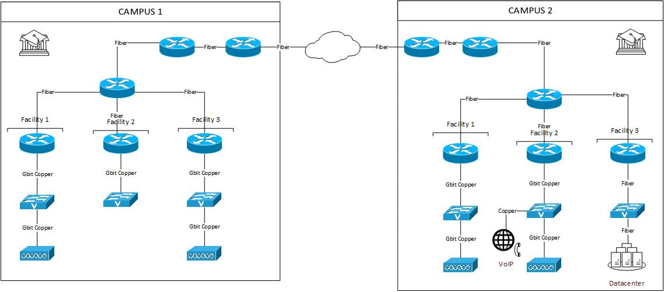

Figure 52- Network Design