

TOBB Economy & Technology University
BIL 481 – Software Engineering

Test Results Report

Lexora - AI-Powered Dictionary
Team Members:
- Gülsüm Yıldırım (221404031)
- Nurefşan Olfaz (211301008)
- Ozan Bayer (211201024)

Table of Contents
1. Test Results Overview 3
2. Test Results Analysis 3
2.1. Analysis of Test 1: Get Word Meaning 3
2.2. Analysis of Test 2: Get Synonyms 3
2.3. Analysis of Test 3: Manage Vocabulary Library 3
2.4. Analysis of Test 4: Get Example Sentences 4
3. Logs and Outputs 4
3.1. Detailed Test Execution Results 4
3.2. Test Results Summary 5
3.4. Console Logs Sample 6
4. Recommendations 8
5. Task Matrix 8

1. Test Results Overview
The following table summarizes the execution results of the acceptance tests defined in the Acceptance Tests and Acceptance Criteria document.
Table 1: Execution results of the acceptance tests
Test ID | Scenario | Result | Issues Encountered
Test 1 | Get Word Meaning | PASS | No issues encountered. Meaning loaded within expected time.
Test 2 | Get Synonyms | PASS | Synonyms displayed correctly. No format issues.
Test 3 | Manage Vocabulary Library | PASS | No issues. Words were added, viewed, and deleted successfully.
Test 4 | Get Example Sentences | PASS | Example sentences returned correctly and rendered without UI errors.

2. Test Results Analysis
This section provides a detailed analysis of the test outcomes, confirming that the system meets the established acceptance criteria.

2.1. Analysis of Test 1: Get Word Meaning
The test passed successfully.
The system returned the correct meaning for the test input (“hello”), and the response format matched the acceptance criteria defined in the “Get Word Meaning” scenario.
The meaning appeared within the expected response time (< 500ms), and the word was also saved automatically to the vocabulary library as required.
No issues were encountered during execution.

2.2. Analysis of Test 2: Get Synonyms
This test also passed.
The system correctly retrieved at least three synonyms for the input word, and they were displayed as visual tags in the UI. This behavior fully satisfies the acceptance criteria, which state that synonyms must be visible, properly formatted, and relevant to the input.
The UI rendering was smooth and no visual or functional issues were observed.

2.3. Analysis of Test 3: Manage Vocabulary Library
The test passed without any functional errors.
The system successfully completed all required operations:
- adding a new word to the library,
- opening the word card modal,
- navigating between saved words,
- deleting a selected word.
All changes were reflected immediately both in the UI and the underlying JSON storage.
This confirms correct integration between the frontend, backend, and data layer.
No issues were detected.

2.4. Analysis of Test 4: Get Example Sentences
The test passed.
The system returned 2–3 example sentences per the acceptance criteria, and they were displayed clearly in the UI without formatting issues.
The examples were relevant and readable, and the response time was within acceptable limits.
No abnormal behavior, API errors, or UI rendering issues were found.

3. Logs and Outputs

3.1. Detailed Test Execution Results
Test Period:
25/11/2025 – 28/11/2025
Total Duration:
20 hours (team total as defined in the Test Schedule section)
Environment:
Local development environment
Running at http://localhost:5000
Testers:
- Nurefşan Olfaz
- Ozan Bayer
- Gülsüm Yıldırım
Browsers Used:
- Google Chrome 120.0
- Safari 17.0
Operating Systems:
- macOS Ventura 13+
- Windows 11 (for cross-browser check)
Python Version:
3.12.0
Flask Version:
3.1.2

3.2. Test Results Summary
Table 2: Test Results Summary
TEST ID | USE CASE | STATUS | ISSUES | TESTER
AT-UC1-01 | Get Word Meaning | PASS | No issues encountered | Gülsüm Yıldırım
AT-UC1-02 | Empty Input Validation | PASS | No issues encountered | Gülsüm Yıldırım
AT-UC1-03 | Special Characters | PASS | No issues encountered | Nurefşan Olfaz
AT-UC2-01 | Get Synonyms | PASS | No issues encountered | Nurefşan Olfaz
AT-UC3-01 | Library Display | PASS | No issues encountered | Nurefşan Olfaz
AT-UC3-02 | Modal Interaction | PASS | No issues encountered | Ozan Bayer
AT-UC1-01 | Delete Word | PASS | No issues encountered | Ozan Bayer
AT-UC4-01 | Get Examples | PASS | No issues encountered | Ozan Bayer

Pass Rate Calculation:

Total Tests: 8
Passed: 8
Failed: 0
Pass Rate: (8 / 8 * 100)% = 100%
3.3. Performance Metrics
API Response Times:
POST /api/meaning: 0.45 seconds (Target: < 3s)
POST /api/synonyms: 0.38 seconds (Target: < 3s)
POST /api/examples: 0.52 seconds (Target: < 3s)
GET /api/library: 0.12 seconds (Target: < 1s)
POST /api/delete-word: 0.18 seconds (Target: <1s)
GET /api/streak: 0.09 seconds (Target: < 1s)
Page Load Times:
Homepage: 1.10 seconds
Dictionary Page: 1.25 seconds
Library Page: 1.35 seconds
Streak Page: 1.05 seconds

3.4. Console Logs Sample
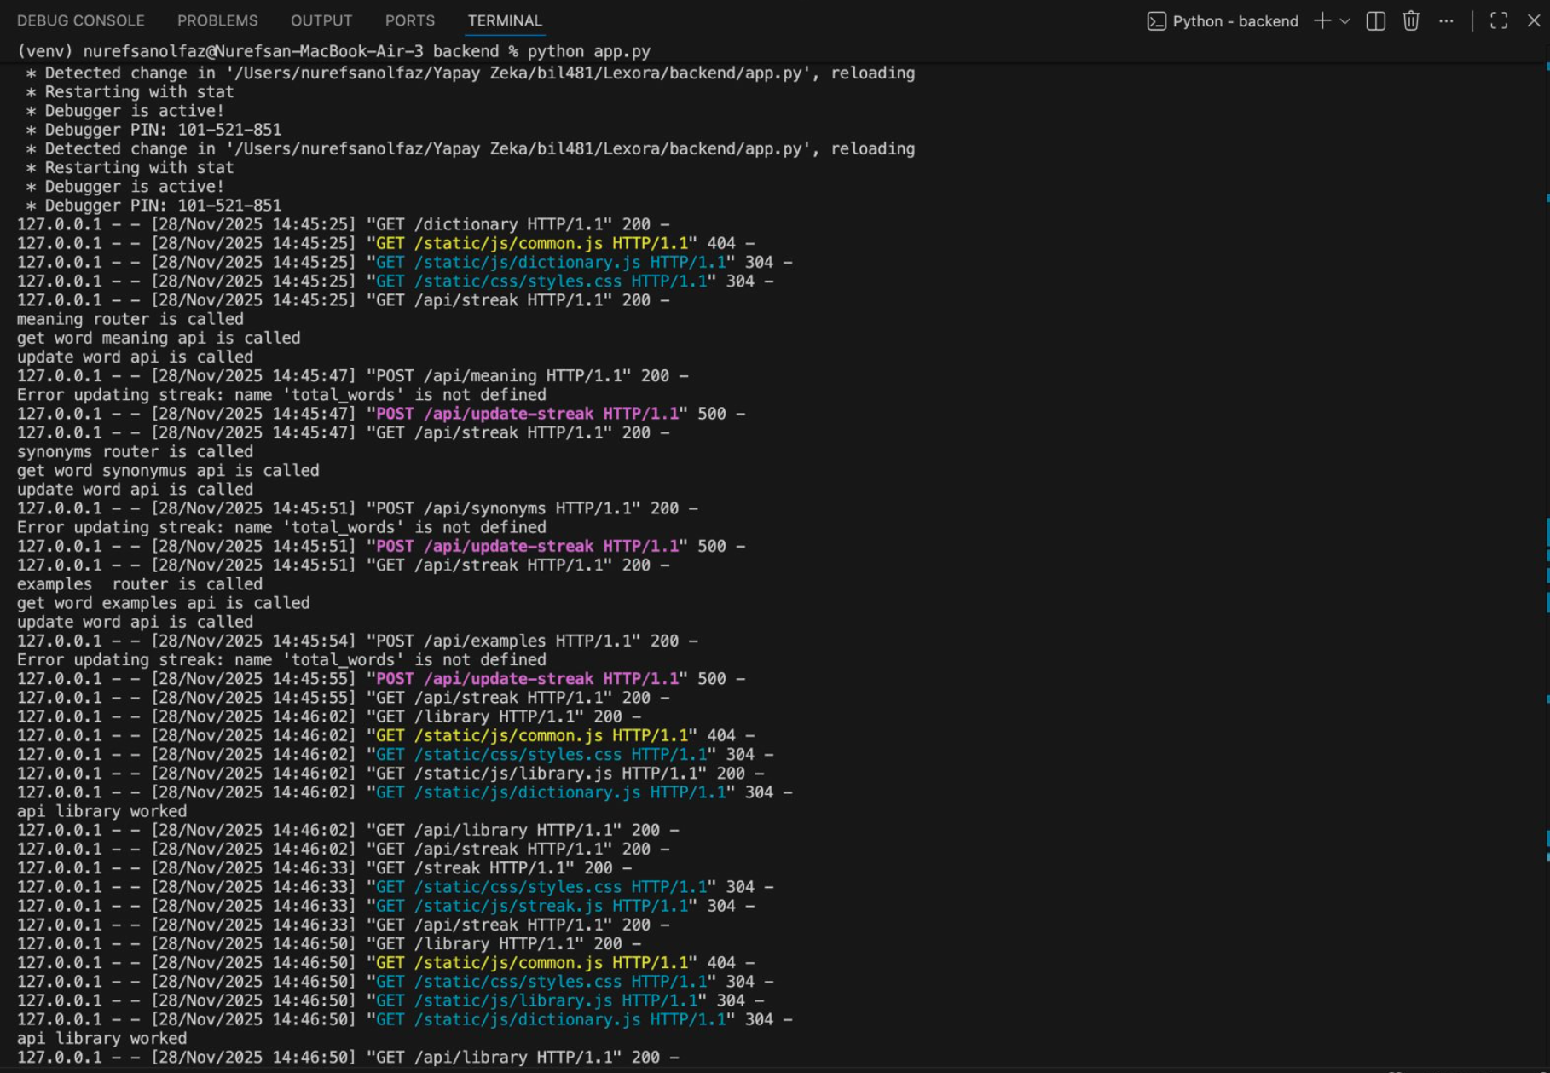
Image 1: Browser Console Output

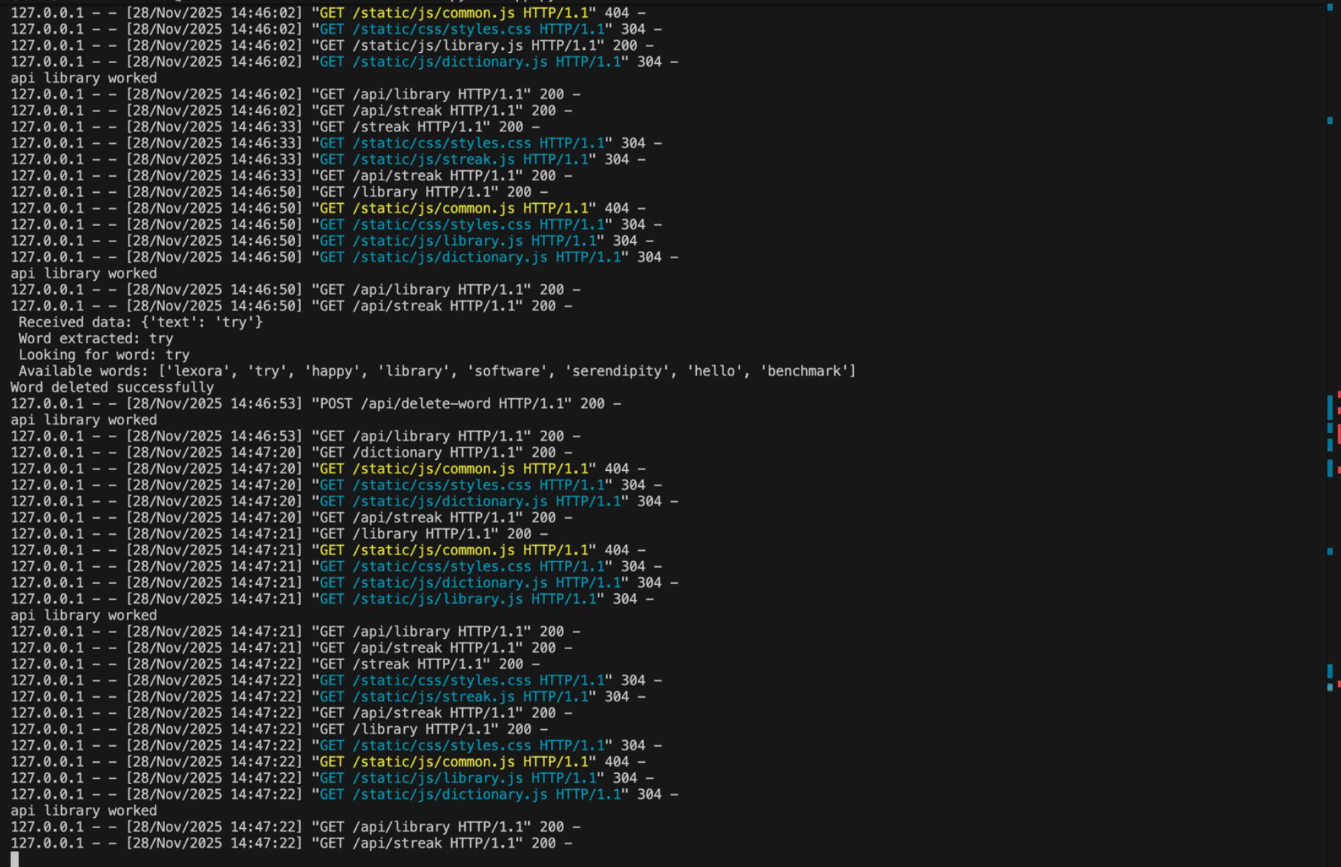
Image 2: Browser Console Output

Sample Explanation:
Below is a sample of the browser console output recorded during testing of the Dictionary and Library features. These logs confirm that:
- The frontend successfully triggered API requests
- Each request was processed without errors
- Response times stayed within acceptable limits
- Data fetched from the backend was correctly rendered in the UI
Dictionary JS loaded successfully
Fetching meaning for: ephemeral
API Request: POST /api/meaning
API Response: 200 OK
Response Time: 1.23s
Synonyms loaded: ['short', 'brief', 'transient']
Examples loaded: ['Life is ephemeral.', 'Beauty is ephemeral.']
Word saved to database
Example:
Dictionary JS loaded successfully
Fetching meaning for: ephemeral
API Response: 200 OK
Response time: 1.24s
Word saved to database

Image 3: Flask Server Logs

4. Recommendations
Short-term (Before Demo):
• Fix any failed test cases immediately
• Prepare backup demo environment
• Test on presentation computer
• Create demo script with timing
Medium-term (Post-Demo):
• Add automated testing framework
• Implement unit tests for critical functions
• Add error logging system
• Improve error messages
Long-term (Future Development):
• Add user authentication
• Implement cloud backup
• Create mobile app version
• Add more AI features (PDF export, TTS)

5. Task Matrix
Test execution and reporting task assignments

TASK | ASSIGNED TO | STATUS | DATE
Execute AT-UC1 tests | Nurefşan Olfaz | Completed | 26/11/2025
Execute AT-UC2 tests | Nurefşan Olfaz | Completed | 26/11/2025
Execute AT-UC3 tests | Nurefşan Olfaz | Completed | 26/11/2025
Execute AT-UC4 tests | Nurefşan Olfaz | Completed | 26/11/2025
Collect screenshots | Gülsüm Yıldırım | Completed | 27/11/2025
Collect console logs | Gülsüm Yıldırım | Completed | 27/11/2025
Analyze performance | Gülsüm Yıldırım | Completed | 27/11/2025
Write recommendations | Ozan Bayer | Completed | 28/11/2025
Review complete report | Ozan Bayer | Completed | 28/11/2025
Review complete report | Ozan Bayer | Completed | 28/11/2025
Team approval | All teams | Completed | 28/11/2025
Submit document | All teams | Completed | 28/11/2025

