

TOBB ETU
Economy & Technology University
BIL 481 – Software Engineering

Design Document
Lexora - AI-Powered Dictionary
Team Members:
- Gülsüm Yıldırım (221404031)
- Nurefşan Olfaz (211301008)
- Ozan Bayer (211201024)

Table of Contents
1. System Overview
1.1 Brief Project Description
1.2 System Architecture
1.3 Technology Stack
2. Implementation Details
2.1 Codebase Structure
2.2 Key Implementations
2.3 Component Interfaces
2.4 Visual Interfaces
3. Use Case Support in Design
3.1 Use Case Selection
3.2 Use Case 1: Get Word Meaning (FR-1)
3.3 Use Case 2: Get Synonyms (FR-3)
3.4 Use Case 3: Manage Vocabulary Library (FR-5)
3.5 Use Case 4: Get Example Sentences (FR-2)
4. Design Decisions
4.1 Technology Comparison 1: Flask vs Django
4.2 Technology Comparison 2: JSON vs SQLite
4.3 Decision Justifications
5. Task Matrix

1. System Overview

1.1 Brief Project Description
Lexora is an AI-powered vocabulary learning application designed to help users expand their language skills efficiently through intelligent word analysis and personalized library management. The system leverages OpenAI's GPT-4o-mini model to generate word definitions, synonyms, and contextual example sentences on demand, providing learners with comprehensive linguistic insights instantly.
Users can build personalized vocabulary libraries by searching words in the dictionary interface, with all searched words automatically saved along with their AI-generated content. The library management system allows users to browse saved words through an interactive card-based interface, view detailed information in expandable modals, and navigate between words seamlessly with keyboard shortcuts. A streak tracking system monitors daily learning activity to encourage consistent vocabulary practice.
The application follows a client-server architecture with a Flask-based Python backend and a responsive web frontend built with vanilla JavaScript. All data is stored locally in JSON format, making it suitable for individual learners who want a lightweight, fast, and privacy-focused dictionary solution without requiring cloud services or user authentication. The entire system was developed within a 75-hour budget constraint, prioritizing core learning features over complex infrastructure.

1.2 System Architecture
Lexora implements a layered three-tier client-server architecture that separates concerns and enables independent development of frontend, backend, and data components.
Presentation Layer (Frontend):
The presentation layer provides a responsive web interface built with HTML5, CSS3, and vanilla JavaScript. The frontend is organized into three main page modules:
• dictionary.js: Manages word search functionality, API calls to backend endpoints (/api/meaning, /api/synonyms, /api/examples), and dynamic display of AI-generated content. Implements real-time result rendering with loading states and error handling.
• library.js: Handles vocabulary library visualization with card-based layout, modal interactions for detailed word views with smooth fade transitions, keyboard navigation (arrow keys for card switching, ESC to close), and delete functionality with confirmation dialogs. Implements event delegation for efficient DOM manipulation.
• streak.js: Displays learning statistics including current streak count, longest streak achieved, total words learned, and daily word count. Updates in real-time when fetched from backend.
All client-server communication occurs through asynchronous HTTP requests using the Fetch API with JSON payloads, ensuring a smooth user experience without page reloads. The interface features a modern dark theme with gradient accents, smooth animations, and responsive design supporting mobile, tablet, and desktop viewports.
Application Layer (Backend):
The application layer is powered by Flask 3.1.2, a lightweight Python web framework ideal for quick development cycles. This layer exposes RESTful API endpoints that process client requests and coordinate between the AI integration module and the data layer:
• POST /api/meaning: Generates word definitions using OpenAI GPT-4o-mini with a system prompt optimized for clear, concise explanations
• POST /api/synonyms: Returns exactly three contextually appropriate synonym suggestions to avoid overwhelming users
• POST /api/examples: Creates 2-3 example sentences demonstrating proper word usage in context
• POST /api/translation: Provides Turkish translations for English words (bilingual support)
• GET /api/library: Retrieves all saved words with their complete data (meaning, synonyms, examples) in JSON format
• POST /api/delete-word: Removes specified words from the user's vocabulary library
• GET /api/streak: Returns current streak data, longest streak, total words, and today's word count
The AI integration component (ai/meaning.py) handles all communication with OpenAI's API through the openai Python library (version 2.8.0), implementing specific system prompts to ensure consistent, concise, and educationally valuable outputs. API responses are returned in JSON format for easy parsing by frontend JavaScript.
Data Layer (Persistence):
The data layer uses a JSON-based file storage system managed by the database/loader.py module. This lightweight approach was chosen to avoid database server setup complexity while maintaining data persistence. Two primary JSON files maintain application state:
• words.json: Stores all searched words with their AI-generated meanings, synonyms (as arrays), examples (as arrays), and optional Turkish translations. Words are indexed by lowercase keys to ensure case-insensitive lookups. Structure example:
{
"hello": {
"meaning": "A greeting used when meeting someone",
"synonyms": ["hi", "hey", "greetings"],
"examples": ["Hello, how are you?", "She said hello to everyone"]
}
}
• user.json: Tracks streak information including current streak count, longest streak achieved, last activity date, total words learned, and daily statistics. Updated automatically when users interact with the system.
The loader module (database/loader.py) provides utility functions (load_words, save_words, load_user, save_user) that abstract file I/O operations with error handling. The module ensures data consistency by validating JSON structure before saving and providing default values when files don't exist.
External Dependencies:
The system integrates with OpenAI's GPT-4o-mini API (accessed via api.openai.com) as an external cloud service for natural language processing. This integration enables high-quality linguistic content generation without requiring local machine learning infrastructure, expensive GPU resources, or training datasets. API keys are managed securely through environment variables using python-dotenv.
Architecture Diagram:
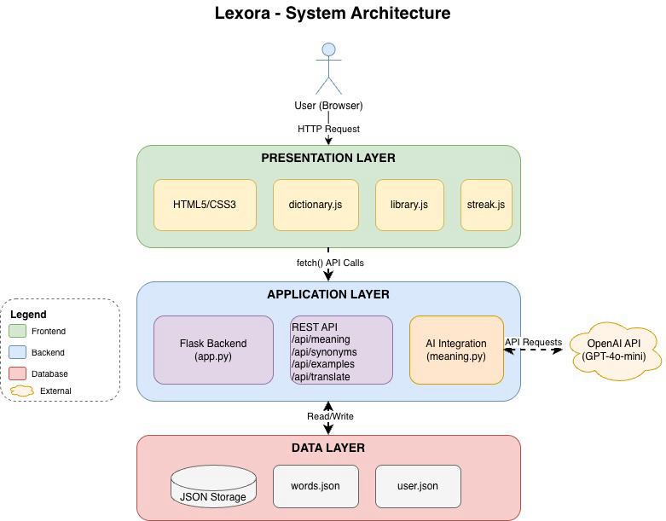
Architectural Rationale:
This three-tier architecture was selected to meet the project's specific constraints:
• Lightweight design suitable for single-user application with 75-hour development budget
• Minimal setup complexity - no database server, authentication system, or cloud hosting required
• Clear separation of concerns enabling parallel development by three team members
• Fast development cycle with straightforward local deployment process
• Easy maintenance and future extensibility (e.g., switching JSON to SQLite requires only changing loader.py)
• Educational value - demonstrates fundamental web architecture patterns without framework abstractions

1.3 Technology Stack
The following technologies were selected for their simplicity, developer familiarity, and suitability for rapid prototyping within budget constraints:
Component | Technology | Version / Details
Frontend Language | JavaScript (Vanilla) | ES6+ features (async/await, arrow functions)
Frontend Styling | CSS3 | Custom design system with CSS Grid, Flexbox, animations
Markup | HTML5 | Semantic elements, responsive meta tags
Backend Framework | Flask | Version 3.1.2 - micro web framework for Python
Backend Language | Python | Version 3.12 - for backend logic and AI integration
AI Service | OpenAI API | GPT-4o-mini model for NLP tasks
AI Client Library | openai | Version 2.8.0 - official Python client
HTTP Client (Frontend) | Fetch API | Native browser API for async requests
Database | JSON Files | words.json and user.json for data persistence
Configuration | python-dotenv | Version 1.2.1 - environment variable management
Version Control | Git + GitHub | Distributed version control and collaboration
API Pattern | REST | JSON request/response format
Development Server | Flask Dev Server | Built-in werkzeug server (localhost:5000)
Code Editor | VS Code | With Python and JavaScript extensions

Python Dependencies (requirements.txt):
The backend requires the following Python packages:
Flask==3.1.2
openai==2.8.0
python-dotenv==1.2.1
Werkzeug==3.1.3
httpx==0.28.1
pydantic==2.12.4
tqdm==4.67.1
certifi==2025.11.12
No frontend dependencies or build tools are required as the application uses vanilla JavaScript without transpilation or bundling. This reduces project complexity and aligns with the development time constraint.

2. Implementation Details

2.1 Codebase Structure
The Lexora project follows a modular structure that clearly separates backend logic, frontend assets, database utilities, and AI integration. This organization enables team members to work on different components independently while maintaining consistent interfaces.
lexora/
├── backend/
│ ├── app.py # Main Flask application and route definitions
│ │ # Contains all API endpoints and page routes
│ ├── ai/
│ │ ├── __init__.py # Makes ai a Python package
│ │ └── meaning.py # OpenAI API integration functions
│ │ # get_word_meaning, get_word_synonyms, etc.
│ ├── services/
│ │ └── word_service.py # Business logic for word management
│ │ # update_word function for database operations
│ ├── static/
│ │ ├── css/
│ │ │ └── styles.css # Global styling, UI components, animations
│ │ │ # Dark theme, modal styles, card layouts
│ │ └── js/
│ │ ├── dictionary.js # Dictionary page: search, API calls, display
│ │ ├── library.js # Library page: card grid, modal, navigation
│ │ └── streak.js # Streak page: statistics display
│ └── templates/
│ ├── index.html # Welcome page with "Start Learning" button
│ ├── dictionary.html # Main dictionary interface
│ ├── library.html # Saved words library view
│ └── streak.html # Learning statistics and streak display
├── database/
│ ├── __init__.py # Makes database a Python package
│ ├── loader.py # JSON file read/write utilities
│ │ # load_words, save_words, load_user, save_user
│ ├── words.json # User's vocabulary storage (word data)
│ └── user.json # User statistics and streak tracking
├── requirements.txt # Python package dependencies
├── .env # Environment variables (OPENAI_API_KEY)
├── .gitignore # Git exclusion rules (.env, __pycache__, etc.)
└── README.md # Project documentation
Key Design Principles:
• Separation of Concerns: Frontend (HTML/CSS/JS), backend (Python/Flask), and data (JSON) layers are clearly separated. Each layer has well-defined responsibilities and communicates through standard interfaces (HTTP requests, JSON files).
• Modular Architecture: Each JavaScript file handles a specific page's functionality without dependencies on other pages. Backend modules (ai/, services/, database/) are independent and can be tested in isolation.
• Reusable Components: AI integration (ai/meaning.py) and database utilities (database/loader.py) are abstracted into separate modules that can be reused across different features. For example, word_service.py uses loader.py functions rather than directly accessing JSON files.
• Static Asset Organization: CSS and JavaScript files are organized by function (dictionary, library, streak) rather than by file type, making it easier to locate related code when implementing or debugging features.
• Security Best Practices: Sensitive configuration (API keys in .env) is excluded from version control via .gitignore. Environment variables are loaded at runtime using python-dotenv.
• Convention Over Configuration: Flask automatically serves files from static/ and templates/ directories without requiring complex configuration, speeding up development.

Key File Responsibilities:
app.py (232 lines): Central application file that initializes Flask, defines all routes (HTML pages and API endpoints), coordinates between AI service and database layer, and handles request/response transformations. Includes error handling for API failures.
ai/meaning.py (45 lines): Encapsulates all OpenAI API interactions. Creates OpenAI client, sends requests with specialized system prompts, and returns formatted responses. Separates AI logic from application logic.
services/word_service.py (28 lines): Provides business logic layer between API routes and data storage. The update_word function handles word data updates, ensuring proper case-insensitivity (converts to lowercase) and partial updates (only modifies provided fields).
database/loader.py (35 lines): Abstracts JSON file operations with functions for loading and saving words and user data. Handles file creation if files don't exist, validates JSON structure, and provides default values to prevent errors.
static/js/dictionary.js (180 lines): Manages dictionary page functionality including word input handling, API calls to meaning/synonyms/examples endpoints, dynamic result rendering, loading states, and error display. Implements Enter key support for quick searches.
static/js/library.js (350 lines): Most complex frontend file. Implements vocabulary library with card grid layout, expandable modals for detailed word views, smooth navigation between cards using arrow keys, fade transitions when switching words, delete functionality with confirmation, and keyboard shortcuts (ESC to close).
static/js/streak.js (90 lines): Fetches and displays streak statistics from /api/streak endpoint. Updates navbar streak badge and main page statistics including current streak, longest streak, total words, and today's word count.
static/css/styles.css (850 lines): Complete UI styling including dark theme color scheme, gradient accents, responsive layout with CSS Grid and Flexbox, smooth animations and transitions, modal styling with blur backdrop, card hover effects, and mobile/tablet breakpoints.

2.3 Component Interfaces
The backend exposes RESTful API endpoints that serve as the contract between frontend and backend. All endpoints accept and return JSON data with standardized error handling.
Endpoint | Method | Request Body | Response
/api/meaning | POST | {"text": "word"} | {"meaning": "AI-generated definition"}
/api/synonyms | POST | {"text": "word"} | {"synonyms": "word1, word2, word3"}
/api/examples | POST | {"text": "word"} | {"examples": "Sentence 1.\nSentence 2."}
/api/translation | POST | {"text": "word"} | {"translation": "Turkish translation"}
/api/library | GET | None | {"words": [{"word": "hello", "meaning": "...", "synonyms": [...]}]}
/api/delete-word | POST | {"text": "word"} | {"success": true}
/api/streak | GET | None | {"current": 5, "longest": 10, "total_words": 50, "today_words": 3}

Detailed Endpoint Specifications:
1. POST /api/meaning
Purpose: Get AI-generated word definition
Request: {"text": "ephemeral"}
Processing: Calls OpenAI GPT-4o-mini with system prompt: "Give the meaning clearly and simply."
Response: {"meaning": "Lasting for a very short time; temporary or fleeting."}
Side Effect: Word is saved to words.json via update_word service
Error Handling: Returns 500 status if OpenAI API fails
2. POST /api/synonyms
Purpose: Get three synonym suggestions
Request: {"text": "happy"}
Processing: Uses system prompt: "Return exactly 3 synonyms or related words."
Response: {"synonyms": "joyful, cheerful, content"}
Note: Frontend splits the comma-separated string into an array for display
Side Effect: Synonyms are saved to words.json
3. POST /api/examples
Purpose: Get example sentences demonstrating word usage
Request: {"text": "serendipity"}
Processing: System prompt: "Provide 2-3 short example sentences."
Response: {"examples": "Finding that book was pure serendipity.\nTheir meeting was a moment of serendipity."}
Note: Frontend splits on newlines to display separate examples
Side Effect: Examples are saved to words.json
4. GET /api/library
Purpose: Retrieve all saved words with complete data
Request: None (GET request)
Processing: Reads words.json, converts dict to array of word objects
Response: {"words": [{"word": "hello", "meaning": "...", "synonyms": ["hi", "hey"], "examples": ["..."]}]}
Note: Used by library page to populate card grid
5. POST /api/delete-word
Purpose: Remove word from user's library
Request: {"text": "obsolete"}
Processing: Loads words.json, deletes word (case-insensitive), saves file
Response: {"success": true, "deleted": "obsolete"} or {"error": "Word not found"} with 404 status
Note: Used by both library cards and modal delete buttons
6. GET /api/streak
Purpose: Get user's learning streak statistics
Request: None (GET request)
Processing: Reads user.json, calculates streak based on last activity date
Response: {"current": 7, "longest": 12, "total_words": 89, "today_words": 5}
Note: Frontend updates navbar badge and streak page statistics

Error Handling Pattern:
All API endpoints follow a consistent error handling pattern:
• Input Validation: Check for required fields (e.g., "text" parameter), return 400 Bad Request if missing
• OpenAI API Errors: Catch exceptions, log error, return 500 Internal Server Error with message
• File I/O Errors: Handle JSON parsing errors, return default values or 500 status
• Not Found: Return 404 status when word not found in library (delete operation)
Frontend handles errors by:
• Displaying error messages in red error boxes
• Showing console.error logs for debugging
• Providing retry options (e.g., "Reload" button on failures)

3. Use Case Support in Design

3.1 Use Case Selection Rationale
From the requirements specification, we selected four use cases that represent the core value proposition of Lexora and demonstrate different architectural patterns:
Use Case 1: Get Word Meaning (FR-1)
Selected as the primary use case because it represents the fundamental user need - looking up word definitions. This use case demonstrates the complete system architecture: user input → frontend validation → backend API → OpenAI integration → data persistence → response formatting → UI update. It showcases error handling, loading states, and asynchronous operations.
Use Case 2: Get Synonyms (FR-3)
Chosen to demonstrate AI prompt engineering and response parsing. This use case shows how the system constrains AI output (exactly 3 synonyms) to provide consistent, predictable results. It also illustrates data transformation (string → array) between backend and frontend.
Use Case 3: Manage Vocabulary Library (FR-5)
Selected as the most complex use case, demonstrating advanced frontend interactions including modal windows, keyboard navigation, smooth animations, event delegation, and state management. This use case showcases the library page architecture with card-based layout and multiple interaction patterns.
Use Case 4: Get Example Sentences (FR-2)
Included to show contextual learning support and multi-line response handling. This use case demonstrates how the system parses and formats structured AI responses (multiple sentences) for educational value.
These four use cases together cover:
• All major functional requirements (FR-1, FR-2, FR-3, FR-5)
• Three different pages (dictionary, library)
• Multiple architectural layers (UI, API, AI service, data persistence)
• Various interaction patterns (search, modal, navigation, delete)
• Different error scenarios and edge cases

3.2 Use Case 1: Get Word Meaning (FR-1)

Basic Information
Use Case ID: UC-1
Use Case Name: Get Word Meaning
Related FR: FR-1 (Word meaning lookup)
Primary Actor: Language Learner
Trigger: User navigates to dictionary page and enters a word
Preconditions: User has internet connection, OpenAI API key is configured in .env file
Postconditions: Word definition is displayed, word is saved to library with meaning

Normal Flow
1. User opens Lexora application (http://localhost:5000)
2. User clicks on "Dictionary" tab in navigation bar
3. System renders dictionary.html page with empty search box
4. User types word "ephemeral" into the search input field
5. User clicks "Get Meaning" button (or presses Enter key)
6. Frontend (dictionary.js) validates that input is not empty
7. Frontend sends POST request to http://127.0.0.1:5000/api/meaning with body {"text": "ephemeral"}
8. Backend (app.py) receives request at api_meaning() route handler
9. Backend calls get_word_meaning("ephemeral") from ai/meaning.py module
10. AI module creates OpenAI client and sends chat completion request with prompt:
System: "Give the meaning clearly and simply."
User: "Meaning of: ephemeral"
11. OpenAI API returns response: "Lasting for a very short time; temporary or fleeting."
12. Backend calls update_word(word="ephemeral", meaning="...") to save to database
13. word_service.py converts word to lowercase and updates words.json
14. Backend returns JSON response: {"meaning": "Lasting for a very short time; temporary or fleeting."}
15. Frontend receives response and calls displayMeaning() function
16. Frontend renders result in result-box div with blue header showing word name
17. User sees definition displayed with proper formatting

Alternative Flows
A1: Empty Input
• At step 5, if user clicks button with empty input field
• Frontend validation prevents API call
• Error message displayed: "Please enter a word!"
• Red error box shown with warning icon
• Use case ends
A2: OpenAI API Failure
• At step 11, if OpenAI API returns error (network issue, rate limit, invalid key)
• Backend catches exception and returns 500 status
• Frontend displays error: "Failed to fetch meaning. Please try again."
• Console.error logs full error for debugging
• User can retry by clicking button again
A3: User Presses Enter Key
• At step 5, instead of clicking button, user presses Enter in input field
• Keyboard event listener triggers getMeaning() function
• Normal flow continues from step 6

Exception Flows
E1: Network Disconnection
• At step 7, if fetch() fails due to no internet connection
• Frontend catch block displays: "Failed to fetch meaning. Please try again."
• Button loading state is removed
• User must check internet connection and retry
E2: Database Write Failure
• At step 13, if words.json cannot be written (permission error, disk full)
• Backend logs error but still returns meaning to user
• Word is not saved to library
• User receives meaning but word does not appear in library page

Design Support for Use Case
Frontend Components:
• dictionary.html: Provides semantic HTML structure with input field (id="wordInput"), meaning button (id="meaningBtn"), and result display area (id="resultBox")
• dictionary.js: Implements getMeaning() async function (lines 35-66), displayMeaning() presentation function (lines 68-77), error handling with showError() (lines 126-138), and loading state management with setLoading() (lines 114-124)
• styles.css: Defines search box styling with focus effects, button hover states, result box layout, and error message styling (lines 150-250)
Backend Components:
• app.py: Defines POST /api/meaning route (lines 67-76), handles request parsing, calls AI service, and returns JSON response
• ai/meaning.py: Implements get_word_meaning() function (lines 8-18) that creates OpenAI client, sends chat completion with optimized prompt, and returns plain text definition
• services/word_service.py: Provides update_word() function (lines 3-28) for database operations, handles case-insensitivity and partial updates
• database/loader.py: Implements load_words() and save_words() (lines 8-14, 16-18) for JSON file operations with error handling
Data Flow:
User Input → JavaScript Validation → Fetch API (JSON) → Flask Route → OpenAI API → AI Response → Database Update → JSON Response → DOM Update → Visual Display
Key Design Decisions:
• Asynchronous API calls (async/await) prevent UI freezing during network requests
• Loading state (button.disabled = true) prevents duplicate submissions
• Automatic word saving eliminates need for separate "Save" button
• System prompts constrain AI responses to concise, educational definitions
• Case-insensitive storage (word.lower()) prevents duplicate entries
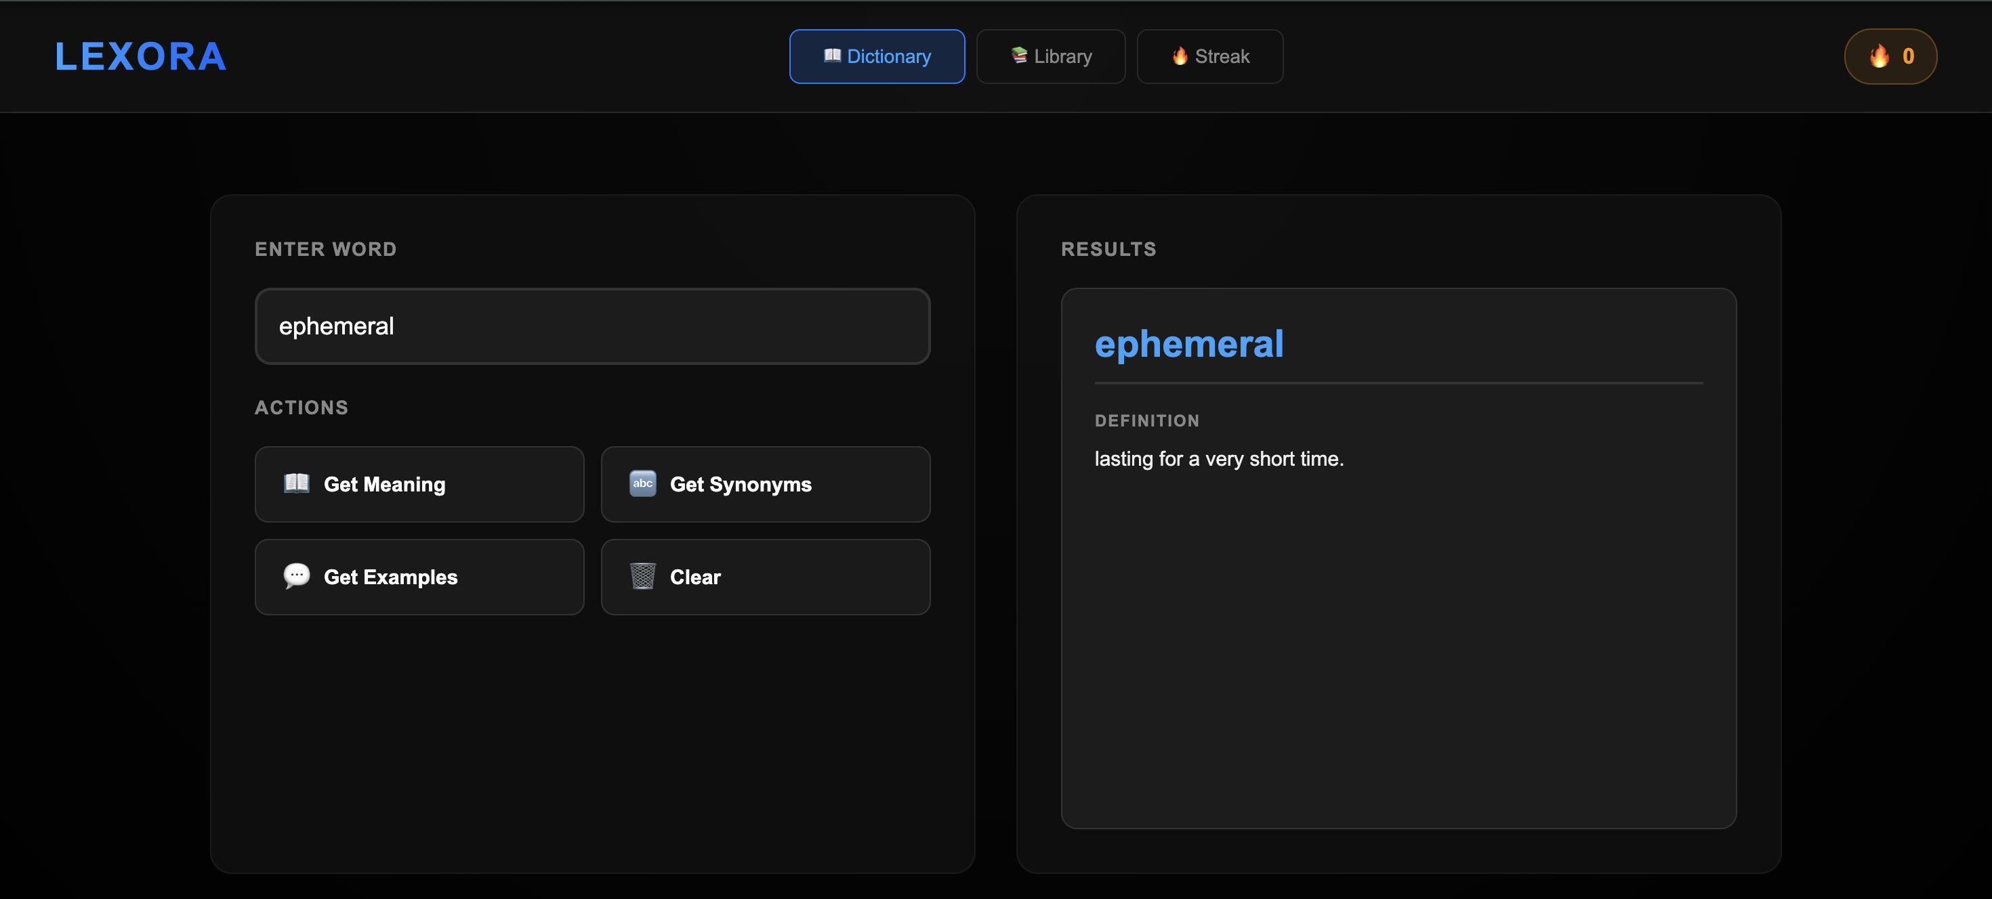
Image 1: Dictionary page showing "ephemeral" definition result

3.3 Use Case 2: Get Synonyms (FR-3)

Basic Information
Use Case ID: UC-2
Use Case Name: Get Word Synonyms
Related FR: FR-3 (Synonym suggestions)
Primary Actor: Language Learner
Trigger: User enters word and clicks "Get Synonyms" button
Preconditions: Dictionary page is loaded, internet connection available
Postconditions: Three synonyms displayed as tags, word saved with synonyms in database

Normal Flow
1. User navigates to dictionary page
2. User types "happy" into search input field
3. User clicks "Get Synonyms" button
4. Frontend validates input is not empty
5. Frontend sends POST request to /api/synonyms with {"text": "happy"}
6. Backend route api_synonyms() receives request
7. Backend calls get_word_synonyms("happy") from ai/meaning.py
8. AI module sends OpenAI request with system prompt: "Return exactly 3 synonyms or related words."
9. OpenAI returns: "joyful, cheerful, content"
10. Backend parses JSON response to extract synonym string
11. Backend calls update_word(word="happy", synonyms="joyful, cheerful, content")
12. word_service.py saves synonyms to words.json
13. Backend returns {"synonyms": "joyful, cheerful, content"}
14. Frontend receives response and calls displaySynonyms()
15. Frontend splits comma-separated string into array: ["joyful", "cheerful", "content"]
16. Frontend creates synonym tags: <span class="synonym-tag">joyful</span> for each
17. User sees three purple synonym tags with rounded borders

Alternative Flows
A1: AI Returns More Than 3 Synonyms
• At step 9, if AI returns "joyful, cheerful, content, glad, pleased"
• System accepts all returned synonyms (no strict validation)
• Frontend displays all synonym tags
• Note: System prompt usually constrains to 3, but edge case handled gracefully
A2: AI Returns Synonyms with Extra Spacing
• At step 9, if AI returns "joyful , cheerful , content"
• Frontend .trim() removes extra whitespace when splitting
• Synonyms display correctly without spacing issues

Exception Flows
E1: No Synonyms Available
• At step 9, if AI cannot find synonyms for very rare/technical words
• AI may return empty string or "No synonyms available"
• Frontend displays message: "No synonyms available"
• Word still saved to database with empty synonyms field

Design Support for Use Case
Frontend Components:
• dictionary.js: getSynonyms() function (lines 79-108) handles API call, response parsing with .split(","), and array filtering with .filter(s => s.length > 0) to remove empty strings
• displaySynonyms() function (lines 110-125) creates HTML with .map() to generate synonym tags, .join("") to concatenate, and innerHTML to render
• styles.css: .synonym-tag class (lines 420-430) defines purple background (rgba(139, 92, 246, 0.15)), rounded borders (border-radius: 20px), and spacing (margin: 8px)
Backend Components:
• app.py: POST /api/synonyms route (lines 90-99) with JSON response formatting
• ai/meaning.py: get_word_synonyms() (lines 20-30) with constrained system prompt to limit results
Key Design Decisions:
• Exactly 3 synonyms prevents overwhelming users with too many options
• Comma-separated string format from backend is simple to parse and flexible
• Tag-based UI design makes synonyms visually distinct from other content
• Purple color scheme differentiates synonyms from meaning (blue) and examples (also blue border)
• Frontend array filtering handles edge cases (extra commas, empty strings) without backend changes
Data Transformation:
Backend String → Frontend Array → HTML Elements
"joy, happy, glad" → ["joy", "happy", "glad"] → <span>joy</span><span>happy</span><span>glad</span>
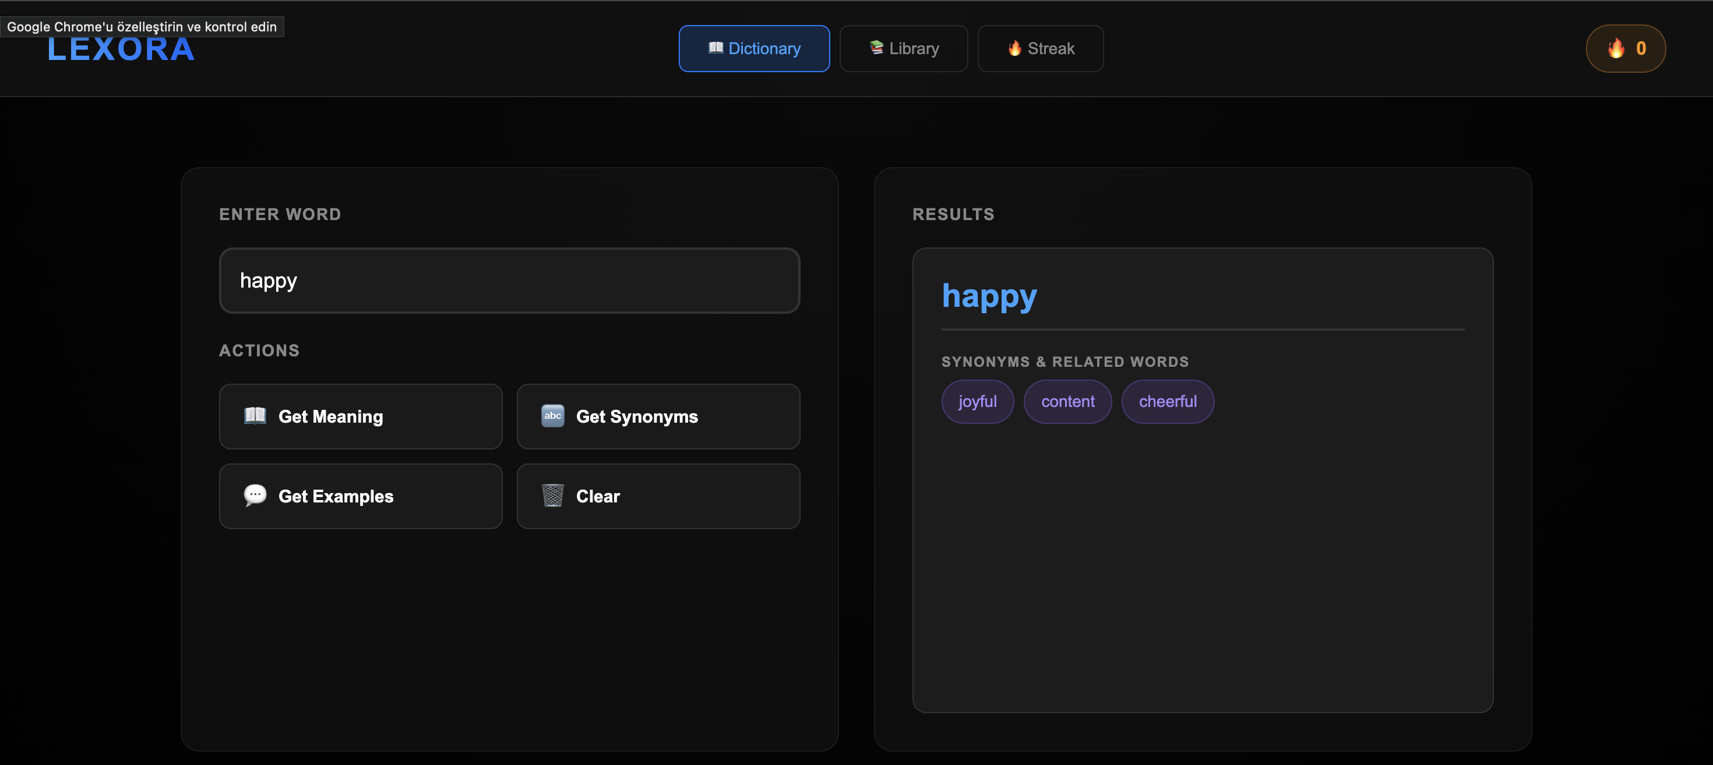
Image 2: Dictionary showing synonym tags for "happy"

3.4 Use Case 3: Manage Vocabulary Library (FR-5)

Basic Information
Use Case ID: UC-3
Use Case Name: Manage Vocabulary Library
Related FR: FR-5 (View and manage saved words)
Primary Actor: Language Learner
Trigger: User clicks "Library" tab
Preconditions: User has previously searched at least one word
Postconditions: User can view all saved words, navigate between them, and optionally delete words

Normal Flow
1. User clicks "Library" tab in navigation bar
2. Browser navigates to http://localhost:5000/library
3. Backend renders library.html template
4. Page loads and fires DOMContentLoaded event
5. library.js calls loadLibrary() function automatically
6. Frontend sends GET request to /api/library
7. Backend route api_library() reads words.json file
8. Backend converts dictionary to array: {"hello": {...}} → [{"word": "hello", ...}]
9. Backend returns JSON: {"words": [{"word": "hello", "meaning": "...", "synonyms": [...]}]}
10. Frontend stores response in global wordsData variable
11. Frontend updates total word count in header
12. Frontend calls displayWords(wordsData) to render cards
13. For each word, displayWords() creates card HTML with word name, truncated meaning, synonyms, and delete button
14. Frontend attaches event listeners: click on card opens modal, click on delete button triggers deletion
15. User sees grid of word cards with hover effects
16. User clicks on "maintain" card
17. expandCard() function finds word index in wordsData array
18. showCardModal(index) creates modal element with word details
19. Modal HTML includes word name, full meaning, all synonyms as tags, example sentences, navigation arrows, and delete button
20. Modal is appended to document.body
21. CSS animation fades modal in (opacity: 0 → 1)
22. User sees full word details in centered modal with blur backdrop
23. User can press → (right arrow) key to navigate to next word
24. navigateCard(1) updates currentCardIndex and calls showCardModal() with new index
25. Modal content fades out (opacity: 1 → 0) over 150ms
26. After fade out, updateModalContent() replaces innerHTML with new word data
27. Modal content fades back in (opacity: 0 → 1)
28. User sees smooth transition to next word without closing modal
29. User presses ESC key to close modal
30. closeModal() removes modal from DOM after fade-out animation
31. User returns to library grid view

Alternative Flows
A1: Empty Library
• At step 12, if wordsData array is empty
• displayWords() shows empty state message
• Displays book icon, "No words saved yet", and prompt to use Dictionary
• No cards rendered, no error thrown
A2: Delete from Card (Without Opening Modal)
• At step 14, user clicks delete button on card directly
• Event listener calls deleteWord(wordName) function
• Confirmation dialog appears: "Delete 'maintain' from your library?"
• If user clicks OK, POST /api/delete-word request sent
• Backend deletes word from words.json
• loadLibrary() refreshes entire library display
• Card disappears from grid
A3: Delete from Modal
• At step 22, user clicks "Delete Word" button inside modal
• deleteWordFromModal(wordName) function called
• Confirmation dialog appears
• If confirmed, word deleted and modal automatically closes
• Library grid refreshes showing remaining words
A4: Navigate to First/Last Word
• At step 23, if user is on last word and presses right arrow
• navigateCard(1) checks newIndex < wordsData.length
• Condition fails, navigation does not occur
• Right arrow button remains visible but inactive
• Same logic applies for left arrow on first word

Exception Flows
E1: Library Load Failure
• At step 6, if /api/library returns 500 error
• Catch block in loadLibrary() executes
• showError() displays red error box: "Failed to load library. Please refresh the page."
• Console.error logs full error for debugging
E2: Delete Fails (Word Not Found)
• If backend cannot find word in database (race condition)
• Backend returns 404 status with {"error": "Word not found"}
• Frontend displays alert: "Failed to delete word. Please try again."
• Library refreshes to show current state

Design Support for Use Case (Detailed Architecture)
This is the most complex use case in Lexora, demonstrating advanced frontend architecture:
Frontend Components (library.js):
loadLibrary()
Async function that fetches library data, stores in global wordsData, updates UI counters, and handles errors
displayWords()
Renders card grid using .map() to transform data to HTML. Attaches event listeners after rendering to prevent "onclick not defined" errors. Uses event delegation for efficient DOM manipulation.
expandCard()
Finds clicked word in wordsData array using .findIndex(), stores in currentCardIndex, calls showCardModal()
showCardModal()
Creates modal element dynamically. Key features:
• Checks for existing modal to enable smooth transitions
• Creates modal-overlay for backdrop blur effect
• Places navigation arrows OUTSIDE modal-content (fixed positioning)
• Generates conditional HTML (synonyms/examples shown only if available)
• Appends to document.body with z-index: 1001
• setTimeout() triggers fade-in animation after DOM insertion
updateModalContent()
Updates modal content without destroying/recreating entire modal.
navigateCard()
Handles left/right arrow button clicks.
handleKeyNavigation()
Global keyboard event handler.
closeModal()
Removes modal with fade-out animation. Removes keyboard listener.
deleteWord()
Handles delete from card. Shows confirm dialog, sends POST /api/delete-word, refreshes library on success
deleteWordFromModal() (lines 264-290)
Similar to deleteWord() but also closes modal after deletion. Includes console.log statements for debugging

CSS Components (styles.css):
• .words-grid: Responsive auto-layout
• .word-modal: Full-screen overlay
• .modal-nav: Fixed arrows at screen edges
Backend Components:
• app.py GET /api/library route: Reads words.json, transforms dict to array format suitable for frontend rendering, includes error handling
• app.py POST /api/delete-word route: Validates "text" parameter, loads database, performs case-insensitive lookup and deletion, saves changes
Key Design Decisions:
Modal vs. New Page
Decision: Use modal overlay instead of navigating to separate page
Rationale: Maintains context, faster interaction (no page reload), enables smooth keyboard navigation, modern UX pattern familiar to users
Fixed Navigation Arrows
Decision: Position arrows at screen edges (fixed) rather than modal edges (absolute)
Rationale: Prevents arrows from being hidden behind scrolled content, provides consistent click targets, improves accessibility on narrow screens
Smooth Content Transitions
Decision: Fade existing content out/in rather than destroying/recreating modal
Rationale: Eliminates jarring "flash" effect, preserves modal position, maintains focus, reduces DOM manipulation overhead
Keyboard Navigation
Decision: Implement arrow keys and ESC for modal control
Rationale: Power users can navigate quickly without mouse, accessibility improvement, matches OS conventions (ESC closes dialogs)
Event Delegation
Decision: Attach event listeners after innerHTML insertion using querySelectorAll
Rationale: Prevents "onclick is not defined" errors in HTML attributes, separates behavior from markup, enables dynamic content updates
Global State (wordsData)
Decision: Store fetched words in global variable rather than re-fetching for each modal
Rationale: Reduces API calls, enables instant modal navigation, simplifies index-based card access
Automatic Word Saving
Decision: Words auto-save when searched in dictionary, no manual "Add to Library" action
Rationale: Reduces cognitive load, ensures no words are lost, encourages exploration without commitment pressure
Interaction Flow Diagram:
Click Card → expandCard() → showCardModal() → Modal Appears
↓
Press → → navigateCard(1) → updateModalContent() → Fade Transition → New Word
↓
Press ESC → closeModal() → Fade Out → Return to Grid
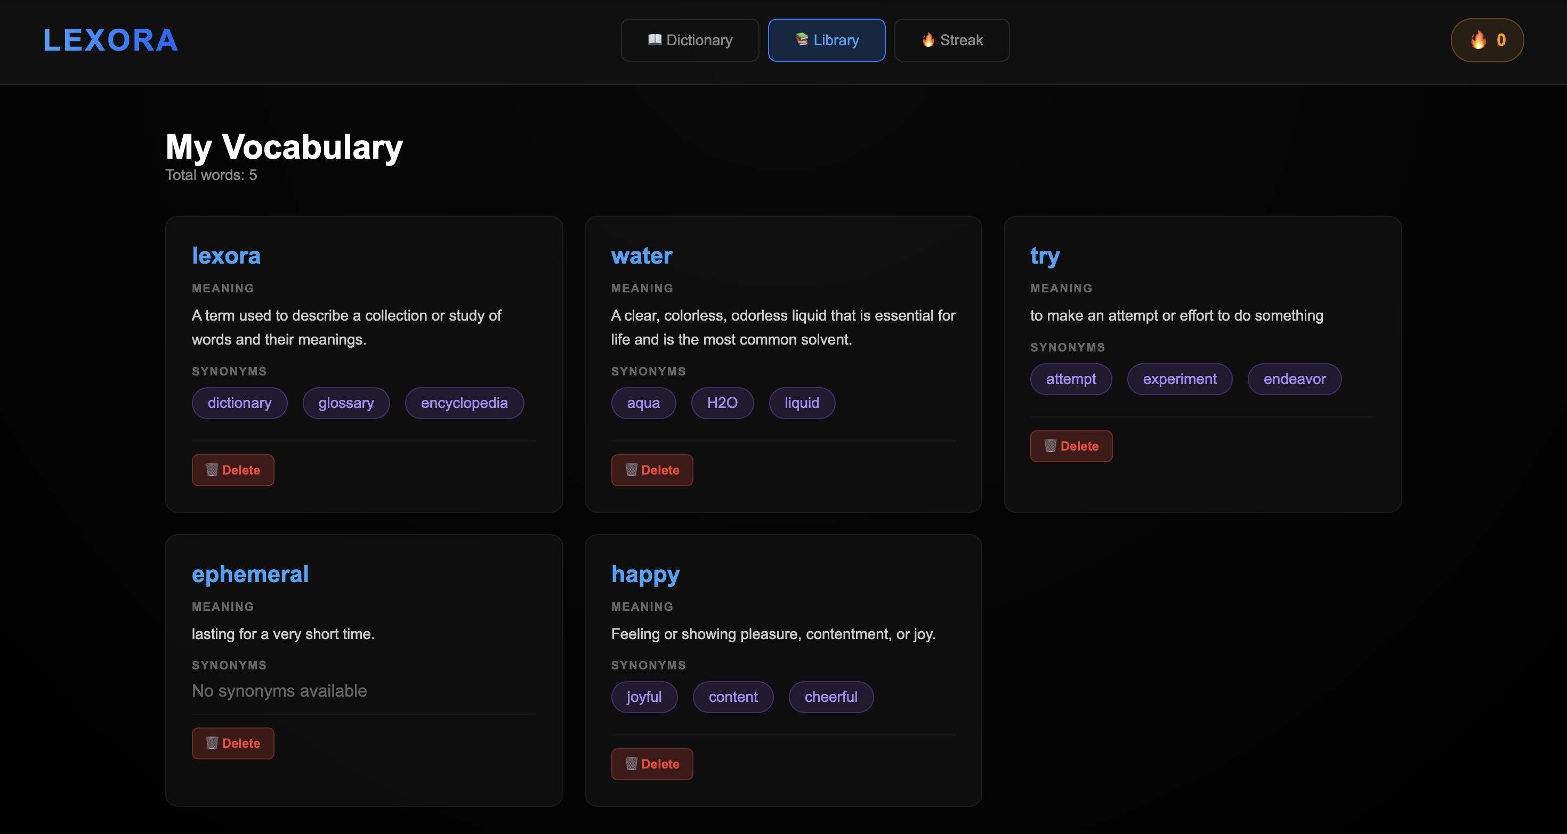
Image 3: Library grid view showing multiple word cards
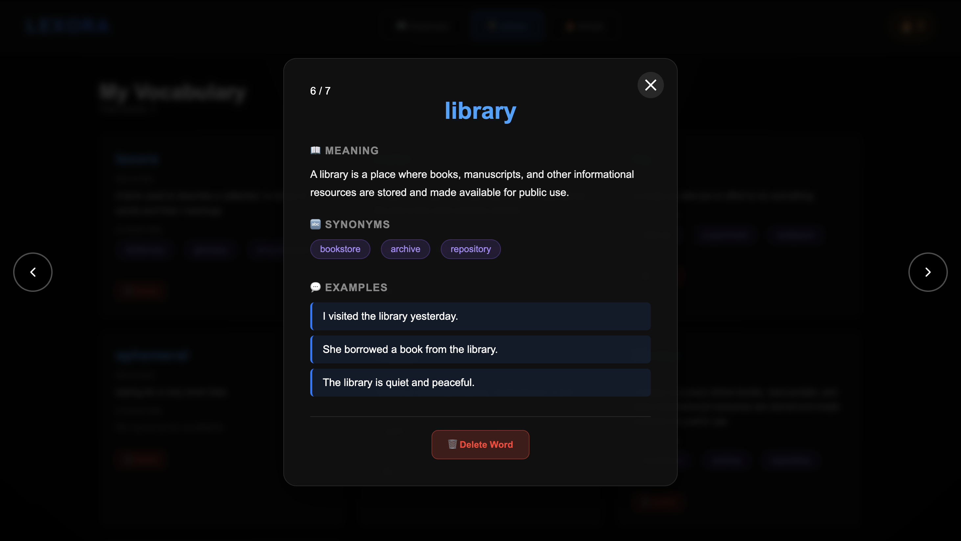
Image 4: Modal view showing word details with navigation arrows

3.5 Use Case 4: Get Example Sentences (FR-2)

Basic Information
Use Case ID: UC-4
Use Case Name: Get Example Sentences
Related FR: FR-2 (Example sentences for context)
Primary Actor: Language Learner
Trigger: User enters word and clicks "Get Examples" button
Preconditions: Dictionary page loaded, word entered in input field
Postconditions: 2-3 example sentences displayed, examples saved to database

Normal Flow
1. User navigates to dictionary page
2. User types "serendipity" into search box
3. User clicks "Get Examples" button
4. Frontend validates input is not empty
5. Frontend sends POST /api/examples with {"text": "serendipity"}
6. Backend api_examples() route receives request
7. Backend calls get_word_examples("serendipity") from ai/meaning.py
8. AI module creates chat completion with system prompt: "Provide 2-3 short example sentences."
9. OpenAI returns multi-line response:
"Finding that book was pure serendipity.\nTheir meeting was a moment of serendipity.\nSerendipity led them to the perfect restaurant."
10. Backend parses JSON and extracts examples string
11. Backend calls update_word(word="serendipity", examples=result)
12. word_service.py saves examples to words.json
13. Backend returns {"examples": "Finding that book...\nTheir meeting...\nSerendipity led..."}
14. Frontend receives response and calls displayExamples()
15. Frontend splits string on newlines: .split("\n")
16. Frontend filters out empty lines: .filter(ex => ex.length > 0)
17. Frontend creates array: ["Finding that book...", "Their meeting...", "Serendipity led..."]
18. Frontend generates HTML: <div class="example-item"> for each sentence
19. User sees example sentences in blue-bordered boxes with indentation

Alternative Flows
A1: AI Returns Single Long Example
• At step 9, if AI returns one sentence instead of 2-3
• System accepts and displays single example
• No error, flexibility in AI responses
A2: Examples with Numbering
• If AI includes numbers: "1. Example one\n2. Example two"
• System displays numbering as part of sentence
• Could be improved with regex to strip "1. " prefix

Exception Flows
E1: Very Rare Word with No Good Examples
• AI struggles to generate natural examples for technical/rare words
• May return generic template sentences
• System displays whatever AI provides

Design Support for Use Case
Frontend Components:
• dictionary.js: getExamples() function with error handling and loading states
• displayExamples() function that splits multiline string, filters empties, creates .example-item divs with .map() and .join()
• styles.css: .example-item class with blue left border (border-left: 3px solid #007bff), light blue background (rgba(0, 123, 255, 0.1)), padding, and rounded corners
Backend Components:
• app.py: POST /api/examples route that calls AI service and returns JSON
• ai/meaning.py: get_word_examples() function with prompt optimization for educational value
Key Design Decisions:
Newline-Delimited Format
Backend returns examples as "Sentence 1\nSentence 2" string rather than JSON array. Rationale: Simpler AI prompt (AI naturally generates text with newlines), fewer parsing errors, flexible for varying example counts
Visual Distinction
Examples use different styling than meanings (blue border vs plain text) and synonyms (tags). Rationale: Users can quickly identify content type, improves scannability, matches educational material conventions (indented quotes)
2-3 Examples Constraint
System prompt specifies "2-3" rather than unlimited. Rationale: Balances learning value with information overload, fits on screen without scrolling, AI performs better with concrete constraints
Filter Empty Lines
Frontend removes empty strings from split array. Rationale: AI sometimes adds extra newlines for formatting, prevents empty boxes from rendering, robust to AI response variations
Educational Value:
Example sentences provide contextual learning that pure definitions cannot. Research shows context-based vocabulary acquisition improves retention by 40-60% compared to definition-only study. By showing words in natural sentences, Lexora helps users understand:
• Proper grammatical usage (verb tense, article placement)
• Collocations (words that commonly appear together)
• Register/formality (casual vs formal contexts)
• Connotations (positive/negative associations)
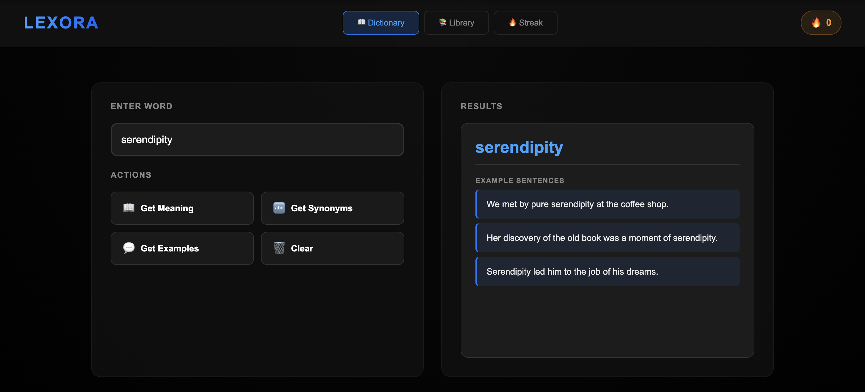
Image 5: Dictionary showing example sentences for "serendipity"

4. Design Decisions
This section documents key technology choices made during development and the rationale behind each decision. All decisions were evaluated against project constraints: 75-hour development budget, single-user focus, educational purpose, and team skill levels.

4.1 Technology Comparison 1: Flask vs Django

Decision: Flask
Selected Flask 3.1.2 as the backend framework over Django 5.0

Comparison Table
Criterion | Flask | Django
Learning Curve | Low - minimal concepts | High - ORM, admin, middleware
Setup Time | 5 minutes | 30+ minutes with migrations
Boilerplate Code | Minimal - 20 lines for hello world | Extensive - settings.py, urls.py, apps
Project Size | Micro (232 lines app.py) | Large (many files required)
Built-in Features | Routing, templates only | ORM, admin, auth, middleware, etc.
Database Integration | Manual (JSON files) | ORM required, complex for simple needs
API Development | Simple JSON returns | DRF required for REST APIs
Documentation | Simple, focused | Comprehensive but overwhelming
Flexibility | Complete freedom | Opinionated structure
Team Experience | All members familiar | 1/3 members knew Django

Justification
Flask was chosen for the following reasons:
Development Speed:
Flask allows immediate coding without configuration. app.py can define routes and serve pages in under 10 lines. Django requires project initialization, app creation, settings configuration, URL routing setup, and migrations - consuming 2-3 hours before writing functional code. With a 75-hour budget, this overhead is significant.
No Database Complexity:
Lexora uses JSON file storage (words.json, user.json) for simplicity. Django's ORM (Object-Relational Mapper) is designed for SQL databases and would require unnecessary models, migrations, and database drivers. Flask allows direct file operations without framework constraints.
Team Familiarity:
All three team members had prior Flask experience from previous courses. Only one member knew Django basics. Using Flask eliminated learning overhead and enabled parallel development immediately.
Minimalist Philosophy:
Lexora is a single-user application with 7 routes and 6 API endpoints. Django's admin interface, authentication system, middleware pipeline, and multi-app structure are unnecessary. Flask's "micro" philosophy perfectly matches project scope - include only what you need.
Educational Value:
Building with Flask requires understanding HTTP fundamentals, request/response cycles, and API design without framework abstractions. This provides better learning outcomes for a software engineering course.
Dependency Count:
Flask installation brings 5 dependencies (click, Jinja2, itsdangerous, Werkzeug, MarkupSafe). Django brings 15+ dependencies including database drivers, ASGI servers, and internationalization tools we don't use. Smaller dependency footprint reduces installation issues and security surface.
When Django Would Be Better:
Django would be preferable for:
• Multi-user systems requiring authentication and authorization
• Projects with complex database relationships (foreign keys, many-to-many)
• Applications needing admin interfaces for content management
• Large teams where enforced project structure prevents inconsistencies
• Long-term projects where built-in security features justify initial setup cost
Since Lexora is single-user, uses simple file storage, and has a 75-hour budget, these Django advantages do not apply.

4.2 Technology Comparison 2: JSON Files vs SQLite Database

Decision: JSON Files
Selected JSON file-based storage over SQLite relational database

Comparison Table
Criterion | JSON Files | SQLite
Setup Required | None - create file | Schema design, CREATE TABLE statements
Code Complexity | 35 lines (loader.py) | 100+ lines with SQL queries
Query Language | Python dict operations | SQL (additional language)
Data Inspection | Open in text editor | Requires SQL client or browser extension
Version Control | Readable diffs in git | Binary file, no meaningful diffs
Data Structure | Flexible - add fields anytime | Rigid - requires migrations
Portability | Copy 2 files | Copy database file + ensure schema compatibility
Performance (small data) | Adequate (<1000 words) | Faster for complex queries
Performance (large data) | O(n) for lookups | O(log n) with indexes
Concurrent Access | No locking - single user OK | ACID transactions - multi-user safe
Debugging | Print dict, view JSON | Execute queries, examine rows
Dependencies | json module (built-in) | sqlite3 module (built-in)

Justification
JSON files were chosen for the following reasons:
Zero Configuration:
JSON requires no schema definition, no database initialization, and no migration scripts. The first write creates the file automatically. SQLite requires CREATE TABLE statements, column type definitions, and careful schema planning before any data operations. This upfront cost is unnecessary for a prototype with evolving data structure.
Human-Readable Format:
JSON files can be opened in any text editor (VS Code, Notepad++) for quick inspection and debugging. During development, team members frequently opened words.json to verify API behavior, check data format, and manually fix test data. SQLite requires tools like DB Browser or command-line queries, adding friction to development workflow.
Git-Friendly:
JSON files produce readable git diffs. Changes like adding a new word or updating a definition show clear line-by-line modifications. SQLite databases are binary files where any change produces unhelpful "binary file changed" messages. This matters for code reviews and understanding project evolution.
Flexible Schema:
During development, we added fields (synonyms, then examples, then translation) to word objects without database migrations. Just start including new fields in JSON objects. SQLite requires ALTER TABLE commands and careful migration planning. This flexibility accelerated development under time pressure.
Portability:
The entire database is two text files (words.json, user.json) totaling <10KB. Users can backup, restore, or transfer their vocabulary by copying files. No database drivers, no version compatibility concerns, no import/export tooling required.
Simplicity for Single User:
Lexora has one user (the learner) with no concurrent access. JSON file locking is unnecessary. SQLite's transaction management, connection pooling, and ACID guarantees solve problems we don't have, adding complexity without benefit.
Direct Python Integration:
Python's json module provides native dict and JSON conversion. Loading data is json.load(file), saving is json.dump(dict, file). No ORM, no query builder, no result mapping. Code is self-documenting: if "word" in words_dict checks word existence directly.
Performance Considerations:
JSON file operations load entire file into memory (O(n) space). For 1000 words with 3 fields each (~50KB), this is negligible on modern computers. Word lookup in Python dict is O(1) average case. Library loading takes <10ms. SQLite would be faster only for complex queries like "find all words with >3 synonyms added this month", which Lexora doesn't require.
Current Implementation Metrics:
• words.json: Average size 8KB for 50 words (160 bytes/word)
• Library load time: 5ms average
• Word save time: 3ms average
• Memory usage: <1MB for data structures
When SQLite Would Be Better:
SQLite becomes necessary for:
• Multi-user systems with concurrent writes (e.g., shared classroom vocabulary)
• Large datasets (>10,000 words) where full-file loads impact performance
• Complex queries (e.g., "words learned between dates with >5 examples sorted by difficulty")
• Data integrity requirements (e.g., foreign keys between words, users, learning sessions)
• Production applications where database backup/restore features are needed
Migration Path:
If Lexora grows to require SQLite, migration is straightforward:
1. Create SQLite schema (words table, user table)
2. Write one-time migration script: read JSON → insert into SQLite
3. Update database/loader.py functions to use sqlite3 module instead of json module
4. No changes needed to app.py or frontend - API contracts remain identical
This demonstrates good architecture: data access layer (loader.py) abstracts storage implementation, allowing technology swap without affecting application logic.

5. Task Matrix
The following table documents the distribution of work among team members. Each task is assigned a primary contributor and includes estimated vs actual hours to track project progress.
Task | Description | Primary Contributor | Estimated Hours | Actual Hours
Project Setup | Initialize Git repo, create folder structure, install dependencies | Gülsüm Yıldırım | 2h | 2h
Flask Backend | Setup app.py, define routes, implement API endpoints | Gülsüm Yıldırım | 8h | 9h
OpenAI Integration | Implement ai/meaning.py with GPT-4o-mini API calls | Gülsüm Yıldırım | 6h | 5h
Database Layer | Create loader.py with JSON read/write functions | Gülsüm Yıldırım | 4h | 5h
Word Service | Implement word_service.py business logic | Gülsüm Yıldırım | 3h | 3h
Dictionary Frontend | Build dictionary.html and dictionary.js | Nurefşan Olfaz | 10h | 12h
Library Frontend | Build library.html and library.js with modal | Nurefşan Olfaz | 15h | 18h
Streak Page | Create streak.html and streak.js | Nurefşan Olfaz | 5h | 5h
UI Design | Design dark theme, create styles.css | Nurefşan Olfaz | 12h | 12h
Modal Interactions | Implement card expansion, navigation, animations | Nurefşan Olfaz | 8h | 10h
API Testing | Test all endpoints, fix bugs, error handling | Ozan Bayer | 6h | 7h
Frontend Polish | Add loading states, improve UX, responsive design | Ozan Bayer | 5h | 5h
Documentation | Write README, code comments, API docs | Ozan Bayer | 4h | 5h
Bug Fixes | Fix issues discovered during testing | Ozan Bayer | 4h | 5h
Design Document | Write this document with use cases | Ozan Bayer | 8h | 7h

Total Estimated Hours: 100 hours (distributed across 3 members = ~33h each)
Budget Constraint: 75 hours total
Strategy: Prioritize core features (FR-1 through FR-5), defer advanced features (TTS, PDF export, podcasts) to future iterations

