**IBM Engineering Requirements DOORS System:**

“IBM Engineering Requirements DOORS System” was originally published by Quality Systems and Software Ltd (QSS) in 1991 as Rational DOORS. DOOR stands for Dynamic Object-Oriented Requirements System. It optimizes requirements communication, collaboration, and verification throughout organizations and across supply chains. It also has its own programming language called “DOORS eXtension Language” similar to C and C++. Doors can run on Windows, Linux®, and Solaris systems It also has its own web client service “DOORS Web Access”. DOORS has an open architecture. Business users, marketing, suppliers, systems engineers, business analysts can collaborate easily, using its “Requirements Interchange Format” suppliers and development partners can directly be involved in the development process.IBM offers solutions for small, medium and large businesses.

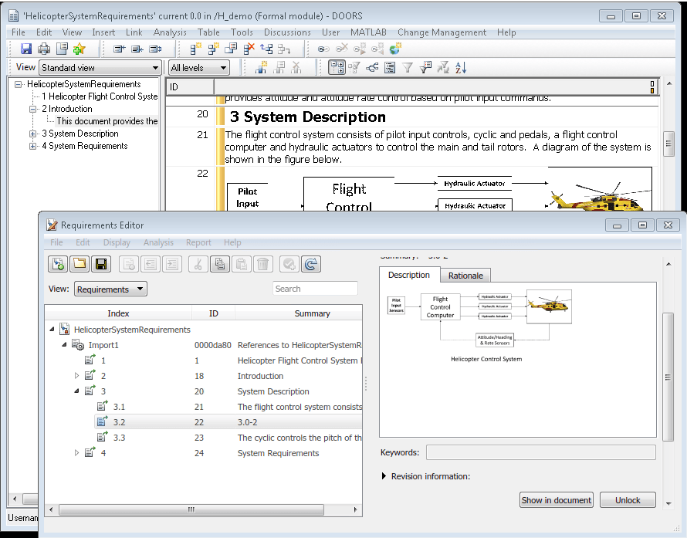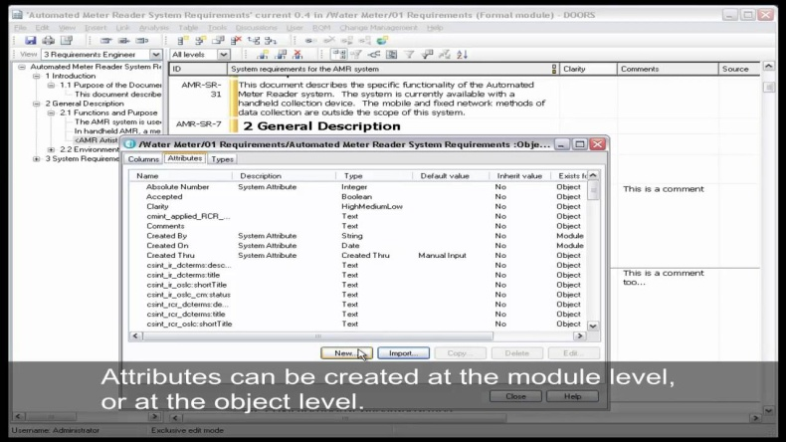

**Azure DevOps Server:**

Azure DevOps Server is initially released in 2005 (used to be known as “Team Foundation Server”). It is a Microsoft product that can be used in various uses such as version control, reporting, requirements management, project management (for agile software development and waterfall teams), automated builds, testing and release management capabilities so itbasically covers the entire application lifecycle. It is originally made to fit Microsoft Visual Studio and Eclipse on all platforms, but it can also be used as a back end todevelopment environments. It is a platform that provides a variety of services for both small businesses and large enterprise companies.

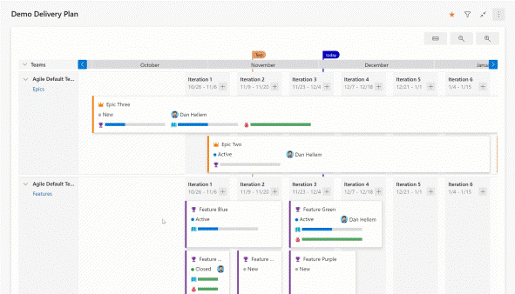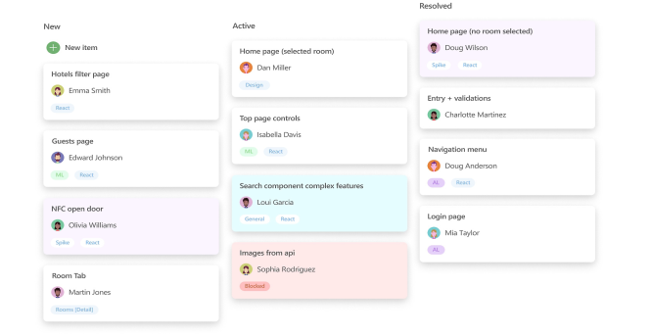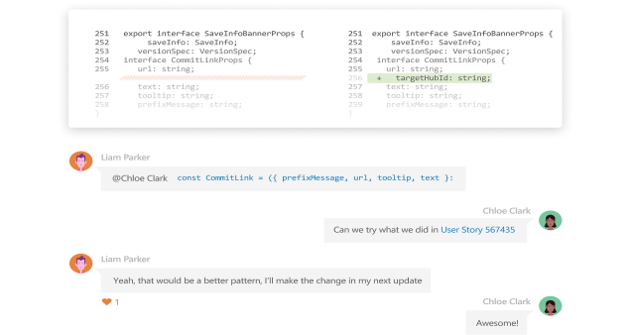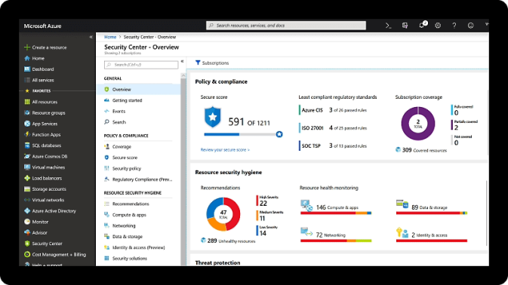

**Jira Software:**

Jira Software is a software product developed by Atlassian. When Jira was launched in 2002 it was purely used as an issue tracking software. Jira Softwareis suited for agile work management solutions. It allows bug tracking, issue tracking and agile project management and can before project, time, requirements, task, bug, change, code, test, release, sprint management. Jira is generally used by small teams and individuals.

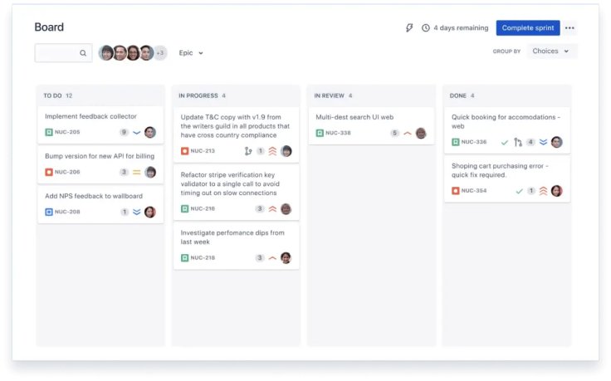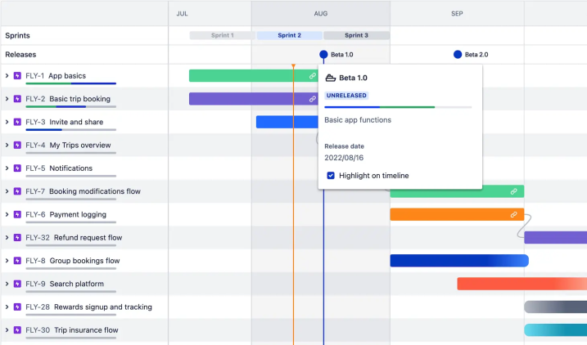

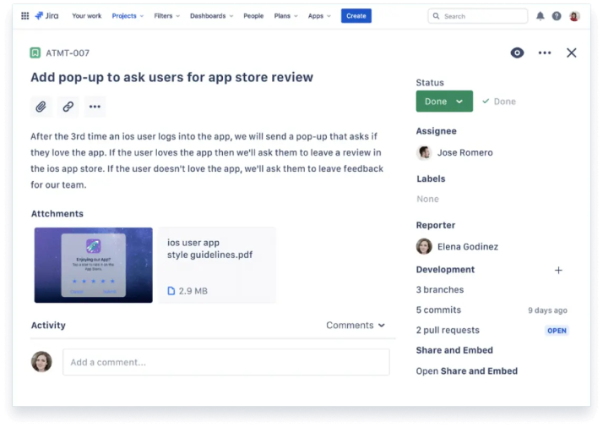

**Sources:**

<https://www.ayrotek.com.tr/cozumler/uygulama-yasam-dongusu-58/ibm-doors-134/>

https://www.ibm.com/docs/en/engineering-lifecycle-management-suite/doors/9.6.0?topic=overview-rational-doors

### [*https://en.wikipedia.org/wiki/Azure_DevOps_Server*](https://en.wikipedia.org/wiki/Azure_DevOps_Server)

[*https://azure.microsoft.com/en-us/products/devops/server#:~:text=What%20is%20Azure%20DevOps%20Server%3F&text=Previously%20known%20as%20Team%20Foundation,on%20projects%20of%20all%20sizes*](https://azure.microsoft.com/en-us/products/devops/server#:~:text=What%20is%20Azure%20DevOps%20Server%3F&text=Previously%20known%20as%20Team%20Foundation,on%20projects%20of%20all%20sizes)*.*

[*https://www.atlassian.com/software/jira?&aceid=&adposition=&adgroup=144803328427&campaign=18452096610&creative=663328874104&device=c&keyword=jira%20software&matchtype=e&network=g&placement=&ds_kids=p73363643288&ds_e=GOOGLE&ds_eid=700000001558501&ds_e1=GOOGLE&gad_source=1&gclid=Cj0KCQiArrCvBhCNARIsAOkAGcVASKhG_IkVYTSc3r5MTVfPKgdI-h4MrTN6NYVJzmB0F0mBfiEBsKkaAkd0EALw_wcB&gclsrc=aw.ds*](https://www.atlassian.com/software/jira?&aceid=&adposition=&adgroup=144803328427&campaign=18452096610&creative=663328874104&device=c&keyword=jira%20software&matchtype=e&network=g&placement=&ds_kids=p73363643288&ds_e=GOOGLE&ds_eid=700000001558501&ds_e1=GOOGLE&gad_source=1&gclid=Cj0KCQiArrCvBhCNARIsAOkAGcVASKhG_IkVYTSc3r5MTVfPKgdI-h4MrTN6NYVJzmB0F0mBfiEBsKkaAkd0EALw_wcB&gclsrc=aw.ds)

[*https://en.wikipedia.org/wiki/Jira_(software)*](https://en.wikipedia.org/wiki/Jira_(software))

*https://www.atlassian.com/software/jira/guides/more/jira-family#what-is-the-jira*