YAMAHA

YM2163
N0 . 8 4 - 04 2

Y M 2 1 6 3

Digital Sound Generator (DSG)

■Summary
TheDSG(DigitalsoundGenerator)usesacpuwithbuilt-in quartz crystals to
set the initial pitch and timbre.The NMOS-LSI chip effortlessly produces
two-beat and rhythmic tones through waveform memory technology.

■Features
● 5V Single-Channel Power N-Channel E/D MOS
●TTL8-bitboard
8-pinor16-pincpusocketforcasyconnection
●5 different musical notes and 4 different rhythm sounds, can
easily produce 4 octaves scale sounds.
●Built-in7-bitD/Aconverter
●Built-in14-bittimer
●24-pin DIL socket

Japan Musical Instrument
Manufacturing Co., LTD
Contents No.LSl-1121630

YAMAHA

■Terminal
configuration diagram

YM2163

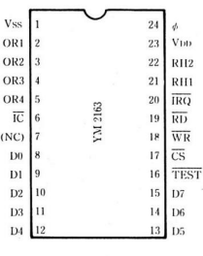

■Block Diagram
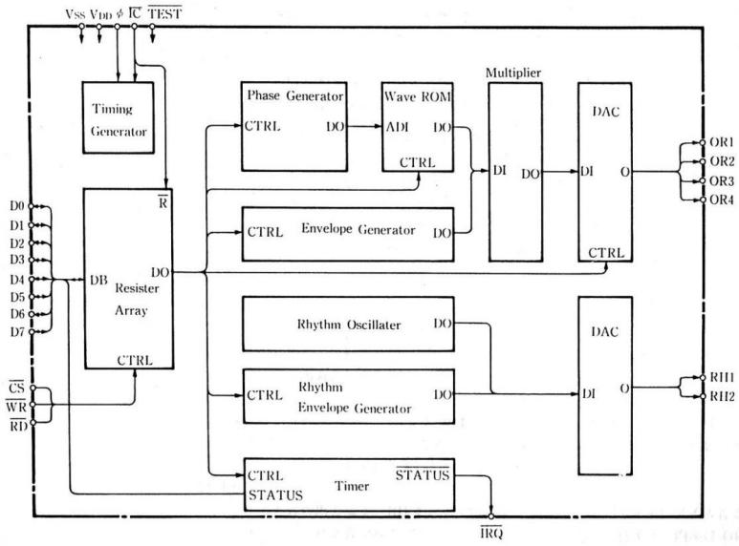

YM2163 YAMAHA

■Terminal Function [1]Vss Ground Terminal
Description [2]OR1～[5 ]OR4
The volume output terminal (orchestral sound) features a 4-channel Rex-style structure with
analog interface output. This terminal allows independent selection to output signals to either the 4-0 or 4-1 interface.
The internal source circuit design enables mixing with the rhythm sound (output from RH1 and RH2 terminals) through an external load resistor (standard 1KΩ).
[6] IC
Clear the terminal. When the terminal is in low power mode, it resets the contents ofthe DSG internal register.
[7] NC
The two terminals inside the DSG are not electrically connected.
[8] D0～[15] D7
Data input terminal. This terminal is used to write data to the DSG internal register array and serves as an output terminal to read the status of the internal timer flag. (See Table 1)
[16] Test
This is a terminal for testing LSI. It contains a full impedance resistor. Do not connect it to anything under normal circumstances.
[17]CS
Select the chip terminal. When this terminal is set to high level, the D0 to D7 data bus terminals enter high
interference state, and the data intheDSG internal register array will be overwritten. In this case, the fault flag status cannot be read. (See Table 1)
[18]WR
Write to the signal input terminal. Switch from CS·WR·RD= "1" to CS·WR= "0"
When a transfer occurs, the path data is written into the register array. (See Table 1)
[19] RD
Guide signal input terminal . Set CS·WR·RD to ' 1 ' to transmit data to the data bus terminal (flag status) . This status is output internally by DSG (see Table 1) .

 | CS | WR | RD | D O～D 7 status | Notes
a | 1 | * | * | high saturation | *： don ’t care
b | 0 | 1 | 1 | Heinrichs | When a c→b or c→a transfer occurs, the path data is written into the register array.
C | 0 | 0 | 1 | Input (Write)
d | 0 | 1 | 0 | Output (Read) | Reading the flag status.
e | 0 | 0 | 0 | （ prohibit ） | Do not use this status.
Table 1 Data Path Control

[20]IRQ

When the DSG's built-in timer's periodic delay state reverses, the CPU generates an allocation request signal (with '0' activated) and outputs it to the specified terminal.
When the flag register signal (FGR) on the data bus is set to ' 1', the flag is pulled low, and the IRQ signal returns to ' 1'. Additionally, the interrupt enable signal (IEN) is set to 0.
The status of the register array is affected by the flag parameter when writing 'O' from the data channel. The IRQ=1 flag will remain set. (The flag is masked.)

[21] RH1 [22] RH2

YM2163 YAMAHA
The RH1-type drum sound system features two primary tones, each analogically output
through the OR1-OR4 terminals. These terminals are equipped with identical S1-S2 interfaces. The load resistor is an external component with a nominal value of 1kΩ .
[23] VDD
Power terminal (nominal voltage +5V)
[24] ∮
Clock pulse (standard 1 MHz) input terminal.

. function declaration
All DSG functions are managed by a 23-register array, with the CPU controlling these functions through the register array.
Simply import the data into the register instruction, and the DSG system will automatically
generate the sound. According to the configuration of each sound block, the sound will be played in sequence.
●Interval divider: a precision device for adjusting musical intervals.
●Waveform ROM: Stores musical waveforms and supports lossless audio.
● Envelope Generator: Can generate envelope sound effects.
● Multiple tracks: Create sounds with additional envelopes.
● Rhythm oscillator: generates the frequency components of rhythmic sounds.
● Rhythm Envelope Generator: Add low-frequency effects to rhythm sound effects.
●D/A converter: Converts computational results into digital signals, while also digitizing musical and rhythmic sounds.
In addition, the timer generates a CPU 8x frequency division request signal by calculating the period time set in the register array.
As shown in Table 2, the register array stores the following data: When the most significant bit (D7) of the data channel DO ～D7 is set to 1, the address is written into the DSG's internal register array. If D7 is set to 0, the previously written addresses D0 ～ D6 are cleared. Written data is not overwritten by default (as indicated by the asterisk (*) in Table 2, even when set to'
1 ', it automatically resets to' 0' after a specified period).

YM2163 YAMAHA
;
*Write data

address | D7 | D6 | D5 | D4 | D3 | D2 | D1 | D0 | COMMENT
80H  81H  82H  83H | 0  0  0  0 | DV4 (0)  (1)  (2)  (3) | DV3(0)  (1)  (2)  (3) | DV2(0)  (1)  (2)  (3) | DV1(0)  (1)  (2)  (3) | DV0(0)  (1)  (2)  (3) | DV1/2(0)  (1)  (2)  (3) | DV1/4(0)  (1)  (2)  (3) |  | Weeks (lower) |  |  |  |  |  | Music (Wind and String)
84H  85H  86H  87H | 0  0  0  0 | KON(O )  (1)  (2)  (3) | FD(0)  (1)  (2)  (3) | B2 (0)  (1)  (2)  (3) | B1(0) (1)  (2)  (3) | DV7(0)  (1)  (2)  (3) | DV6(0)  (1)  (2)  (3) | DV5(0)  (1)  (2)  (3) |  | Button | Full octaves | octave |  | Weeks (upper) |  | Music (Wind and String)
88H  89H  8AH  8BH | 0  0  0  0 | E2(0)  (1)  (2)  (3) | E1(0)  (1)  (2)  (3) | SUS(0)  (1)  (2)  (3) |  | W3 (0)  (1)  (2)  (3) | W2 (0)  (1)  (2)  (3) | W1 (0)  (1)  (2)  (3) |  | Envelope  Selection |  | Keep on |  | Waveform  memory |  | Music (Wind and String)
8CH  8DH  8EH  8FH | 0  0  0  0 | Test 1  2  3  4 | VL2(0)  (1)  (2)  (3) | VL1(0)  (1)  (2)  (3) | F4 (0)  (1)  (2)  (3) | F3 (0)  (1)  (2)  (3) | F2 (0)  (1)  (2)  (3) | F1 (0)  (1)  (2)  (3) |  | test | Volume  selection |  | Output  filter  selection |  |  | Music (Wind and String)
90H    91H 92H  1/4 93H | 0 | FGR | IEN | HHD · | HHO · | SDN | HC · | BD · |  |  |  | Rhythm Trigger |  |  |  | Section Sound
 |  |  |  |  |  |  |  |  |  | Effective squeeze Logo Settings |  |  |  |  | Maintain rank | Section Sound
94H  95H  96H  97H | 0  0  0  0 |  | LV4(0)  (1)  (2)  (3) | LV3(0)  (1)  (2)  (3) | LV2(0)  (1)  (2)  (3) | LV1(0)  (1)  (2)  (3) | LV0(0)  (1)  (2)  (3) | LH (0)  (1)  (2)  (3) |  |  | (HH)  (BD)  (HC)  (SDN) |  | Rhythm  Level |  | Maintain rank | Section Sound
98H  99H 9AH    1/4 9BH | 0 | PT6 | PT5 | PT4 | pT3 | PT2 | PT1 | PT0 |  | Timer period (lower bit) |  |  |  |  |  | Timer
  9 CH  9 DH  9 EH 1/4  9 FH | 0 | PT13 | PT12 | PT11 | PT10 | PT9 | PT8 | PT7 |  | Timer period (upper) |  |  |  |  |  | Timer
Note: Add characters (0) to (3) indicate the pronunciation channel.
* read data

address | D7 | D6 | D5 | D4 | D3 | D2 | D1 | D0 | COMMENT
don ’t care |  |  |  |  |  |  |  | FLAG | state

Table 2 DSG Address Mask

YAMAHA YM2163

(1) Frequency and Base Ion · Disable data settings (addresses 80H ～ 87H)
When the number of weeks is set to DV7～DV1/4 and the octave values are B1, B2, the fundamental frequency f
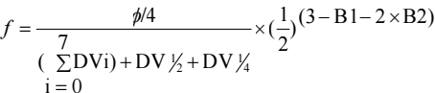

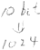
Th i s wi l l be det erm in e d her e .

B2 | B | short-cut  process
0 | 0 | 1
0 | 1 | 2
1 | 0 | 3
1 | 1 | 4

Weeks
superior |  |  | inferior
DV7 | DV6 | DV5 | DV 4 | DV 3 | DV 2 | DV1 | DV0 | DV1/2 | DV1/4
128 | 64 | 32 | 16 | 8 | 4 | 2 | 1 | 1/2 | 1/4
∮: DSG main clock frequency

In K ON ' s dat a configuration , rhythm is controlled by the onset an d offset of
syll able pronunciation . FD , however , employs a decay mechanism
independent of K ON .

KON
0 | Key Off (Start  attenuation)
1 | Press to start (sound  starts)

FD
0
1 | Shape-Shifting Damper (Forced Damping)

(2) Configuration of waveform memory envelope (addresses 88H to 8BH)
Sound waves and envelopes will be selected ba sed on the following dat a .

 | wavememorizer
W  3 | W  2 | W  1
0 | 0 | 0
0 | 0 | 1 | St（string music ）
0 | 1 | 0 | or (organ)
0 | 1 | 1 | Cl（clarinet ）
1 | 0 | 0 | Pf (Xianuo)
1 | 0 | 1 | Hc (half fourth)
1 | 1 | 0
1 | 1 | 1
( Re fer to Figur e 1 )

 | Envelope Selection
E2 | E1
0 | 0 | Envelope 0 (attenuated sound)
0 | 1 | Envelope 1 (sustained tone)
1 | 0 | Envelope 2  (sustained tone)
1 | 1 | Envelope 3 (sustained tone)
(Refer to Figure 2)

Continueto specify
SUS
0 | Keep Off
1 | Keep on

(Refer toFigure 2)

YM2163 YAMAHA

Hc Pf CL Or St
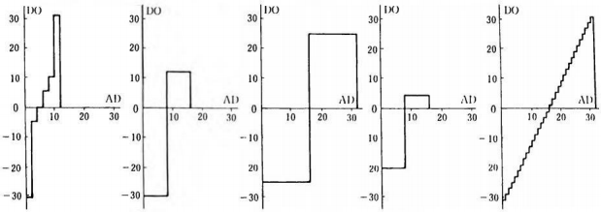
Figure 1 Waveform Memory (Melody)

 | SUS=0(keep off) | SUS=1(keep on)
E n v e l o p e 0 | 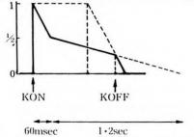 | 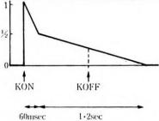
E n v e l o p e 1 | 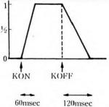 | 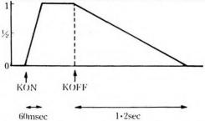
E n v e l o p e 2 | 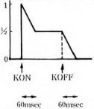 | 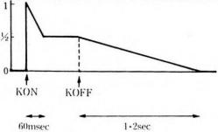
E n v e l o p e 3 | 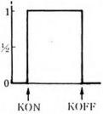 | 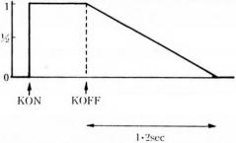

Figure2 Envelope (Melody)

YAMAHA YM2163

(3) Volume and Filter Selection Settings (Addresses 8 CH to 8 FH)
Volume adjustment data and output terminal designation data will be set as follows.

Volume (water chime)
V2 | V1
0 | 0 | 0 dB (normal)
0 | 1 | -6dB
1 | 0 | -12dB
1 | 1 | -∞dB

Output terminal selection (filter)
F1 | 0 | Do not output to OR1 terminal.
F1 | 1 | Output to OR1 terminal.
F2 | 0 | Do not output to OR2 terminal.
F2 | 1 | Send the output to the OR2
F3 | 0 | Do not output to the OR3 terminal.
F3 | 1 | Output to OR 3 terminal.
F4 | 0 | Do not output to OR4 terminal.
F4 | 1 | Output to OR4 terminal.

(4) Rhythm Trigger (Addresses 90H to 93H)
When the data " 1" is deviated, the system will emit the following rhythm sound effect, and the
built-in rhythm envelope generator will naturally change, and the data will automatically recover to "0".
Rhythm Tracker |  |  | explain
BD | 0 |  | Output the signal to terminal RH1.
BD | 1 | Ding | Output the signal to terminal RH1.
HC | 0 |  | Output the signal to the RH1 terminal.
HC | 1 | Speak at high volume | Output the signal to the RH1 terminal.
SD N | 0 |  | Output the signal to the RH2 terminal.
SD N | 1 | Military drum noise | Output the signal to the RH2 terminal.
HHO | 0 |  | Output the signal to the RH2 terminal.
HHO | 1 | High Hat (Open) Pronunciation | Output the signal to the RH2 terminal.
HHD | 0 |  | Output the signal to the RH2 terminal.
HHD | 1 | Hat (end) pronunciation | Output the signal to the RH2 terminal.

(5) Rhythm hierarchy (address 94H～97H)
When controlling the rhythm output rate through the DSG external device, the rate conflicts with the
built-in rhythm envelope generator. In this case, the

Rhythm Level
LV4 | LV3 | LV2 | LV1 | LV0
16 | 8 | 4 | 2 | 1

Level hold
LH
0 | Do not keep the set rhythm level
1 | Maintain the set rhythm level
e is typically set to 1.
The volume level ranges from 0 (maximum) to 31 (minimum).
(6) Timer interrupt control (addresses 98H-9F H, 90H-93H)
The DSG's internal interrupt flag is set every time the preset timing period is reached.
时间周期PT 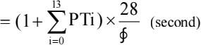 Here, ∮: DSG's main clock frequency (Hz)

superior： |  |  |  |  |  |  | F Position
pT13 | P T12 | PT11 | PT10 | PT9 | PT8 | PT7 | PT6 | PT5 | PT4 | PT3 | PT2 | PT1 | PT0
8192 | 4096 | 2048 | 1024 | 512 | 256 | 128 | 64 | 32 | 16 | 8 | 4 | 2 | 1
The interrupt flag is reset when the reset signal FGR= "1" is written, and FGR automatically returns to "0" at this time.
When the distribution completion flag is in an interrupted state, the IEN signal will turn on. In this case, the IRQ terminal will output an inverted signal, and the D0 terminal will also output a corresponding
signal in read mode.

YM2163 YAMAHA
. electricalcharacter
Absolute maximum freeze
mark |  | min | sta | max | unit
VI | terminal voltage | -0.3 |  | 7 | V
Top | operating temperature | 0 |  | 70 | ℃
Tstg | Save temperature | -50 |  | 125 | ℃
DC Characteristics (@VDD=4.5~5.5V)

mark |  | min | sta | max | unit
VDD | supply voltage | 4.5 | 5.0 | 5.5 | V
IDD | Power supply current @RL= 1KΩ |  | 25 | 45 | mA
VIL | Enter low voltage ( ∮、C S 、D0-D7、W R 、R D 、 I C） |  |  | 0.8 | V
VIH | Enter high-level voltage ( ∮、C S 、D0-D7、W R 、R D 、 I C） | 2.0 |  |  | V
VOL | Output low voltage (D0, IRQ) @IOL= 1.6mA |  |  | 0.4 | V
VOH | Output high-level voltage (D0) | 2.4 |  |  | V
ILK | Enter leakage current ( ∮、 C S 、D 0-D 7 、W R 、R D 、 I C）@VI=5V |  |  | 10 | μA

AC characteristic

mark |  | min | sta | max | unit
Tcw | Chip selection in pulse mode (Figure 3) | 135 |  |  | ns
Tww | In the optical signal pulse (Figure 3) | 135 |  |  | ns
TDS | Data Set Time (Figure 3) | 160 |  |  | ns
TDHW | Data retention time (write) (Figure 3) | 30 |  |  | ns
TACC | Access Time (Figure 4) |  |  | 400 | ns
TDHR | Data retention time (read) (Figure 4) | 0 |  |  | ns
f∮ | Clock frequency (Figure 5) | 0.9 | 1.0 | 1.1 | MHz
T∮ON | Clock enable time (@f∮= 1MHz) (Figure 5) | 400 |  |  | ns
T∮OFF | Clock shutdown time (@f∮= 1MHz) (Figure 5) | 400 |  |  | ns
T∮R | Clock up time (Figure 5) |  |  | 80 | ns
T∮F | Clock down time (Figure 5) |  |  | 80 | ns
TOD | ———  Output delay time IRQ (Figure 5) |  |  | 700 | ns
Vp-p | Maximum Output Vibration (OR1-4, RH1-2) @RL= 1KΩ, VDD=5V (Figure 6) | 0.60 | 0.90 | 1.40 | V

YAMAHA

Figure 3: Write time

—— C S

YM2163

Tcw
——
WR

Tww

D0～D7

TDS TDHW

— —
——
Note: The TDS and TDHW criteria are determined when either CS or WR reaches a high level.

Figure 4: Read time

——
CS

——
RD

D0～D7 ·

TAcc TDHR

—— ——
Note: TACC C S uses DR the party with lower rank and slower response as the reference.
— — — —
TDHW is CSbased DRon the time when one of the parties reaches the higher level.

YM2163 YAMAHA

Figure 5 Clock/Output Timing

f∮

T∮DN T∮R T∮OFF T∮F

I RQ

TOD

Figure 6 Maximum output amplitude

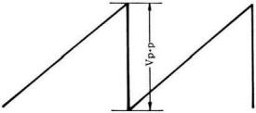

OR1

OR4

(Note) When W1= 1 , W2= W3= 0 , VL1= 0 , and VL2= 0 , this rule applies .

YAMAHA YM2163

■ Dimension

Note:product specifications are subject to change without notice due to improvements or other reasons
Agency — 一 JapanMusicalInstrumentManufacturingco,Ltd.—

Kanematsu semiconductor co.,Ltd.
1-6-1 Shin'fu, Chuo-ku, Tokyo, Japan
Tel:(03) 551-7791

■Our company

contact
■Fukuyama

10-1Nakazawa-cho,Hama matsu shizuoka prefecture TEL: 0534-65-1111
P.C.430
P.C. 438 01
203 Matsunokijima, Toyooka Village, Iwata District
Shizuoka Prefecture
TEL 053962-3111

