YAMAHA *L 3 i*

NO.84- 13, I

YM2203

FM Operator Type-N(OPN)

* OUTLINE

OPN (FM OPERATOR TYPE-N) is a new type synthesizer which can produce all sounds required owing to the FM sound source system. It is provided with a built-in register which can store sound information and be connected easily with a microprocessor or microcomputer. It also comprises a square wave sound source different from the sound source according to the FM system and a noise generator.

/

* FEATURES

*The FM system sound source produce three different sounds simultaneously.

*One of the above three sounds can be set to the mode by which specific sound effects and composite sine wave sound are synthesized.

* Two programmable timers are incorporated.
* 8 bits general purpose input/output ports of two system are incorporated.
* Three square wave sounds and white noise can be produced in addition to the FM system sounds.
* Clock divider is built in so that wide operating frequency range is obtained.
* Input and output are compatible with TTL.
* Nch-Si gate MOS LSI is used.
* Single phase power source of 5 V is used.
* This is compatible with software of YM2 149 and AY-3-8910 and 8912 produced by GI.

YM2203 *115 07* CATALOG NO. : LSI-2122032 1989. 11

YM2203

■ TERMINAL DIAGRAM

|  |  |  |  |
| --- | --- | --- | --- |
| GND | 1 V | *-s* 40 | DO |
| D 1 | 2 | 39 |  |
| D2 | 3 | 38 | 0M |
| D3 | 4 | 37 | AO |
| D4 | 5 | 36 | RD |
| D5 | 6 | 35 | WR |
| D6 | 7 | 34 | CS |
| D7 | 8 | 33 | I0B7 |
| I0A7 | 9 | 32 | I0B6 |
| I0A6 | 1 0 | 31 | I0B5 |
| I0A5 | 1 1 | 30 | I0B4 |
| I0A4 | 12 | 29 | I0B3 |
| I0A3 | 1 3 | 28 | I0B2 |
| I0A2 | 14 | 27 | IOB 1 |
| IOA 1 | 1 5 | 26 | IOBO |
| IOAO | 16 | 25 | IRQ |
| AGND | 1 7 | 24 | ic |
| ANALOG CHANNEL C | 18 | 23 | OP-O |
| ANALOG CHANNEL B | 1 9 | 22 | SH |
| ANALOG CHANNEL A | 20 | 2 1 | Vdd |

■ BLOCK DIAGRAM

AO CS RD WR (6M 0S SH IRQ

**■Q—Q—Q—Q- Q-O-Q" Q-**

DATA BUS CONTROL

TIMING

CONTROL

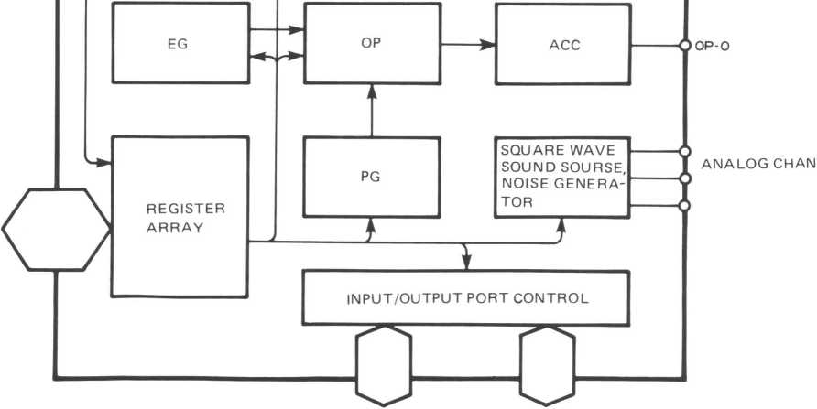

IOA0 ~ IOA7

IOBq — IOB7

A B C

2

YM2203

**■ DESCRIPTION OF TERMINAL FUNCTION**

1. 0M

This is the master clock of the OPN. The FM sound source and square wave sound source operate, based on this clock. The maximum input frequency up to 4.2MHz can be input by using a built-in 1/6 divider.

1. 0S • SH

These are the clock (0s) and the synchronous signal (SH). They drive a D/A converter which converts digital output of the FM sound source into analog output.

1. Do through D7

These 8-bit bi-directional bus exchange the data and address between the OPN and the micro­processor.

1. CS • RD • VVR • Ao

These signals control bi-directional bus of Do through D7.

|  |  |
| --- | --- |
| CS RD WR Ao |  |
| 0 10 0 | Writes address into the register of the OPN. |
| 0 10 1 | Writes the resister content into the OPN. |
| 0 0 10 | Reads the OPN status. |
| 0 0 11 | Reads the content of the OPN register. |
| 1 X X X | Do through D7 bus line become high impedance. |

* Read enable register addresses 00 througe OF (16 bits).

1. IRQ

This is an interrupt signal sent from two timers. It can be masked by the program.

1. IC

This signal resets the system at low level. All the content of register array become “0”.

1. OP-O

This outputs the FM modulated audio signal as 13-bit serial data. Accordingly, an external D/A converter is necessary.

1. Analog channel A, B and C

They are analog square wave audio signals. They can be mixed by setting resistance because of source follower.

1. IOA0 through IOA7, IOB0 through IOB7

They are two sets of 8-bit input/output ports. Each terminal incorporates pull up resistance.

1. AGND

This is analog ground terminal for the D/A converter which is built in the square wave sound source section.

1. Vdd

This is a power terminal of + 5 V.

1. GND

This is a ground terminal.

3

YM2203

■ DESCRIPTION OF FUNCTIONS

The OPN is controlled based on the data written into the register. Accordingly, a microprocessor is free from the sound control operation except sending the data to the register.

The FM sound source determines a sound by the combination (modulation) of four sin waves. All the modulation systems such as feedback FM, simple FM and multiple FM are possible. In respect to the square wave sound source, this is compatible with YM2149 (SSG) and AY-3­8910 and 8912 (PSG.GI) in the use of the software. Therefore, function of the OPN can be improved by the exchange with the above LSI.

Each block of the OPN functions as follows.

* Envelope generator (EG):

* Phase generator (PG):

* Operator (OP):

* Accumulator (ACC):

Determines the modulation index of the envelope and modulation  
wave of the FM sound source.

Determines the sin wave phase at each time step of the FM sound

source.

Calculates the E sin *9* value on the basis of the amplitude from the  
envelope generator and the phase from the phase generator.

Accumulates and adds operator output of each channel to mix  
each sound of the FM sound source and matches with the D/A  
converter.

* Square wave sound source/noise generator:

Generates three different frequency square waves and pseudo­white noise. It can also mix noise and square wave. As for sound volume, it is possible to select either fixed sound volume (program­med value) or 10 pattern envelope producing mode. In this block, one D/A converter is provided for each sound.

*lnput/output port control: These are the general-purpose input/output ports to gets interface with external equipment.

*Timer: Two types of timers are provided.

Register content and address map

The OPN register is provided with the internal address as shown in the address map.

The content of each register (address) is as follows.

|  |  |  |
| --- | --- | --- |
| (1) | $ 00 ~ $ 05 | Generates frequency of the square wave sound source. |
| (2) | $ 06 | Generates frequency of noise source. |
| (3) | $07 | Controls the input and output of the input and output ports and the output of musical sound and noise. |
| (4) | $ 08 ~ $ 0A | Controls sound volume. It is possible to select the fixed sound volume system (program­mable) or the variable sound volume system. |
| (5) | $0B~$0C | Controls the envelope cycle in the variable sound volume sytem. |
| (6) | $ 0D | Specifies the envelope shape in the variable sound volume system. |
| (7) | $0E~$ OF | 8 bit general-purpose input and output ports. |
| (8) | $ 21 | Test information, always set to “0”. |
| (9) | $ 24 ~ $ 26 | Gives the set time of Timers A and B. |

4

YM2203

warn

|  |  |  |
| --- | --- | --- |
| (10) | $ 27 | Controls the operation of Timers A and B, and sets the third channel mode of the FM sound source. |
| (11) | $ 2D ~$ 2F | Specifies the dividing number of the input clock. The dividing numbers 2 through 6 are for the FM sound source, and the numbers 1 through 4 are for square wave sound source. |
| (12) | $ 30 ~ $ 3E | Controls Detune and Multiple. This is used to set tones. This controls the relationship between the fundamental wave and harmonic. |
| (13) | $ 40 ~ $4E | Gives the total level. This information becomes the modulation index of the sound volume and modulation wave of the modulated wave. |
| (14) | $ 50 ~$ 5E | Key -Scale controls the rate of change of A • D • S and R according to the keyboard information. Attack rate gives the rate of change of the envelope at the time of attack. |
| (15) | $ 60 ~ $ 6E | Decay Rate shows the rate of change of the envelope at the time of decay. |
| (16) | $ 70 ~$ 7E | Sustain Rate shows the rate of change of the envelope at the time of sustain. |
| (17) | $ 80 ~ $ 8E | Sustain level shows the level of the shift from decay to sustain. Release rate shows the rate of change of the envelope at the time of release. |
| (18) | $ 90 ~$ 9E | Generates the envelope including the repeat pattern similar to that of square wave sound source. |
| (19) | $ A0 ~ $ A6 | Gives key-code (F-number) of each channel. |
| (20) | $ A8 ~ $ AE | Gives the key-code (F-number) of three channels when set to the special mode. |
| (21) | $ B0 ~ $ B2 | Gives the modulation system (connection) of the FM modulation and the modulation factor of the feedback FM (self-feedback ). |

* FM system

In the FM system, musical sounds are synthesized by controlling various high harmonic waves by use of the frequency modulation.

The basic equation of the FM system is as follows.

F = A sin (cuCt + I sin ojMt) —(1)

Where A is output amplitude, I is modulation index, and wC and wM are angular frequencies of carrier and modulator, respectively.

This equation can also be expressed as follows.

F = A [Jo (I) sin wCt + J2 (I) (sin (wC + wM)t — sin (wC — wM)t)

+ J2 (I) (sin (wC + 2wM)t — sin (wC —2cuM)t)

+ ] -(2)

Where, Jn (I) is the first class Bessel function of nth. As shown in the above equation, the FM system contains various harmonics and can control them.

The OPN provides the multiple FM modulation and feedback FM modulation shown in (3) and (4) in addition to the above FM modulation to produce every possible sound.

F = A sin [wCt + Ij sin (wMj t + I2 sin wM2 t)] — (3)

F = A sin (wCt + 0F) - (4)

5

YM2203

* WRITE DATA

ADDRESS

|  |  |  |  |  |  |  |  |  |  |
| --- | --- | --- | --- | --- | --- | --- | --- | --- | --- |
| 21  24  25  26  27  28  2D  2E  2F | TEST | | | | | | | | |
| TIMER-A | | | | | | | | |
|  | | | | | | | | TIMER -A |
| TIMER-B | | | | | | | | |
| MODE R^ET | | | | | ENABLE B A | | | LOAD B A |
| SLOT | | | | | CH | | | |
| —-— | | | | | | | | |
| — | | | | | | | | |
| ____________—— - | | | | | | | | |
| 30  3E |  | DT | | | | | MULTI | | |
| 40  4E | / |  | | | | | | | |
| 50  5E | KS | |  | |  | | | | |
| 60  6E |  | | | | DR | | | | |
| 70  7E |  | | | | SR | | | | |
| 80  8E | SL | | | | | | RR | | |
| 90  9E |  | | | | | | SSG-EG | | |
| A0  Al  A2 | F-Num. 1 | | | | | | | | |
| A4  A5  A6 |  | | | BLOCK | | | | F-Num. 2 | |
| A8 A9 AA | 3CH * F-Num. 1 | | | | | | | | |
| AC AD  AE |  | | | 3CH *  BLOCK | | | | 3CH *  F-Num. 2 | |
| B0  Bl  B2 |  | | | FB | | | | CONNECT | |

COMMENT

LSI TEST DATA

8 most significant bits of TIMER-A

2 least significant bits of TIMER-A

TIMER-B DATA

TIMER-A/B control and 3 channel mode

Key-ON/OFF

Set pre-scaler.

Selection of the dividing numbers of 1/3 and 1/6.

Set a divider to the dividing number of 1/2.

Detune / Multiple

(Addresses at 33, 37 and 3B are empty.)

Total Level

(Addresses at 43, 47 and 4B are empty.)

Key Scale *I* Attack Rate

(Addresses at 53, 57 and 5B are empty.)

Decay Rate

(Addresses at 63, 67 and 6B are empty.)

Sustain Rate

(Addresses at 73, 77 and 7B are empty.)

Sustain Level / Release Rate

(Addresses at 83, 87 and 8B are empty.)

SSG-Type Envelop Control

(Addresses at 93, 97 and 9B are empty.)

F-Numbers / BLOCK

3CH-3slot

F-Numbers / BLOCK

Self-Feedback / Connection

6

YM2203

*READ / WRITE DATA

ADDRESS

00

01

02

03

04

05

06

07

08

09

0A

OB

0C

0D

0E

OF

|  |  |  |  |
| --- | --- | --- | --- |
| Fine Tune | | | |
|  | | Coarse Tune | |
| Fine Tune | | | |
|  | | Coarse Tune | |
| Fine Tune | | | |
|  | | Coarse Tune | |
|  | Period Control | | |
| IN/OUT  IOB 1OA | /Noise | | /Tone |
|  | M | Level | |
| M | Level | |
| M | Level | |
| Fine Tunc | | | |
| Coarse Tune | | | |
|  | C | ATT | ALT HLD |
| I/O Port-A | | | |
| I/O Port-B | | | |

COMMENT

Channel-A Tone Period

Channel-B Tone Period

Channel-C Tone Deriod

Noise Period

/ENABLE

Channel-A Amplitude

Channel-B Amplitude

Channel-C Amplitude

Envelop Period

Envelop Shape/Cycle

I/O Port Date

*READ DATA

ADDRESS

xx

|  |  |  |
| --- | --- | --- |
| BUSY |  | FLAG B A |

COMMENT

Status

7

YM2203

■ ELECTRICAL CHARACTERISTICS

1. Absolute Maximum Rating

|  |  |  |
| --- | --- | --- |
| ITEM | RATING | UNIT |
| Terminal voltage | - 0.3 ~ 7.0 | V |
| Ambient operating temperature | 0 ~ 70 | °C |
| Storage temperature | - 50 ~ 125 | °C |

1. Recommended Operation Conditions

|  |  |  |  |  |  |
| --- | --- | --- | --- | --- | --- |
| ITEM | SYMBOL | MIN. | STD. | MAX. | UNIT |
| Supply voltage | **VDD**  **Vss** | 4.75 0 | 5.0 0 | 5.25 0 | **V**  **V** |

1. DC Characteristics

|  |  |  |  |  |  |  |  |
| --- | --- | --- | --- | --- | --- | --- | --- |
| ITEM | | SYMBOL | CONDITIONS | MIN. | STD. | MAX. | UNIT |
| Input high level voltage | Total input | **V1H** |  | 2.0 |  | VDD | V |
| Input low level voltage | Total input | **VlL** |  | -0.3 |  | 0.8 | V |
| Input leakage current | 0M, WR, RD, Ao | **II** | Vin = 0 ~ 5 V | - 10 |  | 10 | juA |
| Three-State (off) input current | Do D7 | **ITSL** | Vin = 0 ~ 5 V | - 10 |  | 10 | mA |
| Output higl level voltage | Output except IRQ | **VOHj**  Voh2 | lOHj = 0.4mA IOM2 = 40pA | 2.4  3.3 |  |  | V  V |
| Output low level voltage | Total output | Vol | lOL = 2mA |  |  | 0.4 | V |
| Output leakage current (off) | IRQ | **1OL** | VOH = 0 ~ 5V | - 10 |  | 10 | mA |
| Analog output voltage | ANALOG-CHA, B, C | VOA | Max. Sound volume, no mixing | 0.95 |  | 1.35 | Vpp |
| Power current |  | **IDD** |  |  |  | 120 | mA |
| Pull-up resistance | IOA0 ~ IOA7, IOB0 ~ IOB7, IC, OS | **RPU** |  | 60 |  | 600 | kU |
| Input capacitance | Total input | Ci | f = 1MHz |  |  | 10 | pF |
| Output capacitance | Total output | Co |  |  | 10 | pF |

■ AC CHARACTERISTICS

1. AC Characteristics

|  |  |  |  |  |  |  |  |
| --- | --- | --- | --- | --- | --- | --- | --- |
| ITEM | | SYMBOL | CONDITIONS | MIN. | STD. | MAX. | UNIT |
| Input clock frequency | 0M | fc | Pre-scaler function (Fig. A-l) | 0.7 |  | 4.2 | MHz |
| Input clock duty | </>M |  |  | 40 | 50 | 60 | *%* |
| Input clock rise time | *<pM* | TR | (Fig. A-l) |  |  | 50 | ns |
| Input clock breaking time | 0M | tf | (Fig. A-l) |  |  | 50 | ns |

8

YM2203

Access to FM sound source

|  |  |  |  |  |  |  |  |
| --- | --- | --- | --- | --- | --- | --- | --- |
| ITEM | | SYMBOL | CONDITIONS | MIN. | STD. | MAX. | UNIT |
| Address set-up time | Ao | Tas | (Figs. A-2 and A-3) | 10 |  |  | ns |
| Address hold time | Ao | Tah | (Figs. A-2 and A-3) | 10 |  |  | ns |
| Chip select write width | CS | Tcsw | (Fig. A-2) | 200 |  |  | ns |
| Chip select read width | cs | Tcsr | (Fig. A-3) | 250 |  |  | ns |
| Write pulse write width | WR | Tww | (Fig. A-2) | 200 |  |  | ns |
| Write data set-up time | Do "" D7 | Twds | (Fig. A-2) | 100 |  |  | ns |
| Write data hold time | Do D7 | Twdh | (Fig. A-3) | 20 |  |  | ns |
| Read pulse width | RD | Trw | (Fig. A-3) | 250 |  |  | ns |
| Read data access time | Do D7 | tacc | CL =lOOpF (Fig. A-3) |  |  | 250 | ns |
| Read data hold time | Do ~ D7 | Trdh | (Fig. A-3) | 10 |  |  | ns |
| Output rise time | 0S | TOR! | CL = lOOpF (Fig. A-4) |  |  | 200 | ns |
| OP-O, SH | TOR2 | CL = 100 pF (Fig. A-5) |  |  | 300 | ns |
| Output rise time | 0S | Tofj | CL = lOOpF (Fig. A4) |  |  | 200 | ns |
| OP-O, SH | Tof2 | CL = lOOpF (Fig. A-5) |  |  | 300 | ns |

Access to SSG sound sourse

|  |  |  |  |  |  |  |  |
| --- | --- | --- | --- | --- | --- | --- | --- |
| ITEM | | SYMBOL | CONDITIONS | MIN. | STD. | MAX. | UNIT |
| Address set-up time | Ao | **TSAS** | (Figs. A-7 and A-8) | 10 |  |  | ns |
| Address hold time | Ao | **TSAH** | (Figs. A-7 and A-8) | 10 |  |  | ns |
| Chip select writh width | CS | **TSCSW** | (Fig. A-7) | 250 |  |  | ns |
| Chip select read width | CS | **TSCSR** | (Fig. A-8) | 400 |  |  | ns |
| Write pulse write width | WR | **TSWW** | (Fig. A-7) | 250 |  |  | ns |
| Write data set-up time | Do ~ D7 | **TSWDS** | (Fig. A-7) | 0 |  |  | ns |
| Write data hold time | Do ~ D7 | **TSWDH** | (Fig. A-7) | 20 |  |  | ns |
| Read pulse width | RD | **TSRW** | (Fig. A-8) | 400 |  |  | ns |
| Read data access time | Do ~ D7 | **TSACC** | CL= lOOpF (Fig. A-8) |  |  | 400 | ns |
| Read data hold time | Do D7 | **TSRDH** | (Fig. A-8) | 10 |  |  | ns |

|  |  |  |  |  |  |  |  |
| --- | --- | --- | --- | --- | --- | --- | --- |
| ITEM | | SYMBOL | CONDITIONS | MIN. | STD. | MAX. | UNIT |
| Reset pulse width | **IC** | **T1CW** | (Fig. A-9) | 72* |  |  | cycle |

* Depends on the dividing number of prescaler.

Pulse width = (dividing number) x 12

9

warn

YM2203

■ TIMING DIAGRAM (Timing is set on the basis of the values: Vih = 2.0V and Vil = 0.8V.)

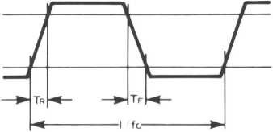

Fig. A-l Clock timing

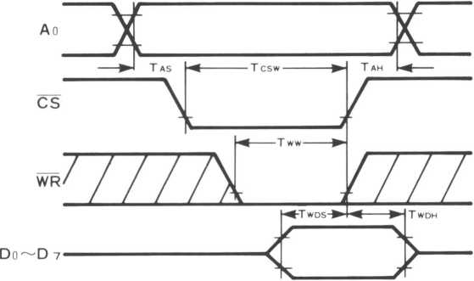

Fig. A-2 FM section write timing

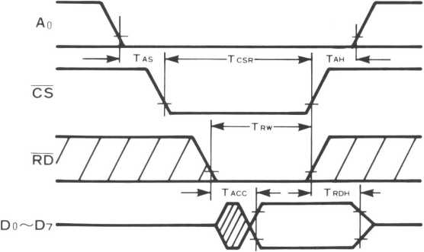

Fig. A-3 FM section read timing

Note.

Tcsw , Tww and T wdh are  
determined based on  
the time when either  
CS or WR goes to the  
high level.

Note.

Taac is determined based on the time when either CS or RD goes to the low level. Tcsr , T rw and Trdh are determined based on the time when either CS or RD goes to the high level.

10

YM2203

WM

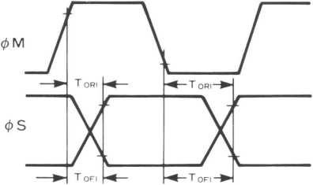

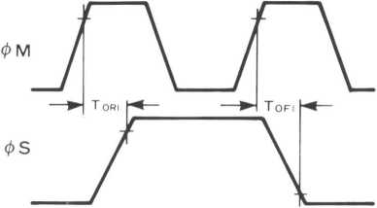

Fig. A-4-a </>M and *<t>* S

(dividing numbers: 2 and 3)

Fig. A-4-b 0Mand 0S

(dividing number: 6)

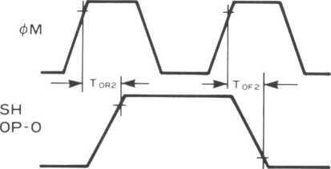

Fig. A-5 </>M and SH • OP-O

0M



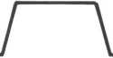

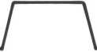

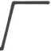

Dividing

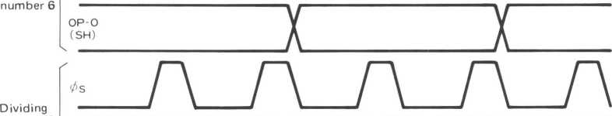

OPO (SH)

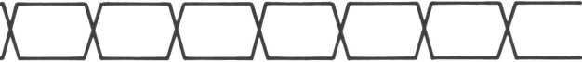

Fig. A-6 Timing of 0S and OP-O/CH at each dividing number

11

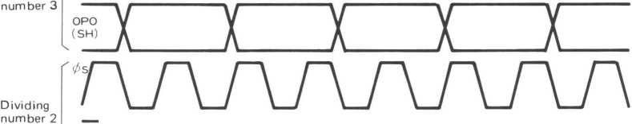

YM2203

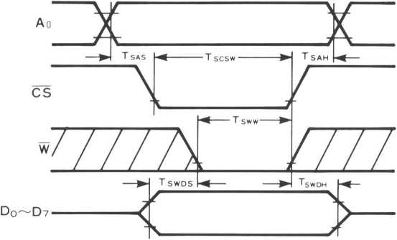

Fig. 6-7 SSG section write timing

Note.

Tswds is determined based on the time when either CS or WR goes to the low level.

Tscw , Tsww and Tswdh are determined based on the time when either CS or WR goes to the High level.

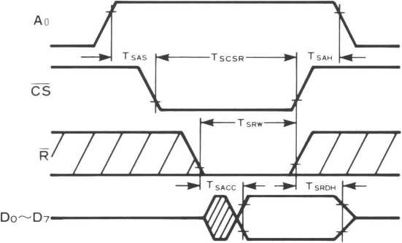

Fig. A-8 SSG section read timing

Note.

Tsacc is determined based on the time when either CS or RD goes to the low level. Tscsr , Tsrw and Tsrdh are determined based on the time when either CS or RD goes to the High level.

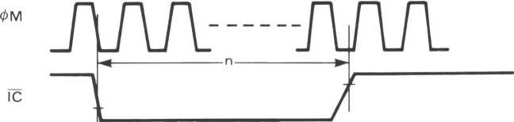

n Ji (Dividing number) x 12

Fig. A-9 Reset pulse

12

YM2203

**■ OUTER DIMENSION DRAWING**

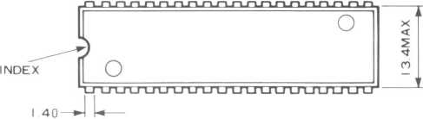

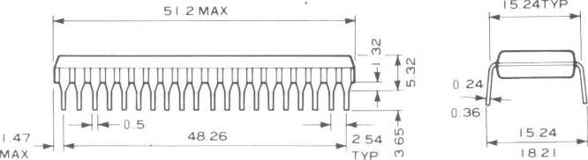

13

The specifications of this product are subject to improvement changes without prior notice.

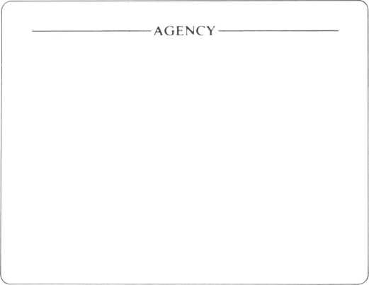

YAMAHA CORPORATION

YAMAHA CORPORATION

Address inquiries to:

Semi-conductor Sales Department

* Head Office 203, Matsunokijima, Toyooka-mura,

Iwata-gun, Shizuoka-ken, 438-01 Electronic Equipment business section Tel. 0539-62-4918 Fax. 0539-62-5054

* Tokyo Office 2-17-11, Takanawa, Minato-ku, Tokyo, 108

Tel. 03-5488-5431 Fax. 03-5488-5088

* Osaka Office 3-12-9, Minami Senba. Chuo-ku, Osaka City, Osaka, 542 Shinsaibashi Plaza Bldg. 4F Tel. 06-252-7980 Fax. 06-252-5615
* U.S.A. Office YAMAHA Systems Technology.

100 Century Center Court, San Jose, CA95112 Tel. 408-467-2300 Fax. 408-437-8791

**14**

Copying prohibited © 1987 YAMAHA CORPORATION 0.3K-1102 *C* Printed in Japan 85.11