**YAMAHA LSI**

YM2413B

OPLL

FM OPERATOR TYPE-LL

* OUTLINE

This LL-Type FM Operator incorporates a DA Converter and a Quartz Oscillator in addition to a YAMAHA original FM Sound Generator, allowing for a much easier and economical sound generating system assembly than conventional LSIs. Tone data are stored in ROM for software simplicity, making it possible to execute data alterations involved in tone changes with just one Instruments selection operation. Furthermore, a built-in Tone Data Register with capacity for one tone permits sound effects and original tones generation. Tones applicable to the “CAPTAIN” and TELETEXT are included among built-in tone data.

* FEATURES
* FM Sound Generator for real sound creation.
* Two selectable modes: 9 simultaneous sounds or 6 melody sounds plus 5 rhythm sounds (different tones can be used together in either case).
* Built-in Instruments data (15 melody tones, 5 rhythm tones, “CAPTAIN” and TELETEXT applicable tones).
* Built-in DA Converter.

•Built-in Quartz Oscillator.

* Built-in Vibrato Oscillator/AM Oscillator.
* TTL Compatible Input.
* A single 5V power source.

YAMAHA CORPORATION

YM2413B CATALOG  
CATALOG No.:LSI-212413B2  
1999.5

**YM2413B**

**■ PIN ASSIGNMENT**

**• YM2413B**

• YM2413B-F

|  |  |  |  |  |  |  |  |
| --- | --- | --- | --- | --- | --- | --- | --- |
| gndE |  | is | □ D1 | GND E | 1 K_ | *J* 24 | □ D1 |
| D2 E | 2 | 17 | □ do | D2 E | 2 | 23 | □ do |
|  | D3 E | 3 | 22 | □ NO |
| D3 E | 3 | 16 | □ vcc | D4 E | 4 | 21 | □ vcc |
| D4 E | 4 | 15 | □ ro | D5 E | 5 | 20 | □ ro |
| D5 E |  | 14 | □ mo | NO E | 6 | 19 | □ MO |
| 5 |  |
|  | D6 E | 7 | 18 | □ NC |
| D6 E | 6 | 13 | □ ic | NO E | 8 | 17 | □ ic |
| D7 E |  | 12 | □ cs | D7 E | 9 | 16 | □ nc |
| xinE |  |  | □ we | XIN E | 10 | 15 | □ cs |
| 8 | 11 | XOUT E | 11 | 14 | □ we |
| xoutE | 9 | 10 | □ ao | NO E | 12 | 13 | □ AO |

18 pin DIP Top View

24 pin SOP Top View

■ BLOCK DIAGRAM

AO WE CS XIN XOUT

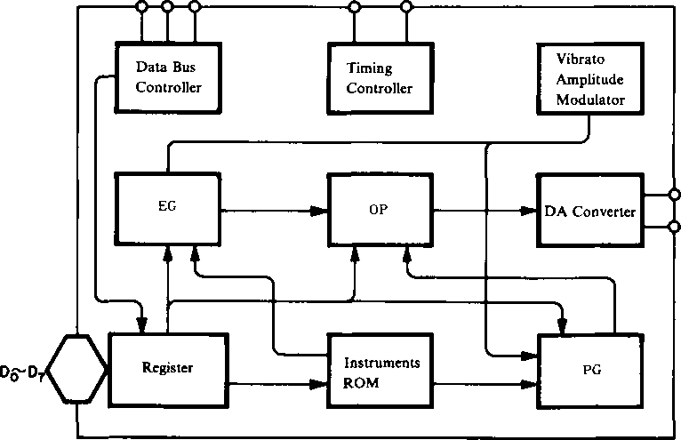

MO

RO

2

**YM2413B**

■ PIN FUNCTIONS

|  |  |  |  |
| --- | --- | --- | --- |
| **SYMBOL** | **I/O** | **FUNCTION** | |
| XIN XOUT | I O | A quartz oscillator (3.579545 MHz) is connected between these two pins. | |
| Do *I* D? | I/O | 8-Bit Data Bus for OPLL control. | |
| Ao CS  WE | I | For controlling the Do~D? Data Bus. | |
| CS WE Ao |  |
| 0 0 0  0 0 1  0 1 0 | Writes register address into OPLL.  Writes register contents into OPLL.  Outputs OPLL test data to Do/Di Pins. Normally not used. |
| 0 1 1  0 x x | OPLL Data Bus high impedance |
| ic | I | Resets the system when level is low, clearing OPLL Registers. | |
| MO RO | o | Melody (MO) and Rhythm (RO) Outputs. Both sound types are output by a source follower. Integrated circuitry and an amplifier are necessary for subsequent processing. | |
| Vcc | I | + 5V Power Pin. | |
| GND | — | Ground Pin. | |

Note: Please do not connect NC.

■ EXPLANATION OF FUNCTIONS

This OPLL is a FM Sound Generator LSI with a built-in 9-Bit DA Converter. It has two sound generation modes: 9 melody sounds or 6 melody sounds plus 5 rhythm sounds, both allowing for simultaneous generation of different tones. Selection between these two modes can be performed from the software. One of the special features of this LSI is its built-in Instruments ROM. As shown in the table hereunder, this ROM incorporates 15 melody tones and 5 rhythm tones, as well as all tones used for “CAPTAIN” and TELETEXT for easy application to “CAPTAIN” Adaptors and Character Multiplex TVs. Furthermore, a built-in Tone Register with capacity for one tone allows for sound effects and original sounds creation. By controlling the parameters of this register (E, wl, I and w2 in the equation below), all kinds of harmonic can be created on the basis of the sample wave wl.

FM = E sin (wit + I sin w2t)

Unlike conventional FM sound generators, this OPLL has a bulti-in Instruments ROM, per­mitting a substantial simplification of sound generation commands from the processor. First, the desired Instruments code is stored in the Instruments Selection Register. Then, after data has been input at the fixed intervals and timing, the unit starts generating sound. Processor automatic play can be easily performed by writing data appropriate to the music into the Sustain and Volume Registers. For using an original tone, the Instruments Selection Register must be cleared after writing data into the Tone Register as explained above. Rhythm sounds are generated by turning ON or OFF the corresponding bits in the Rhythm Control Register. In this case, the specified data must be input to the Key ON/OFF and F-Number Registers 8CH and 9CH.

3

**YM2413B**

**■ REGISTER MAP**

|  |  |  |  |  |  |  |  |  |  |
| --- | --- | --- | --- | --- | --- | --- | --- | --- | --- |
| Address | D7 Ds D5 D4 D3 D? Di Do | | | | | | | |  |
| **00**  **01**  **02**  **03**  **04**  **05**  **06**  **07** | A  M | V I  B | **E G**  **P** | K S  R | **MULTI** | | | | User Tone Register |
| KSL | | T L © | | | | | |
|  | DC | DM | F B | | |
| A R | | | | D R | | | |
| S L | | | | R R | | | |
| **0 E** |  | | R | BD | SD | TOM | T-CT | HH | Rhythm Control |
| **0 F** | TEST | | | | | | | | OPLL Test Data |
| **10**  **?**  **18** | F-Num. 0 ~ 7 | | | | | | | | F-Number LSB 8 bits |
| **20**  **i**  **28** |  | | S U s ON  OFF | K E Y ON  OFF | BLOCK 0 ~ 2 | | | F N u m 8 | F-Number MSB, Octave set  Key ON/OFF Register Sustain ON/OFF Register |
| **30**  **?**  **38** | INST. | | | | VOL | | | | Instruments Selection and Volume Register |

4

**YM2413B**

Register Contents

|  |  |  |  |
| --- | --- | --- | --- |
|  | **Address** | **Bit** |  |
| 1 | 00, 01 | D7 | Amplitude modulation ON/OFF switch |
| D6 | Vibrato ON/OFF switch |
| Ds | Sustained sound/decaying sound switch. 0: decaying sound 1: sustained sound |
| D4 | RATE key scale |
| Do~D3 | Controls MULTI sample wave - harmonics relationship |
| 2 | 02, 03 | Ds D? | LEVEL key scale |
| 3 | 02 | Do~Ds | Modulated wave total level. Modulation index control |
| 4 | 03 | D3 D4 | Carrier and modulated wave distortion waveform (flat wave rectification) ON/OFF switch |
| Do~D2 | FM feedback constant |
| 5 | 04, 05 | D4~D7 | Attack envelope change rate control |
| Do~D3 | Decay envelope change rate control |
| 6 | 06, 07 | D4~D7 | Indication of decay - sustain level |
| Do~D3 | Release envelope change rate control |
| 7 | 0E | Ds | Rhythm sound mode selection. 1: Rhythm sound mode 0: Melody sound mode |
| Do~D4 | Rhythm instruments ON/OFF switch |
| 8 | 10~ 18 | Do~D7 | F-Number LSB 8 bits |
| 9 | 20~28 | Ds | Sustain ON/OFF switch |
| D4 | Key ON/OFF |
| Di~D3 | Octave setting |
| Do | F-Number MSB |
| 10 | 3O~38 | D4~D7 | Instruments selection |
| Do~D3 | Volume data |

Tone Data

|  |  |  |  |
| --- | --- | --- | --- |
|  | **Instrument** |  | **Instrument** |
| 0 | Original | 8 | Organ |
| 1 | Violin | 9 | Hom |
| 2 | Guitar | 10 | Synthesizer |
| 3 | Piano | 11 | Harpsichord |
| 4 | Flute | 12 | Vibraphone |
| 5 | Clarinet | 13 | Synthesizer Bass |
| 6 | Oboe | 14 | Acoustic Bass |
| 7 | Trumpet | 15 | Electric Guitar |

5

WM

**YM2413B**

Envelope Waveforms

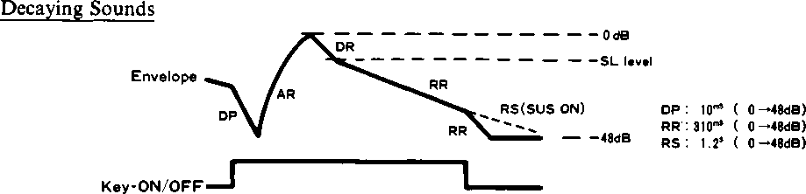

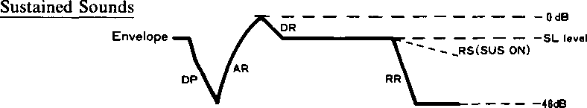

Key-ON/OFF



**■ TIMING DIAGRAMS (Standard timing settings are** Vih **= 2.0V,** Vil **= 0.8V)**

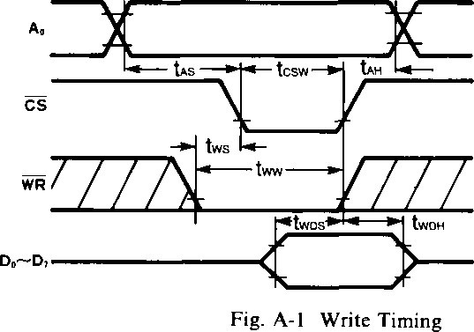

*twDs > 10ns : tcsw < t0MX7 twos > lO+tcsw-t0MX7ns

: tcsw > t0MX7

NOTE:

tcsw, tww and Iwdh have been measured with either CS or WR high.

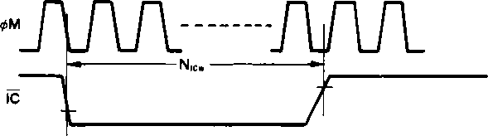

Fig. A-2 Reset Timing

6

**YM2413B**

**■ ELECTRICAL CHARACTERISTICS**

1. Absolute Maximum Ratings

|  |  |  |
| --- | --- | --- |
| **ITEM** | **RATING** | **UNIT** |
| Pin voltage | 0.3~7.0 | V |
| Ambient operating temperature | 0~70 | °C |
| Storage temperature | -50~125 | °C |

2. Recommended Operating Conditions

|  |  |  |  |  |  |
| --- | --- | --- | --- | --- | --- |
| **ITEM** | **SYMBOL** | **MIN.** | **TYP.** | **MAX.** | **UNIT** |
| Supply voltage | Vcc | 4.75 | 5 | 5.25 | V |
| GND | 0 | 0 | 0 | V |

3. DC Characteristics

|  |  |  |  |  |  |  |  |
| --- | --- | --- | --- | --- | --- | --- | --- |
| **ITEM** | | **SYMBOL** | **CONDITION** | **MIN.** | **TYP.** | **MAX.** | **UNIT** |
| High level input voltage | All input | VlH |  | 2.0 |  |  | V |
| Low level input voltage | All input | VlL |  |  |  | 0.8 | V |
| Leak input current | AO, WE | II | Vin = 0-5 V | -10 |  | 10 | |1A |
| Three-state (off) Input current | D0-D7 | I TSL | Vin = 0-5 V | -10 |  | 10 | pA |
| Analog output voltage | **MO** | Vmoa | Rload = 2.2Q peak to peak |  | 1.6 |  | V |
| RO | Vroa | Rload = 2.20 peak to peak |  | 1.6 |  | V |
| Pullup resistance | IC,CS | Ru |  | 100 |  |  | kQ |
| Input capacity | All input | Ci |  |  |  | 10 | PF |
| Output capacity | All input | Co |  |  |  | 10 | pF |
| Power current |  | I cc |  |  | 5 | 10 | mA |

4. AC Characteristics

|  |  |  |  |  |  |  |  |
| --- | --- | --- | --- | --- | --- | --- | --- |
| **ITEM** | | **SYMBOL** | **CONDITION** | **MIN.** | **TYP.** | **MAX.** | **UNIT** |
| Address setup time | Ao | **tAS** | Fig. A-l | 10 |  |  | ns |
| Address hold time | Ao | **tAH** | Fig. A-l | 10 |  |  | ns |
| Chip select write width | CS | **tcsw** | Fig. A-l | 80 |  |  | ns |
| Write pulse write width | WE | **tww** | Fig. A-l | 110 |  |  | ns |
| Write pulse set up | WE | **tws** | Fig. A-l | 30 |  |  | ns |
| Write data setup time | D0~D7 | **twDS\*** | Fig. A-l | 10 |  |  | ns |
| Write data hold time | Do~D7 | **twDH** | Fig. A-l | 25 |  |  | ns |
| Reset pulse width | IC | **Nicw** | Fig. A-2 |  | 80 |  | cycle |

7

w™

**YM2413B**

■ OUTLINE DIMENSIONS YM2413B

o  
co

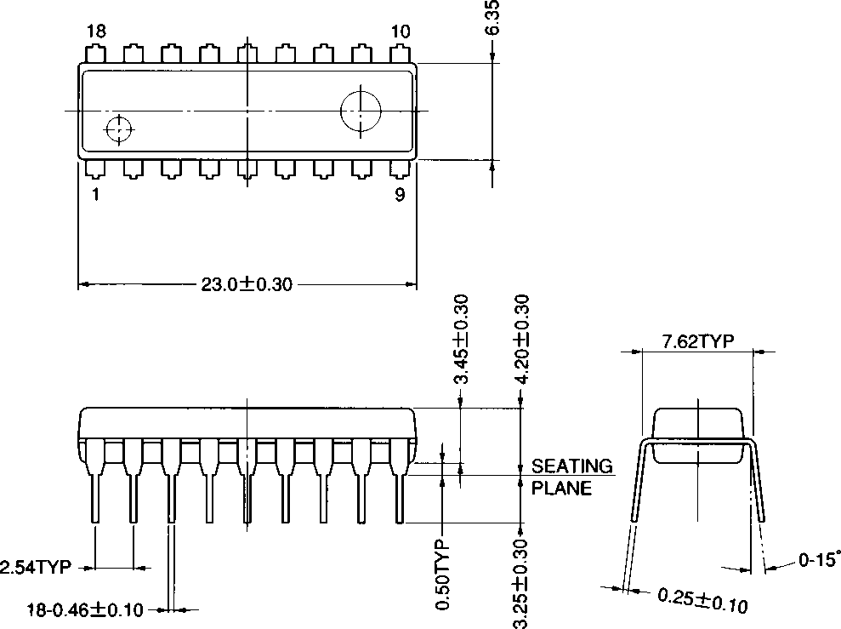

*t-Jls* K li A U £ '

Mti (UNIT): mm (millimeters)

8

**YM2413B**

WBK

YM2413B-F

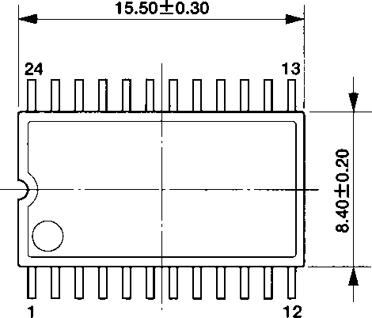

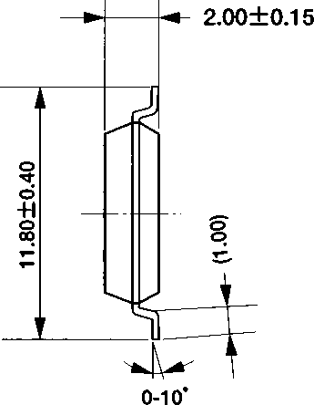

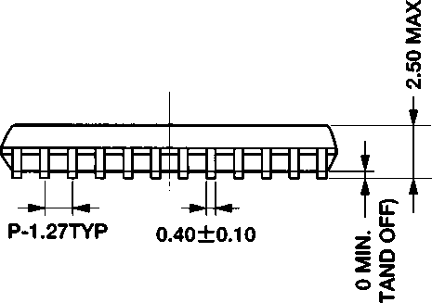

: 0.15±0.10 (LEAD THICKNESS)

**\* y □ 11 t T 5**

FW&Tf&liA'J

Mfi(UNIT): mm (millimeters)

The figure in the parenthesis ( )  
should be used as a reference.  
Plastic body dimensions do not  
include burr of resin.

UNIT: mm

Note : The LSIs for surface mount need especial consideration on storage and soldering conditions. For detailed information, please contact your nearest agent of yamaha.

**9**

**YM2413B**

IMPORTANT NOTICE

1. Yamaha reserves the right to make changes to its Products and to this document without notice. The information contained in this document has been carefully checked and is believed to be reliable. However, Yamaha assumes no responsibilities for inaccuracies and makes no commitment to update or to keep current the information contained in this document.

2. These Yamaha Products are designed only for commercial and normal industrial applications, and are not suitable for other uses, such as medical life support equipment, nuclear facilities, critical care equipment or any other application the failure of which could lead to death, personal injury or environmental or property damage. Use of the Products in any such application is at the customer’s sole risk and expense.

1. YAMAHA ASSUMES NO LIABILITY FOR INCIDENTAL, CONSEQUENTIAL OR SPECIAL DAMAGES OR INJURY THAT MAY RESULT FROM MISAPPLICATION OR IMPROPER USE OR OPERATION OF THE PRODUCTS.
2. YAMAHA MAKES NO WARRANTY OR REPRESENTATION THAT THE PRODUCTS ARE SUBJECT TO INTELLECTUAL PROPERTY LICENSE FROM YAMAHA OR ANY THIRD PARTY, AND YAMAHA MAKES NO WARRANTY OR REPRESENTATION OF NON-INFRINGEMENT WITH RESPECT TO THE PRODUCTS. YAMAHA SPECIFICALLY EXCLUDES ANY LIABILITY TO THE CUSTOMER OR ANY THIRD PARTY ARISING FROM OR RELATED TO THE PRODUCTS’ INFRINGEMENT OF ANY THIRD PARTY’S INTELLECTUAL PROPERTY RIGHT, INCLUDING THE PATENT, COPYRIGHT, TRADEMARK OR TRADE SECRET RIGHTS OF ANY THIRD PARTY.
3. EXAMPLES OF USE DESCRIBED HEREIN ARE MERELY TO INDICATE THE CHARACTERISTICS AND PERFORMANCE OF YAMAHA PRODUCTS. YAMAHA ASSUMES NO RESPONSIBILITY FOR ANY INTELLECTUAL PROPERTY CLAIMS OR OTHER PROBLEMS THAT MAY RESULT FROM APPLICATIONS BASED ON THE EXAMPLES DESCRIBED HEREIN. YAMAHA MAKES NO WARRANTY WITH RESPECT TO THE PRODUCTS, EXPRESS OR IMPLIED, INCLUDING, BUT NOT LIMITED TO THE WARRANTIES OF MERCHANTABILITY, FITNESS FOR A PARTICULAR USE AND TITLE.

The specifications of this product are subject to improvement changes without prior notice.

YAMAHA CORPORATION

AGENCY

**Address inquiries to:**

**Semiconductor Sales & Marketing Department**

**■ Head Office**

203, Matsunokijima, Toyooka-mura, Iwata-gun, Shizuoka-ken, 438-0192 Electronic Equipment Business section Tel. 81-539-62-4918 Fax. 81-539-62-5054

**■ Tokyo Office**

2-17-11, Takanawa, Minato-ku,

Tokyo, 108-8568

Tel. 81 -3-5488-5431 Fax. 81 -3-5488-5088

**■ Osaka Office**

Namba Tsujimoto Nissei Bldg. 4F 1-13-17, Namba Naka, Naniwa-ku, Osaka City, Osaka, 556-0011

Tel. 81 -6-6633-3690 Fax. 81 -6-6633-3691

**■ l .S.A. Office**

YAMAHA Systems Technology

100 Century Center Court, San Jose, CA 95112

Tel. 1-408-467-2300 Fax. 1-408-437-8791

Copying prohibited © 1987 YAMAHA CORPORATION

0.05K-0520 Printed in Japan 99.05