**YAMAHA *L 3***

YM2413

**FM OPERATOR TYPE-LL (OPLL)**

APPLICATION MANUAL

CATALOG No. *I* LSI»2424I32*

1987.9

* Sourced by Hi-Top MSX Club
* Scanned by Ricardo Bittencourt
* Bitmap cleanup, figures redraw, enhanced reference circuit and PDF generation by F^bio R. Schmidlin

**Table of Contents**

I. WHAT IS OPLL? I-I. Outline I

1-2. Features I

1-3. Sound Synthesis by FM I

H. FUNCTIONS n-1. Primary Functions 2

II - 2. Pin Assignmens 3

H-3. Pin Functions 3

n-4. Bus Control 4

H-5. Channels and Slots .. 5

II-6. Block Diagram 5

II-7. Register Map „ 6

HL DESCRIPTION OF OPERATION •HI-I. Registers 8

IH-2. Phase Generator (PG).. .............. 18

HI - 3. Envelope Generator (EG) ... ........ 18’

HI-4. Operator (OP) and DAC 19

IV. INTERFACING IV - 1. Clock Generation ....... 20

IV-2. Audio Output Interface _ 20

IV-3. Interfacing Microprocessor/Microcomputcr 21

V. SYNTHESIS OF MUSIC SOUNDS V- I. Procedure of Synthesizing Sounds 22

* -2. Fundamentals of Sound Synthesis 22
* -3. Examples of Sound Synthesis, .. 22
* -4. Procedure of Percussion Sound Synthesis 24

**VL ELECTRICAL CHARACTERISTICS**

**25**

**VOL TIMING DIAGRAMS - 26**

**VIE. OUTLINE DIMENSIONS 27**

1. **WHAT IS OPLL?**

**(1 — 1) Outline**

This LL-Type FM Operator incorporates a DA Converter and a Quartz Oscillator in addition to a YAMAHA original FM Sound Generator, allowing for a much easier and more economical sound generating system assembly than conventional LSIs. Tone data are stored in ROM for software simplicity, making it possible to execute data alterations involved in tone changes with just one Instruments selection operation. Furthermore, a built-in Tone Data Register with capacity to store one tone allows for the generation of sound effects and original tones. Tones applicable to the “CAPTAIN" and TELETEXT are included among built-in tone data.

**(1-2) Features**

* FM Sound Generator for real sound creation.
* Two selectable modes: 9 simultaneous sounds or 6 melody sounds plus 5 rhythm sounds (different tones can be used together in either case).
* Built-in Instruments data (15 melody tones. 5 rhythm tones. “CAPTAIN” and TELETEXT applicable tones).
* Built-in DA Converter.
* Built-in Quartz Oscillator.
* Built-in Vibrato OscillatonAM Oscillator.
* TTL Compatible Input.
* Si-Gate NMOS LSI.
* A single 5V power source.

**(I — 3) Sound Synthesis by FM**

This is a method that makes use of harmonics generated by modulation to synthesize musical sounds. Circuitry to realize this method is relatively simple and is capable of generating waveforms including high order harmonics and un-harmonious sounds. It is known that re­lationships between the modulation index and the spectrum of harmonics are so natural that it is possible to synthesize a wide variety of sounds from natural musical instruments to artificial sounds.

This method is expressed with four parameters as follows.

F = A sin (o>ct + I sin u) mt) (1)

Where A is the amplitude of output. I modulation index, oe and aim angular frequencies of carrier and modulator respectively. The equation (1) can be expressed alternatively as follows.

F = A (Jo (I) sin wet 4- Ji (I) (sin (oc 4- wm)t - sin (wc — com)t )

+• Ji (I) (sin (coc + 2wm)t + sin (cue - 2om)t + ] (2)

Where Jn (I) is the nth-order Bessel function of the first kind. The amplitude of each harmonic component is expressed as a Bessel function of the modulation index. Sound synthesis by FM is found to be useful to obtain specific musical sounds or sound effects. String sounds, however, cannot be obtained as the distribution of harmonics is not uniform. A method called

- 1 -

'Feedback FM’ has been incorporated to solve the problem. This method is characterized by the following equation.

F = Asin (ax:t + pF) (3)

Where 0 is the rate of feedback. The spectrum of harmonics produced by 'feedback FM’ has a saw-tooth waveform and therefore it can be used to synthesize string sounds.

Three function blocks, as follows, are needed to realize the above method of sound synthesis bv FM. <

1. Phase generator (PG) generating <ot
2. Envelope generator (EG) generating amplitude A and modulation index (1) which vary with time
3. sin table (SIN)

The method of sound synthesis by FM can be realized as shown in Figure I- 1 with units (operator ceils) which combine the three function blocks. By this method, all we have to do is to define a frequency parameter and EG parameters.

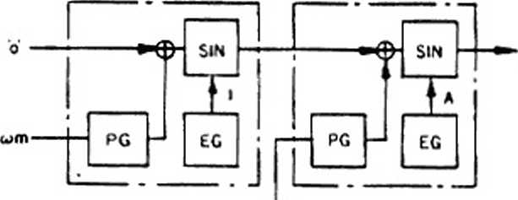

F(0

a. F(l)=ASlN (wct + l SIN wmt)



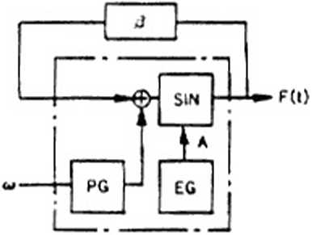

b . F(l) =A SIN(aH + 0F(l))

Figure i - I Sourd synthesis by FM with units

1. **FUNCTIONS**

**(II—I) Primary Functions**

This OPLL is an FM Sound Generator LSI with a built-in 9-Bit DA Converter. It has two sound generation modes: 9 melody sounds or 6 melody sounds plus 5 rhythm sounds, both allowing for simultaneous generation of different tones. Selection between these two modes can be performed from the software. One of the special features of this LSI is its built-in In­struments ROM. As shown in the table hereunder, this ROM incorporates 15 melody tones and 5 rhythm tones, as well as all tones used for “CAPTAIN” and TELETEXT. Furthermore, a built-in Tone Register with capacity to store one tone allows for the creation of sound effects and original sounds. By controlling the parameters of this register (E, mt, I and m2 in the equation below), all kinds of harmonics can be created on the basis of the sample wave wl.

FM = E sin (wit ■+■ I sin u>2i)

- 2 -

Unlike conventional FM sound generators, this OPLL has a built-in Instruments ROM. per­mitting a substantial simplification of sound generation commands from the processor. First, the desired Instruments code is stored in the Instruments Selection Register. Then, after data has been input at the fixed intervals and timing, the unit starts generating sound. Automatic Processor play can be easily performed by writing data appropriate to the desired music into the Sustain and Volume Registers. For using an original tone, the Instruments Selection Register must be cleared after writing data into the Tone Register as explained above. Rhythm sounds are generated by turning ON or OFF the corresponding bits in the Rhythm Control Register. In this case, the specified data must be input to the Key ON/OFF and F-Number Registers 8CH and 9CH.

(II-2) Pin Assignment

• YM2413B

GND

02

03 04

D5 06

D7

XIN

XOUT

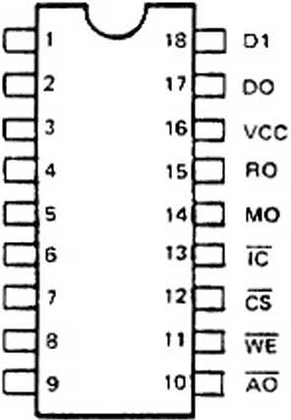

18 t»> Teo V-e*

• YM24I3BF

GND T

02 r do r

osC NC C

Dec NC E

07 E xinE

xovtE ncC

9

10

12

Joi  
loo  
Inc

Hvcc  
J RO

**24***n  
n*

21  
20

1»pM0 18 2NC 17 De 18 2 NC is DCS 14

is Hao

24 pin SOP Top View

**1 2**

5

(II-3) Pin Functions

|  |  |  |  |
| --- | --- | --- | --- |
| **SYMBOL** | **I/O** | **FUNCTION** | |
| XIN XOUT | I O | A quartz oscillator (3.579545 MHz) is connected between these two pins. | |
| Do *I* Dr | I/O | 8-Bil Data Bus for OPLL control. | |
| Ao CS  WE | I | For controlling the Do~D? Data Bus. | |
| CS WE Ao |  |
| 0 0 0  0 0 1  0 1 0 | Writes register address into OPLL.  Writes register contents into OPLL.  Outputs OPLL test data to Do, Di Pins. Normally not used. |
| 0 1 1  0 X X | OPLL Data Bus high impedance |
| ic | 1 | Resets the system when level is low. clearing OPLL Registers. | |
| MO  RO | o | Melody (MO) and Rhythm (RO) Outputs. Both outputs are source followers. Integrated circuitry and an amplifier are necessary for subsequent processing. | |
| V<x | 1 | + 5V Power Pin. | |
| GND | — | Ground Pin. | |

- 3 -

(II-4) Bus Control

The signals CS • WE and AO provide control in the data bus for items such as addressing the register in OPLL and read/wnte of the data. Namely, they select one of four operating modes as follows.

Table 11 - 1 Mode selection

|  |  |  |  |  |
| --- | --- | --- | --- | --- |
|  | **CS** | **WE** | **AO** |  |
| **1** | **1** | **X** | **X** | **Inactive mode** |
| **2** | **0** | **0** | **0** | **Address write mode** |
| **3** | **0** | **0** | **1** | **Data write mode** |
| **4** | **0** | **1** | **0** | **Bus inhibited** |

1. Inactive mode

The bus lines (Do - Dr) are at high impedance while CS is ’I'.

1. Address write mode

When writing an address, set the control signals to the address write mode and place the address data on the data bus. The address of the specified internal register is now ready to receive data. After writing an address, be sure to wait for 12 cycles of the master clock (0M) before writing in sound data.

1. Data write mode

When the control signals as set for the data write mode, the data existing on the data bus enters the register of the given address. Wait for 84 cycles of the master clock (oM) before writing in further data or another address.

1. Bus inhibited

In this mode, the data of the data bus is meaningless and uncontrollable.

Take note of the following regarding the address/data write modes.

OPLL needs a certain length of wail time between successive writings of addresses or data into the registers. The wait time vanes between the address and data write modes. The processor waits for a time shown in Table II-2 before OPLL performs another function. If the wait time is not observed data will be uncertain.

Table tl-2 Wait limes

|  |  |
| --- | --- |
| **Mode** | **Wait time** |
| **Address write** | **12 cycles** |
| **Data write** | **84 cycles** |

Note: The wail times are given in cycles of the master clock.

- 4 -

**(II-5) Channels and Slots**

OPLL can produce nine channels of FM sounds as it has two operator cells per channel. However the FM Generator system has only one operator cell, therefore, calculation for nine channels of FM sound is performed by passing through the operator cell 18 times. The order (slot number) of the pass through the operator cel) corresponds to the register number. Control of the sound production is effected by controlling the register associated with the slot.

Channel data, like the F-number. controls two slots. No. I and 2.

In FM mode, the No. I slot handles the modulating waves and the No.2 slot the carrier. The No. I slot can also be set for feedback FM mode. See (III - I -3) for setting this mode.

Table II - J Channels and Slots

|  |  |  |  |  |  |  |  |  |  |  |  |  |  |  |  |  |  |  |
| --- | --- | --- | --- | --- | --- | --- | --- | --- | --- | --- | --- | --- | --- | --- | --- | --- | --- | --- |
| **1** | **2** | **3** | **4** | **5** | **6** | * / | **8** | **9** | **10** | **11** | **12** | **13** | **14** | **15** | **16** | **17** | **18** | **Slot No.**  **Channel No.**  **Slot No. when a channel is seen**  **Relationship between the data of each channel and the register.** |
| **1** | **2** | **3** | **1** | **2** | **3** | **4** | **5** | **6** | **4** | **5** | **6** | **7** | **8** | **9** | **7** | **8** | **9** |
| **1** | | | **2** | | | **1** | | | **2** | | | **1** | | | **2** | | |
| **20** | **21** | **22** | **20** | **21** | **22** | **23** | **24** | **25** | **23** | **24** | **25** | **26** | **27** | **28** | **26** | **27** | **28** |

(Example $20 to $28)

(II-6) Block Diagram

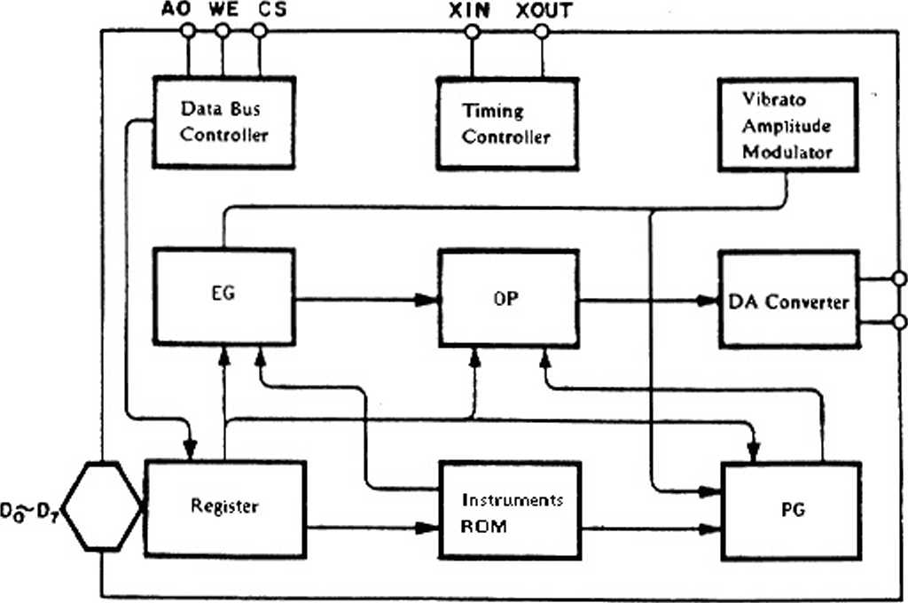

MO

R 0

- 5 —

**(II —7) Register Map**

|  |  |  |  |  |  |  |  |  |  |
| --- | --- | --- | --- | --- | --- | --- | --- | --- | --- |
| Address | **O Q □**  **•• O o Q**  **\* □ o Q** | | | | | | | |  |
| **00**  **01**  **02**  **03**  **04**  **05**  **06**  **07** | **A**  **M** | **V I**  **B** |  | **K S R** | **MULTI** | | | | User Tone Register  =© : Carner ® : Modulator |
| **KSL** | | **T L •** | | | | | |
|  | **DC** | **DM** | **F B** | | |
| **A R** | | | | **D R** | | | |
| **S L** | | | | **R R** | | | |
| **0E** |  | | **R** | **BD** | **SD** | **TOM** | **T-CT** | **HH** | Rhythm Control |
| **0 F** | **TEST** | | | | | | | | OPLL Test Data |
| **10**  **e**  **18** | **F-Num. 0 - 7** | | | | | | | | F-Number LSB 8 bits |
| **20**  *i*  **28** |  | | **S U s**  **ON**  **OFF** | **K E Y ON**  **OFF** | **BLOCK 0-2** | | | **F I N u m 8** | F-Number MSB, Octave set  Key ON/OFF Register  Sustain ON/OFF Register |
| **30 ?**  **38** | **INST.** | | | | **VOL** | | | | Instruments Selection and Volume Register |

**Register map for Rhythm mode (addr. SOE** Dj **- *H*)**

|  |  |  |  |
| --- | --- | --- | --- |
| 36  37 | HH-VOL | BD-VOL  SD-VOL | Rhythm volume register |
| 38 | TOM-VOL | T-CY-VOL |  |

- 6 -

**Register Contents**

|  |  |  |  |
| --- | --- | --- | --- |
|  | **Address** | **Bit** |  |
| 1 | 00: ® 01 :© | D' | Amplitude modulation ON/OFF switch |
| D* | Vibrato ON/OFF switch |
| Ds | Sustained tone/decaying tone switch. 0: Percussive tone 1: sustained tone |
| Da | RATE key scale |
| Do — Ds | Controls MULTI sample wave • harmonics relationship |
| 2 | 02. 03 | Da D> | LEVEL key scale S02 : ®. S03 : © |
| 3 | 02 | Do— Ds | Modulator total level. Modulation index control |
| 4 | 03 | Da:©  Ds: ® | Carrier and modulated wave distortion waveform (Hat wave rectification) ON/OFF switch |
| Do — D2 | FM feedback constant: ® |
| 5 | 04 : ® 05:© | D4-D7 | Attack envelope change rate control |
| Do —Ds | Decay envelope change rate control |
| 6 | 06 : ® 07:© | Da— D? | Indication of decay - sustain level |
| Do—Ds | Release envelope change rate control |
| 7 | 0E | D$ | Rhythm sound mode selection. 1: Rhythm sound mode 0: Melody sound mode |
| Do- Da | Rhythm instruments ON/OFF switch |
| 8 | 10-18 | Da-D? | F-Number LSB 8 bitt |
| 9 | 20-28 | Dj | Sustain ON/OFF switch |
| Da | Key ON/OFF |
| Di — Ds | Octave setting |
| Do | F-Number MSB |
| 10 | 30-38 | Da-Dr | Instruments selection |
| Do —Ds | Volume data |

**Tone Data**

|  |  |  |  |
| --- | --- | --- | --- |
| **INST** | **Instrument** | **INST** | **Instrument** |
| 0 | Original | 8 | Organ |
| 1 | Violin | 9 | Horn |
| 2 | Guitar | 10 | Synthesizer |
| 3 | Piano | II | Harpsichord |
| 4 | Flute | 12 | Vibraphone |
| 5 | Clarinet | 13 | Synthesizer Bass |
| 6 | Oboe | 14 | Acoustic Bass |
| 7 | Trumpet | 15 | Electric Guitar |

|  |  |
| --- | --- |
|  | **Instrument** |
| BD | Bass drum |
| SD | Snare drum |
| TOM | Tom-tom |
| TCY | Top Cymbal |
| HH | High hat |

- 7 -

**01. DESCRIPTION OF OPERATION**

AU functions of the OPLL are controlled by data written in a register array by the processor. The data specifies the sound envelope shape, the degree of modulation, frequency, and output mode, etc. A complete set of data defines the sound as that of a piano or violin, etc. For the use of complex varieties of data sets see "Synthesis of music sounds”.

**(HI —** 1) **Registers**

A register comprises an area of 271 bits, as shown in the address map II - 7. The address referred to here is the sub-address assigned to each register of the OPLL. Musical sound data will be written into a register referred lb by the sub-address. To store a data in the OPLL. we send a sub-address then the sound data. If we access a location having the same sub-address many times, we only have to send the sub-address the first time. In subsequent accesses, we can send sound data alone to renew old data.

All registers are cleared to 0 by initialization (initial clear: IC terminal = 0).

**(TH—I —1) TEST: ADDRESS |$0F]**

This address is established to test this LSI.

Normally all addresses are 0.

**(IH-1-2) AM/VIB/EG-TYP/KSR/MULTIPLE : ADDRESS ($00. $011**

This register controls the multiplying factor that converts F-number into the carrier ($01) and modulator ($00) frequencies which matches the sound frequency components, and the envelope shape etc.

SOO, SO1

|  |  |  |  |  |
| --- | --- | --- | --- | --- |
| **Dr** | **D«** | de | d4 | **D? Di Di Do** |
| **s**  **<r** | VIB | EG-TYP | KSR | MULTI  **23 21 2’ 2°** |

Do - Ds (MULTIPLE) : The frequencies of the carrier wave and the modulated wave are controlled according to the multiplying factors in Table HI - I.

< Example > F (t) = E sin (oift + I sin (7 <nft))

Frequency according to F-number wf

Carrier multiple I

Modulator multiple 7

- 8 -

Table HI - I Multiplying factors

|  |  |  |  |  |  |  |  |
| --- | --- | --- | --- | --- | --- | --- | --- |
| **MUL** | **Multiplication factor** | **MUL** | **Multiplication 'actor** | **MUL** | **Multiplication factor** | **MUL** | **Multiplication factor** |
| **0** |  | **4** | **4** | **8** | **s** | **C** | **12** |
| **1** | **i** | **5** | **5** | **9** | **9** | **0** | **12** |
| **2** | **2** | **6** | **6** | A | **10** | **E** | **IS** |
| **3** | **3** | **7** | **7** | **8** | **10** | **F** | **IS** |

D4 (KSR) : This bit specifics the key scale of RATE.

Since almost all musical steps become high for natural instruments, the sound can quikly change to high or low. This is accomplished by the key scale of RATE. Values in Table III -2 include the speed offset for the musical steps. Therefore, the actual RATE set for the ADSR will be these values which include the offset.

RATE = 4 x R + R ks

o R is the set value for ADSR  
o R ks is the key scale offset value  
o Note that when R = 0, RATE = 0

Table HI -2

|  |  |  |  |  |  |  |  |  |  |  |  |  |  |  |  |  |
| --- | --- | --- | --- | --- | --- | --- | --- | --- | --- | --- | --- | --- | --- | --- | --- | --- |
| **0** | | **1** | | **2** | | **3** | | **4** | | **5** | | **6** | | **7** | | **Octave**  **8LOCK Otti**  **F-Num-MSB**  **D4 = 0 key scale**  **D4 = 1 off set** |
| **0** | |  |  | **2** | | **3** | | **4** | | **5** | | **6** | | **7** | |
| **0** | **1** | **0** | **1** | **0** | **1** | **0** | **1** | **0** | **1** | **0** | **1** | **0** | **1** | **0** | **1** |
| **0** | **0** | **0** | **0** | **1** | **1** | **1** | **1** | **2** | **2** | **2** | **2** | **3** | **3** | **3** | **3** |
| **0** | **1** | **2** | **3** | **4** | **5** | **6** | **7** | **8** | **9** | **10** | **II** | **12** | **13** | **14** | **15** |

Ds (EG-TYP) : Switching between sustained tone and Percussive tone.

When Ds = “0.” it will be percussive tone. When Ds = “Iit will be sustained tone. These sound modes are different in that the RELEASE RATE usage differs. The difference is shown in Figure III - I.

- 9 -

Percussive Tone (Ds = 0)

DR

-Ode

**Envelope**

SL level

AR

RR

DP

RS(SUS ON) RR’X*'

—48dB

dp : 10"*

RR’: 310**

RS : 1.2*

( 0 -48d8)

( 0 *48dB)

( 0-48dB)

**Key-ON/OFF**

Sustained Tone (Ds = I)

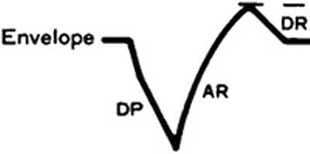

Key-ON/OFF

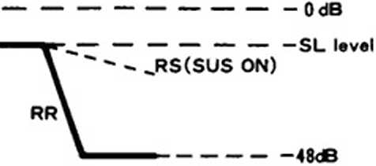

"If

Da (VIB) : Vibrato on/off switch. When this bit is “I”, vibrato will be applied to the slot. The frequency is 6.4 Hz *((a) 0* M = 3.6 MHz).

Di (AM) : Amplitude modulation on/off switch. When this bit is ‘T, amplitude modulation will be applied to the slot. The frequency is 3.7 Hz (@ 0 M = 3.6 MHz).

**(ID - 1 - 3) KSL/TOTAL LEVEL/DISTORTION/FEED BACK LEVEL : ADDRESS j$02, $03|** Total Level is used to control the modulation index (tone) by adding attenuation to the output of the envelope generator. Level key scale (KSL) ensures, like the key scale of RATE, that the output level of natural musical instruments falls as the pitch of sound rises.

$02

$03

|  |  |
| --- | --- |
| **D? De** | **Ds D+ Ds D2 Di Do** |
| **KSL** | **Total Level** |
|  | **DC DM FB** |

Do - Ds (Total Level) : The minimum resolution of the attenuation level is 0.75 dB and the sound level can be reduced down to 47.25 dB.

- 10 -

Table m — 3 Total level

|  |  |  |  |  |  |  |
| --- | --- | --- | --- | --- | --- | --- |
|  | d5 | d4 | **Dj** | **Da** | **Di** | **D«** |
| **Attmuition lev^** | **CD** | **33** | **Q X)** | **CD** | **S 08** | ***CD 2*** |
|  | **(VI** | **<XJ**  **—•** | **uO** |  | **—** | *6* |

D* • D? (KSL) : This bit controls the level of key scaling. In key scale mode, the level of attenuation increases as pitch rises, to 1.5 dB/oct. 3dB?oct. 6 dB/oct. and 0 dB/oct.

Table HI-4

|  |  |  |
| --- | --- | --- |
| **D,** | *Dt* | **Attenuation rate** |
| **0** | *0* | **0** |
| **1** | **0** | **I.SdB/OCT** |
| **0** | **1** | **3 dB/OCT** |
| **1** | **1** | **6 dB/OCT** |

Table III-5 Attenuatioa at each F-Number at 3 dB/OCT.

iV’i 0x1i2x3x4tSi6i7i

’ oct\ 1 8 t 9 I 10 < Il 1 12 1 13 • 14 t 15 t

I ( j j ( ( । ( _ j (

I Q I 0.000 ( 0.000 I 0.000 I 0.000 I 0.000 I 0.000 1 0.000 1 0.000 t

I I 0.000 I 0.000 I 0.000 I 0.000 I 0.000 I 0.000 I 0.000 I 0.000 I

I r I J [ ■ I — I —— « — — _ £ ■ ■ ■ ■ I *.»«.**«*.» I — — _ - — |

1 . I 0.000 I 0.000 t 0.000 I 0.000 I 0.000 I 0.000 I 0.000 I 0.000 I

I I 0.000 I 0.750 I 1.123 t 1.500 I 1.873 t 2.250 1 2.625 t 3.000 1

I • ■ I { ———————— ( ———————— | ———————— J ———————— [ — — —————— ( ———————— ( -—— — — ——» g

t 2 1 0.000 I 0.000 1 0.000 I 0.000 J 0.000 I 1.123 I 1.6 75 I 2.623 I

I 4 I 3.000 I 3. 7S0 I 4.125 I 4-500 1 4-675 I 5.250 I 5.625 1 6.000 1

1. “ I ———————— I —— — —— — — I —_ J ———— — — — — I — —— — — — — I —— — — — ——— I — — — — — — J

I « I 0.000 I 0.000 t 0.000 I 1.875 1 3.000 1 4. 123 I 4.875 1 3.625 I

I J 1 6.000 I 6.750 S 7.125 I 7.500 I 7. 875 1 8.250 *I* 9.625 ( 9.000 1

I — — — [ — — — — — — [ — — — — — — — — [ ———— — — — [ ——————— — g — — — — — — — g —— — — — — — I — — — — — — — — ( — —— .. ———— I

I x I 0.000 1 0.000 I 3.000 1 4.075 I 6.000 I 7.123 1 7.875 I 8.623 I

I q I 9.000 < 9.750 I 10.125 I 10.500 1 10.675 I 11.250 I 11.625 I 12.000 I

j 1 J [ 1 । , 1 । j

I c I 0.000 1 3.000 1 6.000 I 7.675 I 9.000 I 10.125 I 10.875 1 11.623 t

( ° 1 12.000 1 12.750 1 13. 125 I 13.500 I 13.875 J 14.250 I 14.625 I 15.000 1

I I ———————— I — — — — — — — — I — — — — — — — — I — — — — — —— I — — — — — — — J — —— — — — J — — — — — — —— J — — — — — — g

I g 1 O. U'» I 6.000 1 9.000 1 10.675 I 12-000 I 13.125 I 13.875 1 14.625 I

I ” I 15.000 1 15.750 I 16.125 t 16.500 I 16.875 1 17.250 I 17.625 1 18.000 I

t I ( I ( ( | - ( t (

I 7 I 0.000 I 9.000 I 12.000 I 13.8 75 ) 15.000 I 16.125 I 16.875 ( 17.623 t

I I 18.000 I 18.750 *I* 19.125 1 19.500 1 19.675 I 20.250 1 20.625 I 21.000 1

1. — — — — — f ——— — — — — — g —— — — — — —— | — — — — — — — — | — — — — — — — — £ — — — — — — — — J -r — — — — — — — J — —— — — — — — ( — — — — — — — —|

UNIT dB

Notes:

* F-Number is the value of the four MSBs..
* Half of the above data at 1.5 d8/oct
* Double of the above data at 6 d0/oct

S03

Ds DM : The modulated wave is rectified to half wave.

D4 DC : The earner wave is rectified to half wave.

S03

De to D: (FEEDBACK) : For the modulated wave of the first slot's feedback FM modulation.

Table III-6 Modulation index

|  |  |  |  |  |  |  |  |  |
| --- | --- | --- | --- | --- | --- | --- | --- | --- |
|  | **0** | **1** | *2* | 3 | **4** | **5** | **6** | **7** |
| **Modulation index** | **0** | *nA 6* | V8 | ’/4 |  | **rr** | *2x* | **4»r** |

**(ID - 1 - 4) ATTACK/DECAY RATE : ADDRESS l$04~$05]**

Attack Rate defines the attack time of the sounds, and Decay Rate the decay time. The Rates are set as given in Table III-7.

|  |  |  |  |  |  |  |  |  |  |
| --- | --- | --- | --- | --- | --- | --- | --- | --- | --- |
|  | **D7** | **D6** | **Ds** | **D4** | D3 | Dz | Di | Do |  |
|  |  | **AR** |  |  |  | **DR** |  |  |  |
| **$04** | **2’** | **2\*** | **2’** | **2\*** | **2’** | **2\*** | **21** | **2°** | **Modulator** |
| **$06** | **2»** | **2\*** | **2’** | **2\*** | **2’** | **2\*** | **21** | **2«** | Carrier |

**(01-1-5) SUSTAIN LEVEL/RELEASE RATE : ADDRESS [S06~S07|**

Sustain Level is the critical point that, when sustaining sound has been attenuated to the presenbed level, the level is maintained thereafter. With percussive tone, it is the critical point of change from decay mode to release mode.

Release Rate is the disappearing rate of sustaining sounds after key OFF. For percussive tone, attenuation above the sustain level is expressed with decay rate and attenuation below the sustain level with release rate.

|  |  |  |  |  |  |  |  |  |
| --- | --- | --- | --- | --- | --- | --- | --- | --- |
| **$06** | **D?** | **D6** Ds | | **D4** | **Dl** | **D2** Di | **Do** | **Modulator** |
| **2408** | **SL** | | **3d 8** | **2’** | **RR 2* 2’** | **2°** |
| **1208** | **6dB** |
| **$07** | **24d8** | **12d8** | **6dB** | **3d8** | **2»** | **2* 2i** | **2°** | **Carrier** |

* Attenuation tim.es of the release rate are the same as that o’ the decay rate

- 12 -

TABLE DI -7 ATTACK AND DECAY TIMES IN RELATION TO RATE

RATE given below is that of the after key scale. RATE - RM x 4 + RL

|  |  |  |  |  |  |
| --- | --- | --- | --- | --- | --- |
| **♦♦♦♦♦♦♦♦♦** | **EG OECAV TIME** | **♦♦♦♦♦♦♦♦♦♦** | **TXTTTTTTY** | **EG ATTACK TIME** | **TTTTTTT** |
| **RATE** | **(•S)** | **(aS)** | **RATE** | **(»S)** | **(■5)** |
| **RM-RL** | **8d0 - 48dB** | **10*4 - 90*4** | **RM-RL** | **8d8 - 40d8** | **10t» 9lt** |
| **15 3** | **1. 27** | **8.52** | **15 0** | **8.00** | **0.00** |
| **15 2** | **1. 27** | **0.52** | **15 0** | **8.08** | **0. 00** |
| **15 1** | **I. 27** | **0.52** | **15 0** | **6.00** | **0.00** |
| **15 G** | **1.27** | **8.52** | **15 8** | **6. 00** | **0. 00** |
| **14 3** | **1.47** | **0.60** | **14 3** | **0. 14** | **0. 10** |
| **14 2** | **1.71** | **8. 68** | **14 2** | **0. 18** | **8. 12** |
| **14 1** | **2.05** | **8.82** | **14 1** | **8.22** | **0. 14** |
| **14 G** | **2. 55** | **1 . 83** | **14 6** | **8. 28** | **8. 18** |
| **13 3** | **2. M** | **1. 21** | **13 3** | **8. 30** | **0.22** |
| **13 2** | **3. 42** | **1.37** | **13 2** | **8. 34** | **0.22** |
| **13 1** | **4.18** | **1.65** | **13 1** | **8.42** | **8.26** |
| **13 0** | **5.11** | **2. 85** | **13 8** | **8. 58** | **0.32** |
| **12 3** | **5.87** | **2. 41** | **12 3** | **8.54** | **8.36** |
| **12 2** | **6.84** | **2. 74** | **12 2** | **8.60** | **0.38** |
| **12 1** | **8.21** | **3. 30** | **12 1** | **0.70** | **8.44** |
| **12 0** | **10.22** | **4. 18** | **12 0** | **0.84** | **0.54** |
| **11 3** | **11.75** | **4. 83** | **11 3** | **8. 97** | **8.64** |
| **11 2** | **13.68** | **5. 47** | **11 2** | **I. 13** | **0.72** |
| **11 1** | **16.41** | **6. 68** | **11 1** | **I. 37** | **8.84** |
| **I 1 0** | **20.44** | **8. 21** | **11 8** | **1.69** | **1.09** |
| **te 3** | **23.49** | **9. 65** | **10 3** | **1.93** | **1.29** |
| **10 2** | **27. 36** | **10.94** | **18 2** | **2.25** | **1.45** |
| **If* 1** | **32. 83** | **13. 19** | **IB 1** | **2.74** | **1.69** |
| **10 0** | **40.87** | **16.41** | **10 0** | **3.38** | **2. 17** |
| **9 3** | **46.99** | **19.31** | **9 3** | **3. 86** | **2.57\*** |
| **9 2** | **54. 71** | **21.80** | **9 2** | **4.51** | **2.98** |
| **9 1** | **65.65** | **26. 39** | **9 1** | **5. 47** | **3.38** |
| **9 0** | **81.74** | **32. 83** | **9 0** | **6.76** | **4.34** |
| **8 3** | **93. 97** | **38. 62** | **8 3** | **7.72** | **5. 15** |
| **8 2** | **189.42** | **43. 77** | **8 2** | **9.01** | **5. 79** |
| **A 1** | **131.31** | **52. 78** | **8 1** | **10.94** | **6.76** |
| **8 0** | **163.49** | **65. 65** | **0 0** | **13.52** | **8.69** |
| **7 3** | **187.95** | **77. 24** | **7 3** | **15.45** | **18. 38** |
| **7 2** | **218.84** | **87.54** | **7 2** | **18.02** | **11.59** |
| **7 1** | **262.61** | **105.56** | **7 1** | **21.88** | **13.52** |
| **7 0** | **326.98** | **131.31** | **7 0** | **27.83** | **17. 38** |
| **6 3** | **375.90** | **154.48** | **6 3** | **38.98** | **20.68** |
| **£ 2** | **437.69** | **175.87** | **6 2** | **36.84** | **23.17** |
| **6 1** | **525.22** | **211. 12** | **6 1** | **43.77** | **27.03** |
| **6 0** | **653.95** | **262.61** | **6 8** | **54.07** | **34. 76** |
| **5 3** | **751.79** | **388.96** | **5 3** | **61.79** | **41. 19** |
| **5 2** | **875. 37** | **350. 15** | **5 2** | **72.89** | **46.34** |
| **5 1** | **1858.45** | **422.24** | **5 1** | **87.54** | **54.87** |
| **5 0** | **I 307.91** | **525.22** | **5 6** | **108.13** | **69.51** |
| **4 3** | **1583.58** | **617.91** | **4 3** | **123.58** | **82.39** |
| **4 2** | **I 750.75** | **780.30** | **4 2** | **144.18** | **92.69** |
| **4 1** | **2 1 88.8“** | **844.48** | **4 1** | **175.07** | **100.13** |
| **4 0** | **2615.82** | **1858.45** | **4 8** | **216.27** | **139.03** |
| **3 3** | **1007.16** | **1235.82** | **3 3** | **247. 16** | **164.78** |
| **3 2** | **3501.49** | **I 488.66** | **3 2** | **288.36** | **185.37** |
| **3 1** | **1201. .'9** | **1688. 95** | **3 1** | **350. 15** | **216.27** |
| **3 0** | **5231.64** | **2180.89** | **3 8** | **432.54** | **278.06** |
| **2 3** | **6014.32** | **2471.64** | **2 3** | **494.33** | **329.55** |
| **2 2** |  | **2801.19** | **2 2** | **576.72** | **378.75** |
| **2 1** | **840’.. 5$** | **33 7,7. 9’** | **2 1** | **700.30** | **432.54** |
| *2* **9** | **1 84t.3. 31’** | **4201.79** | **2 8** | **865. 08** | **556. 12** |
| **1 3** | **12028.60** | **4943 . /'ft** | **1 3** | **988.66** | **659.11** |
| **1 2** | **14006.80** | **5602.39** | **1 2** | **1153.43** | **741.49** |
| **1 1** | **16887.?0** | **e.755. 82** | **1 1** | **1400.68** | **863.80** |
| **1 0** | **20“26.60** | **840 3. r.p.** | **I 8** | **1730.15** | **1112.24** |

Note: When RATE is "O’, the envelope well not change.

-13 -

**(01- 1-6) BLOCK/F-NUMBER : ADDRESS ($A0-SB8|**

Data defining a musical scale and interval. The F-Number is contained in the registers $l*and $2x.

|  |  |  |  |  |  |  |  |
| --- | --- | --- | --- | --- | --- | --- | --- |
| **S1O-S18** | D? | *De* | Ds | **D4 Dj** | Dz | Di | Do |
|  | 27 | 26 | 25 | F-Number  24 25 | 22 | 2’ | 2° |

$20^ $28

|  |  |  |  |  |
| --- | --- | --- | --- | --- |
| D? *De* | Ds | D4 | D? Dz Di | Do |
|  | •s u S  ON oTf | *K* E Y  ON oTf | BLOCK  22 21 2° | F i N U M 2s |

Dd~D? [$1x]. Do [$2*] (F-Number):

The F-Number is defined with 8 bits of the $1* register and LSB of $2*, for a total of 9 bits. This F-Number defines a scale (how a value is assigned to the F-numbcr is described later.)

Di —D? (BLOCK) : Defines octave information.

D« (Key-ON) : This bit indicates the ON/OFF state of the key. When this bit is the

associated channel is on and sound is produced. ‘ 0” is equivalent to Kcy-OFF.

Ds (SUS-ON/OFF) : When this bit is "1”. the RR with the key off will be 5.

* F-Number/Block

The OPLL generates the necessary frequency when an appropriate increment of phase is given. The increment is determined by F-Number. Block, and Multiple information. The following formula gives the increment for a desired frequency.

- P = fmus ♦ 2is/fsam Q

fsam = fM/72

fmus : Desired frequency

fsam : Sampling frequency (50 kHz)

fM : Input clock frequency (3.6 MHz)

14 -

Because the increment value specification occupies many bits, we can give the increment within an octave and shift the value to double. 4 times, etc. for a specific octave. Then the increment is expressed as follows.

AP“ 2#«F’» MUL ®

B : Octave information F* : Increment within an octave MUL : Multiple data

From equation ® and ® the increment (F*) is expressed with I bit. F-Number and Block are expressed as follows.

F = (fmus * 218/fsam) /2b l @ Mui = I

F : F-Number data

b : Block data

Table m-8-1 F-Number (1)

|  |  |  |  |  |  |  |  |  |  |  |  |
| --- | --- | --- | --- | --- | --- | --- | --- | --- | --- | --- | --- |
| **Sound steps** | **Frequency (4 octi** | **F-Number** | **$2* ;** | | | | **51\*** | | | | |
| **DO 1** | **D?** | **Di** | **05** | **D4** | Dj | **Di** | **Di** | **Do** |
| **c#** | **277.2** | **181** | **0 i** | **1** | **0** | **I** | **1** | **0** | **1** | **0** | **1** |
| **D** | **293.7** | **192** | **0 !** | **1** | **1** | **0** | **0** | **0** | **0** | **0** | **0** |
| **D\*** | **311.1** | **204** | **0 I** | **I** | **1** | **0** | **0** | **1** | **1** | **0** | **0** |
| **E** | **329.6** | **216** | **0 1** | **1** | **1** | **0** | **1** | **1** | **0** | **0** | **0** |
| **F** | **349 2** | **229** | **0 I** | **1** | **1** | **1** | **0** | **0** | **I** | **0** | **1** |
| **F#** | **370.0** | **242** | **o ;** | **1** | **1** | **1** | **1** | **0** | **0** | **1** | **0** |
| **G** | **392.0** | **257** | **[ 1** | **0** | **0** | **0** | **0** | **0** | **0** | **0** | **I** |
| **G\*** | **415.3** | **272** | **1 1** | **0** | **0** | **0** | **1** | **0** | **0** | **0** | **0** |
| **A** | **440.0** | **288** | **1 1** | **0** | **0** | **I** | **0** | **0** | **0** | **0** | **0** |
| **A\*** | **466.2** | **305** |  | **0** | **0** | **1** | **1** | **0** | **0** | **0** | **1** |
| **B** | **493.9** | **323** | **1 1** | **0** | **1** | **0** | **0** | **0** | **0** | **1** | **1** |
| **C\*** | **523.3** | **343** | **। :** | **0** | **1** | **0** | **1** | **0** | **I** | **I** | **1** |

- 15 -

TabieJn-8-2 F-Number (2)

|  |  |  |  |  |  |  |  |  |  |  |
| --- | --- | --- | --- | --- | --- | --- | --- | --- | --- | --- |
| Sound steps | Frequency (4 — 5 oct) | F-Number | $2* | | | | $1* | | | | |
| **Do । 07** | **D<** | **Ds** | **D<** | **Di** | Dj | **Di** | **Do** |
| **G** | **392.2** | **257** | **1 ' 0** | **0** | **0** | **0** | **0** | **0** | **0** | **1** |
| **G\*** | **415.3** | **272** | **1 l o** | **0** | **0** | **I** | **0** | **0** | **0** | **0** |
| **A** | **440.0** | **288** | **I ' 0** | **0** | **I** | **0** | **0** | **0** | **0** | **0** |
| **A\*** | **466.2** | **305** | **1 | 0** | **0** | **1** | **1** | **0** | **0** | **0** | **I** |
| **B** | **493.9** | **323** | **1 1 0** | **1** | **0** | **0** | **0** | **0** | **1** | **1** |
| **C** | **523.3** | **343** | **1 i 0** | **1** | **0** | **I** | **0** | **1** | **1** | **1** |
| **C\*** | **554.4** | **363** | **’ ! 0** | **I** | **1** | **0** | **1** | **0** | **I** | **I** |
| **D** | **587.3** | **385** | **i । i** | **0** | **0** | **0** | **0** | **0** | **0** | **1** |
| **D\*** | **622.2** | **408** | **1 1 1** | **0** | **0** | **1** | **I** | **0** | **0** | **0** |
| **E** | **659.3** | **432** | **i । i** | **0** | **1** | **1** | **0** | **0** | **0** | **0** |
| **F** | **698.5** | **458** | **> :1** | **1** | **0** | **0** | **j** | **0** | **1** | **0** |
| **F\*** | **740.0** | **485** | **i • 1 i** | **I** | **1** | **0** | **0** | **1** | **0** | **I** |

(in

**1-7) RHYTHM : ADDRESS (SOE]**

To control ON/OFF of the Rhythm mode selection and percussion instruments.

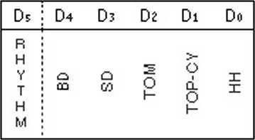

Do^Dj (RHYTHM) : When D5 = 1, OPLL is in Rhythm mode with percussion sounds produced through channels 7-9 (see page 5). In this mode, the melody section is limited to six sounds. Do- D* controls ON/OFF of percussion instruments. Therefore the Key-ON bits $26. $27. $28 must always be cleared to 0. Slots 13 — 18 are related with percussion sounds as shown in Table IH-9. and data of F Num must input values that match percussion sounds.

Table HI — 9 Rhytbm siols

|  |  |
| --- | --- |
| **Instrument** | **Slot** |
| **B0** | **13.16** |
| **SD** | **17** |
| **TOM** | **IS** |
| **T0P-CYM** | **18** |
| **HH** | **14** |

|  |  |
| --- | --- |
| **Address** | **Data** |
| **16** | **20** |
| **17** | **50** |
| **18** | **CO** |
| **26** | **05** |
| **27** | **05** |
| **28** | **01** |

- 16 -

**(Ill-1-8) INSTRUMENT/VOLUME: ADDRESS {$30-S38|**

Determine the voice (15 voices preset in ROM and original voices) and the volume.

$30-$38

|  |  |  |  |  |
| --- | --- | --- | --- | --- |
| **07** | **0'6 Os** | **04 ! 03** | **Di Di** | **Do** |
|  | **INST** | **1**  **1**  **1**  **1 1** | **VOL** |  |

D«-D? (INST.) : These four bits determine voices as follows:

|  |  |  |  |
| --- | --- | --- | --- |
| INST | Instrument | INST | Instrument |
| 0 | Original | 8 | Organ |
| I | Violin | 9 | Hom |
| 2 | Guitar | A | Synthesizer |
| 3 | Piano | B | Harpsichord |
| 4 | Flute | C | Vibraphone |
| 5 | Clannet | D | Synthesizer Bass |
| 6 | Oboe | E | Wood Bass |
| 7 | Trumpet | F | Electric Guitar |

Do- D» (VOL) : Determines the volume for the voices. The minimum resolution is 3 dB and the maximum 45 dB.

|  |  |  |  |
| --- | --- | --- | --- |
| Dj | Dj | **Di** | **Do** |
| **24d8** | **I2d8** | **□dB** | **3d 8** |

lntherythmmode(addr = SOE, Ds = "H"), each rhythm volume for $36-$38 are set as follows:

|  |  |  |
| --- | --- | --- |
| **add\*** | **Ot 06 D5 04** | **03 02 Dl Oo** |
| **$36** |  | **80** |
| **S37** | **HH** | **SO** |
| **$38** | **TOM** | **T»CYM** |

- 17 -

((II — 2) Phase Generator (PG)

The phase generator produces a phase value by accumulating increments that correspond to the frequency required at a given unit of time. The increment is generated from frequency data (F-Number. Block, and Multiple) sent from the registers. The frequency data is combined with the output of a built-in vibrato oscillator to produce a vibrato effect.

(Ill-3) Envelope Generator (EG)

The envelope generator (EG) vanes tone and sound level with time under the control of ATTACK RATE. DECAY RATE. RELEASE RATE. Sustain Level and Total Level. Its dynamic range is 48 dB (resolution: 0.325 dB). EG uses a logarithmic scale and is represented with an attenuation level. The general waveform is shown in Figure 111-2. Distinctively the waveform rises exponentially during attack time and varies linearly everywhere else. Attack stops and decay begins at 0 dB. Decay changes to sustain as soon as the sustain level is reached. Sustain will change to release when the key is released. The envelope waveform varies when parameters representing the effects of the total level, level key scale, and amplitude modulation, etc. arc applied to EG.

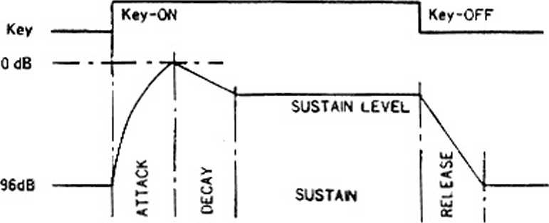

Figure III - 2 Envelope wareform

- 18 -

(1H-4) Operator (OP) and DAC

The operator performs FM calculations. Using the phase output from the phase generator, the operator calculates the value of SIN and multiplies it by the output of the envelope generator. Then if there are modulated waves, they are returned to the input of the operator and any sounds are sent to the DAC. This is controlled by the Feedback data.

The DAC performs DA conversion for all the sounds then outputs them as shown in Figure III-3 (a). To sum up the sounds, an integrated circuit is added to Mo. Ro. [Figure III-3 (b)] Since the level of percussion sounds seem lower, when compared to music sounds, the same percussion sounds are output twice. [Figure III - 3 (c)]

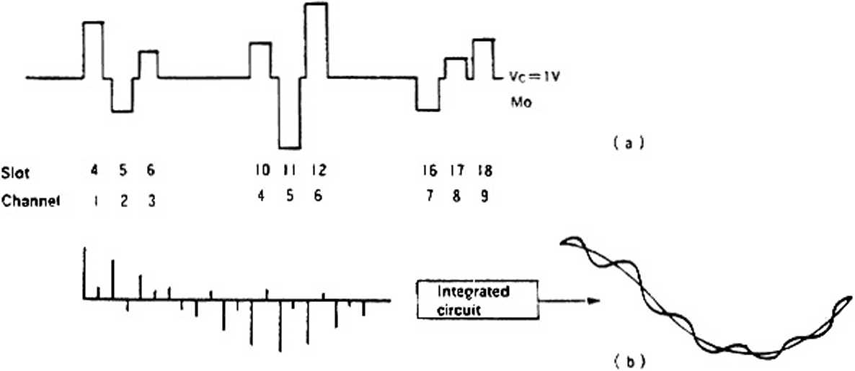

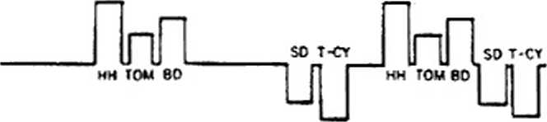

Figure 1U -

- 19 ~

**IV. INTERFACING**

OPLL. controlled by a microprocessor or microcomputer, outputs an audio signal, being an analog signal converted with a D/A converter. To obtain sound from OPLL, it is necessary to interface it with other devices. This chapter describes interfacing.

YM24I3

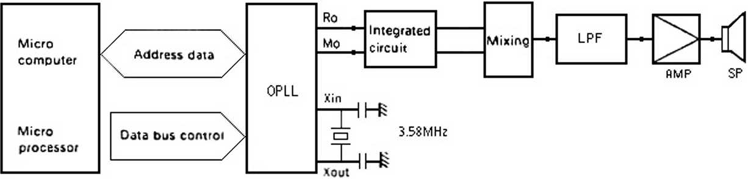

Figure IV - 1 System block diagram

**(IV-1) Clock Generation**

OPLL operates in the range of 2 to 4 MHz. Amplitude modulation, the frequency of the vibrato oscillator, and attack decay speeds are designed to take 3.6 MHz (3.579545 MHz) as the reference frequency. Therefore, when this LSI is used, it will be economical to connect the quartz crystal oscillator (for color burst signals) with Xin Xout.

**(IV-2) Audio Output Interface**

An external integrated circuit is needed for the OPLL's music sound output, which is a pulse signal as described earlier. The output (and buffer) of this integrated circuit may be directly connected to an audio amplifier. For better sound quality, you can remove step noises by inserting a low-pass filter (cutoff frequency: 20 kHz or so) between the integrated circuit and amplifier. Click noises accompanying power-ON/OFF will be necessary to protect the audio equipment (amplifier and speakers).

- 20 -

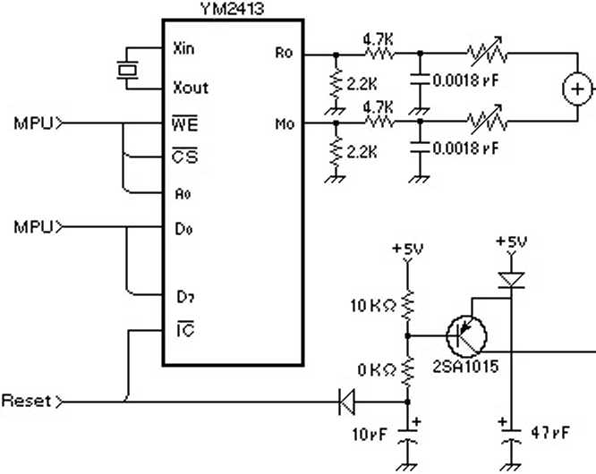

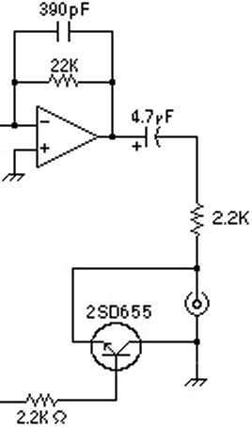

Figure JV — 2 Audio interface

Note: Ihe original circuit once shown here had a simplistic low-pass filter set up with an excessively strong cut-off frequency at 2.2 kHz that distorted the sound by attenuating the high frequencies too much, resulting in a very muffled/dull sound. This is an enhanced circuit based on the design that Yamaha used for their SFG-05 module for the MSX. thathas a much better the frequency response.

Ihe original circuit is shown, for historical purposes, at page 24.

**(IV-3) INTERFACING MICROPROCESSOR/MICROCOMPUTER**

Do~ D? of OPEL are the bidirectional bus lines which *connect* io a processor. OPLL exchanges address and data with the processor. The bus control signals CS • WE and AO control transfer of data. It is possible to build up an FM sound source system with the minimum configuration of OPLL, memory, and processor.

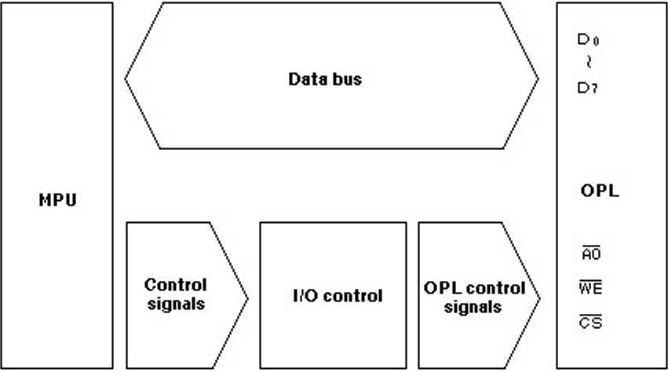

Figure (V - *3* Interfacing processor

21

**V. SYNTHESIS OF MUSIC SOUNDS**

This chapter describes what data to enter the OPLL registers in order to synthesize sound of the piano and brass.

**(V - 1) Procedure of Synthesizing Sounds**

First, you have-to analyze the sounds of the musical instrument which you want to synthesize by the FM method. For example, the sound of a piano is characterized by a fast attack and. if the key is held down, a gradual decay. The will sound include many overtones at the attack time however, as time elapses, overtones disappear, resulting in a different overtone composition. When you are aware such characteristics, you are belter able to synthesize the sounds by the FM method. The output amplitude can be determined from the characteristics of the envelope form and the modulation index from the overtone composition. Frequency ratio can also be determined roughly from the overtone composition because the frequency of the operator is related to it. In this way, you can determine the FM parameters roughly from characteristics of the sounds and. by listening to the synthesized sound, make minor corrections to obtain a more desirable result.

**(V — 2) Fundamentals of Sound Synthesis**

The FM sound source makes use of carrier wave modulation by the modulater.

Since the FM*s basic parameter (carrier output level, modulator output level, modulator feedback, level, carrier frequency, modulator frequency) is handled effectively, the pitch, tone and volume of sounds can all be decided. Table V-l shows the relationship between FM pa­rameters and OPLL parameters.

**(V - 3) Examples of Sound Synthesis**

Table V — 1 Fundamentals of sound synthesis

|  |  |  |
| --- | --- | --- |
| Item | Related parameters | MIN *• (Change of sounds) -* MAX |
| Output level of carrier | TOTAL LEVEL (Data of A, D. S. R, and Key Scale data) | Low volume *— High volume |
| Output level of modulator | Dull sound ♦— Bright sound |
| Feedback level of modulator | FB | Ordinary tone —♦ Sharp tone (Noise) |
| Carrier frequency | MULT) | Low pitch *-* High pitch |
| Frequency of modulator | (BLOCK/F-Number) | Near overtone ♦—* Far overtone |

(i) Electric piano

(D Determination of operator frequencies

Set MULTIPLE to “I”, for both operators, to produce an overtone of higher frequency. (Increases are by integer multiples)

*- 22 -*

© Output level of the operator

Change the output of the modulator to adjust the tone. When determining the level of operator I. adjust the bass sounds for rich overtones like those of the piano. Then make adjustment for sounds of higher frequencies by level scaling of operator 1. Level scaling is necessary so that the waveforms are nearly sine waves in high frequency ranges.

© Setting EG

Determine sound volume, tone, and envelope. Set operator 2 so that the sounds have a sharp attack and long sustain. (This can be set varying degrees.) Let operator 1. the modulator, produce many overtones at the attack time and later keep a certain composition of overtones unchanged. To adjust sound volume, apply key scaling to operator 2. Perform RATE scaling to make the sounds of higher pitches sharp.

© Readjustment of data

Now sound synthesis is almost completed. Tones will vary somewhat depending on the setting of EG. Make a final adjustment with the output level and feedback level of the operators. If the sound is too metallic, for example, reduce the level of operator 1.

© Adding effect

Finally, add tremolo effect by LFO to simulate the sounds of the electric piano. This is possible by using the built-in amplitude modulation function or by refreshing the value of **TOTAL** LEVEL in intervals of 2-6 Hz (possible with triangular waves) by software.

(ii) Trumpet

® Output of operator

Adjust the total level of operator I. the modulator, at $10*428 and the feedback level to the maximum of “7*' for bright tones.

© Operator frequencies

Set both operators at “I**.

© EG

Adjust two EGs for a slow attack. For brass sounds, ensure the modulator attack is slower than the carrier’s. This is necessary to express the characteristic attack of brass sounds.

© Key scalling

High-pitched sounds are not crisp because the envelope is set for a slow rise. Apply rate scaling for a more natural feeling of fast passages.

- 23 -

® LFO

With a brass instrument, the pitch of long tones fluctuates a little even when a good player is playing. To express this, apply vibrato effect.

(V —4) Procedure of Percussion Sound Synthesis

Channels 7, 8 and 9 are used to synthesize percussion sounds. Five kinds of percussion sounds are generated by using these three channels and six slots. For a the bass drum (BD), two slots are used to synthesize FM sounds. Therefore, bass drum sounds can be produced basically by .the same procedure from (a) to (cl. The other four kinds of percussion sounds (high hat, top cymbal, tom-tom. and snare drum) are described as follows.

OPLL includes a noise oscillator obtained by composing a white noise generator with several frequencies. This noise oscillator is specified by the frequency information (BLOCK, F-Number*Multi) of the 8 and 9 channels. When composed with white noise, phase output suitable for percussion instruments is generated and given to the operator. Thus phases of four instruments are generated from two sets of frequency information. It is known empirically that the optimum ratio of two frequencies is 3 : 1 (f7CH = 3*f8CH). Now phase data of individual instruments are obtained. Next, we multiply this output with envelope information. Since the envelope is set as 1 slot - 1 percussion instrument, values that reflect the characteristics of individual percussion instruments, as with melody instruments, are set in tone ROM. (Refer to III-I-7)

**Original circuit that was shown in page-21 of this document, for historical purposes:**

YM2413

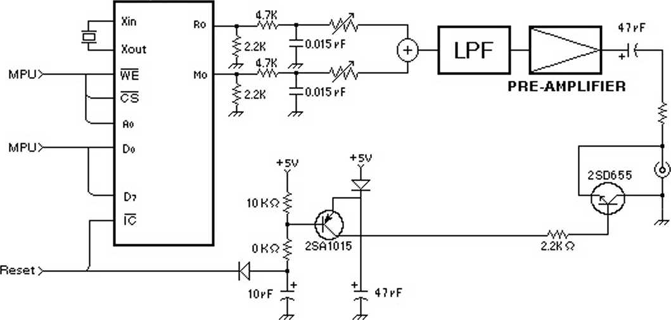

- 24 -

**VI. ELECTRICAL CHARACTERISTICS**

1. **Absolute Maximum Ratings**

|  |  |  |
| --- | --- | --- |
| **ITEM** | **RATING** | **UNIT** |
| Pin voltage | 0.3-7.0 | V |
| Ambient operating temperature | 0-70 | *°C* |
| Storage temperature | -50-125 | *°C* |

1. **Recommended Operating Conditions**

|  |  |  |  |  |  |
| --- | --- | --- | --- | --- | --- |
| **ITEM** | **SYMBOL** | **MIN.** | **TYP.** | **MAX.** | **UNIT** |
| Supply voltage | Vcc | 4.75 | 5 | 5.25 | V |
| GND | 0 | 0 | 0 | V |

1. **DC Characteristics**

|  |  |  |  |  |  |  |  |
| --- | --- | --- | --- | --- | --- | --- | --- |
| **ITEM** | | **SYMBOL** | **CONDITION** | **MIN.** | **TYP.** | **MAX.** | **UNIT** |
| High level input voltage | All input | **Vih** |  | 2.0 |  |  | V |
| Low level input voltage | All input | Vn. |  |  |  | 0.8 | V |
| Leak input current | A0. WE | Il | Vin = 0-5 V | -10 |  | 10 | pA |
| Three-state (off)  Input current |  | Itsl | Vin = 0-5 V | -10 |  | 10 | pA |
| Analog output voltage | MO | **Vmoa** | **Rload** = 2.20 peak to peak |  | 1.6 |  | V |
| RO | **Vroa** | **Rload** = 2.20 peak to peak |  | 1.6 |  | V |
| Pullup resistance | 1C.CS | Rv |  | 100 |  |  | kO |
| Input capacity | All input | Ci |  |  |  | 10 | pF |
| Output capacity | All input | Co |  |  |  | 10 | pF |
| Power current |  | I cc |  |  | 5 | 10 | mA |

1. **AC Characteristics**

|  |  |  |  |  |  |  |  |
| --- | --- | --- | --- | --- | --- | --- | --- |
| **ITEM** | | **SYMBOL** | **CONDITION** | **MIN.** | **TYP.** | **MAX.** | **UNIT** |
| Address setup time | Ao | tAS | Fig. A-l | 10 |  |  | DS |
| Address hold time | Ao | tAH | Fig. A-l | 10 |  |  | ns |
| Chip select write width |  | tesw | Fig. A-l | 80 |  |  | ns |
| Write pulse write width | WE | tww | Fig. A-l | 110 |  |  | ns |
| Write pulse set up | WE | tws | Fig. A-l | 30 |  |  | ns |
| Write data setup time | Do—D? | tWDS* | Fig. A-1 | 10 |  |  | ns |
| Write data hold time | Do— D? | tWDH | Fig. A-l | 25 |  |  | ns |
| Reset pulse width | IC | Nicw | Fig. A-2 |  | 80 |  | cycle |

-25-

5. DAC properties

|  |  |  |  |  |  |  |  |
| --- | --- | --- | --- | --- | --- | --- | --- |
| **ITEM** | | **SYMBOL** | **CONDITION** | **MIN.** | **TYP.** | **MAX.** | **UNIT** |
| Maximum output oscillation | Ro. Mo | Vout | Fig. IV-2 |  | 2/5 Vcc |  | Vpp |
| Resolution | Ro. Mo |  | Fig. IV-2 |  | 9 |  | Bit |
| Noise | Ro. Mo |  | Fig. IV-2 |  | -65 |  | dB |

Note: The noise level should be suitable for the volume level.

**VII. TIMING DIAGRAMS (STANDARD TIMING SETTINGS ARE** Vih **= 2.0V,** Vil **= 0.8V)**

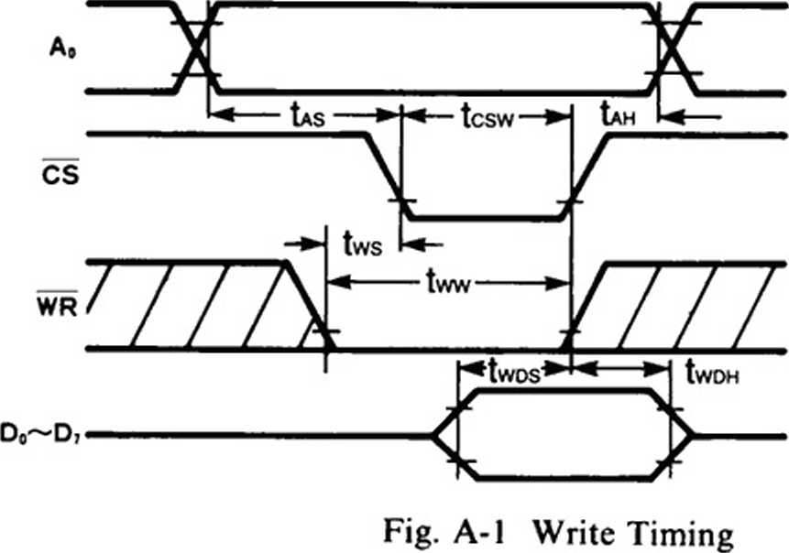

*twDs>10ns : tcsw<t0MX7  
twos > lO+tcsw-t0MX7ns

: tcsw > t0MX7

**NOTE:**

tcsw, tww and twon have  
been measured with either  
CS or WR high.

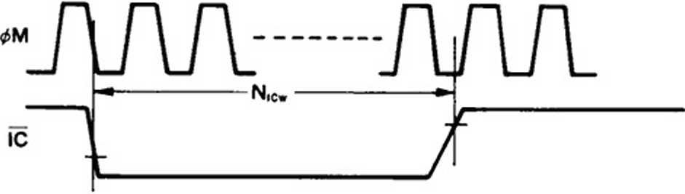

Fig. A-2 Reset Timing

- 26 -

**VIII. OUTLINE DIMENSIONS**

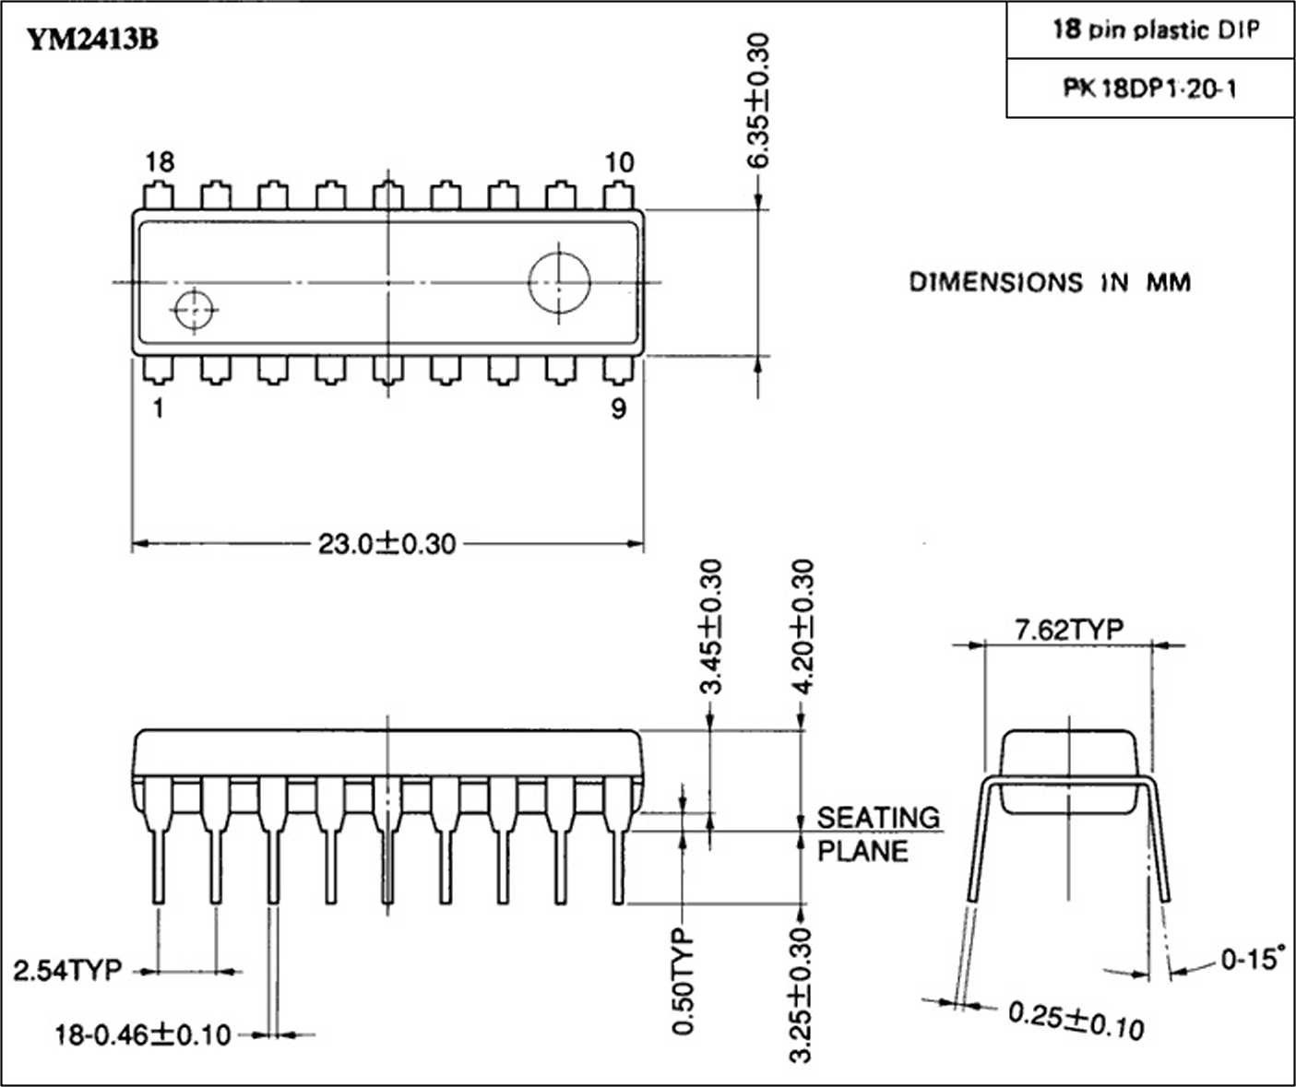

27 -

YM2413B-F

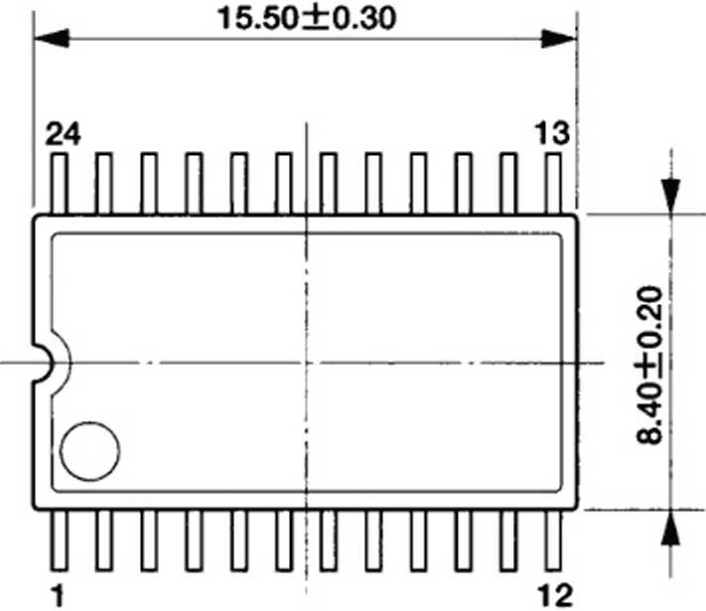

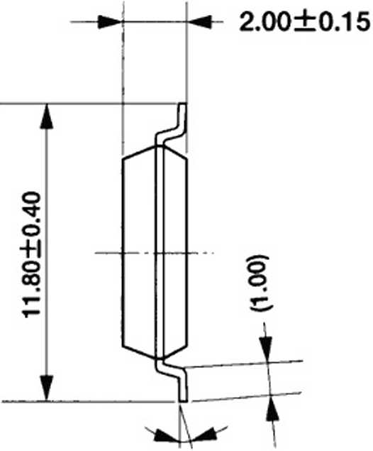

0-10*

**S**

ID

<N

WurtruW^^-4

The figure in the parenthesis ( ) should be used as a reference. Plastic body dimensions do not include burr of resin.

UNIT: nro

P-1.27TYP 0.40±0.10

**Q**

LEAD THICKNESS: 0.15±0.10

co

28 -

MM

YM2413B

IMPORTANT NOTICE

1. Yamaha reserves the right to make changes to its Products and to this document without notice. The information contained in this document has been carefully checked and is believed to be reliable. However, Yamaha assumes no responsibilities for inaccuracies and makes no commitment to update or to keep current the information contained in this document.
2. These Yamaha Products are designed only for commercial and normal industrial applications, and are not suitable for other uses, such as medical life support equipment, nuclear facilities, critical care equipment or any other application the failure of which could lead to death, personal injury or environmental or property damage. Use of the Products in any such application is at the customer’s sole risk and expense.
3. YAMAHA ASSUMES NO LIABILITY FOR INCIDENTAL, CONSEQUENTIAL OR SPECIAL DAMAGES OR INJURY THAT MAY RESULT FROM MISAPPLICATION OR IMPROPER USE OR OPERATION OF THE PRODUCTS.
4. YAMAHA MAKES NO WARRANTY OR REPRESENTATION THAT THE PRODUCTS ARE SUBJECT TO INTELLECTUAL PROPERTY LICENSE FROM YAMAHA OR ANY THIRD PARTY, AND YAMAHA MAKES NO WARRANTY OR REPRESENTATION OF NON-INFRINGEMENT WITH RESPECT TO THE PRODUCTS. YAMAHA SPECIFICALLY EXCLUDES ANY LIABILITY TO THE CUSTOMER OR ANY THIRD PARTY ARISING FROM OR RELATED TO THE PRODUCTS’ INFRINGEMENT OF ANY THIRD PARTY’S INTELLECTUAL PROPERTY RIGHT. INCLUDING THE PATENT. COPYRIGHT. TRADEMARK OR TRADE SECRET RIGHTS OF ANY THIRD PARTY.
5. EXAMPLES OF USE DESCRIBED HEREIN ARE MERELY TO INDICATE THE CHARACTERISTICS AND PERFORMANCE OF YAMAHA PRODUCTS. YAMAHA ASSUMES NO RESPONSIBILITY FOR ANY INTELLECTUAL PROPERTY CLAIMS OR OTHER PROBLEMS THAT MAY RESULT FROM APPLICATIONS BASED ON THE EXAMPLES DESCRIBED HEREIN. YAMAHA MAKES NO WARRANTY WITH RESPECT TO THE PRODUCTS. EXPRESS OR IMPLIED, INCLUDING. BUT NOT LIMITED TO THE WARRANTIES OF MERCHANTABILITY, FITNESS FOR A PARTICULAR USE AND TITLE.

The specifications of this product arc subject to improvement changes without prior notice.

YAMAHA CORPORATION

AGENCY

Address inquiries to:

Semiconductor Saks & Marketing Department

■ Head Office

Hl-TOP MSX CLUB  
Rua Emilio Andrielli, 163  
18810-000 - LEME - SP

203, Matsunokijima. Toyooka-mura. Iwata-gun. Shizuoka-kcn. 438-0192 Electronic Equipment Business section Tel. 81-539-62-4918 Fax. 81-539-62-5054

■ Tokyo Office

2-17-11. Takanawa. Minato-ku.

Tokyo. 108-8568

Tel. 81-3-5488-5431 Fax. 81-3-5488-5088

■ Osaka Office

Namba Tsujimoto Nissci Bldg. 4F 1-13-17. Namba Naka. Naniwa-ku.

Osaka City. Osaka. 556-0011

Tel. 81-6-6633-3690 Fax. 81-6-6633-3691

■ L.S.A. Office

YAMAHA Systems Technology

100 Century Center Court. San Jose.

CA 95112

Tel. 1-408-467-2300 Fax. 1-408-437-8791

Copying prohibited © 1987 YAMAHA CORPORATION

0.3K*0915 & Printed in Japan 99.05