**YAMAHA CORP OF AMERICA/ EbE D ■ IIHSSSM OOPOHIO 5 ■**

YM3014

N0.84-I2 I

*T-5l'Cfi > Ik*

YM3O14

Serial Input Floating D/A Converter (DAC-SS)

* OUTLINE

YM3014: DAC-SS (hereinafter referred to as DAC) is a floating D/A converter with serial input for single channel. It can generate analog output (dynamic range 16 bits) having 10-bit mantissa section and 3-bit exponent section on the basis of input digital signal.

* FEATURES
* An external buffer operational amplifier is provided to obtain analog output easily.
* A wide dynamic range with 16 bits.
* Sample holding circuit is unnecessary.
* It is possible to reduce noise and the distortion rate of high harmonic and to obtain good temperature characteristics.
* It is produced by the monolithic process with high precision thin film resistance and CMOS and contained in a 8 pin plastic DIL package.

NIPPON GAKKI CO, LTD.

**CATALOG No.:LSI-2130140**



IBM

■ 5^45524 0000411 4 *■ T-51-b^-lb* **YM3014**

YAMAHA CORP OF AMERICA/ 2bE D

**■ TERMINAL DIAGRAM**

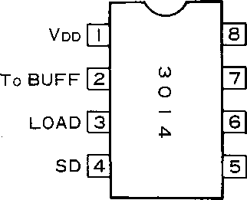

MP

Rb

GND

(Vss)

0 I

CLOCK

* BLOCK DIAGRAM

0I CLOCK LOAD

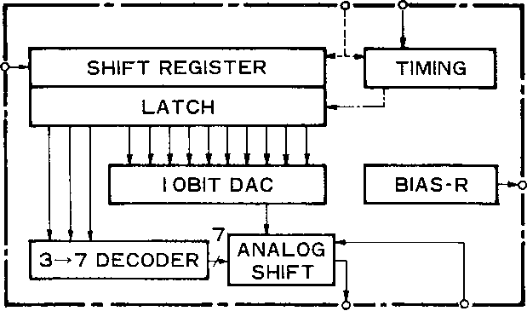

To BUFF MP **(ANALOG OUT)**

**2**

YM3014

. ^SS2y ooooma t

YAMAHA CORP OF AMERICA/ 2bE D

■ DESCRIPTION OF TERMINAL FUNCIOTNS

|  |  |  |
| --- | --- | --- |
| PIN NO. | SYMBOL NAME | FUNCTIONS |
| 1 | Vdd | Reference power sourch on the high potential side. |
| 2 | To BUFF | Analog output from DAC is input into a buffer operational amplifier. |
| 3 | LOAD | Generates in ternal signal to latch the serial data by use of trailing edge. |
| 4 | SD | Serial input of the converted digital siganl. |
| 5 | CLOCK | Clock (01) to operate the shift register and timing generator. |
| 6 | VSS | Power source on the low potential side (GND). |
| 7 | RB | High precision 1/2 VDD voltage generated inside of the unit is obtained at this terminal. It is added to 8 pin through the buffer operational amplifier. |
| 8 | MP | Exponential analog value is obtained by S signal with reference to potential given to MP. Normally it is biased to 1/2VDD. |

* DESCRIPTION OF FUNCTIONS

1. Relationship between Digital Input Data and Analog Output Voltage

To perform one conversion at 16-bit time by YM3014, the first 3-bit data among the 16-bit serial data is processed as invalid data in the DAC. The next 10 bit data (Do through D9 ) is input into the 10-bit DAC section as the MSB data from the LSB to constitute the mantissa section of analog output. The remaining 3-bit data (So through S2) is input into the 2-N analog shift section to constitute the exponent section of analog output.

For example, when the basic circuit is used, output voltage is as follows.

Vour= 1/2 Vdd + 1/4 Vdd (- 1 + D9 +D82_1 + • ••• Do2’9 +2-10)2-N

N = S222 4-S^1 +So

S2 = Si = So = 0: not allowed.

That is, it has the maximum aplitude of ± 1/4Vdd and the minimum amplitude of ± 1/4Vdd 2-16 with 1/2Vd.d potential in the center.

1. Operation in the DAC

Digital input data is taken into the shift register through SD terminal in synchronous with the clock rise. Latch signal is generated in the timing circuit by use of the trailing edge of LOAD. By this latch signal, the serial data of Do through D9 and So through S2 is latched, which drives the 10-bit DAC section and the analog shift section, respectively, to start conversion.

Its analog output is obtained at the terminal “TO BUTT”. It can be output through an adequate buffer operational amplifier.

1. Summary of Operation

* As shown in Fig. 3, Timing diagram, coincide the trailing edge of LOAD with the timing of the S2 rear end of the SD signal. “H” time of LOAD requires more than one bit time.
* Conversion at the bit time other than 16 bits is possible by increasing or decreasing the invalid bit number part.

**3**

wmm ■ wssaq oooomi3 8 ■T'5,'°CHU

YAMAHA CORP OF AMERICA/ SHE D

**YM3014**

■ EXAMPLE OF BASIC CIRCUIT

LOADo

Vddq

VOUT .

O—r<-

**W O**

6] 1

072AND OTHERS

SDO K

SCLOCK

I 0I

■ ELECTRICAL CHARACTERISTICS

1. Absolute Maximum Rating

|  |  |  |
| --- | --- | --- |
| ITEM | RATING | UNIT |
| Supply voltage | — 0.3 ~ +15.0 | V |
| High level input voltage | VDD+ 0.3 | V |
| Low level input voltage | VSS - 0.3 | V |
| Ambient operating temperature | 0~70 | °C |
| Storage temperature | - 50 ~ + 125 | °C |

1. Recommended Operation Conditions

|  |  |  |  |  |  |  |
| --- | --- | --- | --- | --- | --- | --- |
| ITEM | SYMBOL | | MIN. | STD. | MAX. | UNIT |
| Supply voltage | VDD  VSS | | + 4.75 0 | 5.0 0 | 10.0 0 | V  V |
| Input signal voltage | CLOCK SD LOAD |  | 0 | — | VDD | V |
| Ambient operation temperature | Ta | | 0 | — | 70 | °C |

1. D.C. Characteristics

|  |  |  |  |  |  |  |
| --- | --- | --- | --- | --- | --- | --- |
| ITEM | SYMBOL | MEASUREMENT CONDITIONS | MIN. . | STD. | MAX. | UNIT |
| High level input voltage | VIH | Vdd= 5.0 V | 3.3 | — | — | V |
| Low level input voltage | VIL | Vdd= 5.0 V | — | — | 1.5 | V |
| Input current | UN | VDD= 10,0 V | — | *—* | 10-3 |  |
| Analog output voltage | VOUT | Vdd= 5.0 V | — | — | 2.5 | Vp-p |
| Power current | IDD | VDD= 5.0 V | — | — | 6 | mA |

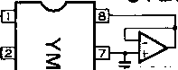

**YM3014**

■ TTMSSEM ODOOHIM T *nT-SHfi-lle*

YAMAHA CORP OF AMERICA/ SHE D

1. AC Characteristics

|  |  |  |  |  |  |  |
| --- | --- | --- | --- | --- | --- | --- |
| ITEM | SYMBOL | CONDITIONS | MIN. | STD. | MAX. | UNIT |
| • Clock Frequency | fc |  | 0.65 | 0.8 | 2.6 | MHz |
| High level time | Th |  | 180 |  |  | ns |
| Rise time | Tr |  |  |  | 50 | ns |
| Breaking time | Tf |  |  |  | 50 | ns |
| • Data  Set-up time | TDS | SD  LOAD | 0 |  |  |  |
| Rise time | Tr |  |  |  | 50 | ns |
| Breaking time | Tf |  |  |  | 50 | ns |

1. Capacity

|  |  |  |  |  |  |  |
| --- | --- | --- | --- | --- | --- | --- |
| ITEM | SYMBOL | CONDITIONS | MIN. | STD. | MAX. | UNIT |
| Input capacity | CIN |  | — | — | 5 | PF |

1. DAC Characteristics

|  |  |  |  |  |  |  |
| --- | --- | --- | --- | --- | --- | --- |
| ITEM | SYMBOL | CONDITIONS | MIN. | STD. | MAX. | UNIT |
| Max. out put amplitude | VOUT |  |  | 1/2 Vdd |  | Vpp |
| Resolution |  |  |  | 16 |  | Bit |
| Settling time | Ts |  |  | 4 |  | /isec |
| Total distortion rate of high harmonic | THD1  THD6 | VDD=5V, 110Hz level 0 dB  — 36dB |  | 0.05 | 0.2  0.2 | *% %* |
| Noise |  |  |  | — 92 | -80 | dBm |
| Temperature characteristics |  | Out put voltage Total distortion rate of high hermonic |  | 5 |  | ppm/°C |

1. Timind Diagram

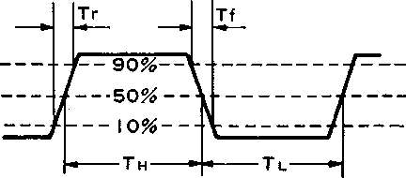

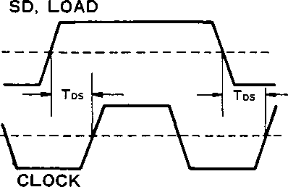

Fig. 2 Input data clock timing

Fig. 1 Data timing

**5**

■ TTHSSEH 0000M15 1

**YM3014**

YAMAHA CORP OF AMERICA/ EbE D

**< Z 0**

**0**

**H D Q. Z**

**o < Q**

CLOCK

LOAD

SD

LATCH







]d'd!d'd'd'd!d!d!d!d|s]s!s JO}I!2|3l4{s|6}7ja|9|0tIJ2







CONVERT

To BUFF ANALOG

OUT



Fig. 3 YM3014 timing

■ OUTER DIMENSION DRAWING

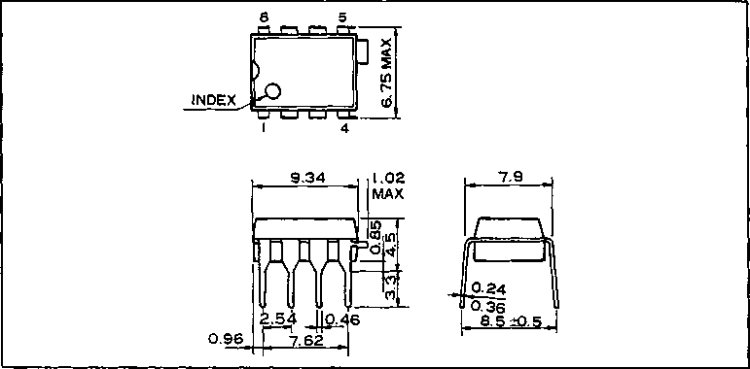

The specifications of this product are subject to improvement changes without prior notice.

**AGENCY**

NIPPON GAKKI CO., LTD

**■ Head Office**

10-1, Nakazawa-cho, Hamamatsu-shi,

Shizuoka-ken, 430

Tel. 0534-65-1111

Address inquiries to:

**Electronic System Divistion**

■ Toyooka Factory 203, Matsunokijima, Toyooka-mura. Iwata-gun, Shizuoka-ken, 438-01 Electronic Equipment business section Tel. 053962-3125

■ Tokyo Office

■ Osaka Office

3-4, Surugadai Kanda, Chiyoda-ku,

Tokyo, 104

Ryumeikan Bldg. 4F

Tel. 03-255-4481

1-16, Shin-ashiyashimo, Suita-shi,

Osaka, 565

Tel. 06-877-7731

**6**

1.0K-0725 CPrinted in Japan 85.11