



YM3812

NO.86-04

YM3812

FM OPERATOR TYPE-LII (OPLII)

* OVERVIEW

The FM Operator Type-LII (OPLII) is a new type of sound generator designed for use with Captain systems and videotext systems. This allows for the production of a wide variety of sounds using software control. This sound generator is also equipped with functions for the production of rhythm sounds.

The OPLII also has a built-in low frequency oscillator for vibrato and AM effects, reducing the amount of programming required to produce special effects.

As this sound output from OPLII is digital, a D/A converter such as YM3014 is necessary.

* FEATURES
* FM sound generation system for realistic sound
* Mode selection of simultaneous voicing of 9 sounds or 6 melody sounds and 5 rhythm sounds is possible. Both modes can produce various sounds.
* Built-in vibrato oscillator/amplitude modulation oscillator (AM)
* Composite sine wave speech synthesis also possible
* Input/output TTL compatible

•Si-gate CMOS-LSI

* 5V single power supply

NIPPON GAKKI CO., LTD. .

^CATALOG No.TLSI-2138120 i

This Material Copyrighted By Its Respective Manufacturer

**YM3812**

■ PIN LAYOUT

|  |  |  |  |
| --- | --- | --- | --- |
| vss | **I** | ***S* 24** | **0M** |
| **IRQ"** | **2** | **23** | **0SY** |
| **ic** | **3** | **22** | **NC** |
| **AO** | **4** | **21** | **MO** |
| **WR** | **5** | **20** | **SH** |
| **RD** | **6** | **19** | **NC** |
| **cs"** | **7** | **1 8** | **D7** |
| **NC** | **8** | **i7** | **D6** |
| **NC** | **9** | **16** | **D5** |
| **DO** | **IO** | **15** | **D4** |
| **DI** | **II** | **14** | **D3** |
| **GND** | **12** | **13** | **D2** |

**\* NC : No Connection**

■ BLOCK DIAGRAM

AOCS RDWR

4WSYSH

IRQ

D0~D7

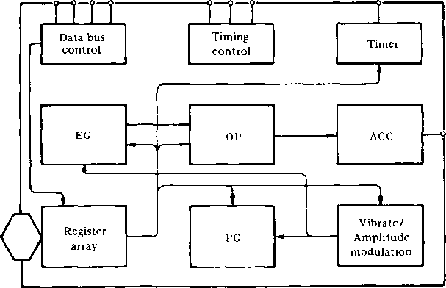

MO

2

This Material Copyrighted By Its Respective Manufacturer

**YM3812**

MM

**■ DESCRIPTION OF PIN FUNCTIONS**

1. 4>M

Master clock of OPL; input frequency is 3.58MHz.

1. 4>SY*SH

Clock (0SY) and Syncronization Signal (SH) to convert digital output of FM sound generator to analog signal.

1. D0~D7

8 bit bidirectional data communication between OPLII and processor.

1. CS-RD-WRAO

Control data bus comprised of Do~D7.

|  |  |  |  |  |
| --- | --- | --- | --- | --- |
| cs | RD | WR | AO |  |
| 0 | 1 | 0 | 0 | Write address of register to OPL |
| 0 | 1 | 0 | 1 | Write contents of register to OPL |
| 0 | 0 | 1 | 0 | Status of OPL is read. |
| 0 | 0 | 1 | 1 | Data of data bus not assured |
| 1 | X | X | X | Set data bus DO ~ D7 to high impedance |

**e) IRQ**

Interrupt signal sent from either of two timers. Interrupts can be masked by program.

1. ic

Set the contents of registers to “0” and the system will be reset when driven to low level.

1. **MO**

Digital output of FM sound generator. The external D/A convertor unit is necessary.

1. Vcc

+ 5V power supply pin

1. GND

Ground pin

■ DESCRIPTION OF FUNCTIONS

OPLII has two sounding modes: nine melodies, and a combination of six melodies and five rhythms. This mode selection can be controlled by the program. For melodies, the same FM sound generator as used in the Yamaha DX-7 synthesizer is used for creating excellent sound quality.

For this reason, this LSI is the most suitable for sound generators for new media-related equipment, including CAPTAIN systems and teletex.

Frequency modulation for this LSI is obtained by the following expressions. Either sine waves synthesis (1) or frequency modulation (2) can be programmed for individual sounds.

Fi= Ii sin wit + L sin W2t —(1)

F; = L (wit + L sin W2t) —(2)

3

This Material Copyrighted By Its Respective Manufacturer

**YM3812**

A noise generator and synthesizer are provided for rhythmic sounds. Sounding requires no special external control. Five rhythmic sounds: bass drum (BD), snare drum (SD), high-hat cymbals (HH), top cymbal (TC) and tom-tom (TOM) can be generated.

The internal parts of OPL are functionally divided into nine blocks to perform the following:

1. Register array:

OPL is controlled by the register array contents and the shape of the envelope and phase data are determined.

1. Phase generator (PG):

A phase of the FM sound generator at each time step is generated. This receives and accumulates phases from the register array, thereby calculating a phase at each time step.

1. Envelope generator (EG):

This generates an envelope and modulation index for each sound. This generator receives instructions for such items as slope (rate) and offset (total level) from the register array to generater an envelope.

1. Operator (OP):

The operator receives phase information (0) from PG and envelope information (E) from EG, and calculates EsinG.

1. Accumulator (ACC):

The accumulator is used to accumulate each sound at each sampling time (50 KHz) in order to convert data to match the D/A converter.

1. Vibrato oscillator/amplitude modulation oscillator:

Low frequency oscillators for vibrato and amplitude modulation. The oscillation frequency is 6.4 Hz for vibrato and 3.7 Hz for amplitude modulation.

1. Timers:

There are two types for general-purpose timers for long and short.

1. Data bus control.
2. Timing control.

4

This Material Copyrighted By Its Respective Manufacturer

**YM3812**

MM

■ CONTENTS OF EACH REGISTER

|  |  |  |
| --- | --- | --- |
|  | **Address** |  |
| 1 | 01 | TEST information. Usually set to “0”. On this stage the waveform is Sine wave and compatible with YM3526. If any waveform other than Sine wave will be selected, set D5 to “1”. |
| 2 | 02 | Times setting on timer 1. 80gs~ 20.4ms |
| 3 | 03 | Times setting on timer 2. 320gs —82ms |
| 4 | 04 | Controls the operation of timers 1 and 2 and resets interrupt signals. |
| 5 | 08 | CSM is for the CSM speech synthesis modie.  NOTE SEL is for switching the keyboard split by using the F-Number. |
| 6 | 20-35 | MULTI controls the relationship between fundamental waves and harmonics.  K.SR is key scale of RATE.  EG-TYPE is for the switching of Non Percussive Tone and Percussive Tone. 0 is for Percussive Tone and 1 is for Non Percussive Tone.  VIB indicates the ON/OFF of vibrato.  AM indicates the ON/OFF of modulation. |
| 7 | 40-55 | TL provides a total level for adjustment of each sound level. KSL is the level key scale. |
| 8 | 60-75 | DR sets the decay rate at the decay time.  AR sets the rate of increase at the attack time. |
| 9 | 80-95 | RR provides the decay rate at Release/Sustain time.  SL provides the level for shifting from decay to sustain. |
| 10 | A0-B8 | F-Number provides chords within one octave, Block represents octave information for each sound. KON indicates that the sound being generated when it is “1”. |
| 11 | BD | Controls rhythmic sounds and the corresponding bits for setting ON/OFF of each rhythm.  When the R bit is 1, the system is in the rhythm mode.  VIB DEP indicates the depth of vibrato. 0 = 7e», 1 = 14e>.  AM DEP indicates the depth of amplitude modulation. 0= IdB, 1 =4.8dB. |
| 12 | C0-C8 | FB indicates FM feedback factor.  C indicates Sin wave synthesis or FM modulation. |
| 13 | E0-F5 | Wave Select signal.  When D5 of address $01 is “1”, four kinds of waveform can be selected. |

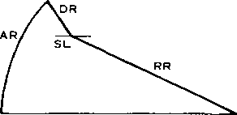

Percussive Tone

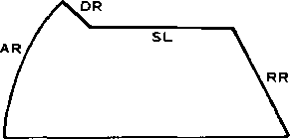

Non Percussive Tone

5

This Material Copyrighted By Its Respective Manufacturer

**YM3812**

■ ELECTRICAL CHARACTERISTICS

1. **Absolute Maximum Ratings**

|  |  |  |
| --- | --- | --- |
|  | Rating | Units |
| Pin voltage | — 0.3~7.0 | V |
| Operating ambient temperature | 0 ~70 | °C |
| Storage temperature | -50 ~ 125 | °C |

1. **Recommended Operating Conditions**

|  |  |  |  |  |  |
| --- | --- | --- | --- | --- | --- |
| Item | Symbol | Minimum | Typical | Maximum | Unit |
| Power voltage | Vcc | 4.5 | 5 | 5.5 | V |
| GND | 0 | 0 | 0 | V |

1. **DC Characteristics**

|  |  |  |  |  |  |  |  |
| --- | --- | --- | --- | --- | --- | --- | --- |
| Item | | Symbol | Conditions | Minimum | Typical | Maximum | Unit |
| Input high level voltage | All input | VlH |  | 2.0 |  |  | V |
| Input low level voltage | All input | VIL |  |  |  | 0.8 | V |
| Input leak current | 0M WR RD Ao | IL | Vin = 0~5V | -10 |  | 10 | pA |
| Three-state (OFF state) input current | Do~D7 | **ITSL** | Vin = 0~5V | -10 |  | 10 | pA |
| Output high level voltage | Output expect IRQ | **VOHl** | Iohi = 0.4mA | 2.4 |  |  | V |
| **VOH2** | IOH2 = 40pA | 3.3 |  |  | V |
| Output low level voltage | All output | VOL | Iol = 2.0mA |  |  | 0.4 | V |
| Output leak current (OFF state) | IRQ | **ILOFF** | Voh = 0~5V | -10 |  | 10 | V |
| Pullup resistance | KfCS | Rpu |  | 80 |  | 400 | KQ |
| Input capacity | All input | Ci |  |  |  | 10 | PF |
| Output capacity | All output | Co |  |  |  | 10 | PF |
| Power voltage |  | ICC |  |  |  | 30 | mA |

1. **AC Characteristics**

|  |  |  |  |  |  |  |  |
| --- | --- | --- | --- | --- | --- | --- | --- |
| Item | | Symbol | Conditions | Minimum | Typical | Maximum | Unit |
| Input clock frequency | oM | fc | Fig. A-l | 2.0 | 3.58 | 4.0 | MHz |
| Input clock duty cycle | oM |  |  | 40 | 50 | 60 | % |
| Input clock rise time | bM | Tr | Fig. A-l |  |  |  | ns |
| Input clock fall time | oM | Tf | Fig. A-l |  |  |  | ns |
| Address setup time | Ao | Tas | Fig. A-2, Fig. A-3 | 10 |  |  | ns |
| Address hold time | Ao | Tah | Fig. A-2, Fig. A-3 | 20 |  |  | ns |
| Chip select write width | CS | Tcsw | Fig. A-2 | 100 |  |  | ns |
| Chip select read width | cs | Tcsr | Fig. A-3 | 200 |  |  | ns |
| Write pulse write width | WR | Tww | Fig. A-2 | 100 |  |  | ns |
| Write data setup time | Do~D7 | Tds | Fig. A-2 | 20 |  |  | ns |
| Write data hold time | Do~D7 | Tdh | Fig. A-2 | 30 |  |  | ns |
| Read pulse width | RD | Trw | Fig. A-3 | 200 |  |  | ns |
| Read data access time | Do~D7 | Tacc | Fig. A-3 |  |  | 200 | ns |
| Read data hold time | Do~D7 | Trdh | Fig. A-3 | 10 |  |  | ns |
| Output rise time | 0SY | Tori | Fig. A-4 |  |  | 100 | ns |
| MOSH | Torz | Fig. A-5 |  |  | 150 | ns |
| Output fall time | oSY | Tofi | Fig. A-4 |  |  | 100 | ns |
| MOSH | **TOF2** | Fig. A-5 |  |  | 150 | ns |
| Reset pulse width | Tc | Nicw | Fig. A-6 | 80 |  |  | Cycle |

6

This Material Copyrighted By Its Respective Manufacturer

**YM3812**

■ REGISTER MAP

|  |  |  |  |  |  |  |  |  |  |
| --- | --- | --- | --- | --- | --- | --- | --- | --- | --- |
| ADDRESS | **D7** | **D6** | **Ds** | **D4** | **D3** | **D2** | **Di** | **Do** | COMMENT |
| **01** |  | |  | TEST | | | | | TEST DATA OF LSI  Ds indicates WAVE SELECT ENABLE. |
| **02** | TIMER-1 | | | | | | | | DATA OF TIMER-1 |
| **03** | TIMER-2 | | | | | | | | DATA OF TIMER-2 |
| **04** | **RST** | MASK  T1 T2 | |  | |  | ST2ST1 | | IRQ-RESET/CONTROL OF RIMER-1, 2 |
| **08** | **CSM** | **SEL** |  | | | | | | CSM SPEECH SYNTHESIS MODE/NOTE SELECT |
| **20**  **35** | s < | oa > | EG-TYP | KSR | MULTI | | | | AM/VIB/EG-TYPE/KSR/MULTIPLE |
| **40**  **55** | KSL | | TL | | | | | | KSL/TOTAL LEVEL |
| **60**  **75** | AR | | | | DR | | | | ATTACK RATE/DECAY RATE |
| **80**  **95** | SL | | | | RR | | | | SUSTAIN RATE/RELEASE RATE |
| **AO**  **A8** | F-Number (L) | | | | | | | | KON/BLOCK/F-Number |
| **BO**  **B8** |  |  | । KON | BLOCK | | | F-Num  (H) | |
| **BD** | DEP AM VIB | | R | BD SDTOMTC HH | | | | | DEPTH(AM/VIB)/RHYTHM(BD-SD-TOM-TC-HH) |
| **CO**  **C8** |  | | | | FB | | | C | FEEDBACK/CONNECTION |
| **EO**  **F5** |  | | | | | | WS | | WAVE SELECT |

■ STATUS REGISTERS

|  |  |  |  |
| --- | --- | --- | --- |
| **IRQ** | FLAG T1 T2 |  | IRQ/FLAG(T1, T2) |

This Material Copyrighted By Its Respective Manufacturer

**YM3812**

■ TIMING DIAGRAMS (Timing is based upon settings of Vih = 2.0V and Vil = 0.8V)

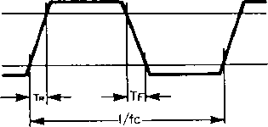

***Fig. A-l Clock Timing***

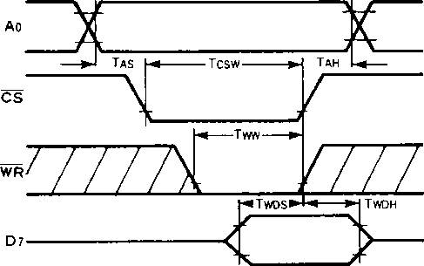

Note: Tcsw, Tww, and Twdh are based on either CS or WS being driven to high level.

***Fig. A-2 Write Timing***

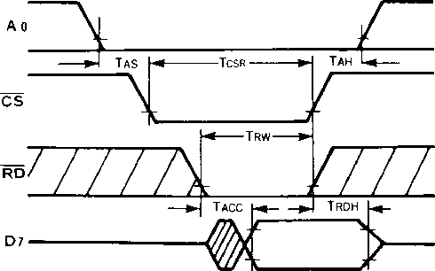

Note: Tacc is based on whichever of CS or RD goes to the low level last.

Tcsr, Trw, and Trdh are based on either CS or RD being driven to high level.

***Fig. A-3 Read Timing***

8

This Material Copyrighted By Its Respective Manufacturer

**YM3812**

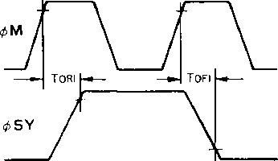

Fig. A-4 and 4’5'F

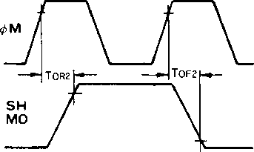

Fig. A-5 <$M and SH-MO

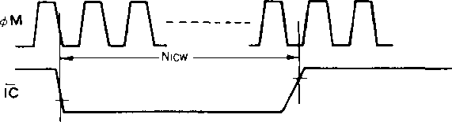

Fig. A-6 Reset Pulse

■ WAVE SELECT

When bit Ds of address $4>1 is “0”, the OPLH is fully compatible with YM3526 (OPL); there are no differences between the two devices. If a sine wave is input in this mode, the output will be a sine wave like the input. When bit Ds of address $<t>l is “1”, the input sine wave will be output as the distorted wave shown in Table 3-10.

**SE0-SF5**

|  |  |
| --- | --- |
| **D7 D6 DS D4 D3 D2** | Dl Do |
|  | WAVE  SELECT |

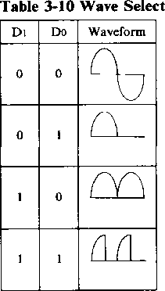

9

This Material Copyrighted By Its Respective Manufacturer

warn

**YM3812**

■ DIMENSIONS

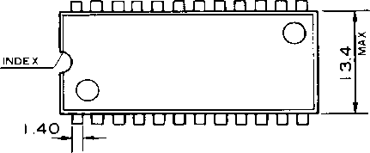

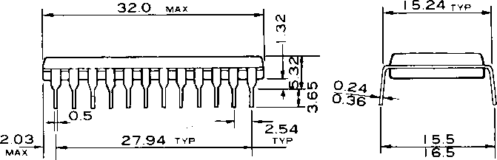

The specifications of this product are subject to improvement changes without prior notice.

AGENCY

***io***

NIPPON GAKKI CO., LTD -

■ Head Office 10-1, Nakazawa-cho, Hamamatsu-shi,

Shizuoka-ken, 430  
Tel. 0534-65-1111

|  |  |
| --- | --- |
| **Address inquiries to: Electronic System Divistion** | |
| **■ Toyooka Factory** | 203, Matsunokijima, Toyooka-mura.  I wata-gun, Shizuoka-ken, 438-01 Electronic Equipment business section Tel. 053962-3125 |
| **■ Tokyo Office** | 3-4, Surugadai Kanda. Chiyoda-ku,  Tokyo, 104  Ryumeikan Bldg. 4F  Tel. 03-255-4481 |
| **■ Osaka Office** | 1-16, Shin-ashiyashimo, Suita-shi, |

Osaka, 565

Tel.06-877-7731 **007695** X

0.3K-0425 ***C*** Printed in Japan 86.4

This Material Copyrighted By Its Respective Manufacturer