**YAMAHA *L SI***

YM3812

FM OPERATOR TYPE-LII (OPLII)

* OUTLINE:

The OPLII(FM OPERATOR type-LII) is an LSI IC which can be used as a sound generation system for computer apparatus, teletext instruments, etc. The OPLII employs frequency mod­ulation for the melody sounds, and has rhythm sounds very close to those of natural musical instruments, making it possible to synthesize various tones by software control from a CPU. In addition, an LFO is built in to generate effects such as vibrato and tremolo, thus reducing the software load.

The OPLII can be easily interfaced with the DAC YM3014.

* FEATURES

•FM sound generation system for realistic sound

•Mode selection of simultaneous voicing of 9 sounds or 6 melody sounds and 5 rhythm sounds is possible. Both modes can produce various sounds.

• Built-in vibrato oscillator/amplitude modulation oscillator (AM)

•Composite sine wave speech synthesis also possible

•Input/output TTL compatible

•Si-gate CMOS-LSI

• 5V single power supply

YAMAHA CORPORATION

■ inHSSEM 0002M00 05b ■

**I**

YM3812 CATALOG  
CATALOG No.: LSI-2138123  
1992. 4

**YM3812**

■ PIN LAYOUT

|  |  |  |  |
| --- | --- | --- | --- |
| vss | **1** | **24** | **tfM** |
| **IRQ"** | **2** | **23** | **0SY** |
| **ic** | **3** | **22** | **NC** |
| **AO** | **4** | **21** | **MO** |
| wr~ | **5** | **20** | **SH** |
| **RD-** | **6** | **19** | **NC** |
| **OS'** | **7** | **18** | **D7** |
| **NC** | **8** | **17** | **D6** |
| **NC** | **9** | **16** | **D5** |
| **DO** | **10** | **15** | **D4** |
| **DI** | **II** | **14** | **D3** |
| **GND** | **12** | **13** | **D2** |

**\* NC ' No Connection**

**TOP VIEW (24PIN DIP, 24 PIN SOP)**

■ BLOCK DIAGRAM

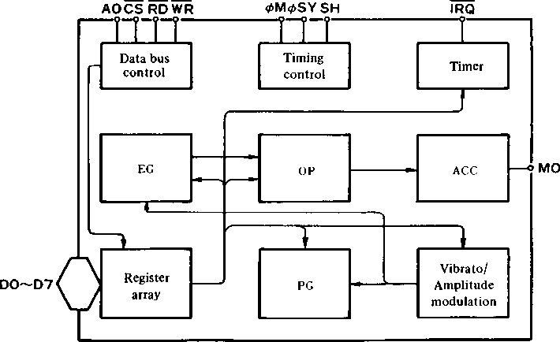

2

■ 5545524 0002401 T52 ■

**YM3812**

■ DESCRIPTION OF PIN FUNCTIONS

1. <t>M

Master clock of OPL; input frequency is 3.58MHz.

1. <t>SY-SH

Clock (<bSY) and Syncronization Signal (SH) to convert digital output of FM sound generator to analog signal.

1. D0-D7

8 bit bidirectional data communication between OPLII and processor.

1. CSRDWRAO

Control data bus comprised of Do~D7.

|  |  |  |  |  |
| --- | --- | --- | --- | --- |
| cs | RD | WR | A0 |  |
| 0 | 1 | 0 | 0 | Write address of register to OPL |
| 0 | 1 | 0 | 1 | Write contents of register to OPL |
| 0 | 0 | 1 | 0 | Status of OPL is read. |
| 0 | 0 | 1 | 1 | Data of data bus not assured |
| 1 | X | X | X | Set data bus DO ~ D7 to high impedance |

1. IRQ

Interrupt signal sent from either of two timers. Interrupts can be masked by program.

1. IC

Set the contents of registers to “0” and the system will be reset when driven to low level.

1. MO

Digital output of FM sound generator. The external D/A convertor unit is necessary.

1. Vcc

+ 5V power supply pin

1. GND

Ground pin

5'345524 0002402 525 ■

3

**YM3812**

JENERAL FUNCTIONS

OPLII has two voice modes: simultaneous voicing of 9 sounds, and 6 melody sounds and 5 rhythm sounds. Furthermore, these melody sounds can be produced with different voices at one time. Operation by software control makes the OPLII suitable as a sound generation system for computer-based apparatus such as game machines, teletext, etc.

The frequency modulation system in the OPLII synthesizes tones with 2 operators in 9 channels. The resultant algorithms are expressed by the following formula.

Fi= Ii sin wit + L sin W2t —(1)

F2 = h (wit + h sin W2t) —(2)

where formula (1) shows the production of a tone by sine waves addition,and formula (2) shows a sine wave modulating another sine wave, i.e. frequency modulation.

The synthesizer, which mixes several waveforms, and the noise generator are used to produce each individual rhythm sound. Five voices are available: Bass drum (BD), Snare drum (SD), High hat (HH), Top cymbal (TC), and Tom (TOM).

The following 8 functional blocks detail the OPLII internal configuration.

1. Register array:

Voice parameters and data for FM operation such as frequency data are set here. All the functions of the OPLII are controlled by the data set in this register array.

1. Phase generator:

This circuit generates the frequency of the operators (phase) data, which corresponds to the frequency data set in the register array, to determine the frequency of the operators.

1. Envelope generator;

This is a circuit which creates the envelope, that is the change in the sound over time that corresponding to the register data.

1. Operator:

The operator receives the phase data (wt) from the phasegenerator and the envelope data (I(t)) from the envelope generator, and computes I sin wt.

1. Accumulator:

This accumulates the output levels of the operators at each sampling period (sampling is carried out at 50kHz), and converts them into data available for the DAC and interface.

1. Vibrato/Amplitude modulation oscillator:

This is a low frequency oscillator for vibrato and amplitude modulation.

1. Timer:

General purpose timer applicable for variable length time settings.

1. Data bus controller.

4

0002403 flbS ■

**YM3812**

■ CONTENTS OF EACH REGISTER

|  |  |  |
| --- | --- | --- |
|  | **Address** |  |
| 1 | 01 | TEST information. Usually set to “0”. On this stage the waveform is Sine wave and compatible with YM3526. If any waveform other than Sine wave will be selected, set D5 to “1”. |
| 2 | 02 | Times setting on timer 1. 80|is~ 20.4ms |
| 3 | 03 | Times setting on timer 2. 320ns-82ms |
| 4 | 04 | Controls the operation of timers 1 and 2 and resets interrupt signals. |
| 5 | 08 | CSM is for the ***CSM*** speech synthesis modie.  NOTE SEL is for switching the keyboard split by using the F-Number. |
| 6 | 20-35 | MULTI controls the relationship between fundamental waves and harmonics.  KSR is key scale of RATE.  EG-TYPE is for the switching of Non Percussive Tone and Percussive Tone. 0 is for Percussive Tone and 1 is for Non Percussive Tone.  VIB indicates the ON/OFF of vibrato.  AM indicates the ON/OFF of modulation. |
| 7 | 40-55 | TL provides a total level for adjustment of each sound level. KSL is the level key scale. |
| 8 | 60-75 | DR sets the decay rate at the decay time.  AR sets the rate of increase at the attack time. |
| 9 | 80-95 | RR provides the decay rate at Release/Sustain time.  SL provides the level for shifting from decay to sustain. |
| 10 | A0-B8 | F-Number provides chords within one octave, Block represents octave information for each sound. K.ON indicates that the sound being generated when it is “1”. |
| 11 | BD | Controls rhythmic sounds and the corresponding bits for setting ON/OFF of each rhythm.  When the R bit is 1, the system is in the rhythm mode.  VIB DEP indicates the depth of vibrato. 0 = 70, 1 = 14o.  AM DEP indicates the depth of amplitude modulation. 0= IdB, 1 =4.8dB. |
| 12 | C0-C8 | FB indicates FM feedback factor.  C indicates Sin wave synthesis or FM modulation. |
| 13 | E0-F5 | Wave Select signal.  When D5 of address $01 is “1”, four kinds of waveform can be selected. |

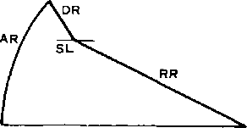

Percussive Tone

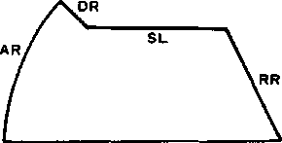

Non Percussive Tone

5

■ 5545524 0002404 ?T1 ■

**YM3812**

■ ELECTRICAL CHARACTERISTICS

1. **Absolute Maximum Ratings**

|  |  |  |
| --- | --- | --- |
|  | Rating | Units |
| Pin voltage | - 0.3 ~ 7.0 | V |
| Operating ambient temperature | 0 ~70 | °C |
| Storage temperature | -50 ~ 125 | °C |

1. **Recommended Operating Conditions**

|  |  |  |  |  |  |
| --- | --- | --- | --- | --- | --- |
| Item | Symbol | Minimum | Typical | Maximum | Unit |
| Power voltage | Vcc  GND | 4.5 0 | 5 0 | 5.5 0 | V  V |

1. **DC Characteristics**

|  |  |  |  |  |  |  |  |
| --- | --- | --- | --- | --- | --- | --- | --- |
| Item | | Symbol | Conditions | Minimum | Typical | Maximum | Unit |
| Input high level voltage | All input | Vih |  | 2.0 |  |  | V |
| Input low level voltage | All input | VlL |  |  |  | 0.8 | V |
| Input leak current | **omWRRDAo** | II | Vin = 0~5V | -10 |  | 10 | pA |
| Three-state (OFF state) input current | **Do~D7** | **ITSL** | Vin = 0~5V | -10 |  | 10 | pA |
| Output high level voltage | Output expect IRQ | VOH1 | IOH1 = 0.4mA | 2.4 |  |  | V |
| VOH2 | IOH2 = 40pA | 3.3 |  |  | V |
| Output low level voltage | All output | Vol | lOL — 2.0mA |  |  | 0.4 | V |
| Output leak current (OFF state) | IRQ | **ILOFF** | VOH=0~5V | -10 |  | 10 | V |
| Pullup resistance | ic?cs | Ru |  | 80 |  | 400 | KQ |
| Input capacity | All input | Ci |  |  |  | 10 | PF |
| Output capacity | All output | Co |  |  |  | 10 | pF |
| Power voltage |  | ICC |  |  |  | 30 | mA |

1. **AC Characteristics**

|  |  |  |  |  |  |  |  |
| --- | --- | --- | --- | --- | --- | --- | --- |
| Item | | Symbol | Conditions | Minimum | Typical | Maximum | Unit |
| Input clock frequency | oM | fc | Fig. A-l | 2.0 | 3.58 | 4.0 | MHz |
| Input clock duty cycle | oM |  |  | 40 | 50 | 60 | % |
| Input clock rise time | oM | **tR** | Fig. A-l |  |  |  | ns |
| Input clock fall time | oM | **tf** | Fig. A-l |  |  |  | ns |
| Address setup time | Ao | **tAS** | Fig. A-2, Fig. A-3 | 10 |  |  | ns |
| Address hold time | Ao | **tAH** | Fig. A-2, Fig. A-3 | 20 |  |  | ns |
| Chip select write width | CS | **tcsw** | Fig. A-2 | 100 |  |  | ns |
| Chip select read width | CS | **tCSR** | Fig. A-3 | 200 |  |  | ns |
| Write pulse write width | WR | **tww** | Fig. A-2 | 100 |  |  | ns |
| Write data setup time | D0~D7 | **tos** | Fig. A-2 | 20 |  |  | ns |
| Write data hold time | D0~D7 | ton | Fig. A-2 | 30 |  |  | ns |
| Read pulse width | RD | **tRW** | Fig. A-3 | 200 |  |  | ns |
| Read data access time | Do~D7 | **tACC** | Fig. A-3 |  |  | 200 | ns |
| Read data hold time | D0~D7 | **tRDH** | Fig. A-3 | 10 |  |  | ns |
| Output rise time | **bSY** | **tORl** | Fig. A-4 |  |  | 100 | ns |
| MOSH | **tOR2** | Fig. A-5 |  |  | 150 | ns |
| Output fall time | oSY | **tOFl** | Fig. A-4 |  |  | 100 | ns |
| MOSH | **tOF2** | Fig. A-5 |  |  | 150 | ns |
| Reset pulse width | ic | Nicw | Fig. A-6 | 80 |  |  | Cycle |

■ T'mssaq oooemos baa ■

6

**YM3812**

MM

■ REGISTER MAP

|  |  |  |  |  |  |  |  |  |  |
| --- | --- | --- | --- | --- | --- | --- | --- | --- | --- |
| ADDRESS | **D?** | D6 | **Ds** | D4 | D3 | D2 | **Di** | **Do** | COMMENT |
| **01** | ! | | | TEST | | | | | TEST DATA OF LSI  Ds indicates WAVE SELECT ENABLE. |
| **02** | TIMER-1 | | | | | | | | DATA OF TIMER-1 |
| **03** | TIMER-2 | | | | | | | | DATA OF TIMER-2 |
| **04** | **RST** | MASK  T1 T2 | |  | | | ST2ST1 | | IRQ-RESET/CONTROL OF RIMER-1, 2 |
| **08** | **CSM** | **SEL** |  | | | | | | CSM SPEECH SYNTHESIS MODE/NOTE SELECT |
| **20**  **35** | 2 < | ffl > | EG-TYP | KSR | MULTI | | | | AM/VIB/EG-TYPE/KSR/MULTIPLE |
| **40**  **55** | KSL | | TL | | | | | | KSL/TOTAL LEVEL |
| **60**  **75** | AR | | | | DR | | | | ATTACK RATE/DECAY RATE |
| **80**  **95** | SL | | | | RR | | | | SUSTAIN RATE/RELEASE RATE |
| **AO**  **A8** | F-Number (L) | | | | | | | | KON/BLOCK/F-Number |
| **BO**  **B8** |  | | KON | BLOCK | | | F-Num  (H) | |
| **BD** | DEP AM VIB | | R | BD SDTOMTC HH | | | | | DEPTH(AM/VIB)/RHYTHM(BD-SD-TOM-TC-HH) |
| **CO**  **C8** |  | | |  | FB | | | C | FEEDBACK/CONNECTION |
| **EO**  **F5** | r<7-j i i i i | | | | | | WS | | WAVE SELECT |

■ STATUS REGISTERS

|  |  |  |  |
| --- | --- | --- | --- |
| **IRQ** | FLAG T1 T2 |  | IRQ/FLAG(T1, T2) |

■I T145524 □□□24Db 574 ■

7

**YM3812**

■ TIMING DIAGRAMS (Timing is based upon settings of Vm = 2.0V and Vil = 0.8V)

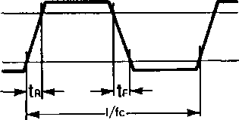

***Fig. A-l Clock Tinting***

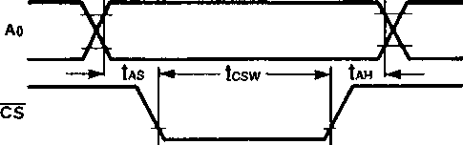

H—tww—►  
■77777T V777

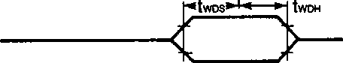

Note: **tcsw, tww,** and **twDH** are based on either CS or WS being driven to high level.

***Fig. A-2 Write Tinting***

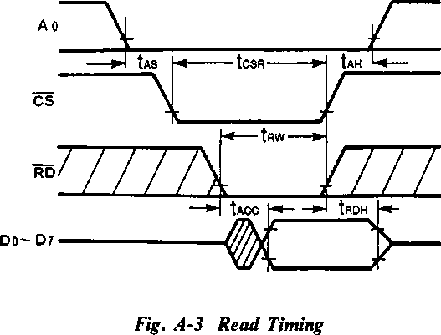

Note: tACC is based on whichever of CS or RD goes to the low level last.

**tscR, tRW,** and tRDH are based on either CS or RD being driven to high level.

8 ■ 5545524 0002407 MOO ■

**YM3812**

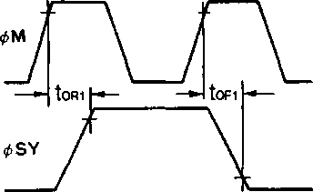

Fig.A-4 4>M and $>SY

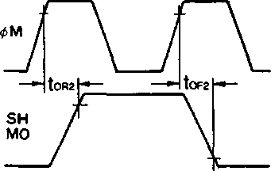

Fig. A-5 and SFFMO

NlCW •-



Fig. A-6 Reset Pulse

■ WAVE SELECT

When bit Ds of address $4>1 is “0”, the OPLII is fully compatible with YM3526 (OPL); there are no differences between the two devices. If a sine wave is input in this mode, the output will be a sine wave like the input. When bit Ds of address $4>1 is “1”, the input sine wave will be output as the distorted wave shown in Table 3-10.

$E0~$F5

|  |  |
| --- | --- |
| **D7 D6 D5 D4 D3 D2** | Dl Do |
|  | WAVE  SELECT |

Table 3-10 Wave Select

|  |  |  |
| --- | --- | --- |
| Dl | Do | Waveform |
| 0 | 0 | *%* |
| 0 | 1 | n |
| 1 | 0 | m |
| 1 | 1 |  |

9

■ 5545524 00D2406 34?

**YM3812**

■ DIMENSIONS

**YM3812**

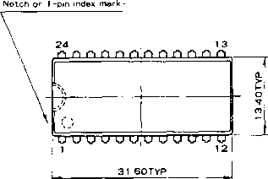

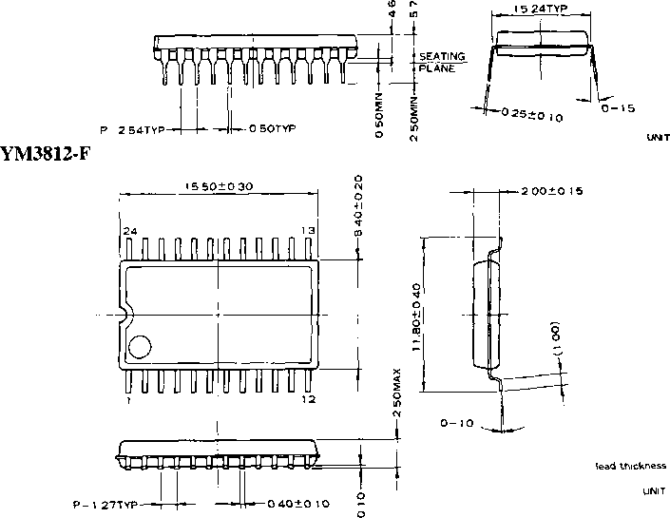

The specifications of this product are subject to improvement changes without prior notice.

AGENCY

-YAMAHA CORPORATION

—YAMAHA CORPORATION

Address inquiries to:  
Semi-conductor Sales Department

|  |  |
| --- | --- |
| ■ Head Office | 203, Matsunokijima, Toyooka-mura, |
| ■ Tokyo Office | Iwata-gun, Shizuoka-ken, 438-01 Electronic Equipment business section Tel. 0539-62-4918 Fax. 0539-62-5054 2-17-11, Takanawa, Minato-ku, |
| ■ Osaka Office | Tokyo, 108  Tel. 03-5488-5431 Fax. 03-5488-5088 3-12-9, Minami Senba, Chuo-ku, |
| ■ U.S.A. Office | Osaka City, Osaka, 542  Shinsaibashi Plaza Bldg. 4F  Tel. 06-252-7980 Fax. 06-252-5615  YAMAHA Systems Technology. |
|  | 100 Century Center Court, San Jose, CA95112 Tel. 408-467-2300 Fax. 408-437-8791 |

10 Copying prohibited © 1987 YAMAHA CORPORATION

■ 554S524 0002405 563 ■

0.3K-0430 C* Printed in Japan 86.4