D/A CONVERTER

2-Channel Serial & Binary input Floating D/A Converter

V IX/13 0*1 6 □ACCCD)

* OUTLINE

The YM3016 : DAC-GS is a Floating D/A converter (referred to as DAC hereafter) with the 2- channel serial and 16-bit binary input or 2’s complement input. It can produce analog output (16-bit dynamic range) which has 10-bit mantissa and 7-step exponent characteristic for the input digital signal.

* FEATURES
* 16-bit input format can select either binary or 2’s complement (due to built-in floating converter logic).
* Analog output can be obtained easily by adding a buffer operational amplifier, etc.
* 16-bit wide dynamic range.
* Capable of processing PCM sound source up to 2 channels.
* Equipped with a built-in analog switch for sample hold.
* Lower noise and less harmonic distortion and outstanding temperature characteristics.
* Made by the monolithic process of highly accurate thin film resistor and CMOS.
* Package type: 16 pin plastic SOP: YM3016F

DIP : YM3016D

* +5V single power supply.

■ Electrical characteristics

O Absolute Maximum Ratings

|  |  |  |
| --- | --- | --- |
| Item | Rating | Unit |
| Supply voltage | -0.3 - +15.0 | V |
| High-level input voltage | Vdd +0.3 | V |
| Low-level input voltage | Vss -0.3 | V |
| Operating ambient temperature | 0-70 | °C |
| Storing temperature | -50- +125 | °C |

@ Recommended Operating Conditions

|  |  |  |  |  |  |
| --- | --- | --- | --- | --- | --- |
| Item | Symbol | Min |  | Max | Unit |
| Supply voltage | Vdd | 4.75* | 5.0 | 5.25 | V |
| Input signal voltage | Vss  CLOCK | 0 | 0 | 0 | V |
|  | SD SMP1, 2 ICL | 0 | — | Vdd | V |
| Operating ambient temperature | Ta | 0 | — | 70 | °C |

0) DC Characteristics

|  |  |  |  |  |  |  |
| --- | --- | --- | --- | --- | --- | --- |
| Item | Symbol | Measuring Conditions | Min | Typ | Max | Unit |
| High-level input voltage | VlH |  | 0.66Vdd | — | — | V |
| Low-level input voltage | ViL |  | — | — | 0.30Vdd | V |
| Input current | I IN | Vdd - 5.0V | — | — | 10 3 | ^A |
| Analog output voltage | VOUT |  | — | 0.50Vdd | — | Vp-p |
| Supply current | Idd | Vdd = 5.0 V | — | — | 6 | mA |

32

■ OUTLINE DIMENSIONS

YM3OI6-F

YM3O I 6-D

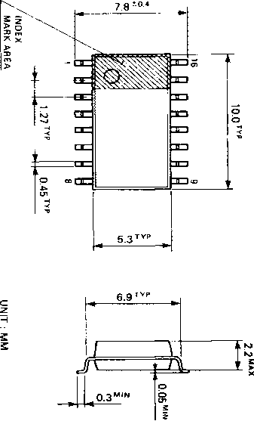

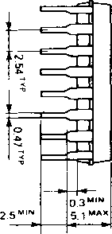

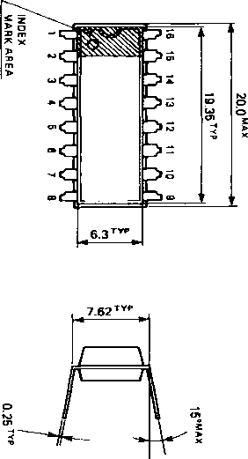

■ BLOCK DIAGRAM

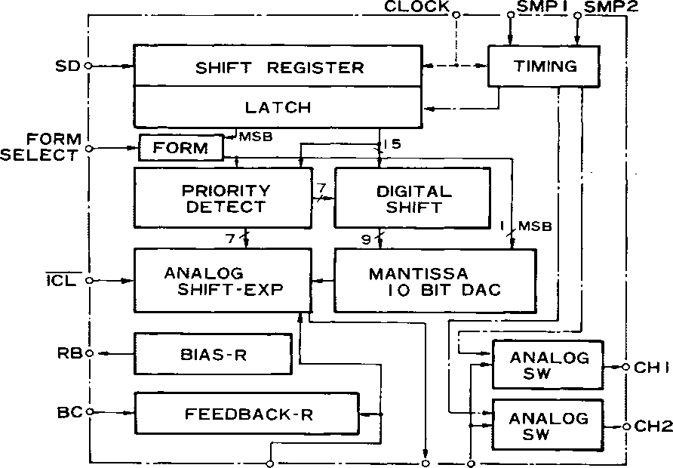

MP

TO BUFF COM

33