PHP

# 26. a ) Write a program in php to print hello World.

<?php

echo "Hello World";

?>

# Create a php program to find odd or even number from given number.

<!DOCTYPE html>

<html lang="en">

<head>

<title>Document</title>

</head>

<body>

<form action="practical15.php" method="get">

Enter a number : <input type="number" name="num">

</form>

</body>

</html>

<?php

$num = $_GET["num"];

if($num % 2 == 0){

echo "[$num ] is even!";

}else{

echo "[$num] is odd!";

}

?>

# Write a php program to find maximum of three numbers.

<?php

$a = 200;

$b = 140;

$c = 90;

echo " Numbers are $a , $b , $c <br>";

if ($a > $b && $a > $c) { echo "$a is greatest";

}else if($b > $c){

echo "$b is greatest";

}else{

echo "$c is greatest";

}

?>

# OUTPUT



**OUTPUT**

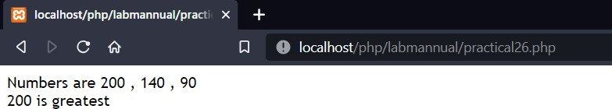

# OUTPUT

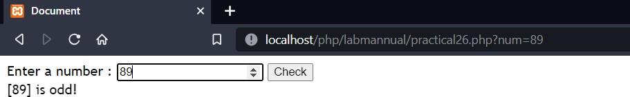

**27 . Write a program to enter TWO numbers and print the Swap Numbers using PHP Example.**

<!DOCTYPE html>

<html lang="en">

<head>

<title>Document</title>

</head>

<body>

<form action="" method="get">

Number 1 : <input type="number" name="num1"><br> NUmber 2 : <input type="number" name="num2"><br>

<button type="submit">Swap</button>

</form>

</body>

</html>

<?php

$num1 = $_GET['num1'];

$num2 = $_GET['num2'];

echo "Numbers before swapping are num1 = $num1 and num2 = $num2<br>";

$temp = $num1;

$num1 = $num2;

$num2 = $temp;

echo "Numbers after swapping are num1 = $num1 and num2 = $num2<br>";

?>

# OUTPUT

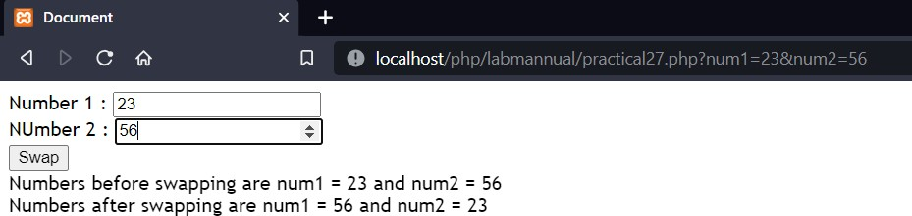

**28. a) Write a PHP Program to demonstrate the variable function: gettype() and settype()**

**gettype()**

<?php

$a = 3;

echo gettype($a) . "<br>";

$b = 3.2;

echo gettype($b) . "<br>";

$c = "Hello";

echo gettype($c) . "<br>";

$d = array();

echo gettype($d) . "<br>";

$e = array("red", "green", "blue"); echo gettype($e) . "<br>";

$f = NULL;

echo gettype($f) . "<br>";

$g = false;

echo gettype($g) . "<br>";

?>

## settype()

<?php

$a = "32"; // string settype($a, "integer"); echo "$a<br>";

$b = 32; // integer settype($b, "string"); echo "$b<br>";

$c = true; // boolean settype($c, "integer"); echo "$c<br>";

?>

# Write a PHP Program to demonstrate the variable unction: isset()

<?php

$a = 0;

// True because $a is set if (isset($a)) {

echo "True Variable 'a' is not null and is SET.<br>";

}

$b = null;

// False because $b is NULL if (isset($b)) {

echo "True Variable 'b' is not null and is SET.<br>";

}else{

echo "False variable 'b' is null or not SET";

}

?>

# Write a PHP Program to demonstrate the variable unction: unset()

<?php

$a = "Value of a is Present";

echo "The value of variable 'a' before unset: " . $a . "<br>"; unset($a);

echo "The value of variable 'a' after unset: $a";

?>

# OUTPUT

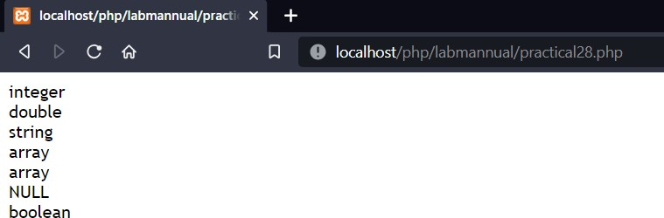

**OUTPUT**

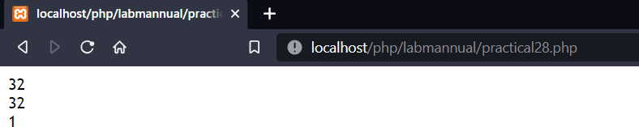

# OUTPUT

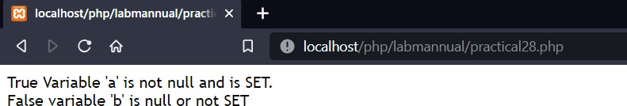

**OUTPUT**



# 29.) Electricity Bill Using PHP (To Understand Form Handling in PHP)

<!DOCTYPE html>

<html lang="en">

<head>

<title>Document</title>

</head>

<body>

<form action="" method="get">

ConsumerNumber: <input type="text" name="cnum"><br> Name : <input type="text" name="name"><br>

PreviousReading : <input type="number" name="previousR"><br> PresentReading : <input type="number" name="presentR"><br>

<button type="submit">Submit</button>

</form>

</body>

</html>

<?php

$cnum = $_GET['cnum'];

$name = $_GET['name'];

$previousR = $_GET['previousR'];

$presentR = $_GET['presentR'];

echo "<h1>ELECTRICITY BILL</h1><br>";

$unitConsumed = $presentR - $previousR;

$bill = 0;

if ($unitConsumed < 100) {

$bill = $unitConsumed * 3;

}elseif($unitConsumed > 100 && $unitConsumed < 200){

$bill = $unitConsumed * 4;

}elseif($unitConsumed > 200 && $unitConsumed < 300){

$bill = $unitConsumed * 5;

}else{

$bill = $unitConsumed * 6;

}

echo "ConsumerNumber : $cnum <br>"; echo "Name : $name<br>";

echo "Previous reading : $previousR<br>"; echo "Present Reading : $presentR<br>";

echo "Units Consumed : $unitConsumed<br>"; echo "Total Bill = $bill";

?>

# OUTPUT

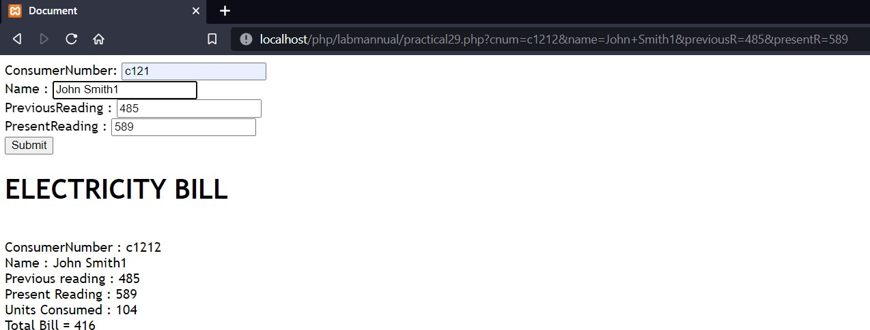

1. **) Session Handling Using PHP**

**Cookie**

<?php

## // Set the cookie

$c_name = "user";

$c_value = "John Smith";

$expiry_time = time() + (86400 * 30); // 30 days

setcookie($c_name, $c_value, $expiry_time, "/"); // ‘/’ means cookie available for entire site.

## // Access the cookie

if(isset($_COOKIE[$c_name])) {

echo "Cookie value: " . $_COOKIE[$c_name];

} else {

echo "Cookie not set.";

}

?>

**Session**

<?php

## // Start the session

session_start();

$_SESSION['username'] = 'JohnSmith';

$_SESSION['email'] = 'johnSmith@email.com';

## // Access the session variables

echo "Username: " . $_SESSION['username'] . "<br>"; echo "Email: " . $_SESSION['email'];

session_abort();

?>

# OUTPUT



**OUTPUT**

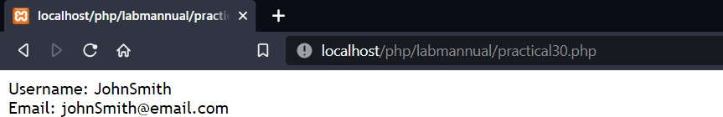

# ) File Uploading Using PHP (To Understand File Uploading in PHP)

<?php

$file_size = 10 * 1024 * 1024;

$allowedFileTypes = array('image/jpeg', 'image/png'); if ($_SERVER['REQUEST_METHOD'] === 'POST') {

if ($_FILES['file']['error'] === UPLOAD_ERR_OK) {

$fileName = $_FILES['file']['name'];

$fileType = $_FILES['file']['type'];

$fileSize = $_FILES['file']['size'];

$fileTmpPath = $_FILES['file']['tmp_name']; if (in_array($fileType, $allowedFileTypes)) {

if ($fileSize <= $file_size) {

$destinationPath = 'C:' . $fileName;

if (move_uploaded_file($fileTmpPath, $destinationPath)) { echo 'File uploaded successfully.<br>';

echo "filename : $fileName<br>"; echo "fileType : $fileType<br>"; echo "fileSize : $fileSize<br>";

} else {

echo 'Failed to move the uploaded file.';

}

} else {

echo 'File size exceeds the allowed limit.';

}

} else {

echo 'Invalid file type.';

}

} else {

echo 'File upload error: ' . $_FILES['file']['error'];

}

}

?>

<!DOCTYPE html>

<html>

<head>

<title>File Upload</title>

</head>

<body>

<form method="POST" enctype="multipart/form-data">

<input type="file" name="file" required>

<button type="submit">Upload</button>

</form>

</body>

</html>

# OUTPUT



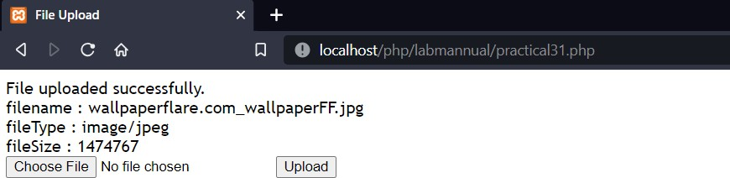

1. **) PHP with MySQL Develop a simple application**

## Enter data into database

<?php session_start();

$conn = mysqli_connect("localhost", "root", "", "reglog");

if (isset($_POST["submit"])) {

$name = $_POST["name"];

$username = $_POST["username"];

$email = $_POST["email"];

$password = $_POST["password"];

$confirmpassword = $_POST["confirmpassword"];

$duplicate = mysqli_query($conn, "SELECT * FROM tb_user WHERE username = '$username' OR email = '$email'");

if (mysqli_num_rows($duplicate) > 0) {

echo "<script> alert('Username or Email Has Already Taken'); </script>";

} else {

if ($password == $confirmpassword) {

$query = "INSERT INTO tb_user VALUES('','$name','$username','$email','$password')"; mysqli_query($conn, $query);

echo "<script> alert('Registration Successful'); </script>";

} else {

echo "<script> alert('Password Does Not Match'); </script>";

}

}

}

?>

?>

<!DOCTYPE html>

<html lang="en" dir="ltr">

<head>

<meta charset="utf-8">

<title>Registration</title>

<link rel="stylesheet" href="style.css">

</head>

<body>

<div class="container">

<h2>Registration</h2>

<hr>

<form method="post">

<label for="name">Name</label><br>

<input type="text" name="name" id="name" required value=""> <br>

<label for="username">Username</label><br>

<input type="text" name="username" id="username" required value=""> <br>

<label for="email">Email</label><br>

<input type="email" name="email" id="email" required value=""> <br>

<label for="password">Password</label><br>

<input type="password" name="password" id="password" required value=""> <br>

<label for="confirmpassword">Confirm Password</label><br>

<input type="password" name="confirmpassword" id="confirmpassword" required value=""> <br>

<button type="submit" name="submit">Register</button>

</form>

<br>

</div>

</body>

</html>

# OUTPUT

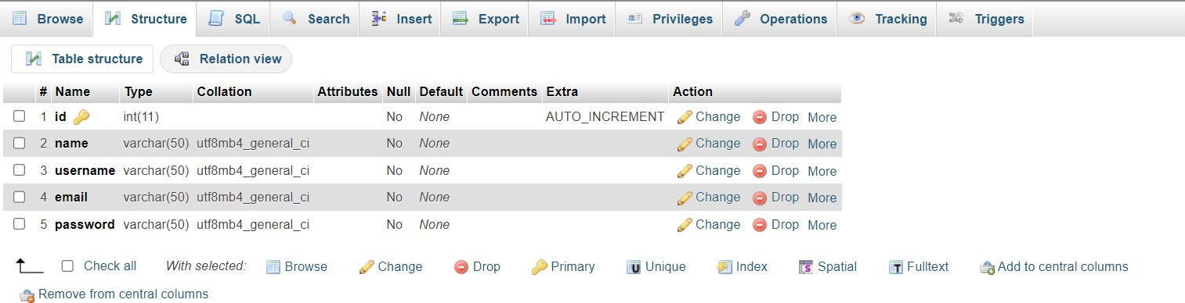

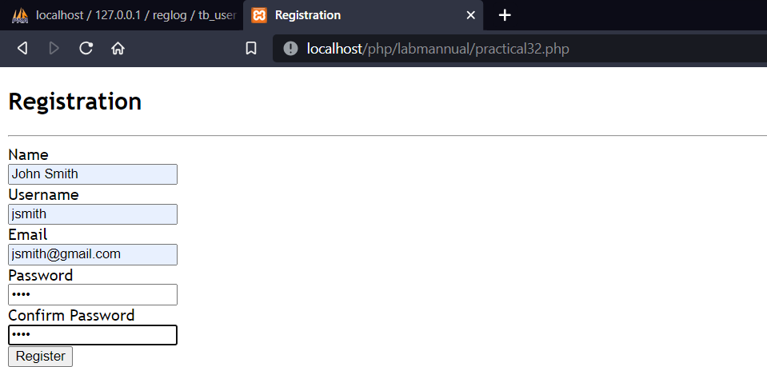

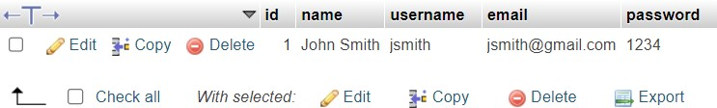

## Retrieve and present data from database

<?php

$conn = mysqli_connect("localhost", "root", "", "reglog");

if ($conn->connect_error) {

die("Connection failed: " . $conn->connect_error);

}

$sql = "SELECT * FROM tb_user";

$result = mysqli_query($conn, $sql); if (mysqli_num_rows($result) > 0) {

echo "<table>";

echo "<tr><th>ID</th><th>Name</th><th>Email</th></tr>"; while ($row = mysqli_fetch_assoc($result)) {

echo "<tr>";

echo "<td>" . $row["id"] . "</td>";

echo "<td>" . $row["name"] . "</td>";

echo "<td>" . $row["email"] . "</td>"; echo "</tr>";

}

echo "</table>";

} else {

echo "No results found";

}

?>

# OUTPUT

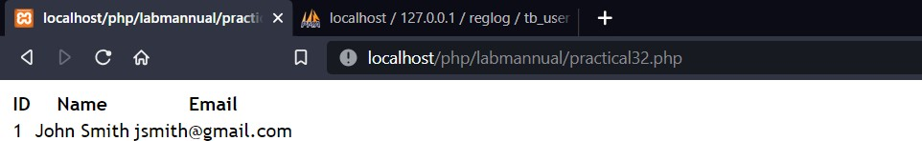

1. **) Create a PHP page for login page with sql connection.**

<?php

$conn = mysqli_connect("localhost", "root", "", "reglog"); if (isset($_POST["submit"])) {

$usernameemail = $_POST["usernameemail"];

$password = $_POST["password"];

$result = mysqli_query($conn, "SELECT * FROM tb_user WHERE username = '$usernameemail' OR email = '$usernameemail'");

$row = mysqli_fetch_assoc($result); if (mysqli_num_rows($result) > 0) {

if ($password == $row['password']) {

$_SESSION["login"] = true;

$_SESSION["id"] = $row["id"]; echo "Logged in Successfully";

} else {

echo

"<script> alert('Wrong Password'); </script>";

}

} else {

echo

"<script> alert('User Not Registered'); </script>";

}

}

?>

<!DOCTYPE html>

<html lang="en" dir="ltr">

<head>

<meta charset="utf-8">

<title>Login</title>

<link rel="stylesheet" href="style.css">

</head>

<body>

<div class="container">

<h2>Login</h2>

<hr>

<form class="" action="" method="post" autocomplete="off">

<label for="usernameemail">Username or Email</label><br>

<input type="text" name="usernameemail" id="usernameemail" required value=""><br>

<label for="password">Password</label><br>

<input type="password" name="password" id="password" required value=""> <br>

<button type="submit" name="submit">Login</button>

</form>

<br>

</div>

</body>

</html>

# OUTPUT

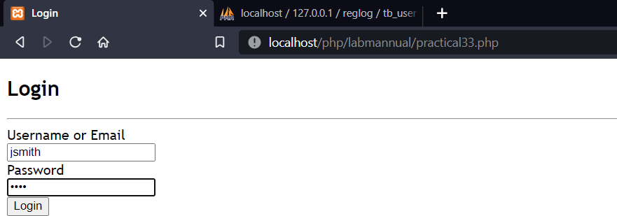

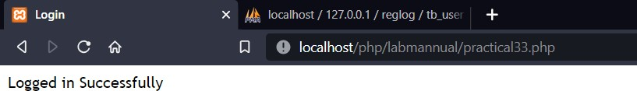

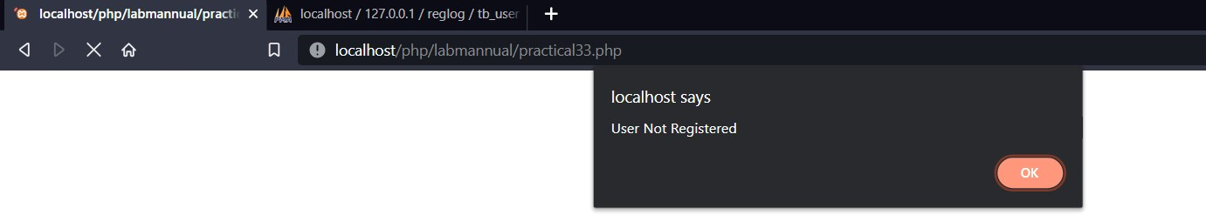

1. **File Handling Using PHP**

# Read from a file

<?php

$file_path = 'E:\new.txt';

$file_contents = file_get_contents($file_path); echo $file_contents;

?>

## // or read the file by fopen() and fgets()

<?php

$file_path = 'E:\new.txt';

$file_handle = fopen($file_path, 'r'); while (!feof($file_handle)) {

$line = fgets($file_handle); echo $line;

}

fclose($file_handle);

?>

# Write a file

<?php

$file_path = 'E:\new.txt';

$content = "This is the new contnet in the file"; file_put_contents($file_path, $content);

echo "Written Successfully";

?>

## // or write the file using fwrite()

<?php

$file_path = 'E:\new.txt';

$content = "This is the new contnet in the file";

$file_handle = fopen($file_path, 'w'); fwrite($file_handle, $content); fclose($file_handle);

?>

# OUTPUT





**OUTPUT**

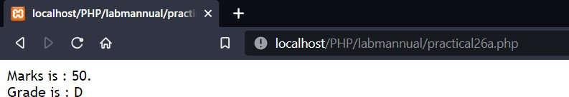

# 26 a) Use of If-Else condition in PHP.

<?php

$marks = 50;

echo "Marks is : $marks. <br>"; echo "Grade is : ";

if ($marks >= 90 ) { echo "A+";

}else if($marks < 90 && $marks >= 80){ echo "A";

}else if ($marks < 80 && $marks >= 70) { echo "B";

}else if ($marks < 70 && $marks >= 60) { echo "C";

}else if ($marks < 60 && $marks >= 50) { echo "D";

}else if ($marks < 50 && $marks >= 40) { echo "E";

}else if ($marks < 80 && $marks >= 70) { echo "F";

}

?>

# 26 b) Use of Switch Case Statement

<?php

$days = 4;

echo "The day number is : $days<br>"; echo "The day is : ";

switch ($days) { case '1':

echo "Monday"; break;

case '2':

echo "Tuesday"; break;

case '3':

echo "Wednesday"; break;

case '4':

echo "Thusday"; break;

case '5':

echo "Friday"; break;

case '6':

echo "Saturday"; break;

case '7':

echo "Sunday"; break;} ?>

## OUTPUT

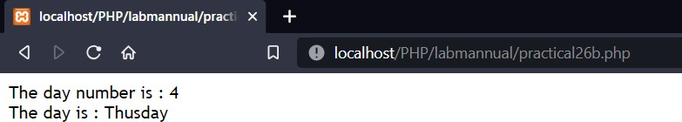

**OUTPUT**

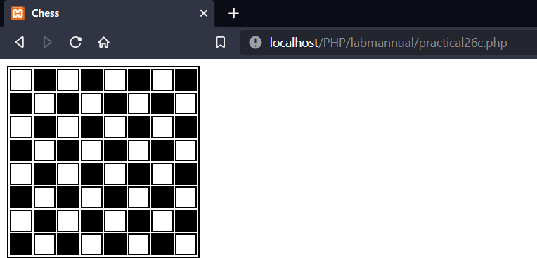

## 26 c) Use of Nested Loops to create a Chess Board.

<!DOCTYPE html>

<html lang="en">

<head>

<title>Chess</title>

<style>

table{border: 2px solid black} td{

height: 20px; width:20px;

border: 2px solid black;

}

</style>

</head>

<body>

<table>

<?php

for($i=0;$i<8;$i++){ echo "<tr>"; for($j=0; $j<8; $j++){

if(($i+$j) %2 ==0) echo "<td> </td>"; else echo "<td bgcolor='black'> </td>";

}echo"</tr>";}

?>

</table>

</body>

</html>