Project Documentation: Student Portfolio website


Punjab Tianjin University of Technology
Department of Software Engineering Technology
Name: Muhammad Bilal Saleem
Sub_Name: Software Project Management
Registration No: 23-ST-016
Session: Fall 25 (5th semester)

Table of Contents
Student Portfolio System: Executive Summary 1
1.1 Abstract 1
1.2 Problem Statement 1
1.3 Proposed Solution 1
1.4 Project Scope 2
2.1 Architectural Pattern 2
2.2 detailed Technology Stack 3
2.2.1 Frontend: The View Layer 3
2.2.2 Backend: The Controller Layer 4
2.2.3 Infrastructure & Database 4
2.3 Deployment Strategy 5
3.1 Version Control Workflow 5
3.2 Testing Strategy 5
3.2.1 Unit Testing Frameworks 5
4.1 Database Overview 6
4.2 Entity Relationship Diagram (ERD) Description 7
5.1 Functional Requirements Specification 8
1. Authentication & Identity Management 8
2. Student Profile Management 9
3. Project Portfolio Management 9
4. Administrative Oversight & Moderation 10
5. Public Showcase & Access 11
6. System & Data Integrity 11
5.2 Non-Functional Requirements Specification 12
1. Performance & Efficiency 12
2. Security & Compliance 12
3. Reliability & Availability 13
4. Usability & Accessibility 13
5. Maintainability & Scalability 14
5.3 Detailed Table Definitions 14
5.3.1 Table: profiles 14
5.3.2 Table: projects 15
5.3.3 Table: project_requirements 15
5.3.4 Table: project_comments 16
5.3.5 Utility Tables 16
5.4 Data flow diagram: 17
6.1 Authentication Module (/api/auth) 18
6.2 Projects Module (/api/projects) 18
6.3 Profile Module (/api/profile) 19
6.4 Admin Module (/api/admin) 19
7.1 Student Onboarding Flow 19
7.2 Project Submission Lifecycle 20
7.3 Admin Review Process 20
8.1 Student Use Cases 21
UC-01: Register & Onboard 21
UC-02: Create New Project 21
UC-03: Upload Project Thumbnail 22
UC-04: Manage Project Requirements 22
UC-05: Update Student Profile 23
UC-06: Reset Password 23
UC-07: Delete Project 24
8.2. Administrator Use Cases 24
UC-08: Admin Login 24
UC-09: Review and Comment 25
UC-10: Remove Student (Moderation) 25
UC-11: Search and Filter Students 26
UC-12: Delete Admin Comment 26
8.3. Public Use Cases 27
UC-14: View Public Portfolio 27
UC-15: Filter Projects 27
9.1 Use Case Diagram 28
10.1. Test Case Specification 30
10.1.1 Authentication Module (Backend) 30
10.1.2 Project Management Module (Backend) 31
10.1.3. Admin Module (Backend) 32
10.1.4. Frontend Component Tests (React/Vitest) 32
11.1 Quality Register 33
12.1 Risk Register 34
12.1. High Severity Risks (Immediate Attention) 34
11.2. Medium Severity Risks (Monitoring Required) 35
12.3 Low Severity Risks (Acceptable) 36
13.1 Project Conclusion 37

Student Portfolio System: Executive Summary

Repository: https://github.com/denji444/Student_portfolio_project
Live Deployment: https://udent-portfolio-gppt.onrender.com
License: Open Source
Version: 1.0 (Branch: v5)

The Student Portfolio System is a mission-critical, open-source web application designed to modernize how university software departments manage, archive, and showcase student intellectual property. In the current academic landscape, valuable student outputs—ranging from semester capstones to complex engineering assignments—are often lost to data fragmentation, scattered across personal drives, ephemeral email attachments, and unverified third-party repositories. This project addresses this systemic inefficiency by establishing a centralized, verified, and persistent digital repository. By integrating a high-performance React (Vite) frontend with a scalable Node.js (Express) backend within a unified Monorepo architecture, the system provides a seamless bridge between academic achievement and professional presentation.
University departments currently face a dual challenge regarding visibility and verification. Excellent student work often goes unnoticed by industry recruiters due to the lack of a unified showcase platform, while faculty struggle to verify the authenticity of submitted projects without a centralized audit trail. The Student Portfolio System solves this by implementing a robust identity management workflow. Utilizing Supabase Authentication, the system enforces strict email verification logic, ensuring that only students with valid university credentials can register. This creates a "Walled Garden" of trust, where every portfolio item displayed is guaranteed to be linked to a verified student identity.
The platform is engineered for scalability and security from the ground up. On the frontend, it is built on React and TypeScript, leveraging TanStack Query for efficient state management and Tailwind CSS for a responsive, accessible UI that ensures a professional user experience across mobile and desktop devices. The backend features a RESTful API built with Express.js to handle business logic. Crucially, it employs Zod for runtime schema validation, ensuring that all incoming data meets strict integrity standards before reaching the database. Supporting this infrastructure, PostgreSQL (via Supabase) serves as the backbone data layer, utilizing Row-Level Security (RLS) policies to enforce data privacy at the database engine level. This ensures that while public visitors can view portfolios, only the original creator can edit or delete their records.
Stakeholder benefits are central to the system's design. For students, the platform transforms passive assignments into active career assets, allowing them to document their technical stack, upload project thumbnails, and track specific implementation requirements, thereby fostering the critical soft skill of documentation. For administrators, the system provides a powerful oversight dashboard where faculty can review projects, track submission timestamps, and provide qualitative feedback directly on the project artifact. An integrated notification system ensures students are immediately alerted to feedback, tightening the loop between submission and improvement.
Deployed on Render with a fully automated Continuous Integration (CI) pipeline, the Student Portfolio System serves as a vital piece of institutional infrastructure. It secures the department's intellectual property, validates student achievements, and enhances the university's reputation by publicly showcasing the technical caliber of its graduates to the wider world.

1.1 Abstract
The Student Portfolio System is a comprehensive, open-source web application designed to digitize and centralize the academic output of university software departments. Traditionally, student projects—ranging from capstones to semester assignments—are scattered across disparate storage mediums or lost after grading. This project addresses the need for a unified repository by offering a full-stack solution where students can document their technical achievements, and administrators (faculty) can verify, review, and curate these submissions. The system leverages modern web technologies to ensure scalability, security, and a seamless user experience.

1.2 Problem Statement
In the current academic landscape, software departments face several challenges regarding student work:
- Fragmentation: Student projects are often submitted via email, physical drives, or temporary links, making long-term archiving difficult.
- Lack of Visibility: Excellent student work often goes unnoticed by the public or potential recruiters due to the lack of a showcase platform.
- Verification Gaps: Without a centralized verification system, it is difficult to validate the authenticity and completion status of claimed projects.
- Inefficient Feedback Loops: Providing structured feedback on specific project requirements is often cumbersome and disconnected from the project artifact itself.

1.3 Proposed Solution
The Student Portfolio Monorepo solves these issues by providing:
- For Students: A professional dashboard to create detailed project portfolios including descriptions, tech stacks, and deployment links, fostering a culture of documentation.
- For Administrators: A robust oversight mechanism allowing faculty to verify email identities, review project requirements line-by-line, and comment directly on submissions.
- For the Public: A transparent, accessible landing page that serves as a window into the department's technical Caliber.

1.4 Project Scope
The application is built as a Monorepo, housing both client and server logic.
- In Scope: User authentication (Custom & OAuth), Profile Management, Project CRUD operations, Admin Dashboard, Commenting System, Requirement Tracking, and Public Showcasing.
- Out of Scope: Native mobile apps (currently Web-only), proprietary LMS integrations (e.g., Moodle/Canvas), and direct code hosting (links to GitHub are used instead).

2.1 Architectural Pattern
The system utilizes a Client-Server Architecture managed within a Monorepo structure. This approach was chosen to unify dependency management and streamline the development lifecycle across the stack.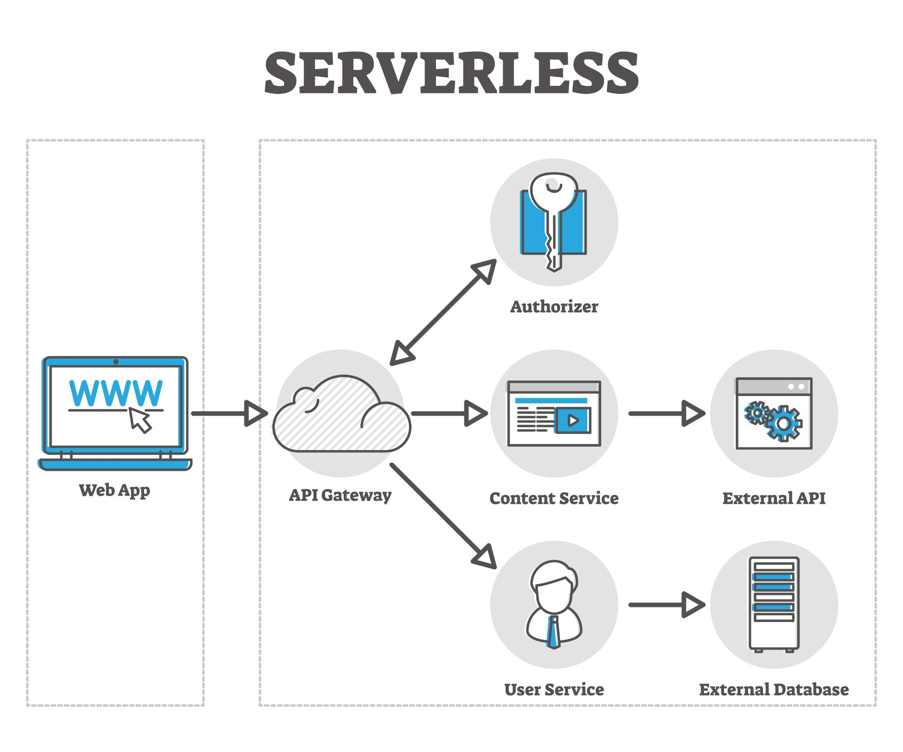
- Frontend (Client): A generic Single Page Application (SPA) responsible for presentation logic and state management.
- Backend (Server): A RESTful API responsible for business logic, data validation, and database communication.
- Database (Persistence): A relational database coupled with an Authentication-as-a-Service provider.

2.2 detailed Technology Stack

2.2.1 Frontend: The View Layer
- Core Framework: React (via Vite)
  - Rationale: Vite offers superior build times compared to CRA. React's component-based architecture allows for reusable UI elements (buttons, cards, forms) essential for the dashboard interface.
- Language: TypeScript
  - Rationale: Enforces static typing, drastically reducing runtime errors related to data shapes (e.g., ensuring a Project object always has a title).
- State Management: TanStack Query (React Query)
  - Rationale: Handles server state (fetching, caching, synchronizing, and updating server state). It eliminates the need for complex useEffect chains and ensures the UI always reflects the latest database state.
- Styling: Tailwind CSS & shadcn/ui
  - Rationale: Utility-first CSS allows for rapid prototyping. shadcn/ui provides accessible, unstyled components that adhere to modern design principles without the bloat of heavy component libraries.
- Routing: React Router DOM
  - Rationale: Manages client-side routing, enabling the SPA experience where the page does not reload during navigation.

2.2.2 Backend: The Controller Layer
- Runtime Environment: Node.js
  - Rationale: Allows the use of JavaScript/TypeScript on the server, unifying the language across the full stack.
- Web Framework: Express.js
  - Rationale: A minimal, unopinionated framework that simplifies route definition and middleware integration.
- Validation: Zod
  - Rationale: Used for runtime schema validation. Every API request body is parsed through Zod schemas to ensure data integrity before it ever reaches the database logic.
- Security Middleware:
  - Helmet: Sets secure HTTP headers.
  - HPP: Protects against HTTP Parameter Pollution attacks.
  - CORS: Configured to strictly allow requests only from the frontend origin.

2.2.3 Infrastructure & Database
- Platform: Supabase (PostgreSQL)
  - Rationale: Provides a robust PostgreSQL database with built-in features for Authentication (Auth) and File Storage (Buckets). This reduces the overhead of managing a standalone database server.
- Authentication Flow:
  - Uses JWTs (JSON Web Tokens) via Supabase.
  - Access Tokens (Short-lived, 1 hour).
  - Refresh Tokens (Long-lived, 7 days).
  - Tokens are stored in HTTP-Only, Secure Cookies to prevent Cross-Site Scripting (XSS) attacks.

2.3 Deployment Strategy
The application is deployed on Render, a unified cloud platform.
- Frontend & Backend: Both services are hosted on Render.
- Continuous Deployment: The deployment is linked to the GitHub repository.
- Production Branch: The live site (udent-portfolio-gppt.onrender.com) reflects the state of the v5 branch.

3.1 Version Control Workflow
The project is hosted on GitHub and utilizes a multi-branch workflow to manage feature development and stability.
- Repository Structure: Monorepo (Frontend/Backend separation at root).
- Branching Strategy:
  - The project evolved through iterative versions.
  - v1 - v4: Development and feature integration branches.
  - v5 (Current Production): The stable release branch currently deployed to Render. All final features and bug fixes are merged here.

3.2 Testing Strategy
To ensure system reliability, the project employs a testing strategy focusing on unit integrity and API correctness.

3.2.1 Unit Testing Frameworks
- Frontend: Vitest (Compatible with Vite) + React Testing Library.
  - Focus: Testing individual React components in isolation to ensure they render correctly and respond to user events (clicks, inputs).
- Backend: Jest or Mocha + Supertest.
  - Focus: Testing API endpoints and utility functions.

4.1 Database Overview
The application uses PostgreSQL, managed via Supabase. The schema is designed to enforce referential integrity between students, their projects, and administrative feedback.
Key Design Principles:
- Row Level Security (RLS): Policies are enforced at the database level to ensure users can only edit their own data.
- Cascading Deletes: Deleting a user automatically removes their profile, projects, and requirements to prevent orphaned records.

4.2 Entity Relationship Diagram (ERD) Description
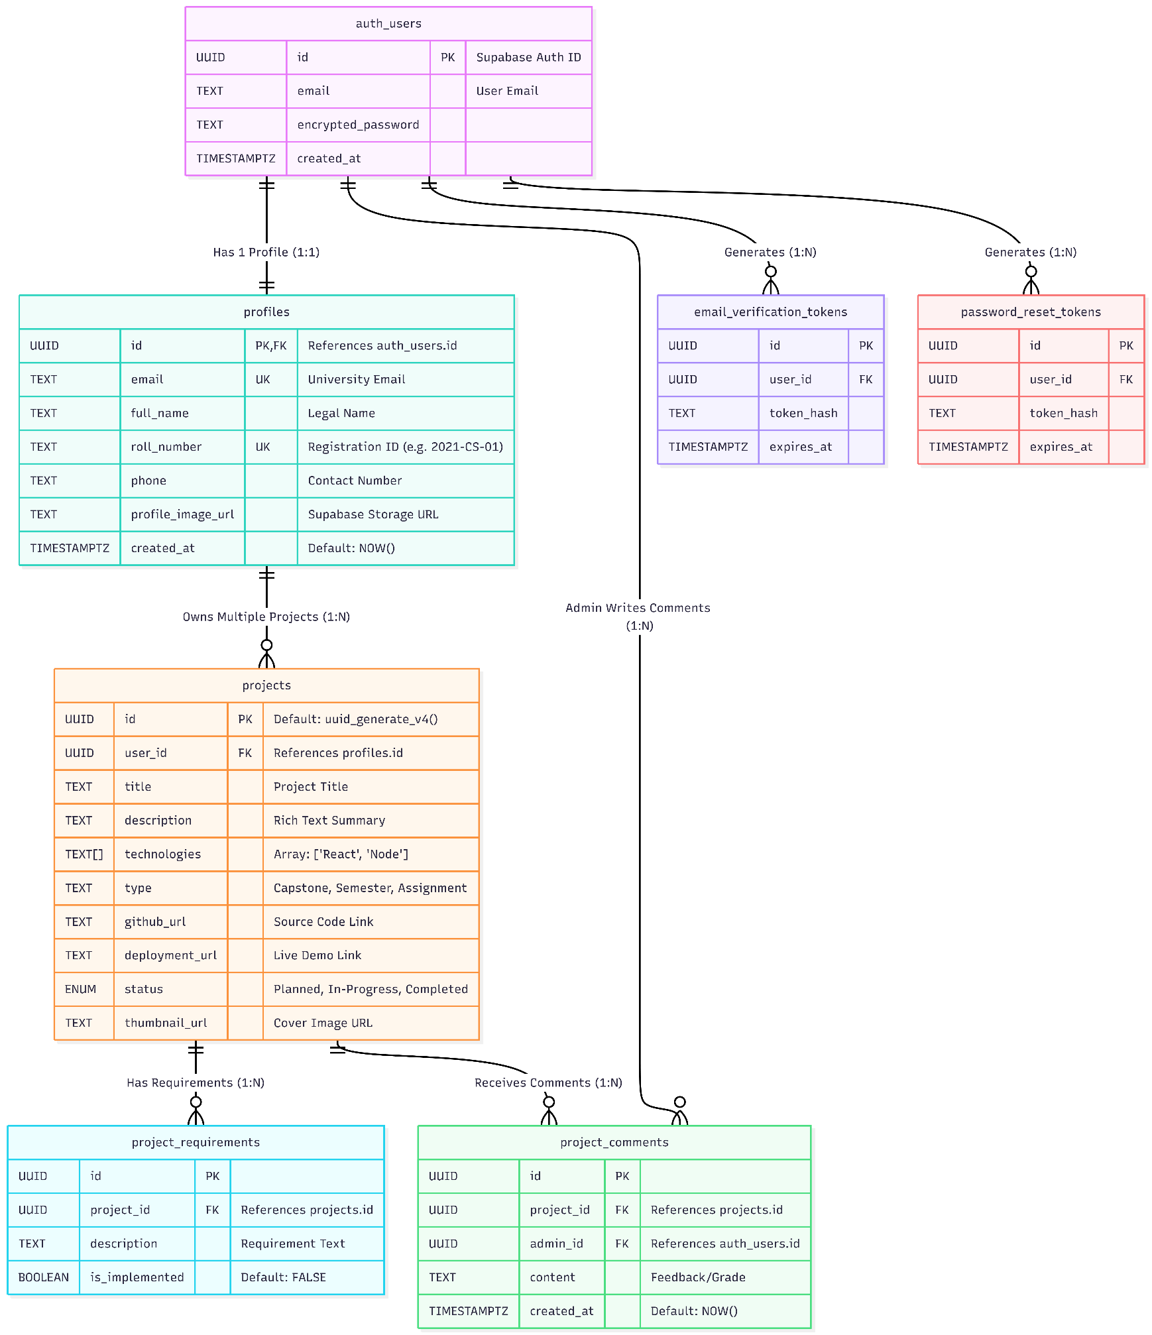
- profiles has a one-to-one relationship with auth.users.
- profiles has a one-to-many relationship with projects.
- projects has a one-to-many relationship with project_requirements.
- projects has a one-to-many relationship with project_comments.

5.1 Functional Requirements Specification

1. Authentication & Identity Management
ID | Requirement Description | Priority | Actor
FR-AUTH-01 | The system must allow students to register using a valid university email address. | MUST | Student
FR-AUTH-02 | The system must send a verification email with a unique, time-sensitive link upon registration. | MUST | System
FR-AUTH-03 | The system must prevent login access until the email verification link is clicked. | MUST | System
FR-AUTH-04 | The system must issue secure HTTP-Only JWT cookies (Access & Refresh) upon successful login. | MUST | System
FR-AUTH-05 | The system should allow users to reset their password via an emailed recovery link. | SHOULD | Student
FR-AUTH-06 | The system should support Google OAuth login for easier access. | SHOULD | Student
FR-AUTH-07 | The system must automatically log out users when the Refresh Token expires (7 days). | MUST | System

2. Student Profile Management
Goal: Enable students to manage their professional identity.
ID | Requirement Description | Priority | Actor
FR-PROF-01 | The system must require new users to complete an onboarding form (Name, Roll Number) before accessing the dashboard. | MUST | Student
FR-PROF-02 | The system must enforce unique Roll Numbers to prevent duplicate student profiles. | MUST | System
FR-PROF-03 | The system should allow students to update their bio and contact phone number. | SHOULD | Student

3. Project Portfolio Management
Goal: Allow students to document and showcase their work.
ID | Requirement Description | Priority | Actor
FR-PROJ-01 | The system must allow logged-in students to create a new project with a mandatory Title. | MUST | Student
FR-PROJ-02 | The system must allow students to upload a project thumbnail image (JPG/PNG, max 2MB). | MUST | Student
FR-PROJ-03 | The system must support tagging projects with technologies (e.g., "React", "Python"). | MUST | Student
FR-PROJ-04 | The system must allow students to set project status: "Planned", "In-Progress", or "Completed". | MUST | Student
FR-PROJ-05 | The system must allow students to add external links for GitHub Repositories and Live Deployments. | MUST | Student
FR-PROJ-06 | The system must allow students to define granular "Project Requirements" (Tasks) and toggle their completion status. | MUST | Student
FR-PROJ-07 | The system must prevent a student from editing or deleting a project they do not own (Row Level Security). | MUST | System

4. Administrative Oversight & Moderation
Goal: Provide faculty with tools to verify and grade student work.
ID | Requirement Description | Priority | Actor
FR-ADM-01 | The system must provide a dedicated Admin Login page secured by environment variables. | MUST | Admin
FR-ADM-02 | The system must display a searchable list of all registered students to the Administrator. | MUST | Admin
FR-ADM-03 | The system must allow Admins to view the full details of any student project, regardless of its status. | MUST | Admin
FR-ADM-04 | The system must allow Admins to post text comments on a student's project. | MUST | Admin
FR-ADM-05 | The system should trigger an email notification to the student whenever an Admin posts a comment. | SHOULD | System
FR-ADM-06 | The system must allow Admins to permanently delete a student account (including all their projects) for moderation purposes. | MUST | Admin
FR-ADM-07 | The system should allow Admins to delete their own comments if a mistake was made. | SHOULD | Admin

5. Public Showcase & Access
Goal: Display student achievements to the outside world.
ID | Requirement Description | Priority | Actor
FR-PUB-01 | The system must provide a public landing page accessible without login. | MUST | Public
FR-PUB-02 | The system must display a grid of "Completed" and "In-Progress" projects on the landing page. | MUST | System
FR-PUB-03 | The system must paginate the project list to ensure fast load times. | MUST | System
FR-PUB-04 | The system could allow public users to filter projects by technology tag (Future Scope). | COULD | Public
FR-PUB-05 | The system must allow public users to click a project card to view its full details (Description, Links, Requirements). | MUST | Public

6. System & Data Integrity
Goal: Ensure the application runs reliably and securely.
ID | Requirement Description | Priority | Actor
FR-SYS-01 | The system must validate all API inputs against a strict schema (Zod) before processing. | MUST | System
FR-SYS-02 | The system must handle database connection failures gracefully by showing a "Service Unavailable" message. | MUST | System
FR-SYS-03 | The system must sanitize all user-generated text inputs to prevent XSS attacks. | MUST | System

5.2 Non-Functional Requirements Specification

1. Performance & Efficiency
Goal: Ensure the system is responsive and scalable under load.
ID | Requirement Description | Constraint
NFR-PERF-01 | API Latency: The system must respond to API requests (e.g., fetching project lists) within an acceptable timeframe. | < 200ms (95th percentile).
NFR-PERF-02 | Load Time: The initial landing page (LCP) must load quickly on standard 4G networks. | < 2.5 seconds.
NFR-PERF-03 | Concurrency: The system should support simultaneous active users (e.g., during exam submissions) without degradation. | 50+ concurrent users.
NFR-PERF-04 | Database Efficiency: The system must utilize connection pooling to stay within the platform's limits. | Max 60 connections (Supabase Free Tier).
NFR-PERF-05 | Asset Optimization: Project thumbnails must be optimized/compressed before storage to save bandwidth. | Max 2MB per file.

2. Security & Compliance
Goal: Protect user data and system integrity.
ID | Requirement Description | Constraint
NFR-SEC-01 | Data Privacy: The system must enforce Row Level Security (RLS) so users cannot access private data of others. | 100% enforcement via DB Policies.
NFR-SEC-02 | Transport Security: All data in transit must be encrypted using standard protocols. | TLS 1.2+ / HTTPS enforced via HSTS.
NFR-SEC-03 | Session Security: Authentication tokens must be stored securely to prevent XSS attacks. | HttpOnly, Secure, SameSite=Strict cookies.
NFR-SEC-04 | Input Sanitization: The system must validate and sanitize all user inputs to prevent Injection attacks. | Zero SQL/NoSQL Injection vulnerabilities.
NFR-SEC-05 | Rate Limiting: The Auth API should limit requests to prevent brute-force attacks. | Max 5 attempts per 15 minutes per IP.

3. Reliability & Availability
Goal: Minimize downtime and data loss.
ID | Requirement Description | Metric / Constraint
NFR-REL-01 | Availability: The system should remain operational during core business hours. | 99.9% Uptime (approx. 45m downtime/month).
NFR-REL-02 | Recoverability: The system must have automated backup mechanisms in place. | Daily Backups (RPO: 24h).
NFR-REL-03 | Fault Tolerance: The UI must fail gracefully when the backend is unreachable (e.g., due to Render cold start). | Display "Service Unavailable" toast/message.
NFR-REL-04 | Data Integrity: The system must prevent orphaned records when a user is deleted. | Cascading Deletes enforced via Foreign Keys.

4. Usability & Accessibility
Goal: Ensure the system is easy to use for all audiences.
ID | Requirement Description | Metric / Constraint
NFR-USE-01 | Responsiveness: The UI must adapt to various screen sizes, from mobile phones to desktops. | 375px (Mobile) to 1920px (Desktop).
NFR-USE-02 | Accessibility: The system should comply with basic accessibility standards for visually impaired users. | WCAG 2.1 AA (Contrast > 4.5:1).
NFR-USE-03 | Browser Support: The application must function correctly on all modern web browsers. | Chrome, Firefox, Safari, Edge (Latest 2 versions).
NFR-USE-04 | Feedback: The system must provide immediate visual feedback for user actions (success/error). | < 100ms visual response latency.

5. Maintainability & Scalability
Goal: Facilitate future development and updates.
ID | Requirement Description | Metric / Constraint
NFR-MAINT-01 | Code Quality: The codebase should adhere to strict typing to minimize runtime errors. | 100% TypeScript with no implicit any.
NFR-MAINT-02 | Modularity: The project must follow a Monorepo structure with clear separation of concerns. | Frontend and Backend directories independent.
NFR-MAINT-03 | Documentation: The system must maintain up-to-date documentation for developers. | API Docs & ERD updated per release.
NFR-MAINT-04 | Deployment: The system must support automated deployment pipelines. | CI/CD triggered on push to main/v5.

5.3 Detailed Table Definitions

5.3.1 Table: profiles
Stores public information about the user. Linked strictly to the Supabase Auth ID.
Column | Type | Constraints | Description
id | UUID | PK, FK (auth.users) | Unique User ID (matches Auth).
email | TEXT | UNIQUE, NOT NULL | Student's university email.
full_name | TEXT |  | Student's legal name.
roll_number | TEXT |  | University Roll/Registration Number.
phone | TEXT |  | Contact number.
profile_image_url | TEXT |  | URL to image in Supabase Storage.
created_at | TIMESTAMPTZ | DEFAULT NOW() | Record creation timestamp.

5.3.2 Table: projects
The core entity representing a student's portfolio item.
Column | Type | Constraints | Description
id | UUID | PK, DEFAULT uuid_generate_v4() | Unique Project ID.
user_id | UUID | FK (profiles.id) | The owner of the project.
title | TEXT | NOT NULL | Project title.
description | TEXT |  | Detailed project summary.
technologies | TEXT[] |  | Array of tech stack (e.g., ["React", "Node"]).
type | TEXT |  | e.g., "Capstone", "Semester Project".
github_url | TEXT |  | Link to source code.
deployment_url | TEXT |  | Link to live demo.
status | ENUM | 'Planned', 'In-Progress', 'Completed' | Current development state.
thumbnail_url | TEXT |  | Project cover image.

5.3.3 Table: project_requirements
Tracks specific functional requirements for a project (e.g., "Must have User Auth").
Column | Type | Constraints | Description
id | UUID | PK | Unique Requirement ID.
project_id | UUID | FK (projects.id) | Parent project.
description | TEXT | NOT NULL | The specific requirement text.
is_implemented | BOOLEAN | DEFAULT FALSE | Status of the requirement.

5.3.4 Table: project_comments
Stores feedback provided by administrators.
Column | Type | Constraints | Description
id | UUID | PK | Unique Comment ID.
project_id | UUID | FK (projects.id) | The project being reviewed.
admin_id | UUID | FK (auth.users) | The admin who commented.
content | TEXT | NOT NULL | The feedback text.
created_at | TIMESTAMPTZ | DEFAULT NOW() | Date of comment.

5.3.5 Utility Tables
- email_verification_tokens: Stores hashed tokens for email verification workflows.
- password_reset_tokens: Stores hashed tokens for password recovery flows.

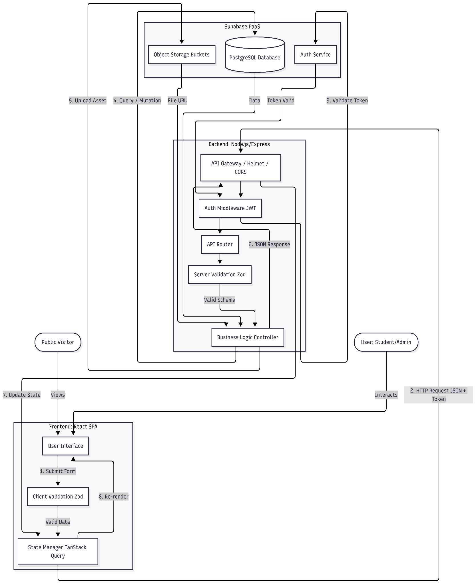
5.4 Data flow diagram:

6.1 Authentication Module (/api/auth)

Method | Endpoint | Access | Description
POST | /signup | Public | Register a new student. Triggers verification email.
POST | /signin | Public | Authenticates user; sets accessToken cookie.
POST | /logout | Private | Clears auth cookies.
POST | /refresh | Public | Uses refreshToken cookie to issue new access token.
GET | /verify-email | Public | Verifies user via token query param.
GET | /oauth/google | Public | Initiates Google OAuth flow.

6.2 Projects Module (/api/projects)

Method | Endpoint | Access | Description
GET | /public | Public | Fetch all projects for the landing page (Paginated).
GET | / | Private | Fetch projects belonging to the current user.
POST | / | Private | Create a new project.
PUT | /:id | Private | Update project details (Owner only).
DELETE | /:id | Private | Delete a project (Owner only).
POST | /upload-thumbnail | Private | Upload image to Supabase Bucket; returns URL.
GET | /:id/requirements | Private | Get requirements for a specific project.

6.3 Profile Module (/api/profile)

Method | Endpoint | Access | Description
GET | /me | Private | Get full profile details of the logged-in user.
PUT | /me | Private | Update profile fields (Phone, Avatar, Bio).
POST | /change-password | Private | Securely update password.

6.4 Admin Module (/api/admin)

Security Note: Protected by strict middleware checking for specific admin credentials or roles.
Method | Endpoint | Access | Description
POST | /login | Public | Dedicated admin login using .env credentials.
GET | /students | Admin | List all registered students.
DELETE | /students/:id | Admin | Delete a student (and all their data).
POST | /projects/:id/comments | Admin | Post official feedback on a student project.

7.1 Student Onboarding Flow
- Registration: Student submits Email/Password via /signup.
- Verification: Backend sends an email with a unique token link.
- Activation: Student clicks link -> API verifies token -> Database sets email_verified: true.
- Profile Setup: User logs in. If the profile is empty, UI redirects to the Onboarding Form to collect Roll Number and Name.

7.2 Project Submission Lifecycle

- Drafting: Student clicks "New Project". Fills in Title and Description. Status defaults to "Planned".
- Asset Upload: Student uploads a thumbnail. Frontend sends file to /upload-thumbnail, receives URL, and attaches it to the project form.
- Refinement: Student adds "Requirements" (e.g., "Implement Login").
- Completion: As development progresses, student updates status to "In-Progress" and eventually "Completed", adding the GitHub/Deployment URLs.

7.3 Admin Review Process

- Access: Admin logs in via /admin/login.
- Monitoring: Admin views the "Students List" to see who has registered.
- Review: Admin selects a student, views their "Completed" projects.
- Feedback: Admin posts a comment on a project. The system triggers a notification (email) to the student alerting them of new feedback.

8.1 Student Use Cases

UC-01: Register & Onboard
Field | Description
Use Case Name | Register & Onboard
Actor | Student
Precondition | - Student possesses a valid university email address.  - System database is online.
Post Condition | Success: Account is created, verified, and user is redirected to Dashboard.  Failure: Error message displayed (e.g., "User already exists").
Exception | - Email already exists: System displays error notification.  - Token expired: System prompts user to resend verification email.  - Invalid Password: System warns about complexity requirements.

UC-02: Create New Project
Field | Description
Use Case Name | Create New Project
Actor | Student
Precondition | - Student is logged in.  - Student is on the Dashboard.
Post Condition | Success: New project record is created in the database.  Failure: Form submission is blocked with validation errors.
Exception | - Missing Title: System highlights field in red.  - Network Error: Toast notification "Failed to create project".

UC-03: Upload Project Thumbnail
Field | Description
Use Case Name | Upload Project Thumbnail
Actor | Student
Precondition | - Student is editing an existing project.  - Image file is available on local device.
Post Condition | Success: Image stored in Supabase Bucket; URL saved to Project.  Failure: Upload rejected (file size/type).
Exception | - Invalid File Type: System alerts "Only JPG/PNG allowed".  - File too large: System alerts "Max size 2MB".

UC-04: Manage Project Requirements
Field | Description
Use Case Name | Manage Project Requirements
Actor | Student
Precondition | - Student is editing a project.
Post Condition | Success: Requirement added/updated in database.  Failure: No change in data.
Exception | - Empty Text: "Add" button remains disabled.

UC-05: Update Student Profile
Field | Description
Use Case Name | Update Student Profile
Actor | Student
Precondition | - Student is logged in and on the Settings page.
Post Condition | Success: Profile details (Name, Phone, Bio) updated in database.  Failure: Validation errors displayed.
Exception | - Validation Error: Invalid phone format triggers error message.  - Upload Fail: Profile picture fails to upload.

UC-06: Reset Password
Field | Description
Use Case Name | Reset Password
Actor | Student
Precondition | - Student is logged out.  - Student has access to their registered email.
Post Condition | Success: Password is securely updated in Auth DB.  Failure: Token invalid or expired.
Exception | - Email Not Found: System may (security dependent) show generic message or error.  - Token Expired: User must request a new link.

UC-07: Delete Project
Field | Description
Use Case Name | Delete Project
Actor | Student
Precondition | - Student is logged in and owns the project.
Post Condition | Success: Project and requirements permanently removed.  Failure: Deletion cancelled or DB error.
Exception | - Action Cancelled: User clicks "Cancel" in confirmation modal.

8.2. Administrator Use Cases

UC-08: Admin Login
Field | Description
Use Case Name | Admin Login
Actor | Administrator
Precondition | - Admin credentials are configured in server environment variables.
Post Condition | Success: Admin authenticated with elevated privileges.  Failure: Access denied.
Exception | - Invalid Credentials: System denies access.  - Route Not Found: If accessing via wrong URL.

UC-09: Review and Comment
Field | Description
Use Case Name | Review and Comment
Actor | Administrator
Precondition | - Admin is logged in.  - Students have submitted projects.
Post Condition | Success: Comment saved; Student notified via email.  Failure: Comment not saved.
Exception | - Email Service Down: Comment saved, but notification fails (logged).

UC-10: Remove Student (Moderation)
Field | Description
Use Case Name | Remove Student
Actor | Administrator
Precondition | - Admin is logged in.
Post Condition | Success: Student and all associated data permanently deleted.  Failure: Action cancelled.
Exception | - Database Lock: Deletion fails due to active transaction.

UC-11: Search and Filter Students
Field | Description
Use Case Name | Search and Filter Students
Actor | Administrator
Precondition | - Admin is on the Student List view.
Post Condition | Success: List updates to show only matching profiles.  Failure: No changes if API fails.
Exception | - No Results: System displays "No students found" message.

UC-12: Delete Admin Comment
Field | Description
Use Case Name | Delete Admin Comment
Actor | Administrator
Precondition | - Admin is logged in.  - A comment exists on a project.
Post Condition | Success: Comment removed from database.  Failure: DB error.
Exception | - Already Deleted: If another admin removed it concurrently.

8.3. Public Use Cases

UC-14: View Public Portfolio
Field | Description
Use Case Name | View Public Portfolio
Actor | Public User
Precondition | - None (Public internet access).
Post Condition | Success: Projects displayed in grid.  Failure: "No projects found" or error page.
Exception | - Server Error: Displays generic "Under Maintenance" page.

UC-15: Filter Projects
Field | Description
Use Case Name | Filter Projects (Future Scope)
Actor | Public User
Precondition | - Projects exist with technology tags.
Post Condition | Success: Grid updates to show matching items.  Failure: Empty state displayed.
Exception | - No Matches: Display "No projects found with this tag".

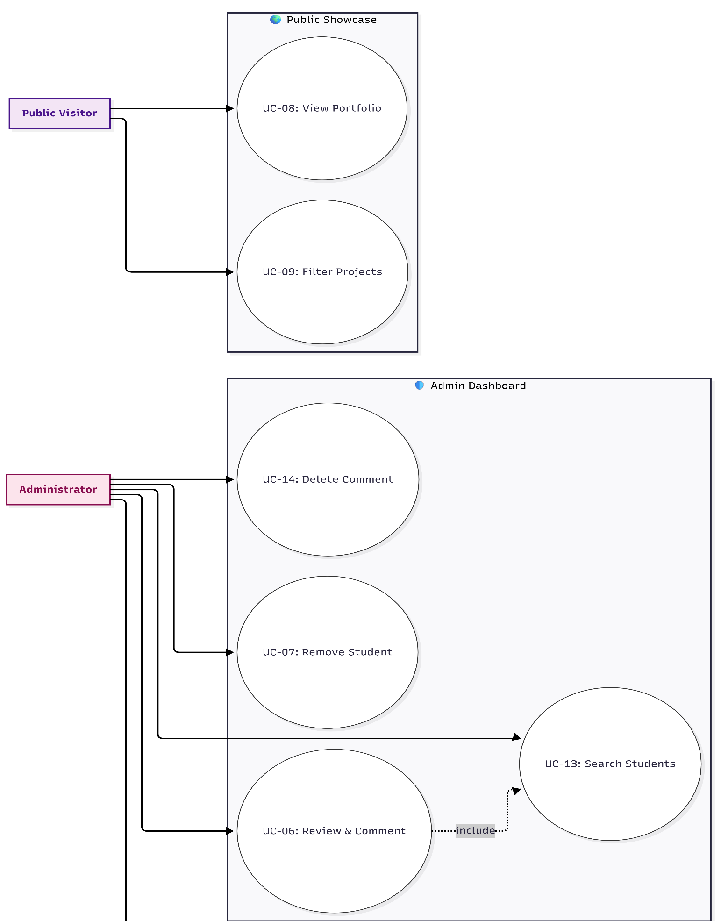
9.1 Use Case Diagram
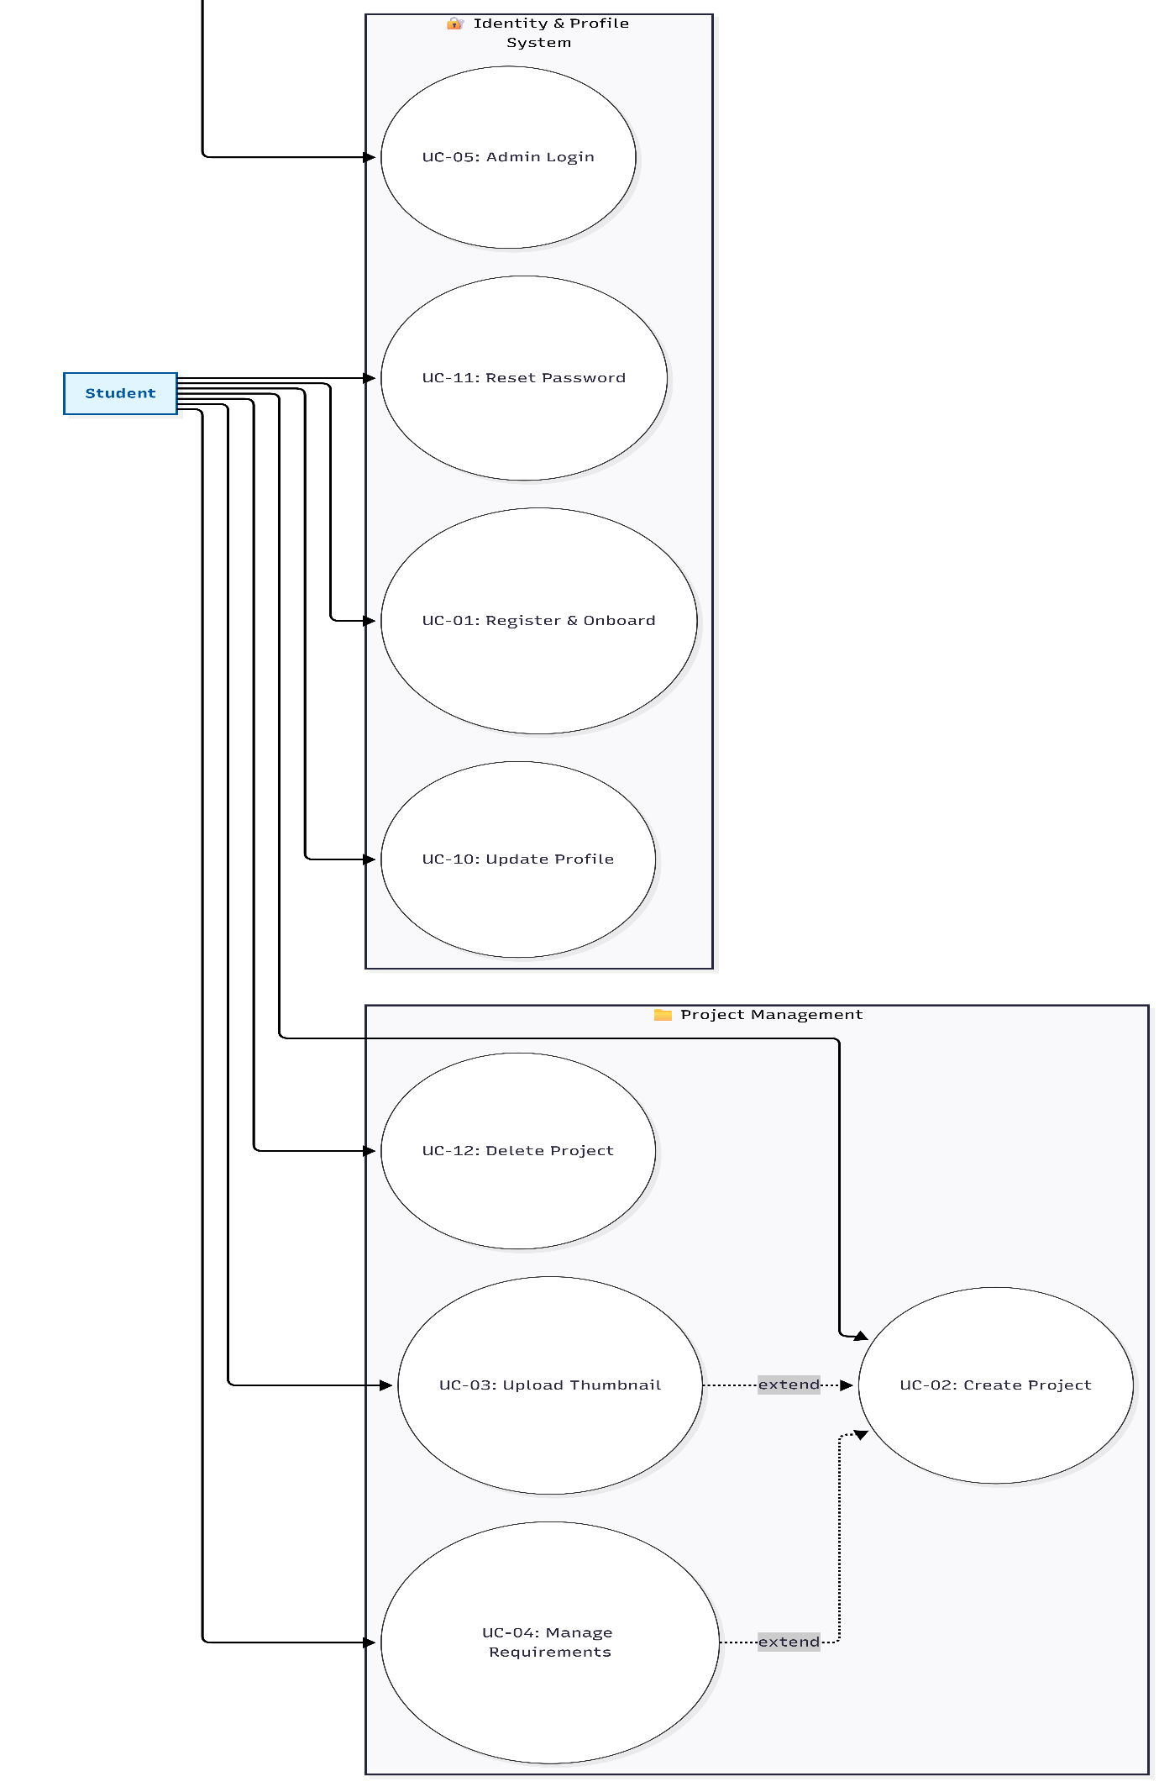

10.1. Test Case Specification

10.1.1 Authentication Module (Backend)
Objective: Verify the security and logic of the custom auth flow (Supabase + JWT).

ID | Test Scenario | Endpoint | Pre-condition / Input | Expected Result
TC-AUTH-001 | Successful Student Registration | POST /api/auth/signup | Pre: Email does not exist.  Input:{email: newuser@student.edu", password:"Password123!", fullName: "John Doe" } | Status:201 Created  Body:{message: "Verification email sent”}  DB: New record in auth.users and profiles.
TC-AUTH-002 | Registration with Duplicate Email | POST /api/auth/signup | Pre: existing@student.edu exists.  Input: { email:"existing@student.edu", ... } | Status: 409 Conflict  Body: { error: "User already exists"}
TC-AUTH-003 | Login with Unverified Email | POST /api/auth/signin | Pre: User registered but email link NOT clicked.  Input: Valid credentials. | Status: 403 Forbidden  Body: { error: "Email not verified" }
TC-AUTH-004 | Successful Login & Token Issue | POST /api/auth/signin | Pre: Email is verified.  Input: Valid credentials. | Status: 200 OK  Cookies:access Token, refreshToken (HttpOnly).  Body: User object returned.
TC-AUTH-005 | Refresh Token Rotation | POST /api/auth/refresh | Pre:accessToken expired, refreshToken valid in cookies.  Input: None (Cookie based). | Status: 200 OK  Cookies: New accessToken is set.

10.1.2 Project Management Module (Backend)
Objective: Verify CRUD operations and Row-Level Security (RLS).
ID | Test Scenario | Endpoint | Pre-condition / Input | Expected Result
TC-PROJ-001 | Create Valid Project | POST /api/projects | Pre: Auth Token Valid.  Input: { title: "AI Capstone", description: "ML Model", status: "Planned" } | Status: 201 Created  DB: New row in projects linked to user_id.
TC-PROJ-002 | Create Project Validation Failure | POST /api/projects | Pre: Auth Token Valid.  Input:{description: "Missing Title" } (Title missing). | Status: 400 Bad Request  Body: Zod validation error for title.
TC-PROJ-003 | Update Own Project | PUT /api/projects/:id | Pre: User owns project :id.  Input:{status: "Completed", github_url: "..." } | Status: 200 OK  DB: status updated to 'Completed'.
TC-PROJ-004 | Unauthorized Delete (RLS) | DELETE /api/projects/:id | Pre: User A logged in, but :id belongs to User B.  Input: Delete request. | Status: 403 Forbidden OR 404 Not Found.  DB: Record remains intact.
TC-PROJ-005 | Add Project Requirements | POST /api/projects/:id/requirements | Pre: User owns project :id.  Input:{description: "Must have Dark Mode" } | Status: 201 Created  DB: New row in project_requirements.

10.1.3. Admin Module (Backend)
Objective: Verify administrative privileges and specific workflows.
ID | Test Scenario | Endpoint | Pre-condition / Input | Expected Result
TC-ADM-001 | Admin Login | POST /api/admin/login | Input: Admin credentials from .env. | Status: 200 OK  Body: { role: "admin", token: "..." }
TC-ADM-002 | Admin Comment on Student Project | POST /api/admin/projects/:id/comments | Pre: Logged in as Admin.  Input: { content: "Fix responsive layout." } | Status: 201 Created  DB: Entry in project_comments.  System: Email notification triggered.

10.1.4. Frontend Component Tests (React/Vitest)
Objective: Verify UI state, rendering logic, and user interactions.
ID | Test Scenario | Component | Test Logic / Interaction | Expected Result
TC-UI-001 | Protected Route Redirection | <ProtectedLayout /> | Render component without Auth Context. | useNavigate is called with /login.  User is redirected.
TC-UI-002 | Project Status Badge Rendering | <ProjectCard /> | Render with prop status="Completed". | Badge element exists.  Contains text "Completed".  Has green styling
TC-UI-003 | Requirement Checkbox Interaction | <RequirementItem /> | Click the checkbox element. | onToggle prop function is called with the correct ID.
TC-UI-004 | Login Form Error State | <LoginForm /> | Mock API response: 401 Unauthorized.  Submit form. | UI displays error alert.  Text matches: "Invalid email or password".

11.1 Quality Register
Quality Area | Quality Criteria | Success Indicators
Functionality | All core modules (Profile Creation, Project Uploads, Admin Panel, Authentication, Public Showcase) must work without errors. | 100% functional tests passed, no major bugs.
Usability/UI | Interface should be clean, intuitive, mobile-responsive, and easy to navigate. | Positive feedback from test users, consistent UI, responsive layout.
Performance | Pages must load within 2 seconds under normal traffic. | Lighthouse score > 80 for performance.
Security | Secure login, encrypted passwords, protected CRUD operations, no exposed API endpoints. | No major vulnerabilities; OWASP checks passed.
Compatibility | Works across major browsers and mobile devices. | Tests passed on Chrome, Edge, Firefox + Android & iOS.
Documentation | Proper developer documentation, user guides, ERDs, and test cases. | All docs completed and approved by supervisor.
Reliability | System should not crash under normal use; data must be backed up. | Uptime > 99%, regular backups configured.

12.1 Risk Register

12.1. High Severity Risks (Immediate Attention)
Risk ID | Risk Description | Category | Prob. (1-5) | Impact (1-5) | Mitigation Strategy | Owner
R-001 | Email Delivery Failure  Reliance on Gmail SMTP is fragile. Google often blocks less secure apps or imposes rate limits. Failure here blocks user registration entirely. | Operational | 4 | 5 | 1. Monitor SMTP logs.  2. Migrate to a dedicated transactional email provider (SendGrid, Resend) for production.  3. Implement "Resend Verification" UI flow. | Backend Dev
R-002 | Hardcoded Admin Credentials  Admin login uses credentials stored in .env. If these leak, an attacker gains full system access. Rotating passwords requires a redeploy. | Security | 3 | 5 | 1. Migrate Admin role to the Database (profiles table role column) linked to Supabase Auth.  2. Restrict Admin login route via IP Allow-listing (Middleware). | Security Lead
R-003 | RLS Policy Misconfiguration  Complex Row Level Security logic might accidentally expose private projects or allow unauthorized deletions if a rule is flawed. | Security | 2 | 5 | 1. Maintain strict integration tests (like TC-PROJ-004) specifically for negative permission cases.  2. Regular audit of Supabase SQL policies. | Backend Dev
R-004 | Render Cold Starts  Free/Starter tier on Render spins down after inactivity. First request might take 30s+, causing timeout errors for users. | Technical | 5 | 2 | 1. Use a self-pinging uptime monitor (e.g., UptimeRobot) to keep the service awake.  2. Upgrade to a paid instance for production. | DevOps

11.2. Medium Severity Risks (Monitoring Required)
Risk ID | Risk Description | Category | Prob. (1-5) | Impact (1-5) | Risk Score | Mitigation Strategy | Owner
R-005 | Vendor Lock-in (Supabase)  Heavy reliance on Supabase specific features (Auth, Storage, Realtime) makes migrating to another provider (e.g., AWS) difficult. | Strategic | 5 | 2 | 10 (Med) | 1. Abstraction layers in code (Service Pattern) to minimize direct dependency calls.  2. Ensure regular SQL dumps of the database schema and data. | Architect
R-006 | Malicious File Uploads  Users might upload non-image files masquerading as images, or extremely large files filling storage quota. | Security | 3 | 3 | 9 (Med) | 1. Strict MIME type validation on Backend (Zod).  2. Enforce 2MB file size limit (Nginx/Express & Zod).  3. Serve images via Supabase CDN with content-disposition headers. | Backend Dev
R-007 | Database Connection Exhaustion  High traffic spikes might exceed the max connection pool limits of the Supabase free tier, causing 500 errors. | Technical | 3 | 3 | 9 (Med) | 1. Ensure usage of PgBouncer (Transaction Pooling) provided by Supabase.  2. Implement caching (React Query) to reduce read load. | Backend Dev

12.3 Low Severity Risks (Acceptable)
Risk ID | Risk Description | Category | Prob. (1-5) | Impact (1-5) | Risk Score | Mitigation Strategy | Owner
R-009 | Google OAuth Changes  Google occasionally deprecates API versions or changes OAuth consent screen policies, potentially breaking the "Sign in with Google" button. | External | 2 | 2 | 4 (Low) | 1. Subscribe to Google Developer updates.  2. Ensure the "Custom Email" flow always works as a fallback. | Lead Dev
R-010 | Browser Compatibility  Advanced CSS features (Tailwind) or ES6+ JS might not work on legacy browsers (IE11). | Technical | 2 | 2 | 4 (Low) | 1. Define browser support matrix (Modern Browsers only).  2. Rely on Vite's build polyfills. | Frontend Dev
R-011 | Admin Email Spoofing  Attackers might try to spoof the "from" address of admin notifications if SPF/DKIM records aren't set up correctly for the SMTP domain. | Operational | 2 | 2 | 4 (Low) | 1. Configure SPF/DKIM records for the sending domain.  2. Use a dedicated subdomain for transactional emails. | DevOps
R-012 | Dependency Vulnerabilities  npm packages might introduce vulnerabilities over time if not updated. | Technical | 3 | 1 | 3 (Low) | 1. Enable GitHub Dependabot alerts.  2. Schedule monthly npm audit and dependency update sprints. | Lead Dev

13.1 Project Conclusion
The Student Portfolio System represents a significant leap forward in the digital management of academic achievements. By transitioning from fragmented, disparate storage methods to a unified Monorepo architecture, the project successfully addresses the critical needs of visibility, verification, and centralization within the university software department.
Technically, the successful deployment on Render using a CI/CD pipeline linked to the v5 production branch demonstrates a mature DevOps capability. The integration of React (Vite) with Node.js and Supabase has resulted in a highly responsive, secure, and scalable application. The implementation of Row Level Security (RLS) and strict Zod validation ensures that the system is not only functional but also resilient against common web vulnerabilities, safeguarding student intellectual property.
Operationally, the system bridges the gap between academic submission and professional presentation. Students are now empowered to take ownership of their digital identity, documenting their growth through detailed project portfolios that are verified by faculty. For administrators, the platform offers unprecedented oversight, streamlining the feedback loop and ensuring that the university's technical output is curated and accessible.
Looking ahead, the roadmap includes promising enhancements such as Docker containerization for consistent development environments and E2E testing with Cypress to further harden critical user flows. As it stands, the Student Portfolio System is a robust, production-ready asset that elevates the standard of academic project management, providing tangible value to students, faculty, and external stakeholders alike.

