Log-in
E-mail address: (fill in)
Password: (fill in)
Group name: (optional, fill in)
Password: (fill in)
Create a new account
Change your account or password
Forgotten your password or username?
Create an account
Surename: (fill in)
Name: (fill in)
Title: (fill in)
Institution: (fill in)
Address: (fill in)
City: (fill in)
ZIP code: (fill in)
Country: (fill in)
Phone number: (fill in)
E-mail address: (transfer from above automatically)
Member of EHS: Yes
No
Select your language English (scroll text)
François
Deutsch
Italiano
Español

Instructions and rules of the registry
Text with the user license agreement will follow.
I have read the instructions for use of the EuraHS database and I accept the rules of the registry

Select an option
Enter a new operation (option: print PDF #T1)
Enter operative or postoperative data of an operation (option: print PDF #T2) (automated e-mail #E1)
EuraHS registration number (fill in)
Enter follow up data of an operation (option: print PDF #T3) (automated e-mail #E2)
EuraHS registration number (fill in)
Get information on your patients (generate user-database report)
Lost the registration number? (Automated e-mail #E3)

Primary ventral hernia route*
Epigastric hernia (automatic transfer to Grid 1)
Umbilical hernia (automatic transfer to Grid 1)
Lumbar hernia (automatic transfer to Grid 1)
Spighelian hernia (automatic transfer to Grid 1)
Incisional ventral hernia route*
Incisional ventral hernia
Recurrent epigastric hernia
Recurrent umbilical hernia
Recurrent lumbar hernia
Recurrent Spieghelian hernia
Parastomal hernia route*
Parastomal hernia
* Je nachdem was hier angekreuzt wird, werden die entsprechenden Fenster zum ausfüllen angeboten.
Common route
Please choose the database Level:
(Level 1)
Level 2
Year of birth: (fill in)
Gender: Male
Female
Scheduled date of operation: (fill in)
EuraHs registration number: (Pop-up #2)
Informed consent obtained (PDF #T4)

Comorbidities

No co-morbidities
Comorbidities: Gemäß Pop-up #3 Schweregrad anklicken
Diabetes mellitus type I (juvenil)
Diabetes mellitus type II (adult)
Cardiac disease
Arterial hypertension
Pulmonary disease
Hepatic disease: Ascites present: No
Yes
Renal disease: Haemodyalysis: No
Yes
Peritoneal dialysis: No
Yes
Malignant disease: Curatively treated: No
Yes

Risk factors
No risk factors
Risk factors:
Aneurysmatic disease
Collagen related disease: Lung emphysema
Marfan syndrome
Ehlers Danlos
Polycystic kidney disease
Personal history of previous hernia repair at another site
Family history of hernia surgery (more than 2 first grade relatives)
Chronic use of corticosteroids
Use of immunosuppressive medication
Use of anticoagulant therapy (cumarine)
Weight of the patient: Kg BMI: Kg/m² (fill in)
Length of the patient: cm (fill in)

Other risk factors
Occupation:
Heavy physical labour
Mild physical labour
Administrative labour
No employment
Sporting activities:
None
Sporadic
Moderate (1/week)
Intense (>1/week)
Smoking habits:
Never smoked
Ex-smoker (>12 months stopped)
Occasional smoker
Daily smoker:
Pack years: (fill in) Pop-up #4

Primary ventral hernia route
Width of the hernia: cm (fill in, automatic transfer to Grid 1)
Length of the hernia: cm (fill in, automatic transfer to Grid 1) Pop-up #5
Diameter of the hernia:
Reducibility of the hernia: Completely reducible
Partially reducible
Non reducible
Indication for surgery: Elective
Emergency

(Summary of inserted data / Grid 1)
E H S  Primary Abdominal Wall Hernia Classification |  | Diameter  cm | Small  <2cm | Medium  ≥2-4cm | Large  ≥4cm
Midline | Epigastric
Midline | Umbilical
Lateral | Spigelian
Lateral | Lumbar

Incisional ventral hernia route
Width of the hernia: cm (fill in, automatic transfer to Grid 2)
Length of the hernia: cm (fill in, automatic transfer to Grid 2) Pop-up #6
Reducibility of the hernia:
Completely reducible
Partially reducible
Non reducible
Indication for surgery:
Elective
Emergency
Mark the incisional hernia areas involved: (click in the box, automatic transfer to Grid 2)
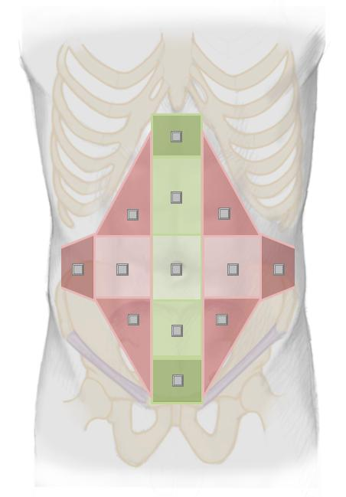
Pop-up #7
Upload photography Pop-up #8

Date of the operation that caused the incisional hernia:
The exact date: (fill in)
Year and month: (fill in)
Year: (fill in)
Unknown
Type of operation (speciality) that caused the incisional hernia:
Gastrointestinal
Abdominal wall surgery
Gynecological
Vascular
Orthopedic
Plastic surgery
Thoracic surgery
Urological
Unknown
Recurrent hernia:
No (automatic transfer to Grid 2)
Yes: (automatic transfer to Grid 2)
Number of previous repairs (Fill in)
Has there been a previous mesh repair?
No
Yes:
Date of the last repair:
The exact date: (fill in)
Year and month: (fill in)
Year: (fill in)
Unknown
(Summary of inserted data / Grid 2)
E H S - Incisional Ventral Hernia Classification
Midline |  |  | subxiphoidal |  |  | M1
 |  |  | epigastric |  |  | M2
 |  |  | umbilical |  |  | M3
 |  |  | Infraumbilical |  |  | M4
 |  |  | Suprapubic |  |  | M5
Lateral |  |  | subcostal |  |  | L1
 |  |  | flank |  |  | L2
 |  |  | iliac |  |  | L3
 |  |  | lumbar |  |  | L4
Recurrent incisional hernia? |  |  |  | Yes No
length: cm |  |  |  | width: cm
Width  cm | W1  <5cm |  |  | W2  ≥5-10cm | W3  ≥10cm

Parastomal hernia route
Years since stoma creation: Unknown
Years with parastomal hernia: Unknown
Type of stoma:
Colostomy
Ileostomy
Ileal conduit
Indication for stoma creation:
Malignancy
Benign disease
Unknown
Symptoms of the parastomal hernia (several possibilities allowed):
None
Pain
Incarceration
Obstruction
Esthetical
Difficulty for bag appliance
Unknown
Previous repair of the parastomal hernia:
No
Yes:
Number of previous repairs: (fill in)
Has there been a previous mesh repair? Pop-up #9
No mesh repair
Yes:
Laparoscopic
Open
Date of the last previous parastomal hernia repair:
The exact date (if known): (fill in)
The year and month: (fill in)
The year: (fill in)
Reducibility of the hernia:
Completely reducible
Partially reducible
Not reducible
Indication for surgery:
Elective
Emergency
Width of the hernia (cm): (fill in)
Length of the Hernia (cm): (fill in) Pop-up #10
Is there a concomitant incisional hernia present?
No
Yes:
Localization of the concomitant incisional hernia: (click in the box)
Pop-up #7
Unknown
Upload photography button Pop-up #8
Operative Data – Common route

Operation date: (fill in)
Anesthesia: General
Regional
Local
Antibiotic prophylaxis: None
Single dose
Prolonged (therapeutic)
Patient is on AB for another infection
Intraoperative wound contamination: Pop-up #11
Class I
Class II
Class III
Class IV
Operator:
Senior surgeon
Resident with direct supervisor (surgeon scrubbed in)
Resident without direct supervision (surgeon not scrubbed in)
Resident without supervision
Operating time: Starting time (first incision): (fill in)
End (last skin suture): (fill in)
Content of the hernia sac:
None
Small bowel
Colon
Stomach
Omentum majus
Ovaries
Appendix
Bladder
Other
Incarceration: No
Yes
Bowel resection needed: No
Yes (small bowel)
Yes (colon)

Operative data – Approach – Common route
Type of access: Open surgery Pop-up #12
Laparoscopic surgery:
Number of ports used
Conversion to open: No
Yes
Type of repair: Mesh repair
Non mesh repair

Operative Data – Common route – Concomitant procedures
Concomitant abdominal surgery?
No
Yes:
Gastrointestinal surgery: Gallbladder
Stomach
Small bowel
Colon
Liver/spleen
Other hernia repair
Gynecological
Urological
Vascular
Other
Is the hernia repair the main indication for surgery?
Yes
No

Operative Data – Common route – Surgical technique
Non mesh repair:
Suture repair: Single suture
Running suture
Name of the suture material: (scroll index)
Component separation technique without mesh augmentation
Mesh repair: (click the list or the box) Pop-up #13
Mesh position: Onlay
Inlay
Retromuscular
Preperitoneal
Intraperitoneal
Combination of above
Non-classifiable
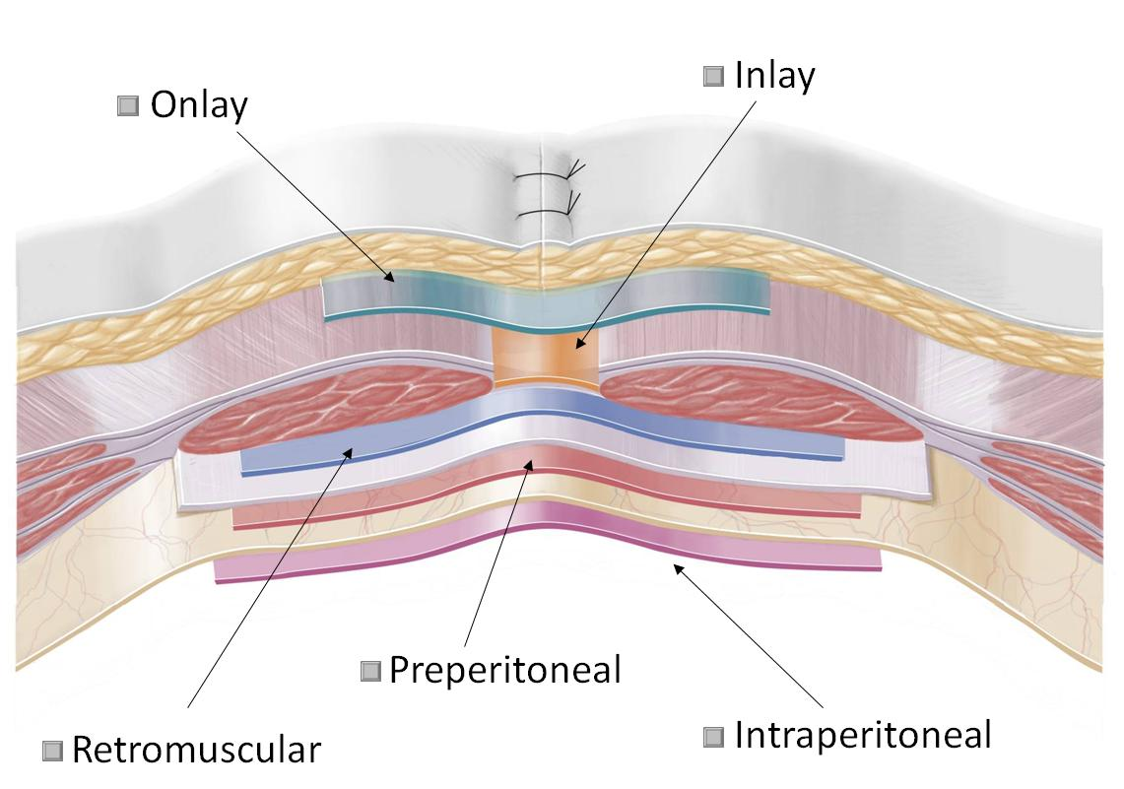
Component separation technique with mesh augmentation

Type of mesh used: Product name: (scroll index)
Company name: (scroll index)
Other mesh: (Fill in)
Was the hernia defect closed? Yes
No
What was the size of the implanted mesh? Width (cm): (Fill in)
Length (cm): (Fill in)
Estimated minimal overlap of the mesh beyond the hernia defect in cm? (Fill in)
Fixation of the mesh:
No fixation
Suture: Name of the suture material: (scroll index)
Transfascial: Yes
No
Fixation device: Absorbable
Non absorbable
Glue
Combination

Intraoperative complications – Common route
Pop-up #14
Conversion from laparoscopic to open surgery: No
Yes:
Reason for conversion: Bleeding
Adhesions
Bowel injury
Bladder injury
Technical problems
Other
Intraoperative complications: No
Yes:
Severe bleeding: Abdominal wall
Mesentery
Liver
Spleen
Large retroperitoneal vessels
Bowel lesion: Type of lesion: Small bowel
Colon
Severity: Not full thickness
Full thickness lesion
Management: Nothing
Suture
Bowel resection
Bladder injury
General complication (e.g. cardiac)
Other

Discharge data – Common route
Date of discharge: (Fill in)
Hour of discharge: (Fill in)
No complications
Bleeding complications: Abdominal wall bleeding or hematoma
Intraperitoneal bleeding
Treatment:
None needed
Transfusion
Revision not under general anaesthesia
Revision under general anaesthesia

Surgical site infection (SSI):
Type of SSI: Superficial
Deep
Intra-abdominal
Mesh infection: No
Yes:
Was the mesh removed: No
Yes
Partially
Postoperative seroma
Prolonged ileus or obstruction
Organ lesion or perforation
Urinary complication
General complications

Did the patient need intensive care because of life threatening complications?
No
Yes: Single organ failure
Multiple organ failure
Did the patient die postoperatively? No
Yes
Classification of surgical complications: (Fill in) Pop-up #15

Follow-up – Common route
Lost to follow up:
Unable to contact the patient
Patient refuses further follow up
The patient deceased
Date of death: (Fill in)
Cause of death: (Fill in)
Recurrence at death: No
Yes
Unknown
Date of follow up: (Fill in)
Type of follow up:
Clinical
Clinical and with medical imaging
Telephone questioning the patient
Telephone questioning the family doctor

Quality of life measurement – Common route
Chronic abdominal wall pain at the operation site: No
Yes:
Intensity of pain: (scroll index) No pain Pop-up #16
Mild pain
Moderate pain
Severe pain
Frequency of pain: No pain
Sporadic
Frequent
Constant
Foreign body feeling at operation site: No
Yes

Late complications – Common route
No late complications
Late surgical site infection:
Superficial surgical site infection:
Wound infection
Deep surgical site infection:
Wound infection, including subcutaneous abscess
Mesh infection
Enterocutaneous fistula
Intraabdominal surgical site infection:
Mesh infection
Intraabdominal abscess
Bowel perforation
Small bowel obstruction:
Conservative treatment without hospitalization
Conservative treatment with hospitalization
Operative treatment with adhesiolysis:
Adhesions not related to hernia repair
Adhesions related to hernia repair
Cause of adhesions unknown
Operative treatment with need for small bowel resection
Persisting clinical seroma (more than 30 days): (scroll index) (pop-up #17)
Asymptomatic seroma (Type I)
Symptomatic seroma, conservatively treated (Type II)
Seroma requiring evacuating puncture (Type III)
Seroma requiring surgical intervention (Type IV)
Persisting abdominal wall pain (more than 30 days):
Need for pain medication related to hernia repair
Non-surgical intervention needed (e.g. local infiltration)
Surgical intervention because of pain (local anesthesia)
(e.g. removing of fixation suture)
Surgical intervention because of pain (general anesthesia)
(e.g. laparoscopic exploration, removal of fixation or mesh)
Was there need for removal of the mesh?
No
Yes:
Reason for removal:
Mesh infection
Enterocutaneous fistula
Bowel perforation
Small bowel obstruction due to mesh adhesions
Persisting abdominal wall pain
Mesh removed during operation not related to complications of the mesh
Other reason
Was the mesh completely removed?
No, partially
Yes
Unknown
Postoperative bulging (recurrence excluded by imaging):
No
Yes:
Asymptomatic
Symptomatic but accepted as it is
Symptomatic and reason for reoperation
Recurrent abdominal wall hernia:
No
Yes:
Date of diagnosis: (fill in)
Site of recurrence:
At the original hernia site
At the margin of the repair or the mesh
At a distance from the original hernia
Symptoms of the recurrence:
None (asymptomatic)
Pain
Obstructive symptoms
Incarceration
Other
Treatment needed:
No
Yes:
New repair done:
Date: (Fill in)
Open
Laparoscopic
Mesh
Non mesh
Patient refuses repair
Repair is planned in the future
Postulated cause of recurrence (more than one possible answers):
Mesh had to be removed
Hernia was induced by the repair itself:
Tacker induced hernia
Suture induced hernia
Trocar induced hernia
Missed during repair:
Recurrent hernia in a part of the incision that was not repaired
Mesh shrinkage
Inadequate mesh fixation
Inadequate mesh overlap
Central mesh failure (recurrence through the mesh)
Increased patient risk factors
Other: (free text option)

(Pop-up #2)
Information about data policy (text will follow)
Information about the informed consent (text will follow)
Responsibility of the participant institution (text will follow)
Confirmation of knowledge about the law (text will follow)
Examples of „phantasy-names“(text will follow)
PDF for informed consent (PDF #T4 will follow)
PDF for List of Patients and EuraHs registration number (PDF #T5 will follow)

(Pop-up #3)
Klinge U, Fiedler A. Severity of comorbidity score.

Severity of co-morbidity Score (SOC-Score)
SOC-score | Definition
0 | No co-morbidities
1 | Asymptomatic, no medical consultation needed in last 12 months
2 | Stable disease, intermittent therapy and medical consultation needed ≤ 4x/year
3 | Stable disease, continuous therapy with regular medical consultation> 4x/year
4 | Progressive disease, with changing or intensified therapy and frequent medical consultation > 12x/year

(Pop-up #4)
Definition of pack years: it is a way to measure the amount a person has smoked over a long period of time. It is calculated by multiplying the number of packs of cigarettes smoked per day by the number of years the person has smoked.
pack years = packs smoked per day X years as a smoker
Example: 1 pack year is equal to smoking 1 pack per day for 1 year, or 2 packs per day for half a year, and so on.
As 1 pack is assumed to have 20 cigarettes, alternatively:
pack years=number of cigarettes smoked per day X number of years smoked 20
Example: a patient who has smoked 12 cigarettes a day for 30 years has a (12x30)/20 = 18 pack years smoking history.

(Pop-ups #5 and #10)

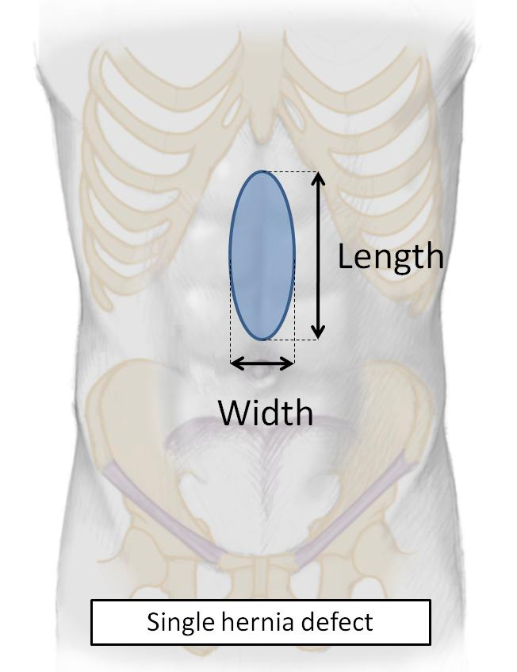

(Pop-up #6) Definition of the size for one or more hernia defects

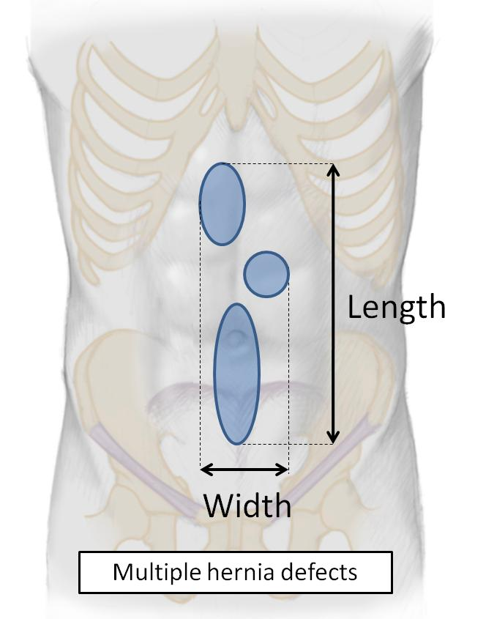
(Pop-up #7)
Midline area:
The borders of the midline area are defined as: cranial: the xiphoid; caudal: the pubic bone; lateral: the lateral margin of the rectal sheath. So all incisional hernias between the lateral margins of the rectus muscle sheath are classified as midline hernias.

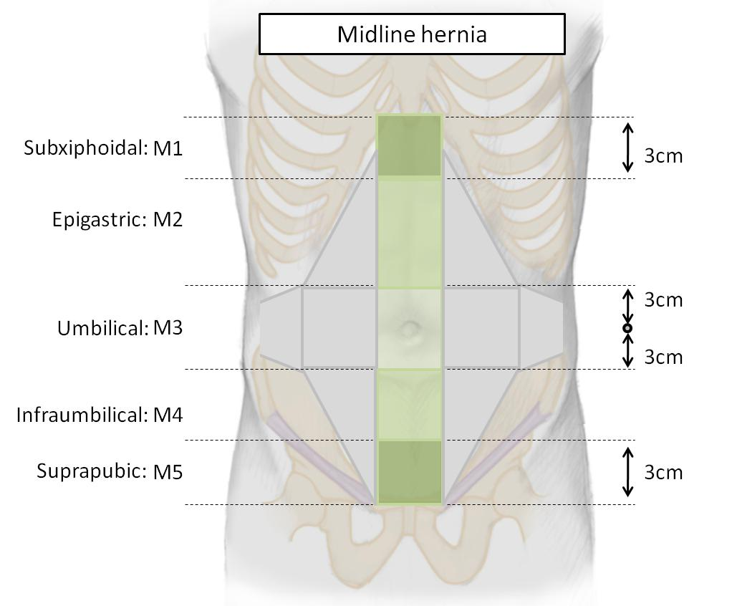
Lateral area:
The borders of the lateral area to classify incisional abdominal wall hernias are defined as: cranial: the costal margin; caudal: the inguinal region; medially: the lateral margin of the rectal sheath; laterally: the lumbar region.

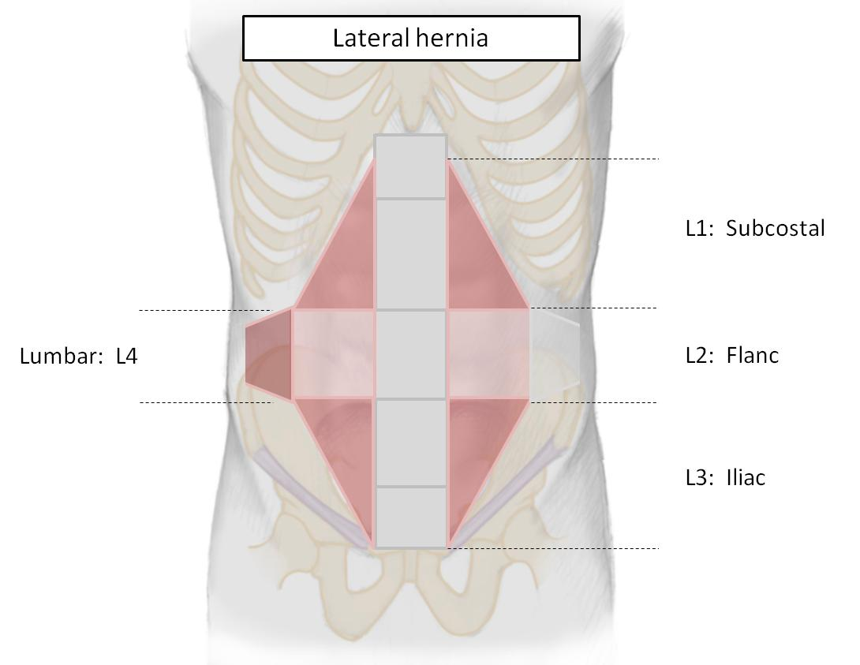
(Pop-up #8)
Specify the type of files accepted
Maximum of 5MB
(Pop-up #9) ist in Arbeit

(Pop-up #11)

Class of operation and wound contamination | Definition | Example for ventral hernia repair
Class I:  Clean | These are uninfected operative wounds in which no inflammation is encountered and the respiratory, alimentary, genital, or uninfected urinary tracts are not entered. | - Elective repair of a hernia.
Class II:  Clean-Contaminated | These are operative wounds in which the respiratory, alimentary, genital, or urinary tract is entered under controlled conditions and without unusual contamination. | - Bowel lesion during adhesiolysis, without spillage of bowel content.  - Combined cholecystectomy and hernia repair.  - Bowel resection for incarceration.
Class III:  Contaminated | These include open, fresh, accidental wounds, operations with major breaks in sterile technique or gross spillage from the gastrointestinal tract, and incisions in which acute, nonpurulent inflammation is encountered. | - Bowel lesion with gross spillage.  - Enterocutaneous fistula.
Class IV:  Dirty | These include old traumatic wounds with retained devitalized tissue and those that involve existing clinical infection or perforated viscera. This definition suggests that the organisms causing postoperative infection were present in the operative field before the operation. | - Perforation of strangulated bowel.  - diverticular abcess  - diverticular perforation

Pop-up #12: Type of access on intention-to-treat basis

(Pop-up #13)
Definition of mesh positions:

Onlay: the mesh is positioned above the abdominal wall muscles, behind the subcutaneous fat.
Inlay: the mesh is positioned in the hernia defect and fixed to the margins of the defect.
Retromuscular (syn.: sublay):
a) for medial abdominal wall hernias: the mesh is positioned behind the rectus abdominis muscle and in front of the posterior rectus fascia (or in front of the peritoneum, when caudal to the linea arcuata).
b) for lateral abdominal wall hernias: the mesh is placed in a plane between the lateral abdominal wall muscles.
Preperitoneal (syn.: underlay): the mesh is placed in the plane behind all abdominal wall muscles in front of the peritoneum.
Intraperitoneal (syn.: IPOM): the mesh is placed behind all layers of the abdominal wall in the peritoneum.

(Pop-up #14)
Operative morbidity: the percentage of patients treated who had at least one complication occurring during the operation, during the hospitalisation or within 30 days postoperatively.
Operative mortality: the percentage of patients treated who died during the operation, during the hospitalisation or within 30 days postoperatively.
Intraoperative complication: complication occurring during the time of the patients arrival in the operating room and the patient leaving the operating room.
Acute or early postoperative complication: postoperative complication occurring during the hospitalization or within 30 days.

(Pop-up #15)
Dindo D, Demartines N, Clavien PA. Classification of surgical complications: a new proposal with evaluation in a cohort of 6336 patients and results of a survey. Ann Surg. 2004 Aug;240(2):205-13.

Grade 0: No complications.
Grade I: Any deviation from the normal postoperative course without the need for pharmacological treatment or surgical, endoscopic and radiological interventions (are allowed: antiemetics, antipyretics, analgesics, diuretics, electrolytes and physiotherapy. This grade includes wound infections opened at the bedside)
Grade II: Requiring pharmacological treatment with drugs other than such allowed for grade I complications. Blood transfusion and TPN are included.
Grade III: Requiring surgical, endoscopic and radiological interventions
IIIa: Intervention not under general anaesthesia
IIIb: Intervention under general anaesthesia

Grade IV: Life threatening complication requiring IC/ICU management
Iva: Single organ dysfunction
IVb: Multiorgan dysfunction

Grade V: Death of the patient.

(Pop-up #16)
Cunningham J, Temple WJ, Mitchell P, Nixon JA, Preshaw RM, Hagen NA. Cooperative hernia study. Pain in the postrepair patient. Ann Surg. 1996 Nov;224(5):598-602.

No pain: no discomfort experienced
Mild pain: was defined to the patient as discomfort that did not limit activity, with a return to pre-hernia lifestyle
Moderate pain: was defined as pain preventing return to normal preoperative activities ( i.e. inability to continue with pre-hernia activities such as golf, tennis and other sports, and inability to lift objects, without pain, that patient had been lifting before the hernia occurrence)
Severe pain: pain that incapacitated the patient at frequent intervals or interfered with activities of daily living (i.e. pain constantly present or intermittently present but so severe as to impair normal activities, such as walking.)

(Pop-up #17)
Morales-Conde S, Alarcon del Agua I, Socas Macias M, Barranco Moreno A. A new classification of seroma after laparoscopic ventral hernia repair. Hernia (2009) 13 (suppl.): S81.

Type of seroma
0 No clinical seroma
I Clinical seroma lasting < 5 weeks
II Clinical seroma lasting > 5 weeks
III Minor seroma related complications
IV Major seroma related complications

