OFFICIAL SEC COVER PAGE — RESERVED
Physics in Practice Investigation
Leaving Certificate 2027
WORKING DRAFT — NOT READY FOR SUBMISSION
Replace this entire page with the completed official SEC cover page. This is not the official cover or an authentication form.
This AI-assisted draft uses the supplied brief, project photographs and provisional transcriptions of notebook results. It does not certify a grade or SEC compliance of unfinished work.
Before submission: verify every reading and opening size; complete the bracketed fields using your actual supervised work; rewrite and take ownership of the report; acknowledge AI assistance under the SEC Coursework Rules and Procedures. Do not invent missing observations, repeats, equipment details or model results.
The optional computer-model subsection is deliberately unfinished. Replace or remove its prompts, then recheck the 1,500-word limit. The final report must be submitted as a checked PDF through your teacher by the applicable deadline in the brief: 11 December 2026.
Draft word-count check: approximately 1116 words in Sections 1–6, including prompts, headings and captions; excluding equations and data tables. References and this replacement cover page are excluded. Recount after all edits. Current figures: 2; optional model graph would bring the total to 3.

1. Title and Introduction
Effect of an opening on the cooling of an insulated model room
Domestic sustainability includes reducing unwanted energy losses while maintaining a comfortable indoor environment [1]. An insulated box provides a simplified way to investigate this issue. It cannot reproduce a complete house, but it allows cooling under different opening conditions to be compared.
Research question: How does opening area affect the mean cooling rate of an insulated model room over the first ten minutes?
The hypothesis is that a larger opening increases cooling by allowing greater exchange between warmer internal air and cooler surroundings. A directly proportional relationship is not assumed. The investigation compares a no-hole record with opening trials; uncertain area labels must be resolved before testing the area relationship.
[Add your own reason for choosing this investigation.]

2. Background Research
Heat flows because of a temperature difference. Conduction transfers energy through materials; convection involves fluid motion; radiation transfers energy through electromagnetic waves [2]. Insulation reduces some heat-transfer pathways but does not eliminate heat loss. An opening can permit air exchange, although its position, shape and obstruction also affect that exchange.
The SEC brief establishes the domestic-sustainability context, not a predicted cooling rate [1]. OpenStax provides relevant textbook explanations [2], but no measurements for this apparatus. Therefore these sources support the hypothesis without establishing which mechanism dominates the experiment. No numerical secondary dataset has been analysed.
Newton’s law of cooling provides an optional approximate model [3]:
T(t) = Troom + (T0 − Troom) exp(−kt)
Here T0 is initial temperature, Troom is constant ambient temperature and k is a positive cooling constant with units of inverse minutes. The model assumes effectively uniform temperature and approximately constant thermal behaviour. Uneven temperatures, changing airflow and stored heat in the box may violate these assumptions.
[After reading the sources yourself, add one relevant research finding and evaluate its applicability.]

3. Designing and Planning
The independent variable is opening area; the dependent variable is the mean temperature decrease per minute over a common interval. The no-hole condition is a comparison control, not proof of an airtight box. Circular area is calculated from measured diameter:
A = π(d/2)²; 1 cm² = 100 mm²
The photographs show an insulated box and a digital probe thermometer [4]. [Specify box dimensions and materials, insulation thickness, heat source, measured substance, thermometer model/range/accuracy, timer and diameter-measuring instrument.]
A fair comparison requires the same insulation, opening position, probe location, lid seal, heating procedure and room conditions. The same starting probe reading does not guarantee the same stored energy in the walls. [Explain the controls actually used and record starting room temperature.]
For further teacher-supervised work, use independent reheating/cooling repeats for each verified area, preferably at least three. Keep insulation clear of the measured opening and use a consistent warm-up and reset procedure. These are proposed improvements, not completed trials.
Safety planning must address hot surfaces, cutting openings and any electrical equipment near insulation. [Record the actual teacher-approved precautions and safe heating arrangement; do not claim precautions not taken.]
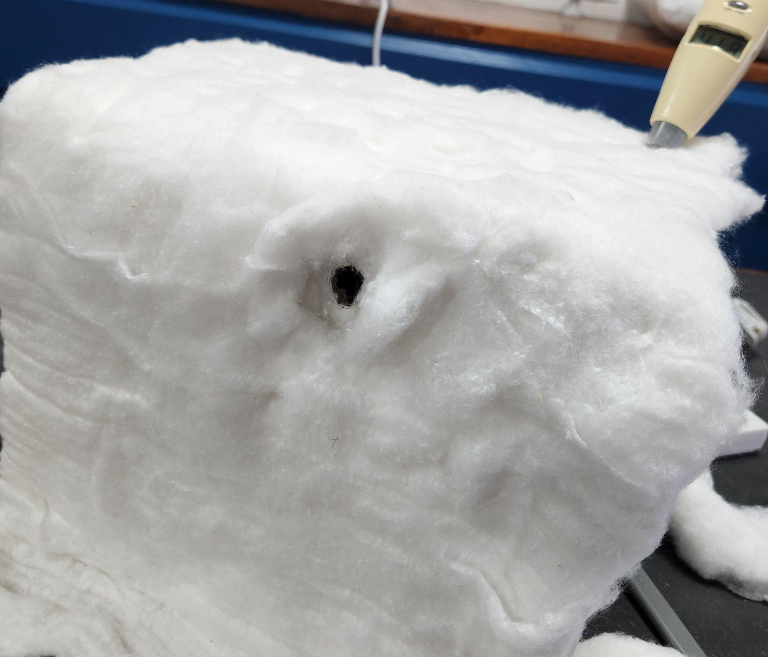
Figure 1. Apparatus photograph, cropped from the supplied project [4].

4. Conducting the Experiment
The supplied notebook photographs record cooling at one-minute intervals, starting near 60.4–60.5°C. Four records share a complete 0–10 minute interval [4]. The following details are needed to make the method reproducible:
1. [State dates, supervised setting, apparatus assembly, measured substance and exact probe position.]
2. [Explain how each opening was measured and how the box was heated; state whether the source was removed or switched off.]
3. [Define time zero, the warm-up procedure and when readings were taken.]
4. [Describe resetting between runs, actual repeats, room-temperature monitoring and any procedural changes.]
A separate notebook record is labelled “bottom hole”. Its area and comparability need confirmation, so it is not pooled with the four records. The draft also lists 500 mm² without an identified result series. No measurements are invented for that condition.
[Add genuine observations, difficulties and any pilot-test changes. Confirm direct teacher supervision of all experimental work and primary-data collection.]

5. Data and Data Analysis
Table 1 is a provisional transcription, not a new experiment. A is labelled “no hole”; B has conflicting small-opening labels; C and D are labelled 100 and 300 mm². Areas remain nominal pending dimension checks. Each column is one record, not a mean of repeats. Longer records are compared only over their common first ten minutes.
Table 1. Recorded temperatures; check against the original notebook [4].
Time / min | A / °C | B / °C | C / °C | D / °C
0 | 60.4 | 60.4 | 60.4 | 60.5
1 | 59.7 | 56.5 | 57.2 | 56.8
2 | 58.6 | 52.7 | 54.6 | 53.9
3 | 56.6 | 49.9 | 52.3 | 51.5
4 | 54.9 | 47.5 | 50.2 | 49.2
5 | 52.9 | 45.4 | 47.7 | 47.1
6 | 50.8 | 43.6 | 45.7 | 45.1
7 | 48.9 | 42.0 | 44.0 | 43.3
8 | 46.8 | 40.7 | 42.3 | 42.0
9 | 45.3 | 39.3 | 40.9 | 40.9
10 | 43.5 | 38.0 | 39.6 | 39.9

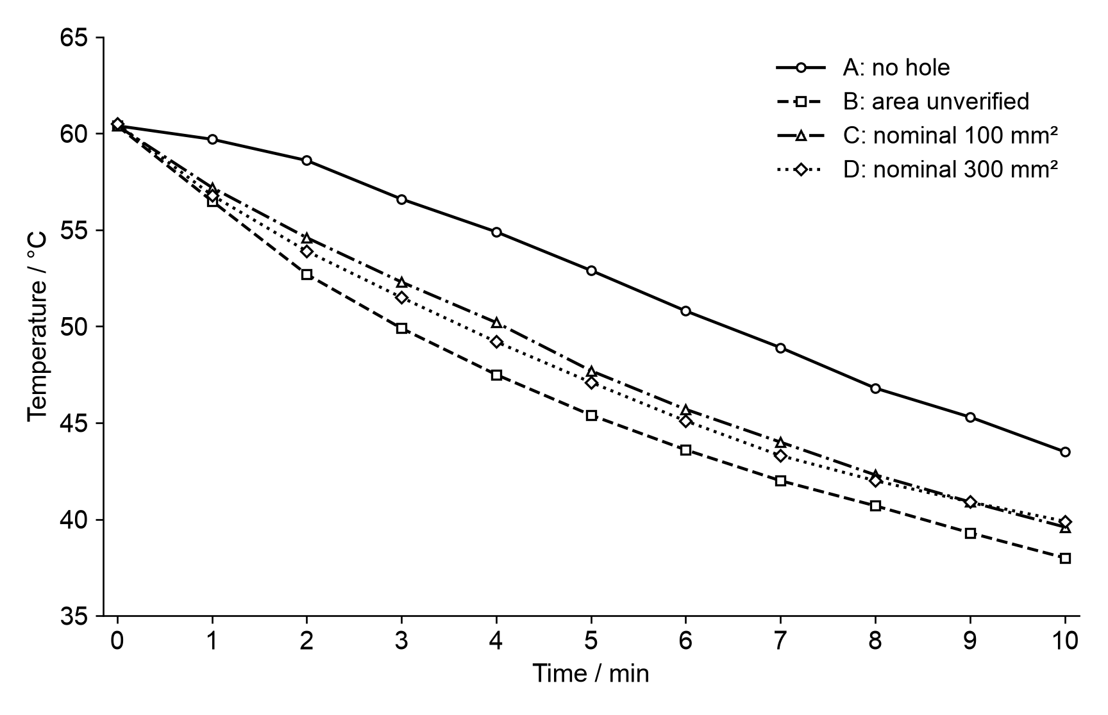
Figure 2. Provisional cooling records. Lines join readings; they are not fitted models.
Mean cooling rate, R = [T(0) − T(10)] / 10
For A: R = (60.4 − 43.5) / 10 = 1.69 °C/min
Record | Temperature fall / °C | Mean rate / (°C/min)
A | 16.9 | 1.69
B | 22.4 | 2.24
C | 20.8 | 2.08
D | 20.6 | 2.06
A cooled slowest over this interval. B cooled fastest, while C and D gave similar average rates. Thus the records do not establish a monotonic increase with opening area. Different initial wall temperatures, probe conditions, obstruction or area labelling could contribute; these are possibilities, not demonstrated causes.

Uncertainty and limitations
The readings are recorded to 0.1°C, but this is not evidence of thermometer accuracy. [Insert specified accuracy and timing uncertainty.] Without independent repeats, run-to-run variation cannot be estimated. Consequently the 0.02°C/min difference between C and D cannot be treated as significant. All provisional calculations require checking against the source records.

Energy and cost
Temperature decrease is not itself an energy measurement. Applying Q = mcΔT requires a justified mass and specific heat capacity. Internal air alone would exclude heat stored in the box and contents. These records therefore do not support a numerical household energy saving or annual cost claim.

Computer model — placeholder, not completed
[Optional: replace this subsection with your own completed model and evaluation, or remove it.]
Use the equation in Section 2 with measured ambient temperature. [Insert software, input values, units, fitted k values and fitting method.]
[Insert one measured-versus-modelled graph here. Clearly distinguish measurements from model output.]
[Evaluate residuals, assumptions and where agreement is poor.] A k fitted to these measurements describes their behaviour; it is not independent confirmation of the hypothesis. Do not invent room temperature or model results.

6. Conclusions
For the provisional 0–10 minute records, the no-hole condition cooled at 1.69°C/min, compared with 2.24, 2.08 and 2.06°C/min for B, C and D. These observations are consistent with openings increasing cooling, but they do not isolate opening area as the cause. Unverified dimensions and unquantified repeatability prevent a reliable area–rate relationship.
The main improvements are verified opening dimensions, identical thermal starting conditions, measured ambient temperature and independent repeats. The analysis must retain results that challenge the prediction rather than remove them to obtain an expected trend.
The model illustrates a reason to investigate unwanted domestic air leakage, not a basis for scaling savings to a house. Necessary ventilation must not be confused with avoidable leakage.
[Update after verified data and any further supervised trials: state whether the hypothesis is supported, quote uncertainty, and explain what you personally learned. Include model findings only if completed.]

7. References
Sources used during preparation of this AI-assisted draft. Read and check them yourself; retain only sources genuinely used in your final work.
[1] State Examinations Commission. Leaving Certificate Examination 2027: Physics in Practice Investigation, Higher Level and Ordinary Level, 2027L021C2EL. User-supplied brief, pp. 2–8.
[2] Urone, P. P. and Hinrichs, R. College Physics 2e, Section 14.4, “Heat Transfer Methods”. OpenStax (2022). Accessed during draft preparation: 21 September 2026. https://openstax.org/books/college-physics-2e/pages/14-4-heat-transfer-methods
[3] OpenStax. Calculus Volume 2, Section 4.3, “Separable Equations”, subsection “Newton’s law of cooling”. Accessed during draft preparation: 21 September 2026. https://openstax.org/books/calculus-volume-2/pages/4-3-separable-equations
[4] Candidate-supplied Physics.docx: apparatus photographs and photographed handwritten cooling records. Experiment dates: [insert]. Figure 1 is cropped from embedded image1; Table 1 uses image9 (A), image3 (B), image12 (C) and image7 (D). These image numbers identify embedded files, not numbered figures in the original document.
[5] AI-assistance disclosure — draft record: OpenAI GPT-6 Astra via Hoplite, conversation dated 21 September 2026. Assistance included reviewing the brief, transcribing photographed readings, checking calculations, generating a graph, drafting wording and formatting this document. No experiment or simulation was conducted by the AI. The candidate must verify, revise and acknowledge assistance under Appendices 1 and 2 of the SEC Coursework Rules and Procedures, with teacher guidance. Retain the relevant prompts and outputs. [Add any further assistance and the required reference details.]

