Configurations

Please follow this document.

Components Required

- 5v single channel optocoupler relay - https://www.lazada.com.ph/products/1-channel-5v-relay-module-with-optocoupler-protection-i100047427-s100061336.html

- Model 623 multi coin acceptor https://cdn.sparkfun.com//assets/parts/7/9/2/6/11719-01a.jpg
https://www.sparkfun.com/products/11719

- USB 3.0 Gigabit Adapter http://img.dxcdn.com/productimages/sku_213357_2.jpg

- 12v Power Supply https://www.sparkfun.com/products/9442

Open Raspberry Pi terminal and execute following commands

pip install websocket
pip3 install websocket-client

git clone https://github.com/pihomeserver/Kupiki-Hotspot-Script.git

sudo chmod +x pihotspot.sh && sudo ./pihotspot.sh
sudo ./etc/kupiki/kupiki_updater.sh

to open configuration page visit
https://raspberrypi.local/daloradius
Node-Red

Node-red is a visual programming language developed by IBM. It is a powerful tool that reduce the development time.

Open your Ubuntu terminal and install node-red by executing following commands.

sudo apt-get install nodejs-legacy
node -v
sudo apt-get install npm
npm -v
sudo npm install -g --unsafe-perm node-red node-red-admin

and printer

sudo apt install cups-client

Open a port on firewall

sudo ufw allow 1880

and at last run the node-red by executing

node-red

open any browser on the same machine and navigate to

http://localhost:1880

you will see something like in the image below:

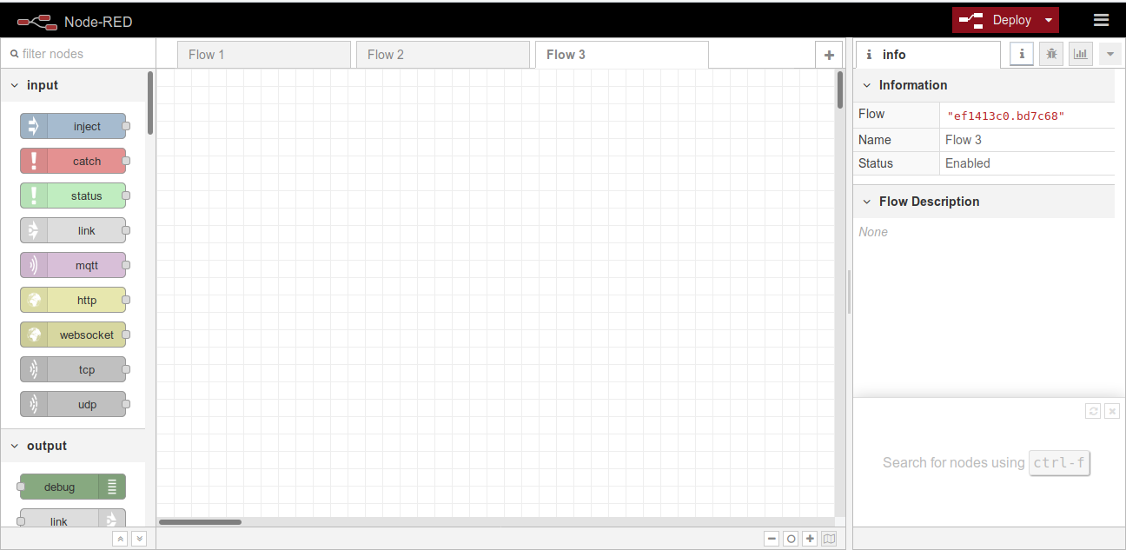
The above interface is the development interface of node-red.
Now we will install node-red-dashboard for making nice UIs.
Open terminal and execute the following command:

npm i node-red-dashboard

and

npm install node-red-node-sqlite

to install SQLite for storing data.
install npm functions

npm install node-red-contrib-function-npm
Now import the existing code to your node-red flow by clicking on Import and import from clipboard.
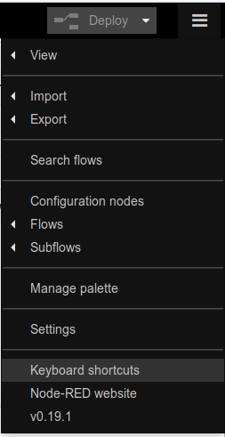

Then you can copy and paste the data in NodeRedFlow.txt file to node-red box. After that navigate to

http://localhost:1880/ui

You will see the main dashboard.
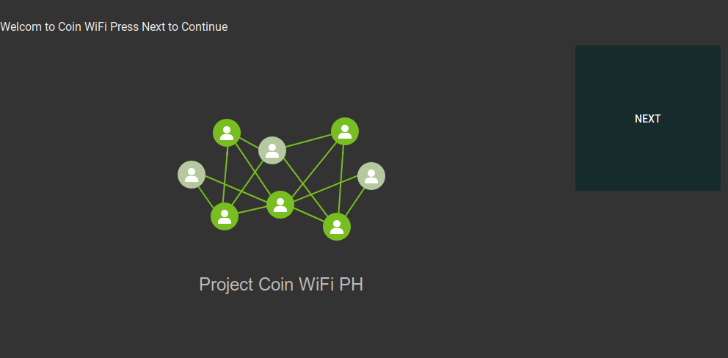

Configure Coin Acceptor

Follow the instructions below to configure the coin acceptor.
First the switches:
select "NC" by sliding the top switch to the bottom position.
select "FAST" by sliding the bottom switch to the top position.
Power Up the unit with a 12v supply.
1. Hold the "ADD" and "MINUS" buttons down at the same time for about 3 seconds, release and then the letter "A" will appear on the LED display.
2. Press the "SETUP" button once, and the letter "E" will appear. Then use the "ADD" and "MINUS" buttons to choose how many kinds of coins your going to use. Press the "SETUP" button again to finish.
3. The letter "H" will appear. Use the "ADD" and "MINUS"buttons to choose how many sample coins your going to feed it later. Press the"SETUP" button again to finish.
4. The letter "P" will appear. Again use the "ADD" and "MINUS" buttons to choose the amount of output pulses you want. Press the "SETUP" button to finish. Refer to the above example to determine number of pulses.
5. The letter "F" will appear. Using the "ADD" and "MINUS" buttons, choose the accuracy. The value is from 1 to 30, with 1 being the most accurate. I use 10 and it works fine. Again "SETUP" to finish.
You have now setup the first coin, depending on how many coins you selected in step 2, you'll have to repeat Step's 3 to 5 for each one.
The letter "A" will appear when you've setup all the coins. Hold "SETUP" for 3 seconds to finish, the letter "E" will appear.
Finally, switch the unit off and then back on.
Sampling time:
1. Hold the "SETUP" button down for about 3 seconds, release and then the letters "A1" will appear on the LED display. This is your first coin (5p/c)
2. Feed the Coin Selector your sample coins, the LED display will show the amount of coins you've entered. "A1" will appear again when finished.
3. Hold the "SETUP" button down again for about 3 seconds, release and then"A2" will appear, repeat these steps until all coins are sampled.
If your not using all of the coin types available (eg 5 coins of a 6 type coin selector) the unit will ask for samples of a coin type you haven't setup, just hold the "SETUP" button down for 3 seconds of each of t
he remaining coins.
The Coin Selector restarts itself and is now ready to connect to the Raspberry Pi.

In terminal of Raspberry Pi execute,

python3 mainProgram.py

For reference see the video and for technical details see Technical Document.

