Technical Document

Data-sheet

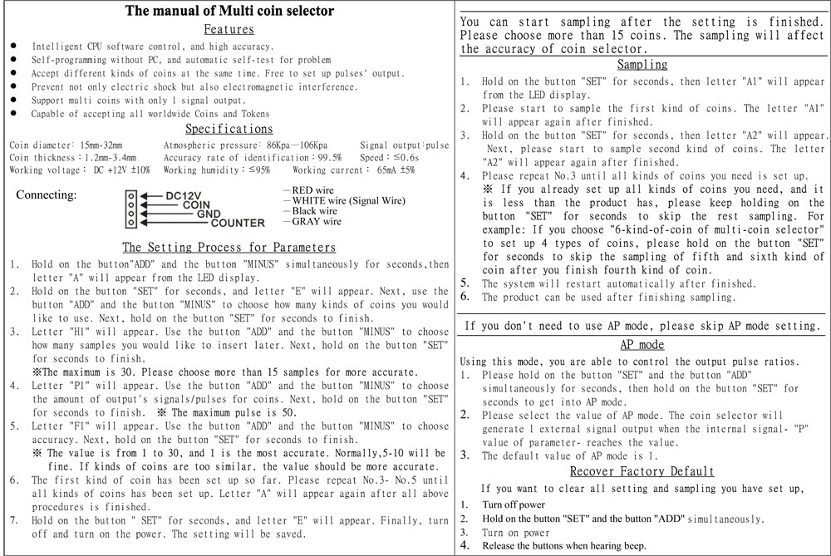
Pulses:

All the the coins can be made up with multiple 5p or 5c coins, so we make 1 pulse equal to 5p or 5c.
5p/c = 1 pulse, 10p/c = 2 pulses, 20p = 4 pulses, 25c = 5 pulses, 50p/c = 10 pulses, £/$1 = 20 pulses.

