TURMER-10mn-1dec : Half-Normal Cosine

QQ-plot
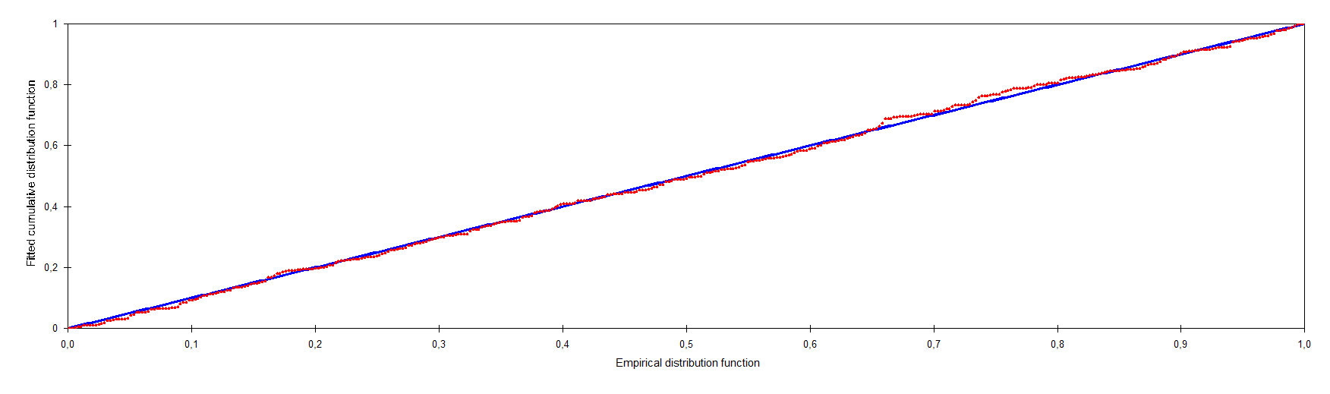

Detection Fct/Global/Plot: Detection Probability 1

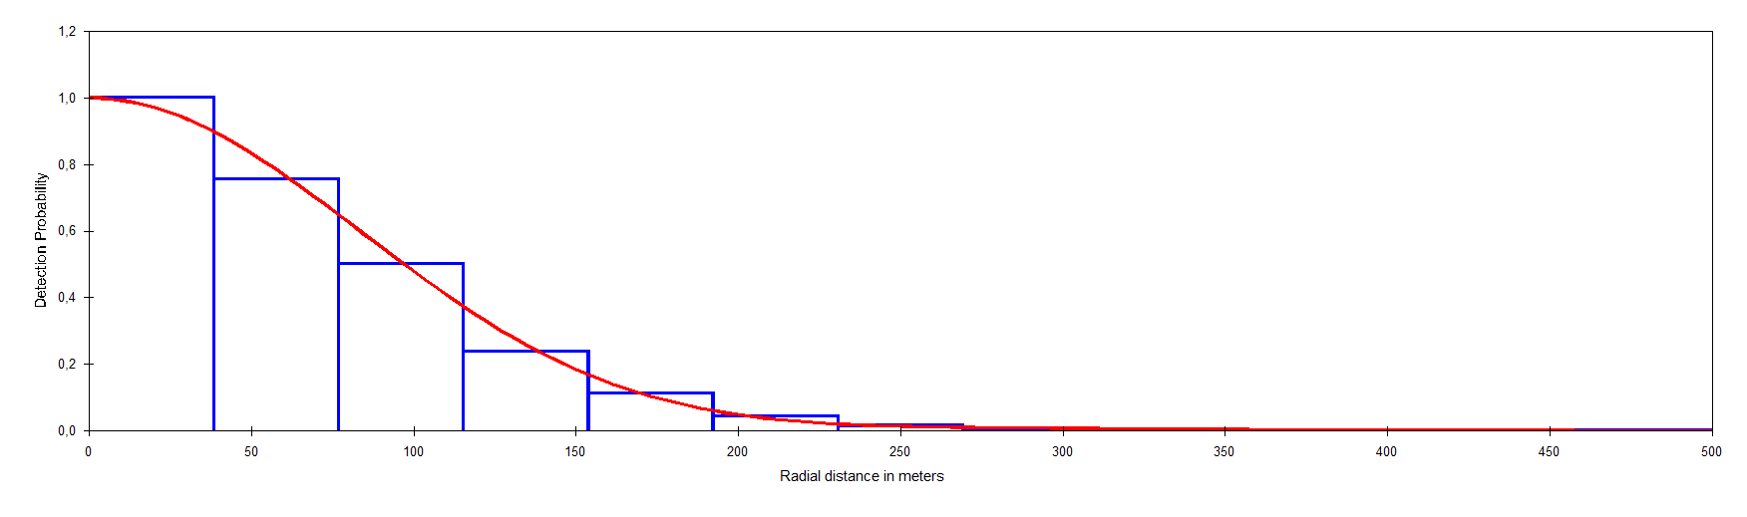
Detection Fct/Global/Plot: Pdf 1

