distance-sampling] MCDS.exe sensitive to distance data sort order (inside transect grouping) ?

4 août 2019 11:04

Eric Rexstad <er26@st-andrews.ac.uk>
Dear Melodious warbler

Thanks for your detailed examination of the data set you have provided. I've not examined the issue of data sorting and its impact upon the mcds optimisation routines.

Instead, thanks to the data you sent along, I've had a look at the data themselves. Ignoring the fitted curve for the moment, it is clear that there is little information in the data beyond 250-300m:
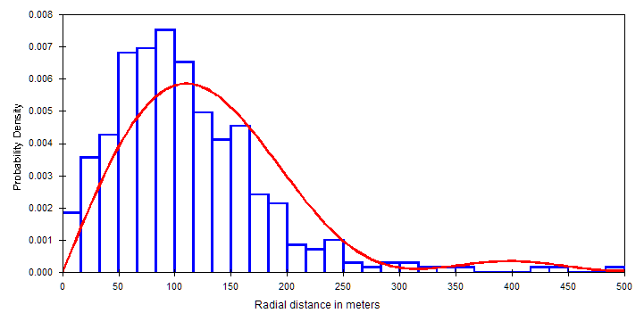
The fundamental parameter to be estimated from point transect data is h(0); the slope of this PDF at distance 0. There is virtually no information in detections make at 300m to help in estimating h(0). That is why truncation plays a role in analysing distance sampling data. Note from the figure that the fit of the PDF to the data is poor; the great proportion of the detections are in the range 50-150m and the PDF is not fitting that peak. This is because the optimisation routines are struggling to figure out how to mimic the data in the tail (beyond 300m). Note the silly hump at 400m where there are no detections.

I reanalysed this data set imposing a reasonable truncation distance; I tried both 250m and 300m; the resulting estimates were virtually identical at those two truncation distances. In addition, the fit of the PDF to the data was much improved:
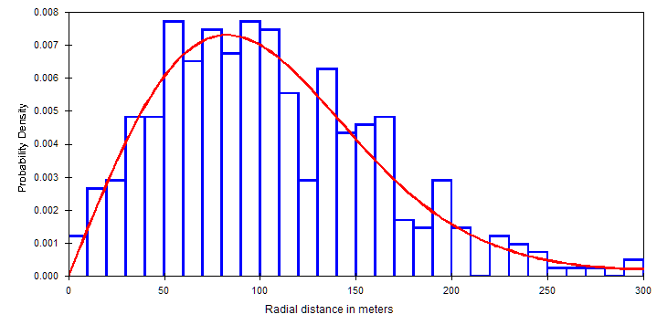
The estimate of h(0) from the untruncated data is 0.85807E-04, resulting in an estimate of P=0.09 (only 1 in 10 birds were detected within the 500m radius of the point). The same quantities assessed from analysis of the truncated data h(0)=0.14508E-03 and P=0.15. That 50% increase in P results in a 50% increase in estimated density from 0.29 to 0.46. The goodness of fit statistics are all quite good for the truncated data (as your eye can deduce by looking at the PDF figure above).

It is difficult to fit PDFs to point transect data; the shape of the detection function at small distances is most critical, but these small distances coincide with small areas around the point where few birds reside.

The fundamental message from this analysis is that exploratory work needs to first be conducted with the data (look at the radial distance histogram) before attempting to fit models. Rather than worrying about the performance of the optimisation routines and the sorting of distances within transects, a good look at the data will make analysis more straightforward.

Eric Rexstad
Senior Research Fellow, CREEM, Univ. of St Andrews, Charity SC013532
eric.rexstad@st-andrews.ac.uk
+44 (0)1334 461833
The Observatory, Buchanan Gardens, St Andrews KY16 9LZ
http://erex.github.io

On Aug 3 2019, at 3:56 pm,
Hypolais Polyglotte <hypolais67@gmail.com> wrote:

Hello.

While validating a python program for automating Distance Sampling analyses through MCDS.exe R6.2,
we've encountered a few strange cases linked sightings order in input data files for MCDS.exe.

Let me explain one of these cases :
* from the same point transect sample (Turdus merula sightings in Auvergne, France, april to june, 2019),
* we ran the same simple CDS analyses with Half-normal Cosine and Uniform Cosine models
(nothing else special, no distance truncation, ...) :

1) through Distance 7.3 software,
2) through direct use of MCDS.exe command line.
$ cd <into the data.txt + cmd.txt folder>
$ "C:\Program Files (x86)\Distance 7\MCDS.exe" 0, cmd.txt

For these analyses, when comparing method 1 and 2, the results were :
* rigourously identical for the Half-normal Cosine,
* quite different for the Uniform Cosine model, with quite same AIC, but double / half estimate density (!).

After investigating, it appears that :
1) Distance 7.3 (under Windows 7) has slightly changed the order of imported sightings before calling MCDS.exe :
the sightings were still sorted by point, but for some points, they were no more in the order of the original
data file imported into Distance ;
the order change was systematic, whatever model, Uniform Cosine or Half-normal Cosine, whatever analysis execution ;
and subsequent re-runs (after cleanup) of the same analyses, or subsequent tries to rebuild the Distance projects
from scratch ... didn't change anything : always the same order change and results.
Note: To access the data passed to MCDS.exe, we activated the data logging, and also the Debug mode.
2) MCDS.exe produced different results for the same input data set and Uniform Cosine analysis model,
when the sigthings were not in the same order (but still sorted by point) ;
but the results remained the same whatever method for the Half-normal Cosine model.

Isn't this sensitivy to data order some kind of bug or weakness of MCDS.exe ?

Is this simply due to a "bad quality" of our sample that makes the Uniform Cosine model fitting not / pourly applicable ?
(hence the computation warning : ** Warning: Parameters are being constrained to obtain monotonicity. **)

What is you recommandation as a workaround for this, if any :
* change data order ? (as here, a sort by increasing distance inside each point seems to improve things)
* anything else ?

For reference, you'll find attached a zip archive with the following :
* file "dist-order-sens.xlsx" : the results of 3 analyses run with the same sample data for the Uniform Cosine model,
1 analysis per line :
- case "dist-win7-dist-order" : run with Distance 7.3 (method 1), results collected by hand in the results window,
- case "cmd-win7-dist-order" : run directly by command line (method 2), with input data to MCDS.exe
copied from Distance run (previous line), and results collected by hand in the output.txt file,
100% identical to the first line,
- case "cmd-win7-orig-order" : run directly by command line (method 2), with input data to MCDS.exe
generated "by hand", in the same order of the sample data file given to Distance in line 1,
and results collected by hand in the output.txt file.
* sub-folder "dist-win7-dist-order" : a reconstructed by hand file set for a MCDS.exe run by Distance 7.3,
with MCDS.exe input data.txt and cmd.txt (got through Debug mode), and output files log.txt and output.txt
with contents copied and pasted from Distance analysis result window.
* sub-folder "cmd-win7-dist-order" : run directly by commande line (method 2), with input data to MCDS.exe
copied from Distance run (previous line), and "natural" output files of MCDS.exe, mainly stats.txt,
output.txt and log.txt,
* sub-folder "cmd-win7-orig-order" : run directly by commande line (method 2), with input data to MCDS.exe
generated "by hand", in the same order of the sample data file given to Distance in line 1,
and "natural" output files of MCDS.exe, mainly stats.txt, output.txt and log.txt.
* file "dist-win7.dst" and subfolder "dist-win7.dat" : the Distance 7.3 project used for this test,
* file "import-data-set.txt" : the sample data imported to Distance 7.3 for this test, and slightly reformated
into data.txt for the MCDS.exe direct run "cmd-win7-orig-order".
Note fro myself: Same data as in refin/ACDC2019-Papyrus-TURMER-AB-10mn-1dec-dist.txt
* file "dist-order-sens.txt" : this message :-)

Thanks in advance for your help.

