

# [DFPPI Data Bank]

A PROTOTYPE

FINAL PROJECT OUTPUT

IT 2202

Database Systems

By:

Caboyo, Francis

Lee, YeHoo

I. Introduction

Davao Fibreboard Packaging Plant, Inc.



**Since** 2009

**Owner** Unknown

**Branches/Location**

* Km., 12. Sasa, Davao CityKm., 12. Sasa, Davao

**Industry** Manufacturing **Employees** ~200

**Company History**

Davao Fibreboard Packaging Plant, Inc. (DFPPI) is a  manufacturer of high quality corrugated carton boxes and other packaging materials. Incorporated on December 27, 2007, it is formed to cater a wider-range of customers and more diverse markets.  
          The company had its first run on February 27, 2009 and commenced formal operations on August 7, 2009. The company's main products, corrugated carton boxes, are sold to direct fresh fruits (e.g. bananas and pineapples) exporting companies in  the region. On May 2009, DFPPI's registration for Custom Bonded Manufacturing Warehouse has been approved by the Bureau of Customs. DFFPI employs only highly skilled people armed with industry expertise, and first-rate machineries, upgraded equipments and facilities to be able to produce quality products and provide quality service.

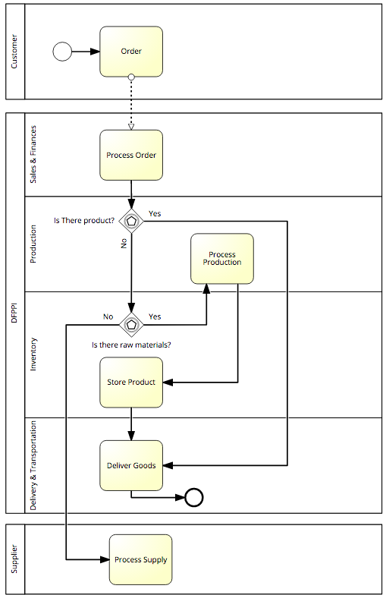 Business Process

**DFPPI Company Business Process**

UPDATED ENTITY RELATIONSHIP DIAGRAM

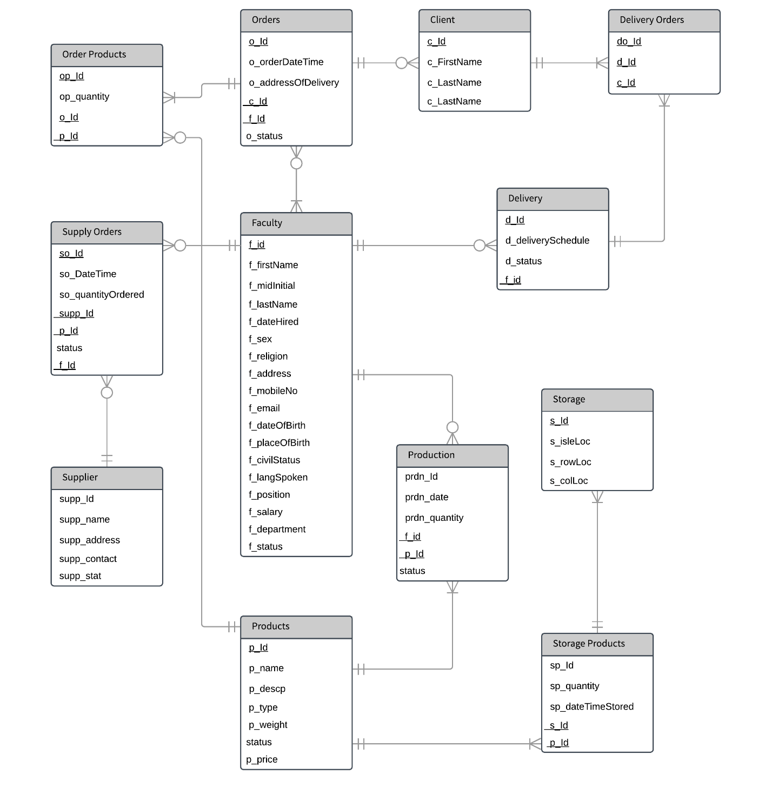

MODULES AND ROLES

|  |  |  |  |  |  |
| --- | --- | --- | --- | --- | --- |
| **Module Name:** | **C** | **R** | **U** | **D** | **Done By:** |
| Create Records | Y | N | Y | N | Francis Caboyo |
| Update Records | N | N | Y | N | Francis Caboyo |
| View Records | N | Y | N | N | Lee, Ye Hoo |

|  |  |  |  |  |  |
| --- | --- | --- | --- | --- | --- |
| **User Level: Administrator** | **C** | **R** | **U** | **D** | **Module Name:** |
| Priv | N | Y | N | N | View accounts |
| Y | N | N | N | Add accounts |
| N | Y | N | N | View employee w/ no accounts |
| N | N | Y | N | Enable/Disable accounts |

|  |  |  |  |  |  |
| --- | --- | --- | --- | --- | --- |
| **User Level: Employee (All)** | **C** | **R** | **U** | **D** | **Module Name:** |
| User | N | Y | N | N | View Informations |

|  |  |  |  |  |  |
| --- | --- | --- | --- | --- | --- |
| **User Level: Employee *(Sales & Finances)*** | **C** | **R** | **U** | **D** | **Module Name:** |
| Employee | Y | N | N | N | AdCustomers/Orders |
| N | N | Y | N | Update Customers/Orders |
| N | N | Y | N | Edit products From Orders |

|  |  |  |  |  |  |
| --- | --- | --- | --- | --- | --- |
| **User Level: Employee *(Delivery & Transportation)*** | **C** | **R** | **U** | **D** | **Module Name:** |
| Employee | Y | N | N | N | Add Delivery Scheduls/Delivery Orders |
| N | N | Y | N | Update Delivery Scheduls/Delivery Orders |

|  |  |  |  |  |  |
| --- | --- | --- | --- | --- | --- |
| **User Level: Employee *(Human Resources)*** | **C** | **R** | **U** | **D** | **Module Name:** |
| Employee | Y | N | N | N | Add faculty member |
| N | N | Y | N | Update faculty member |

|  |  |  |  |  |  |
| --- | --- | --- | --- | --- | --- |
| **User Level: Employee *(Inventory)*** | **C** | **R** | **U** | **D** | **Module Name:** |
| Employee | Y | N | N | N | Add storage Info / Item to storage |
| N | N | Y | N | Update storage Info / Item to storage |

|  |  |  |  |  |  |
| --- | --- | --- | --- | --- | --- |
| **User Level: Employee *(Production)*** | **C** | **R** | **U** | **D** | **Module Name:** |
| Employee | Y | N | N | N | Add products / production / suppliers |
| N | N | Y | N | Update products / production / suppliers |

V. SQL Queries

**CHARTS**

|  |  |  |
| --- | --- | --- |
| SELECT p_type, ROUND(SUM(p_price),2) <PHP_VARIABLE>  FROM products  GROUP BY p_type  ORDER BY <PHP_VARIABLE> DESC | | |
| **From**: priv/queries.php | **Expected Rows**: Many | **Output**: Chart |

|  |  |  |
| --- | --- | --- |
| SELECT f_department, COUNT(*) AS <PHP_VARIABLE>  FROM faculty  GROUP BY f_department  ORDER BY f_department | | |
| **From**: priv/ queries.php | **Expected Rows**: Many | **Output**: Chart |

|  |  |  |
| --- | --- | --- |
| SELECT p_name,p_type,SUM(op_quantity) AS <PHP_VARIABLE>  FROM order_products op  JOIN products p  ON p.p_Id = op.p_Id  GROUP BY p_name  ORDER BY <PHP_VARIABLE> DESC  LIMIT 7 | | |
| **From**: priv/queries.php | **Expected Rows**: Many | **Output**: Chart |

|  |  |  |
| --- | --- | --- |
| SELECT f.f_firstName,f.f_lastName, COUNT(*) AS <PHP_VARIABLE>  FROM orders o  JOIN faculty f  ON f.f_id = o.f_Id  GROUP BY f.f_id  ORDER BY <PHP_VARIABLE> DESC  LIMIT 7 | | |
| **From**: priv/queries.php | **Expected Rows**: Many | **Output**: Chart |

**CREATE RECORDS**

|  |  |  |
| --- | --- | --- |
| INSERT INTO `faculty`  (`f_id`, `f_firstName`, `f_midInitial`,`f_lastName`, `f_dateHired`, `f_sex`, `f_religion`,`f_address`, `f_mobileNo`, `f_email`, `f_dateOfBirth`,`f_placeOfBirth`, `f_civilStatus`, `f_langSpoken`, `f_position`, `f_salary`,`f_department`)  VALUES (NULL, '<PHP_VARIABLE>', '<PHP_VARIABLE>', '<PHP_VARIABLE>', DATE(NOW()), '<PHP_VARIABLE>', '…', '<PHP_VARIABLE>') | | |
| **From**: add-employee.php | **Expected Rows**: One | **Output**: HTML |

|  |  |  |
| --- | --- | --- |
| INSERT INTO `delivery_orders` (`do_Id`, `d_Id`, `c_Id`)  VALUES (NULL, '<PHP_VARIABLE>', '<PHP_VARIABLE>') | | |
| **From**: add-dop.php | **Expected Rows**: One | **Output**: HTML |

|  |  |  |
| --- | --- | --- |
| INSERT INTO `delivery` (`d_Id`, `d_deliverySchedule`, `f_id`)  VALUES (NULL, CURRENT_DATE, '<PHP_VARIABLE>') | | |
| **From**: add-delivery.php | **Expected Rows**: One | **Output**: HTML |

|  |  |  |
| --- | --- | --- |
| INSERT INTO client (c_Id, c_FirstName, c_LastName, c_contactInfo)  VALUES (NULL,'<PHP_VARIABLE>','<PHP_VARIABLE>','<PHP_VARIABLE>' | | |
| **From**: add-customer.php | **Expected Rows**: One | **Output**: HTML |

|  |  |  |
| --- | --- | --- |
| INSERT INTO `supply_orders` (`so_Id`, `so_DateTime`, `so_quantityOrdered`, `f_Id`) VALUES (NULL, CURRENT_TIMESTAMP, '<PHP_VARIABLE>', '<PHP_VARIABLE>') | | |
| **From**: add-supply-order.php | **Expected Rows**: One | **Output**: HTML |

|  |  |  |
| --- | --- | --- |
| INSERT INTO `production` (`prdn_Id`, `prdn_date`, `prdn_quantity`, `f_Id`,`p_Id`) VALUES (NULL, '<PHP_VARIABLE>', '<PHP_VARIABLE>', '<PHP_VARIABLE>','<PHP_VARIABLE>') | | |
| **From**: add-production.php | **Expected Rows**: One | **Output**: HTML |

|  |  |  |
| --- | --- | --- |
| INSERT INTO `products` (`p_Id`, `p_name`, `p_descp`, `p_type`, `p_weight`, `p_price`)  VALUES (NULL, '<PHP_VARIABLE>', '<PHP_VARIABLE>', '<PHP_VARIABLE>', '{$we}', '<PHP_VARIABLE>') | | |
| **From**: add-products.php | **Expected Rows**: One | **Output**: HTML |

|  |  |  |
| --- | --- | --- |
| INSERT INTO `orders` (`o_Id`, `o_orderDateTime`, `o_addressOfDelivery`, `c_Id`, `f_Id`, `o_status`)  VALUES ('NULL', CURRENT_TIMESTAMP, '<PHP_VARIABLE>', '<PHP_VARIABLE>', '<PHP_VARIABLE>', 'Not started') | | |
| **From**: add-order.php | **Expected Rows**: One | **Output**: HTML |

|  |  |  |
| --- | --- | --- |
| INSERT INTO `order_products` (`op_Id`, `op_quantity`, `o_Id`, `p_Id`)  VALUES (NULL, <PHP_VARIABLE>,<PHP_VARIABLE>,<PHP_VARIABLE> | | |
| **From**: add-op.php | **Expected Rows**: One | **Output**: HTML |

|  |  |  |
| --- | --- | --- |
| INSERT INTO `products` (`p_Id`, `p_name`, `p_descp`, `p_type`, `p_weight`, `p_price`)  VALUES (NULL, '<PHP_VARIABLE>', '<PHP_VARIABLE>', '<PHP_VARIABLE>', '<PHP_VARIABLE>', '<PHP_VARIABLE>') | | |
| **From**: add-products.php | **Expected Rows**: One | **Output**: HTML |

|  |  |  |
| --- | --- | --- |
| INSERT INTO `storage` (`s_Id`, `s_isleLoc`, `s_rowLoc`, `s_colLoc`)  VALUES (NULL, '<PHP_VARIABLE>', '<PHP_VARIABLE>', '<PHP_VARIABLE>') | | |
| **From**: add-inventory-materials.php | **Expected Rows**: One | **Output**: HTML |

|  |  |  |
| --- | --- | --- |
| INSERT INTO `storage_products` (`sp_Id`, `sp_quantity`, `sp_dateTimeStored`, `s_Id`, `p_Id`)  VALUES (NULL, '<PHP_VARIABLE>', CURRENT_TIMESTAMP, '<PHP_VARIABLE>', '<PHP_VARIABLE>') | | |
| **From**: add-inventory-items.php | **Expected Rows**: One | **Output**: HTML |

|  |  |  |
| --- | --- | --- |
| SELECT op_Id,op_quantity,o.o_orderDateTime,c.c_FirstName,  c.c_LastName,p.p_name,ROUND((p.p_price * op_quantity),2) AS <PHP_VARIABLE>  FROM order_products op  JOIN orders o  ON o.o_Id = op.o_Id  JOIN client c  ON o.c_Id = c.c_Id  JOIN products p  ON p.p_Id = op.p_Id  ORDER BY o.o_orderDateTime DESC | | |
| **From**: customers-view-op.php | **Expected Rows**: Many | **Output**: Table |

|  |  |  |
| --- | --- | --- |
| SELECT * FROM client WHERE <PHP_VARIABLE>= '<PHP_VARIABLE>' ORDER BY <PHP_VARIABLE> LIMIT <PHP_VARIABLE>, <PHP_VARIABLE> | | |
| **From**: customers-view-customer.php | **Expected Rows**: One | **Output**: Table |

|  |  |  |
| --- | --- | --- |
| SELECT COUNT(*) as rowCount FROM client WHERE <PHP_VARIABLE>= <PHP_VARIABLE> | | |
| **From**: customers-view-customer.php | **Expected Rows**: One | **Output**: Table |

|  |  |  |
| --- | --- | --- |
| SELECT op.*,o.o_orderDateTime,p.p_name,c.c_FirstName,c.c_LastName  FROM order_products op  JOIN products p  ON p.p_Id = op.p_Id  JOIN orders o  ON o.o_Id = op.o_Id  JOIN client c  ON o.c_Id = c.c_Id  ORDER BY o.o_orderDateTime DESC | | |
| **From**: customers-update-op.php | **Expected Rows**: One | **Output**: HTML |

|  |  |  |
| --- | --- | --- |
| SELECT op.*,o.o_Id,o.o_orderDateTime,  p.p_Id,p.p_name,c.c_FirstName,c.c_LastName  FROM order_products op  JOIN products p  ON p.p_Id = op.p_Id  JOIN orders o  ON o.o_Id = op.o_Id  JOIN client c  ON o.c_Id = c.c_Id  WHERE op.op_Id = ' <PHP_VARIABLE>' | | |
| **From**: customers-update-op.php | **Expected Rows**: One | **Output**: HTML |

|  |  |  |
| --- | --- | --- |
| SELECT o_Id,o_orderDateTime,c.c_Id,c.c_FirstName,c.c_LastName  FROM orders o  JOIN client c  ON c.c_Id = o.c_Id  ORDER BY o_orderDateTime DESC | | |
| **From**: customers-update-op.php | **Expected Rows**: Many | **Output**: HTML |

|  |  |  |
| --- | --- | --- |
| SELECT p_Id,p_name,p_type  FROM products p  ORDER BY p_name | | |
| **From**: customers-update-op.php | **Expected Rows**: Many | **Output**: HTML |

|  |  |  |
| --- | --- | --- |
| SELECT o.*,c.c_FirstName,c.c_LastName,f.f_firstName,f.f_lastName  FROM orders o  JOIN faculty f  ON f.f_id = o.f_Id  JOIN client c  ON c.c_Id = o.c_Id  ORDER BY o.o_orderDateTime DESC | | |
| **From**: customers-update-orders.php | **Expected Rows**: Many | **Output**: HTML |

|  |  |  |
| --- | --- | --- |
| SELECT o.*,f.f_id,f.f_firstName,f.f_lastName  ,c.c_Id,c.c_FirstName,c.c_LastName  FROM orders o  JOIN client c  c.c_Id = o.c_Id  JOIN faculty f  ON f.f_id = o.f_Id WHERE o_id = '<PHP_VARIABLE>' | | |
| **From**: customers-update-orders.php | **Expected Rows**: One | **Output**: HTML |

|  |  |  |
| --- | --- | --- |
| SELECT c_Id,c_FirstName,c_LastName FROM client ORDER BY c_LastName | | |
| **From**: customers-update-orders.php | **Expected Rows**: Many | **Output**: HTML |

|  |  |  |
| --- | --- | --- |
| SELECT f_Id,f_firstName,f_lastName  FROM faculty  WHERE f_department = 'Sales & Finances' AND f_status = 'Okay'  ORDER BY f_lastName | | |
| **From**: customers-update-orders.php | **Expected Rows**: Many | **Output**: HTML |

|  |  |  |
| --- | --- | --- |
| SELECT * FROM client ORDER BY c_LastName | | |
| **From**: add-inventory-items.php | **Expected Rows**: Many | **Output**: HTML |

|  |  |  |
| --- | --- | --- |
| SELECT * FROM client WHERE c_Id = '<PHP_VARIABLE>’ | | |
| **From**: customers-update-customer.php | **Expected Rows**: Many | **Output**: HTML |

|  |  |  |
| --- | --- | --- |
| SELECT * FROM products WHERE status = 'In-use' ORDER BY p_name | | |
| **From**: customers-add-op.php | **Expected Rows**: Many | **Output**: HTML |

|  |  |  |
| --- | --- | --- |
| SELECT orders.o_Id,orders.o_orderDateTime,client.c_Id,client.c_LastName,client.c_FirstName  FROM orders  JOIN client  ON client.c_Id = orders.c_Id  WHERE o_status = 'Not started'  ORDER BY o_orderDateTime DESC | | |
| **From**: customers- add-op.php | **Expected Rows**: Many | **Output**: HTML |

|  |  |  |
| --- | --- | --- |
| SELECT f_id,f_lastName,f_firstName FROM faculty WHERE f_department LIKE 'Sales%'ORDER BY f_lastName | | |
| **From**: customers-add-order.php | **Expected Rows**: Many | **Output**: HTML |

|  |  |  |
| --- | --- | --- |
| SELECT c_Id,c_LastName,c_FirstName FROM client ORDER BY c_LastName | | |
| **From**: customers-add-order.php | **Expected Rows**: Many | **Output**: HTML |

|  |  |  |
| --- | --- | --- |
| SELECT COUNT(*) as rowCount FROM orders WHERE <PHP_VARIABLE> = '<PHP_VARIABLE>' | | |
| **From**: customers-update-orders.php | **Expected Rows**: Many | **Output**: HTML |

|  |  |  |
| --- | --- | --- |
| SELECT * FROM orders WHERE <PHP_VARIABLE> = '<PHP_VARIABLE>' ORDER BY <PHP_VARIABLE> <PHP_VARIABLE>LIMIT <PHP_VARIABLE>, <PHP_VARIABLE> | | |
| **From**: customers-view-orders.php | **Expected Rows**: Many | **Output**: Table |

|  |  |  |
| --- | --- | --- |
| SELECT do_Id,d.d_deliverySchedule,d.d_status,c.c_FirstName,c.c_LastName  FROM delivery_orders do  JOIN delivery d  ON d.d_Id = do.d_Id  JOIN client c  ON c.c_Id = do.c_Id  ORDER BY d.d_deliverySchedule DESC | | |
| **From**: deliveries-dop-view.php | **Expected Rows**: Many | **Output**: Table |

|  |  |  |
| --- | --- | --- |
| SELECT deo.*,d.d_deliverySchedule,c.c_FirstName,c.c_LastName  FROM delivery_orders deo  JOIN delivery d  ON deo.d_Id = d.d_Id  JOIN client c  ON c.c_Id = deo.c_Id  ORDER BY do_Id DESC | | |
| **From**: deliveries-dop-upd.php | **Expected Rows**: Many | **Output**: HTML |

|  |  |  |
| --- | --- | --- |
| SELECT * FROM delivery_orders WHERE do_Id = <PHP_VARIABLE> | | |
| **From**: deliveries-dop-upd.php | **Expected Rows**: Many | **Output**: HTML |

|  |  |  |
| --- | --- | --- |
| SELECT d.*,f.f_firstName,f.f_lastName  FROM delivery d  JOIN faculty f  ON f.f_id = d.f_id  ORDER BY d_deliverySchedule DESC | | |
| **From**: deliveries-dop-upd.php | **Expected Rows**: Many | **Output**: HTML |

|  |  |  |
| --- | --- | --- |
| SELECT * FROM client | | |
| **From**: deliveries-dop-upd.php | **Expected Rows**: Many | **Output**: HTML |

|  |  |  |
| --- | --- | --- |
| SELECT d.*, f.f_id, f.f_firstName, f.f_lastName  FROM delivery d  JOIN faculty f  ON f.f_id = d.d_Id  ORDER BY d_deliverySchedule DESC | | |
| **From**: deliveries-dop-add.php | **Expected Rows**: Many | **Output**: HTML |

|  |  |  |
| --- | --- | --- |
| SELECT *  FROM client  ORDER BY c_LastName | | |
| **From**: deliveries-dop-add.php | **Expected Rows**: Many | **Output**: HTML |

|  |  |  |
| --- | --- | --- |
| SELECT d_Id,d_deliverySchedule,f.f_firstName,f.f_lastName  FROM delivery d  JOIN faculty f  ON d.f_id = f.f_id  ORDER BY d_deliverySchedule DESC | | |
| **From**: deliveries-delete.php | **Expected Rows**: Many | **Output**: HTML |

|  |  |  |
| --- | --- | --- |
| SELECT d.*,f.f_firstName,f.f_lastName  FROM delivery d  JOIN faculty f  ON f.f_id = d.f_id  WHERE d_Id = <PHP_VARIABLE> | | |
| **From**: deliveries-delete.php | **Expected Rows**: One | **Output**: HTML |

|  |  |  |
| --- | --- | --- |
| SELECT f_id,f_lastName,f_firstName FROM faculty WHERE f_department = 'Delivery & Transportation' | | |
| **From**: deliveries-add.php | **Expected Rows**: Many | **Output**: HTML |

|  |  |  |
| --- | --- | --- |
| SELECT * FROM delivery WHERE <PHP_VARIABLE> = '<PHP_VARIABLE>' ORDER BY <PHP_VARIABLE> <PHP_VARIABLE> LIMIT <PHP_VARIABLE>,<PHP_VARIABLE> | | |
| **From**: deliveries-view.php | **Expected Rows**: Many | **Output**: Table |

|  |  |  |
| --- | --- | --- |
| SELECT COUNT(*) as rowCount FROM delivery WHERE <PHP_VARIABLE> = '<PHP_VARIABLE>' | | |
| **From**: deliveries-view.php | **Expected Rows**: Many | **Output**: Table |

|  |  |  |
| --- | --- | --- |
| SELECT *,(YEAR(NOW())-YEAR(f_dateOfBirth)) AS Age  FROM faculty  WHERE f_id = '<PHP_VARIABLE>' | | |
| **From**: home-profile.php | **Expected Rows**: One | **Output**: HTML |

|  |  |  |
| --- | --- | --- |
| SELECT * FROM faculty WHERE <PHP_VARIABLE>= '<PHP_VARIABLE>' ORDER BY <PHP_VARIABLE><PHP_VARIABLE> LIMIT <PHP_VARIABLE>,<PHP_VARIABLE> | | |
| **From**: employees-view.php | **Expected Rows**: Many | **Output**: Table |

|  |  |  |
| --- | --- | --- |
| SELECT COUNT(*) as rowCount FROM faculty WHERE <PHP_VARIABLE> = '<PHP_VARIABLE>' | | |
| **From**: employees-view.php | **Expected Rows**: Many | **Output**: Table |

|  |  |  |
| --- | --- | --- |
| SELECT * FROM faculty ORDER BY f_lastName | | |
| **From**: employees-delete.php | **Expected Rows**: Many | **Output**: HTML |

|  |  |  |
| --- | --- | --- |
| SELECT * FROM faculty WHERE f_Id = '<PHP_VARIABLE>' | | |
| **From**: employees-delete.php | **Expected Rows**: One | **Output**: HTML |

|  |  |  |
| --- | --- | --- |
| SELECT fn,ln  FROM users  WHERE id_num = '<PHP_VARIABLE>' AND pw = '<PHP_VARIABLE>' AND stat = 'Enabled' | | |
| **From**: customers-update-orders.php | **Expected Rows**: Many | **Output**: HTML |

|  |  |  |
| --- | --- | --- |
| SELECT f_id,f_department FROM faculty WHERE  f_firstName = '<PHP_VARIABLE>'  AND f_lastName = '<PHP_VARIABLE>'  AND f_status = 'Okay' | | |
| **From**: customers-update-orders.php | **Expected Rows**: Many | **Output**: HTML |

|  |  |  |
| --- | --- | --- |
| SELECT * FROM users WHERE id_num = '<PHP_VARIABLE>' | | |
| **From**: priv/account-en.php | **Expected Rows**: One | **Output**: HTML |

|  |  |  |
| --- | --- | --- |
| UPDATE `users` SET `stat` = '<PHP_VARIABLE>' WHERE `users`.`id` = <PHP_VARIABLE> | | |
| **From**: priv/account-en.php | **Expected Rows**: One | **Output**: HTML |

|  |  |  |
| --- | --- | --- |
| SELECT * FROM users | | |
| **From**: priv/index.php | **Expected Rows**: Many | **Output**: Table |

|  |  |  |
| --- | --- | --- |
| SELECT f_firstName,f_lastName,f_department FROM faculty ORDER BY f_lastName | | |
| **From**: priv/account-non.php | **Expected Rows**: Many | **Output**: Table |

|  |  |  |
| --- | --- | --- |
| SELECT fn,ln FROM users ORDER BY ln | | |
| **From**: priv/account-non.php | **Expected Rows**: Many | **Output**: HTML |

|  |  |  |
| --- | --- | --- |
| SELECT * FROM faculty  WHERE f_firstName = '<PHP_VARIABLE>' AND f_lastName = '<PHP_VARIABLE>' | | |
| **From**: priv/account-add.php | **Expected Rows**: One | **Output**: HTML |

|  |  |  |
| --- | --- | --- |
| SELECT id  FROM users  WHERE id_num = '<PHP_VARIABLE>' | | |
| **From**: priv/account-add.php | **Expected Rows**: One | **Output**: HTML |

|  |  |  |
| --- | --- | --- |
| INSERT INTO `users` (`id`, `stat` ,`id_num`, `pw`, `fn`, `ln`, `dor`)  VALUES (NULL, 'Enabled' ,'<PHP_VARIABLE>', '<PHP_VARIABLE>', '<PHP_VARIABLE>', '<PHP_VARIABLE>', CURRENT_TIMESTAMP) | | |
| **From**: priv/account-add.php | **Expected Rows**: One | **Output**: HTML |

*Output can either be Table, HTML or Chart.

*HTML output refers to data from database that are not displayed a HTML table. (<p>, <div>, <li> etc..)

*Queries with PHP variables can be denoted with <PHP_VARIABLE>

*Do this for every single query in your system.

Rubrics:

|  |  |  |
| --- | --- | --- |
| **Presentation and Documentation** | |  |
| **Criteria** | **Weight** | **Score** |
| Mastery and Believability | 20% |  |
| Participation in Team Presentation | 20% |  |
| Content Development | 20% |  |
| Context and Purpose | 40% |  |

|  |  |  |
| --- | --- | --- |
| **Database System** |  |  |
| **Criteria** | **Weight** | **Score** |
| Queries | 40% |  |
| Functions /Features | 40% |  |
| Data Presentation | 10% |  |
| Readability | 10% |  |