Temperature and Humidity Control via Air Monitoring System with Fan Control

Jan Richard BUNIEL1, Francis CABOYO2, Sofia Llorent PETANCIO3

1,2&3Department of Computer and Information Sciences, University of San Carlos - Talamban Campus Emails:jrbuniel15@gmail.com, fcaboyo@gmail.com, sofiapetancio@gmail.com

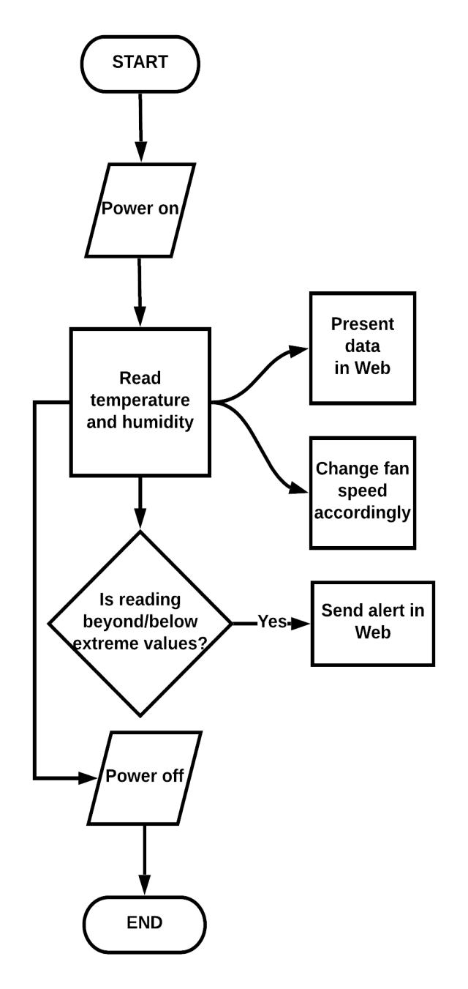***Abstract*— In this paper, a temperature and humidity monitoring** II. FLOWCHART **system is presented. The system aims to aid warehouse managers in monitoring the environment in their facilities. It alerts the user whenever in a certain time, a particular reading exceeds or falls below an set extreme value via web. After the device receives that warning, a nearby thermal modifying device’s output (e.g. fan) will then be modified accordingly to the temperature. The client can also set the minimum and maximum values for both temperature (°C) and humidity (%). The web application continually receives data readings from the device with real time display for all data. In order to measure the air environment, DHT22 sensor is attached to an intermediary device (Arduino Nano) which is then connected to the main controller (Arduino Uno Rev3) and a wireless connection module is added (ESP8266).**

# INTRODUCTION

Warehouses contain stocks that needs to be stored and preserved at a specific temperature. When kept in storage inappropriately, these goods become damaged and will lead to additional expenses. Depending on what is being stored, it is important to maintain and monitor the temperature and humidity of a warehouse to preserve goods much longer and keep them as fresh as possible. Similarly, Data Centers across the globe are utilized for the storage and support of countless amounts of sensitive data. In order to fulfill client demands, servers must be constantly kept online. This equipment creates a significant amount of heat, however, which can have an adverse effect on its functionality if left unchecked. Therefore, data center operators must maintain the optimum server room temperature to ensure these systems are in top working order while keeping an eye on energy consumption.

This project is used to aid operators to keep track of the warehouse’s and data center’s temperature. Through a humidity sensor, the system records the temperature levels of the room. When a server room becomes too hot, equipment can easily overheat, causing the data being stored or supported by the system to be lost. This could cause a huge disaster for an organization that counts on this information to perform business functions and capabilities. Through the system, operators can monitor the current temperature of the room and set constraints and display warnings if a certain constraint has been violated and employ cooling systems to cool the room and prevent equipment from overheating as well as prevent

warehouse products to be spoiled. Figure 1. Flowchart of System III. PROTOTYPE

## REFERENCES

 Random Nerd Tutorials eBook.

(n.d.). Retrieved from https://randomnerdtutorials.com

Figure 2. Prototype

IV. BLOCK DIAGRAM

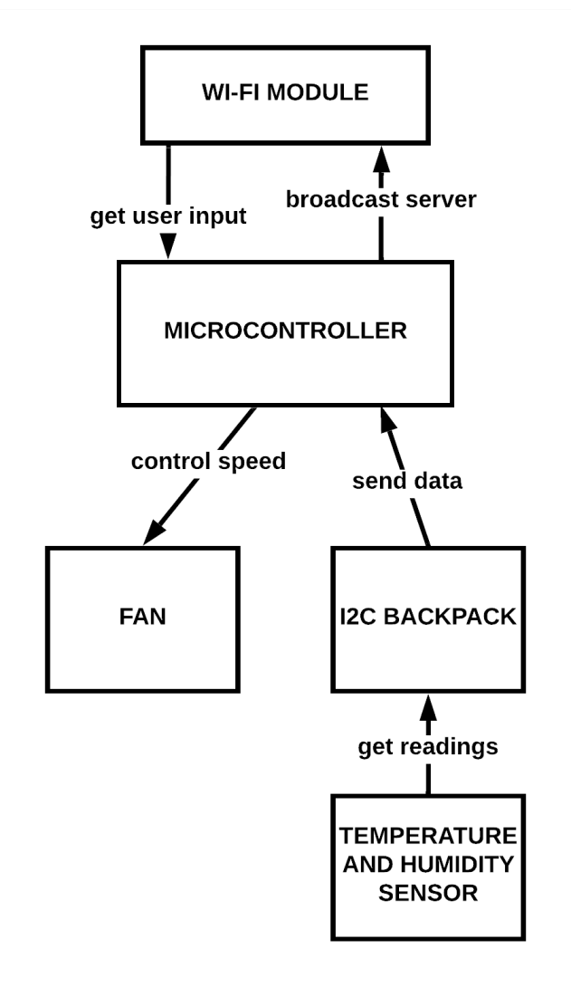

Figure 3. System Block Diagram