Task
Implement the "Shop" web application as a Maven project.

1. The first screen should contain a field for entering a name, a checkbox “I agree with the terms of service”, which the user must check to enter the application (if the checkbox is not checked, the user should be redirected to an error page) and the “Enter” button, allowing you to go to the second screen.

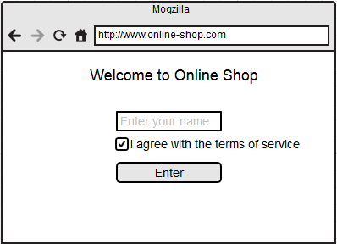
2. The second screen should contain a welcome page, a shop menu in the form of a list (<select>), as well as the “Add Item” and “Submit” buttons. The process of placing an order is divided into several stages. The user can only add one item to the order at a time using the "Add Item" button. The user should see a list of already ordered items. The user can add the same product to the order several times. When the order is ready, click the "Submit" button. In this case, it will be directed to the third screen.

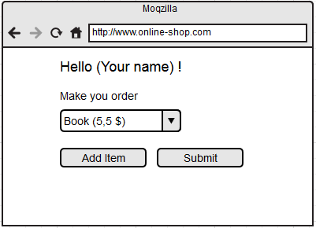
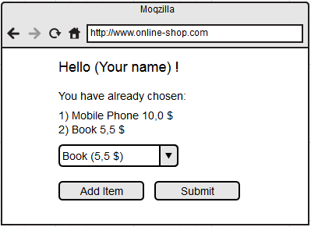

3. The third screen should contain a check printout in tabular form, that is, a list of selected products with prices, as well as the total amount of the order in dollars.

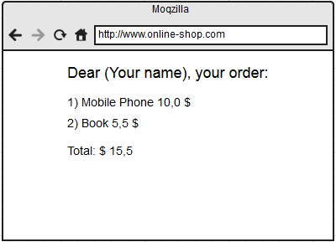

4. A random user (who did not check the checkbox on the home page) should not have access to the application. It should be redirected to an error page.

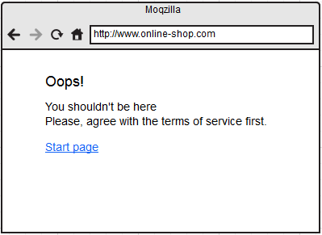

The application must be launched with a single mvn command. Write the command in the description of the pull request.

