**Landing Layer**

drop table if exists landing.lnd_Customers;

drop table if exists landing.[lnd_Order Details];

drop table if exists landing.lnd_categories;

drop table if exists landing.lnd_Suppliers;

drop table if exists landing.lnd_Employees;

drop table if exists landing.lnd_Products;

drop table if exists landing.lnd_Orders;

drop table if exists landing.lnd_Shippers;

select * into landing.lnd_Customers from dbo.Customers;

alter table landing.lnd_Customers add ModifiedDate datetime, SourceTable varchar(30);

update landing.lnd_Customers set ModifiedDate = CURRENT_TIMESTAMP,SourceTable='Customers';

select * into landing.[lnd_Order Details] from dbo.[Order Details];

alter table landing.[lnd_Order Details] add ModifiedDate datetime,SourceTable varchar(30);

update landing.[lnd_Order Details] set ModifiedDate = CURRENT_TIMESTAMP,SourceTable='Order Details';

select * into landing.lnd_categories from dbo.Categories;

alter table landing.lnd_categories add ModifiedDate datetime, SourceTable varchar(30);

update landing.lnd_categories set ModifiedDate = CURRENT_TIMESTAMP,SourceTable='categories';

select * into landing.lnd_Suppliers from dbo.Suppliers;

alter table landing.lnd_Suppliers add ModifiedDate datetime, SourceTable varchar(50);

update landing.lnd_Suppliers set ModifiedDate = CURRENT_TIMESTAMP,SourceTable='Suppliers';

select * into landing.lnd_Employees from dbo.Employees;

alter table landing.lnd_Employees add ModifiedDate datetime,SourceTable varchar(30);

update landing.lnd_Employees set ModifiedDate = CURRENT_TIMESTAMP,SourceTable='Employees';

select * into landing.lnd_Products from dbo.Products;

alter table landing.lnd_Products add ModifiedDate datetime, SourceTable varchar(max);

update landing.lnd_Products set ModifiedDate = CURRENT_TIMESTAMP,SourceTable='Products';

select * into landing.lnd_Orders from dbo.Orders;

alter table landing.lnd_Orders add ModifiedDate datetime, SourceTable varchar(50);

update landing.lnd_Orders set ModifiedDate = CURRENT_TIMESTAMP,SourceTable='Orders';

select * into landing.lnd_Shippers from dbo.Shippers;

alter table landing.lnd_Shippers add ModifiedDate datetime,SourceTable varchar(30);

update landing.lnd_Shippers set ModifiedDate = CURRENT_TIMESTAMP,SourceTable='Shippers';

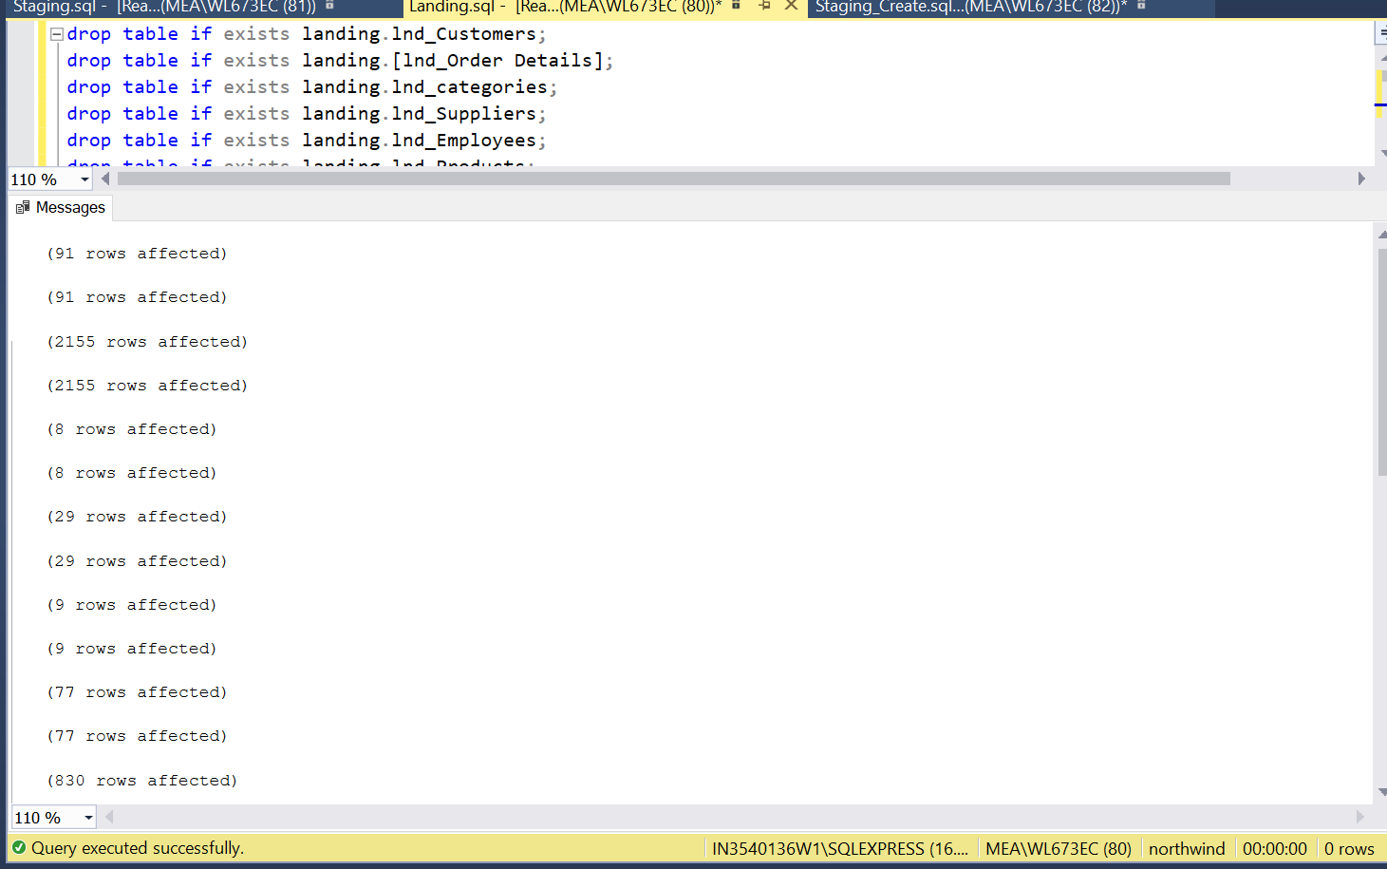

**Staging Layer**

drop table if exists staging.stg_Customers;

drop table if exists staging.[stg_Order Details];

drop table if exists staging.stg_categories;

drop table if exists staging.stg_Suppliers;

drop table if exists staging.stg_Employees;

drop table if exists staging.stg_Products;

drop table if exists staging.stg_Orders;

drop table if exists staging.stg_Shippers;

select * into staging.stg_Suppliers from landing.lnd_Suppliers where 1=2;

alter table staging.stg_Suppliers drop column [Fax],[HomePage];

select * into staging.stg_Orders from landing.lnd_Orders where 1=2;

select * into staging.stg_Customers from landing.lnd_Customers where 1=2;

alter table staging.stg_Customers drop column Fax;

select * into staging.[stg_Order Details] from landing.[lnd_Order Details] where 1=2;

select * into staging.stg_categories from landing.lnd_Categories where 1=2;

alter table staging.stg_categories drop column Picture;

select * into staging.stg_Employees from landing.lnd_Employees where 1=2;

alter table staging.stg_Employees drop column [Title],[TitleOfCourtesy],[Address],[City],[PostalCode],[HomePhone],[Extension],[Photo],[Notes],[ReportsTo],[PhotoPath];

select * into staging.stg_Products from landing.lnd_Products where 1=2;

alter table staging.stg_Products drop column [SupplierID],[CategoryID],[QuantityPerUnit],[UnitsInStock],[UnitsOnOrder],[ReorderLevel];

select * into staging.stg_Shippers from landing.lnd_Shippers where 1=2;

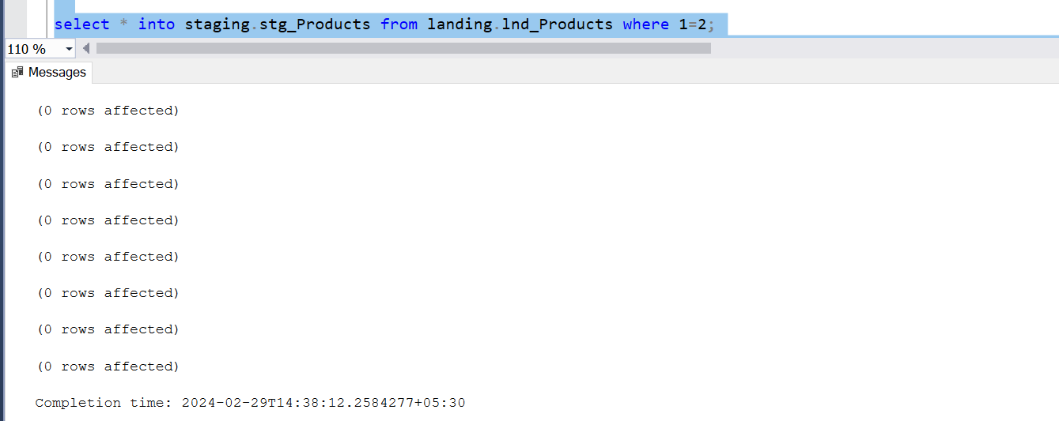

merge staging.stg_Suppliers as tab1

using landing.lnd_Suppliers as tab2 on tab1.SupplierID = tab2.SupplierID

when not matched

then insert(CompanyName,ContactName,ContactTitle,Address,City,Region,PostalCode,Country,Phone,ModifiedDate,SourceTable)

values(tab2.CompanyName, tab2.ContactName, tab2.ContactTitle, tab2.Address, tab2.City, tab2.Region, tab2.PostalCode,

tab2.Country, tab2.Phone, current_timestamp, 'lnd_Suppliers')

when not matched by source

then delete

when matched and

tab1.CompanyName != tab2.CompanyName or

tab1.ContactName != tab2.ContactName or

tab1.ContactTitle != tab2.ContactTitle or

tab1.Address != tab2.Address or

tab1.City != tab2.City or

tab1.Region != tab2.Region or

tab1.PostalCode != tab2.PostalCode or

tab1.Country != tab2.Country or

tab1.Phone != tab2.Phone

then update

set

tab1.CompanyName = tab2.CompanyName,

tab1.ContactName = tab2.ContactName,

tab1.ContactTitle = tab2.ContactTitle,

tab1.Address = tab2.Address,

tab1.City = tab2.City,

tab1.Region = tab2.Region,

tab1.PostalCode = tab2.PostalCode,

tab1.Country = tab2.Country,

tab1.Phone = tab2.Phone,

tab1.ModifiedDate = current_timestamp;

set identity_insert staging.stg_Orders on;

merge staging.stg_Orders as tab1

using landing.lnd_Orders as tab2 on tab1.OrderID = tab2.OrderID

when not matched

then insert(OrderID,CustomerID,EmployeeID,OrderDate,RequiredDate,ShippedDate,ShipVia,Freight,ShipName,ShipAddress,ShipCity,ShipRegion,

ShipPostalCode,ShipCountry,ModifiedDate,SourceTable)

values(tab2.OrderID,tab2.CustomerID,tab2.EmployeeID,tab2.OrderDate,tab2.RequiredDate,tab2.ShippedDate,tab2.ShipVia,tab2.Freight,tab2.ShipName,

tab2.ShipAddress,tab2.ShipCity,tab2.ShipRegion,tab2.ShipPostalCode,tab2.ShipCountry,CURRENT_TIMESTAMP,'lnd_Orders')

when not matched by source

then delete

when matched and

tab1.CustomerID!=tab2.CustomerID or

tab1.EmployeeID!=tab2.EmployeeID or

tab1.OrderDate!=tab2.OrderDate or

tab1.RequiredDate!=tab2.RequiredDate or

tab1.ShippedDate!=tab2.ShippedDate or

tab1.ShipVia!=tab2.ShipVia or

tab1.Freight!=tab2.Freight or

tab1.ShipName!=tab2.ShipName or

tab1.ShipAddress!=tab2.ShipAddress or

tab1.ShipCity!=tab2.ShipCity or

tab1.ShipRegion!=tab2.ShipRegion or

tab1.ShipPostalCode!=tab2.ShipPostalCode or

tab1.ShipCountry!=tab2.ShipCountry

then update

set

tab1.CustomerID=tab2.CustomerID,

tab1.EmployeeID=tab2.EmployeeID,

tab1.OrderDate=tab2.OrderDate,

tab1.RequiredDate=tab2.RequiredDate,

tab1.ShippedDate=tab2.ShippedDate,

tab1.ShipVia=tab2.ShipVia,

tab1.Freight=tab2.Freight,

tab1.ShipName=tab2.ShipName,

tab1.ShipAddress=tab2.ShipAddress,

tab1.ShipCity=tab2.ShipCity,

tab1.ShipRegion=tab2.ShipRegion,

tab1.ShipPostalCode=tab2.ShipPostalCode,

tab1.ShipCountry=tab2.ShipCountry,

tab1.ModifiedDate = CURRENT_TIMESTAMP;

merge staging.stg_Customers as tab1

using landing.lnd_Customers as tab2

on tab1.CustomerID=tab2.CustomerID

when not matched then

insert (CustomerID,CompanyName,ContactName,ContactTitle,Address,City,Region,PostalCode,Country,Phone,ModifiedDate,SourceTable)

values (tab2.CustomerID,tab2.CompanyName,tab2.ContactName,tab2.ContactTitle,tab2.Address,tab2.City,tab2.Region,tab2.PostalCode,tab2.Country,tab2.Phone,current_timestamp,'lnd_Customers')

when not matched by source

then delete

when matched and

(tab1.CustomerID != tab2.CustomerID or

tab1.CompanyName != tab2.CompanyName or

tab1.ContactName != tab2.ContactName or

tab1.ContactTitle != tab2.ContactTitle or

tab1.Address != tab2.Address or

tab1.City != tab2.City or

tab1.Region != tab2.Region or

tab1.PostalCode != tab2.PostalCode or

tab1.Country != tab2.Country or

tab1.Phone != tab2.Phone)

then update set tab1.CustomerID = tab2.CustomerID ,

tab1.CompanyName = tab2.CompanyName ,

tab1.ContactName = tab2.ContactName ,

tab1.ContactTitle = tab2.ContactTitle ,

tab1.Address = tab2.Address ,

tab1.City = tab2.City ,

tab1.Region = tab2.Region ,

tab1.PostalCode = tab2.PostalCode ,

tab1.Country = tab2.Country ,

tab1.Phone = tab2.Phone ,

tab1.ModifiedDate = current_timestamp;

merge staging.[stg_Order Details] as tab1

using landing.[lnd_Order Details] as tab2

on tab1.orderid=tab2.orderid and tab1.productID=tab2.productID

when not matched then

insert (orderid,productid,unitprice,quantity,discount,ModifiedDate,SourceTable)

values (tab2.orderid,tab2.productid,tab2.unitprice,tab2.quantity,tab2.discount,current_timestamp,'lnd_Order Details')

when not matched by source

then delete

when matched and

tab1.orderid != tab2.orderid or

tab1.productid!= tab2.productid or

tab1.unitprice!=tab2.unitprice or

tab1.quantity!=tab2.quantity or

tab1.discount!=tab2.discount

then update set

tab1.orderid = tab2.orderid ,

tab1.productid = tab2.productid ,

tab1.unitprice=tab2.unitprice ,

tab1.quantity=tab2.quantity ,

tab1.discount=tab2.discount,

tab1.modifieddate=current_timestamp;

set identity_insert staging.stg_Orders off;

set identity_insert staging.stg_categories on;

merge staging.stg_categories as tab1

using landing.lnd_Categories as tab2

on (tab1.CategoryID=tab2.CategoryID)

when not matched then

insert (CategoryID,CategoryName,Description,ModifiedDate,SourceTable)

values (tab2.CategoryID,tab2.CategoryName,tab2.Description,current_timestamp,'lnd_Categories')

when not matched by source

then delete

when matched and

(tab1.CategoryName != tab2.CategoryName or

convert(nvarchar(max),tab1.Description) <> convert(nvarchar(max),tab2.Description))

then update set

tab1.CategoryName = tab2.CategoryName ,

tab1.Description = tab2.Description ,

tab1.ModifiedDate=current_timestamp;

set identity_insert staging.stg_Categories off;

set identity_insert staging.stg_employees on;

merge staging.stg_Employees as tab1

using landing.lnd_Employees as tab2

on tab1.EmployeeID=tab2.EmployeeID

when not matched then

insert (EmployeeID,LastName,Firstname,BirthDate,HireDate,Region,Country,ModifiedDate,SourceTable)

values (tab2.EmployeeID,tab2.LastName,tab2.Firstname,tab2.BirthDate,

tab2.HireDate,Region,tab2.Country,current_timestamp,'lnd_Employees')

when not matched by source

then delete

when matched and

tab1.LastName != tab2.LastName or

tab1.Firstname != tab2.Firstname or

tab1.BirthDate != tab2.BirthDate or

tab1.HireDate != tab2.HireDate or

tab1.Region != tab2.Region or

tab1.Country != tab2.Country

then update set

tab1.LastName = tab2.LastName ,

tab1.Firstname = tab2.Firstname ,

tab1.BirthDate = tab2.BirthDate ,

tab1.HireDate = tab2.HireDate ,

tab1.Region = tab2.Region ,

tab1.Country = tab2.Country ,

tab1.Modifieddate=current_timestamp;

set identity_insert staging.stg_employees off;

set identity_insert staging.stg_Products on;

merge staging.stg_Products as tab1

using landing.lnd_Products as tab2

on tab1.ProductID=tab2.ProductID

when not matched then

insert (ProductID,ProductName,UnitPrice, Discontinued, ModifiedDate, SourceTable)

values (tab2.ProductID, tab2.ProductName, tab2.UnitPrice, tab2.Discontinued,current_timestamp,'lnd_Products')

when not matched by source

then delete

when matched and

tab1.ProductName != tab2.ProductName or

tab1.UnitPrice != tab2.UnitPrice or

tab1.Discontinued != tab2.Discontinued

then update set tab1.ProductName = tab2.ProductName ,

tab1.UnitPrice = tab2.UnitPrice ,

tab1.Discontinued = tab2.Discontinued,

tab1.ModifiedDate = current_timestamp;

set identity_insert staging.stg_Products off;

set identity_insert staging.stg_Shippers on;

merge staging.stg_Shippers as tab1

using landing.lnd_Shippers as tab2

on tab1.shipperid=tab2.shipperid

when not matched then

insert (shipperid,companyname,phone,ModifiedDate,SourceTable)

values (tab2.shipperid,tab2.companyname,tab2.phone,current_timestamp,'lnd_Shippers')

when not matched by source

then delete

when matched and

tab1.shipperid !=tab2.shipperid or

tab1.companyname!=tab2.companyname or

tab1.phone!=tab2.phone

then update set

tab1.companyname=tab2.companyname ,

tab1.phone=tab2.phone,

tab1.modifieddate=current_timestamp;

set identity_insert staging.stg_Shippers off;

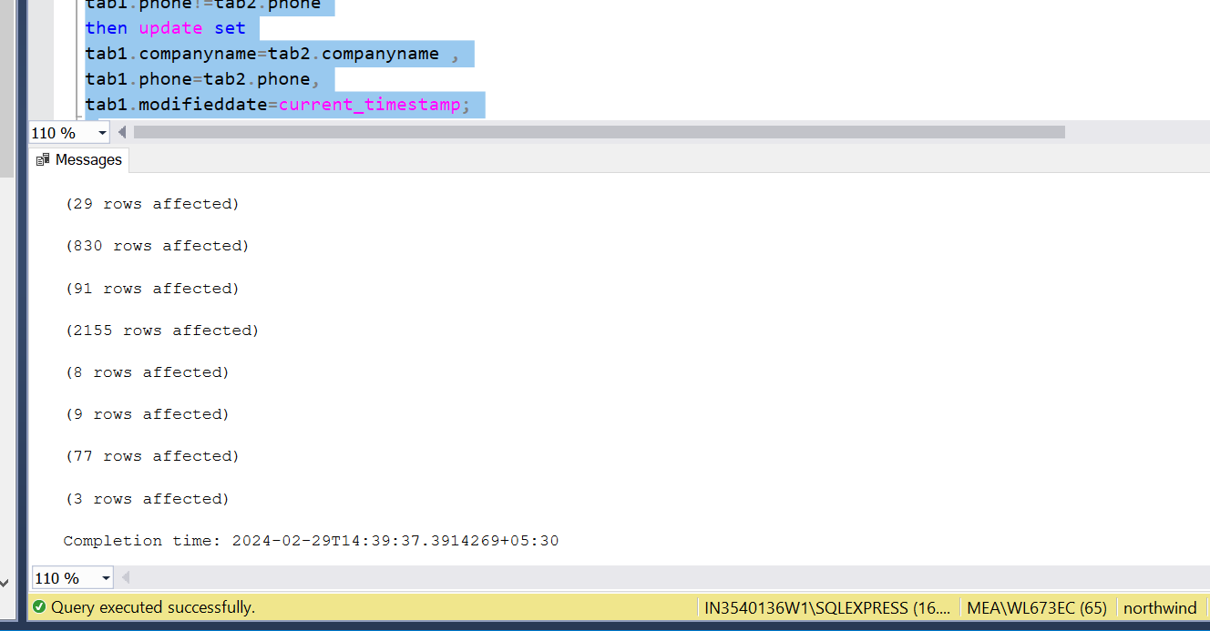

**Dimension Tables**

drop table if exists DW.Customers_Dim

DROP TABLE IF EXISTS DW.Employees_Dim

DROP TABLE IF EXISTS DW.Suppliers_Dim

drop table if exists DW.Categories_Dim

drop table if exists DW.Products_Dim

CREATE TABLE DW.Customers_Dim(

CustomerKey int identity(1,1) primary key,

[CustomerID] [varchar](10) NOT NULL,

[CompanyName] [nvarchar](50) NOT NULL,

[ContactName] [nvarchar](50) NULL,

[ContactTitle] [nvarchar](50) NULL,

[Address] [nvarchar](60) NULL,

[City] [nvarchar](20) NULL,

[Region] [nvarchar](20) NULL,

[PostalCode] [nvarchar](20) NULL,

[Country] [nvarchar](20) NULL,

[Phone] [nvarchar](20) NULL,

[StartDate] [datetime] NULL,

[EndDate] [datetime] NULL);

CREATE TABLE DW.Employees_Dim (

"EmployeeKey" "int" identity(1,1) primary key,

"EmployeeID" "int" NOT NULL,

"LastName" nvarchar (max) NOT NULL,

"FirstName" nvarchar (max) NOT NULL,

"BirthDate" "datetime" NULL,

"HireDate" "datetime" NULL,

"Region" nvarchar (max) NULL,

"Country" nvarchar (max) NULL,

"StartDate" "datetime" NULL,

"EndDate" "datetime" NULL

);

CREATE TABLE DW.Suppliers_Dim(

SupplierKey int IDENTITY(1,1) primary key,

"SupplierID" "int" NOT NULL ,

"CompanyName" nvarchar (max) NOT NULL ,

"ContactName" nvarchar (max) NULL ,

"ContactTitle" nvarchar (max) NULL ,

"Address" nvarchar (max) NULL ,

"City" nvarchar (max) NULL ,

"Region" nvarchar (max) NULL ,

"PostalCode" nvarchar (max) NULL ,

"Country" nvarchar (max) NULL ,

"Phone" nvarchar (max) NULL,

"StartDate" [datetime] NULL,

"EndDate" [datetime] NULL

);

CREATE TABLE DW.Categories_Dim(

CategoriesKey int identity(1,1),

"CategoryID" "int" NOT NULL ,

"CategoryName" nvarchar (15) NOT NULL ,

"Description" nvarchar (max) NULL,

StartDate datetime NULL,

EndDate datetime NULL);

CREATE TABLE DW.Products_Dim(

"ProductKey" int identity(1,1) primary key,

"ProductID" "int" NOT NULL ,

"ProductName" nvarchar (40) NOT NULL ,

"UnitPrice" nvarchar (max) NULL ,

"Discontinued" "int" NOT NULL,

"StartDate" [datetime] NULL,

"EndDate" [datetime] NULL

);

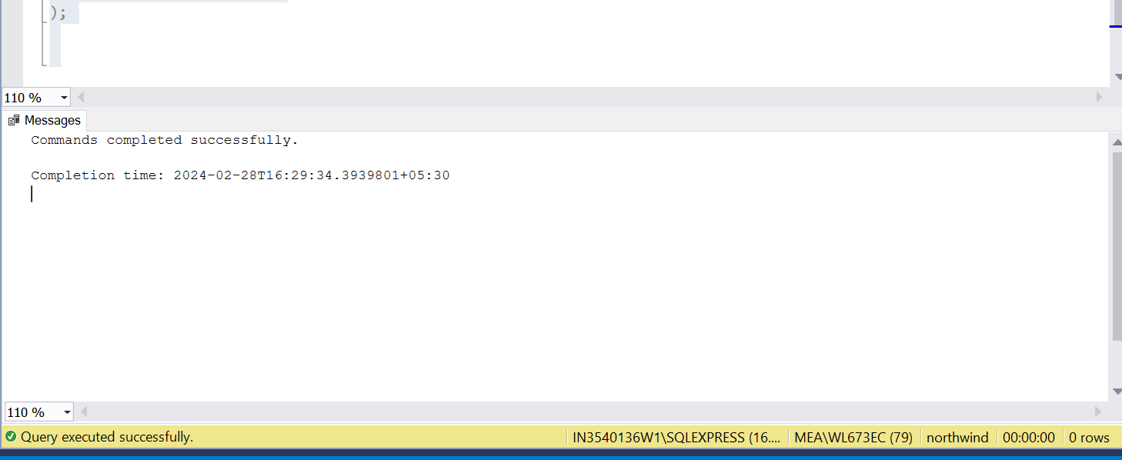

insert into DW.Customers_Dim(CustomerID,CompanyName,ContactName,ContactTitle,Address,City,Region,PostalCode,Country,Phone,StartDate,EndDate)

select CustomerID,CompanyName,ContactName,ContactTitle,Address,City,Region,PostalCode,Country,Phone,CURRENT_TIMESTAMP,NULL from (

merge DW.Customers_Dim as tab1

using staging.stg_customers as tab2

on tab1.CustomerID=tab2.CustomerID

when not matched then

insert (CustomerID,CompanyName,ContactName,ContactTitle,Address,City,Region,PostalCode,Country,Phone,StartDate)

values (tab2.CustomerID,tab2.CompanyName,tab2.ContactName,tab2.ContactTitle,tab2.Address,tab2.City,tab2.Region,tab2.PostalCode,

tab2.Country,tab2.Phone,Current_Timestamp)

when matched and

tab1.Enddate is NULL and

(tab1.CustomerID != tab2.CustomerID or

tab1.CompanyName != tab2.CompanyName or

tab1.ContactName != tab2.ContactName or

tab1.ContactTitle != tab2.ContactTitle or

tab1.Address != tab2.Address or

tab1.City != tab2.City or

tab1.Region != tab2.Region or

tab1.PostalCode != tab2.PostalCode or

tab1.Country != tab2.Country or

tab1.Phone != tab2.Phone )

then

update set tab1.EndDate=Current_Timestamp

output tab2.CustomerID,tab2.CompanyName,tab2.ContactName,tab2.ContactTitle,tab2.Address,tab2.City,tab2.Region,tab2.PostalCode,

tab2.Country,tab2.Phone,

$action as MergeAction) as MRG

where MRG.MergeAction = 'UPDATE';

insert into DW.Categories_Dim (CategoryID,CategoryName,Description,StartDate,EndDate)

select CategoryID,CategoryName,Description,CURRENT_TIMESTAMP,NULL from (

merge DW.Categories_Dim as tab1

using staging.stg_Categories as tab2

on tab1.CategoryID=tab2.CategoryID

when not matched then

insert (CategoryID,CategoryName,Description,StartDate)

values (tab2.CategoryID,tab2.CategoryName,tab2.Description,current_timestamp)

when matched and

tab1.Enddate is NULL and

(tab1.CategoryName != tab2.CategoryName or

convert(nvarchar(max),tab1.Description) <>convert(nvarchar(max),tab2.Description) )

then update set tab1.EndDate=Current_Timestamp

output tab2.CategoryID,tab2.CategoryName,tab2.Description,

$action as MergeAction) as MRG

where MRG.MergeAction = 'UPDATE';

insert into DW.Suppliers_Dim(SupplierID, CompanyName,ContactName,ContactTitle, Address, City, Region, PostalCode,

Country,Phone,StartDate, EndDate)

select SupplierID, CompanyName, ContactName, ContactTitle, Address, City, Region,PostalCode, Country,

Phone, CURRENT_TIMESTAMP, NULL from(

merge into DW.Suppliers_Dim as tab1

using staging.stg_Suppliers as tab2 on tab1.SupplierID=tab2.SupplierID

when not matched then

insert(SupplierID,CompanyName,ContactName,ContactTitle,Address,City,Region,PostalCode,Country,Phone,StartDate)

values(tab2.SupplierID,tab2.CompanyName,tab2.ContactName,tab2.ContactTitle, tab2.Address, tab2.City,tab2.Region,

tab2.PostalCode,tab2.Country,tab2.Phone,CURRENT_TIMESTAMP)

when matched and

tab1.Enddate is NULL and

(tab1.SupplierID != tab2.SupplierID or

tab1.CompanyName != tab2.CompanyName or

tab1.ContactName != tab2.ContactName or

tab1.ContactTitle != tab2.ContactTitle or

tab1.Address != tab2.Address or

tab1.City != tab2.City or

tab1.Region != tab2.Region or

tab1.PostalCode != tab2.PostalCode or

tab1.Country != tab2.Country or

tab1.Phone != tab2.Phone)

then

update set EndDate = CURRENT_TIMESTAMP

output tab2.SupplierID,tab2.CompanyName,tab2.ContactName,tab2.ContactTitle,tab2.Address,tab2.City,tab2.Region,tab2.PostalCode,

tab2.Country,tab2.Phone,

$action as MergeAction) as MRG

where MRG.MergeAction = 'UPDATE';

insert into DW.Employees_Dim(EmployeeID,LastName,FirstName,BirthDate,HireDate,Region,Country,StartDate,EndDate)

select EmployeeID,LastName,FirstName,BirthDate,HireDate,Region,Country, CURRENT_TIMESTAMP, NULL from(

merge into DW.Employees_Dim as tab1

using staging.stg_Employees as tab2 on tab1.EmployeeID=tab2.EmployeeID

when not matched then

insert(EmployeeID,LastName,FirstName,BirthDate,HireDate,Region,Country,StartDate)

values(tab2.EmployeeID,tab2.LastName,tab2.FirstName,tab2.BirthDate, tab2.HireDate, tab2.Region,tab2.Country,

CURRENT_TIMESTAMP)

when matched and

tab1.Enddate is NULL and

(tab1.EmployeeID != tab2.EmployeeID or

tab1.LastName != tab2.LastName or

tab1.FirstName != tab2.FirstName or

tab1.BirthDate != tab2.BirthDate or

tab1.HireDate != tab2.HireDate or

tab1.Region != tab2.Region or

tab1.Country != tab2.Country)

then

update set EndDate = CURRENT_TIMESTAMP

output tab2.EmployeeID,tab2.LastName,tab2.FirstName,tab2.BirthDate,tab2.HireDate,tab2.Region,tab2.Country,

$action as MergeAction) as MRG

where MRG.MergeAction = 'UPDATE';

insert into DW.Products_Dim(ProductID,ProductName,UnitPrice,Discontinued,StartDate,EndDate)

select ProductID,ProductName,UnitPrice,Discontinued,CURRENT_TIMESTAMP,NULL from (

merge DW.Products_Dim as tab1

using staging.stg_Products as tab2

on tab1.ProductID=tab2.ProductID

when not matched then

insert (ProductID,ProductName,UnitPrice,Discontinued,StartDate)

values (tab2.ProductID,tab2.ProductName,tab2.UnitPrice,tab2.Discontinued,Current_Timestamp)

when matched and

tab1.Enddate is NULL and

(tab1.ProductID != tab2.ProductID or

tab1.ProductName != tab2.ProductName or

tab1.UnitPrice != tab2.UnitPrice or

tab1.Discontinued != tab2.Discontinued )

then

update set tab1.EndDate=Current_Timestamp

output tab2.ProductID,tab2.ProductName,tab2.UnitPrice,tab2.Discontinued,

$action as MergeAction) as MRG

where MRG.MergeAction = 'UPDATE';

DROP TABLE IF EXISTS DW.Calendar_Dim;

CREATE TABLE DW.Calendar_Dim(

CalendarKey INT NOT NULL IDENTITY(1,1),

FullDate datetime,

DAYOFWEEK char(15),

DayType char(20),

DAYOFMONTH int,

MONTH char(10),

QUARTER char(2),

YEAR int,

PRIMARY KEY (CalendarKey));

INSERT INTO DW.Calendar_Dim (FullDate, DAYOFWEEK, DayType, DAYOFMONTH, MONTH, QUARTER, YEAR)

SELECT DISTINCT(CONVERT(varchar, O.OrderDate, 23)) date, DATENAME(DW,O.OrderDate),

Choose(DATEPART(DW,O.OrderDate),'Weekend','Weekday','Weekday','Weekday', 'Weekday','Weekday','Weekend'),

DATEPART(DAY, O.OrderDate), MONTH(O.OrderDate), CONCAT('Q', DATEPART(q,O.OrderDate)), YEAR(O.OrderDate)

FROM Staging.stg_Orders O;

drop table if exists DW.CustomerEmployee_Fact;

Create table DW.CustomerEmployee_Fact(

CustomerKey INT,

EmployeeKey INT,

CalendarKey INT,

OrderID INT,

Sales money);

insert into DW.CustomerEmployee_Fact(CustomerKey, EmployeeKey, CalendarKey, OrderID,Sales)

select

ISNULL(C.CustomerKey,0),

ISNULL(E.EmployeeKey,0),

ISNULL(CD.CalendarKey, 0),

ISNULL(O.OrderId, 0),

s.ord

from staging.stg_Orders O left join DW.Customers_Dim C on O.CustomerID=C.CustomerID

left join DW.Employees_Dim E on O.EmployeeID=E.EmployeeID

left join DW.Calendar_Dim CD on O.OrderDate=CD.FullDate

left join (select OrderID,sum(UnitPrice*Quantity) as ord from staging.[stg_Order Details] group by OrderID)as s on s.OrderID=O.orderID;

drop table if exists DW.ProductInStock_fact;

create table DW.ProductInStock_Fact(

CalendarKey int,

ProductKey int,

CategoriesKey int,

SupplierKey int,

UnitinStock int,

UnitsOnOrder int,

ReorderLevel int,

TotalQuantity int,

OrderID int);

insert into DW.ProductInStock_Fact(CalendarKey,ProductKey,CategoriesKey,SupplierKey,UnitinStock,UnitsOnOrder,

ReorderLevel,TotalQuantity,OrderID)

select

ISNULL(CD.CalendarKey, 0),

ISNULL(PD.ProductKey,0),

ISNULL(C.CategoriesKey, 0),

ISNULL(S.SupplierKey, 0),

ISNULL(P.UnitsInStock, 0),

ISNULL(P.UnitsOnOrder, 0),

ISNULL(P.ReorderLevel, 0),

ISNULL(P.UnitsInStock+P.UnitsOnOrder,0),

ISNULL(O.OrderId, 0)

from

staging.stg_Orders O left join staging.[stg_Order Details] OD on O.OrderID=OD.OrderID

left join DW.Products_Dim PD on OD.ProductID=PD.ProductID

left join landing.lnd_Products P on OD.ProductID=P.ProductID

left join DW.Categories_Dim C on P.CategoryID=C.CategoryID

left join DW.Suppliers_Dim S on P.SupplierID=S.SupplierID

left join DW.Calendar_Dim CD on O.OrderDate = CD.FullDate;

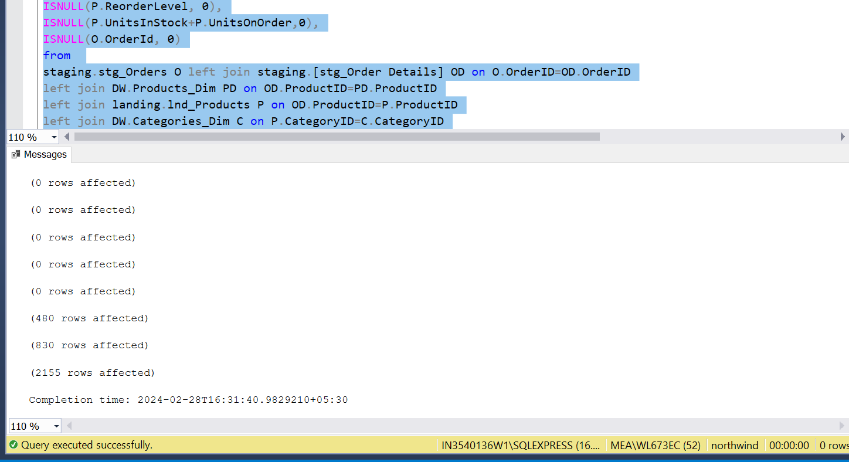

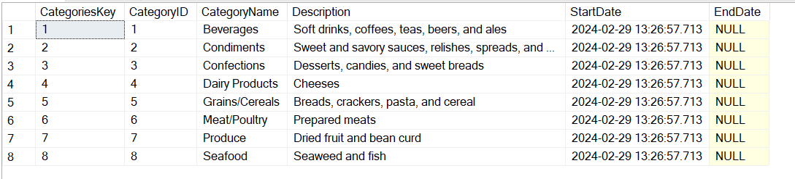

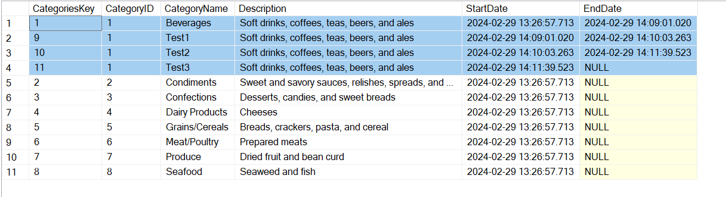

**PYTHON**

def function1():

    with open('landing.py', 'r') as file:

        exec(file.read())

def function2():

    with open('stg create.py', 'r') as file1:

        exec(file1.read())

    with open('dim create.py', 'r') as file2:

        exec(file2.read())

def function3():

    with open('staging.py', 'r') as file:

        exec(file.read())

def function4():

    with open('dim.py', 'r') as file:

        exec(file.read())

def function5():

    with open('landing.py', 'r') as file:

        exec(file.read())

    with open('staging.py', 'r') as file:

        exec(file.read())

    with open('dim.py', 'r') as file:

        exec(file.read())

def default():

    print('Invalid Input')

switcher = {

    1: function1,

    2: function2,

    3: function3,

    4: function4,

    5: function5

}

def switch(case):

    switcher.get(case, default)()

n=int(input(('\n Enter the operation:\n1.Landing\n2.Create stg and dim tables\n3.Staging\n4.Dimension\n5.OLTP to DW\n')))

switch(n)

**Landing:**

import pyodbc

conn = pyodbc.connect('DRIVER={SQL Server};'

                      'SERVER=IN3540136W1\SQLEXPRESS;'

                      'DATABASE=nw;'

                      'Trusted_Connection=yes')

cursor = conn.cursor()

with open('C:/Users/LD184YA/OneDrive - EY/Documents/SQL Server Management Studio/Landing.sql', 'r') as f:

    sql_script = f.read()

try:

    cursor.execute(sql_script)

except Exception as e:

    print(f"Error executing command: {sql_script}", e)

print('Landing Successfully')

conn.commit()

conn.close()

import pyodbc

import pandas as pd

conn = pyodbc.connect('DRIVER={SQL Server};'

                      'SERVER=XWCS50Q04\SQLEXPRESS;'

                      'DATABASE=northwind;'

                      'Trusted_Connection=yes')

cursor = conn.cursor()

sqlfile = 'SELECT * FROM landing.lnd_categories'

df = pd.read_sql_query(sqlfile, conn)

print(df)

conn.close()

**Staging:**

import pyodbc

conn = pyodbc.connect('DRIVER={SQL Server};'

                      'SERVER=XWCS50Q04\SQLEXPRESS;'

                      'DATABASE=nw;'

                      'Trusted_Connection=yes')

cursor = conn.cursor()

with open('C:/Users/LD184YA/OneDrive - EY/Documents/SQL Server Management Studio/Staging_Create.sql', 'r') as f:

    sqlstg = f.read()

try:

    cursor.execute(sqlstg)

except Exception as e:

    print("Error executing SQL command:", sqlstg)

    print("Error message:", e)

print("Staging tables created Succesfully")

conn.commit()

conn.close()

import pyodbc

conn = pyodbc.connect('DRIVER={SQL Server};'

                      'SERVER=XWCS50Q04\SQLEXPRESS;'

                      'DATABASE=nw;'

                      'Trusted_Connection=yes')

cursor = conn.cursor()

with open('C:/Users/LD184YA/OneDrive - EY/Documents/SQL Server Management Studio/Staging.sql', 'r') as f:

    sqlfile = f.read()

try:

    cursor.execute(sqlfile)

except Exception as e:

    print("Error executing SQL command:", sqlfile)

    print("Error message:", e)

print("Staging Merged Succesfully")

conn.commit()

conn.close()

**Dimension:**

import pyodbc

conn = pyodbc.connect('DRIVER={SQL Server};'

                      'SERVER=XWCS50Q04\SQLEXPRESS;'

                      'DATABASE=nw;'

                      'Trusted_Connection=yes')

cursor = conn.cursor()

with open('C:/Users/LD184YA/OneDrive - EY/Documents/SQL Server Management Studio/Dim_Create.sql', 'r') as l:

    sqldim = l.read()

try:

    cursor.execute(sqldim)

except Exception as e:

    print("Error executing SQL command:", sqldim)

    print("Error message:", e)

print("Dimension tables created Succesfully")

conn.commit()

conn.close()

import pyodbc

conn = pyodbc.connect('DRIVER={SQL Server};'

                      'SERVER=XWCS50Q04\SQLEXPRESS;'

                      'DATABASE=nw;'

                      'Trusted_Connection=yes')

cursor = conn.cursor()

with open('C:/Users/LD184YA/OneDrive - EY/Documents/SQL Server Management Studio/Dim.sql', 'r') as f:

    sqlfile = f.read()

try:

    cursor.execute(sqlfile)

except Exception as e:

    print("Error executing SQL command:", sqlfile)

    print("Error message:", e)

print("Dimensions Merged Succesfully")

conn.commit()

conn.close()

**Test Operations:**

import pyodbc

import pandas as pd

def function1():

    conn = pyodbc.connect('DRIVER={SQL Server};'

                      'SERVER=XWCS50Q04\SQLEXPRESS;'

                      'DATABASE=northwind;'

                      'Trusted_Connection=yes')

    cursor = conn.cursor()

    sqlfile = 'select * from DW.Products_Dim where Discontinued=1 and EndDate is NULL;'

    df = pd.read_sql_query(sqlfile, conn)

    print(df)

    conn.close()

def function2():

    conn = pyodbc.connect('DRIVER={SQL Server};'

                      'SERVER=XWCS50Q04\SQLEXPRESS;'

                      'DATABASE=northwind;'

                      'Trusted_Connection=yes')

    cursor = conn.cursor()

    sqlfile = 'SELECT Distinct P.ProductKey,P.ProductID,P.ProductName,P.UnitPrice,PF.UnitsOnOrder,C.CategoryID from DW.Products_Dim P inner join DW.ProductInStock_fact PF on P.ProductKey=PF.ProductKey inner join DW.Categories_Dim as C on C.CategoriesKey=PF.CategoriesKey inner join (select C.CategoryID,Max(UnitsOnOrder) as BestSellingProduct from DW.Categories_Dim as C inner join DW.ProductInStock_fact as PF on C.CategoriesKey=PF.CategoriesKey Group BY C.CategoryID)as s on s.CategoryID=C.CategoryID where s.BestSellingProduct=PF.UnitsOnOrder and P.EndDate is NULL order by C.CategoryID;'

    df = pd.read_sql_query(sqlfile, conn)

    print(df)

    sqlfile1 = 'SELECT Distinct P.ProductKey,P.ProductID,P.ProductName,P.UnitPrice,PF.UnitsOnOrder,C.CategoryID from DW.Products_Dim P inner join DW.ProductInStock_fact PF on P.ProductKey=PF.ProductKey inner join DW.Categories_Dim as C on C.CategoriesKey=PF.CategoriesKey inner join (select C.CategoryID,MIN(UnitsOnOrder) as BestSellingProduct from DW.Categories_Dim as C inner join DW.ProductInStock_fact as PF on C.CategoriesKey=PF.CategoriesKey Group BY C.CategoryID)as s on s.CategoryID=C.CategoryID where s.BestSellingProduct=PF.UnitsOnOrder and P.EndDate is NULL order by C.CategoryID;'

    df1 = pd.read_sql_query(sqlfile1, conn)

    print(df1)

    conn.close()

def function3():

    conn = pyodbc.connect('DRIVER={SQL Server};'

                      'SERVER=XWCS50Q04\SQLEXPRESS;'

                      'DATABASE=northwind;'

                      'Trusted_Connection=yes')

    cursor = conn.cursor()

    sqlfile = 'select distinct C1.CustomerKey, MAX(t.sales) over(partition by C1.CustomerKey) MaxCustomerSales,MIN (t.sales) over(partition by C1.CustomerKey) MinCustomerSales,AVG(t.sales) over(partition by C1.CustomerKey) AvgCustomerSales from DW.Customers_Dim as C1 inner join (select CF.OrderID,CF.CustomerKey,Sum(Cf.Sales) as Sales from DW.Customers_Dim C inner join Dw.CustomerEmployee_Fact CF on C.CustomerKey=Cf.CustomerKey group by CF.OrderID,CF.CustomerKey) as t on C1.CustomerKey=t.CustomerKey;'

    df = pd.read_sql_query(sqlfile, conn)

    print(df)

    conn.close()

def function4():

    conn = pyodbc.connect('DRIVER={SQL Server};'

                      'SERVER=XWCS50Q04\SQLEXPRESS;'

                      'DATABASE=northwind;'

                      'Trusted_Connection=yes')

    cursor = conn.cursor()

    sqlfile = 'select * from Dw.Employees_Dim where EmployeeID=(select E.EmployeeID from DW.Employees_Dim E inner join DW.CustomerEmployee_fact CF on E.EmployeeKey=CF.EmployeeKey group by EmployeeID having sum(CF.sales) in (select max(s.su) from (Select E.EmployeeID,Sum(CF.sales)as su from DW.Employees_Dim E inner join DW.CustomerEmployee_fact CF on E.EmployeeKey=CF.EmployeeKey group by E.EmployeeID) s)) ;'

    df = pd.read_sql_query(sqlfile, conn)

    print(df)

    conn.close()

def default():

    print('Invalid Input')

switcher = {

    1: function1,

    2: function2,

    3: function3,

    4: function4

}

def switch(case):

    switcher.get(case, default)()

n=int(input(('\n Enter the operation:\n1.Discontinued_product_report\n2.Best and least selling product in each category\n3.Min max avg customer billing\n4.Best Salesperson\n')))

switch(n)