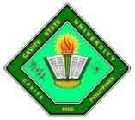
Republic of t
CvSU Vision
The premier university in historic Cavite globally recognized for excellence in character development, academics, research, innovation and sustainable community engagement.
CvSU Mission
Cavite State University shall provide excellent, equitable and relevant educational opportunities in the arts, science and technology through quality instruction and responsive research and development activities.
It shall produce professional, skilled and morally upright individuals for global competitiveness.
CAVITE STATE UNIVERSITY
Bacoor City Campus
Soldiers Hills IV, Molino VI,
City of Bacoor, Cavite
(046) 476 - 5029
www.cvsu.edu.ph

DEPARTMENT OF COMPUTER STUDIES
ITEC 95- Quantitative Methods

Name: Date:
Course and Section: Score:

GRADING RUBRICS:

CRITERIA | PERFORMANCE INDICATORS | POINTS
Data Accuracy and Clarity | Data is completely accurate, very easy to understand, and correctly represented. | 25
Effectiveness | Effectively communicates the key insights and answers the intended question. | 25
Right Chart Type | Chart type is highly appropriate. | 20
Visual Design | Visually appealing and well-organized. | 30
Total |  | 100

Construct an data visual for the tabulated data below.
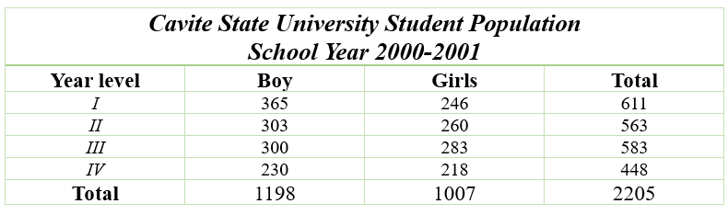

Screenshot of Output:

