Conceptual Framework
The Conceptual Framework of The Study Used the Input-Process-Output Model for
Developing the DEVELOPMENT OF A WEB-BASED DOCUMENT MANAGEMENT SYSTEM FOR CAVITE STATE UNIVERSITY-BACOOR CAMPUS EXTENSION SERVICES


- Minimum RAM: 8GB
- Minimum CPU: Intel Core I5 6th Generation
v
- Windows 10 22H2
- Python 3.13
- Git 2.37.0
- HTML5
- CSS 4.15
- Pycharm 2024.3
- Project and System Development
- Data Security and Privacy
- Data Storage and Archietecture
Hardware Requirements
Process
- Database Programming
- System Coding
- Functionality Test
- Efficiency Test

Development and Testing
- Database Design
- User Interface Design

Software Design
- Advance investigation of the study
Requirements Analysis

Knowledge Requirements

Software Requirements

DEVELOPMENT OF A WEB-BASED DOCUMENT MANAGEMENT SYSTEM FOR CAVITE STATE UNIVERSITY-BACOOR CAMPUS EXTENSION SERVICES

Input

Process

Output

Evaluation
Evaluate based on the ISO 2510

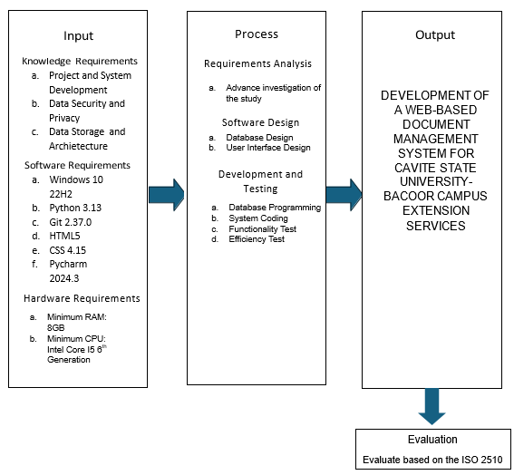

Figure 1. Conceptual framework of the study
The above figure shows the Conceptual Framework and how the system was developed. The Input Stage consists of the Hardware Requirements, Software Requirements, Knowledge Requirements. The system's Hardware Requirements must have a minimum of 8GB RAM with Intel core i5 6th Generation. For the software requirements of the system, Windows 10 must be used to support essential development tools such as MySQL, Python, and Pycharm to create the Web-Based Document System for Extension Services. The knowledge requirement for the system must have a good understanding of web development, database design, and system testing.
The front end of the system is developed using html and css. This development tool makes creating a user friendly interface possible. On the other hand, the back end of the system will be developed using python and My sqlite. Python and db sqlite3 is an open-source web application framework that aims to create conventions for common tasks, such as authentication, routing, and database interactions.
The system's database was developed using MySQL, an open-source relational database management system widely used for web applications and other database-driven software.
Hardware and Software requirements are also considered, as they can organize the System's UI components and codes using the above software services. For the Process Stage, the process has requirements where the researchers need to investigate in advance so they can study the problem and collect all the data. Design is the one that will show the layout design of the system, process the flow, and document how.

Objective of the study
The general objective of the study was to design and develop a Web-Based Document Management System for Cavite State University – Bacoor Campus Extension Services, promoting and it is easier to submit documents and other papers.
Specifically, aimed to:
- Design a website using a methodology that will:
  - provides intuitive navigation and easy access to the key features and functionalities;
  - Improve the interface that allows the coordinator and the facilitator to easily access and manage submissions;
  - Enable real – time updates to documents as they are being forwarded;
  - Implement features that record the time in and time out to each department and extension coordinator of the event;
- develop the system using the following:
  - HTML5 and CSS 4.15 for the front end of the system;
  - Python 3.13 for the back end of the system;
  - Pycharm 2024.3 for a programming language; and
- test the system in terms of system testing;
- evaluate the system using the adapted ISO 25010 evaluation instrument; and
- prepare an implementation plan.

REVIEW OF RELATED LITERATURE
This chapter researcher gathered local and foreign related literature and studies to provide a background for the present research. It gives the researcher a brief knowledge of the concept of the study.

Design and Implementation of a Web-based Document Management System
Addresses the challenges of document management in organizations, particularly in educational institutions in Nigeria, where traditional paper-based systems are still prevalent. The authors propose a web-based document management system (WBEDMS) designed to be user-friendly, secure, and efficient, offering features such as document capture, storage, retrieval, version control, and workflow management. The system was developed using Object-Oriented Hypermedia Design Methodology (OOHDM) and implemented using NetBeans, HTML, CSS, JavaScript, PHP, and MySQL. The evaluation results indicate that the WBEDMS achieved a high level of success, with a 95% accuracy rating, a 99.20% usability rating, and a 97% overall quality rating. The paper concludes that the developed WBEDMS is a valuable tool for organizations in Nigeria, particularly in the education sector(Samuel L. Alade 2023).

Web Service for Document Management of University Degree Projects
Addresses the challenges of managing and exchanging documents related to university degree projects. They propose a web service solution that facilitates the storage, exchange, classification, and search of files generated during the graduation process. The service is built using a REST API architecture with Django (Python) for the backend and Vuejs (Javascript) for the frontend. The paper details the development process using the XP (Extreme Programming) methodology, outlining the planning, design, coding, testing, and release phases. The authors present the results, including functional and non-functional requirements, modules, use cases, entity relationship model, and performance tests. They conclude that the web service effectively addresses the challenges of managing degree project documents and highlights its potential for both administrative and didactic use. The paper suggests future work to enhance the service's functionality, such as implementing file previews, notification alerts, and a shared files module (Sarmiento, et. al, 2022).

Development and Implementation of Document Management System for Ilocos Sur Polytechnic State College, Tagudin Campus
Addresses the challenges faced by ISPSC in managing paper-based documents as it prepares to become a university with additional campuses and a larger student and staff population. The researchers developed and implemented a web-based DMS at ISPSC, Tagudin Campus, designed to capture, store, organize, retrieve, and manage documents and files in a centralized digital environment. They conducted a user-satisfaction survey using the Website Analysis and Measurement Inventory (WAMMI) questionnaire, finding that respondents were generally very satisfied with the DMS's ability to arrange, store, track, and manage paper files within the campus. The study highlights the successful implementation of a digital solution to address the challenges of managing paper-based documents in educational institutions, demonstrating the potential for similar systems to improve efficiency and effectiveness (Angala, et. al, 2023).

Comprehensive Full Stack Document Management System
Addresses the challenges faced of document system, the system aims to provide organizations with a user-friendly platform for efficient document creation, storage, retrieval, and collaboration. The front-end is built using HTML, CSS, and JavaScript for a responsive and intuitive interface, while the back-end utilizes PHP for server-side scripting and seamless communication with the MySQL database. The system prioritizes security by implementing secure coding practices and a robust database schema for efficient document storage and organization. The paper outlines an Agile methodology for development, including project initiation, planning, design, development, testing, deployment, and maintenance phases. The architecture of the system is based on a three-tier client/server model, separating the user interface, business logic, and database management for scalability and security (Kumar, et. al, 2024).

WEB-BASED DOCUMENT MANAGEMENT AND TRACKING SYSTEM

Web-based document management system developed to tackle the difficulties organizations face with the increasing volume of documents, highlighting Anna Joy D Vitto's contributions on Academia.edu, which detail the system's design aimed at enhancing traditional document handling practices, motivated by the challenges of organizing, storing, retrieving, sharing, and tracking information effectively, especially in the context of inter-departmental communication; the study identified specific organizational challenges through surveys to guide the system's development, which offers features for document storage, retrieval, updating, sharing, and tracking, ultimately intending to simplify document management for employees and suggesting avenues for future research on its effectiveness and integration with other organizational systems, applicable across various sectors like government, education, business, and non-profits, while also referencing existing literature on web-based document management solutions for further improvements (Vitto's, et. al, 2022).

Technical Background
The researchers have used a Web-Based Document Management System for Cavite State University – Bacoor Campus Extension Services wherein the Campus extension coordinator, Department extension coordinator, and Extension facilitator can access it through their both computer and cellular phone. The Web-Based Document Management System for Cavite State University – Bacoor Campus is a system for extension services for easy and convenient access by the Campus extension coordinator, Department extension coordinator, and Extension facilitator without using the traditional process. These are some of the technical terms that are being used in our system Pycharm, Python, and HTML is the technology being used in our system.
Some extension services in universities are still using the traditional process of manually handing over documents and it can cause problems like slow to pass documents and it's tiring that's why The Web-Based Document Management System is a solution for this kind of situation.

Some articles are related to Web-Based Document Management System. The chosen articles regarding the Web-Based Document Management System have few similarities but have their unique features. The backgrounds of the articles that the researchers choose provide insights and knowledge about the system of both foreign literature and local literature.

https://ceur-ws.org/Vol-3282/icaiw_aiesd_14.pdf
https://www.academia.edu/35957708/WEB_BASED_DOCUMENT_MANAGEMENT_AND_TRACKING_SYSTEM
https://ispsc.edu.ph/e-dawa-hpcb6748
https://www.ijcrt.org/papers/IJCRT2402672.pdf
https://www.mecs-press.org/ijitcs/ijitcs-v15-n2/IJITCS-V15-N2-4.pdf

