Meeting Minutes

Project Name: | 4th Quarter Campus Extension Coordinator Meeting
Date of Meeting: | October 16, 2024
Minutes Prepared By: | Diana Belarmino

1. Purpose of Meeting
- To discuss the status of Department Extension Projects, cascading information during the October 8, 2024 Packaging an Extension Proposal and Monitoring and Evaluation Plan, and MOA Updates.

2. Names of Attendees

Present: Janice A. Nealega, Kathy Gumboc, Alvina Ramallosa, Lloyd Cordero, Art Mangcoy
Absent:

3. Agenda
- Status of Department Extension Projects
- Cascading Information from Extension Services Main orientation for Packaging and Extension
Proposal and Monitoring and Evaluation
- MOA Updates

4. Meeting Notes
- Encourage to Propose New Extension Project or Program that is align with the objectives of the
department

5. Decisions
- Possible MOA Signing and Follow up Community Needs Assessment at BJMP

6. Action Items
Action | Assigned to | Due Date | Status

7. Next Meeting
Date: |  | Time: |  | Location:
Agenda:

TITLE: 2ND QUARTER CAMPUS EXTENSION COORDINATOR MEETING
DOCUMENTATION
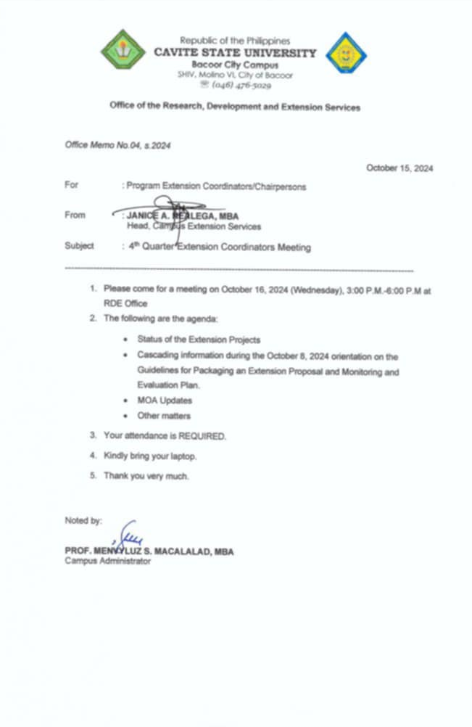
PHOTO DOCUMENTATION
