TRAINING REPORT

Campus/College/Unit: | CvSU – Bacoor City Campus
Title of Training: | wow
Related Degree/Program: | Department of Computer Studies in collaboration with the Campus Extension Services – BSIT/BSCS Program
No. of days: | 5 days
Date conducted: | July 6-10, 2025
Place: | BNHS
Partner Agency/ies: | CANVA
Part of a project: |  |  | Yes |  |  | No
Category of training: |  | Technical, vocational, livelihood |  |  | Agricultural and environmental trainings
 |  | Continuing education for professionals |  |  | Basic education
 |  | Gender and Development |  |  | Others

- Objectives of the Training

Upon the completion of the activity, the participants will be able to:
- understand the basic principles of layout and design;
- familiarized on the process of creating and designing visual contents using Canva; and
- Create and present their own visual content designs.

- Mode and Method of Training
Face-to-face learning and via zoom and FB live

- Number of Participants

Faculty

- By Sex

- Male | 19
- Female | 11
TOTAL | 30
- By Category

- Student | 6
- Farmer | 0
- Fisherfolk | 0
- Agricultural Technician | 0
- Government Employee | 24
- Private Employee | 0
- Others | 0
TOTAL | 30
- For technical, vocational, and livelihood trainings only

- No. of participants who are solo parents | NA
- No. of participants with disabilities | NA
- Type of disability | NA

- Evaluation

- No. of participants surveyed | 10
- Client’s rating on the training in terms of relevance
- 5 | 2
- 4 | 2
- 3 | 2
- 2 | 2
- 1 | 2
- Client’s rating on the training in terms of quality
- 5 | 2
- 4 | 2
- 3 | 2
- 2 | 2
- 1 | 2
- Client’s rating on the training in terms of timeliness
- 5 | 2
- 4 | 2
- 3 | 2
- 2 | 2
- 1 | 2
- Budget

- Amount charged to CvSU (campus/college/unit) | P 31,500.00
- Amount charged to partner agency (PhP) (if there is no cash involve, include estimates/value) | none
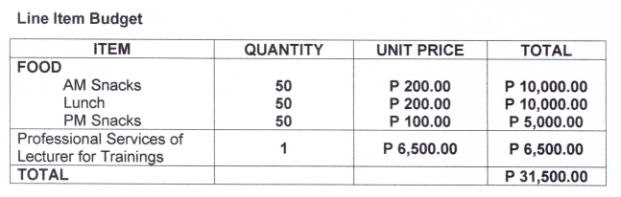

- Photos

Attachments:

- Program
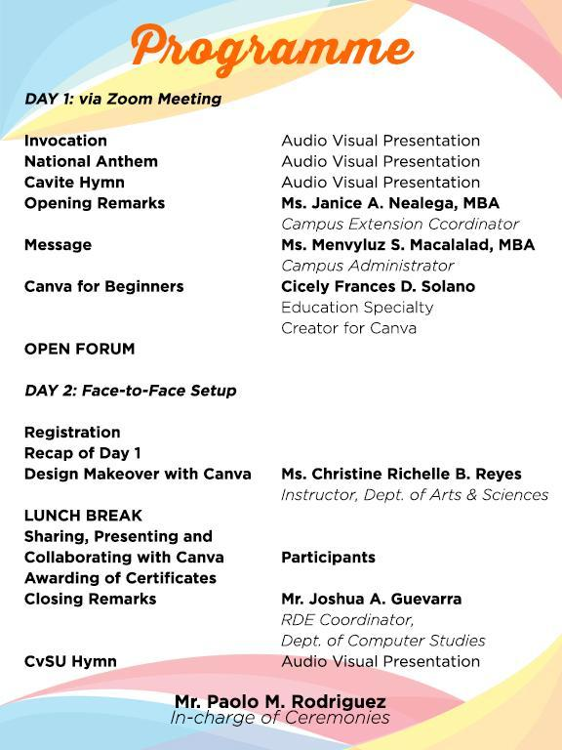


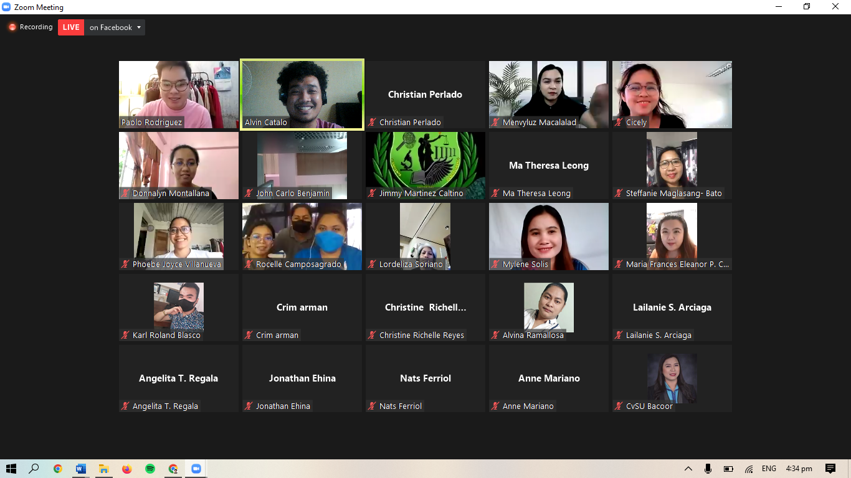
- Attendance sheet
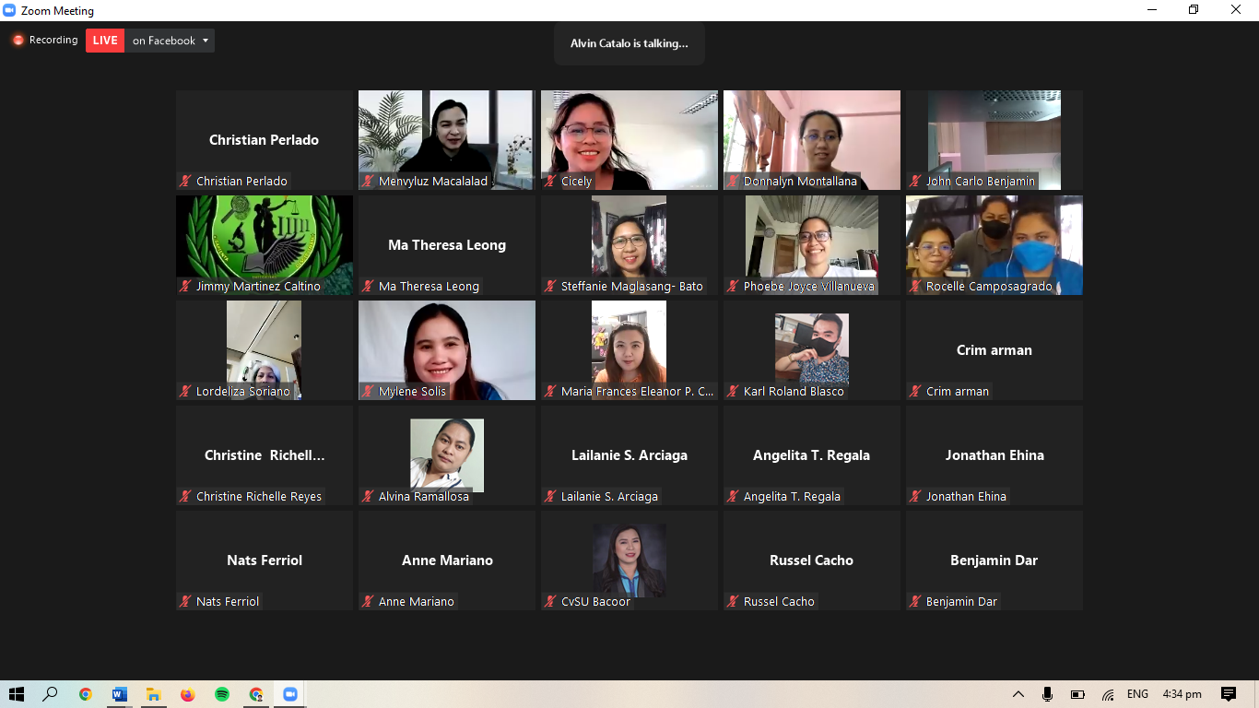

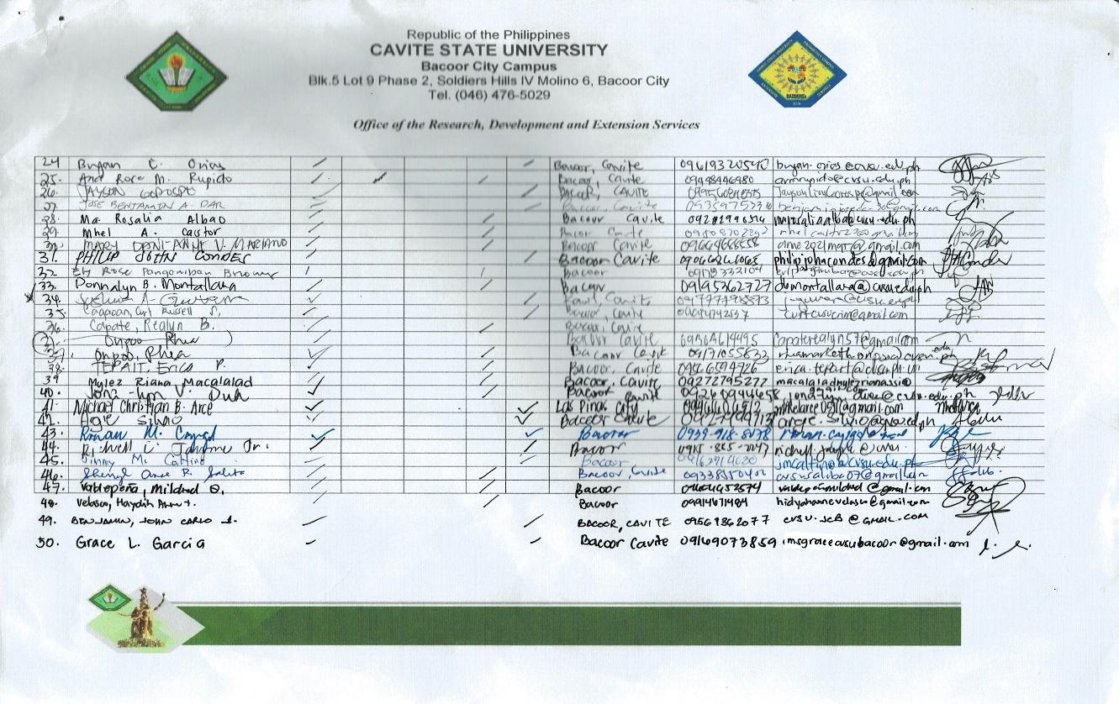
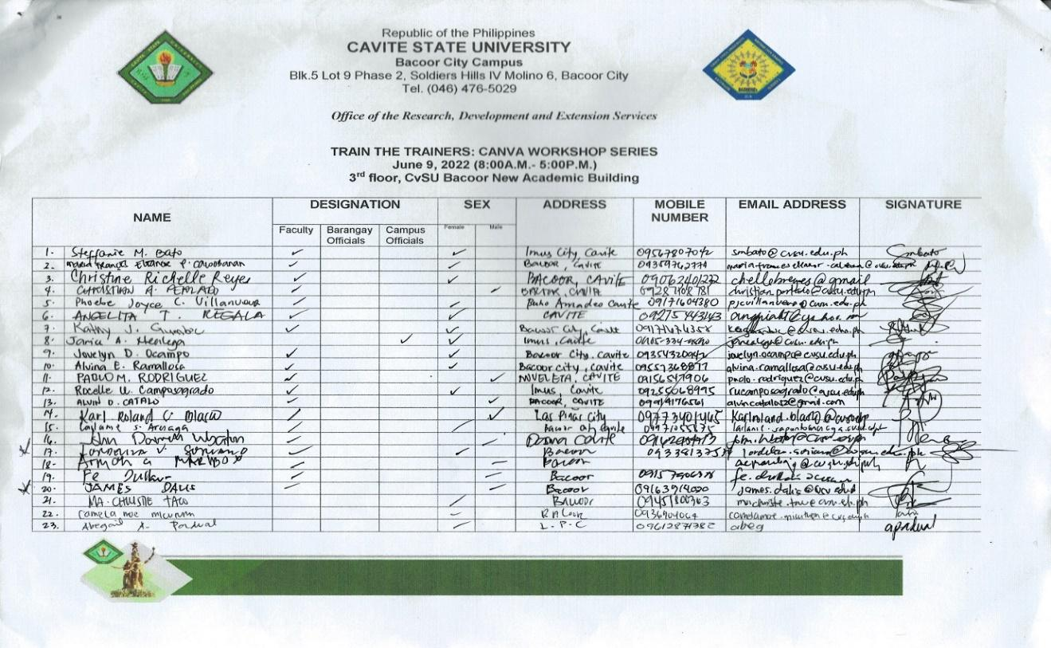

Prepared by:

Training Coordinator |  | Date

Verified by:

Extension Coordinator |  | Date

