DEVELOPMENT OF A WEB-BASED DOCUMENT MANAGEMENT SYSTEM FOR
CAVITE STATE UNIVERSITY-BACOOR CITY CAMPUS
EXTENSION SERVICES
Undergraduate Capstone Project
Submitted to the Faculty
Cavite State University-Bacoor City Campus
Bacoor Cavite
In partial fulfillment
of the requirements for the degree of
Bachelor of Science in Information Technology

DENNIEL M. ESTIRA
ROSE ANNE PAPA
LOUISE GABRIELLE D. QUIOYO
JADE P. TAGUBA

Purpose and Description
The proposed web-based document management system is expected to bring significant benefits to various stakeholders within Cavite State University Bacoor City Campus, particularly in its Extension Services Unit. The study's significance is outlined as follows:

University, Extension Services Unit and RDE
The system enhances efficiency in managing documents related to extension programs, reports, and partnerships by providing a centralized and secure digital repository, which reduces reliance on paper-based records. This improves accessibility, allowing faculty and staff to retrieve and submit documents remotely. Additionally, it streamlines workflows, minimizing delays in approvals, submissions, and archiving, ensuring a more efficient and organized process overall.
Staff Extensionist and Department Coordinator
The system simplifies document filing and retrieval processes, reducing the time spent on administrative tasks. It ensures document integrity and security through proper access controls and backup mechanisms. Additionally, it provides an automated attendance system and sends Gmail notifications for upcoming meetings, enhancing efficiency and communication.

Beneficiaries and Stakeholders
The system enhances transparency in extension service projects by enabling them to track engagements effectively. It also encourages greater participation in university-led outreach programs by providing easy access to reports, fostering a more informed activity.

Future Researchers

The system serves as a reference for future studies related to digital document management in educational institutions. It provides a framework for further improvements and technological advancements in university records management, supporting the continuous evolution of efficient and secure processes.

Time and Place of the Study
The study was conducted at Cavite State University – Bacoor City Campus, where innovation and digital transformation serve as the foundation for research and development. The project’s conceptualization began in November 2024, with the team envisioning a more advanced and adaptive web-based management system designed to streamline documentation processes for the future of academic institutions.

From the onset, the researchers adopted the Scrum agile methodology to ensure an iterative, efficient, and technology-driven approach to system development. This framework enabled continuous refinement, adaptive planning, and rapid response to change — all essential in today’s fast-paced digital landscape. The process began with product scoping and backlog creation, followed by iterative sprint cycles that produced functional system components every one to four weeks.

Formal development started in January 2025, when the team conducted interviews with campus stakeholders to gather futuristic insights on automation, usability, and scalability. These data were used to define the initial product backlog and guide the sprint planning phase. Using Python and other modern web technologies, each sprint delivered tangible progress from user interface prototypes to backend optimization ensuring that the system evolved dynamically with each iteration.

Throughout February to May 2025, the team maintained weekly sprint reviews and retrospectives with their advisers, promoting collaboration and adaptive learning. The agile process allowed them to integrate continuous feedback, apply advanced debugging, and enhance performance optimization in real-time.

By June 2025, the system was in its defense-ready stage, showcasing not only the researchers’ technical mastery but also the effectiveness of Scrum as a futuristic model for research-based system development. The study demonstrated how agile practices could redefine academic research workflows, ensuring that every phase from planning to implementation remained aligned with innovation, efficiency, and user-centered design.

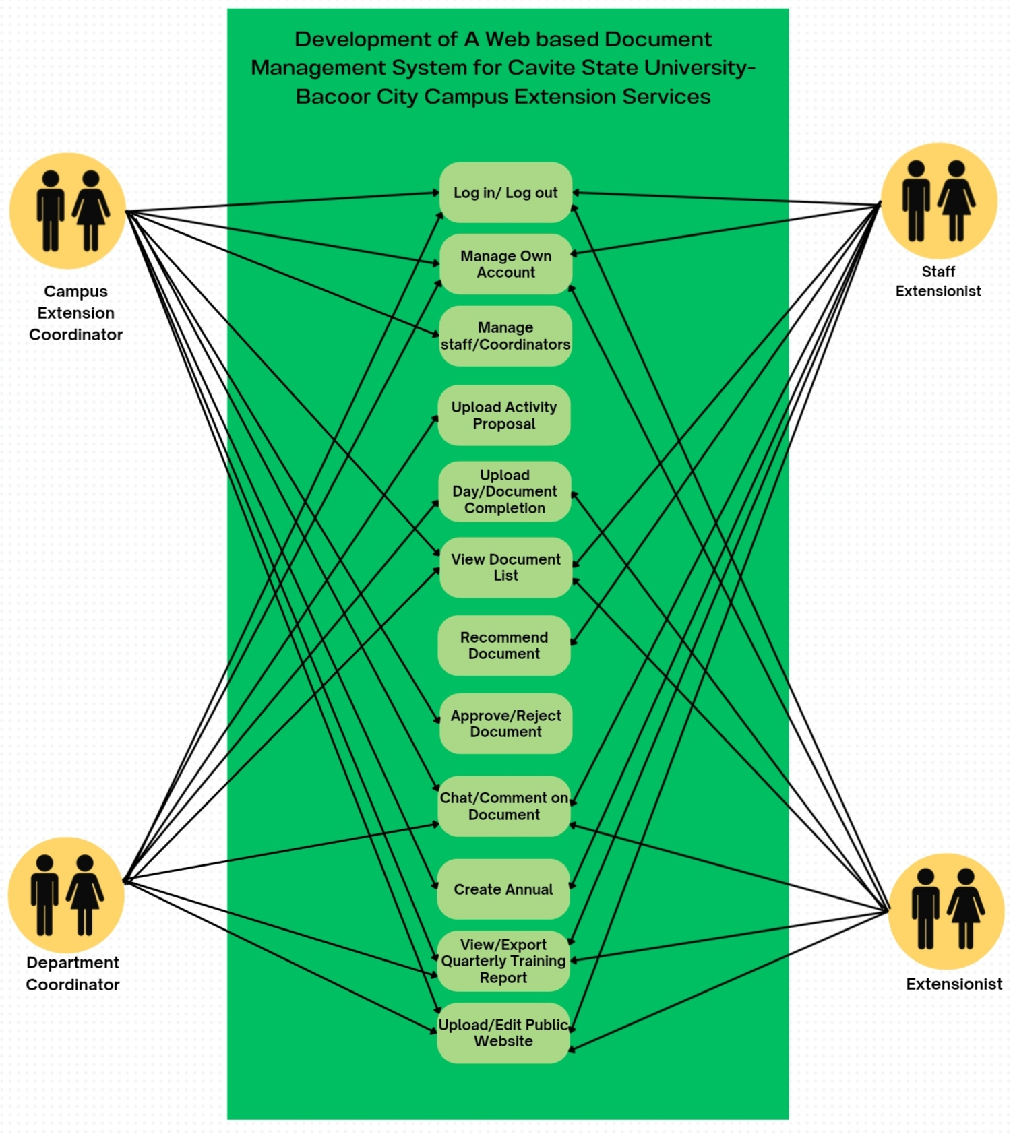
to work on the system and pa
Figure 3 Use Case Diagram of the Development of a Web-based Document Management System for Cavite State University-Bacoor City Campus Extension Services

Figure 3 illustrates the Use Case Diagram for the Development of a Web-Based Document Management System for Cavite State University–Bacoor City Campus Extension Services. The diagram demonstrates the interaction among different user roles, namely the Department Extension Coordinator, Campus Extension Coordinator, Extensionist, and Staff Extensionist. Each role performs specific functions within the system to ensure the smooth and organized management of extension-related documents and activities. The system allows users to log in and out, manage personal accounts, and handle coordination tasks. Core functions include uploading activity proposals, uploading daily or completion documents, viewing document lists, and recommending or approving documents. Users can also communicate through the comment feature, record attendance, and generate annual or quarterly reports. Additionally, the system enables exporting of quarterly targets and updating the public website. This diagram emphasizes the collaborative workflow of the system, showing how coordinators manage, review, and approve submissions while extensionists and staff contribute documents and updates. Overall, the Use Case Diagram captures the system’s goal of enhancing document organization, accessibility, and transparency across the university’s extension services.

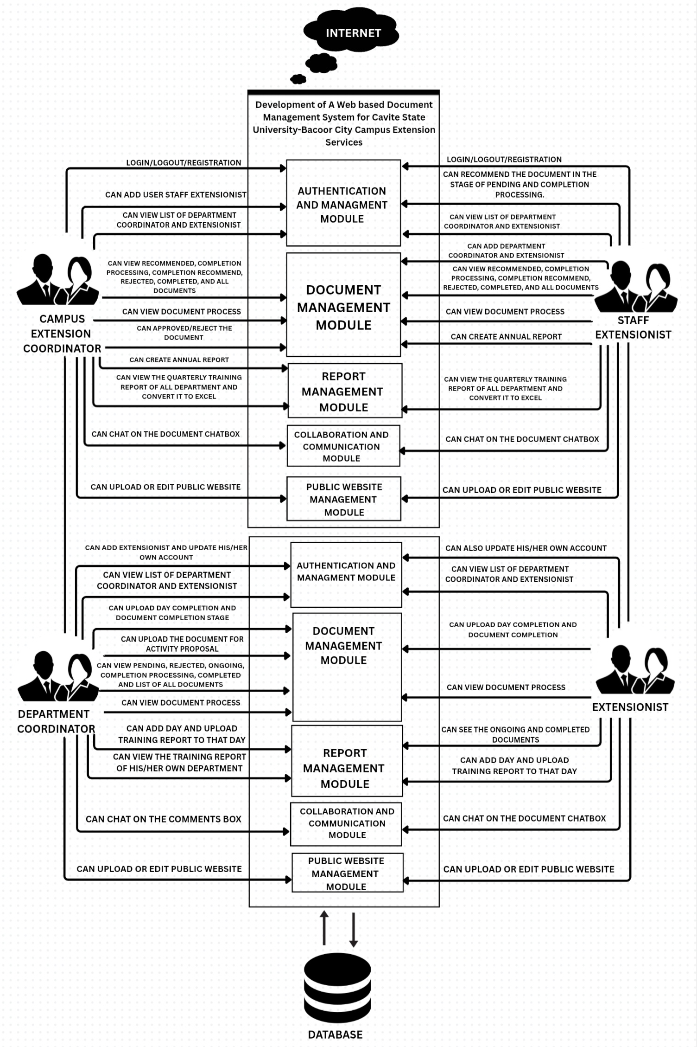

Figure 8 System architecture

Authentication and User Management Module is responsible for verifying user identities, handling logins and logouts, and securing sessions with encrypted password storage and optional multi-factor authentication. It also manages user roles, such as Extensionist, Department Coordinator, Staff Extensionist, Campus Coordinator, and Administrator, and governs their permissions within the system. In addition, this module keeps account records up to date, manages account activation or suspension, and logs authentication activities for security auditing. Notifications and password resets are supported through integration with email services.
Document Management Module handles all institutional documents, including proposals, attendance photos, reports, and other uploaded files. It provides secure storage, metadata tagging, version control, and workflow transitions such as Pending, Ongoing, Completion Processing, Completed, and Rejected. This ensures traceable document lifecycles, fine-grained access control, and reliable governance. Documents can be previewed or downloaded, comments may be attached for review, and audit trails record all actions related to each file.Attendance and Time Tracking ensures reliable recording of participation in extension activities. Attendance may be logged through photo-based check-in and check-out, timestamped entries, or administrative adjustments. Each record is validated against activity schedules, stored with complete logs, and used to calculate compliance with required quotas, such as the 54-hour extension service requirement. Reports can be exported in Excel or PDF format, and users may receive reminders about incomplete quotas or upcoming events.
Report Management Module generates and archives institutional reports, including quarterly, annual, and activity accomplishment reports. It aggregates data from the Document Management and Attendance modules, applies filters such as date or department, and produces reports in standardized templates. Reports are reviewed and approved before distribution, and once finalized, they are archived along with their metadata for traceability.
Collaboration and Communication Module enables contextual discussion linked to documents and activities. Users can post comments or threaded discussions tied to specific files, mention colleagues, and receive notifications through both in-system alerts and integrated email. This ensures communication remains relevant and traceable, while still maintaining a clear audit trail.
Public Website and Content Management Module provides a secure public-facing interface that allows visitors to view selected extension outputs, such as announcements, MOAs, and activity highlights. Administrators and editors control which content is published, ensuring sensitive or internal documents remain private. The website supports static content such as About and Objectives pages, as well as dynamic content like news, events, and embedded media. Supporting all these modules are cross-cutting components. The API layer ensures consistent communication across modules with authentication and role-based access control enforced at every request. The data layer integrates a relational database for structured information and a file storage system for uploaded documents. Centralized logging captures security events, document activity, and workflow transitions, while automated backup and retention policies ensure long-term reliability and compliance.

