Level 0 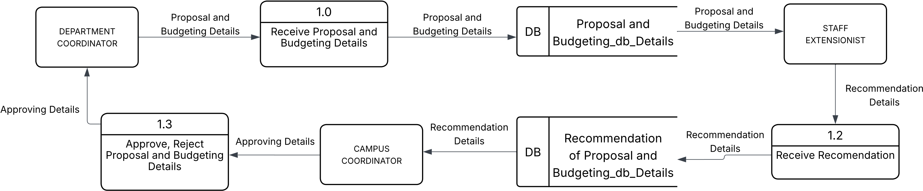
Level 1 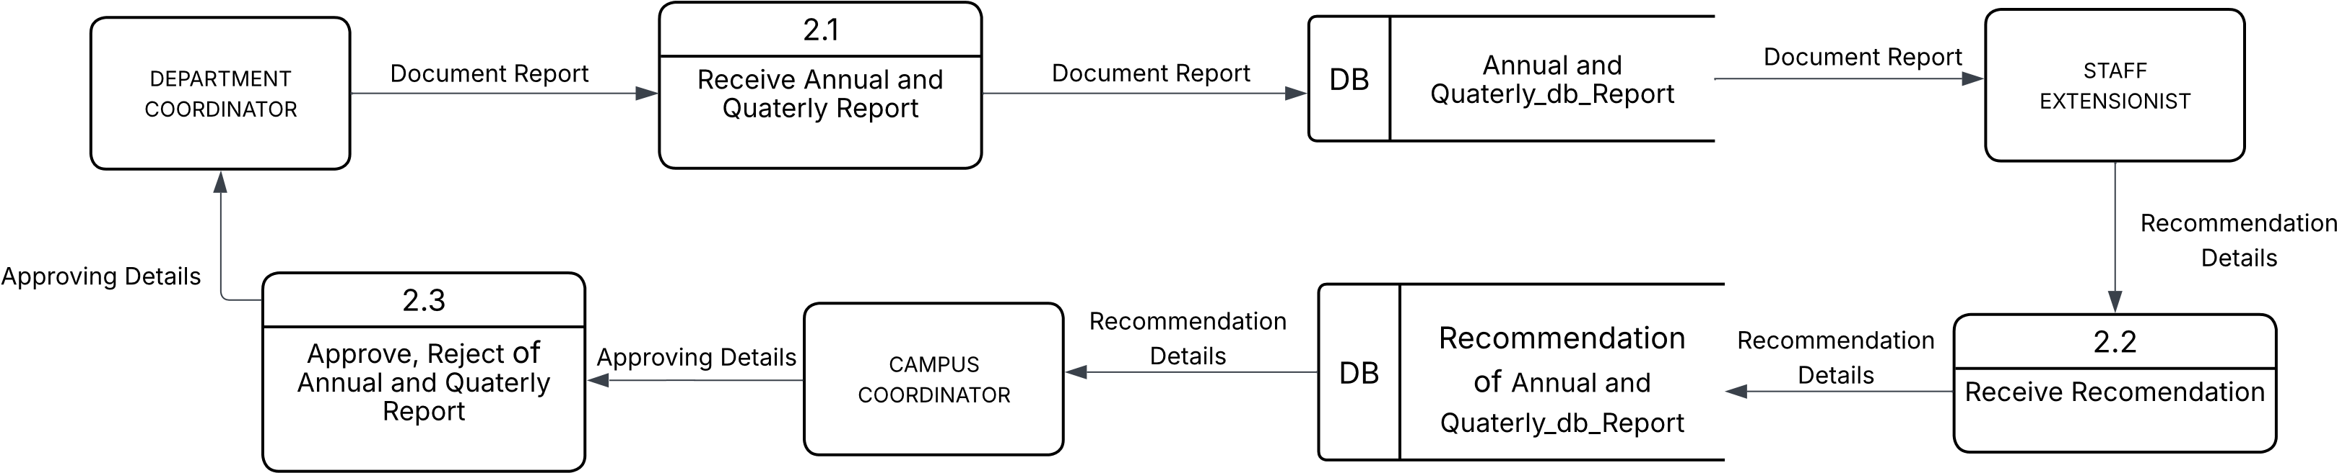
Level 2 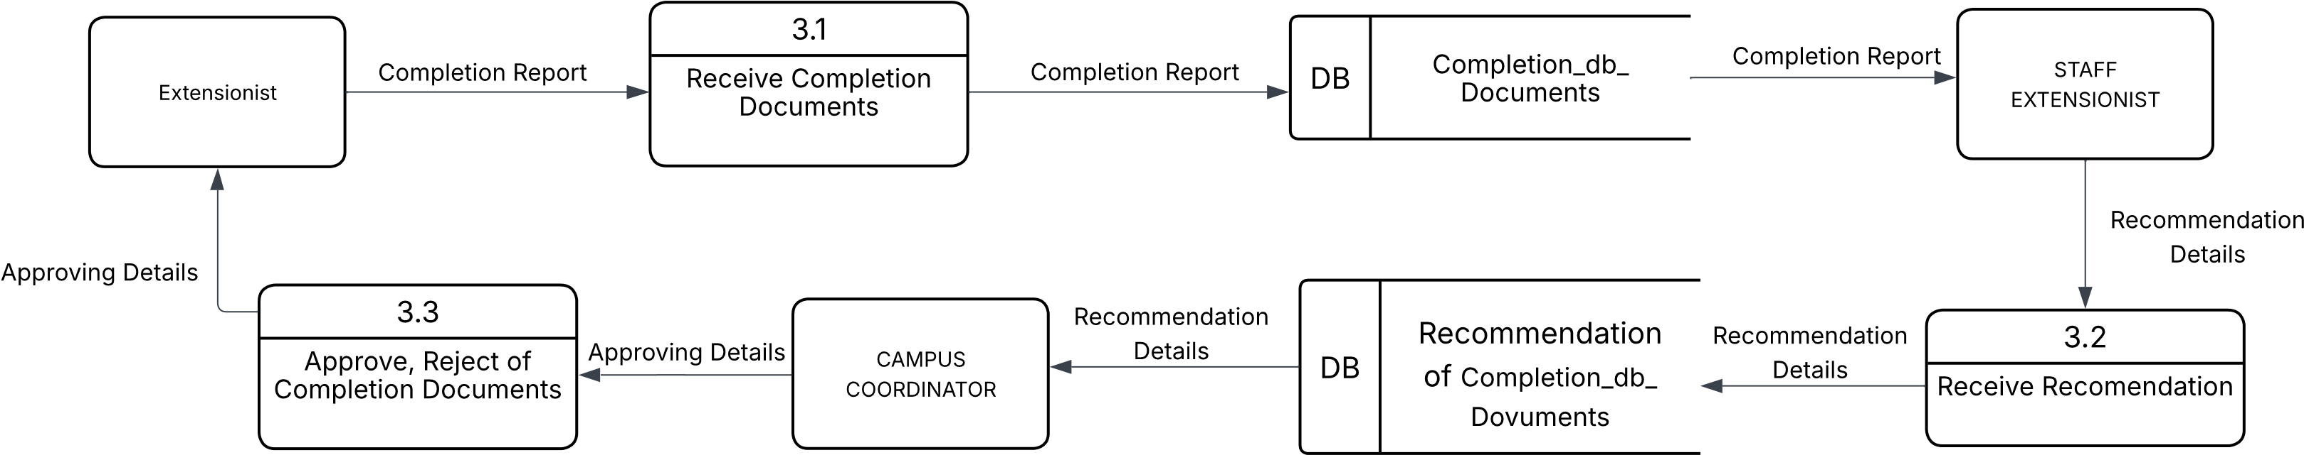
Level 3 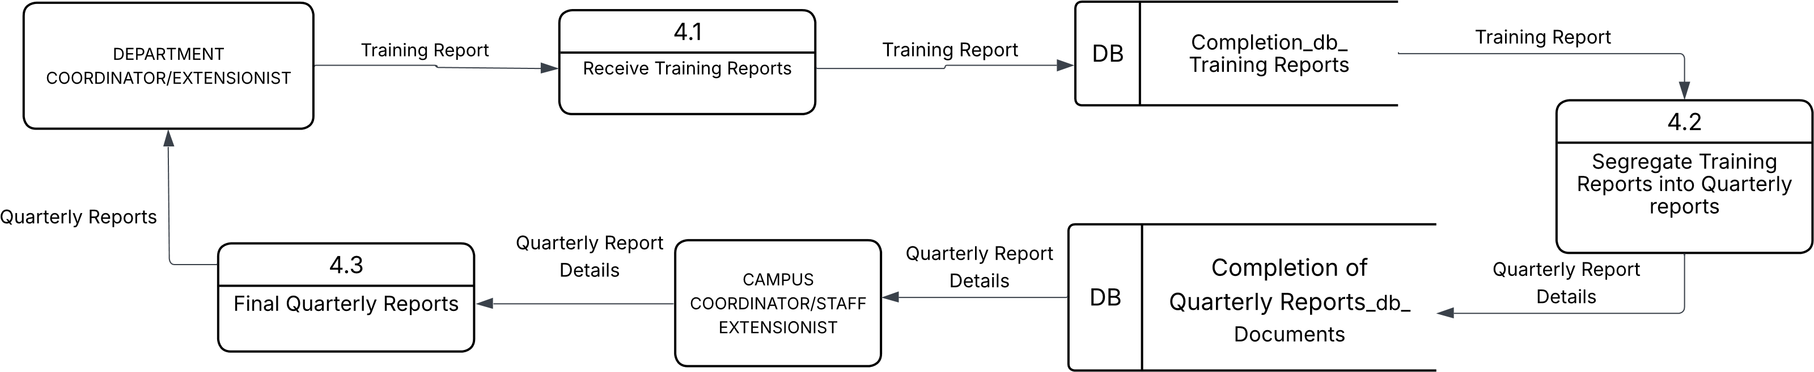
Level 4 