PENTECOST UNIVERSITY


SOWUTUOM, ACCRA, GHANA
FACULTY OF ENGINEERING, SCIENCE AND COMPUTING
DEPARTMENT OF INFORMATION TECHNOLOGY

DESIGNING AND IMPLEMENTING AN AUTOMOBILE MAINTENANCE AND REPAIR BOOKING SYSTEM
(A CASE OF KORLE BU HOSPITAL, SPEECH THERAPY DEPARTMENT)
By
DENNIS OPOKU ASIEDU PUIT/22210058
EUGENE ANTWI GYAASE PUIT/22210013

SUPERVISOR: MR. HARRY ATIEKU

DECLARATION
We hereby declare that this project work here in submitted as the Final-Year Project Report in partial fulfillment of the requirement for the award of Bachelor of Science degree in Information Technology is the result of our own research. Therefore, no part of this project work has been presented whole or in part to any other institution for any recommendation and that the project has been duly supervised and assessed by MR. HARRY ATIEKU in accordance with the laid down guidelines of Pentecost University.

……………………………. …………………………….
DENNIS OPOKU ASIEDU Date
PUIT/22210058

……………………………. …………………………….
EUGENE ANTWI GYAASE Date
PUIT/22210013

CERTIFICATION
I hereby certify that the preparation and presentation of the project were supervised in accordance with the guidelines on supervision laid down by Pentecost University.

……………………………. …………………………….
MR. HARRY ATIEKU Date

DEDICATION
We dedicate this project to the research team of Information Technology (I.T) department of Pentecost University for their massive support and supervision which led to the success of this project. We also want to dedicate this Project to our Families for always believing in us and providing us with their unwavering support in every aspect of this educational journey towards achieving this milestone.

ACKNOWLEDGEMENT
First of all, we are grateful to the Almighty God who is the Source and Sustainer of life for seeing us through to achieving this great milestone. Our second thanks go to the entire Faculty Staff especially our Project Supervisor in the person of Mr. Harry Atieku for his effective supervision and guidance that helped to make this project a success, God blessed him for his immense support. Thirdly, we express heartfelt thanks to all our classmates, friends and family for their invaluable support, encouragement and prayers which contributed to the success of this project. God bless everyone who in one way or the other contributed to ensuring that this piece of work becomes a success.

TABLE OF CONTENTS
DECLARATION ii
CERTIFICATION iii
DEDICATION iv
ACKNOWLEDGEMENT iii
TABLE OF CONTENTS iv
LIST OF FIGURES viii
LIST OF TABlES ix
ABBREVIATIONS x
EXECUTIVE SUMMARY xi
CHAPTER ONE 12
INTRODUCTION 12
1. 0 Background 12
1.1 Problem Statement 13
1.2 Objectives 14
1.3 Scope 14
1.4 Significance of the Project 15
CHAPTER TWO 16
LITERATURE REVIEW 16
2.0 Introduction 16
2.1 Reviewed Systems 16
2.1.1 YourMechanic 16
2.1.2 AUTOsist 17
2.1.3 CarFax Car Care 18
2.2 Gaps Identified in Existing Systems 18
2.3 Features of the Proposed System 19
2.4 Importance of the Proposed System 19
CHAPTER THREE 20
METHODOLOGY 20
3.0 Introduction 20
3.1 Sprint-Based Development Activities and Results 20
3.2 User-Centered Requirement Gathering 21
3.2.1. Data Gathering Techniques 22
3.2.2 Primary Data Collection: 22
3.2.3 Secondary Data Collection: 24
3.3 Feature Design and Prototyping 24
3.4 Development Implementation 24
3.5 Testing Protocols and Outcomes 25
3.6 Deployment and Training 25
3.7 Maintenance and Feedback Integration 26
3.8 Tools and Technologies Summary 26
3.9 Challenges Encountered 26
CHAPTER FOUR 27
SYSTEM ANALYSIS AND DESIGN 27
4.0 Introduction 27
4.1 Functional Requirements 27
4.2 Non-Functional Requirements 28
4.2 Technical Design 28
4.2.1 Use Case Diagram 29
4.2.2 Context Analysis Diagram 32
4.2.3 Flow Chart 34
4.2.4 Entity Relationship Diagram 36
4.3 Graphical User Interfaces (GUI) 37
CHAPTER FIVE 48
TESTING AND IMPLEMENTATION 48
5.0 Introduction 48
5.1 Testing 48
5.2 Unit Testing 48
5.3 Integrated Testing 49
5.4 Implementation 49
5.5 Training 50
5.6 Maintenance 50
5.7 Conclusion 51
5.8 Limitations 51
5.9 Recommendations 51
REFERENCE 53
APPENDIX 54
Programming Codes 54
Splash Screen Codes 54
Welcome Screen Codes 62
Home Screen Codes 67
Booking Appointments Codes 81
Chat Screen Codes 133
Roadside Screen Codes 144
APPENDIX B 154
Questionnaires Jojo Mechanics Booking System. 154
Interview Guide For Jojo Mechanics Booking System. 155

LIST OF FIGURES

Figure 1: Use Case Diagram of the Jojo Mechanics 28
Figure 2: Context Analysis Diagram 30
Figure 3: Flow Chart Diagram 32
Figure 4: Entity Relationship Diagram 33
Figure 5: Splash Screen 34
Figure 6: Splash Screen 35
Figure 7: Welcome Screen 36
Figure 8 Sign-Up Screen 37
Figure 9 Login Screen 38
Figure 10: Homepage Screen 39
Figure 11: In-app messaging screen 40
Figure 12: Booking Appointments Screen 41
Figure 13: GPS Tracking Screen 42
Figure 14: Repair Tracking Screen 43
Figure 15: Profile Screen 44

LIST OF TABles
Table 4.0 Meaning of the symbols in the Use Case Diagram 27
Table 4.1 Meaning of the Symbols in the CAD………………………………………………… 29
Table 4.3 Meaning of the Symbols in the FC…………………………………………………… 31

ABBREVIATIONS
APK: | Android Package Kit
CAD: | Context Analysis Diagram
ERD: | Entity Relationship Diagram
FC: | Flow Chart
GPS: | Global Positioning System
GSMA: | Groupe Spécial Mobile Association
iOS: | iPhone Operating System
STC: | State Transport Corporation
UAT: | User Acceptance Testing
UCD: | Use Case Diagram
UI/UX: | User Interface / User Experience
URL: | Uniform Resource Locator

EXECUTIVE SUMMARY
This project, "Designing and Implementation an Automobile Maintenance and Repair Booking System: The Case Study of Jojo Mechanics," addresses the limitations of the existing manual service booking and communication process by developing a user-friendly mobile application. The system allows customers to book vehicle maintenance or repair services, track the status of their vehicles in real time, communicate directly with mechanics, and request emergency roadside assistance via GPS ultimately streamlining operations and enhancing customer satisfaction.
Using the Agile (Scrum) model, the system was developed through iterative cycles with continuous feedback from stakeholders including customers, mechanics, and administrative staff. System modeling tools such as use case diagrams, context diagrams, and flowcharts were used to represent key system functionalities and interactions.
Comprehensive unit and integration testing was conducted to validate the system’s reliability, performance, and real-world usability. The result is a mobile maintenance and repair platform that improves operational efficiency for Jojo Mechanics and delivers a significantly improved, convenient, and professional experience for customers.

CHAPTER ONE

INTRODUCTION
Should be between Chapter 1: between 800 to1000 words

1. 0 Background
The automotive service industry is undergoing a significant transformation globally, driven by the increasing adoption of digital technologies to enhance service delivery and customer experience. In recent years, mobile applications have emerged as vital tools for managing automobile maintenance and repair services, offering customers the convenience of 24/7 service access, real-time updates, and automated reminders. Research shows that mobile app solutions have improved operational efficiency and customer satisfaction in the automotive sector, with companies like "YourMechanic" and "AUTOsist" setting benchmarks in providing seamless, tech-enabled services. These innovations underscore the global shift towards integrating technology into traditional industries, highlighting the need for localized solutions in emerging markets [1][2].
In Africa, the rapid adoption of mobile technology has opened new opportunities for transforming industries, including automotive services. With over 40% smartphone penetration on the continent, customers increasingly demand mobile-enabled services tailored to their needs. However, many service providers in Africa still rely on traditional methods of operation, which limits accessibility and efficiency. Digital tools are particularly relevant in addressing challenges such as fragmented communication, lack of transparency, and inefficiencies in service delivery. Automotive service apps could significantly bridge the gap by offering innovative solutions to customers across urban and peri-urban areas in Africa [3].
In Ghana, the automotive industry has grown significantly, fueled by rising vehicle ownership and the demand for reliable maintenance and repair services. However, the local industry is still dominated by manual and traditional practices, such as in-person visits to service centers. These outdated methods often lead to inefficiencies, including missed appointments, long wait times, and poor communication. Ghanaians are increasingly adopting digital solutions across various sectors, but the automotive service industry remains underdeveloped in terms of leveraging mobile technology. This presents a unique opportunity to introduce a mobile app that addresses the specific needs of Ghanaian vehicle owners and service providers.
Jojo Mechanics, a growing automotive service provider in Ghana, has recognized the need to modernize its operations to better serve its customers. Currently, the company faces challenges such as limited accessibility outside business hours, inefficient communication, and difficulties in tracking repairs and maintenance schedules. By designing and implementing a mobile app, Jojo Mechanics aims to overcome these obstacles and position itself as a leader in providing tech-enabled automotive services in Ghana. The app will streamline service delivery, enhance customer satisfaction, and enable Jojo Mechanics to compete effectively in the evolving automotive service landscape [4].

1.1 Problem Statement
In the fast-paced and increasingly digital world, customers demand convenience and efficiency in managing their vehicle maintenance and repair needs. However, Jojo Mechanics currently relies on traditional methods such as phone calls and walk-ins for service booking and communication, which present several challenges. Customers face difficulties having a finished vehicles at the estimated time given to them and the lack of real-time updates on repair status often leaves customers dissatisfied and uncertain about the progress of their vehicle repairs, diminishing their trust in the process. Additionally, limited communication channels between customers and mechanics cause delays and misunderstandings, which further affect service delivery efficiency and customer satisfaction.

A significant challenge for vehicle owners is remembering scheduled maintenance, leading to neglect of essential upkeep and causing avoidable breakdowns or costly repairs. This problem is exacerbated by the absence of a system to provide timely reminders and notifications about upcoming maintenance tasks. These inefficiencies not only impact the customer experience but also limit Jojo Mechanics' ability to optimize its operations and grow its customer base.
In Ghana’s growing automotive service industry, vehicle owners often face difficulties accessing timely roadside assistance, especially when their vehicles break down in unfamiliar or remote locations. Jojo Mechanics, currently lacks a system to accurately pinpoint and respond to such emergencies. This results in delayed response times, customer frustration, and operational inefficiencies. Traditional phone-based directions are unreliable and prone to miscommunication, especially under stressful or emergency conditions.

Addressing these challenges requires a comprehensive digital solution that enables 24/7 service booking, real-time updates, efficient communication, automated maintenance reminders and GPS technology to locate stranded or damaged vehicles accurately and respond with timely pickup or roadside assistance. A well-designed mobile app can bridge these gaps, ensuring a seamless experience for customers and empowering Jojo Mechanics to enhance operational efficiency and competitiveness in the Ghanaian automotive service industry.

1.2 Objectives
This project seeks to build a mobile maintenance and repair booking application that will allow:
- Customers book appointments.
- The integration of real-time service tracking to keep customers informed about their repair progress.
- The integration of in-app messaging feature and notifications to facilitate direct communication between customers and mechanics, ensuring quick consultations and reducing wait times.
- The integration of GPS tracking to help mechanics locate damaged vehicles in real-time, enabling prompt assistance and improving the overall service experience.

1.3 Scope
The project focuses on designing, developing, and deploying a mobile app tailored to the needs of Jojo Mechanics' customers in Ghana. The app will include secure user registration and profile management to personalize the user experience. It will feature an interface for booking and scheduling maintenance and repair services, available 24/7. Real-time service tracking will allow customers to monitor the progress of their repairs, ensuring transparency and trust.
The app will also include an in-app messaging feature to enable seamless communication between customers and mechanics, ensuring quick consultations and resolution of issues. Additionally, automated reminders and notifications will help customers keep track of upcoming maintenance tasks and promotions. The backend system will support efficient job scheduling, ensuring that Jojo Mechanics can handle increased customer demands while maintaining high service quality.

1.4 Significance of the Project
The mobile app will change the way Jojo Mechanics interacts with its customers by providing a convenient, user-friendly platform for service access and management. By addressing the inefficiencies in traditional service delivery, the app will enhance customer satisfaction and foster loyalty, leading to increased revenue. Operationally, the app will automate key processes, such as booking and communication, reducing manual workload and minimizing errors. This project will also position Jojo Mechanics as a leader in digital innovation within Ghana's automotive service industry, giving it a competitive edge over traditional service providers. Furthermore, the app will serve as a valuable tool for collecting customer feedback and data, enabling Jojo Mechanics to continually improve its services and maintain long-term growth.

CHAPTER TWO

LITERATURE REVIEW
Should be between Chapter 2: between 1500 and 2000 words

2.0 Introduction
A thorough literature review was conducted to understand the current landscape of digital automotive service platforms. This review focused on examining various car maintenance and repair booking systems to identify their core features, strengths, and weaknesses. The insights gained were crucial in shaping the design and development of the proposed mobile application for Jojo Mechanics, ensuring it addresses existing gaps and delivers improved functionality [6].

2.1 Reviewed Systems

2.1.1 YourMechanic
YourMechanic is a U.S.-based platform offering mobile car repair and maintenance services. It connects customers with certified mechanics who perform services at the customer's home or office [1].
Features:
- On-Demand Booking: Customers can schedule repair and maintenance services from their mobile devices, choosing from a wide range of services like oil changes, brake replacements, and diagnostics.
- Real-Time Repair Tracking: Once the mechanic begins work, customers can track the status of the repair through the app, promoting transparency.
- Transparent Pricing: The app provides upfront pricing for services, helping customers avoid unexpected charges.
- Service History Management: Users can view and store their vehicle’s maintenance history.

Limitations:
- Lack of In-App Communication: There’s no integrated messaging system. If customers need to contact the mechanic, they must use external means like email or phone calls, which hinders seamless communication.
- No Preventive Maintenance Alerts: While service tracking exists, the system lacks personalized maintenance scheduling or automated reminders to prompt customers about upcoming service dates.

2.1.2 AUTOsist
AUTOsist is a fleet management and personal vehicle maintenance platform that focuses on tracking and organizing service data rather than facilitating direct service bookings [7].
Features:
- Maintenance Log Tracking: Users can record every service performed on their vehicles, such as tire rotations, oil changes, and inspections.
- Document Management: The platform supports uploading and organizing receipts, service reports, and registration documents in one place.
- Vehicle Fleet Management: Ideal for organizations managing multiple vehicles, allowing them to assign vehicles and monitor service records efficiently.
Limitations:
- Outdated Interface: The user interface is relatively simple and not optimized for modern smartphones, which affects user experience.
- No Real-Time Features: The platform doesn’t support service progress tracking or booking functionalities. It focuses more on documentation rather than real-time interaction.
- Limited Individual User Utility: While useful for fleet managers, the system lacks tools like mechanic search, service tracking, or booking features that individual customers would expect.

2.1.3 CarFax Car Care
CarFax Car Care is a digital vehicle management tool built into the larger CarFax ecosystem, primarily used for maintaining accurate service histories for vehicles in the U.S.[8].
Features:
- Service History Tracking: CarFax automatically logs maintenance data from partner garages and service providers.
- Maintenance Reminders: Users receive automated notifications for recommended or overdue services, based on the car’s mileage and manufacturer recommendations.
- Recall Monitoring: The app alerts users when there are manufacturer recalls that affect their registered vehicles.
Limitations:
- No Mechanic Booking Capability: Unlike Jojo Mechanics' proposed system, CarFax doesn’t allow users to book services or interact directly with mechanics.
- Limited Customization: The system doesn’t support personalized workflows or shop-specific services—it's more of a general maintenance log than a service platform.
- No Two-Way Communication: Users cannot communicate with garages or service centers within the app.

2.2 Gaps Identified in Existing Systems
After analyzing these systems, several limitations were identified that the proposed Jojo Mechanics mobile application aims to address:
- Communication Gaps: None of the reviewed systems offer built-in two-way communication between customers and mechanics. This causes delays and inefficiencies when clarifying service details or updates.
- Limited Real-Time Progress Updates: Most systems do not provide real-time status tracking for repairs, which leaves customers uninformed during service.
- Lack of Local Adaptation: These platforms are designed for mature digital markets. They often fail to address challenges in less digitized environments like Ghana, such as intermittent internet access or the need for simplified interfaces.
- Fragmented Features: While some systems offer reminders or service logs, others offer booking or repair tracking—rarely are all features integrated in one platform.

2.3 Features of the Proposed System
To bridge the identified gaps, the proposed system for Jojo Mechanics integrates the following features:
- Mobile Appointment Scheduling: Customers can schedule vehicle maintenance and repair services directly from their phones without having to visit the mechanic in person.
- Real-Time Repair Tracking: Users can receive live updates on the progress of their repairs, enhancing transparency and reducing unnecessary inquiries.
- In-App Messaging: A built-in chat function allows customers to communicate directly with the assigned mechanic to discuss service details, ask questions, or request additional services.
- GPS Tracker: The GPS tracker helps mechanics locate damaged vehicles in real-time.

2.4 Importance of the Proposed System
The development of this system is not just about digitizing processes; it represents a strategic advancement for Jojo Mechanics and similar local businesses by:
- Improving Customer Experience: Through better communication, booking ease, and progress visibility.
- Enhancing Operational Efficiency: By streamlining workflows, reducing booking errors, and ensuring timely service delivery.
- Enabling Business Growth: With a reliable and modern platform, Jojo Mechanics can attract more customers and scale operations.
- Promoting Digital Inclusion: By creating a user-friendly solution tailored for the local market, it helps bridge the digital divide in the automotive service sector.

CHAPTER THREE

METHODOLOGY

3.0 Introduction
The methodology adopted for this project is pivotal to its successful execution and deployment. Given the need to provide an efficient and user-centric solution for Jojo Mechanics, the project employed the Agile development methodology, specifically the Scrum framework. This chapter outlines the entire methodology used to design and develop the mobile car maintenance and repair booking system. It details each step undertaken from initial planning to final deployment. The Agile Scrum model is known for its flexibility, iterative processes, and continuous feedback mechanism, making it ideal for this type of system development where user requirements are dynamic and evolve over time.
The Agile Scrum methodology enables rapid and continuous delivery of functional software through collaborative and cross-functional team efforts. This chapter discusses the rationale for choosing Scrum, its implementation in this project, and the tools, techniques, and processes followed. Each phase of development is examined, including planning and analysis, system design, development, testing, and deployment. Furthermore, the chapter elaborates on the technologies utilized, stakeholder involvement, and the challenges encountered along the way.

3.1 Sprint-Based Development Activities and Results
Our development process was divided into five sprints of two weeks each. Here is a breakdown of the core tasks executed in each sprint and the corresponding deliverables:
Sprint | Tasks Embarked On | Results Achieved
Sprint 1 | Conducted interviews with mechanics, customers, and admin staff; observed workshop operations | Mapped 9 core functional requirements and pain points; produced requirements documentation
Sprint 2 | Designed UI mockups using Figma; reviewed wireframes with stakeholders | Produced final app UI prototype based on user feedback
Sprint 3 | Developed booking module and integrated push notifications | Working booking system with Firestore data entry and functional notification delivery
Sprint 4 | Built and connected in-app messaging; integrated real-time tracking features | Functional chat module and repair tracking dashboard for customers
Sprint 5 | Conducted user acceptance testing (UAT), finalized system, and prepared for deployment | Bugs fixed, UAT feedback incorporated, APK generated and yet to be submitted to Google Play

3.2 User-Centered Requirement Gathering
We conducted qualitative interviews with the head of Jojo Mechanics. These interviews uncovered common issues including unreliable service status updates, manual booking inefficiencies, and poor communication. Our observational study supported these findings by revealing workflow gaps such as overbookings and lost paper records.
Empirical studies from the sector confirmed our findings: a report by Deloitte noted that over 60% of vehicle owners globally prefer digital interaction for service bookings [9]. Similarly, YourMechanic has seen over 1.2 million services booked via their app [10], underscoring the demand for automated solutions.

3.2.1. Data Gathering Techniques
The developers gathered requirements for the Mobile Booking System using a combination of primary and secondary data sources. Primary data was collected through interviews with Jojo Mechanics and Repair management and clients, allowing for a clear definition of their specific needs and expectations. The team also reviewed secondary sources, such as industry publications and online resources, to contextualize the requirements within the broader mobile booking landscape. This multi-pronged approach provided a comprehensive understanding of the system requirements.

3.2.2 Primary Data Collection:
Interview with Jojo Mechanics Owner was conducted with Micah (the head of Jojo Mechanics) to understand their practices and challenges.

Interview Responses (Worker’s Perspective)
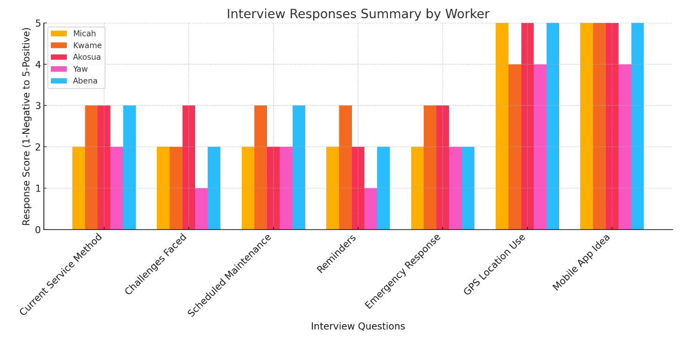

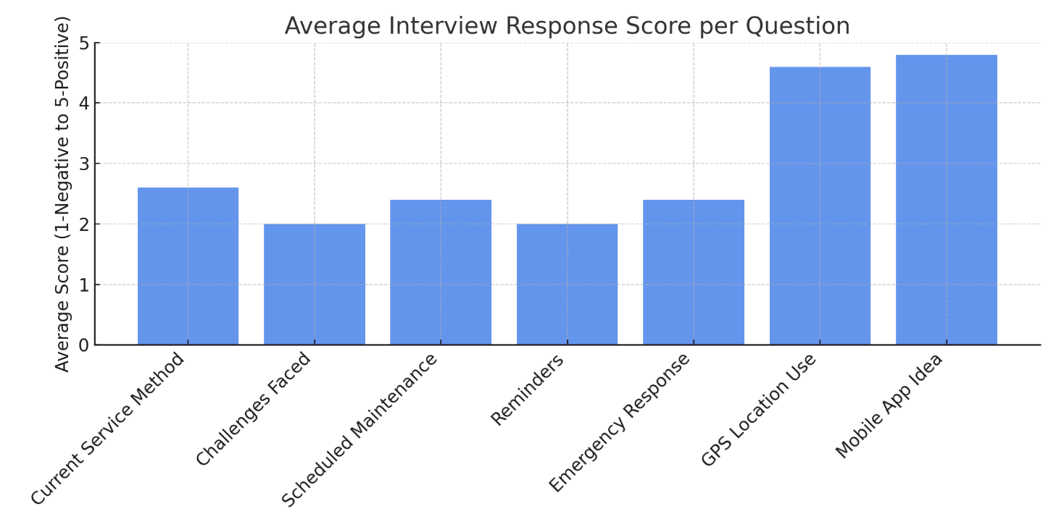

Interview Responses (Driver’s Perspective)
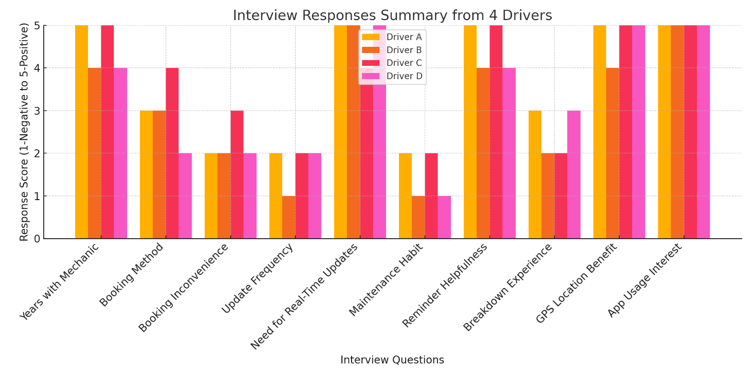

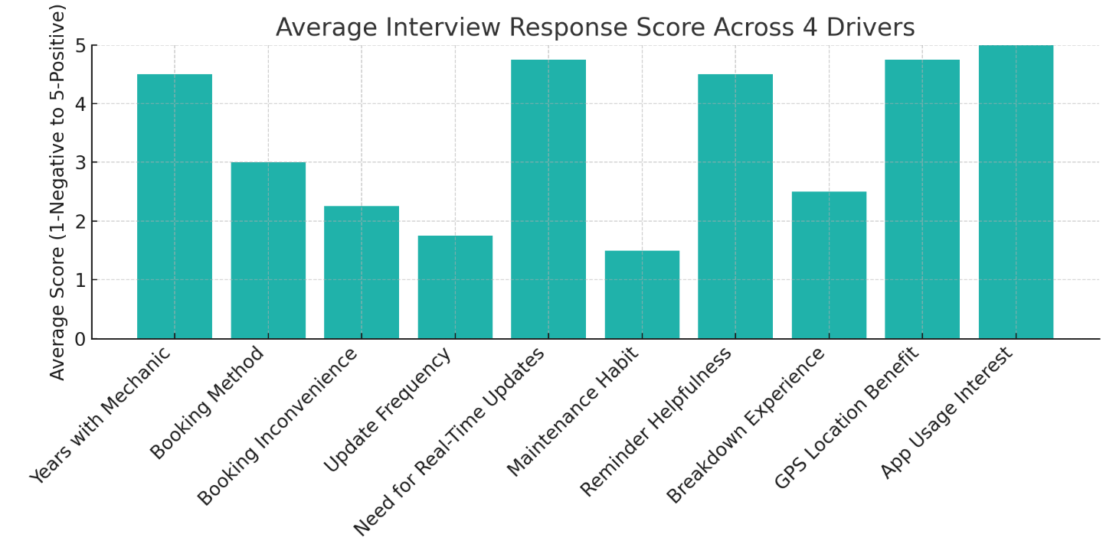

3.2.3 Secondary Data Collection:
Literature reviews were conducted on other applications.

3.3 Feature Design and Prototyping
Using Figma, we created interactive wireframes for the booking, chat, and tracking features. Weekly stakeholder review sessions led to three iterations of the design to better suit user expectations. We emphasized local usability, like simple menus and offline support, based on regional constraints identified by GSMA [11].

3.4 Development Implementation
The system was built using Flutter and Firebase, enabling cross-platform compatibility and real-time backend communication. Key components developed include:
- Booking Module: Users can choose service date and time
- Real-Time Repair Tracker: Tracks service status updates from the mechanic's interface
- Chat Interface: Facilitates in-app mechanic-customer communication
- GPS Tracker: Sends alerts for GPS tracking to help mechanics locate damaged vehicles in real-time.

All features were tested in isolated environments before integration.

3.5 Testing Protocols and Outcomes
- Unit Testing: Ensured each feature worked independently—booking entries were validated against expected database results.
- Integration Testing: Verified booking data correctly updated the mechanic view and sent push notifications.
- UAT: 10 staff and customers simulated real scenarios. Over 80% reported satisfaction with the interface and response speed.
- Security Testing: Firebase rules were implemented to restrict cross-user access and enforce role-based permissions.

3.6 Deployment and Training
The finalized app will be deployed on Google Play Store. Pre-launch activities included:
- Load testing using 100 simulated concurrent users
- Staff training sessions with interactive guides
- Onboarding materials distributed via email and in-app tutorial videos

3.7 Maintenance and Feedback Integration
A support line was created to capture bugs and feature requests. Weekly review meetings were held to triage user feedback. The first update, pushed two weeks post-deployment, addressed chat speed optimization and improved UI responsiveness.

3.8 Tools and Technologies Summary
Category | Tool/Technology
Design | Figma
Frontend | Flutter
Backend | Firebase
Database | Cloud Firestore
Authentication | Firebase Auth
Version Control | Git, GitHub
Communication | Slack, Zoom

3.9 Challenges Encountered
- Scope Creep: Several feature suggestions emerged after Sprint 3, requiring reprioritization.
- Internet Reliance: Low bandwidth during field testing delayed some review cycles.
- Integration Complexity: Synchronizing in-app messaging with real-time updates was initially unstable.

CHAPTER FOUR

SYSTEM ANALYSIS AND DESIGN

4.0 Introduction
This chapter presents the detailed analysis and architectural design of the proposed automobile maintenance and repair booking system for Jojo Mechanics. The analysis outlines both functional and non-functional requirements while using standard modeling techniques such as Use Case Diagrams, Context Diagrams, Flowcharts, and System Architecture models. These models reflect how the various system components interact with the users — namely the customer, mechanic, and admin. The aim is to offer a seamless, efficient, and digital-first experience that automates vehicle service bookings, maintenance reminders, emergency GPS tracking, and real-time updates.

4.1 Functional Requirements
The system is designed to fulfill the following functional requirements:
- User Registration and Login: Customers and mechanics can securely sign up and log in to the app.
- Book Appointments: Customers can book maintenance or repair services by selecting preferred dates and time slots.
- Real-Time Service Tracking: Customers can monitor the progress of repairs via status updates.
- GPS-Based Vehicle Location: Mechanics receive the exact location of a customer’s vehicle in case of breakdowns.
- In-App Chat: Customers and mechanics can exchange messages for clarifications or updates.
- Notifications and Reminders: The system sends automated alerts for upcoming appointments, promotions, or service reminders.
- Admin Panel: Admin users can view, update, and manage bookings, customers, services offered, and analytics.

4.2 Non-Functional Requirements
The system must meet the following quality standards:
- Availability: 99% system uptime to support real-time service bookings and updates.
- Usability: User-friendly UI/UX to support both tech-savvy and low-tech users.
- Security: Secure user authentication, encrypted data transmission, and role-based access control.
- Scalability: Designed to handle increased load (e.g., multiple bookings and real-time GPS tracking).
- Performance: Response time of less than 2 seconds per user action under standard conditions.
- Maintainability: Modular architecture to allow easy updates and integration of new features.

4.2 Technical Design
At this stage, I developed the various design components that provided a comprehensive overview of the Mobile Booking Application for Jojo Mechanics. These designs captured the core functionalities of the system and addressed all relevant aspects based on the user requirements identified during research and stakeholder interviews. They also illustrated how different users—such as customers, mechanics, and administrators—interact with the application.
The designs included Use Case Diagrams (UCD), Context Analysis Diagrams (CAD), and Flowcharts (FCs). Each of these diagrams offered a visual representation of the system’s structure and behavior. They were instrumental in mapping out user interactions, data flow, and system processes, providing a complete and detailed model of the automobile maintenance and repair booking application, as described below.

4.2.1 Use Case Diagram
The Use Case Diagram (UCD) defines the intended functionalities of the Mobile Booking Application for Jojo Mechanics. A Use Case represents a specific interaction between a user—referred to as an actor—and the system. In this context, the primary actors include the Customer, the Mechanic, and the Admin, each of whom uses the application to accomplish distinct tasks aligned with their roles.
Each Use Case outlines a particular function that the system must support, such as booking an appointment, updating repair status, sending notifications, or requesting emergency pickup via GPS. Some Use Cases may be nested within others or extended to include additional functionality. For instance, the "Book Appointment" Use Case may include "Select Service Type" and "Set Preferred Date and Time."
The collection of Use Cases assigned to each actor defines their role within the system and establishes the scope of their interaction with the application:
- Customers can register, log in, book appointments, track repairs, chat with mechanics, receive notifications, and request roadside assistance using GPS.
- Mechanics can view assigned jobs, update repair statuses, chat with customers, and view customer locations for emergency pickups.
- Admins can manage user accounts, oversee bookings, view service history logs, and generate performance reports.
This diagram serves as a foundational design element, ensuring that all necessary features are captured during development and that the system aligns with user needs and expectations.

Table 4.0: Meaning of the Symbols in the Use Case Diagram
SYMBOLS | DESCRIPTION
 | This represents the system’s boundaries
 | The shape represents processes, procedures, or devices, which could represent programs, people, and organizations that interact with the system.
 | This could refer to actors of other systems.
 | Arrows represent data flow directions

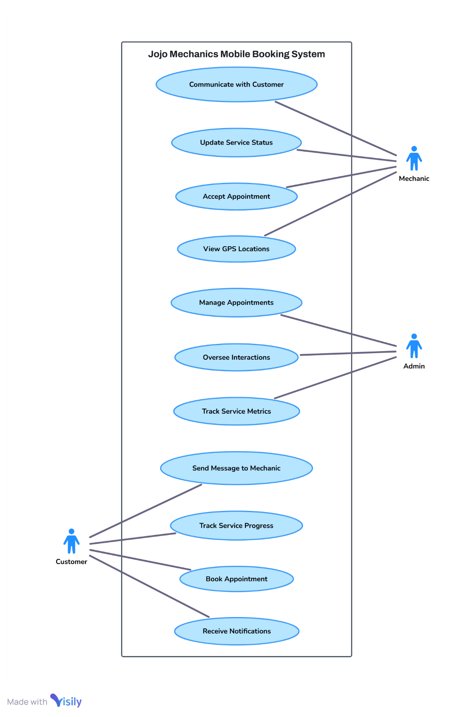
Figure 1: Use Case Diagram of the Jojo Mechanics

Source: Captured from visily

4.2.2 Context Analysis Diagram
The CAD defines the overall business or system boundary of interest. It defines a system’s domain under investigation within an organization’s environment. The CAD depicts the top process as ‘black box’ together with its major incoming and outgoing data flows linked to participating external entities within the domain. The Figure 4.1 below represents the CAD of the Alphabet and Numeral Reciter.

Table 4. 1. Meaning of the Symbols in the CAD
SYMBOLS | DESCRIPTION
 | - This represents external entities which are components outside the system (Jojo Mechanics Booking App).
 | - The arrows represent data flows describing the data that is being transferred from one source to a destination.

Figure 2: Context Analysis Diagram of Jojo Mechanics
Customer
- Books service
- Tracks repairs
- Requests help
- Gets reminders

Mechanics
- Updates repair status
- Confirms appointments
- Handles walk-ins
- Provides roadside help

Mobile App System
- Manage bookings
- Send notifications
- Track GPS for roadside
- Store vehicle history

Admin
- View analytics
-Manage users/requests
- Assign mechanics

4.2.3 Flow Chart
A Flow Chart (FC) uses graphical symbols to illustrate the flow of data and processes within the Jojo mechanics Booking System. It outlines the boundaries of the system and highlights how information moves from one stage to another. The diagram also indicates the origin of each data input and how it is processed throughout the system.
Table 4. 2. Meaning of the Symbols in the FC
SYMBOL | DESCRIPTION
 | This symbolizes the start and ending points.
 | This is the decision symbols, which is used in making decision in the flowchart.
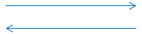 | The arrowheads show direction of data flow.
 | The process symbol shows how data is processed.
 | This is used for inputs and output of data.

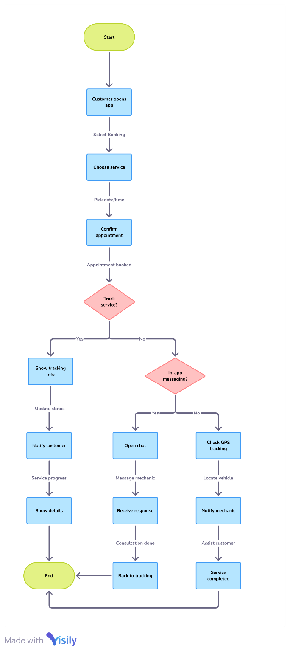
Figure 3: Flow Chart Displaying how Jojo Mechanics Mobile Booking System functions
Source: Captured from visily

4.2.4 Entity Relationship Diagram
An Entity Relationship Diagram (ERD) shows how databases are logically configured by defining entities, their characteristics, and the relationships that connect them. The goal of ERDs is to create a database design. They offer a graphic depiction of how information produced by a system is related.
Figure 4: Entity Relationship Diagram

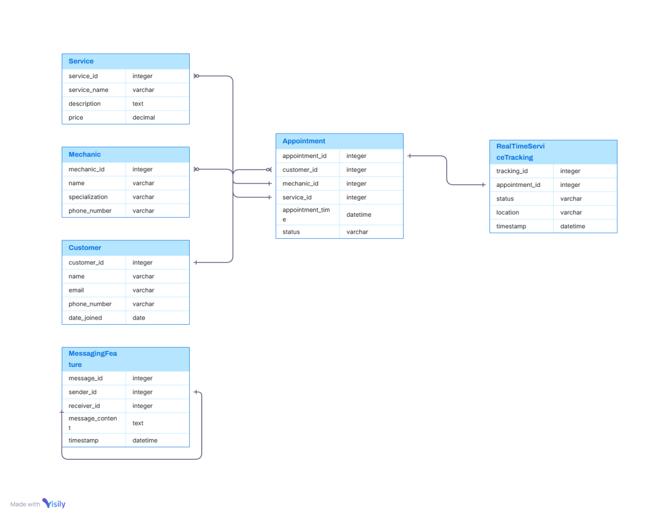
Source: Captured from visily

4.3 Graphical User Interfaces (GUI)
The figures described below were the various GUIs in the Proposed Jojo Mechanics Booking System.

Splash Screen 1

Figure 5: Splash Screen 1
Source: Captured from the software

This image shows Jojo Mechanic’s logo, which is the app's first splash screen or initial screen. It features a black rectangle logo with a stylized shield of tools icon.

Splash Screen 2

Figure 6: Splash Screen 2
Source: Captured from the software

This image shows Jojo Mechanic’s logo, which is the app's main splash screen or initial loading screen. It features a mechanic as the background and the motto of Jojo Mechanics.

Welcome Screen
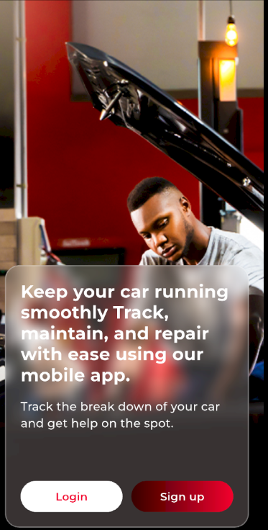
Figure 7: Splash Screen
Captured from the software

The third image shows a mechanic with text explaining that maintenance and repairs has become easier. Users can sign up or Login from this screen.

Sign-Up Screen
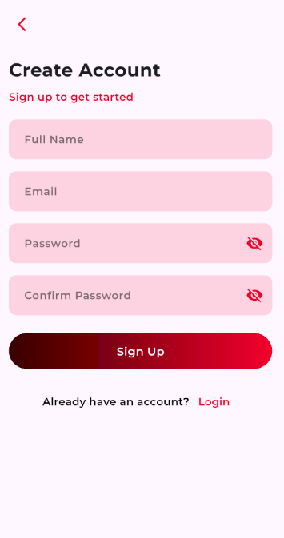
Figure 8: Sign-Up
Source: Captured from software

The sign-up image asks for the user's name, email, and password. There's also a link for those who already have an account to Login.

Login Screen
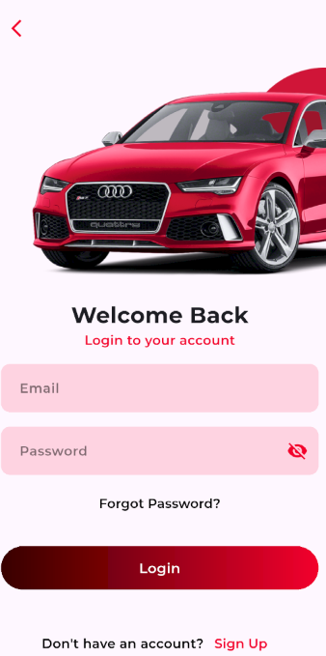
Figure 9: Login Screen
Source: Captured from software
The login image asks for the user's email, and password. Also there is a link to reset password when forgotten. There's also a link for those who don’t have an account to Sign-Up.

Homepage Screen
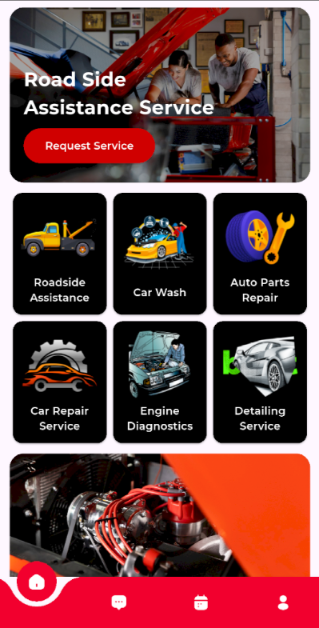
Figure 10: Homepage Screen
Source: Captured from software
The home screen post-login features buttons that show tips of their services. Above this, a section that helps roadside assistance services.

In-app messaging Screen
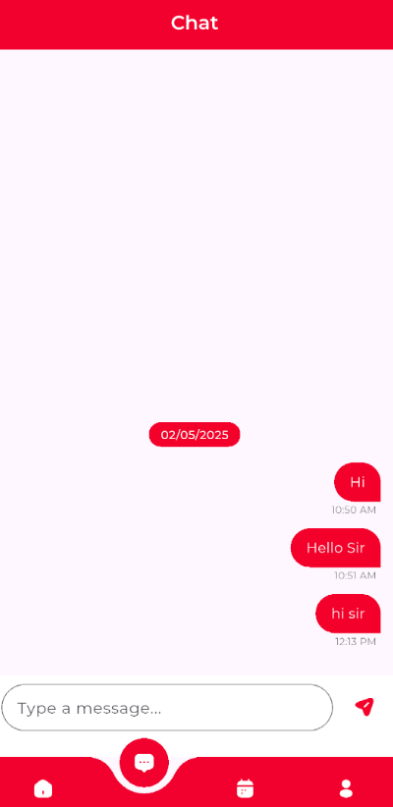
Figure 11: In-app messaging screen
Source: Captured from software

This screen is where interaction goes on between the mechanic and the customer via texting.

Booking Appointments Screen
Figure 12: Booking Appointments Screen
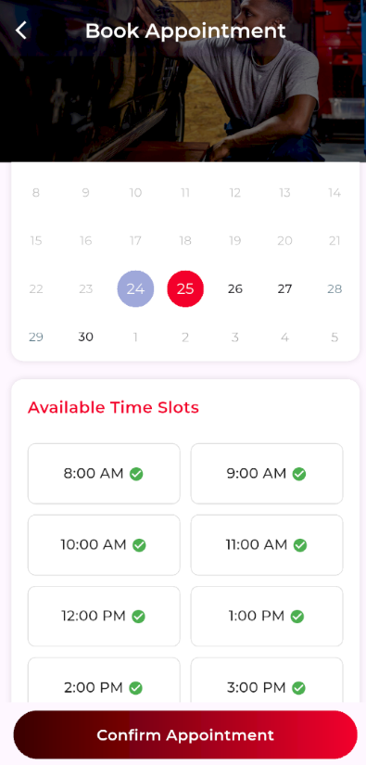
Source: Captured from Software

This image displays a list of “available time slots” available on a particular day selected. It shows multiple options of which each has it own time slot. The interface appears to be part of a web app designed for booking appointments in Ghana, allowing users to check availability and select their desired time.
GPS Tracking Screen
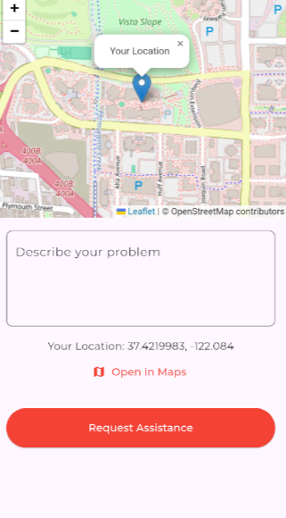
Figure 13: GPS Tracking Screen
Source: Captured from software

This image shows a roadside assistance service where your location would be tracked when “request assistance” button is pressed on. You can input your challenges in the text area, for easy problem solving.

Repair Tracking Screen
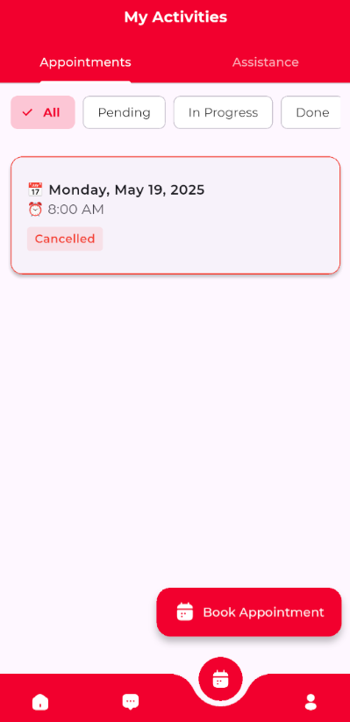
Figure 14: Repair Tracking Screen
Source: Captured from software
This image displays the repair tracking process whether your appointment is cancelled, completed, pending or in progress.

Profile Screen
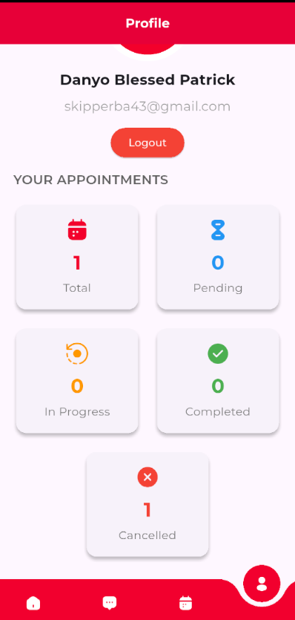
Figure 15: Profile Screen
Source: Captured from software
This image shows the user’s full name, email and the logout button, also it displays the total number of appointments been cancelled, completed, pending or in progress.

CHAPTER FIVE

TESTING AND IMPLEMENTATION

5.0 Introduction
This chapter outlines the testing and implementation phases of the Mobile Maintenance and Repair Booking Application for Jojo Mechanics. It highlights the testing procedures used to validate system reliability and performance, and explains the steps taken to ensure a successful and practical rollout. Training and post-launch maintenance are also discussed, along with system limitations and recommendations for future improvement.

5.1 Testing
Testing is a vital part of software development used to identify and correct defects before deployment. For the Jojo Mechanics system, two primary forms of testing were carried out: Unit Testing and Integrated Testing. These tests ensured that all system components functioned correctly both individually and collectively.

5.2 Unit Testing
Unit testing was conducted on each individual module of the application. The objective was to ensure that every feature worked as expected in isolation. Modules tested included:
- User Authentication: Sign-up and login processes for customers, mechanics, and admin.
- Booking Module: Allows users to book maintenance or repair appointments.
- Repair Status Tracker: Displays real-time updates on repair progress.
- GPS Module: Sends customer location to the mechanic for emergency pickup.
- In-App Chat: Enables communication between mechanic and customer.
- Notification System: Sends reminders, status changes, and alerts.
All modules passed unit testing, and any issues found were promptly resolved.

5.3 Integrated Testing
After unit testing, integrated testing was conducted to ensure all modules worked together seamlessly. This included:
- Full booking flow from registration to payment confirmation.
- GPS location sharing and mechanic assignment for emergency requests.
- Real-time updates being sent and displayed correctly.
- In-app messaging functioning across different user roles.
The integrated system was tested under various scenarios, including multiple concurrent users and network fluctuations. The system performed reliably under all test cases.

5.4 Implementation
Following successful testing, the system proceeded to the implementation phase. Key activities included:
- APK Deployment: The mobile application was compiled into APK format for Android devices and distributed for download.
- Backend Setup: Firebase services were configured to support authentication, real-time databases, and push notifications.
- Data Migration: Existing customer records and service logs were manually migrated into the new digital platform.
- Feature Configuration: Modules such as chat, GPS tracking, and appointment scheduling were activated and tested in live conditions.
The application was first released in beta to a group of mechanics and regular clients for initial real-world use before wider deployment.

5.5 Training
Training sessions were held to ensure effective use of the new application by both staff and customers. The training involved:
- Mechanic and Admin Training:
  - Managing appointments
  - Using the dashboard to view customer details and track jobs
  - Responding to in-app chat and GPS alerts
- Customer Orientation:
  - A simple user guide was created to explain how to:
    - Register and log in
    - Book a service
    - Track repairs and chat with mechanics
    - Share their location in emergencies
These efforts helped promote smooth adoption of the app.

5.6 Maintenance
A maintenance plan was introduced to ensure continuous operation and improvement of the system. This includes:
- Routine Updates: Regular releases to enhance features, fix bugs, and ensure compatibility with newer devices and OS versions.
- Technical Support: A dedicated line of support was made available to respond to user issues or questions.
- Performance Reviews: Regular system checks and performance evaluations are conducted to identify and fix bottlenecks or usability concerns.

5.7 Conclusion
The Mobile Maintenance and Repair Booking Application for Jojo Mechanics has been successfully tested, implemented, and adopted. It solves the inefficiencies associated with the previous manual system by introducing a user-friendly digital platform that enables customers to book services, track repair progress, and request emergency assistance with ease.
The system improves operational efficiency, enhances the customer experience, and positions Jojo Mechanics as a forward-thinking automotive service provider in Ghana.

5.8 Limitations
Despite its success, the system does have a few limitations:
- Dependence on Internet Access: Key features like booking and GPS tracking require an active internet connection, which may not always be reliable in remote areas.
- Adoption Barriers: Some users, particularly those less familiar with technology, may struggle to use the app without support.
- Android-Only Support: The application is currently limited to Android devices; iOS support is pending.
- Limited Offline Capabilities: The system requires real-time access to databases and does not yet support offline bookings or tracking.

5.9 Recommendations
To further improve the performance and user adoption of the system, the following recommendations are proposed:
- Offline Booking Support: Develop functionality that allows users to book services without internet and sync data when reconnected.
- User Support and Helpdesk: Maintain active customer support lines and include in-app guides or tutorials for first-time users.
- Expand to iOS: Build and deploy an iOS version of the app to serve a broader user base.
- Feature Enhancements: Add loyalty programs, service history reports, push promotions, and in-app payments in future updates.
- Gather Continuous Feedback: Use analytics and customer reviews to make iterative improvements based on actual user behavior.

REFERENCE
[1] YourMechanic, "Mobile Auto Repair Services," YourMechanic, Accessed: Oct. 27, 2023.
[2] AUTOsist, "Fleet Management Solutions," AUTOsist, Accessed: Oct. 27, 2023.
[3] Shipalana, P., "Digitizing Industries in Africa," Journal of African Studies, vol. 5, no. 3, pp. 45–56, 2019.
[4] Deloitte, "Digital Trends in Automotive Services in Ghana," Internal Report, 2022.
[5] Jojo Mechanics, "Operational Challenges in Ghana's Automotive Sector," Company Report, 2023.
[6] A. Mehra and J. Paul, "Adoption of Mobile Maintenance Apps," Journal of Business Studies, vol. 18, no. 4, pp. 321–338, 2020.
[7] AUTOsist, "Fleet Manager Tools," AUTOsist Publications, 2022.
[8] CarFax, "Car Care Features," CarFax Updates, 2023.
[9] Deloitte, “Digital Transformation In Automotive Service: Beyond The Connected Car,” Deloitte Insights, 2022. [Online]. Available: Https://Www2.Deloitte.Com
[10] Yourmechanic, "On-Demand Auto Repair Services," [Online]. Available: Https://Www.Yourmechanic.Com. [Accessed: 21-Apr-2025].
[11] GSMA, “The Mobile Economy Sub-Saharan Africa 2023,” GSMA Intelligence, 2023. [Online]. Available: Https://Www.Gsma.Com/Mobileeconomy/

APPENDIX

Programming Codes

Splash Screen Codes
import 'package:flutter/cupertino.dart';
import 'package:flutter/material.dart';
import 'package:flutter_riverpod/flutter_riverpod.dart';
import 'package:flutter_screenutil/flutter_screenutil.dart';
import 'package:jojo_automobile/common/app_colors.dart';
import 'package:jojo_automobile/provider/auth_check_provider.dart';

class SplashScreen extends ConsumerStatefulWidget {
const SplashScreen({super.key});

@override
ConsumerState<SplashScreen> createState() => _SplashScreenState();
}

class _SplashScreenState extends ConsumerState<SplashScreen> {
bool _imagesArePrecached = false;
bool _isLoading = true;

@override
void didChangeDependencies() {
super.didChangeDependencies();
if (!_imagesArePrecached) {
_initialize();
}
}

Future<void> _initialize() async {
if (!mounted) return;

setState(() => _isLoading = true);

try {
await Future.wait([
_precacheImages(),
// Minimum splash duration
Future.delayed(const Duration(seconds: 2)),
]);

if (!mounted) return;

// Listen to auth state and navigate
if (mounted) {
await ref.read(authCheckProvider)(context);
}
} catch (e) {
debugPrint('Initialization error: $e');
} finally {
if (mounted) {
setState(() => _isLoading = false);
}
}
}

Future<void> _precacheImages() async {
if (_imagesArePrecached) return;

try {
final futures = [
precacheImage(
const AssetImage("assets/images/pictures/splash_image.jpeg"),
context,
),
precacheImage(
const AssetImage("assets/images/logos/logo_image.png"),
context,
),
precacheImage(
const AssetImage("assets/images/logos/logo_text.png"),
context,
),
];

await Future.wait(futures);
_imagesArePrecached = true;
} catch (e) {
debugPrint('Error precaching images: $e');
}
}

@override
Widget build(BuildContext context) {
return Scaffold(
body: Container(
height: double.infinity,
width: double.infinity,
decoration: BoxDecoration(
color: AppColors.primary,
image: DecorationImage(
image: const AssetImage("assets/images/pictures/splash_image.jpeg"),
fit: BoxFit.cover,
alignment: Alignment.topCenter,
),
),
child: Stack(
children: [
Container(
height: double.infinity,
width: double.infinity,
color: const Color.fromARGB(103, 243, 2, 42),
),
Positioned(
bottom: 120.h,
left: 0.w,
right: 0.w,
child: Column(
mainAxisAlignment: MainAxisAlignment.center,
children: [
Image.asset(
"assets/images/logos/logo_image.png",
height: 130.h,
frameBuilder:
(context, child, frame, wasSynchronouslyLoaded) {
if (wasSynchronouslyLoaded) return child;
return AnimatedOpacity(
opacity: frame == null ? 0 : 1,
duration: const Duration(milliseconds: 500),
curve: Curves.easeOut,
child: child,
);
},
),
Image.asset(
"assets/images/logos/logo_text.png",
height: 75.h,
frameBuilder:
(context, child, frame, wasSynchronouslyLoaded) {
if (wasSynchronouslyLoaded) return child;
return AnimatedOpacity(
opacity: frame == null ? 0 : 1,
duration: const Duration(milliseconds: 500),
curve: Curves.easeOut,
child: child,
);
},
),
const Text(
"Driven to Care, Built to Last",
style: TextStyle(
color: Colors.white,
fontSize: 16,
fontWeight: FontWeight.w500,
),
),
SizedBox(height: 30.h),
if (_isLoading)
const CupertinoActivityIndicator(
color: Colors.white,
radius: 12,
),
],
),
),
],
),
),
);
}
}

Welcome Screen Codes
import 'package:flutter/material.dart';
import 'package:flutter_screenutil/flutter_screenutil.dart';
import 'package:go_router/go_router.dart';
import 'package:jojo_automobile/common/widgets.dart';
import 'package:jojo_automobile/view/onboarding/widgets/glass_container.dart';

class AuthScreen extends StatelessWidget {
const AuthScreen({super.key});

@override
Widget build(BuildContext context) {
return SafeArea(
child: Scaffold(
body: Stack(
children: [
SizedBox(
height: double.infinity,
width: double.infinity,
child: Image.asset(
'assets/images/pictures/auth_screen_bg.jpeg',
fit: BoxFit.cover,
),
),
Positioned(
bottom: 20.h,
left: 20.w,
right: 20.w,
child: GlassContainer(
height: 370.h,
child: Column(
mainAxisAlignment: MainAxisAlignment.spaceBetween,
children: [
Padding(
padding: EdgeInsets.only(bottom: 18.h),
child: Column(

children: [
Padding(
padding: EdgeInsets.only(bottom: 18.h),
child: Text(
"Keep your car running smoothly Track, maintain, and repair with ease using our mobile app.",
style: TextStyle(
fontSize: 24.sp,
fontWeight: FontWeight.w700,
color: Colors.white,
height: 1.2),
),
),
Text(
"Track the break down of your car and get help on the spot.",
style: TextStyle(
fontSize: 16.sp,
fontWeight: FontWeight.w500,
color: Colors.white,
),
),
],
),
),
Row(

children: [
Expanded(
child: SizedBox(
height: 44.h,
child: customButton(
onPressed: () => context.go('/login'),
text: "Login",
),
),
),
SizedBox(width: 12.w,),
Expanded(
child: SizedBox(
height: 44.h,
child: gradientButton(
text: "Sign up",
onPressed: () => context.go('/register'),
),
),
),
],
),
],
),
),
),
],
),
),
);
}
}

Home Screen Codes
import 'package:cloud_firestore/cloud_firestore.dart';
import 'package:flutter/material.dart';
import 'package:flutter_riverpod/flutter_riverpod.dart';
import 'package:flutter_screenutil/flutter_screenutil.dart';
import 'package:jojo_automobile/provider/auth_state_provider.dart';
import 'package:jojo_automobile/view/main/service_tips_screen.dart';
import 'package:jojo_automobile/view/main/widgets/grid_widgets.dart';

class HomeScreen extends ConsumerWidget {
const HomeScreen({super.key});

@override
Widget build(BuildContext context, WidgetRef ref) {
final authState = ref.watch(authStateProvider);
return Scaffold(
appBar: AppBar(
backgroundColor: Colors.black,
leading: Padding(
padding: EdgeInsets.only(left: 16.0.w),
child: Image.asset(
"assets/images/logos/logo_image.png",
width: 40.0.w,
height: 40.0.h,
),
),
title: authState.when(
data: (user) {
if (user == null) {
return _buildWelcomeText("User");
}
return FutureBuilder<DocumentSnapshot>(
future: FirebaseFirestore.instance
.collection('users')
.doc(user.uid)
.get(),
builder: (context, snapshot) {
if (snapshot.connectionState == ConnectionState.waiting) {
return _buildWelcomeText("Loading...");
}
if (!snapshot.hasData || !snapshot.data!.exists) {
return _buildWelcomeText("User");
}

final userData = snapshot.data!.data() as Map<String, dynamic>;
return _buildWelcomeText(userData['name'] ?? "User");
},
);
},
loading: () => _buildWelcomeText("Loading..."),
error: (_, __) => _buildWelcomeText("User"),
),
),
body: SafeArea(
child: Padding(
padding: EdgeInsets.only(left: 16.0.w, right: 16.0.w, top: 0.0.h),
child: SingleChildScrollView(
// physics: BouncingScrollPhysics(),
child: Column(
children: [
Padding(
padding: EdgeInsets.only(
bottom: 8.h,
top: 8.h,
),
child: heroCard(context),
),
Padding(
padding: EdgeInsets.only(bottom: 8.0.h),
child: GridView.count(
physics:
NeverScrollableScrollPhysics(), // Prevents internal scrolling
shrinkWrap: true, // Ensures it takes only the needed space
childAspectRatio: 0.78,

crossAxisCount: 3,
children: [
cardWidget(
title: "Roadside Assistance",
image:
"assets/images/pictures/home_grid_icons/roadside_assist.png",
onTap: () => Navigator.push(
context,
MaterialPageRoute(
builder: (_) => ServiceTipsScreen(
serviceTitle: "Roadside Assistance Tips",
tips: [
"Always keep emergency contact numbers saved in your phone",
"Move your vehicle to the shoulder or safe area when possible",
"Turn on hazard lights to alert other drivers",
"Place reflective triangles behind your vehicle for visibility",
"Keep a roadside emergency kit in your vehicle at all times",
"Stay inside your vehicle with doors locked if on a busy highway",
"Have your membership information and vehicle details ready when calling for help",
"Take photos of vehicle damage for insurance purposes",
"If you have a flat tire, park on level ground before attempting to change it",
"Keep water and non-perishable snacks in your car for unexpected delays",
"Share your location with a friend or family member when stranded",
"Keep a flashlight with fresh batteries in your glove compartment",
"Know how to change a tire and jump-start your vehicle as basic skills",
"In extreme weather, run the engine periodically to stay warm but ensure exhaust pipe is clear",
"Have a portable battery pack for charging your phone during emergencies"
],
),
),
),
),
// Car Wash Card (your existing code)
cardWidget(
title: "Car Wash",
image:
"assets/images/pictures/home_grid_icons/car_washing.png",
onTap: () => Navigator.push(
context,
MaterialPageRoute(
builder: (_) => ServiceTipsScreen(
serviceTitle: "Car Wash Tips",
tips: [
"Start with rinsing the car thoroughly",
"Use car-specific soap and washing mitt",
"Wash from top to bottom",
"Clean wheels and tires separately",
"Dry with microfiber towels to prevent water spots",
"Apply wax for protection and shine",
"Clean windows with automotive glass cleaner",
"Vacuum interior thoroughly",
"Wipe down dashboard and interior surfaces",
"Clean and condition leather seats if applicable"
],
),
),
),
),

cardWidget(
title: "Auto Parts Repair",
image:
"assets/images/pictures/home_grid_icons/auto_parts_repair.png",
onTap: () => Navigator.push(
context,
MaterialPageRoute(
builder: (_) => ServiceTipsScreen(
serviceTitle: "Auto Parts Repair Tips",
tips: [
"Identify the problematic part before beginning repairs",
"Always disconnect the battery before working on electrical components",
"Use the correct tools for the specific part",
"Consult your vehicle's service manual for specifications",
"Purchase OEM parts when possible for better fitment",
"Keep track of all removed parts and hardware",
"Take photos before disassembly for reference",
"Test the repaired part before complete reassembly",
"Check for any additional wear on connected components",
"Properly dispose of old parts and fluids"
],
),
),
),
),
cardWidget(
title: "Car Repair Service",
image:
"assets/images/pictures/home_grid_icons/car_repair_service.png",
onTap: () => Navigator.push(
context,
MaterialPageRoute(
builder: (_) => ServiceTipsScreen(
serviceTitle: "Car Repair Service Tips",
tips: [
"Maintain regular service intervals as recommended by manufacturer",
"Address unusual noises or vibrations immediately",
"Keep detailed records of all service work performed",
"Use certified mechanics for complex repairs",
"Request original or high-quality parts for replacements",
"Understand the warranty terms for repair work",
"Get a detailed estimate before authorizing repairs",
"Ask for the return of replaced parts for verification",
"Test drive after repairs to ensure issues are resolved",
"Follow up promptly if new issues arise after service"
],
),
),
),
),
cardWidget(
title: "Engine Diagnostics",
image:
"assets/images/pictures/home_grid_icons/engine_diag.png",
onTap: () => Navigator.push(
context,
MaterialPageRoute(
builder: (_) => ServiceTipsScreen(
serviceTitle: "Engine Diagnostics Tips",
tips: [
"Don't ignore check engine lights – address them promptly",
"Use OBD-II scanners to read engine codes",
"Understand that multiple issues may trigger a single code",
"Clear codes after repairs to ensure problems are fixed",
"Monitor engine performance after diagnostics",
"Check for software updates for your vehicle's ECU",
"Consider both sensor readings and physical symptoms",
"Keep records of all diagnostic codes and repairs",
"Repeat diagnostic scans after repairs to confirm resolution",
"Maintain clean air filters and fuel systems to prevent issues"
],
),
),
),
),
cardWidget(
title: "Detailing Service",
image:
"assets/images/pictures/home_grid_icons/detailing_service.png",
onTap: () => Navigator.push(
context,
MaterialPageRoute(
builder: (_) => ServiceTipsScreen(
serviceTitle: "Detailing Service Tips",
tips: [
"Start with a thorough exterior wash and clay bar treatment",
"Use pH-neutral cleaning products to protect surfaces",
"Apply paint protection like wax, sealant, or ceramic coating",
"Clean wheels and tires with dedicated products",
"Detail engine bay with appropriate degreasers and protectants",
"Vacuum all interior surfaces including under seats",
"Clean air vents with compressed air and detail brushes",
"Condition leather surfaces to prevent cracking",
"Clean and protect vinyl and plastic interior components",
"Apply glass treatment for improved visibility in rain"
],
),
),
),
),
],
),
),
// Bottom Scrollable Container
Container(
width: double.infinity,
height: 170.0.h,
margin: EdgeInsets.only(
bottom: 30.h,
),
decoration: BoxDecoration(
color: Colors.red,
image: DecorationImage(
image: AssetImage(
"assets/images/pictures/home_bottom_image.jpeg"),
fit: BoxFit.cover,
),
borderRadius: BorderRadius.circular(
16.r,
),
),
),
],
),
),
),
),
);
}

Widget _buildWelcomeText(String name) {
return Column(
crossAxisAlignment: CrossAxisAlignment.start,
children: [
Text(
"Welcome Back",
style: TextStyle(
color: const Color.fromARGB(255, 198, 198, 198),
fontSize: 13.0.sp,
fontWeight: FontWeight.w500,
),
),
Text(
name,
style: TextStyle(
color: Colors.white,
fontSize: 16.0.sp,
fontWeight: FontWeight.w600,
),
maxLines: 1,
overflow: TextOverflow.ellipsis,
),
],
);
}
}

Booking Appointments Codes
// ignore_for_file: unused_result

import 'package:cloud_firestore/cloud_firestore.dart';
import 'package:firebase_auth/firebase_auth.dart';
import 'package:flutter/cupertino.dart';
import 'package:flutter/material.dart';
import 'package:flutter_screenutil/flutter_screenutil.dart';
import 'package:flutter_riverpod/flutter_riverpod.dart';
import 'package:go_router/go_router.dart';
import 'package:enefty_icons/enefty_icons.dart';
import 'package:intl/intl.dart';
import 'package:jojo_automobile/common/app_colors.dart';
import 'package:jojo_automobile/controller/appointment_repository.dart';
import 'package:jojo_automobile/provider/appointment_provider.dart';
import 'package:url_launcher/url_launcher.dart';

// Provider for assistance requests
final assistanceRequestsProvider =
StreamProvider<List<DocumentSnapshot>>((ref) {
final user = FirebaseAuth.instance.currentUser;
if (user == null) return Stream.value([]);

return FirebaseFirestore.instance
.collection('assistance_requests')
.where('userId', isEqualTo: user.uid)
.orderBy('timestamp', descending: true)
.snapshots()
.map((snap) => snap.docs);
});

class AppointmentScreen extends ConsumerStatefulWidget {
const AppointmentScreen({super.key});

@override
ConsumerState<AppointmentScreen> createState() => _AppointmentScreenState();
}

class _AppointmentScreenState extends ConsumerState<AppointmentScreen>
with SingleTickerProviderStateMixin {
late TabController _tabController;

@override
void initState() {
super.initState();
_tabController = TabController(length: 2, vsync: this);

// Add listener for tab changes
_tabController.addListener(_handleTabChange);

// Refresh both providers on init
WidgetsBinding.instance.addPostFrameCallback((_) {
ref.refresh(userAppointmentsProvider);
ref.refresh(assistanceRequestsProvider);
});
}

void _handleTabChange() {
if (_tabController.indexIsChanging) {
// Refresh the appropriate provider based on the selected tab
if (_tabController.index == 0) {
ref.refresh(userAppointmentsProvider);
} else {
ref.refresh(assistanceRequestsProvider);
}
}
}

@override
void dispose() {
_tabController.removeListener(_handleTabChange);
_tabController.dispose();
super.dispose();
}

@override
Widget build(BuildContext context) {
return Scaffold(
appBar: AppBar(
backgroundColor: AppColors.bottomNavBg,
title: Text(
"My Activities",
style: TextStyle(
fontWeight: FontWeight.w700,
color: Colors.white,
fontSize: 16.sp,
),
),
centerTitle: true,
automaticallyImplyLeading: false,
bottom: TabBar(
controller: _tabController,
labelColor: Colors.white,
unselectedLabelColor: Colors.white70,
indicatorColor: Colors.white,
tabs: const [
Tab(text: 'Appointments'),
Tab(text: 'Assistance'),
],
),
),
body: TabBarView(
controller: _tabController,
children: [
_AppointmentsTab(),
_AssistanceRequestsTab(),
],
),
floatingActionButton: _tabController.index == 0
? Container(
margin: EdgeInsets.only(bottom: 24.h),
child: FloatingActionButton.extended(
backgroundColor: AppColors.bottomNavBg,
foregroundColor: Colors.white,
onPressed: () async {
final result = await context.push('/new-appointment');

if (result == true) {
ref.refresh(userAppointmentsProvider);
}
},
label: Row(
children: [
Icon(EneftyIcons.calendar_2_bold),
SizedBox(width: 8.w),
Text("Book Appointment"),
],
),
),
)
: null,
floatingActionButtonLocation: FloatingActionButtonLocation.endFloat,
);
}
}

class _AppointmentsTab extends ConsumerStatefulWidget {
@override
ConsumerState<_AppointmentsTab> createState() => _AppointmentsTabState();
}

class _AppointmentsTabState extends ConsumerState<_AppointmentsTab> {
String _statusFilter = 'All';
final List<String> _statusOptions = [
'All',
'Pending',
'In Progress',
'Done',
'Cancelled'
];

@override
Widget build(BuildContext context) {
final appointmentAsync = ref.watch(userAppointmentsProvider);
final appointmentRepo = ref.read(appointmentRepositoryProvider);

return RefreshIndicator(
onRefresh: () async {
ref.refresh(userAppointmentsProvider);
},
child: Column(
children: [
// Status Filter
Container(
padding: EdgeInsets.symmetric(horizontal: 16.w, vertical: 8.h),
child: SingleChildScrollView(
scrollDirection: Axis.horizontal,
child: Row(
children: _statusOptions.map((status) {
final isSelected = _statusFilter == status;
return Padding(
padding: EdgeInsets.only(right: 8.w),
child: FilterChip(
selected: isSelected,
label: Text(status),
onSelected: (selected) {
setState(() {
_statusFilter = selected ? status : 'All';
});
},
backgroundColor: Colors.white,
selectedColor: AppColors.primary.withOpacity(0.2),
checkmarkColor: AppColors.primary,
labelStyle: TextStyle(
color: isSelected ? AppColors.primary : Colors.black87,
fontWeight:
isSelected ? FontWeight.bold : FontWeight.normal,
),
),
);
}).toList(),
),
),
),
// Appointments List
Expanded(
child: appointmentAsync.when(
data: (appointments) {
if (appointments.isEmpty) {
return _EmptyState(
icon: EneftyIcons.calendar_2_outline,
message: "Your appointments will appear here",
);
}

// Sort appointments by date and time (newest first)
final sortedAppointments = List<Appointment>.from(appointments)
..sort((a, b) {
final aDateTime = _combineDateAndTime(a.date, a.time);
final bDateTime = _combineDateAndTime(b.date, b.time);
return bDateTime
.compareTo(aDateTime); // Reverse order for newest first
});

// Filter appointments based on status
final filteredAppointments =
sortedAppointments.where((appointment) {
if (_statusFilter == 'All') return true;

final status = _getAppointmentStatus(
appointment.date,
appointment.time,
appointment.status,
);
return status == _statusFilter;
}).toList();

if (filteredAppointments.isEmpty) {
return _EmptyState(
icon: EneftyIcons.calendar_2_outline,
message: "No $_statusFilter appointments found",
);
}

return ListView.builder(
padding: EdgeInsets.all(16.w),
itemCount: filteredAppointments.length,
itemBuilder: (context, index) {
final appointment = filteredAppointments[index];
return _AppointmentCard(
appointment: appointment,
repo: appointmentRepo,
);
},
);
},
loading: () => const Center(child: CupertinoActivityIndicator()),
error: (error, stack) => Center(
child: Column(
mainAxisAlignment: MainAxisAlignment.center,
children: [
Text('Error: $error'),
ElevatedButton(
onPressed: () => ref.refresh(userAppointmentsProvider),
child: Text('Retry'),
),
],
),
),
),
),
],
),
);
}

DateTime _combineDateAndTime(DateTime date, String timeStr) {
final timeParts = timeStr.split(' ');
final time = timeParts[0].split(':');
final period = timeParts[1].toUpperCase();

int hour = int.parse(time[0]);
int minute = 0;

if (time.length > 1) {
minute = int.parse(time[1]);
}

if (period == 'PM' && hour != 12) {
hour += 12;
} else if (period == 'AM' && hour == 12) {
hour = 0;
}

return DateTime(
date.year,
date.month,
date.day,
hour,
minute,
);
}

String _getAppointmentStatus(DateTime date, String time, String status) {
if (status == 'cancelled') return 'Cancelled';
if (status == 'done') return 'Done';

final appointmentDateTime = _parseDateTime(date, time);
final now = DateTime.now();

if (appointmentDateTime.isBefore(now)) {
if (status == 'in_progress') return 'In Progress';
return 'In Progress';
}

if (status == 'in_progress') return 'In Progress';
return 'Pending';
}

DateTime _parseDateTime(DateTime date, String timeStr) {
final timeParts = timeStr.split(' ');
final time = timeParts[0].split(':');
final period = timeParts[1].toUpperCase();

int hour = int.parse(time[0]);
int minute = 0;

if (time.length > 1) {
minute = int.parse(time[1]);
}

if (period == 'PM' && hour != 12) {
hour += 12;
} else if (period == 'AM' && hour == 12) {
hour = 0;
}

return DateTime(
date.year,
date.month,
date.day,
hour,
minute,
);
}
}

class _AssistanceRequestsTab extends ConsumerStatefulWidget {
@override
ConsumerState<_AssistanceRequestsTab> createState() =>
_AssistanceRequestsTabState();
}

class _AssistanceRequestsTabState
extends ConsumerState<_AssistanceRequestsTab> {
String _statusFilter = 'All';
final List<String> _statusOptions = [
'All',
'Pending',
'On The Way',
'Completed'
];

String _getDisplayStatus(String? dbStatus) {
switch (dbStatus?.toLowerCase()) {
case 'on_the_way':
return 'On The Way';
case 'completed':
return 'Completed';
case 'pending':
default:
return 'Pending';
}
}

@override
Widget build(BuildContext context) {
final assistanceRequests = ref.watch(assistanceRequestsProvider);

return RefreshIndicator(
onRefresh: () async {
ref.refresh(assistanceRequestsProvider);
},
child: Column(
children: [
// Status Filter
Container(
padding: EdgeInsets.symmetric(horizontal: 16.w, vertical: 8.h),
child: SingleChildScrollView(
scrollDirection: Axis.horizontal,
child: Row(
children: _statusOptions.map((status) {
final isSelected = _statusFilter == status;
return Padding(
padding: EdgeInsets.only(right: 8.w),
child: FilterChip(
selected: isSelected,
label: Text(status),
onSelected: (selected) {
setState(() {
_statusFilter = selected ? status : 'All';
});
},
backgroundColor: Colors.white,
selectedColor: AppColors.primary.withOpacity(0.2),
checkmarkColor: AppColors.primary,
labelStyle: TextStyle(
color: isSelected ? AppColors.primary : Colors.black87,
fontWeight:
isSelected ? FontWeight.bold : FontWeight.normal,
),
),
);
}).toList(),
),
),
),
// Assistance Requests List
Expanded(
child: assistanceRequests.when(
data: (requests) {
if (requests.isEmpty) {
return _EmptyState(
icon: EneftyIcons.car_outline,
message: "No assistance requests yet",
);
}

// Sort requests by timestamp (newest first)
final sortedRequests = List<DocumentSnapshot>.from(requests)
..sort((a, b) {
final aData = a.data() as Map<String, dynamic>;
final bData = b.data() as Map<String, dynamic>;
final aTime = (aData['timestamp'] as Timestamp).toDate();
final bTime = (bData['timestamp'] as Timestamp).toDate();
return bTime.compareTo(aTime);
});

// Filter requests based on status
final filteredRequests = sortedRequests.where((doc) {
final data = doc.data() as Map<String, dynamic>;
if (_statusFilter == 'All') return true;

final displayStatus = _getDisplayStatus(data['status']);
return displayStatus == _statusFilter;
}).toList();

if (filteredRequests.isEmpty) {
return _EmptyState(
icon: EneftyIcons.car_outline,
message: "No assistance requests found",
);
}

return ListView.builder(
padding: EdgeInsets.all(16.w),
itemCount: filteredRequests.length,
itemBuilder: (context, index) {
final request =
filteredRequests[index].data() as Map<String, dynamic>;
return _AssistanceRequestCard(request: request);
},
);
},
loading: () => const Center(child: CupertinoActivityIndicator()),
error: (error, stack) => Center(
child: Column(
mainAxisAlignment: MainAxisAlignment.center,
children: [
Text('Error: $error'),
ElevatedButton(
onPressed: () => ref.refresh(assistanceRequestsProvider),
child: Text('Retry'),
),
],
),
),
),
),
],
),
);
}
}

class _AppointmentCard extends StatelessWidget {
final Appointment appointment;
final AppointmentRepository repo;

const _AppointmentCard({
required this.appointment,
required this.repo,
});

@override
Widget build(BuildContext context) {
final status = _getAppointmentStatus(
appointment.date,
appointment.time,
appointment.status,
);
final statusColor = _getStatusColor(status);

return Card(
margin: EdgeInsets.only(bottom: 12.h),
elevation: 3,
shape: RoundedRectangleBorder(
borderRadius: BorderRadius.circular(12.r),
),
child: Container(
decoration: BoxDecoration(
borderRadius: BorderRadius.circular(12.r),
border: Border.all(color: statusColor, width: 1),
),
child: ListTile(
contentPadding: EdgeInsets.all(16.w),
title: Text(
"📅 ${DateFormat('EEEE, MMMM d, y').format(appointment.date)}",
style: TextStyle(
fontWeight: FontWeight.w600,
fontSize: 14.sp,
),
),
subtitle: Column(
crossAxisAlignment: CrossAxisAlignment.start,
children: [
Text(
"⏰ ${appointment.time}",
style: TextStyle(fontSize: 14.sp),
),
SizedBox(height: 8.h),
_StatusBadge(status: status, color: statusColor),
],
),
trailing: _buildActionButton(context, status),
),
),
);
}

String _getAppointmentStatus(DateTime date, String time, String status) {
if (status == 'cancelled') return 'Cancelled';
if (status == 'done') return 'Done';

final appointmentDateTime = _parseDateTime(date, time);
final now = DateTime.now();

if (appointmentDateTime.isBefore(now)) {
if (status == 'in_progress') return 'In Progress';
return 'In Progress';
}

if (status == 'in_progress') return 'In Progress';
return 'Pending';
}

DateTime _parseDateTime(DateTime date, String timeStr) {
final timeParts = timeStr.split(' ');
final time = timeParts[0].split(':');
final period = timeParts[1].toUpperCase();

int hour = int.parse(time[0]);
int minute = 0;

// Handle potential formatting issues
if (time.length > 1) {
minute = int.parse(time[1]);
}

if (period == 'PM' && hour != 12) {
hour += 12;
} else if (period == 'AM' && hour == 12) {
hour = 0;
}

return DateTime(
date.year,
date.month,
date.day,
hour,
minute,
);
}

String _formatDate(DateTime date) {
return DateFormat('MMMM d, y').format(date);
}

void _showCancelDialog(BuildContext context) {
showDialog(
context: context,
builder: (BuildContext context) {
return AlertDialog(
title: Center(
child: Text(
"Cancel Appointment",
style: TextStyle(
color: Colors.red,
fontSize: 16.sp,
fontWeight: FontWeight.w600,
),
),
),
content: Text(
"Are you sure you want to cancel this appointment?",
textAlign: TextAlign.center,
style: TextStyle(
fontSize: 14.sp,
fontWeight: FontWeight.w500,
),
),
actions: [
TextButton(
onPressed: () => Navigator.of(context).pop(),
child: Text(
"No",
style: TextStyle(color: Colors.black),
),
),
TextButton(
onPressed: () async {
await repo.updateAppointment(
id: appointment.id,
newDate: appointment.date,
newTime: appointment.time,
newStatus: 'cancelled',
);
if (context.mounted) {
Navigator.of(context).pop();
ScaffoldMessenger.of(context).showSnackBar(
SnackBar(
backgroundColor: Colors.green,
content: Text(
"Appointment cancelled successfully",
style: TextStyle(color: Colors.white),
),
behavior: SnackBarBehavior.floating,
),
);
}
},
child: Text(
"Yes",
style: TextStyle(
color: Colors.red,
fontWeight: FontWeight.w600,
),
),
),
],
);
},
);
}

void _showEditDialog(BuildContext context, AppointmentRepository repo,
Appointment appointment) {
DateTime selectedDate = appointment.date;

TimeOfDay selectedTime;
try {
final timeParts = appointment.time.split(':');
int hour = int.parse(timeParts[0]);
int minute = int.parse(timeParts[1].split(' ')[0]);

if (appointment.time.contains('PM') && hour != 12) {
hour += 12;
} else if (appointment.time.contains('AM') && hour == 12) {
hour = 0;
}

selectedTime = TimeOfDay(hour: hour, minute: minute);
} catch (e) {
selectedTime = TimeOfDay.now();
}

showDialog(
context: context,
builder: (context) {
return AlertDialog(
title: Center(
child: Text(
"Edit Appointment",
style: TextStyle(
color: Colors.blue,
fontSize: 16.sp,
fontWeight: FontWeight.w600,
),
),
),
content: SizedBox(
width: MediaQuery.of(context).size.width * 0.8,
child: Column(
mainAxisSize: MainAxisSize.min,
children: [
ListTile(
leading: Icon(Icons.calendar_today, color: Colors.blue),
title: Text(
_formatDate(selectedDate),
overflow: TextOverflow.visible,
style: TextStyle(fontSize: 14.sp),
),
trailing: IconButton(
onPressed: () async {
DateTime? picked = await showDatePicker(
context: context,
initialDate: selectedDate,
firstDate: DateTime.now(),
lastDate: DateTime(2100),
);
if (picked != null) {
selectedDate = picked;
}
},
icon: Icon(Icons.edit),
),
),
ListTile(
leading: Icon(Icons.access_time, color: Colors.blue),
title: Text(
selectedTime.format(context),
overflow: TextOverflow.visible,
style: TextStyle(fontSize: 14.sp),
),
trailing: IconButton(
onPressed: () async {
TimeOfDay? picked = await showTimePicker(
context: context,
initialTime: selectedTime,
builder: (BuildContext context, Widget? child) {
return MediaQuery(
data: MediaQuery.of(context).copyWith(
alwaysUse24HourFormat: false,
),
child: Theme(
data: ThemeData.light().copyWith(
timePickerTheme: TimePickerThemeData(
hourMinuteColor: WidgetStateColor.resolveWith(
(states) =>
states.contains(WidgetState.selected)
? Colors.blue
: Colors.grey.shade200,
),
),
colorScheme: ColorScheme.light(
primary: Colors.blue,
),
),
child: child!,
),
);
},
);
if (picked != null) {
selectedTime = picked;
}
},
icon: Icon(Icons.edit),
),
),
],
),
),
actions: [
TextButton(
onPressed: () => Navigator.pop(context),
child: Text(
"Cancel",
style:
TextStyle(color: Colors.black, fontWeight: FontWeight.w500),
),
),
TextButton(
onPressed: () async {
final now = DateTime.now();
final selectedDateTime = DateTime(
selectedDate.year,
selectedDate.month,
selectedDate.day,
selectedTime.hour,
selectedTime.minute,
);

final businessHoursStart = TimeOfDay(hour: 8, minute: 0);
final businessHoursEnd = TimeOfDay(hour: 17, minute: 0);

double timeToDouble(TimeOfDay time) =>
time.hour + time.minute / 60.0;

final selectedTimeValue = timeToDouble(selectedTime);
final startTimeValue = timeToDouble(businessHoursStart);
final endTimeValue = timeToDouble(businessHoursEnd);

String? errorMessage;

if (selectedDateTime.isBefore(now)) {
errorMessage = "Cannot schedule appointments in the past.";
} else if (selectedTimeValue < startTimeValue ||
selectedTimeValue >= endTimeValue) {
errorMessage =
"Appointments must be between 8:00 AM and 5:00 PM.";
}

if (errorMessage != null) {
// Show error message
if (context.mounted) {
ScaffoldMessenger.of(context).showSnackBar(
SnackBar(
backgroundColor: Colors.red,
content: Text(
errorMessage,
style: TextStyle(color: Colors.white),
),
behavior: SnackBarBehavior.floating,
),
);
}
return;
}

String formattedTime =
"${selectedTime.hourOfPeriod}:${selectedTime.minute.toString().padLeft(2, '0')} ${selectedTime.period == DayPeriod.am ? 'AM' : 'PM'}";

await repo.updateAppointment(
id: appointment.id,
newDate: selectedDate,
newTime: formattedTime,
newStatus: appointment.status,
);

if (context.mounted) {
Navigator.pop(context);
ScaffoldMessenger.of(context).showSnackBar(
SnackBar(
backgroundColor: Colors.green,
content: Text(
"Appointment updated successfully!",
style: TextStyle(color: Colors.white),
),
behavior: SnackBarBehavior.floating,
),
);
}
},
child: Text(
"Save",
style:
TextStyle(color: Colors.blue, fontWeight: FontWeight.w600),
),
),
],
);
},
);
}

Widget? _buildActionButton(BuildContext context, String status) {
if (status == 'Done' || status == 'Cancelled') return null;

return PopupMenuButton<String>(
onSelected: (value) {
if (value == 'edit') {
_showEditDialog(context, repo, appointment);
} else if (value == 'cancel') {
_showCancelDialog(context);
}
},
itemBuilder: (context) => [
if (status == 'Pending')
PopupMenuItem(
value: 'edit',
child: _MenuItemContent(
icon: Icons.edit,
color: Colors.blue,
text: 'Edit',
),
),
PopupMenuItem(
value: 'cancel',
child: _MenuItemContent(
icon: Icons.cancel,
color: Colors.red,
text: 'Cancel',
),
),
],
child: Icon(Icons.more_vert),
);
}
}

class _MenuItemContent extends StatelessWidget {
final IconData icon;
final Color color;
final String text;

const _MenuItemContent({
required this.icon,
required this.color,
required this.text,
});

@override
Widget build(BuildContext context) {
return Row(
children: [
Icon(icon, color: color, size: 20),
SizedBox(width: 8.w),
Text(
text,
style: TextStyle(
color: color,
fontSize: 14.sp,
),
),
],
);
}
}

class _AssistanceRequestCard extends StatelessWidget {
final Map<String, dynamic> request;

const _AssistanceRequestCard({required this.request});

@override
Widget build(BuildContext context) {
final timestamp = (request['timestamp'] as Timestamp).toDate();

return Card(
margin: EdgeInsets.only(bottom: 12.h),
elevation: 3,
shape: RoundedRectangleBorder(
borderRadius: BorderRadius.circular(12.r),
),
child: Container(
decoration: BoxDecoration(
borderRadius: BorderRadius.circular(12.r),
border: Border.all(
color: _getAssistanceStatusColor(request['status']),
width: 1,
),
),
child: ListTile(
contentPadding: EdgeInsets.all(16.w),
title: Text(
"🚗 Roadside Assistance",
style: TextStyle(
fontWeight: FontWeight.w600,
fontSize: 14.sp,
),
),
subtitle: Column(
crossAxisAlignment: CrossAxisAlignment.start,
children: [
Text(
"📝 ${request['problem'] ?? 'No details provided'}",
style: TextStyle(fontSize: 14.sp),
),
Text(
"⏰ ${DateFormat('MMM d, y h:mm a').format(timestamp)}",
style: TextStyle(fontSize: 14.sp),
),
SizedBox(height: 8.h),
_StatusBadge(
status: _formatAssistanceStatus(request['status']),
color: _getAssistanceStatusColor(request['status']),
),
],
),
trailing: request['locationUrl'] != null
? IconButton(
icon: const Icon(Icons.map_outlined, color: Colors.red),
onPressed: () => _openLocation(request['locationUrl']),
)
: null,
),
),
);
}

void _openLocation(String url) {
// Add check to prevent launching invalid URLs
if (url.isNotEmpty) {
launchUrl(Uri.parse(url), mode: LaunchMode.externalApplication);
}
}
}

class _EmptyState extends StatelessWidget {
final IconData icon;
final String message;

const _EmptyState({
required this.icon,
required this.message,
});

@override
Widget build(BuildContext context) {
return Center(
child: Column(
mainAxisAlignment: MainAxisAlignment.center,
children: [
Icon(
icon,
size: 60.sp,
color: Colors.grey[400],
),
SizedBox(height: 16.h),
Text(
message,
style: TextStyle(
color: Colors.grey[400],
fontSize: 16.sp,
),
),
],
),
);
}
}

class _StatusBadge extends StatelessWidget {
final String status;
final Color color;

const _StatusBadge({
required this.status,
required this.color,
});

@override
Widget build(BuildContext context) {
return Container(
padding: EdgeInsets.symmetric(horizontal: 8.w, vertical: 4.h),
decoration: BoxDecoration(
color: color.withOpacity(0.1),
borderRadius: BorderRadius.circular(4.r),
),
child: Text(
status,
style: TextStyle(
color: color,
fontSize: 12.sp,
fontWeight: FontWeight.w600,
),
),
);
}
}

Color _getStatusColor(String status) {
switch (status.toLowerCase()) {
case 'pending':
return Colors.blue;
case 'in progress':
return Colors.orange;
case 'done':
return Colors.green;
case 'cancelled':
return Colors.red;
default:
return Colors.grey;
}
}

Color _getAssistanceStatusColor(String? status) {
switch (status?.toLowerCase()) {
case 'pending':
return Colors.blue;
case 'on_the_way':
return Colors.orange;
case 'completed':
return Colors.green;
default:
return Colors.grey;
}
}

String _formatAssistanceStatus(String? status) {
if (status == null) return 'PENDING';
return status.replaceAll('_', ' ').toUpperCase();
}

Chat Screen Codes

import 'package:cloud_firestore/cloud_firestore.dart';
import 'package:enefty_icons/enefty_icons.dart';
import 'package:firebase_auth/firebase_auth.dart';
import 'package:flutter/material.dart';
import 'package:flutter_riverpod/flutter_riverpod.dart';
import 'package:flutter_screenutil/flutter_screenutil.dart';
import 'package:jojo_automobile/common/app_colors.dart';
import 'package:jojo_automobile/provider/chat_provider.dart';
import 'package:intl/intl.dart';

import '../../model/message_model.dart';

final adminUserProvider = StreamProvider((ref) {
return FirebaseFirestore.instance
.collection('users')
.where('admin', isEqualTo: true)
.limit(1)
.snapshots()
.map((snapshot) => snapshot.docs.isNotEmpty ? snapshot.docs.first : null);
});

class ChatScreen extends ConsumerStatefulWidget {
const ChatScreen({super.key});

@override
ConsumerState<ChatScreen> createState() => _ChatScreenState();
}

class _ChatScreenState extends ConsumerState<ChatScreen> {
final TextEditingController _messageController = TextEditingController();
final ScrollController _scrollController = ScrollController();

Future<void> _sendMessage(String adminId) async {
if (_messageController.text.trim().isEmpty) return;

final currentUser = FirebaseAuth.instance.currentUser;
if (currentUser == null) return;

try {
await FirebaseFirestore.instance.collection('messages').add({
'senderId': currentUser.uid,
'receiverId': adminId,
'content': _messageController.text.trim(),
'timestamp': FieldValue.serverTimestamp(),
'participants': [currentUser.uid, adminId],
});

_messageController.clear();
_scrollController.animateTo(
0,
duration: const Duration(milliseconds: 300),
curve: Curves.easeOut,
);
} catch (e) {
print('Error sending message: $e');
}
}

String _formatTime(DateTime date) {
return DateFormat('h:mm a').format(date);
}

String _formatDate(DateTime date) {
final now = DateTime.now();
final today = DateTime(now.year, now.month, now.day);
final yesterday = today.subtract(const Duration(days: 1));
final messageDate = DateTime(date.year, date.month, date.day);

if (messageDate == today) {
return 'Today';
} else if (messageDate == yesterday) {
return 'Yesterday';
} else {
return DateFormat('dd/MM/yyyy').format(date);
}
}

String _getDateKey(DateTime date) {
return DateTime(date.year, date.month, date.day).toIso8601String();
}

Widget _buildMessageGroup(List<MessageModel> messages, String currentUserId) {
return ListView.builder(
reverse: true,
shrinkWrap: true,
physics: const NeverScrollableScrollPhysics(),
itemCount: messages.length,
itemBuilder: (context, index) {
final message = messages[index];
final isMe = message.senderId == currentUserId;

return Padding(
padding: const EdgeInsets.only(bottom: 12),
child: Column(
crossAxisAlignment:
isMe ? CrossAxisAlignment.end : CrossAxisAlignment.start,
children: [
Container(
margin: EdgeInsets.only(
left: isMe ? 64 : 0,
right: isMe ? 0 : 64,
),
padding: const EdgeInsets.symmetric(
horizontal: 16,
vertical: 10,
),
decoration: BoxDecoration(
color: isMe ? AppColors.primary : Colors.grey[300],
borderRadius: isMe
? BorderRadius.only(
topLeft: Radius.circular(20.r),
topRight: Radius.circular(20.r),
bottomLeft: Radius.circular(20.r),
)
: BorderRadius.only(
topLeft: Radius.circular(20.r),
topRight: Radius.circular(20.r),
bottomRight: Radius.circular(20.r),
),
),
child: Text(
message.content,
style: TextStyle(
color: isMe ? Colors.white : Colors.black,
),
),
),
Padding(
padding: EdgeInsets.only(
top: 1.h,
left: 4.w,
right: 4.w,
),
child: Text(
_formatTime(message.timestamp?.toDate() ?? DateTime.now()),
style: TextStyle(
fontSize: 10,
color: Colors.grey[600],
),
),
),
],
),
);
},
);
}

Widget _buildDateHeader(String date) {
return Container(
padding: const EdgeInsets.symmetric(vertical: 16),
alignment: Alignment.center,
child: Container(
padding: const EdgeInsets.symmetric(
horizontal: 12,
vertical: 4,
),
decoration: BoxDecoration(
color: AppColors.primary,
borderRadius: BorderRadius.circular(12),
),
child: Text(
date,
style: const TextStyle(
fontSize: 12,
fontWeight: FontWeight.w500,
color: Colors.white,
),
),
),
);
}

Widget _buildEmptyState() {
return const Center(
child: Column(
mainAxisAlignment: MainAxisAlignment.center,
children: [
Icon(
EneftyIcons.message_bold,
size: 64,
color: Colors.grey,
),
SizedBox(height: 16),
Text(
'No messages yet. Start a conversation with Jojo Automobile support!',
textAlign: TextAlign.center,
style: TextStyle(
fontSize: 16,
color: Colors.grey,
),
),
],
),
);
}

Widget _buildMessageInput(String adminId) {
return Container(
padding: EdgeInsets.only(
bottom: 24.h,
left: 8.w,
right: 8.w,
top: 8.h,
),
color: Colors.white,
child: Row(
children: [
Expanded(
child: TextField(
controller: _messageController,
decoration: InputDecoration(
hintText: 'Type a message...',
border: OutlineInputBorder(
borderRadius: BorderRadius.circular(24),
),
contentPadding: const EdgeInsets.symmetric(
horizontal: 16,
vertical: 8,
),
),
maxLines: null,
),
),
const SizedBox(width: 8),
IconButton(
onPressed: () => _sendMessage(adminId),
icon: const Icon(EneftyIcons.send_2_bold),
color: AppColors.primary,
),
],
),
);
}

@override
Widget build(BuildContext context) {
final currentUserId = FirebaseAuth.instance.currentUser?.uid;
final adminAsync = ref.watch(adminUserProvider);
final messagesAsync = ref.watch(chatProvider(currentUserId ?? ''));

return Scaffold(
appBar: AppBar(
automaticallyImplyLeading: false,
title: const Text(
"Chat",
style: TextStyle(
fontSize: 20,
fontWeight: FontWeight.w600,
),
),
centerTitle: true,
backgroundColor: AppColors.bottomNavBg,
foregroundColor: Colors.white,
),
body: SafeArea(
child: adminAsync.when(
loading: () => const Center(child: CircularProgressIndicator()),
error: (error, _) =>
const Center(child: Text('Error loading admin details')),
data: (adminDoc) {
if (adminDoc == null) {
return const Center(child: Text('No admin found'));
}

final adminId = adminDoc.id;

return Column(
children: [
Expanded(
child: messagesAsync.when(
loading: () =>
const Center(child: CircularProgressIndicator()),
error: (error, _) => Center(child: Text('Error: $error')),
data: (messages) {
final filteredMessages = messages
.where((msg) =>
(msg.senderId == currentUserId &&
msg.receiverId == adminId) ||
(msg.senderId == adminId &&
msg.receiverId == currentUserId))
.toList()
..sort((a, b) {
if (a.timestamp == null && b.timestamp == null) {
return 0;
}
if (a.timestamp == null) return 1;
if (b.timestamp == null) return -1;
return b.timestamp!.compareTo(a.timestamp!);
});

if (filteredMessages.isEmpty) {
return _buildEmptyState();
}

// Group messages by date
final messagesByDate = <String, List<MessageModel>>{};
for (final message in filteredMessages) {
if (message.timestamp != null) {
final dateKey =
_getDateKey(message.timestamp!.toDate());
messagesByDate
.putIfAbsent(dateKey, () => [])
.add(message);
}
}

return ListView.builder(
reverse: true,
controller: _scrollController,
padding: const EdgeInsets.all(16),
itemCount: messagesByDate.length,
itemBuilder: (context, index) {
final dateKey = messagesByDate.keys.elementAt(index);
final messagesForDate = messagesByDate[dateKey]!;
final displayDate =
_formatDate(DateTime.parse(dateKey));

return Column(
children: [
_buildDateHeader(displayDate),
_buildMessageGroup(
messagesForDate, currentUserId ?? ''),
],
);
},
);
},
),
),
_buildMessageInput(adminId),
],
);
},
),
),
);
}

@override
void dispose() {
_messageController.dispose();
_scrollController.dispose();
super.dispose();
}
}

Roadside Screen Codes

import 'package:flutter/cupertino.dart';
import 'package:flutter/material.dart';
import 'package:flutter_riverpod/flutter_riverpod.dart';
import 'package:flutter_screenutil/flutter_screenutil.dart';
import 'package:geolocator/geolocator.dart';
import 'package:cloud_firestore/cloud_firestore.dart';
import 'package:firebase_auth/firebase_auth.dart';
import 'package:url_launcher/url_launcher.dart';
import 'package:webview_flutter/webview_flutter.dart';

class RoadsideAssistanceScreen extends ConsumerStatefulWidget {
const RoadsideAssistanceScreen({super.key});

@override
ConsumerState<RoadsideAssistanceScreen> createState() =>
_RoadsideAssistanceScreenState();
}

class _RoadsideAssistanceScreenState
extends ConsumerState<RoadsideAssistanceScreen> {
final _formKey = GlobalKey<FormState>();
final _problemController = TextEditingController();
Position? _currentPosition;
bool _isLoading = false;

// Add these controllers
late WebViewController _webViewController;
bool _isMapLoading = true;

@override
void initState() {
super.initState();
_getCurrentLocation();
_initWebView();
}

void _initWebView() {
_webViewController = WebViewController()
..setJavaScriptMode(JavaScriptMode.unrestricted)
..setBackgroundColor(Colors.white)
..setNavigationDelegate(
NavigationDelegate(
onPageFinished: (String url) {
setState(() {
_isMapLoading = false;
});
},
),
);
}

void _loadMap() {
if (_currentPosition == null) return;

final lat = _currentPosition!.latitude;
final lng = _currentPosition!.longitude;

final mapHtml = '''
<!DOCTYPE html>
<html>
<head>
<meta name="viewport" content="width=device-width, initial-scale=1.0, user-scalable=no">
<link rel="stylesheet" href="https://unpkg.com/leaflet@1.9.4/dist/leaflet.css"/>
<script src="https://unpkg.com/leaflet@1.9.4/dist/leaflet.js"></script>
<style>
body { margin: 0; padding: 0; }
#map {
width: 100%;
height: 100vh;
margin: 0;
padding: 0;
}
</style>
</head>
<body>
<div id="map"></div>
<script>
var map = L.map('map').setView([$lat, $lng], 15);
L.tileLayer('https://{s}.tile.openstreetmap.org/{z}/{x}/{y}.png', {
attribution: '© OpenStreetMap contributors'
}).addTo(map);

var marker = L.marker([$lat, $lng]).addTo(map)
.bindPopup('Your Location')
.openPopup();
</script>
</body>
</html>
''';

_webViewController.loadHtmlString(mapHtml);
}

Future<void> _getCurrentLocation() async {
try {
LocationPermission permission = await Geolocator.requestPermission();
if (permission == LocationPermission.denied) return;

Position position = await Geolocator.getCurrentPosition();
setState(() {
_currentPosition = position;
_loadMap(); // Add this line
});
} catch (e) {
debugPrint('Error getting location: $e');
}
}

Future<void> _submitRequest() async {
if (!_formKey.currentState!.validate() || _currentPosition == null) return;

setState(() => _isLoading = true);

try {
final user = FirebaseAuth.instance.currentUser;
final lat = _currentPosition!.latitude;
final lng = _currentPosition!.longitude;
final locationUrl =
'https://www.google.com/maps/search/?api=1&query=$lat,$lng';

await FirebaseFirestore.instance.collection('assistance_requests').add({
'userId': user?.uid,
'problem': _problemController.text,
'location': GeoPoint(lat, lng),
'locationUrl': locationUrl, // Add shareable URL
'status': 'pending',
'timestamp': FieldValue.serverTimestamp(),
});

if (mounted) {
ScaffoldMessenger.of(context).showSnackBar(
const SnackBar(content: Text('Request submitted successfully')),
);
Navigator.pop(context);
}
} catch (e) {
if (mounted) {
ScaffoldMessenger.of(context).showSnackBar(
const SnackBar(content: Text('Failed to submit request')),
);
}
} finally {
setState(() => _isLoading = false);
}
}

Future<void> _openMap() async {
if (_currentPosition == null) return;

final lat = _currentPosition!.latitude;
final lng = _currentPosition!.longitude;

// Create Google Maps URL with navigation intent
final googleMapsUrl = Uri.parse(
'geo:$lat,$lng?q=$lat,$lng(My Location)',
);

// Create Google Maps web URL as fallback
final webUrl = Uri.parse(
'https://www.google.com/maps/search/?api=1&query=$lat,$lng',
);

try {
// Try to launch native Google Maps first
if (await canLaunchUrl(googleMapsUrl)) {
await launchUrl(googleMapsUrl);
}
// If native map fails, try web URL
else if (await canLaunchUrl(webUrl)) {
await launchUrl(
webUrl,
mode: LaunchMode.externalApplication,
);
} else {
throw 'Could not launch maps';
}
} catch (e) {
if (mounted) {
ScaffoldMessenger.of(context).showSnackBar(
const SnackBar(
content: Text(
'Could not open maps. Please check if you have a maps app installed.'),
duration: Duration(seconds: 3),
),
);
}
}
}

@override
Widget build(BuildContext context) {
return Scaffold(
appBar: AppBar(
title: Text(
'Roadside Assistance',
style: TextStyle(
color: Colors.white,
fontSize: 14.0.sp,
fontWeight: FontWeight.w600,
),
),
backgroundColor: Colors.black,
foregroundColor: Colors.white,
),
body: SingleChildScrollView(
child: Column(
children: [
SizedBox(
height: 300.h,
child: Stack(
children: [
WebViewWidget(
controller: _webViewController,
),
if (_isMapLoading || _currentPosition == null)
const Center(
child: CupertinoActivityIndicator(
color: Colors.red,
),
),
],
),
),
Padding(
padding: EdgeInsets.all(16.w),
child: Form(
key: _formKey,
child: Column(
crossAxisAlignment: CrossAxisAlignment.stretch,
children: [
TextFormField(
controller: _problemController,
maxLines: 4,
decoration: InputDecoration(
hintText: 'Describe your problem',
border: OutlineInputBorder(
borderRadius: BorderRadius.circular(8),
),
),
validator: (value) => value?.isEmpty ?? true
? 'Please describe the problem'
: null,
),
SizedBox(height: 16.h),
_currentPosition == null
? const Center(
child: CupertinoActivityIndicator(
color: Colors.red,
),
)
: Column(
children: [
Text(
'Your Location: ${_currentPosition!.latitude}, ${_currentPosition!.longitude}',
),
TextButton.icon(
onPressed: _openMap,
icon: const Icon(Icons.map, color: Colors.red),
label: const Text(
'Open in Maps',
style: TextStyle(color: Colors.red),
),
),
],
),
SizedBox(height: 24.h),
ElevatedButton(
onPressed: _isLoading ? null : _submitRequest,
style: ElevatedButton.styleFrom(
backgroundColor: Colors.red,
foregroundColor: Colors.white,
padding: EdgeInsets.symmetric(vertical: 16.h),
),
child: _isLoading
? const CupertinoActivityIndicator(
color: Colors.white,
)
: const Text('Request Assistance'),
),
],
),
),
),
],
),
),
);
}

@override
void didUpdateWidget(covariant RoadsideAssistanceScreen oldWidget) {
super.didUpdateWidget(oldWidget);
if (_currentPosition != null) {
_loadMap();
}
}
}

APPENDIX B

Questionnaires Jojo Mechanics Booking System.
Introduction:
Hello and thanks for joining this interview. Your thoughts are really important for making a user-friendly mobile booking system for Jojo mechanics Our goal is to create an app where people can book appointments, allow in-app messaging, provide real-time updates and GPS location tracking. Your feedback will help us understand what drivers want, so we can make sure the app works well for everyone. Don't worry if you don't want to answer some questions, and remember, everything you say is confidential and private.
Section A
- How do you attend to services here at Jojo Mechanics?
- What kind of challenges do you face with that method?
- How about scheduled maintenance? Do most customers come regularly for that?.
- Do they ever ask you to remind them?
- What about emergencies? Like if a customer breaks down on the road and needs help?
- Would it help if you could receive their exact GPS location through an app or system?
- What if there was a mobile app that allowed customers to book services any time, receive real-time updates on their car repairs, get reminders for maintenance, and even request roadside assistance with GPS?
Thank you for your participation and valuable insights! Your feedback will play a crucial role in shaping the development and implementation of the mobile booking system for Jojo Mechanics.

Interview Guide For Jojo Mechanics Booking System.
Section B
- How long have you been bringing your car here?
- That’s good to know. How do you usually book appointments with them?
- Has that process ever caused any inconvenience for you?
- I see. And after you leave the car with them, how often do you get updates?

- Would real-time updates like messages or notifications make things easier for you?
- What about maintenance? Do you usually remember to bring the car for routine servicing?
- Would it be helpful if you got automatic reminders like an app that tells you it's time for an oil change or brake check?
- Have you ever had a breakdown and needed urgent help?
- If there was a way to send your exact location through your phone to the mechanic, would that help?
- We’re actually working on a mobile app that could do all of this service booking, real-time updates, maintenance reminders, and emergency support using GPS. Would that be something you’d use?
Thank you for your participation and feedback. This will help build a better system.

