電通三乙微處理器實驗 實驗結報

實驗名稱 | Lab01
組別 |  | 組員 | 江旻恒

- 實驗目的
使用Tinkercad 模擬Arduino UNO電路及程式
繪製電路
觀察Arduino UNO之輸出
學習將程式碼及實驗報告上傳至Github
- 實驗步驟
填寫分組表單
啟動Arduino IDE,載入Blink 程式碼
至www.tinkercad.com 註冊帳號,啟動Arduino模擬器
接上LED電路
修改程式,將LED輸出改為PIN13
觀察LED之閃爍間隔
修改程式,使LED閃爍間隔分別增加為2倍及1/2倍,重新量測並截圖
劃出電路圖
- 程式碼
/*
Blink

Turns an LED on for one second, then off for one second, repeatedly.

Most Arduinos have an on-board LED you can control. On the UNO, MEGA and ZERO
it is attached to digital pin 13, on MKR1000 on pin 6. LED_BUILTIN is set to
the correct LED pin independent of which board is used.
If you want to know what pin the on-board LED is connected to on your Arduino
model, check the Technical Specs of your board at:
https://www.arduino.cc/en/Main/Products

modified 8 May 2014
by Scott Fitzgerald
modified 2 Sep 2016
by Arturo Guadalupi
modified 8 Sep 2016
by Colby Newman

This example code is in the public domain.

http://www.arduino.cc/en/Tutorial/Blink
*/

// the setup function runs once when you press reset or power the board
void setup() {
// initialize digital pin LED_BUILTIN as an output.
pinMode(13, OUTPUT);
}

// the loop function runs over and over again forever
void loop() {
digitalWrite(13, HIGH); // turn the LED on (HIGH is the voltage level)
delay(1000); // wait for a second
digitalWrite(13, LOW); // turn the LED off by making the voltage LOW
delay(1000); // wait for a second
}
- 實驗結果及分析

更改delay時間使LED開和關產生變化
- 心得討論
今天是上課第一天,希望之後課堂學習會越來越順利.
- 修改電路圖

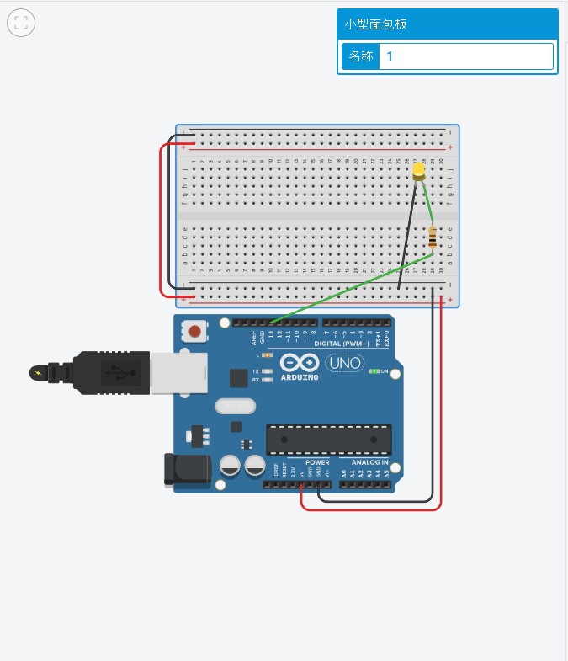
- 修正程式碼
void setup()
{
pinMode(13, OUTPUT);
}

void loop()
{
digitalWrite(13, HIGH);
delay(1000); // Wait for 1000 millisecond(s)
digitalWrite(13, LOW);
delay(1000); // Wait for 1000 millisecond(s)
}

