電通三乙微處理器實驗 實驗結報

實驗名稱 | Lab06-Music
組別 | 28 | 組員 | 江旻恒

- 實驗目的
*如何使Arduino發出特定旋律的聲音?
1.Arduino接喇叭如何接線?
2.如何使用tone library?
3.如何演奏一段音樂?
4.如何使用4x4鍵盤演奏音樂?
5.如何發報摩斯電碼?
- 實驗步驟
*Arduino演奏一段特定的音樂,旋律不得是小蜜蜂
*使用4x4鍵盤演奏音樂
*發報摩斯電碼
- 程式碼
實驗一:
Int length;
#define NOTE_C3 131
#define NOTE_CS3 139
#define NOTE_D3 147
#define NOTE_DS3 156
#define NOTE_E3 165
#define NOTE_F3 175
#define NOTE_FS3 185
#define NOTE_G3 196
#define NOTE_GS3 208
#define NOTE_A3 220
#define NOTE_AS3 233
#define NOTE_B3 247
#define NOTE_C4 262
#define NOTE_CS4 277
#define NOTE_D4 294
#define NOTE_DS4 311
#define NOTE_E4 330
#define NOTE_F4 349
#define NOTE_FS4 370
#define NOTE_G4 392
#define NOTE_GS4 415
#define NOTE_A4 440
#define NOTE_AS4 466
#define NOTE_B4 494
#define WHOLE 1 //全分符
#define HALF 0.5 //半分符
#define QUARTER 0.25
#define EIGHTH 0.125
#define SIXTEENTH 0.0625
#define Space 0.1
#define NOTE_0 0
int SP_PIN=5;
int tune[] = {NOTE_C4, NOTE_0,NOTE_C4,NOTE_0,NOTE_G4,NOTE_0, NOTE_G4,NOTE_0, NOTE_A4,NOTE_0, NOTE_A4,NOTE_0, NOTE_G4,NOTE_0, NOTE_F4,NOTE_0, NOTE_F4,NOTE_0,
NOTE_E4,NOTE_0, NOTE_E4,NOTE_0, NOTE_D4,NOTE_0, NOTE_D4,NOTE_0, NOTE_C4,NOTE_0, NOTE_G4,NOTE_0, NOTE_G4,NOTE_0, NOTE_F4,NOTE_0, NOTE_F4,NOTE_0,
NOTE_E4,NOTE_0, NOTE_E4,NOTE_0, NOTE_D4,NOTE_0, NOTE_G4,NOTE_0, NOTE_G4,NOTE_0, NOTE_F4,NOTE_0, NOTE_F4,NOTE_0, NOTE_E4,NOTE_0,NOTE_E4,NOTE_0,
NOTE_E4,NOTE_0,NOTE_C4,NOTE_0, NOTE_C4,NOTE_0, NOTE_G4,NOTE_0, NOTE_G4,NOTE_0, NOTE_A4,NOTE_0, NOTE_A4,NOTE_0, NOTE_G4,NOTE_0, NOTE_F4,NOTE_0,
NOTE_F4,NOTE_0, NOTE_E4,NOTE_0, NOTE_E4,NOTE_0, NOTE_D4,NOTE_0, NOTE_D4,NOTE_0, NOTE_C4};
float duration[] = {HALF,Space, HALF,Space,HALF,Space ,HALF,Space,HALF,Space, HALF,Space, HALF,Space,HALF,Space,HALF,Space,HALF,Space ,HALF,Space,HALF,Space,HALF,Space,HALF,
Space,HALF,Space, HALF,Space, HALF,Space,HALF,Space,HALF,Space,HALF,Space, HALF,Space, HALF,Space, HALF,Space,HALF,Space, HALF,Space, HALF,Space,HALF,Space,
HALF,Space,HALF,Space,HALF,Space,HALF,Space,HALF,Space,HALF,Space,HALF,Space,HALF,Space,HALF,Space,HALF,Space,HALF,Space,HALF,Space,HALF,Space,HALF,Space,HALF};
void setup() {
pinMode(SP_PIN, OUTPUT);
length = sizeof(tune) / sizeof(tune[0]);
}
void loop() {
for (int x=0; x<length; x++) {
tone(5, tune[x]);
delay(2500 *duration[x]);
noTone(5);
}
delay(5000);
}

實驗二:

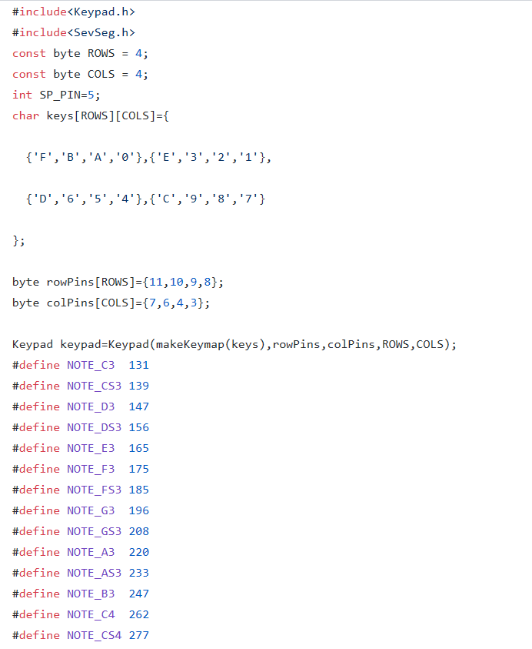
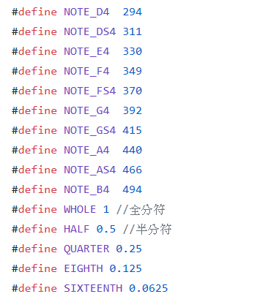
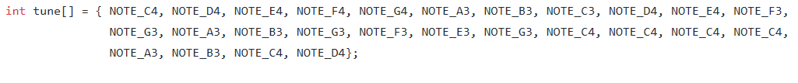
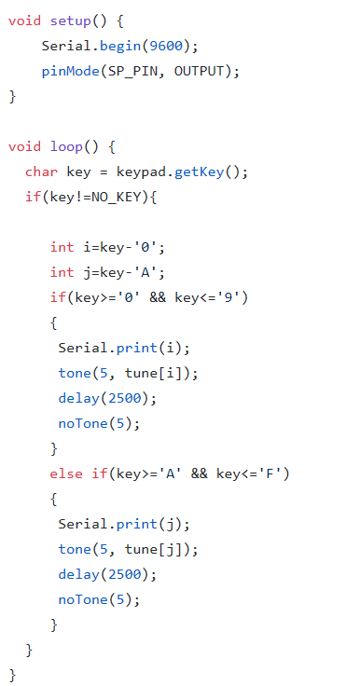

- 實驗結果及分析
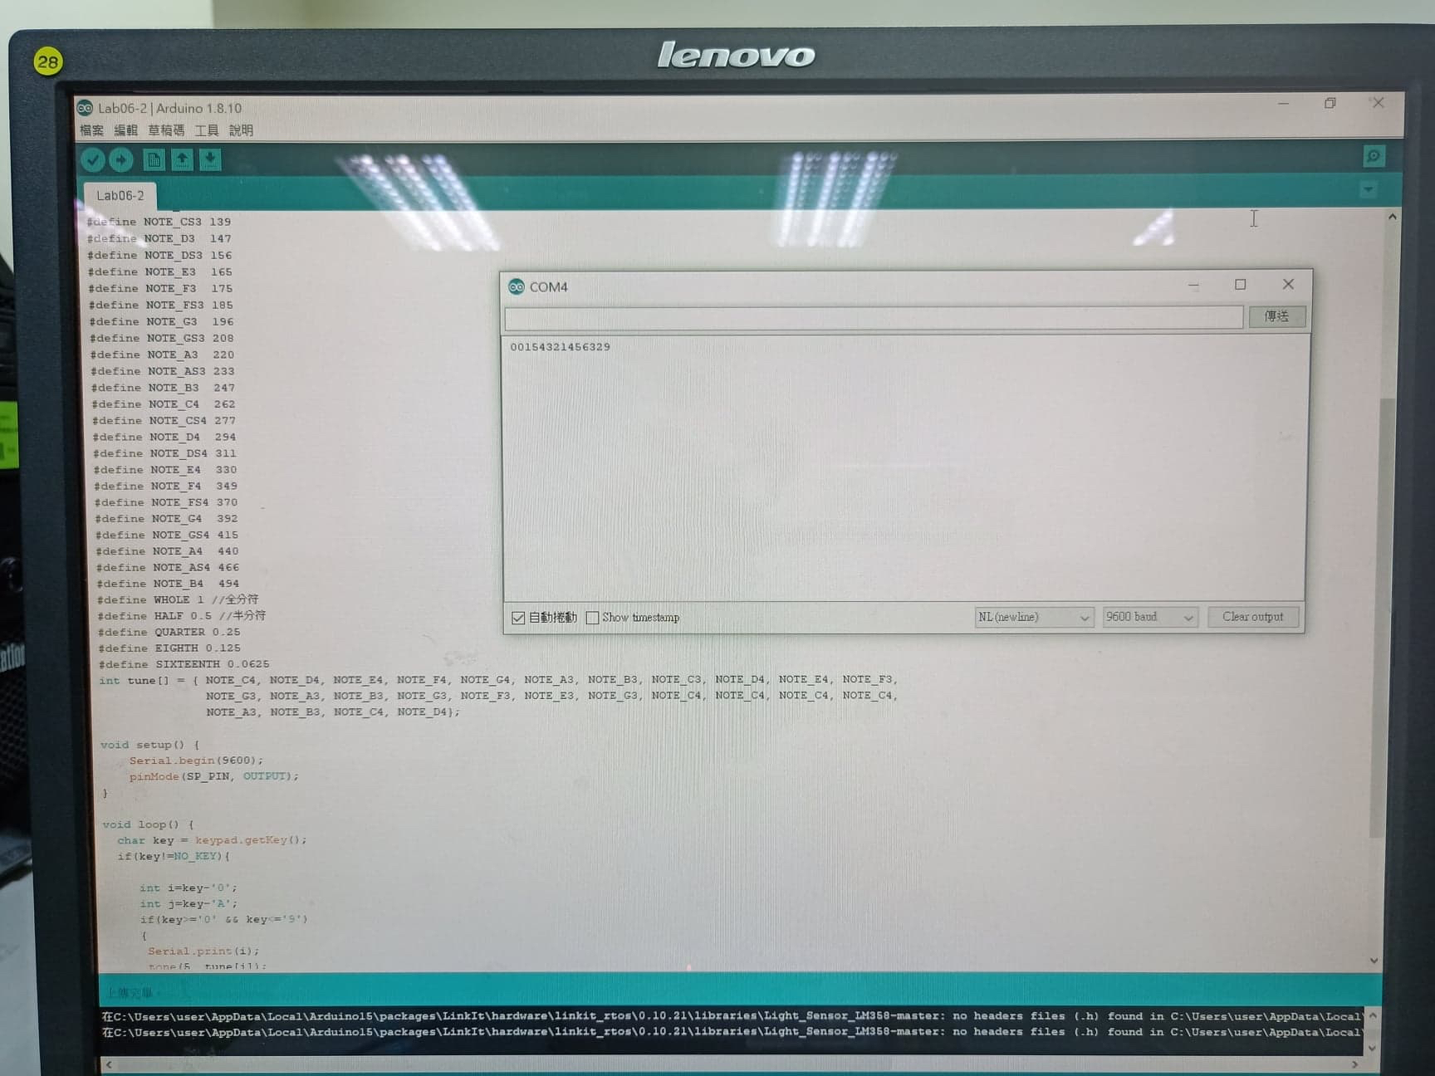

- 心得討論
這週要用程式碼做出一小段音樂,再傳到喇叭裡讓音樂可以發出來,最後做出來是還滿有趣的.

