電通三乙微處理器實驗 實驗結報

實驗名稱 | Lab09-BLE
組別 | 28 | 組員 | 江旻恒

- 實驗目的

- 實驗步驟

- 程式碼

實驗一:
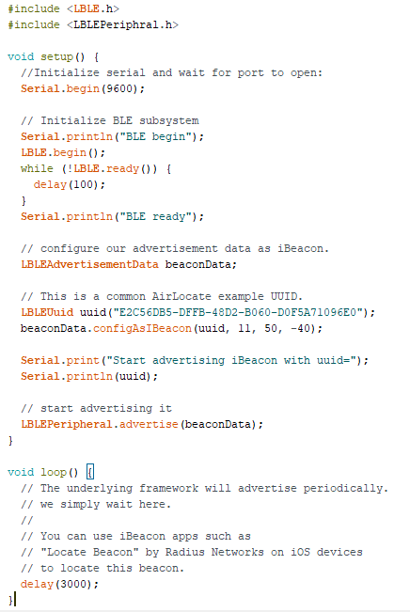

實驗二:
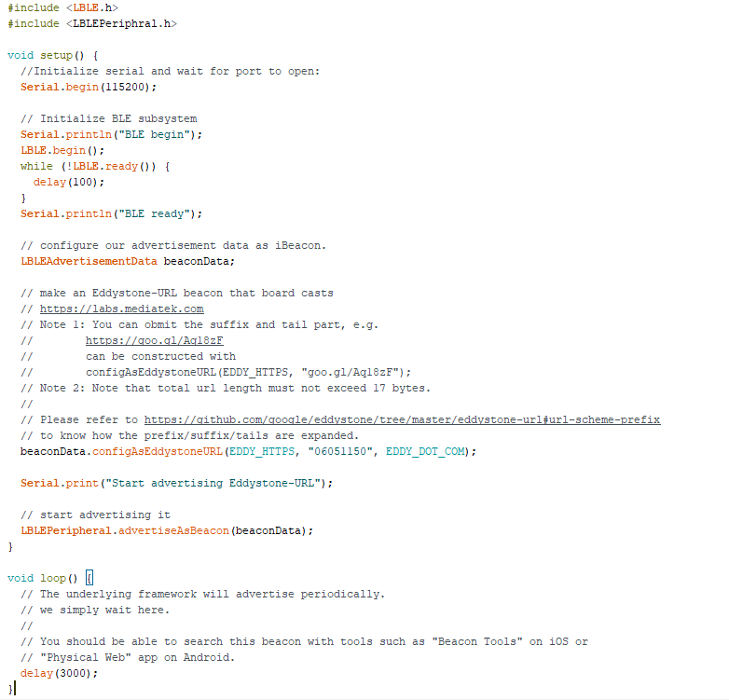

實驗三:
#include <LBLE.h>
#include <LBLEPeriphral.h>

// Define a simple GATT service with only 1 characteristic
LBLEService ledService("06051150-E8F2-537E-4F6C-D104768A1214");
LBLECharacteristicInt switchCharacteristic("06051150-E8F2-537E-4F6C-D104768A1214", LBLE_READ | LBLE_WRITE);

void setup() {

// Initialize LED pin
pinMode(LED_BUILTIN, OUTPUT);
digitalWrite(LED_BUILTIN, LOW);

//Initialize serial and wait for port to open:
Serial.begin(9600);

// to check if USR button is pressed
pinMode(6, INPUT);

// Initialize BLE subsystem
LBLE.begin();
while (!LBLE.ready()) {
delay(100);
}
Serial.println("BLE ready");

Serial.print("Device Address = [");
Serial.print(LBLE.getDeviceAddress());
Serial.println("]");

// configure our advertisement data.
// In this case, we simply create an advertisement that represents an
// connectable device with a device name
LBLEAdvertisementData advertisement;
advertisement.configAsConnectableDevice("06051150");

// Configure our device's Generic Access Profile's device name
// Ususally this is the same as the name in the advertisement data.
LBLEPeripheral.setName("06051150");

// Add characteristics into ledService
ledService.addAttribute(switchCharacteristic);

// Add service to GATT server (peripheral)
LBLEPeripheral.addService(ledService);

// start the GATT server - it is now
// available to connect
LBLEPeripheral.begin();

// start advertisment
LBLEPeripheral.advertise(advertisement);
}

void loop() {
delay(1000);

Serial.print("conected=");
Serial.println(LBLEPeripheral.connected());

if (digitalRead(6))
{
Serial.println("disconnect all!");
LBLEPeripheral.disconnectAll();
}

if (switchCharacteristic.isWritten()) {
const char value = switchCharacteristic.getValue();
switch (value) {
case 1:
digitalWrite(LED_BUILTIN, HIGH);
break;
case 0:
digitalWrite(LED_BUILTIN, LOW);
break;
default:
Serial.println("Unknown value written");
break;
}
}
}
- 實驗結果及分析

- 心得討論
- 修正電路圖
- 修正程式碼

