電通三乙微處理器實驗 實驗結報

實驗名稱 | Lab11-溫溼度感應器
組別 | 28 | 組員 | 江旻恒

- 實驗目的

- 實驗步驟

- 程式碼
// Example testing sketch for various DHT humidity/temperature sensors
// Written by ladyada, public domain

// REQUIRES the following Arduino libraries:
// - DHT Sensor Library: https://github.com/adafruit/DHT-sensor-library
// - Adafruit Unified Sensor Lib: https://github.com/adafruit/Adafruit_Sensor

#include "DHT.h"
#include <LWiFi.h>
#include <WiFiClient.h>
#include "MCS.h"

#define DHTPIN 5 // Digital pin connected to the DHT sensor
// Feather HUZZAH ESP8266 note: use pins 3, 4, 5, 12, 13 or 14 --
// Pin 15 can work but DHT must be disconnected during program upload.
#define _SSID "iPhone"
#define _KEY "jdtyy217zsk0n"
MCSDevice mcs("Dy0GNXnj", "hzbsa300wN6IHM2p");

// Assign channel id
// The test device should have 2 channel
// the first channel should be "Controller" - "On/Off"
// the secord channel should be "Display" - "On/Off"

MCSDisplayFloat Temperature("Temperature");
MCSDisplayFloat Humidity("Humidity");

// Uncomment whatever type you're using!
//#define DHTTYPE DHT11 // DHT 11
#define DHTTYPE DHT11 // DHT 22 (AM2302), AM2321
//#define DHTTYPE DHT21 // DHT 21 (AM2301)

// Connect pin 1 (on the left) of the sensor to +5V
// NOTE: If using a board with 3.3V logic like an Arduino Due connect pin 1
// to 3.3V instead of 5V!
// Connect pin 2 of the sensor to whatever your DHTPIN is
// Connect pin 4 (on the right) of the sensor to GROUND
// Connect a 10K resistor from pin 2 (data) to pin 1 (power) of the sensor

// Initialize DHT sensor.
// Note that older versions of this library took an optional third parameter to
// tweak the timings for faster processors. This parameter is no longer needed
// as the current DHT reading algorithm adjusts itself to work on faster procs.
DHT dht(DHTPIN, DHTTYPE);

void setup() {
Serial.begin(9600);
Serial.println(F("DHTxx test!"));
mcs.addChannel(Temperature);
mcs.addChannel(Humidity);
while (WL_CONNECTED != WiFi.status())
{
Serial.print("WiFi.begin(");
Serial.print(_SSID);
Serial.print(",");
Serial.print(_KEY);
Serial.println(")...");
WiFi.begin(_SSID, _KEY);
}
Serial.println("WiFi connected !!");
while (!mcs.connected())
{
Serial.println("MCS.connect()...");
mcs.connect();
}
Serial.println("MCS connected !!");
dht.begin();
}

void loop() {
// Wait a few seconds between measurements.
delay(1000);

// Reading temperature or humidity takes about 250 milliseconds!
// Sensor readings may also be up to 2 seconds 'old' (its a very slow sensor)
float h = dht.readHumidity();
// Read temperature as Celsius (the default)
float t = dht.readTemperature();
// Read temperature as Fahrenheit (isFahrenheit = true)
float f = dht.readTemperature(true);

// Check if any reads failed and exit early (to try again).
if (isnan(h) || isnan(t) || isnan(f)) {
Serial.println(F("Failed to read from DHT sensor!"));
return;
}

// Compute heat index in Fahrenheit (the default)
float hif = dht.computeHeatIndex(f, h);
// Compute heat index in Celsius (isFahreheit = false)
float hic = dht.computeHeatIndex(t, h, false);
Temperature.set(t);
Humidity.set(h);
Serial.print(F("Humidity: "));
Serial.print(h);//濕度
Serial.print(F("% Temperature: "));
Serial.print(t);//溫度
Serial.print(F("°C "));
Serial.println();
}
- 實驗結果及分析

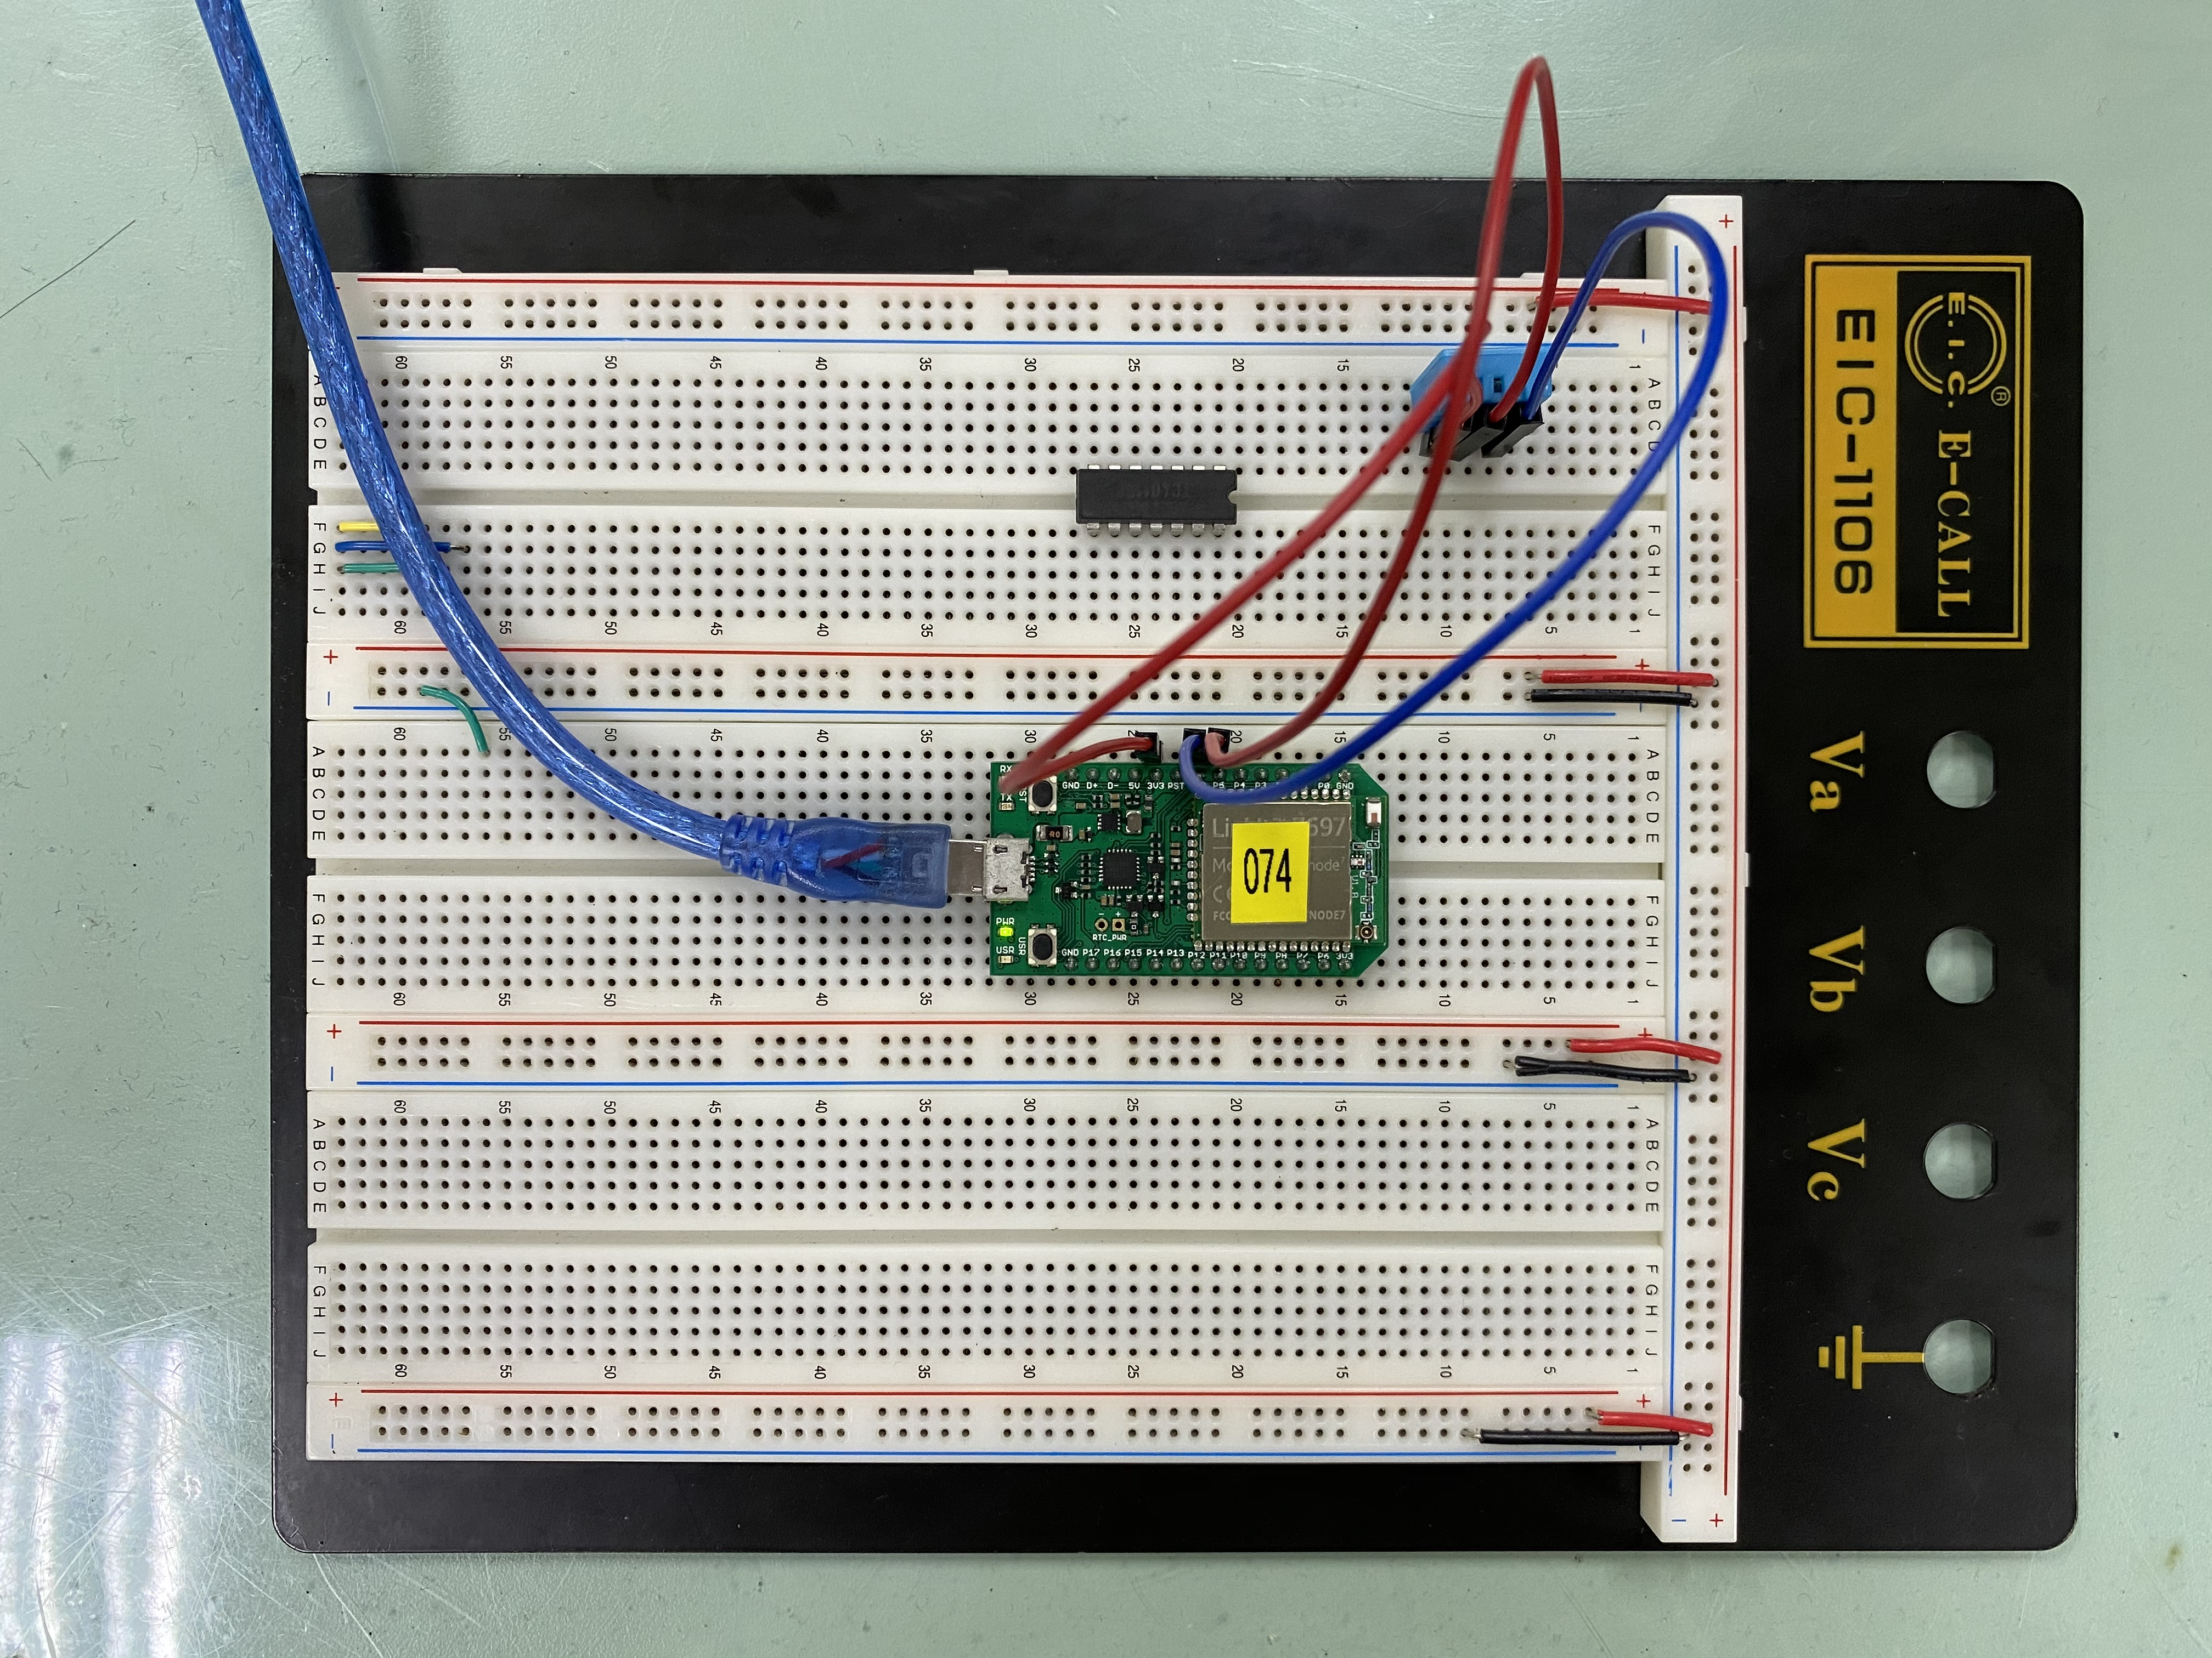
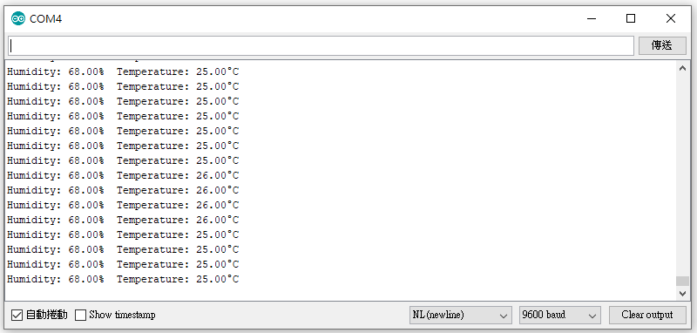

- 心得討論
今天做溫溼度感應器,要把溫度和濕度在mcs顯示出來,剛開始程式碼的部分用比較久,後來有做出來,但我的濕度值偏低,後來換一顆就有好一點了.

