TSHWANE UNIVERSITY OF TECHNOLOGY
Faculty of Information and Communication Technology
Department of Computer Science


INTEGRATED SOFTWARE PROJECT · ISJ107V · 2026
ASSIGNMENT 2
Formal System Specification
Candid — an ethical CV-tailoring platform for South African job seekers

Student | Dennis Mmachoene Ramara
Student number | [STUDENT NUMBER]
Qualification | Advanced Diploma in Computer Science
NQF level / credits | NQF 7 · 15 credits
Assessment weight | 10% of the predicate mark (assessment plan, study guide §24)
Lecturer | Mr HD Masethe
Submitted | 2 August 2026
System documented | Candid — github.com/dennis-mmachoene/candid

Declaration of originality
I, the undersigned, hereby declare that:
- This assignment is my own original work. Where the work of others has been used, it has been acknowledged and referenced in accordance with the Harvard method of referencing.
- I have not allowed, and will not allow, any other person to copy this work with the intention of presenting it as their own.
- I understand that plagiarism is a form of misconduct under Chapter 15 of the Students’ Rules and Regulations, rule 15.1.16, and under the Tshwane University of Technology plagiarism policy RIPPOL067.
- Every internet source used is cited with its full uniform resource locator and the date on which it was accessed.
- The software system described in this document was designed and implemented by me. The full source code, its commit history and its continuous integration results are publicly available at github.com/dennis-mmachoene/candid and may be inspected in support of every claim made here.

A note on verifiability
Every quantitative claim in this document is reproducible from the repository. Test counts come from running the suites, not from memory; file paths, table names and column names are quoted from the source. Section 1.4 lists the exact commands a marker can run to check them.

Full name | Dennis Mmachoene Ramara
Student number | [STUDENT NUMBER]
Signature | __________________________________
Date | __________________________________

The study guide requires a signed Declaration of Originality on the form supplied as Annexure A or B. If your lecturer supplies that form, attach it in front of this page; this declaration does not replace it.

Table of contents
The table below is a Word field. Open the document, click anywhere in it and press F9, or right-click and choose Update Field, to populate it with the current page numbers.

1 Introduction

1.1 Purpose of this document
This document is the formal system specification for Candid, a web application that tailors a job seeker’s curriculum vitae to a specific job advertisement. It states what the system must do, what it must never do, the hardware and infrastructure it requires, and the legal constraints it operates under. It is written to be checked rather than believed: every structural claim it makes points at a file in a public repository.
The document satisfies the requirement in the ISJ107V assessment plan for “the formal system specification document i.e. technical hardware requirements document, incorporating UML designs”, and addresses Learning Outcome B.1 — proficiency in Object Oriented Analysis and Design principles using UML — with supporting material for Outcomes A.1 and C.1.

1.2 Scope of the system
Candid accepts a CV in PDF or Word format together with the text of a job advertisement. It returns a rewritten version of the candidate’s experience expressed in the advertisement’s vocabulary, an integrity report showing where every statement came from, and an honest list of the requirements the candidate does not meet. It exports the result as an ATS-parseable PDF or Word document.
Two things define the system, and they are stated here as requirements rather than as marketing:
- It never fabricates experience. Every claim in the output traces back to the uploaded CV. A claim that cannot be traced is blocked, and a blocked claim has no path to an exported file regardless of what the user clicks.
- It never leaks identity. The candidate’s name, e-mail address and telephone number are removed before any part of the CV is transmitted to an artificial intelligence provider, and reattached afterwards on the server. A South African identity number, if present, is redacted and discarded — the database has no column capable of holding one.
Out of scope: job searching or job matching, application submission, employer-side features, payment, and any form of automated interview preparation. Candid produces a document; it does not apply for anything on the candidate’s behalf.

1.3 Definitions, acronyms and abbreviations
Table 1: Terms used throughout this document
Term | Meaning as used in this document
ATS | Applicant Tracking System. Software an employer uses to parse and filter incoming CVs. A CV that an ATS cannot parse is frequently never read by a person.
Claim | A single assertion extracted from the model’s draft: a skill, an employer or a date. Claims are the unit of validation.
Verdict | The judgement passed on a claim — accepted, borderline or blocked.
Integrity report | The grouped set of verdicts shown to the user beside every draft, with the evidence behind each one.
De-identification | Removal of the identity header and redaction of identity numbers from CV text, performed before the text leaves the server.
Identity header | The candidate’s name, e-mail address, telephone number and remaining header lines, held back on the server and encrypted at rest.
Inventory | The set of skills the uploaded CV demonstrably supports, with the line of the CV each was found on.
POPIA | Protection of Personal Information Act 4 of 2013 (Republic of South Africa, 2013).
RLS | Row-Level Security. A PostgreSQL feature that filters rows inside the database according to the identity of the connected user.
Port / Adapter | An interface owned by the domain layer, and the infrastructure class that implements it.
Operator | Under POPIA, a third party that processes personal information on behalf of the responsible party.

1.4 How to verify the claims in this document
A specification that cannot be checked is an opinion. The source code, its full commit history and its continuous integration results are public. The commands below reproduce every quantitative statement made here.
git clone https://github.com/dennis-mmachoene/candid.git
cd candid && npm ci

npm run typecheck # TypeScript, no errors
npm run lint # ESLint, including the domain dependency rule
npm test # 125 unit and integration tests
npm run build # production build
npm run e2e # 55 Playwright tests against a running instance
The continuous integration workflow runs the first four on a clean Ubuntu runner on every pull request, and the fifth on every push to the main branch. Its logs are public.

1.5 Document overview
Section 2 states the problem and the business case. Section 3 sets out the requirements. Section 4 models them as use cases. Section 5 gives the conceptual class model and the trust boundary. Section 6 is the technical and hardware specification. Section 7 covers the legal constraints imposed by POPIA. Sections 8 to 10 give acceptance criteria, risks and a conclusion.

2 The problem and the business case

2.1 The labour market this system is built for
Statistics South Africa’s Quarterly Labour Force Survey for the first quarter of 2026 records an official unemployment rate of 32,7%, up 1,3 percentage points from 31,4% in the fourth quarter of 2025 (Statistics South Africa, 2026). Among those aged 15 to 34 the rate is 45,8%, and among those aged 15 to 24 it is 60,9%. The number of unemployed young people rose by 181 000 in the quarter, to 4,7 million.
These figures describe a market in which a single vacancy attracts a very large number of applications, and in which the first filter an application meets is usually software rather than a person. A candidate whose CV is not phrased in the advertisement’s vocabulary is filtered out before anyone reads it, whatever their actual ability.

2.2 Why the obvious solution is the wrong one
A generative language model can rewrite a CV to match an advertisement in seconds. Left unconstrained it will also, without being asked, add a skill the advertisement wants and the candidate does not have. It does this because it is optimising for the resemblance between two documents, and the shortest route to resemblance is invention.
The consequence falls entirely on the candidate. An invented competency is discovered in an interview, or worse, after appointment. In South Africa a misrepresentation in a job application can constitute fraud, and the Higher Education Act 101 of 1997, as amended by the Higher Education Amendment Act 9 of 2016, makes the false claiming of a qualification a criminal offence. A tool that quietly inflates a CV is not helping a job seeker; it is transferring risk onto the person least able to carry it.
There is a second, quieter harm. A CV is one of the densest concentrations of personal information a person produces: full name, contact details, physical address, employment history, and in South Africa very often a thirteen-digit identity number. Sending that document wholesale to a third-party inference API, in another jurisdiction, is a disclosure most users would not consent to if it were described to them plainly.

2.3 The two guarantees, stated as design constraints
Guarantee 1 — it never leaks identity
The identity header is separated from the CV before the text can reach an AI provider. The AIProvider port has no field for a name, an e-mail address, a telephone number or an identity number, so passing one is a compilation error rather than an oversight a reviewer must catch. South African identity numbers are validated with the Luhn checksum and a date plausibility check, then redacted and discarded in memory.

Guarantee 2 — it never fabricates experience
Every claim the model produces is judged against an inventory built from the candidate’s own CV, by a single ordered chain of specifications. The chain’s fallthrough verdict is blocked, not accepted: a claim the rule does not understand is refused rather than waved through. Document assembly reads exclusively from the resulting integrity report and never from the model’s draft, so a blocked claim cannot reach a file by any route.

Both guarantees are enforced structurally. That word is used deliberately and is defined here: a guarantee is enforced structurally when violating it requires changing the shape of the code rather than merely forgetting a check. Section 5.1 and Assignment 3 show where each one is located.

2.4 Stakeholders
Table 2: Stakeholders and their principal concerns
Stakeholder | Interest | Concern the specification must answer
Job seeker (primary user) | A CV that passes an ATS and is still true | Will this get me into an interview I can survive?
Employer | Accurate applications | Does this tool make screening harder or easier?
Information Regulator (South Africa) | Lawful processing of personal information | Is consent informed, is retention limited, is erasure honoured?
Anthropic (operator) | Acceptable use of the model | Is the system prompting for honest output and handling untrusted input safely?
Supabase, Vercel (operators) | Platform integrity | Is data access properly scoped and are secrets handled correctly?
Assessor (TUT) | Evidence of NQF 7 competence | Are the design decisions justified, and can the claims be checked?

3 Requirements specification

3.1 Elicitation approach
Requirements were derived from three sources. First, the problem statement and its two guarantees, which fix the boundaries of any acceptable solution. Second, the Protection of Personal Information Act, which imposes obligations that are not negotiable and therefore appear as requirements rather than as preferences. Third, the observable behaviour of applicant tracking systems, which constrains the structure of the exported document.
Requirements are identified as FR-nn for functional and NFR-nn for non-functional. Each is traceable: the right-hand column names the artefact that implements it and the test that proves it, so the specification can be audited against the build rather than against a description of the build.

3.2 Functional requirements
Table 3: Functional requirements, with the implementing artefact and its proof
ID | Requirement | Implemented in | Proven by
FR-01 | The system shall authenticate a user through Google OAuth 2.0 and shall never handle a password. | app/actions/auth.ts | e2e happy-path
FR-02 | The system shall record informed consent against a policy version before processing any CV, and shall require fresh consent when that version changes. | lib/domain/consent.ts | e2e consent gate
FR-03 | The system shall accept a CV in PDF or DOCX format, determining the format from magic bytes rather than the declared MIME type or file extension. | lib/infrastructure/parser.ts | parser.test.ts
FR-04 | The system shall reject any upload exceeding 5 MB, exceeding 30 PDF pages, or yielding more than 200 000 extracted characters. | lib/infrastructure/parser.ts | parser.test.ts
FR-05 | The system shall redact every valid South African identity number from CV text and shall discard the value without storing it. | lib/domain/identity.ts | identity.test.ts
FR-06 | The system shall separate the identity header from the CV body before any text is transmitted to an AI provider. | lib/domain/identity.ts | identity.test.ts
FR-07 | The system shall build an inventory of skills from the de-identified CV, retaining the source line as evidence for each. | lib/domain/inventory.ts | anti-fabrication.test.ts
FR-08 | The system shall submit only de-identified content and the job advertisement to the AI provider. | lib/domain/tailoring.ts | identity.test.ts
FR-09 | The system shall treat the job advertisement as data and never as instruction. | lib/infrastructure/claude-provider.ts | prompt-injection.test.ts
FR-10 | The system shall assign each claim in the model’s reply a verdict of accepted, borderline or blocked, together with the evidence behind that verdict. | lib/domain/validator.ts | anti-fabrication.test.ts
FR-11 | The system shall block any employer or date not named in the source CV, with no borderline path available. | lib/domain/provenance.ts | prompt-injection.test.ts
FR-12 | The system shall present the integrity report to the user and permit approval of borderline claims only. | components/integrity-report.tsx | e2e happy-path
FR-13 | The system shall exclude every blocked claim from every exported document irrespective of the approval state recorded against it. | lib/domain/resume-document.ts | anti-fabrication.test.ts
FR-14 | The system shall export as PDF and as DOCX, containing no tables, images, text boxes, headers or footers. | lib/infrastructure/export/ | ats-round-trip.test.ts
FR-15 | The system shall list the requirements of the advertisement that the CV does not support, and shall never print that list into the exported document. | lib/domain/learning.ts | ats-round-trip.test.ts
FR-16 | The system shall let a user view and delete individual stored CVs and tailorings. | app/history/page.tsx | e2e isolation
FR-17 | The system shall delete a user’s account and every record belonging to it on request, immediately. | app/actions/settings.ts | e2e happy-path
FR-18 | The system shall delete stored CVs not accessed for twelve months, together with everything derived from them. | migration 0003 | reviewed SQL
FR-19 | The system shall limit each user to 10 tailorings and 20 uploads per hour. | lib/infrastructure/rate-limit.ts | reviewed SQL
FR-20 | The system shall offer three export templates that vary typography and spacing only. | lib/domain/resume-document.ts | ats-round-trip.test.ts

3.3 Non-functional requirements
Non-functional requirements are grouped by the product quality characteristics of ISO/IEC 25010 (International Organization for Standardization, 2011), which is the vocabulary the module’s software quality outcome expects.
Table 4: Non-functional requirements by ISO/IEC 25010 quality characteristic
Characteristic | ID | Requirement
Functional suitability | NFR-01 | The anti-fabrication rule shall be expressed in exactly one place, so that its correctness can be established by reading a single file.
Security — confidentiality | NFR-02 | Name, e-mail address and telephone number shall be encrypted with AES-256-GCM in the application layer before reaching the database, with a fresh initialisation vector for every record.
Security — integrity | NFR-03 | Ciphertext shall be authenticated, so that a modified record fails to decrypt rather than decrypting to a plausible different value.
Security — accountability | NFR-04 | The audit trail shall be writable only through a SECURITY DEFINER function, so that a user cannot forge or delete their own history.
Security — access control | NFR-05 | Row-Level Security shall be enabled on every table, so that a defect in application logic still cannot return another user’s rows.
Security — availability | NFR-06 | Rate limiting shall fail closed. If the check itself errors, the request shall be denied.
Reliability | NFR-07 | If the authentication service is unreachable, public pages shall continue to render and protected pages shall redirect to sign-in. An outage shall lock users out, never let them through.
Performance efficiency | NFR-08 | A tailoring request shall complete within 30 seconds at the 95th percentile, bounded by the AI provider’s response time.
Usability | NFR-09 | Every page shall render without horizontal overflow from 320 px to 2 560 px in width.
Usability — accessibility | NFR-10 | Section headings shall be real heading elements, so that a screen reader user can navigate the integrity report by heading.
Maintainability | NFR-11 | The domain layer shall import no vendor SDK, no framework and no I/O library, and this shall be enforced by the linter rather than by review.
Portability | NFR-12 | Replacing the AI provider shall require implementing one interface and shall require no change to any file in the domain layer.
Compatibility | NFR-13 | Exported documents shall be parseable by applicant tracking systems, which is achieved by making unparseable constructs inexpressible in the document model.
Compliance | NFR-14 | Processing shall satisfy POPIA sections 14, 18, 19, 24 and 72. See section 7.

3.4 Constraints
- The repository is public. No secret may appear in tracked source, and the build must succeed without production credentials.
- Authentication is Google only. Apple sign-in was evaluated and deliberately excluded: it would add a second identity provider, a second consent disclosure and a second failure mode for no benefit to the target user, who overwhelmingly holds a Google account already.
- The AI provider is Anthropic’s Claude, pinned to a dated model snapshot rather than a moving alias, because an alias allows the model to change underneath a build that has already passed its tests.
- Hosting must fall within free or low-cost tiers, since the system has no revenue and is built by one student.
- The exported document must survive a round trip through a real parser, which rules out any layout technique an applicant tracking system cannot read.

3.5 Assumptions and dependencies
- The user’s CV is a genuine record of their own experience. Candid prevents inflation of a CV; it cannot detect a CV that was false before upload.
- The user has a Google account and a browser released within roughly the last three years.
- Supabase, Vercel and the Anthropic API are available. Section 9 records the risk this creates and the mitigation.
- Skill detection in prose is bounded by a vocabulary list, and employer detection is heuristic. Both are stated as known limitations rather than concealed; section 9 records their failure direction.

4 Use case model

4.1 Use case diagram
Figure 1 shows the system boundary, its one primary actor and its three secondary system actors. The consent use case is drawn deliberately near the top of the boundary because it gates everything below it: a user who has not accepted the current policy version cannot reach any use case that processes a CV.
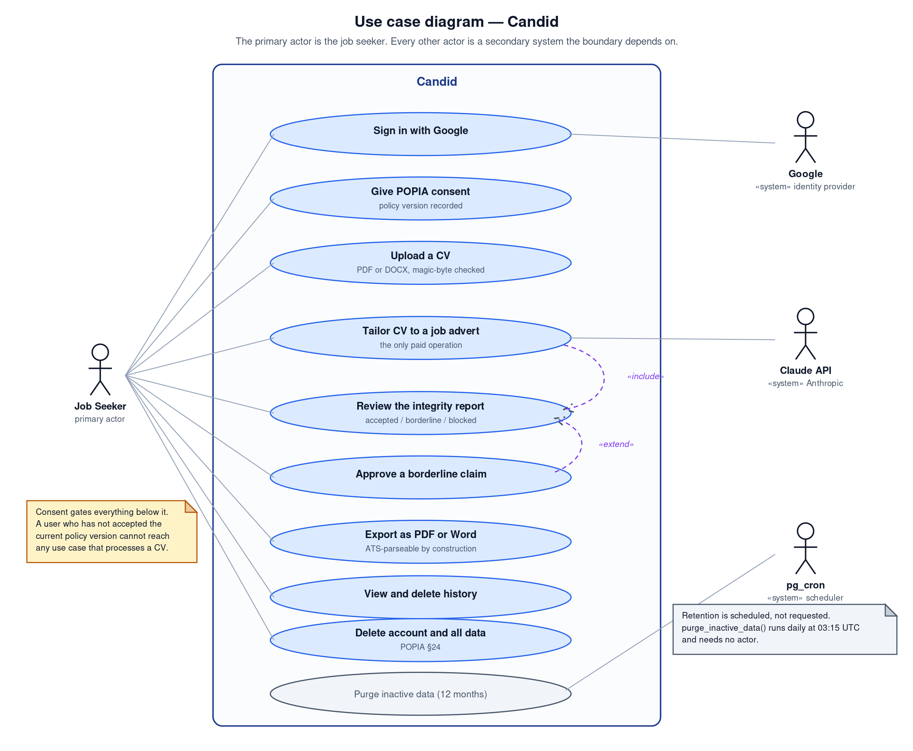
Figure 1: Use case diagram. The job seeker is the only human actor; Google, the Claude API and the pg_cron scheduler are secondary system actors.

4.2 Actors
Table 5: Actors and their responsibilities
Actor | Type | Responsibility
Job seeker | Primary, human | Uploads a CV, supplies an advertisement, judges borderline claims, exports and deletes.
Google | Secondary, system | Asserts the user’s identity through OAuth 2.0 and returns an e-mail address. Receives no CV data.
Claude API (Anthropic) | Secondary, system | Rewrites de-identified experience against the advertisement. Receives no identifying information.
pg_cron | Secondary, system | Invokes the retention purge daily at 03:15 UTC. Has no human trigger and takes no arguments.

4.3 Expanded use case specifications
Three use cases carry the system’s essential complexity and are specified in full. The remainder are straightforward create, read and delete operations over rows the user owns.

4.3.1 UC-03 — Upload a CV
Table 6: UC-03 Upload a CV
Field | Detail
Primary actor | Job seeker
Goal | Place a CV under the user’s account in a form that cannot leak identity.
Precondition | The user is authenticated and has accepted the current policy version.
Postcondition | A de-identified CV and an encrypted identity header are stored. The uploaded file is not stored.
Trigger | The user submits the upload form.
Main flow | 1. The user selects a PDF or DOCX file.  2. The system checks the size against the 5 MB cap.  3. The system reads the leading bytes and determines the format from them.  4. The system extracts text, bounded by a page cap and a character cap.  5. The system redacts every valid South African identity number.  6. The system separates the identity header from the body.  7. The system scrubs residual identifiers from the body.  8. The system encrypts the identity header with AES-256-GCM.  9. The system stores the de-identified body, the ciphertext and a count of redactions.  10. The system discards the uploaded bytes.
Alternative flow A1 | Step 3 finds a ZIP archive that is not a Word document. The system rejects the upload and names the actual problem.
Alternative flow A2 | Step 3 finds a legacy .doc file. The system rejects it and tells the user to save as .docx.
Alternative flow A3 | The hourly upload allowance is exhausted. The system denies the request and states when it resets.
Exception E1 | Text extraction fails. Nothing is stored and the user is told the file could not be read.
Special requirement | The order of steps 5, 6 and 7 is load-bearing. Redaction must precede the header split, or an identity number sitting inside the header would survive into the withheld block where nothing redacts it.

4.3.2 UC-04 — Tailor a CV to a job advertisement
Table 7: UC-04 Tailor a CV to a job advertisement
Field | Detail
Primary actor | Job seeker
Secondary actor | Claude API
Goal | Obtain a rewritten CV that says only what the original CV supports.
Precondition | A de-identified CV is stored and the hourly tailoring allowance is not exhausted.
Postcondition | A draft and an integrity report are stored with status “review”.
Main flow | 1. The user pastes the advertisement and selects a stored CV.  2. The system verifies identity and consent, then consumes one unit of the tailoring allowance.  3. The system de-identifies the CV text.  4. The system builds a skill inventory from the de-identified content.  5. The system sends the de-identified content and the advertisement to the provider.  6. The provider returns a draft, which is validated against a schema at the boundary.  7. The system extracts every claim from the draft, including claims buried in prose.  8. The system judges each claim against the inventory and produces an integrity report.  9. The system stores the draft and the report and shows the report to the user.
Alternative flow A1 | Every claim is blocked. The tailoring is stored with status “blocked” and the user is told there is no honest version.
Exception E1 | The provider returns a reply that fails schema validation. The request fails and nothing is stored.
Exception E2 | The advertisement contains an instruction aimed at the model. The instruction may succeed against the model and still cannot fabricate, because the reply is judged against the inventory afterwards.
Special requirement | The provider is reachable only through the tailoring use case, and that function has no way to hand it anything but de-identified content. The ordering is a property of the call graph rather than a rule a future contributor must remember.

4.3.3 UC-07 — Export as PDF or Word
Table 8: UC-07 Export as PDF or Word
Field | Detail
Primary actor | Job seeker
Goal | Obtain a file that an applicant tracking system can parse and that contains nothing untrue.
Precondition | A tailoring exists and belongs to the requesting user.
Postcondition | A file is streamed to the browser. The tailoring status becomes “exported”.
Main flow | 1. The user chooses a format and a template.  2. The system re-verifies the session.  3. The system loads the stored draft, integrity report and approvals.  4. The system loads and decrypts the identity header.  5. The system assembles a document, reading claims exclusively from the integrity report.  6. The renderer produces bytes for the chosen format.  7. The file is returned as an attachment.
Alternative flow A1 | The identifier belongs to another user. The system returns 404 rather than 403, because 403 would confirm that the identifier exists.
Exception E1 | The ciphertext fails its authentication tag check. Decryption throws and no document is produced.
Special requirement | The request carries three parameters — an identifier, a format and a template — and none of them is content. A caller who controls every parameter still cannot place a blocked claim into a file.

5 Conceptual model and trust boundary

5.1 The trust boundary
Guarantee 1 is most usefully expressed as a data flow rather than as a sentence. Figure 2 shows what crosses the boundary of the Candid server in each direction, and where identity stops.
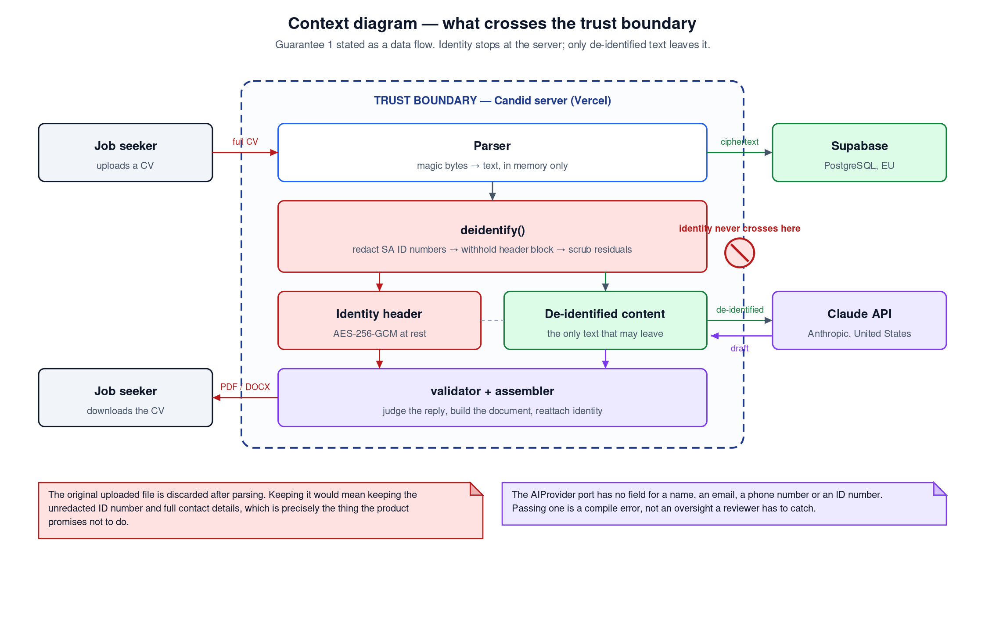
Figure 2: Context diagram. The full CV enters; only de-identified text leaves for the AI provider, and only ciphertext leaves for the database.
Two points on this diagram carry the guarantee. The first is that the original uploaded file is discarded after parsing rather than archived: retaining it would mean retaining the unredacted identity number and the full contact details, which is exactly the disclosure the system exists to prevent. The second is that the outbound arrow to the AI provider originates after de-identification and nowhere else.

5.2 Conceptual class model
Figure 3 gives the analysis-level class model. It is a model of the problem domain rather than of the implementation: the classes here are the concepts a domain expert would recognise. Assignment 3 gives the corresponding design class model, with operations and visibility.
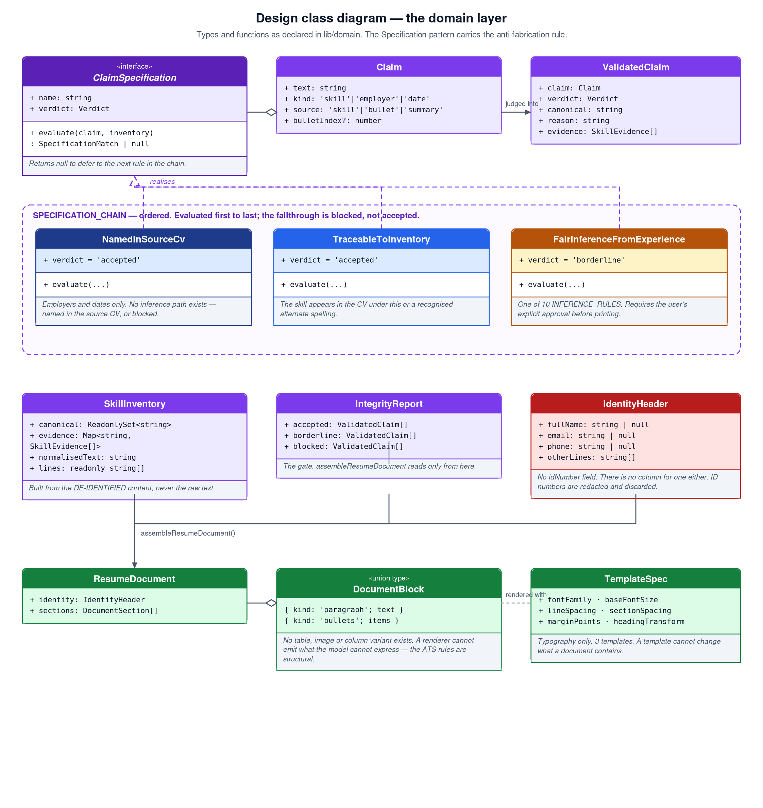
Figure 3: Design class model of the domain layer. The Specification pattern carries the anti-fabrication rule; the three concrete specifications form an ordered chain.
Three modelling decisions deserve comment.
A Claim has a kind, and the kind changes the rule that applies. A skill can be a fair inference from stated experience — “led a team of five” genuinely does evidence team leadership even where the phrase never appears. An employer cannot be inferred from anything: either the CV names it or the model invented it. Modelling kind as an attribute rather than as three unrelated classes keeps the specification chain uniform while letting the first specification in the chain refuse to consider skills at all.
The IdentityHeader has no field for an identity number. This is not an omission to be corrected later. The absence is the requirement, and it is mirrored in the database schema, where the migration states in capital letters that no such column exists and that none may be added.
DocumentBlock is a closed union with two members. There is no table variant, no image variant and no column variant. A renderer cannot emit a construct the document model cannot express, so the applicant tracking constraints of NFR-13 are enforced by the type system rather than by a reviewer noticing.

5.3 State model
A tailoring moves through four states, which correspond exactly to the four values of the tailoring_status enumeration declared in the first migration. Figure 4 shows the permitted transitions.
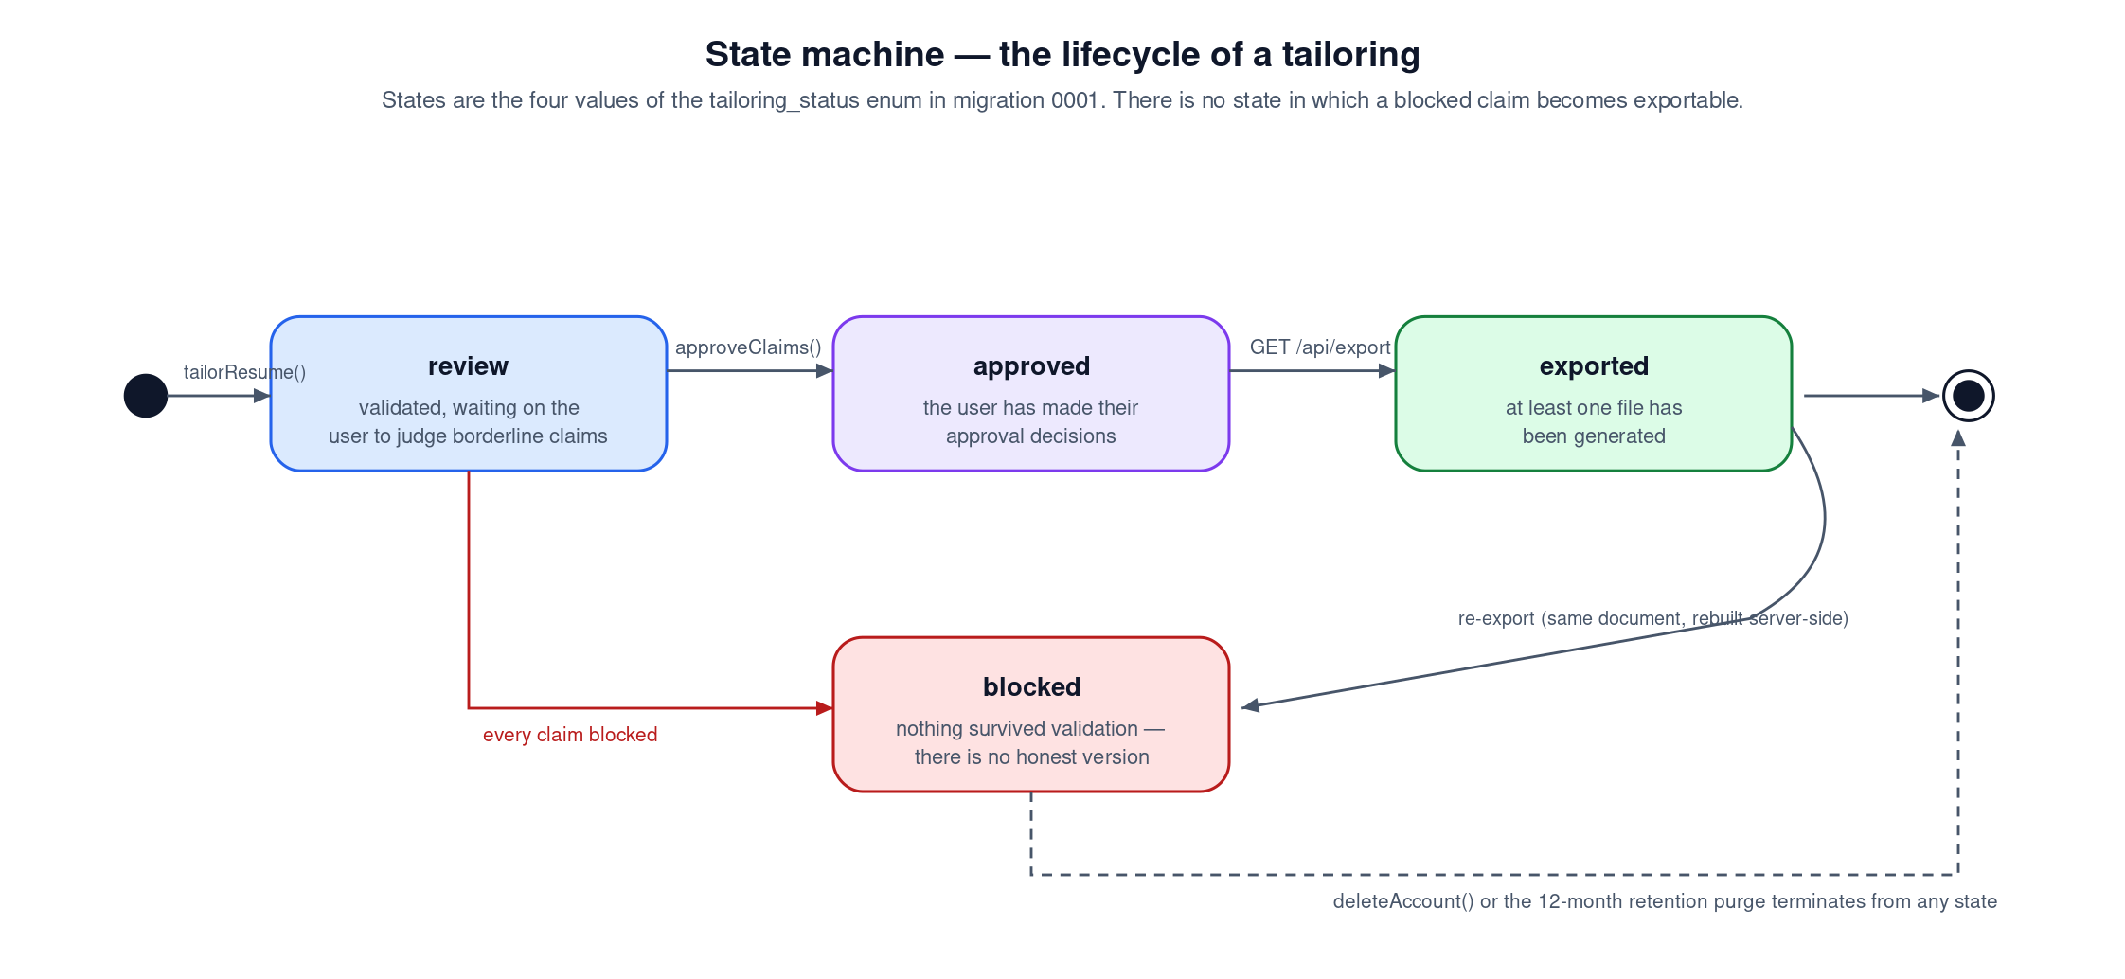
Figure 4: State machine for a tailoring. There is no state in which a blocked claim becomes exportable.

6 Technical and hardware specification
This section is the technical hardware requirements document called for in the assessment plan. Candid is a distributed system: its components run on separate machines under separate ownership, which is both an architectural decision and an explicit requirement of the project brief.

6.1 Deployment topology
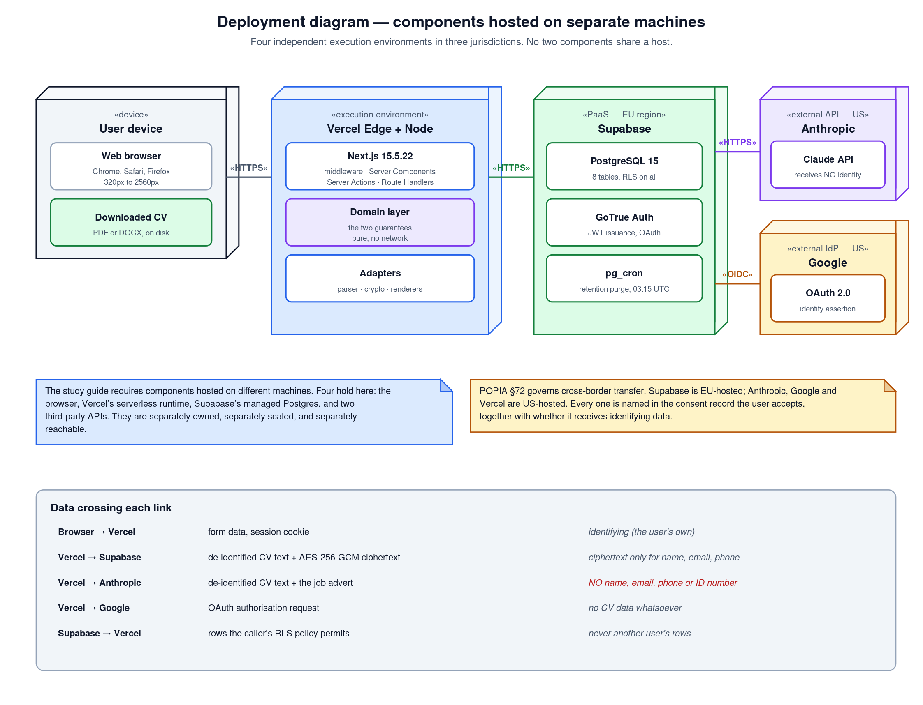
Figure 5: Deployment diagram. Four independent execution environments across three jurisdictions, with the data crossing each link tabulated.
No two components share a host. The browser executes on the user’s device; the application executes in Vercel’s serverless runtime; the database executes on Supabase’s managed PostgreSQL; and two further components are third-party APIs reached over the public internet. They are separately owned, separately scaled and separately reachable, and a failure in any one of them degrades the system in a different and predictable way.

6.2 Application server requirements
The application is deployed to Vercel as serverless functions rather than to a persistent virtual machine. This is a deliberate choice with a consequence worth stating: there is no long-lived process, so nothing may be cached in module scope across requests, and any state that must survive a request lives in PostgreSQL.
Table 9: Application server specification
Attribute | Requirement | Rationale
Runtime | Node.js 22 LTS | process.loadEnvFile and the current Web Crypto surface are available without a polyfill.
Memory per invocation | 1 024 MB | PDF parsing of a 30-page document is the peak. Measured well below this bound.
Maximum execution time | 60 s | One tailoring request, bounded by the AI provider’s response.
CPU architecture | x86-64 or ARM64 | The dependency tree is pure JavaScript and WebAssembly. No native binary is compiled at install time.
Persistent disk | None | By design. The uploaded file is parsed in memory and discarded; writing it to disk would defeat the redaction just performed.
Concurrency model | Horizontal, per-invocation | No shared mutable state between requests, so scaling is a platform concern rather than an application concern.
TLS | Terminated at the edge, 1.2 minimum | HSTS is asserted with a max-age of one year.
Regions | Global edge, single compute region | Latency to Supabase dominates; keeping compute in one region beside the database is faster than distributing it.

6.3 Database server requirements
Table 10: Database specification
Attribute | Requirement | Rationale
Engine | PostgreSQL 15 or later | Row-Level Security, generated identity columns and the pgcrypto and pg_cron extensions.
Storage | 8 GB to begin | A de-identified CV is text. A stored CV averages well under 20 kB, so 8 GB is generous for the first several thousand users.
Memory | 1 GB | The workload is small indexed reads on narrow tables. There is no analytical query in the system.
Extensions | pg_cron | Schedules the daily retention purge. The purge is a database concern and belongs in the database.
Backups | Daily, 7-day retention | Sufficient for the data held. A longer window would conflict with the retention obligation in section 7.3.
Region | European Union | Chosen for adequacy of protection. Recorded in the consent record the user accepts, per POPIA section 72.
Connection model | Pooled, over HTTPS via PostgREST | The serverless runtime creates and destroys workers constantly, which exhausts direct connections.
The security posture of the database is described fully in Assignment 3. The specification-level requirement is this: Row-Level Security is enabled on all eight tables, and the rate-limiting table carries no policy at all, which under PostgreSQL semantics denies every statement from every user role and leaves the SECURITY DEFINER function as the only route in.

6.4 Client device requirements
Table 11: Minimum client specification
Attribute | Minimum | Note
Browser | Chrome 111, Safari 16.4, Firefox 128 or Edge 111 | The floor is set by Tailwind CSS 4, which emits oklch() colour values, @property declarations and cascade layers. It is not set by anything Candid does by hand.
Screen width | 320 px | The responsive suite asserts zero horizontal overflow at 320, 375, 430, 768, 1 280, 1 920 and 2 560 px.
Device memory | 2 GB | The client renders HTML and holds no CV in memory; all processing is server-side.
Connection | 1 Mbit/s | The heaviest payload is the initial JavaScript bundle. Subsequent navigation is server-rendered.
JavaScript | Required | The theme toggle, the upload control and the approval checkboxes need it. Content pages render server-side.
Storage | ~2 MB | Session cookies and the exported file. Nothing else is written to the device.
The 320 px floor is not arbitrary. It is the width of the smallest screen still in common use in South Africa, and a tool built for job seekers that assumes a large screen excludes precisely the people most likely to need it.

6.5 Development environment requirements
Table 12: Development workstation specification
Attribute | Requirement
Operating system | Windows 11, macOS 13 or a current Linux distribution. The toolchain is platform-neutral.
Processor | Quad-core x86-64 or Apple silicon.
Memory | 8 GB minimum, 16 GB recommended. The TypeScript language server and a Chromium instance for end-to-end testing are the consumers.
Disk | 5 GB free — roughly 700 MB of dependencies, plus the browser binary Playwright downloads.
Software | Node.js 22, npm 10, Git, a browser, and the Supabase CLI for regenerating database types.
Accounts | GitHub, Supabase, Vercel, Google Cloud Console and an Anthropic API key.

6.6 Capacity and cost model
The only operation that costs money per use is tailoring, because it calls a paid inference API. Everything else falls inside free tiers at the scale this system will realistically see. The rate limit of ten tailorings per user per hour is therefore both an abuse control and the mechanism that bounds cost.
Table 13: Capacity assumptions and their consequences
Assumption | Value | Consequence
Stored CV size | < 20 kB of text | 8 GB of storage holds a very large number of users before capacity is a concern.
Tailorings per active user per month | 10 to 20 | Bounded by the hourly limit at a hard ceiling of 240 per day.
Peak concurrency | Low, and bursty | Serverless scaling handles this without provisioning.
Retention | 12 months of inactivity | Storage does not grow without bound, because the purge removes what is no longer used.
Cost driver | Anthropic inference tokens | The model is pinned to a small, fast snapshot rather than the largest available, which is a cost decision as much as a latency one.

7 Legal and regulatory specification
POPIA is not a section appended to the end of this specification. It generates requirements that shaped the schema and the architecture, and those requirements are listed here with the mechanism that discharges each one.

7.1 Obligations and the mechanisms that satisfy them
Table 14: POPIA obligations mapped to implementing mechanisms
Section | Obligation | Mechanism in Candid
s. 10 | Minimality — process only what is adequate, relevant and not excessive. | The identity number is redacted and discarded. The original file is never stored. No schema column can hold an identity number.
s. 14 | Retention — do not keep records longer than the purpose requires. | purge_inactive_data() deletes CVs untouched for twelve months and everything cascading from them, daily at 03:15 UTC.
s. 18 | Notification — tell the data subject who is processing and why. | A consent gate names all four operators, their purpose, their jurisdiction and whether each receives identifying data. Consent is recorded against a policy version.
s. 19 | Security safeguards — take appropriate technical measures. | AES-256-GCM field encryption, Row-Level Security on every table, nonce-based Content Security Policy, rate limiting that fails closed.
s. 23 | Access — the data subject may see what is held. | The history and settings pages show every stored CV and tailoring belonging to the user.
s. 24 | Correction and deletion. | Account deletion removes every record immediately. Every user_id cascades from auth.users, so one statement erases the tree.
s. 72 | Cross-border transfer. | Each operator’s jurisdiction is named in the consent record as it was worded when accepted, so the record shows what was agreed rather than what the code says today.

7.2 Operators
POPIA distinguishes the responsible party from operators processing on its behalf. Four operators are named in the consent record, and one row in that list is load-bearing.
Table 15: Operators as declared to the user
Operator | Jurisdiction | Purpose | Receives identifying data
Supabase | European Union | Stores the account, the CV and the tailorings. Name, e-mail and telephone are encrypted before storage. | Yes — as ciphertext
Anthropic (Claude) | United States | Rewrites the wording of experience against an advertisement. | No
Google | United States | Signs the user in. Candid never sees a password. | Yes
Vercel | United States | Hosts the application and serves it to the browser. | Yes — connection metadata
The entry that carries the claim
“Anthropic — receives identifying data: No” is the row on which the product’s central promise rests. If any future change to this codebase makes that entry untrue, the consent file must change with it, the policy version must be incremented, and every existing user must consent again before their CV is processed. This is stated in a comment at the top of the consent module so that the obligation travels with the code.

7.3 Retention
The retention period is twelve months of inactivity, and the figure appears in three places on purpose: the domain constant, the consent notice the user actually reads, and the migration that enforces it. A retention period recorded only in code is not a policy; it is a habit that happens to be documented.
Twelve months rather than three is a considered choice. Job searches are long, people return to a CV they wrote a year ago, and a tool that silently deleted a user’s work after a quarter would be worse than useless to the people this is built for. Audit records are kept for twenty-four months because they contain no CV text and no identity, only actions and counts, and they are the record of what was done to whom.

8 Acceptance criteria
The specification is met when the following statements are demonstrably true. Each is phrased so that it can be falsified, and each names the artefact that would falsify it.
Table 16: Acceptance criteria
ID | Criterion | Falsified by
AC-01 | A CV containing a valid South African identity number is stored with no trace of that number in any column. | Reading the stored row after upload.
AC-02 | The text transmitted to the AI provider contains no name, e-mail address, telephone number or identity number. | Asserting on the value passed to the provider from a fake in a unit test.
AC-03 | An advertisement instructing the model to add an unsupported skill does not cause that skill to appear in the output. | Running the tailoring with an injected advertisement and inspecting the preview.
AC-04 | A blocked claim does not appear in an exported file, even when its canonical key is placed in the approvals list. | Constructing that state directly and rendering the document.
AC-05 | Both exports contain no tables, images, text boxes, headers or footers, and the PDF contains selectable text rather than an image. | Unzipping the DOCX and inspecting the document XML; extracting text from the PDF.
AC-06 | Two separate accounts cannot read each other’s rows, through the application or through a direct unfiltered query. | Running an unfiltered select from the second account’s own session.
AC-07 | Account deletion leaves no row belonging to that user in any table. | Querying every table after deletion using the administrative key.
AC-08 | No page scrolls horizontally at any width from 320 px to 2 560 px. | Measuring scrollWidth against clientWidth at each breakpoint.
AC-09 | The domain layer imports no vendor SDK, framework or I/O library. | Adding such an import and running the linter.
AC-10 | The application continues to serve public pages when the authentication service is unreachable. | Starting the application with an unreachable Supabase URL and requesting the landing page.
At the time of writing, all ten hold. AC-09 and AC-10 are worth singling out because both were established by deliberately breaking them: an import was added to a domain file to confirm the linter fails the build, and the application was started against an unreachable authentication service, which is how the defect behind AC-10 was found in the first place.

9 Risks and known limitations
A specification that lists no limitations is either trivial or dishonest. The items below are known, and each is recorded with the direction in which it fails, because a limitation that fails safe is a different kind of problem from one that fails open.
Table 17: Risks, limitations and their failure direction
Risk or limitation | Failure direction | Mitigation or acceptance
Employer detection is heuristic. Lowercase company names, companies whose name is an ordinary word, and employers named without a preposition can be missed. | Safe. A false positive blocks a bullet point; it does not admit a false claim. | Accepted and documented. Narrowing it further would need a named-entity model, which would put a second inference call in the trust boundary.
Skill detection in prose is bounded by a vocabulary list, so a skill phrased unusually may not be recognised as a claim. | Unsafe in principle — an unrecognised claim is not judged. | Bounded by the fact that the model is instructed to produce skills in the skills array, which is scanned exhaustively.
The style-src Content Security Policy directive permits inline styles. | Unsafe but narrow. Style injection can deface and cannot execute. | Documented, pinned by a test so that tightening it is a conscious decision, with the upgrade path written into the file.
The AI provider may be unavailable or may change behaviour. | Safe. Tailoring fails and nothing is stored. | The provider is reached only through a port, so replacing it requires implementing one interface.
The generated database type definitions are written by hand from the migrations and can drift from the live schema. | Unsafe. Drift would be caught at runtime rather than at compile time. | Regenerate with the Supabase CLI. Recorded as outstanding work.
A user may upload a CV that was already false. | Outside the system boundary. | Stated plainly in the assumptions. Candid prevents inflation; it cannot audit the original.
Cost is driven by a paid inference API on a system with no revenue. | Safe. The limiter fails closed, so an outage denies rather than uncaps. | Ten tailorings per user per hour, enforced in the database rather than in application code.

10 Conclusion
This document specifies a system whose defining characteristic is what it refuses to do. That refusal is expressed as two guarantees, and both are stated here as requirements with named implementing artefacts and named tests, so that the specification can be audited against the build rather than taken on trust.
The technical specification in section 6 describes a genuinely distributed system: four execution environments, separately owned and separately reachable, satisfying the project brief’s requirement that components be hosted on different machines. The legal specification in section 7 treats POPIA as a source of requirements rather than as a compliance appendix, which is why the retention period, the operator list and the absence of an identity-number column appear in the schema itself.
Assignment 3 documents the realisation of this specification: the design class model, the sequence and activity models, the database design, the design patterns applied, and the results of the testing strategy. Assignment 4 examines the technologies chosen and the DevOps practice around them.

References
Referenced in accordance with the Harvard method. Every electronic source carries its full uniform resource locator and the date on which it was accessed, as required by the plagiarism policy reproduced in the study guide.
Cockburn, A. 2005. Hexagonal architecture. [Online]. Available at: https://alistair.cockburn.us/hexagonal-architecture/ [Accessed 2 August 2026].
Dworkin, M.J. 2007. Recommendation for block cipher modes of operation: Galois/Counter Mode (GCM) and GMAC. NIST Special Publication 800-38D. Gaithersburg, MD: National Institute of Standards and Technology.
Erl, T. 2017. Service-oriented architecture: analysis and design for services and microservices. 2nd ed. Boston: Prentice Hall.
Evans, E. 2004. Domain-driven design: tackling complexity in the heart of software. Boston: Addison-Wesley.
Fowler, M. 2002. Patterns of enterprise application architecture. Boston: Addison-Wesley.
Gamma, E., Helm, R., Johnson, R. & Vlissides, J. 1995. Design patterns: elements of reusable object-oriented software. Reading, MA: Addison-Wesley.
Hall, G. 2017. Adaptive code: agile coding with design patterns and SOLID principles. 2nd ed. Redmond, WA: Microsoft Press.
International Organization for Standardization. 2011. ISO/IEC 25010:2011 Systems and software engineering — Systems and software Quality Requirements and Evaluation (SQuaRE) — System and software quality models. Geneva: ISO.
Luhn, H.P. 1960. Computer for verifying numbers. United States Patent 2,950,048.
Martin, R.C. 2017. Clean architecture: a craftsman’s guide to software structure and design. Boston: Prentice Hall.
Object Management Group. 2017. OMG Unified Modeling Language (OMG UML), version 2.5.1. [Online]. Available at: https://www.omg.org/spec/UML/2.5.1/ [Accessed 2 August 2026].
OWASP Foundation. 2021. OWASP Top 10:2021. [Online]. Available at: https://owasp.org/Top10/ [Accessed 2 August 2026].
Republic of South Africa. 1997. Higher Education Act 101 of 1997, as amended. Pretoria: Government Printer.
Republic of South Africa. 2013. Protection of Personal Information Act 4 of 2013. Pretoria: Government Printer.
Schach, S.R. 2011. Object-oriented and classical software engineering. 8th ed. New York: McGraw-Hill.
Sommerville, I. 2016. Software engineering. 10th ed. Boston: Pearson.
Statistics South Africa. 2026. Quarterly Labour Force Survey, Quarter 1: 2026. Statistical Release P0211. Pretoria: Statistics South Africa. [Online]. Available at: https://www.statssa.gov.za/publications/P0211/P02111stQuarter2026.pdf [Accessed 2 August 2026].
Statistics South Africa. 2026. South Africa’s youth and the labour market in Q1 2026. [Online]. Available at: https://www.statssa.gov.za/?p=19526 [Accessed 2 August 2026].
World Wide Web Consortium. 2024. Content Security Policy Level 3. W3C Working Draft. [Online]. Available at: https://www.w3.org/TR/CSP3/ [Accessed 2 August 2026].

Software documentation consulted
These are product documentation rather than scholarly sources, and are listed separately so that the bibliography above is not diluted.
Anthropic. 2026. Claude API documentation. [Online]. Available at: https://docs.claude.com/ [Accessed 2 August 2026].
Supabase. 2026. Row Level Security. [Online]. Available at: https://supabase.com/docs/guides/database/postgres/row-level-security [Accessed 2 August 2026].
Vercel. 2026. Next.js documentation — App Router. [Online]. Available at: https://nextjs.org/docs/app [Accessed 2 August 2026].
PostgreSQL Global Development Group. 2026. PostgreSQL 15 documentation: row security policies. [Online]. Available at: https://www.postgresql.org/docs/15/ddl-rowsecurity.html [Accessed 2 August 2026].

