TSHWANE UNIVERSITY OF TECHNOLOGY
Faculty of Information and Communication Technology
Department of Computer Science


INTEGRATED SOFTWARE PROJECT · ISJ107V · 2026
ASSIGNMENT 3
Project Documentation
Candid — architecture, design, database, interface, security and verification

Student | Dennis Mmachoene Ramara
Student number | [STUDENT NUMBER]
Qualification | Advanced Diploma in Computer Science
NQF level / credits | NQF 7 · 15 credits
Assessment weight | 15% of the predicate mark (assessment plan, study guide §24)
Lecturer | Mr HD Masethe
Submitted | 2 August 2026
System documented | Candid — github.com/dennis-mmachoene/candid

Declaration of originality
I, the undersigned, hereby declare that:
- This assignment is my own original work. Where the work of others has been used, it has been acknowledged and referenced in accordance with the Harvard method of referencing.
- I have not allowed, and will not allow, any other person to copy this work with the intention of presenting it as their own.
- I understand that plagiarism is a form of misconduct under Chapter 15 of the Students’ Rules and Regulations, rule 15.1.16, and under the Tshwane University of Technology plagiarism policy RIPPOL067.
- Every internet source used is cited with its full uniform resource locator and the date on which it was accessed.
- The software system described in this document was designed and implemented by me. The full source code, its commit history and its continuous integration results are publicly available at github.com/dennis-mmachoene/candid and may be inspected in support of every claim made here.

A note on verifiability
Every quantitative claim in this document is reproducible from the repository. Test counts come from running the suites, not from memory; file paths, table names and column names are quoted from the source. Section 1.4 lists the exact commands a marker can run to check them.

Full name | Dennis Mmachoene Ramara
Student number | [STUDENT NUMBER]
Signature | __________________________________
Date | __________________________________

The study guide requires a signed Declaration of Originality on the form supplied as Annexure A or B. If your lecturer supplies that form, attach it in front of this page; this declaration does not replace it.

Table of contents
The table below is a Word field. Open the document, click anywhere in it and press F9, or right-click and choose Update Field, to populate it with the current page numbers.

1 Introduction

1.1 Purpose and relationship to Assignment 2
Assignment 2 specified what Candid must do. This document records how it does it: the architecture chosen and why, the design patterns applied, the class and behavioural models, the database design, the user interface design, the security design, and the results of verifying all of it.
The two documents are meant to be read together. Where Assignment 2 states a requirement, this one names the artefact that discharges it and the test that proves it. Where the two disagree, the code is correct and this document is wrong, which is why section 1.3 gives the commands to check.

1.2 The system in one paragraph
Candid is a Next.js 15 application deployed to Vercel, backed by Supabase PostgreSQL, calling Anthropic’s Claude for language work. It is structured as ports and adapters around a pure domain layer that holds the two guarantees. The domain layer imports no vendor SDK, no framework and no input/output library, and that restriction is enforced by the linter rather than by review. Every one of the eight database tables carries Row-Level Security. The system is verified by 125 unit and integration tests and 55 end-to-end tests.

1.3 Verifying this document
Every figure quoted below is reproducible. The test counts in particular are worth stating precisely, because they are the kind of number that drifts: the unit suite contains 111 test declarations, one of which is a parameterised block that expands over three export templates, turning 7 declarations into 21 executed tests and giving 125. The end-to-end suite contains 27 declarations, of which the responsive block expands over 7 viewports and 3 pages, giving 55.
npm test # 125 passing
npm run e2e # 55 passing against a running instance
npm run lint # includes the domain dependency rule
npm run typecheck

2 Architectural design

2.1 The architectural style, and why this one
Candid uses ports and adapters, also called hexagonal architecture (Cockburn, 2005), with the dependency rule of Clean Architecture (Martin, 2017): source code dependencies point inward, toward the domain, and never outward toward infrastructure.
The choice was not made because the style is fashionable. It was made because of a specific property this system needs. The two guarantees are the product. If the rule that decides whether a claim is fabricated lives in the same file as the code that calls Anthropic, then changing AI providers means touching the honesty rule, and testing the honesty rule means having an API key and a network. Neither is acceptable. Separating them means the guarantee can be tested with a plain fake in milliseconds, and the same test protects the guarantee no matter which provider is swapped in behind it.
A layered architecture would have achieved part of this. What it would not have achieved is the inversion: in a conventional layered design the business layer depends on the data layer, so the business rules still know about the database. Here the domain declares the interfaces it needs and infrastructure implements them, so the arrow points the other way and the domain knows about nothing.

2.2 The layered view
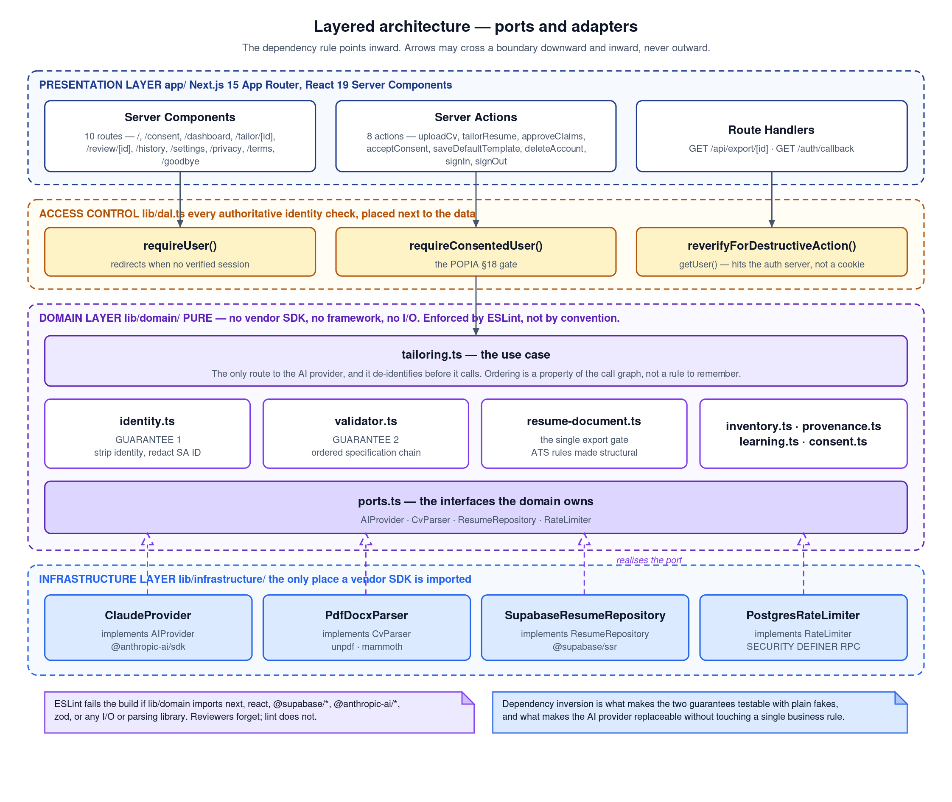
Figure 1: Layered architecture. Presentation and access control sit above the domain; infrastructure sits below it and realises the ports the domain declares.
Four layers, and the boundary that matters is the third. The presentation layer is Next.js — Server Components for rendering, Server Actions for mutations, Route Handlers for the two endpoints that must return something other than HTML. The access control layer is a single file, lib/dal.ts, which is where every authoritative statement about who the caller is gets made.
Placing access control in a dedicated layer beside the data, rather than in middleware, is deliberate. Middleware runs before routing and a single missed matcher pattern silently opens a route. A check placed next to the query means a route that forgets to call it still cannot read another user’s rows, because Row-Level Security is underneath. Two independent things have to fail.

2.3 The dependency rule, mechanised
A dependency rule enforced by convention is a dependency rule that erodes. This one is enforced by the linter. The ESLint configuration forbids lib/domain from importing Next.js, React, any Supabase or Anthropic package, Zod, any parsing library, and Node’s crypto and filesystem modules — and from importing lib/infrastructure at all.
// eslint.config.mjs — the rule that keeps the domain pure
{
group: ['@supabase/*', '@anthropic-ai/*'],
message: 'lib/domain must not import a vendor SDK. Depend on a port in',
// 'lib/domain/ports.ts and implement it in lib/infrastructure/.'
}
The rule can be demonstrated in ten seconds: add an import of the Supabase client to any file under lib/domain and run npm run lint. The build fails. That is the whole point — reviewers forget, and lint does not.

2.4 The component view
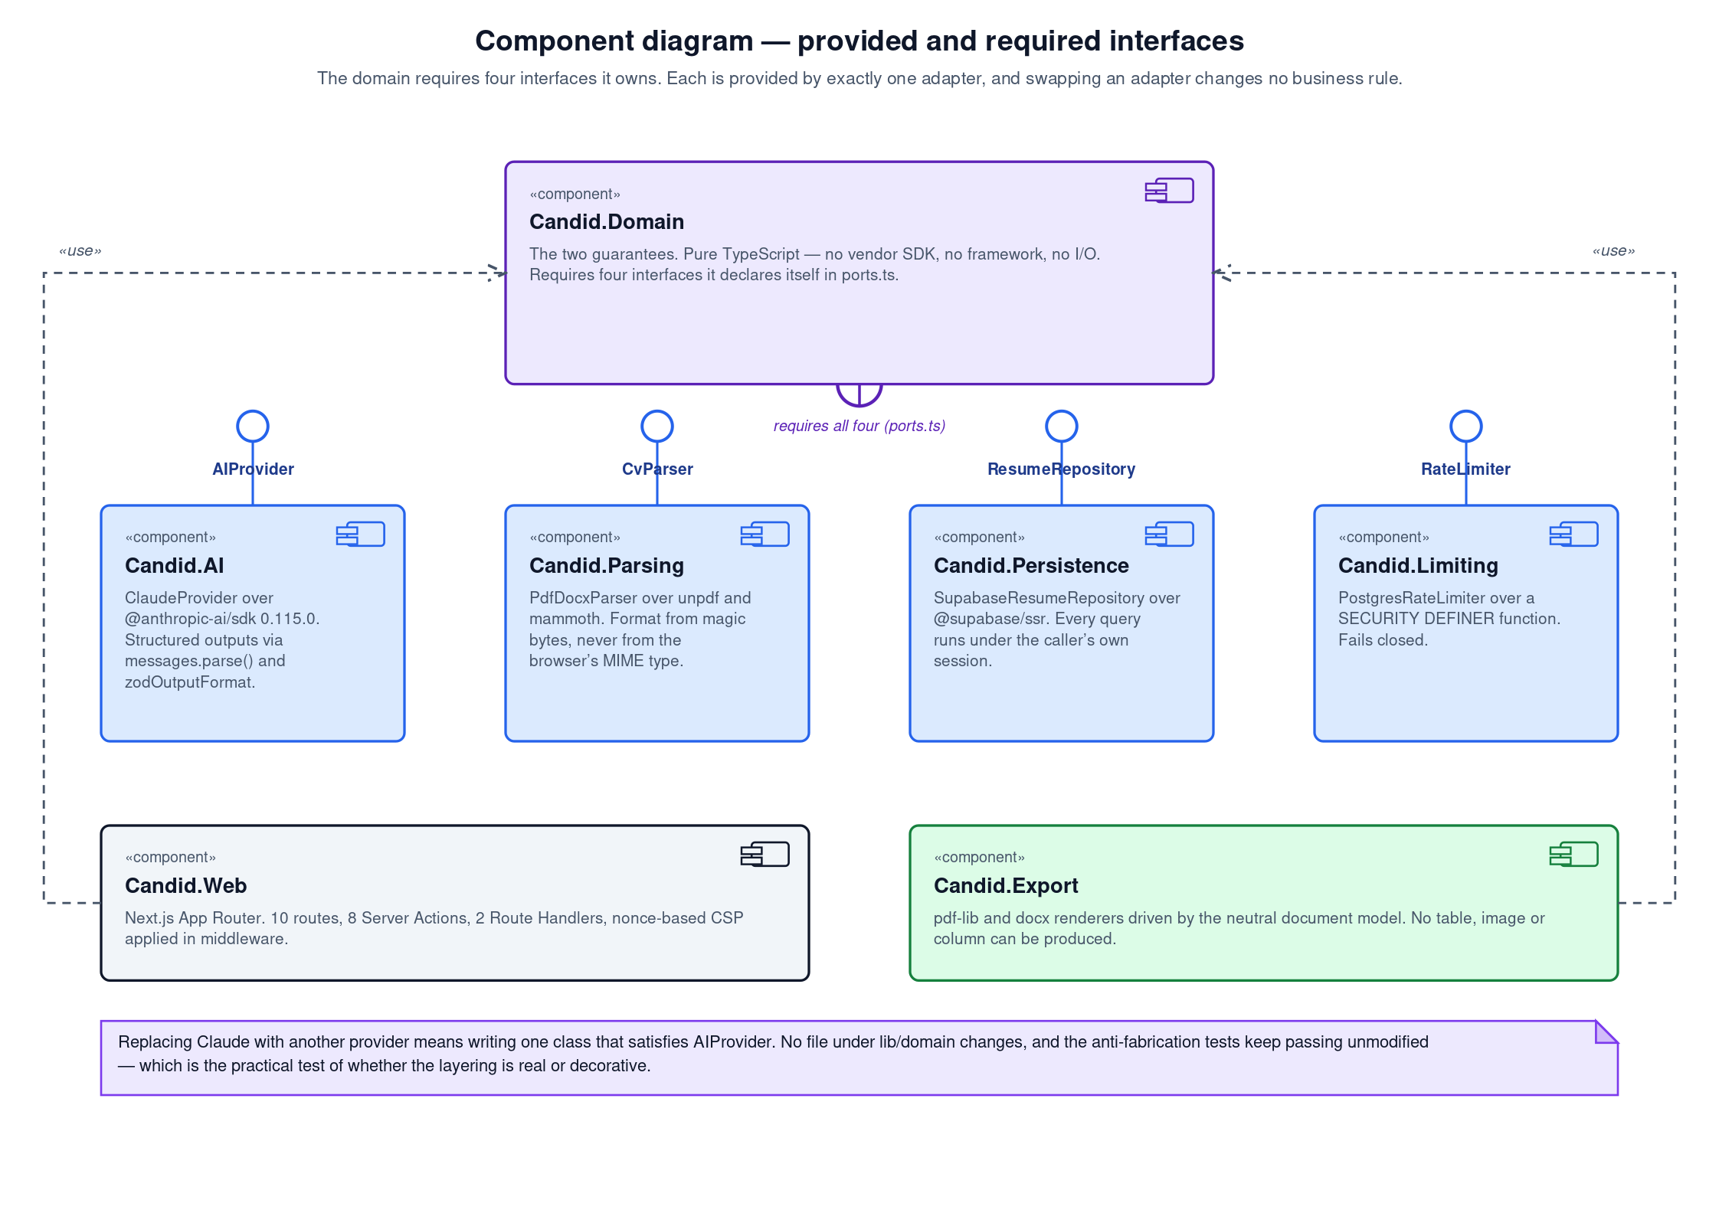
Figure 2: Component diagram. The domain requires four interfaces it declares itself; each is provided by exactly one adapter.
The practical test of whether this layering is real or decorative is what replacing a provider costs. Replacing Claude with another model means writing one class that satisfies the AIProvider interface. No file under lib/domain changes, and the anti-fabrication tests continue to pass unmodified, because they never referred to Anthropic in the first place.

3 Design patterns applied
Patterns are named here where they are actually used and where naming them explains something. A pattern applied for its own sake adds indirection without adding meaning, so section 3.6 records the ones that were considered and rejected.

3.1 Specification — the anti-fabrication rule
The Specification pattern (Evans, 2004) represents a business rule as an object that can answer whether a candidate satisfies it. Candid uses it for the single most important rule in the system.
The rule that decides whether a claim may be printed is not a conditional inside a request handler. It is an ordered chain of three specification objects, each of which returns a match or returns null to defer to the next.
export const SPECIFICATION_CHAIN: readonly ClaimSpecification[] = [
NamedInSourceCv, // employers and dates — no inference path exists
TraceableToInventory, // the skill appears in the CV
FairInferenceFromExperience, // a defensible reading, needs user approval
];
Three properties of this arrangement carry the guarantee. The order is significant: NamedInSourceCv runs first so that an employer name colliding with a skill term cannot be waved through by the skill rules. The verdicts differ per specification, so a fair inference is marked borderline and requires the user’s explicit approval rather than being accepted silently. And the fallthrough is blocked, not accepted — a claim that no specification understands is refused.
Why this is a pattern rather than a switch statement
Expressing the rule as a chain of objects means it has exactly one location, so the question “under what circumstances will this system print something untrue?” is answered by reading one file. It also means the chain can be reordered or extended without touching any caller, and that each specification can be tested in isolation against a hand-built inventory with no database and no network.

3.2 Ports and adapters, and dependency inversion
The domain declares four interfaces — AIProvider, CvParser, ResumeRepository and RateLimiter — in lib/domain/ports.ts, and infrastructure implements them. This is the Dependency Inversion Principle applied at the module level rather than at the class level.
One detail of the AIProvider port is worth drawing out, because it is where an architectural pattern becomes a security control:
export interface TailorRequest {
deidentifiedCv: string; // the output of deidentify(), nothing else
jobAdvert: string; // untrusted; the adapter must delimit it
}
There is no field for a name, an e-mail address, a telephone number or an identity number. Leaking identity to the model is therefore a compilation error rather than an oversight that a code reviewer has to notice.

3.3 Repository
ResumeRepository abstracts persistence behind an interface expressed in domain terms. Its most important design decision is a negative one: no method takes a user identifier as an argument.
Accepting a user identifier would invite a caller to pass an attacker-supplied one. Instead every implementation is scoped by the caller’s own session through Row-Level Security, so the question of whose rows these are is answered by the database rather than by the argument list.

3.4 Strategy — export templates
Three export templates are represented as TemplateSpec values selected at render time. The type deliberately carries typography and spacing only: font family, base size, line spacing, section spacing, margin and heading transform. There is no field for columns, borders, rules, background colours, icons or logos.
This is a Strategy in the classical sense (Gamma et al., 1995), constrained so that the strategy cannot change what the document says — only how it looks. A test asserts that all three templates produce identical text content and different bytes, which is what distinguishes a real choice from cosmetic theatre.

3.5 Use case as a first-class function
tailorCv() in lib/domain/tailoring.ts is the only route from the application to the AI provider, and it takes the provider as an argument. It exists so that the ordering the guarantees depend on is expressed once, in code, rather than being a rule every future caller must remember:
de-identify -> build inventory -> call the model -> validate
Because the function has no way to hand the provider anything but de-identified content, “never call the model before de-identification” stops being a convention and becomes a property of the call graph. Taking the provider as a parameter is what allows the entire flow to be exercised in a unit test against a fake, which is how the guarantee is proved.

3.6 Patterns considered and rejected
Table 1: Patterns evaluated and not adopted, with reasons
Pattern | Why it was not used
Abstract Factory for AI providers | There is one provider. A factory would add a layer whose only current job is to return the single implementation, and the port already gives the substitutability a factory would provide.
Observer for the integrity report | The report is computed once per tailoring and rendered. There is no ongoing state to observe, so events would add asynchrony to a synchronous problem.
Chain of Responsibility for validation | Superficially close to what is used, but the classic form lets a handler mutate and forward. The specification chain deliberately cannot: each specification returns a verdict or defers, and none can alter the claim.
Active Record for persistence | It would put database knowledge inside domain objects, which is precisely the dependency the architecture exists to invert.
Singleton for configuration | Environment access is a function call validated by a schema. A singleton would add hidden global state and make tests order-dependent.

4 Detailed design

4.1 The design class model
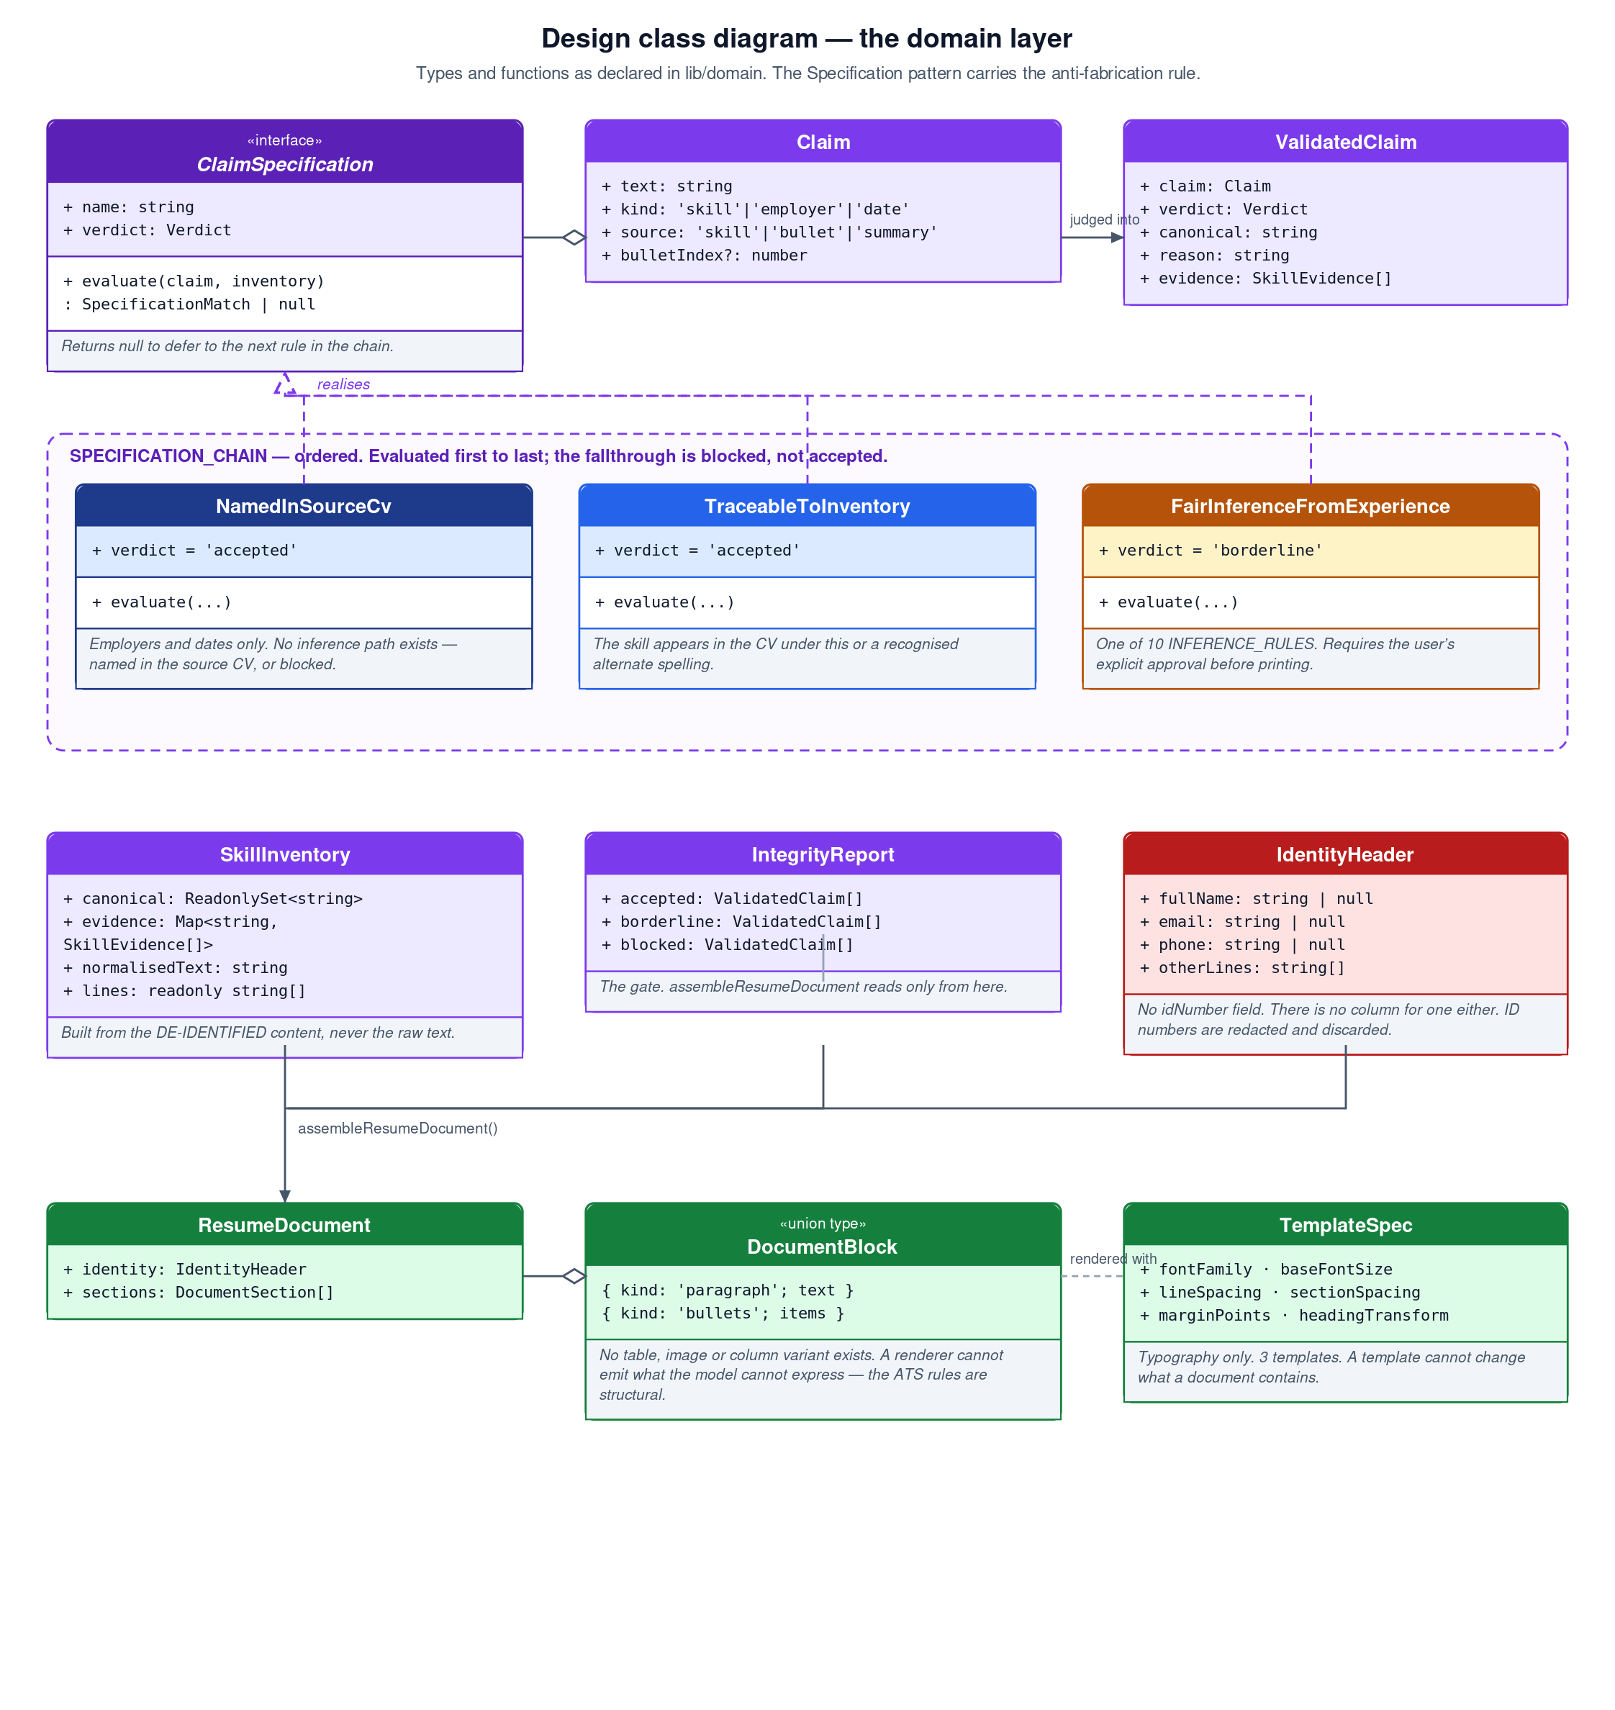
Figure 3: Design class model of the domain layer, showing the specification chain and the types the two guarantees are expressed in.

4.2 Guarantee 1 — de-identification
De-identification is three steps in a fixed order, and the order is load-bearing rather than incidental.
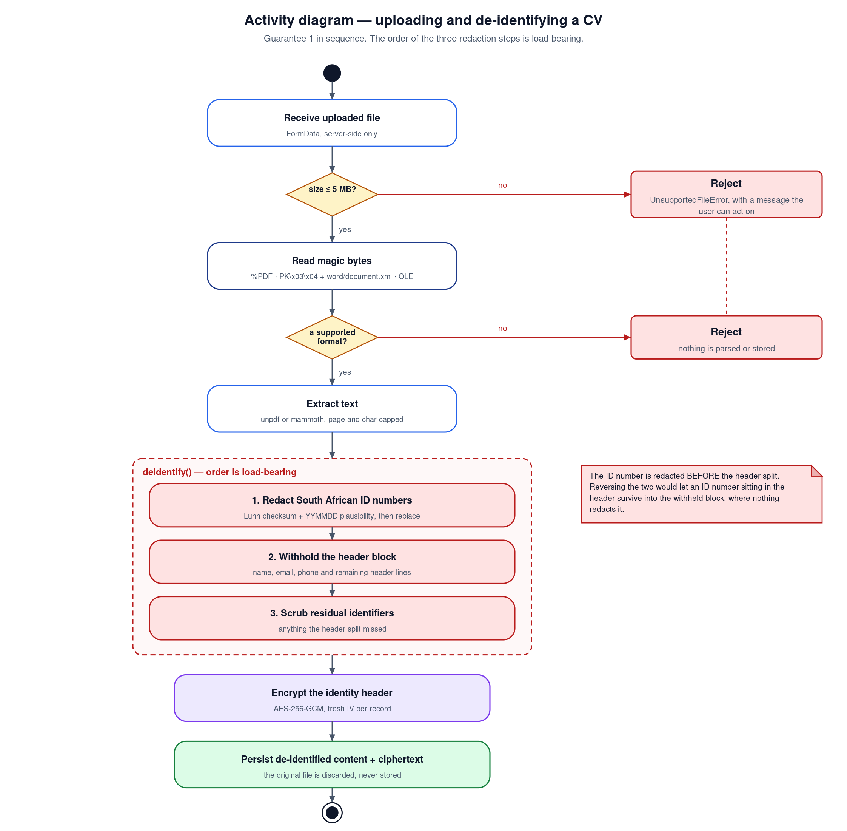
Figure 4: Activity diagram for upload and de-identification. Validation precedes parsing; redaction precedes the header split.
Identity numbers are redacted first, before the header block is separated. Reversing the two would let an identity number sitting inside the header survive into the withheld block, where nothing redacts it. Redaction is not a naive thirteen-digit match: a candidate must pass the Luhn checksum (Luhn, 1960) and carry a plausible YYMMDD date in its first six digits, which prevents a thirteen-digit reference number from being destroyed and prevents a real identity number from being missed.
A bug this design caught
During development a test fixture carried a hand-computed Luhn check digit that was wrong by one. The identity number in that fixture was therefore not a valid one, and was silently not being redacted. The test suite caught it. This is worth recording because it is the class of defect that a system relying on a plain digit-count match would never have noticed.

4.3 Guarantee 2 — the validation chain
Claims are extracted from the model’s reply before they are judged, and extraction covers more than the obvious place. A fabricated skill buried in a bullet point — “used Kubernetes to orchestrate deployments” — is exactly as dishonest as one in the skills array, so bullets and the summary are scanned as well.
Employers and dates are extracted separately, because they are asserted in prose rather than in a structured field. Detection uses multi-word proper nouns, standalone acronyms, four-digit years, and single-word employers identified by the preposition that introduces them. That last case was a real defect found by testing: the first implementation caught “Absa Bank” and missed “Google”.

4.4 The single export gate
assembleResumeDocument() is the only route from a validated draft to a printable document, and it builds the skills list by reading the integrity report. It never reads draft.skills.
The consequence is that approval is not the gate — the report is. Placing a blocked claim’s canonical key into the approvals list changes nothing, because the assembler filters on verdict before it consults approvals. A blocked claim therefore has no path to a file: not through an approval, not through a crafted request, and not through a future refactor that forgets the rule, because the rule is the only way through.

5 Behavioural design

5.1 Tailoring
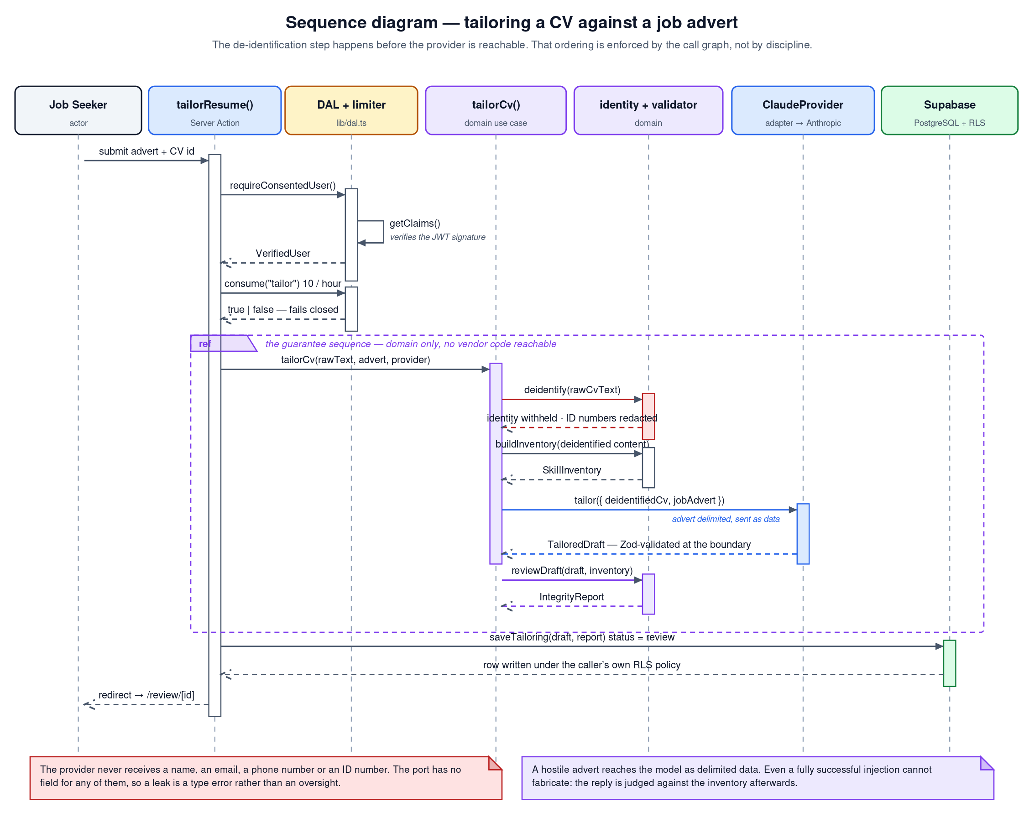
Figure 5: Sequence diagram for tailoring. De-identification completes before the provider becomes reachable.
The referenced fragment in the middle of the diagram is entirely domain code. No vendor SDK is reachable inside it except through the port, which is what makes the whole sequence testable against a fake.

5.2 Export
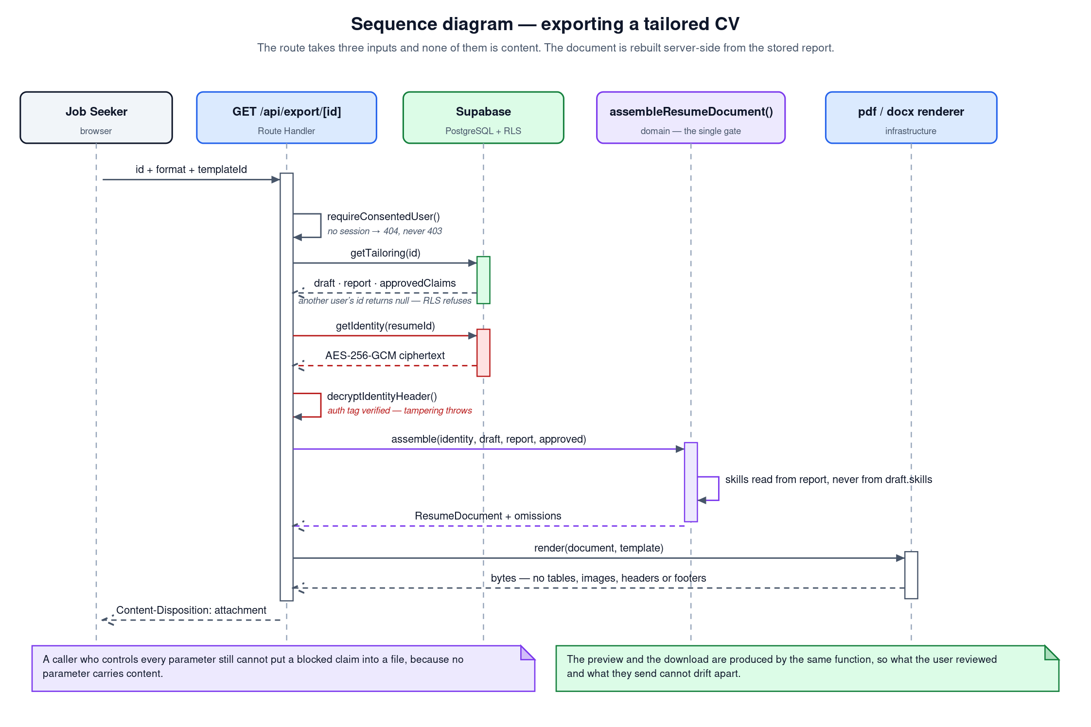
Figure 6: Sequence diagram for export. The request carries an identifier, a format and a template — and no content.
Two details in this sequence are security decisions rather than design conveniences. A request for another user’s tailoring returns 404 rather than 403, because 403 would confirm that the identifier exists. And the identity header is decrypted only here, at the last possible moment, so the plaintext name does not travel through the application on every page load.

5.3 Lifecycle
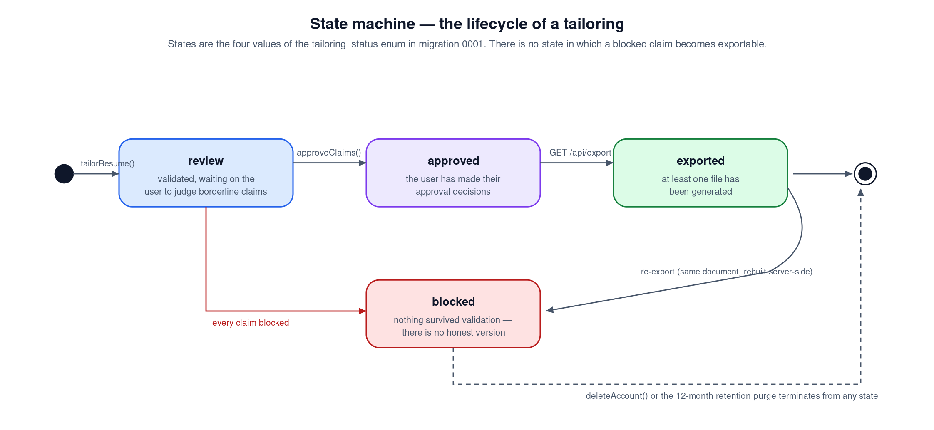
Figure 7: State machine for a tailoring, matching the four values of the tailoring_status enumeration.

6 Database design

6.1 Entity relationship model
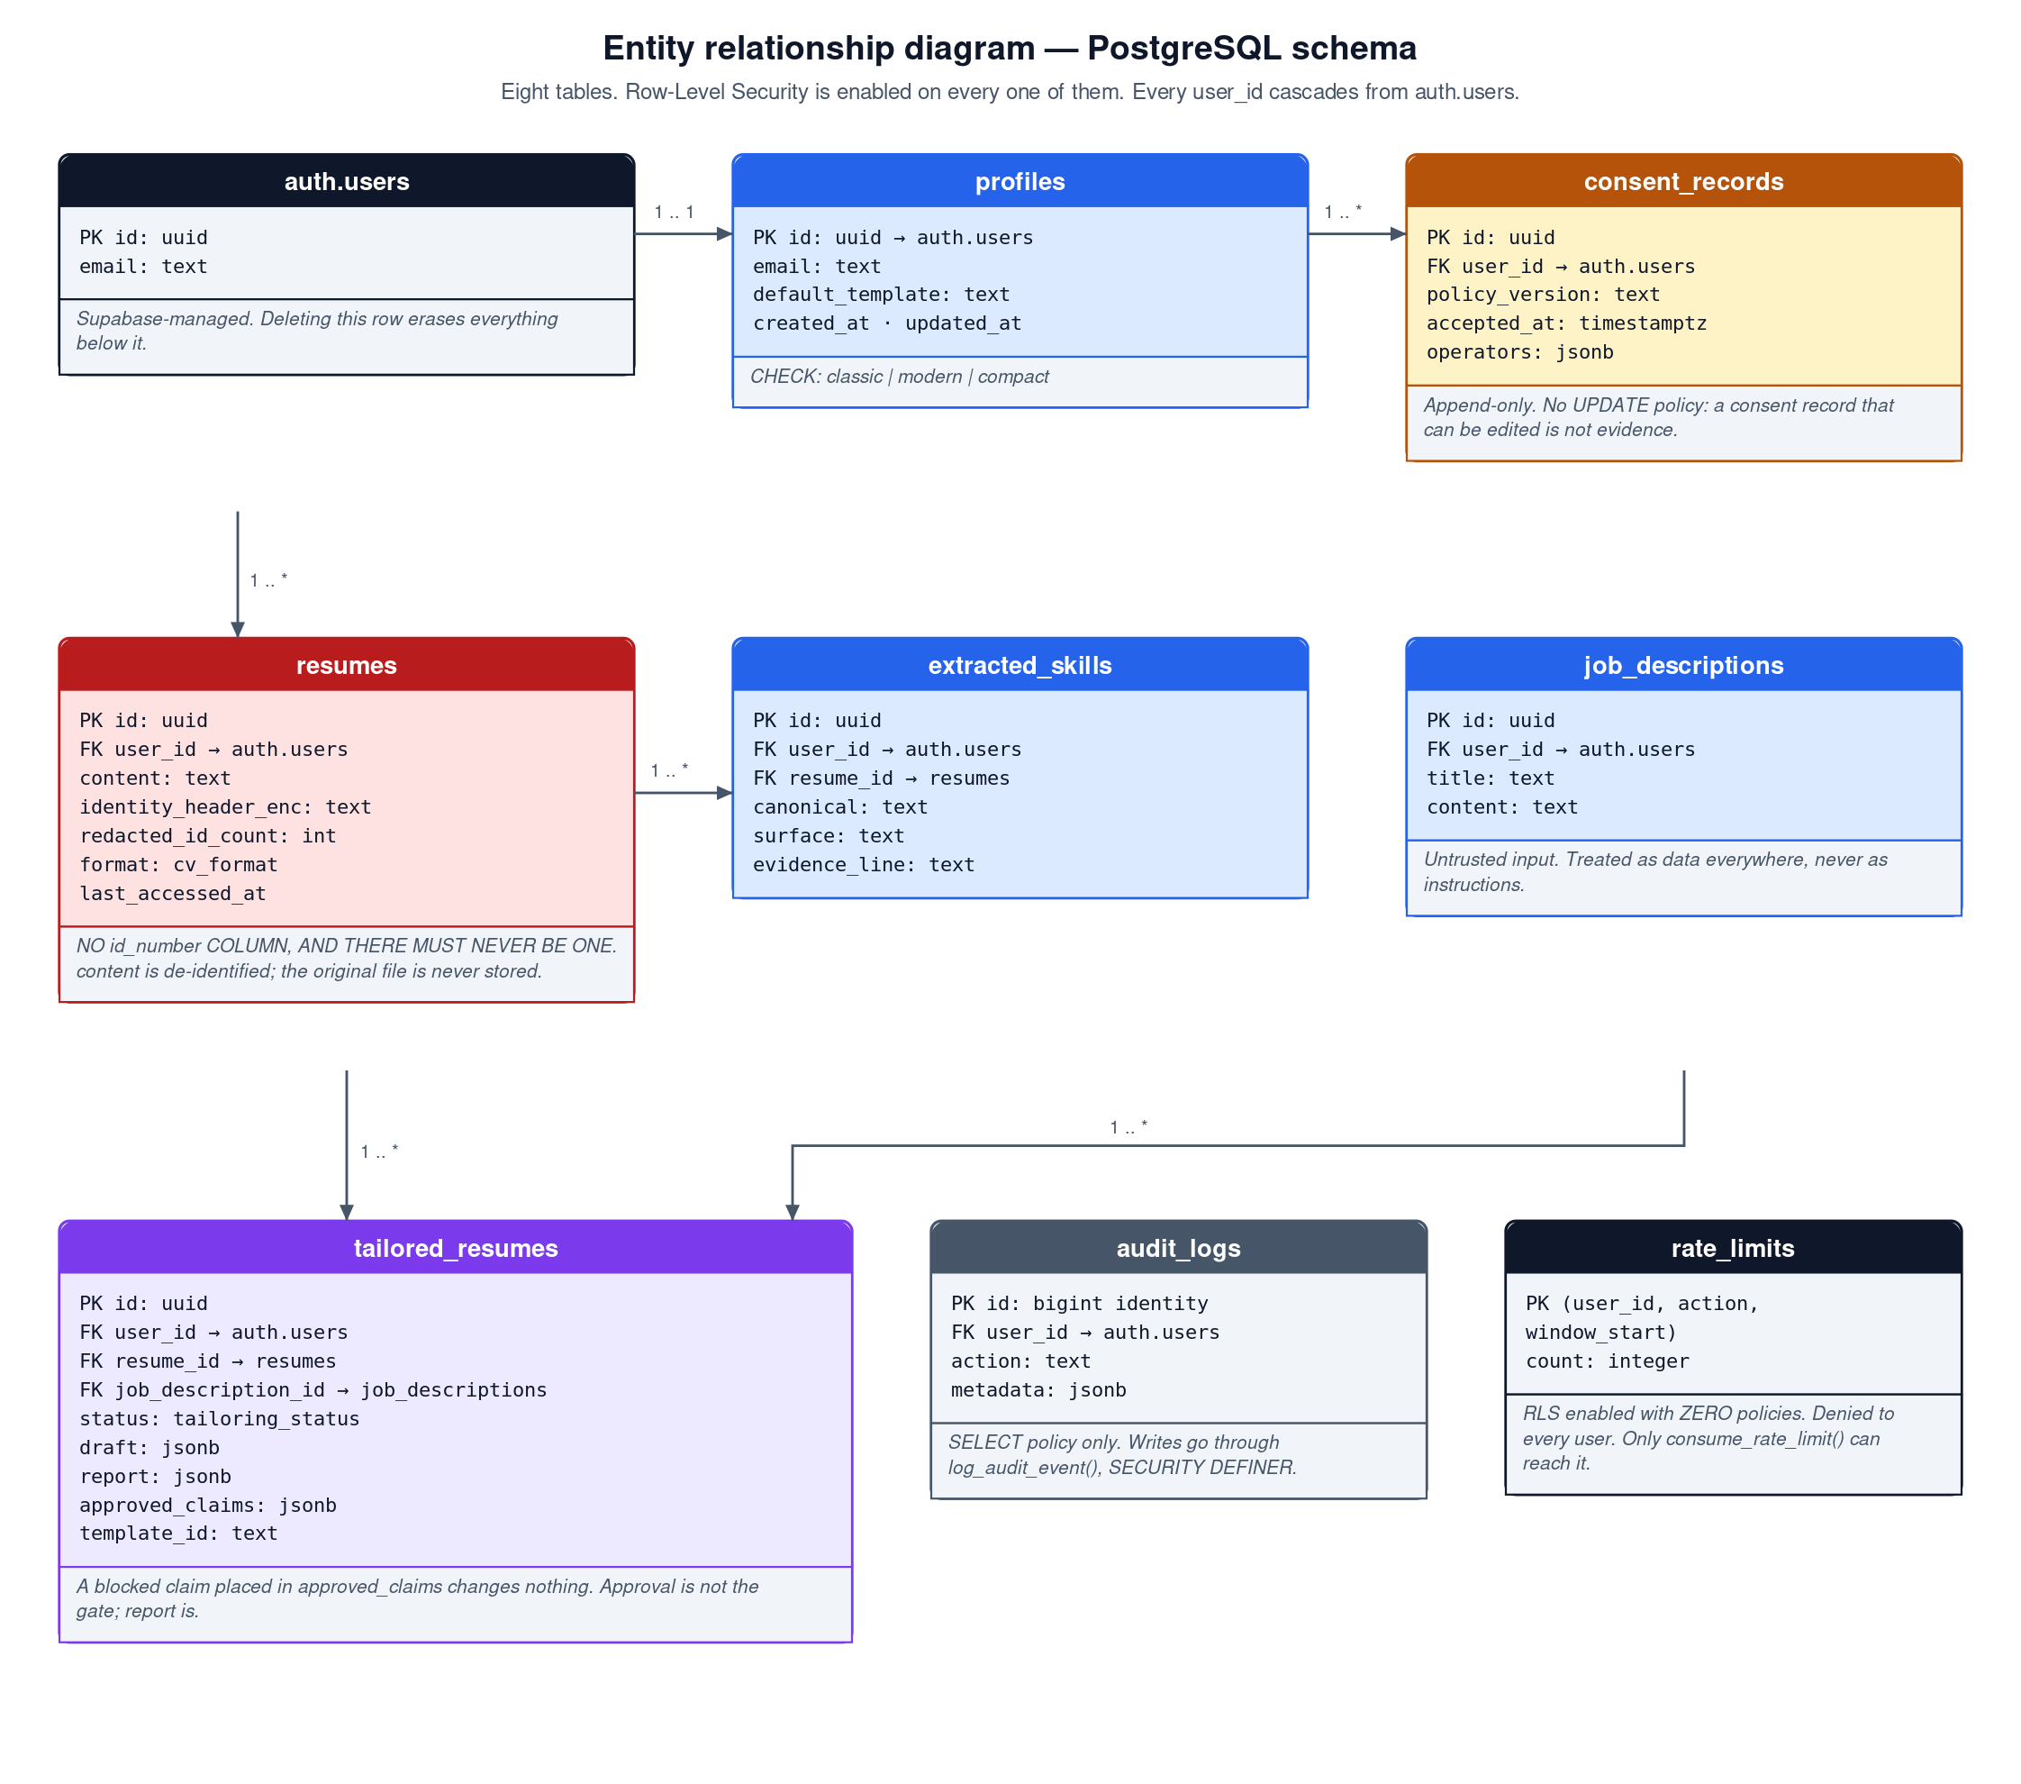
Figure 8: Entity relationship diagram. Eight tables, Row-Level Security on every one, every user_id cascading from auth.users.

6.2 Tables, and the reasoning behind the unusual ones
Table 2: Tables and their design rationale
Table | Purpose and rationale
profiles | One row per signed-in user, holding the e-mail address and the preferred export template. Created by a trigger on auth.users so the application never has to.
consent_records | What each user agreed to, and to which policy version, with the operator list snapshotted as it was worded at the time. Append-only by design: there is deliberately no UPDATE policy, because a consent record that can be edited after the fact is not evidence of anything.
resumes | De-identified CV text, the encrypted identity header, and a count of redactions. There is no id_number column and the migration says so in capitals. The original uploaded file is not stored, because storing it would reinstate the identity number that was just removed.
extracted_skills | The verifiable inventory built from a CV, with the source line for each skill. This is what every later claim is judged against, and what lets the review screen show the user why a claim was accepted.
job_descriptions | The pasted advertisement. Treated as untrusted data everywhere and delimited before it reaches a model.
tailored_resumes | The draft, the integrity report, the user’s approvals and the chosen template. A blocked claim placed into approved_claims has no effect, and a comment on the column records why.
audit_logs | Actions and counts, never content. Read-only to users: there is no INSERT, UPDATE or DELETE policy, so the only way to write one is the SECURITY DEFINER function.
rate_limits | Row-Level Security is enabled and there is deliberately not one policy on this table. Under PostgreSQL semantics that denies every statement from every user role, leaving consume_rate_limit() as the only route in. A user cannot read, reset or inflate their own allowance.

6.3 Row-Level Security design
Row-Level Security is the backstop rather than the plan. The application is written as though it did not exist, and then it exists anyway.
Both the browser client and the server client use the publishable key, so every query — including one issued from a Server Action — runs under the user’s own session and is filtered by policy. The secret key bypasses Row-Level Security entirely and is read in exactly one place, for administrative work only. That single read site is what makes “is the secret key reachable from a user-facing path?” a question answerable by reading one function rather than by grepping hopefully.
One micro-optimisation in the policies is worth noting because it is easy to get wrong. Each policy wraps the identity call in a sub-select:
create policy "resumes: read own"
on public.resumes for select
to authenticated
using ((select auth.uid()) = user_id);
Wrapping the call lets PostgreSQL evaluate it once per query as an initialisation plan rather than once per row. Without the sub-select the function is re-evaluated for every candidate row, which is invisible on a table of ten rows and material on a history list.

6.4 SECURITY DEFINER functions
Four functions run with the privileges of their definer rather than their caller — consume_rate_limit, log_audit_event, handle_new_user and purge_inactive_data. This is how the rate limiter and the audit log resist tampering. Every one of them sets an empty search path and schema-qualifies its references:
create or replace function public.consume_rate_limit(...)
returns boolean language plpgsql
security definer
set search_path = ''
Without that setting a caller can create a shadowing object in a schema that appears earlier on the search path and hijack the elevated privileges. It is a well-known escalation and a single line prevents it.
The rate limiter takes the caller from auth.uid() and never from an argument. Accepting a user identifier there would let any authenticated user spend any other user’s allowance.

6.5 Retention
purge_inactive_data() deletes CVs untouched for twelve months and everything cascading from them, advertisements with no surviving tailoring, audit records older than twenty-four months, and closed rate-limit windows. It is scheduled with pg_cron at 03:15 UTC, which is 05:15 in South African Standard Time and a quiet hour for the target user.
The function takes no arguments, which is a deliberate constraint: there is nothing a caller could point it at. Execution is revoked from public, from anon and from authenticated, so only the scheduler can invoke it.

7 User interface design

7.1 The principles applied
The interface is judged against Nielsen’s usability heuristics (Nielsen, 1994). Three of them shaped decisions that are visible in the product.
Table 3: Usability heuristics and the design decisions they produced
Heuristic | How it is honoured
Visibility of system status | The integrity report is not a footnote. It is the screen the user lands on after tailoring, divided into three named sections — traced to your CV, your call, and refused — so the state of every claim is visible before anything is exported.
Match between system and the real world | Verdicts are written in the user’s language rather than the system’s. A blocked claim reads “Your CV does not name this organisation. Candid will not add an employer you did not list,” not “validation failure”.
Help users recognise, diagnose and recover | A rejected upload names the actual problem and the actual remedy: an old .doc file is told to be saved as .docx, and a ZIP archive that is not a Word document is told so rather than being called invalid.
User control and freedom | Borderline claims are opt-in, never opt-out. Nothing inferred appears in an export unless the user ticked it, having seen the line of their own CV it was inferred from.
Error prevention | The single most effective error prevention in the system is structural: a blocked claim cannot be approved into a document, so the user cannot make that mistake even deliberately.

7.2 Multi-platform and responsive design
The interface is one responsive application rather than separate desktop and mobile builds, and the range it must survive is unusually wide because the target user may be on a very small phone.
The responsive test suite asserts zero horizontal overflow at seven widths on every public page, and additionally checks that touch targets are large enough to hit on a phone and that prose does not run the full width of an ultrawide monitor.
Table 4: Viewports asserted by the responsive suite
Class | Width | What is asserted
Small phone | 320 px | No horizontal scroll; the header remains usable.
Phone | 375 px | As above, plus touch targets of an adequate size.
Large phone | 430 px | No horizontal scroll; the header remains usable.
Tablet | 768 px | No horizontal scroll; the header remains usable.
Laptop | 1 280 px | No horizontal scroll; the header remains usable.
Desktop | 1 920 px | No horizontal scroll; the header remains usable.
Ultrawide | 2 560 px | Prose is constrained rather than stretched; the header and the page heading share a left edge.
Seven widths across three pages, plus the header assertion at each width and the three additional checks, is what produces 31 of the 55 end-to-end tests from five declarations.

7.3 Accessibility
Accessibility is treated as correctness rather than as decoration, and one defect found during end-to-end testing illustrates why it needs testing rather than intention.
A real accessibility defect, found by a real browser
The CardTitle component rendered a div. The integrity report — the most important screen in the product — therefore had three divs where its three section headings should have been. A screen reader user navigating by heading would have found nothing at all. Unit tests could not have caught this, because it is only wrong once rendered. It was fixed across six pages by rendering the correct heading element.
Beyond that, the colour palette maintains contrast in both themes, the theme survives a reload without a flash of the wrong colours, and every interactive control is reachable by keyboard.

7.4 Theming
Light and dark themes follow the operating system by default and can be overridden. The implementation detail worth recording is the interaction with the Content Security Policy: the theme is applied by an inline script that runs before paint, which is exactly what a nonce-based policy blocks. The nonce is therefore read from the request headers in the root layout and handed to the theme provider. That the theme survives a reload is asserted by an end-to-end test, and that assertion doubles as proof that the nonce is reaching the inline script.

8 Security design
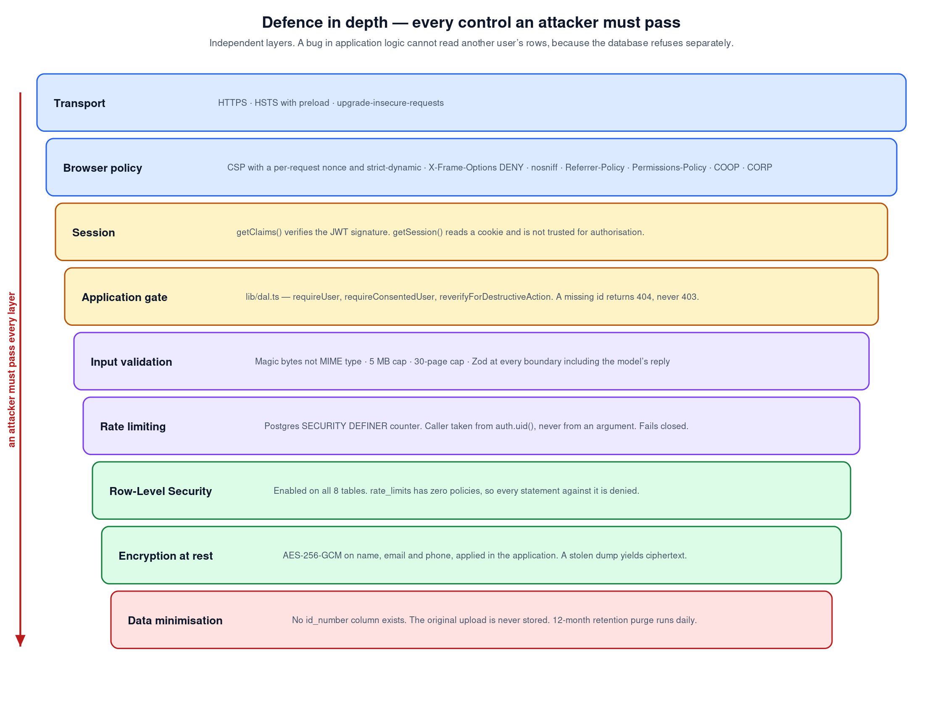
Figure 9: Defence in depth. Nine independent layers, each of which an attacker must pass separately.

8.1 The principle behind the layering
Each layer is independent, which is the property that makes the arrangement worth anything. A defect in application logic still cannot return another user’s rows, because the database refuses separately and for its own reasons. That claim is not asserted here; section 9.3 describes the test that proves it by issuing an unfiltered query from a second account’s own session.

8.2 Encryption at rest
The threat addressed by field encryption is narrow and worth stating plainly: someone obtains a copy of the database. Row-Level Security does nothing in that scenario, because it is a query-time control and a dump is not a query.
Name, e-mail address and telephone number are encrypted with AES-256-GCM in the application, so the key never lives beside the data. Galois/Counter Mode is chosen over CBC because it authenticates as well as encrypts (Dworkin, 2007): without an authentication tag, an attacker with write access could flip bits in the ciphertext and the system would decrypt the result without complaint. A fresh 96-bit initialisation vector is generated for every record, because reusing one across records under the same key is the classic way to break GCM completely.

8.3 Content Security Policy
The policy carries a per-request nonce and uses strict-dynamic, so the script directive permits neither inline script nor eval in production. A test exists whose entire purpose is to keep it that way.
The nonce must be set on the request headers rather than only on the response, because that is how Next.js discovers it and stamps its own bootstrap scripts. This is the kind of detail that is invisible until the policy is verified in a real browser, which it now has been, with zero violations across the public pages.
One compromise is documented rather than hidden. The style directive permits inline styles. Style injection can deface a page and, with effort, exfiltrate limited data through selectors, but it cannot execute — a materially weaker vector than script injection. Removing it requires verifying against a production build that nothing the framework injects inline is missed, and shipping an untested policy that breaks the application in front of a user would be worse than a scoped compromise that is written down and pinned by a test.

8.4 Handling untrusted input
Three inputs are treated as hostile: the uploaded file, the pasted advertisement, and the model’s reply.
- The file is classified by magic bytes rather than by the browser-supplied MIME type or the extension, both of which are trivially set to anything. A ZIP archive is only accepted as a Word document if it contains an entry named word/document.xml, which rejects the neighbouring OOXML formats before a parsing library is handed them. Size, page count and extracted character count are all capped.
- The advertisement is delimited and the model is instructed to treat it as reference data. That instruction can fail — and the design assumes it will. A test exists in which the injection succeeds completely against a simulated compromised model, and the fabricated skill is still blocked, because the reply is judged against the inventory afterwards.
- The model’s reply is validated against a schema at the infrastructure boundary before it is handed inward. A malformed reply is rejected there rather than propagating into the domain.

9 Verification and testing

9.1 Strategy
Testing is organised around a single question: what would have to be true for this system to print something untrue, or to leak an identity? Every test in the suite is an answer to some version of that question, which is why the file names read as claims rather than as modules.
Table 5: Unit and integration suites, with what each one asserts
Suite | Tests | What it establishes
anti-fabrication.test.ts | 18 | The specification chain, the inventory, and what may reach a document. Includes the case where a blocked claim is placed into the approvals list.
identity.test.ts | 18 | Identity number redaction including Luhn and date validation, header detection, and that nothing identifying reaches the AI provider.
ats-round-trip.test.ts | 30 | Exports survive a round trip through a real parser, contain no tables, images, headers or footers, and print no gaps list. Parameterised over all three templates.
security-headers.test.ts | 16 | The Content Security Policy never permits inline script, permits eval only in development, and every static header is present.
prompt-injection.test.ts | 12 | A fully successful injection still cannot fabricate. Invented employers and dates are blocked; ones the CV names are accepted.
parser.test.ts | 12 | Format detection from magic bytes, rejection of neighbouring formats, and the bounds on size, pages and characters.
persisted-records.test.ts | 11 | Records read back from the database are validated, and approvals fail in the safe direction when the data is malformed.
crypto.test.ts | 8 | Encryption round-trips, tampered ciphertext fails to decrypt, and a key of the wrong length is refused.
Total | 125

9.2 End-to-end testing
The end-to-end suite drives a real browser against a running instance backed by real Supabase and, for one test, the real Anthropic API. It adds no test-only code path to the application: there is no bypass mode and no forged cookie. A genuine session is obtained through Supabase’s own API and serialised into cookies by the same library the application uses.
Table 6: End-to-end suites
Suite | Tests | Coverage
public.spec.ts | 12 | Landing page, security headers on a real response, a different nonce on every request, zero Content Security Policy violations in the browser console, the signed-out gate, and the legal pages.
happy-path.spec.ts | 7 | Consent gate, upload of a CV carrying a valid identity number with the stored row asserted clean, tailoring against an advertisement containing an injection attempt, both exports, and account deletion.
isolation.spec.ts | 5 | Two real accounts proven unable to read each other’s data.
responsive.spec.ts | 31 | Seven viewports across three pages, plus touch target sizing and content width on an ultrawide.
Total | 55

9.3 Proving isolation between accounts
Row-Level Security is easy to claim and easy to get wrong. The isolation suite creates two real accounts and attacks from both ends.
Through the application: account B holds account A’s CV identifier and requests it. The response is 404, not 403 — a 403 would confirm that the identifier exists, which is itself a leak.
Through the database: account B’s own session issues an unfiltered SELECT against every user-facing table, bypassing every line of application code. It returns nothing but B’s own consent record. The rate-limiting table is unreadable even by its owner, exactly as the migration intends.

9.4 Testing the tests
A test suite that would stay green while the product broke is worse than no suite, because it manufactures confidence. So the suite was verified by deliberately breaking each guarantee and confirming it turned red.
Table 7: Deliberate regressions used to verify the suite
Change introduced | Result
Allowed a blocked claim through the document assembler. | Anti-fabrication tests failed. Reverted.
Removed the residual identity scrub from de-identification. | Identity tests failed. Reverted.
Flipped the validator’s fallthrough verdict from blocked to accepted. | Anti-fabrication and prompt-injection tests failed. Reverted.
Added a Supabase import to a domain file. | The linter failed the build, as the dependency rule requires.

9.5 Defects found by testing, and what each one shows
The value of a testing strategy is best judged by what it caught rather than by what it covers on paper.
Table 8: Defects found, and the level that found them
Found by | Defect | Why it matters
Unit tests | A hand-computed Luhn check digit was wrong, so a fixture’s identity number was silently not being redacted. | A digit-count match would never have surfaced this. Validating properly is what made the fixture wrong and therefore visible.
Unit tests | Employer detection caught multi-word names such as “Absa Bank” and missed single-word ones such as “Google”. | Fixed by matching on the preposition that introduces an employer. A real gap in a guarantee.
End-to-end | CardTitle rendered a div, so the integrity report had no real headings. | Only visible once rendered. Unit tests could not have found it.
End-to-end | The magic-link flow returns a fragment rather than a query parameter. | The fix belonged in the test, not in the application. Widening the application’s authentication surface to satisfy a test would have been the wrong repair.
Continuous integration | With no Supabase credentials the URL was an empty string, the client threw inside middleware, and every page returned 500 — including the landing page. | Middleware runs on every request, so an unreachable authentication service took the entire site down. The check now fails closed: public pages render, protected pages redirect.
Branch ruleset | A direct push of four commits to the main branch was refused. | The control worked the first time it was tested, which is the only test that counts.

10 Known limitations
These are carried forward from Assignment 2 with their current status, and are stated here because a project document that lists none is not credible.
- Employer detection is heuristic. Lowercase names, companies whose name is an ordinary word, and employers named without a preposition can be missed. The failure direction is safe — a false positive blocks a bullet point rather than admitting a false claim — but it is a real gap and is described as heuristic rather than complete.
- Skill detection in prose is bounded by a vocabulary list. A skill phrased unusually inside a bullet may not be recognised as a claim and therefore not judged. This is the one limitation whose failure direction is not obviously safe, and it is bounded only by the fact that the model is instructed to place skills in the skills array, which is scanned exhaustively.
- The style directive of the Content Security Policy permits inline styles. Documented, pinned by a test so that tightening it must be a conscious act, with the upgrade path written into the file.
- The database type definitions are hand-written from the migrations. They can drift from the live schema. Regenerating them with the Supabase command-line tool is outstanding work.
- The live end-to-end run is not yet reproducible by a third party. An independent auditor verified that the suite adds no bypass to the application and would exercise the real flow, but could not re-run it without credentials. Adding five repository secrets so that continuous integration runs it on a public log is the fix, and is recorded as outstanding.

11 Conclusion
The architecture documented here exists to serve two guarantees, and the test of the architecture is whether those guarantees survive contact with the things that usually erode them: a new contributor, a changed provider, a hostile input, a rushed deadline.
Three mechanisms carry that weight, and each replaces a rule someone must remember with a property of the code. Ordering is structural, because the use case is the only route to the provider and it de-identifies before it calls. Fabrication is structural, because the document assembler reads from the integrity report and cannot see the model’s draft. Purity is structural, because the linter fails the build rather than trusting a reviewer.
The system was also verified rather than merely tested: the guarantees were deliberately broken to confirm the suite noticed, the isolation between accounts was proved at both the application and the database level, and an independent audit examined the result and revised its own findings under evidence. The limitations that remain are recorded in section 10 with their failure directions, because a document that lists none would not deserve to be believed about anything else.

References
Referenced in accordance with the Harvard method. Every electronic source carries its full uniform resource locator and the date on which it was accessed.
Beck, K. 2003. Test-driven development: by example. Boston: Addison-Wesley.
Cockburn, A. 2005. Hexagonal architecture. [Online]. Available at: https://alistair.cockburn.us/hexagonal-architecture/ [Accessed 2 August 2026].
Dworkin, M.J. 2007. Recommendation for block cipher modes of operation: Galois/Counter Mode (GCM) and GMAC. NIST Special Publication 800-38D. Gaithersburg, MD: National Institute of Standards and Technology.
Erl, T. 2017. Service-oriented architecture: analysis and design for services and microservices. 2nd ed. Boston: Prentice Hall.
Evans, E. 2004. Domain-driven design: tackling complexity in the heart of software. Boston: Addison-Wesley.
Fowler, M. 2002. Patterns of enterprise application architecture. Boston: Addison-Wesley.
Gamma, E., Helm, R., Johnson, R. & Vlissides, J. 1995. Design patterns: elements of reusable object-oriented software. Reading, MA: Addison-Wesley.
Hall, G. 2017. Adaptive code: agile coding with design patterns and SOLID principles. 2nd ed. Redmond, WA: Microsoft Press.
Humble, J. & Farley, D. 2010. Continuous delivery: reliable software releases through build, test, and deployment automation. Boston: Addison-Wesley.
International Organization for Standardization. 2011. ISO/IEC 25010:2011 Systems and software engineering — SQuaRE — System and software quality models. Geneva: ISO.
Kim, G., Humble, J., Debois, P. & Willis, J. 2016. The DevOps handbook: how to create world-class agility, reliability, and security in technology organizations. Portland, OR: IT Revolution Press.
Luhn, H.P. 1960. Computer for verifying numbers. United States Patent 2,950,048.
Martin, R.C. 2017. Clean architecture: a craftsman’s guide to software structure and design. Boston: Prentice Hall.
Nielsen, J. 1994. Enhancing the explanatory power of usability heuristics. In: Proceedings of the SIGCHI Conference on Human Factors in Computing Systems. New York: ACM, pp. 152–158.
Object Management Group. 2017. OMG Unified Modeling Language (OMG UML), version 2.5.1. [Online]. Available at: https://www.omg.org/spec/UML/2.5.1/ [Accessed 2 August 2026].
OWASP Foundation. 2021. OWASP Top 10:2021. [Online]. Available at: https://owasp.org/Top10/ [Accessed 2 August 2026].
Republic of South Africa. 2013. Protection of Personal Information Act 4 of 2013. Pretoria: Government Printer.
Schach, S.R. 2011. Object-oriented and classical software engineering. 8th ed. New York: McGraw-Hill.
Sommerville, I. 2016. Software engineering. 10th ed. Boston: Pearson.
Statistics South Africa. 2026. Quarterly Labour Force Survey, Quarter 1: 2026. Statistical Release P0211. Pretoria: Statistics South Africa. [Online]. Available at: https://www.statssa.gov.za/publications/P0211/P02111stQuarter2026.pdf [Accessed 2 August 2026].
World Wide Web Consortium. 2023. Web Content Accessibility Guidelines (WCAG) 2.2. W3C Recommendation. [Online]. Available at: https://www.w3.org/TR/WCAG22/ [Accessed 2 August 2026].
World Wide Web Consortium. 2024. Content Security Policy Level 3. W3C Working Draft. [Online]. Available at: https://www.w3.org/TR/CSP3/ [Accessed 2 August 2026].

Software documentation consulted
Anthropic. 2026. Claude API documentation. [Online]. Available at: https://docs.claude.com/ [Accessed 2 August 2026].
GitHub. 2026. GitHub Actions documentation. [Online]. Available at: https://docs.github.com/actions [Accessed 2 August 2026].
Microsoft. 2026. TypeScript handbook. [Online]. Available at: https://www.typescriptlang.org/docs/handbook/ [Accessed 2 August 2026].
PostgreSQL Global Development Group. 2026. PostgreSQL 15 documentation: row security policies. [Online]. Available at: https://www.postgresql.org/docs/15/ddl-rowsecurity.html [Accessed 2 August 2026].
Supabase. 2026. Row Level Security. [Online]. Available at: https://supabase.com/docs/guides/database/postgres/row-level-security [Accessed 2 August 2026].
Vercel. 2026. Next.js documentation — App Router. [Online]. Available at: https://nextjs.org/docs/app [Accessed 2 August 2026].

